GPU DECK

INTERFACE FOR RECOMMENDING THE BEST MATCHING GPU TO YOUR REQUIREMENT

DESIGNED BY –
TEAM NO. 011 :
SUJAL GUPTA
UTSAV JHA
SRISHTI CHAUHAN

INTRODUCTION

Translates natural language queries into structured resource requirements using Gemini or similar LLMs.

Extracted features include: vCPUs, RAM, price/hour, price/month, spot price, GPU presence, and availability.

Converts the extracted data into an 8-dimensional vector for similarity search.

Searches a FAISS index of precomputed vectors representing real GPU instances.

Retrieves the top most similar instances based on vector proximity.

Returns detailed metadata such as instance name, region, GPU type, pricing, and availability.

Ideal for developers and researchers to discover optimal cloud GPU instances without manual filtering.

HOW TO RUN THE PROJECT

- Clone and fork the git hub repo in local.
- Move to the directory of the repo.
- Run “npm install” in the terminal to install the packages.
- Move to “backend” and start the server by “unicorn index:app –reload”
- Make a new terminal and do “npm run start” to start the front end.
- .env file in the backend folder: “GEMINI_API_KEY”

WORK – FLOW

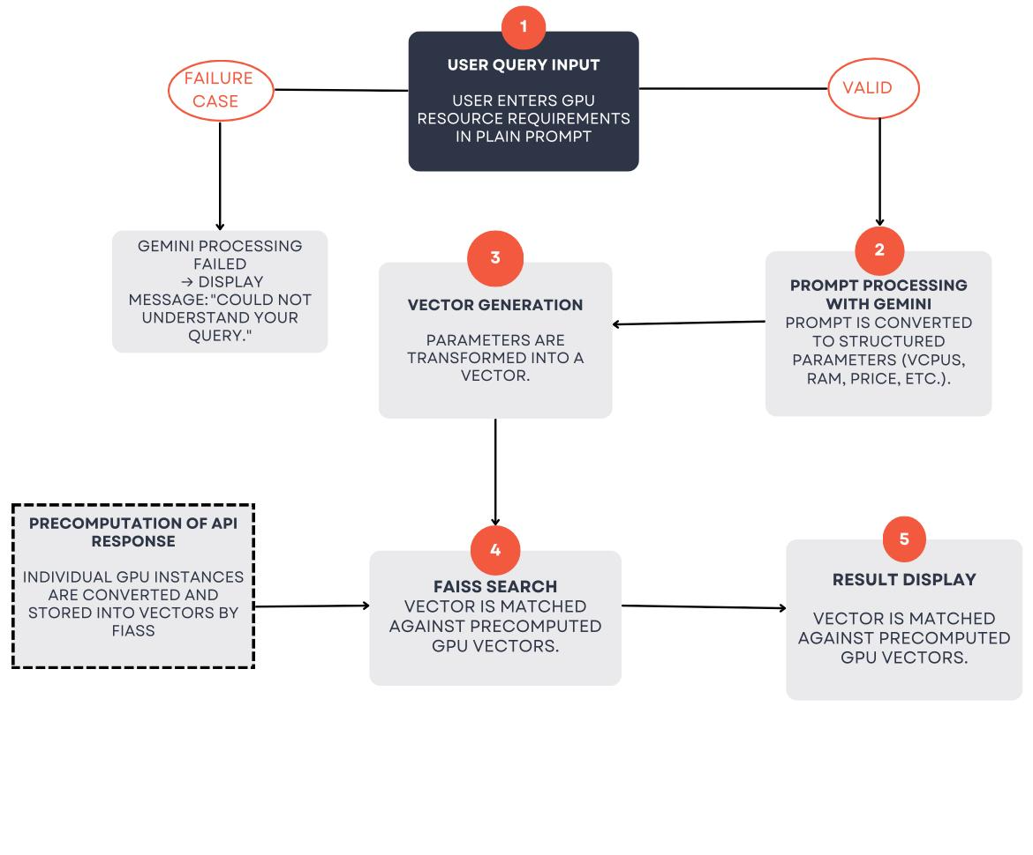

Tech–Stack Overview

This application leverages a blend of modern AI, vector search, backend APIs, and deployment tools to create an intelligent, prompt-driven GPU instance recommendation engine.
- Backend Framework – FastAPI
- Purpose: Serves as the backbone of the web application, handling HTTP requests and defining the API endpoints.
- Why FastAPI?
  - High performance (thanks to ASGI & Starlette)
  - Automatic Swagger/OpenAPI docs generation
  - Type safety via Pydantic
- Usage:
  - Hosts the /search POST endpoint that accepts natural language prompts.
  - Parses and validates requests using Pydantic models (like InputQuery).
  - Returns structured JSON responses.
- Language Model – Google Gemini Pro API
- Purpose: Understands the user's prompt and converts it into structured, machine-readable features.
- Why Gemini?
  - Capable of understanding complex natural language queries.
  - Can generate structured JSON from prompts when guided properly.
- Usage:
  - Receives prompts like "I need a cheap GPU instance with 16GB RAM".
  - Extracts key features such as vCPUs, RAM, price, and GPU requirements.
  - Returns those in a JSON format, which is then vectorized.

- Vector Similarity Search – FAISS (Facebook AI Similarity Search)
- Purpose: Quickly finds the most similar GPU instances from a large pool based on numeric feature vectors.
- Why FAISS?
  - Optimized for large-scale similarity search.
  - Fast and scalable, supports millions of vectors.
- Usage:
  - A precomputed FAISS index holds vectors representing real GPU instances.
  - Input from Gemini is converted into an 8D vector.
  - FAISS searches for the top K most similar vectors (e.g., k=5).
  - Returns the closest matches with associated index positions.
- Data Retrieval & Metadata Mapping
- Purpose: Map FAISS index results back to original instance metadata (e.g., region, OS, price).
- Usage:
  - While building the FAISS index, each vector’s metadata is stored in a list (Python dicts).
  - After a similarity search, the index returned by FAISS is used to fetch full instance details.
- Environment Configuration – python-dotenv
- Purpose: Securely load and manage environment variables such as API keys.
- Usage:
  - Stores sensitive configuration like GEMINI_API_KEY in a .env file.
  - Ensures that credentials are not hardcoded into source files.
- Dependency Management & Execution
- Key libraries:
  - Faiss (vector search)
  - numpy (vector math)
  - requests (for fetching remote metadata, if dynamic)
  - google-generativeai (Gemini API integration)
  - fastapi & uvicorn (API hosting)
- Development & Testing Tools
- Uvicorn:
  - ASGI server used to run FastAPI.
  - Fast and production-ready.
- Postman :
  - For testing API endpoints by sending POST requests with prompt payloads.

UNIT TEST FOR BACKEND

Purpose: Verifies that the /search endpoint of the GPU Resource Search API behaves as expected.
Test Approach: Simulates a POST request using a realistic natural language prompt.
Validation: Ensures the response returns a 200 OK HTTP status.
- Confirms the response body includes a non-empty list of results.
- Each result contains both a match and a distance field.
Efficiency: Uses FastAPI’s TestClient, enabling tests to run without launching the actual server.
Reliability: Validates prompt parsing and GPU instance recommendation logic in isolation, ensuring the core functionality remains stable.

