Week 2 Project: Activity Monitoring Data

ck

16 5 2017

## Setting environment

## Getting data

### macro functions for getting data

# download and unzip file from given url  
dataset.source.get_zip <- function(dataset.name, source.url, dataset.source.type=".csv", ...) {  
 dataset.source.zip <- paste(c(dataset.name, ".zip"), collapse = "")  
 dataset.source <- paste(c(dataset.name, dataset.source.type), collapse = "")  
   
 if (!file.exists(dataset.source)) {  
 download.file(source.url, destfile = dataset.source.zip, mode='wb')  
 unzip(dataset.source.zip)  
 }  
 dataset.source  
}  
  
# generation of clean data from existing (downloaded and unzipped) file  
dataset.get <- function(dataset.name, source.zip, dataset.source.type, ...) {  
 # import data source from file  
 switch(dataset.source.type,   
 ".csv" = {dataset <- read.csv(  
 dataset.source.get_zip(dataset.name, source.zip, dataset.source.type)  
 , sep = ','  
 , dec = '.'  
 #,na.strings = 'NA'  
 )  
 })  
 dataset  
}

### Project specific getting of data

Use of data from a personal activity monitoring device. This device collects data at 5 minute intervals through out the day. The data consists of two months of data from an anonymous individual collected during the months of October and November, 2012 and include the number of steps taken in 5 minute intervals each day.

The data source for this assignment can be downloaded from [coursera project site](https://www.coursera.org/learn/reproducible-research/peer/gYyPt/course-project-1) (downloaded on 2017-05-16)

# check, whether clean data is available, otherwise generation of data source  
# csv-separated with ",", na.strings with "NA"  
if (!exists("set.AMD")) {  
 set.AMD <- dataset.get("activity"  
 , "https://d396qusza40orc.cloudfront.net/repdata%2Fdata%2Factivity.zip"  
 , ".csv")  
}   
  
# data wrangling  
require(lubridate)

## Loading required package: lubridate

##   
## Attaching package: 'lubridate'

## The following object is masked from 'package:base':  
##   
## date

set.AMD$date <- ymd(set.AMD$date)  
  
# make time serie from double  
require(stringr)

## Loading required package: stringr

set.AMD$interval <- paste(substr(str_pad(set.AMD$interval, 4, pad="0"), 1,2)  
 , substr(str_pad(set.AMD$interval, 4, pad="0"), 3,4), sep=":")  
set.AMD$interval <- factor(set.AMD$interval)  
  
rm(dataset.get, dataset.source.get_zip)

# check for var (steps, date, interval), types (int, date, factor) and row-count (17,568)  
str(set.AMD)  
# check, how many rows with missing values are present  
table(is.na(set.AMD))

## I. What is mean total number of steps taken per day?

### 1. histogram of the total number of steps taken each day

# aggregate steps by day  
require(plyr)

## Loading required package: plyr

##   
## Attaching package: 'plyr'

## The following object is masked from 'package:lubridate':  
##   
## here

require(ggplot2)

## Loading required package: ggplot2

set.AMD.aggr_day <- ddply(set.AMD, c("date"), summarise, steps=sum(steps))  
  
# histogramm of days with valid number of steps  
ggplot(data=subset(set.AMD.aggr_day, !is.na(steps))  
 , aes(subset(set.AMD.aggr_day, !is.na(steps))$steps)) +   
 geom_histogram(breaks=seq(0,23000, by =1000),   
 col="steelblue",   
 aes(fill=..count..)) +  
 labs(title="Total Number of Steps taken each day") +  
 labs(x="steps per day", y="count of frequency")

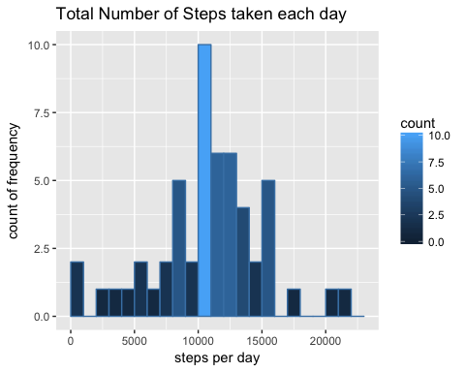

rm(set.AMD.aggr_day)

### 2. mean and median total number of steps taken per day

# aggregate steps by day  
require(plyr)  
set.AMD.aggr_day <- ddply(set.AMD, c("date"), summarise, steps=sum(steps))  
  
# generate output table  
stat_steps <- data.frame(c(mean(set.AMD.aggr_day$steps, na.rm=T)  
 , median(set.AMD.aggr_day$steps, na.rm=T)  
 ))  
colnames(stat_steps) <- c("Steps per day")  
rownames(stat_steps) <- c("Mean", "Median")  
  
stat_steps

## Steps per day  
## Mean 10766.19  
## Median 10765.00

rm(set.AMD.aggr_day, stat_steps)

## II. What is the average daily activity pattern?

### 1. time series plot (i.e. type = "l") of the 5-minute interval (x-axis) and the average number of steps taken, averaged across all days (y-axis)

# aggregate steps by interval  
require(plyr)  
require(ggplot2)  
set.AMD.aggr_interval <- ddply(set.AMD, c("interval"), summarise, steps=mean(steps, na.rm=T))  
  
# line graph of interval versus avg steps  
ggplot(data=set.AMD.aggr_interval  
 , aes(x=interval,y=steps, group=1)) +  
 geom_line(color="steelblue") +  
 labs(title="Average Number of Steps taken each Interval") +  
 labs(y="steps per interval", x="intervals of observation") +  
 scale_x_discrete(breaks = unique(set.AMD.aggr_interval$interval)[seq(1,288,24)])

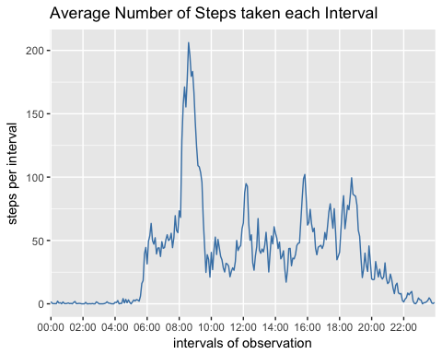

rm(set.AMD.aggr_interval)

### 2. 5-minute interval, on average across all the days in the dataset, contains the maximum number of steps

require(plyr)  
set.AMD.aggr_interval <- ddply(set.AMD, c("interval"), summarise, steps=mean(steps, na.rm=T))  
  
# generate output table  
stat_steps <- set.AMD.aggr_interval[set.AMD.aggr_interval$steps==max(set.AMD.aggr_interval$steps), ]  
colnames(stat_steps) <- c("at interval", "steps")  
rownames(stat_steps) <- c("Maximum")  
  
stat_steps

## at interval steps  
## Maximum 08:35 206.1698

rm(set.AMD.aggr_interval, stat_steps)

## III. Imputing missing values

### 1. total number of missing values in the dataset (i.e. the total number of rows with NAs)

# generate output table  
stat_steps <- data.frame(nrow(set.AMD[is.na(set.AMD)==T,]))  
colnames(stat_steps) <- c("total number of rows with NAs")  
  
stat_steps

## total number of rows with NAs  
## 1 2304

rm(stat_steps)

### 2. Devise a strategy for filling in all of the missing values in the dataset.

The strategy does not need to be sophisticated. For example, you could use the mean/median for that day, or the mean for that 5-minute interval, etc.

Missing value xn will be imputated by mean of xn-1 and xn+1. In cases when xn-1 and/or xn+1 are not available, xn-1 and/or xn+1 is imputated with mean of xn-1 resp. xn+1 of relevant 5-minute interval. Missing value x1 will be calculated with mean of xmax and x2. Missing value xmax will be calculated with mean of xmax-1 and x1.

steps_imputation <- function(df, serie_date) {  
 # extract serie by given date  
 vector.steps <- subset(df, df$date==serie_date, select = c(steps, interval, date))  
   
 # get max pos of serie   
 pos.max <- nrow(vector.steps)  
  
 # get predecessor or successor value and if necessary,   
 # imputate missing step value from mean of all steps in specific interval   
 step.value.neighbor <- function(pos, neighbor){  
 if(neighbor==-1) {  
 if(pos==1){  
 pos <- pos.max # predecessor of pos 1 is last pos of vector  
 } else {  
 pos <- pos-1 # precessor of pos is last pos  
 }  
 }  
 if(neighbor==1) {  
 if(pos==pos.max){  
 pos <- 1 # successor of last pos is first pos of vector  
 } else {  
 pos <- pos+1 # successor of pos is next pos  
 }  
 }  
 # get mean of steps per interval, if predecessor or succesor are NAs  
 if(is.na(vector.steps[pos,1])){  
 step.value <- mean(subset(df, df$interval==vector.steps[pos,2], select = steps)[,1], na.rm=T)  
 } else {  
 step.value <- vector.steps[pos,1]  
 }   
 step.value  
 }  
  
 # imputate missing step-value from mean of predecessor and successor value  
 step.value.current <- function(pos){  
 if(is.na(vector.steps[pos,1])){  
 step.value <- mean(c(step.value.neighbor(pos=pos, neighbor=-1)  
 , step.value.neighbor(pos=pos, neighbor=1))  
 , na.rm=T)   
 } else {  
 step.value <- vector.steps[pos,1]  
 }   
 step.value  
 }  
 # return vector of steps with values instead of NAs  
 require(plyr)  
 steps.imputated <- cbind(vector.steps, ldply(seq(1,pos.max), step.value.current))  
  
 steps.imputated  
}

### 3. new dataset that is equal to the original dataset but with the missing data filled in

# get date series  
series.date <- rownames(table(set.AMD$date))  
  
# generation of new data set with filled data for steps  
require(plyr)  
set.AMD.filled <- ldply(series.date, steps_imputation, df=set.AMD)  
  
# rename var "steps" to "steps_unfilled" and var for filled steps to "steps"  
colnames(set.AMD.filled) <- c("steps_unfilled", "interval", "date", "steps")  
  
str(set.AMD)

## 'data.frame': 17568 obs. of 3 variables:  
## $ steps : int NA NA NA NA NA NA NA NA NA NA ...  
## $ date : Date, format: "2012-10-01" "2012-10-01" ...  
## $ interval: Factor w/ 288 levels "00:00","00:05",..: 1 2 3 4 5 6 7 8 9 10 ...

str(set.AMD.filled)

## 'data.frame': 17568 obs. of 4 variables:  
## $ steps_unfilled: int NA NA NA NA NA NA NA NA NA NA ...  
## $ interval : Factor w/ 288 levels "00:00","00:05",..: 1 2 3 4 5 6 7 8 9 10 ...  
## $ date : Date, format: "2012-10-01" "2012-10-01" ...  
## $ steps : num 0.708 0.925 0.245 0.104 1.123 ...

rm(series.date, steps_imputation)

### 4. histogram of the total number of steps taken each day and Calculate and report the mean and median total number of steps taken per day.

# aggregate steps by day from set with imputated, filled steps  
  
require(plyr)  
set.AMD.filled.aggr_day <- ddply(set.AMD.filled, c("date"), summarise, steps=sum(steps, na.rm=T))  
set.AMD.aggr_day <- ddply(set.AMD, c("date"), summarise, steps=sum(steps, na.rm=T))  
  
require(ggplot2)  
# histogramm of total steps by day  
plot.filled <- ggplot(data=set.AMD.filled.aggr_day  
 , aes(steps)) +   
 geom_histogram(breaks=seq(0, 25000, by=1000),   
 col="steelblue",   
 aes(fill=..count..)) +  
 coord_flip(ylim=c(0,20)) +  
 labs(title="Number of steps taken each Day (after imputation)") +  
 labs(x="steps per day", y="days of occurence")  
  
plot.unfilled <- ggplot(data=set.AMD.aggr_day  
 , aes(steps)) +   
 geom_histogram(breaks=seq(0, 25000, by=1000),   
 col="steelblue",   
 aes(fill=..count..)) +  
 coord_flip(ylim=c(0,20)) +  
 labs(title="Number of steps taken each Day (before imputation)") +  
 labs(x="steps per day", y="days of occurence")  
  
require(grid)

## Loading required package: grid

grid.newpage()  
grid.draw(rbind(ggplotGrob(plot.unfilled), ggplotGrob(plot.filled), size = "last"))

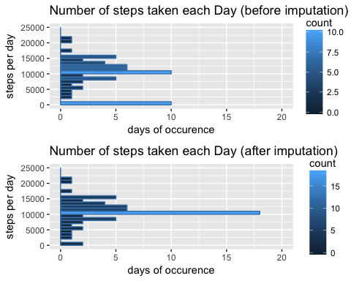

rm(set.AMD.aggr_day, set.AMD.filled.aggr_day)

#### 4.a Do these values differ from the estimates from the first part of the assignment?

require(plyr)  
set.AMD.filled.aggr_day <- ddply(set.AMD.filled, c("date"), summarise, steps=sum(steps, na.rm=T))  
set.AMD.aggr_day <- ddply(set.AMD, c("date"), summarise, steps=sum(steps, na.rm=T))  
  
  
# generate output table  
stat_steps <- data.frame(c(mean(set.AMD.aggr_day$steps, na.rm=T)  
 , median(set.AMD.aggr_day$steps, na.rm=T)  
 ),   
 c(mean(set.AMD.filled.aggr_day$steps, na.rm=T)  
 , median(set.AMD.filled.aggr_day$steps, na.rm=T)  
 ))  
colnames(stat_steps) <- c("steps per day before imputation", "steps per day after imputation")  
rownames(stat_steps) <- c("Mean", "Median")  
  
stat_steps

## steps per day before imputation steps per day after imputation  
## Mean 9354.23 10766.19  
## Median 10395.00 10766.19

rm(set.AMD.aggr_day, set.AMD.filled.aggr_day, stat_steps)

Assumption: Imputation of unfilled values of steps by using mean-function looks like steps tend to vary less from day to day.

#### 4.b What is the impact of imputing missing data on the estimates of the total daily number of steps?

require(plyr)  
set.AMD.filled.aggr_day <- ddply(set.AMD.filled, c("date"), summarise, steps=sum(steps, na.rm=T))  
set.AMD.aggr_day <- ddply(set.AMD, c("date"), summarise, steps=sum(steps, na.rm=T))  
  
par(mfrow=c(1,2))  
qqnorm(set.AMD.aggr_day$steps, main="steps per day before imputation")  
qqline(set.AMD.aggr_day$steps)  
  
qqnorm(set.AMD.filled.aggr_day$steps, main="steps per day after imputation")  
qqline(set.AMD.filled.aggr_day$steps)

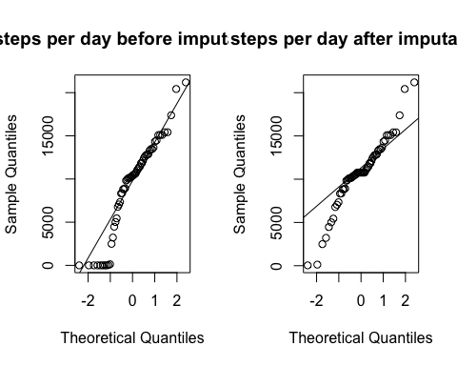

rm(set.AMD.aggr_day, set.AMD.filled.aggr_day, plot.filled, plot.unfilled)

Conclusion: Based on a residual of more than 5000 steps, total number of steps per day varies less then before imputation.

## IV. differences in activity patterns between weekdays and weekends

For complete time-series, missing values are filled-in.

# generate factors of weekday and weekend via day of week  
set.AMD.filled$dayofweek <- factor(weekdays(set.AMD.filled$date))  
set.AMD.filled$partofweek[set.AMD.filled$dayofweek %in% levels(set.AMD.filled$dayofweek)[6:7]] <- "weekend"  
set.AMD.filled$partofweek[set.AMD.filled$dayofweek %in% levels(set.AMD.filled$dayofweek)[1:5]] <- "weekday"  
  
require(plyr)  
set.AMD.filled.aggr_interval.weekday <- ddply(set.AMD.filled[set.AMD.filled$partofweek=="weekday",]  
 , c("interval"), summarise, steps=mean(steps, na.rm=T))  
set.AMD.filled.aggr_interval.weekend <- ddply(set.AMD.filled[set.AMD.filled$partofweek=="weekend",]  
 , c("interval"), summarise, steps=mean(steps, na.rm=T))  
  
require(ggplot2)  
# line graph of interval versus avg steps  
plot.weekday <- ggplot(data=set.AMD.filled.aggr_interval.weekday  
 , aes(x=interval,y=steps, group=1)) +  
 geom_line(color="steelblue") +  
 labs(title="weekday") +  
 labs(y="Number of steps") +  
 theme(plot.title = element_text(colour="steelblue")) +  
 scale_x_discrete(breaks = unique(set.AMD.filled.aggr_interval.weekday$interval)[seq(1,288,24)]) +  
 scale_y_continuous(limits=c(0,250))  
  
plot.weekend <- ggplot(data=set.AMD.filled.aggr_interval.weekend  
 , aes(x=interval,y=steps, group=1)) +  
 geom_line(color="steelblue") +  
 labs(title="weekend") +  
 labs(y="Number of steps") +  
 theme(plot.title = element_text(colour="steelblue")) +  
 scale_x_discrete(breaks = unique(set.AMD.filled.aggr_interval.weekend$interval)[seq(1,288,24)]) +  
 scale_y_continuous(limits=c(0,250))  
  
require(grid)  
grid.newpage()  
grid.draw(rbind(ggplotGrob(plot.weekday), ggplotGrob(plot.weekend), size = "last"))

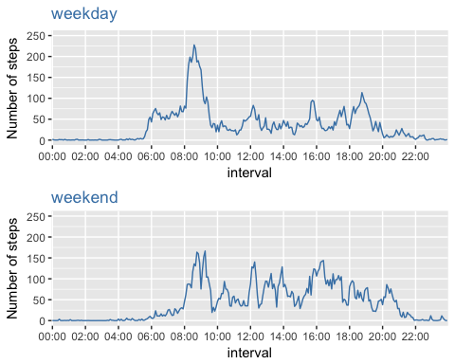

rm(set.AMD.filled.aggr_interval.weekday, set.AMD.filled.aggr_interval.weekend, plot.weekday, plot.weekend)