Pre requisite

1.Create dir

Ex: C:\ CeditRepair40

2.Goto

https://bitbucket.org/dashboard/overview

<https://bitbucket.org/itninfo/creditservice/src/master/>

From Bitbucket, go to your BitbucketLocations repository(Credit service).

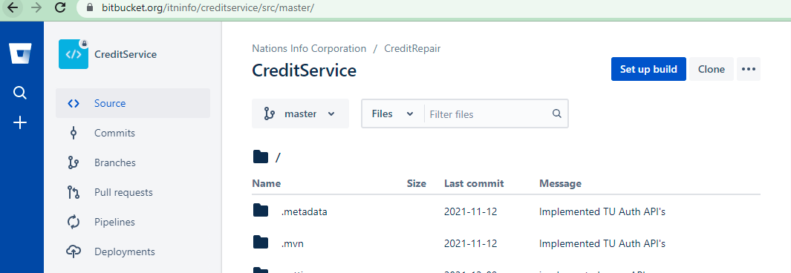

3.Click on the clone button then copy the address highlighted.

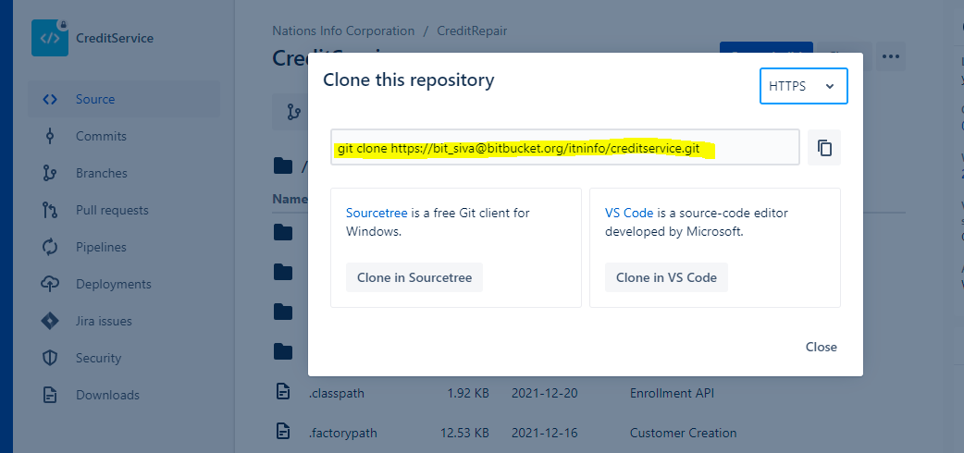

4. goto gitbash terminal window, paste the command you copied from Bitbucket and press Return.

5.Enter your Bitbucket password when the terminal asks for it.

Total file will be copied from remote repos to local.we can see new folder created.

Step1:- goto the C:\CeditRepair\creditservice

Right click ->select git bash

Sivakumar.Kalimuthu@ATMECSINLT-819 MINGW64 /c/CeditRepair/creditservice (master)

Step:2

------------

$ git status

On branch master

Your branch is up to date with 'origin/master'.

Changes not staged for commit:

(use "git add <file>..." to update what will be committed)

(use "git restore <file>..." to discard changes in working directory)

modified: .classpath

modified: .factorypath

modified: src/main/java/com/nic/creditservice/transUnionHelper/PythonRestHelper.java

modified: src/main/resources/application.properties

modified: src/main/resources/messages/creditservice.properties

revert the changes if any

Untracked files:

(use "git add <file>..." to include in what will be committed)

src/main/java/com/nic/creditservice/beans/python/CustomerRequest.java

src/main/java/com/nic/creditservice/beans/python/CustomerResponse.java

src/main/java/com/nic/creditservice/controller/CustomerController.java

src/main/java/com/nic/creditservice/controller/TradelineControll.java

no changes added to commit (use "git add" and/or "git commit -a")

Sivakumar.Kalimuthu@ATMECSINLT-819 MINGW64 /c/CeditRepair/creditservice (master)

$ git status

On branch master

Your branch is up to date with 'origin/master'.

Changes not staged for commit:

(use "git add <file>..." to update what will be committed)

(use "git restore <file>..." to discard changes in working directory)

modified: .classpath

modified: .factorypath

modified: src/main/java/com/nic/creditservice/transUnionHelper/PythonRestHelper.java

Untracked files:

(use "git add <file>..." to include in what will be committed)

src/main/java/com/nic/creditservice/beans/python/CustomerRequest.java

src/main/java/com/nic/creditservice/beans/python/CustomerResponse.java

src/main/java/com/nic/creditservice/controller/CustomerController.java

src/main/java/com/nic/creditservice/controller/TradelineControll.java

no changes added to commit (use "git add" and/or "git commit -a")

Sivakumar.Kalimuthu@ATMECSINLT-819 MINGW64 /c/CeditRepair/creditservice (master)

Step:3

------------

$ git add .

warning: LF will be replaced by CRLF in .factorypath.

The file will have its original line endings in your working directory

Sivakumar.Kalimuthu@ATMECSINLT-819 MINGW64 /c/CeditRepair/creditservice (master)

Step:4

------------

$ git status

On branch master

Your branch is up to date with 'origin/master'.

Changes to be committed:

(use "git restore --staged <file>..." to unstage)

modified: .classpath

modified: .factorypath

new file: src/main/java/com/nic/creditservice/beans/python/CustomerRequest.java

new file: src/main/java/com/nic/creditservice/beans/python/CustomerResponse.java

new file: src/main/java/com/nic/creditservice/controller/CustomerController.java

new file: src/main/java/com/nic/creditservice/controller/TradelineControll.java

modified: src/main/java/com/nic/creditservice/transUnionHelper/PythonRestHelper.java

Sivakumar.Kalimuthu@ATMECSINLT-819 MINGW64 /c/CeditRepair/creditservice (master)

$ git commit -m "Customer Creation"

[master e445662] Customer Creation

7 files changed, 178 insertions(+), 9 deletions(-)

create mode 100644 src/main/java/com/nic/creditservice/beans/python/CustomerRequest.java

create mode 100644 src/main/java/com/nic/creditservice/beans/python/CustomerResponse.java

create mode 100644 src/main/java/com/nic/creditservice/controller/CustomerController.java

create mode 100644 src/main/java/com/nic/creditservice/controller/TradelineControll.java

Sivakumar.Kalimuthu@ATMECSINLT-819 MINGW64 /c/CeditRepair/creditservice (master)

Step:5

----------

$ git Push

fatal: cannot handle Push as a builtin

Sivakumar.Kalimuthu@ATMECSINLT-819 MINGW64 /c/CeditRepair/creditservice (master)

$ git push

Enumerating objects: 33, done.

Counting objects: 100% (33/33), done.

Delta compression using up to 8 threads

Compressing objects: 100% (15/15), done.

Writing objects: 100% (19/19), 2.88 KiB | 983.00 KiB/s, done.

Total 19 (delta 9), reused 0 (delta 0), pack-reused 0

To https://bitbucket.org/itninfo/creditservice.git

215c6f2..e445662 master -> master

Sivakumar.Kalimuthu@ATMECSINLT-819 MINGW64 /c/CeditRepair/creditservice (master)

$

Step:6

Open Jenkin🡪url give uid &pwd click ->dev-creditservice

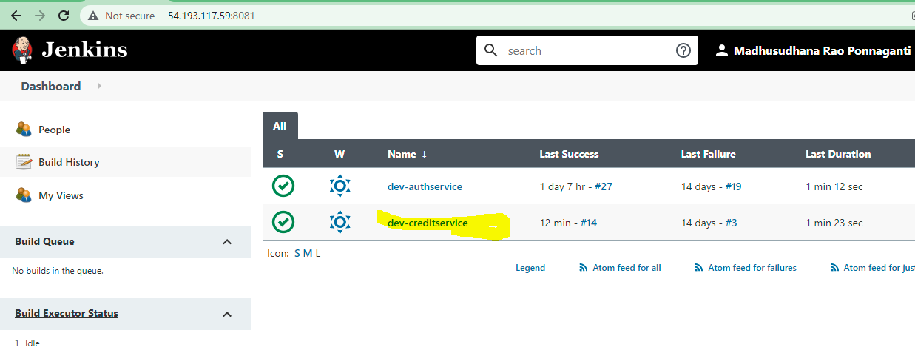

Step:7

Click build now

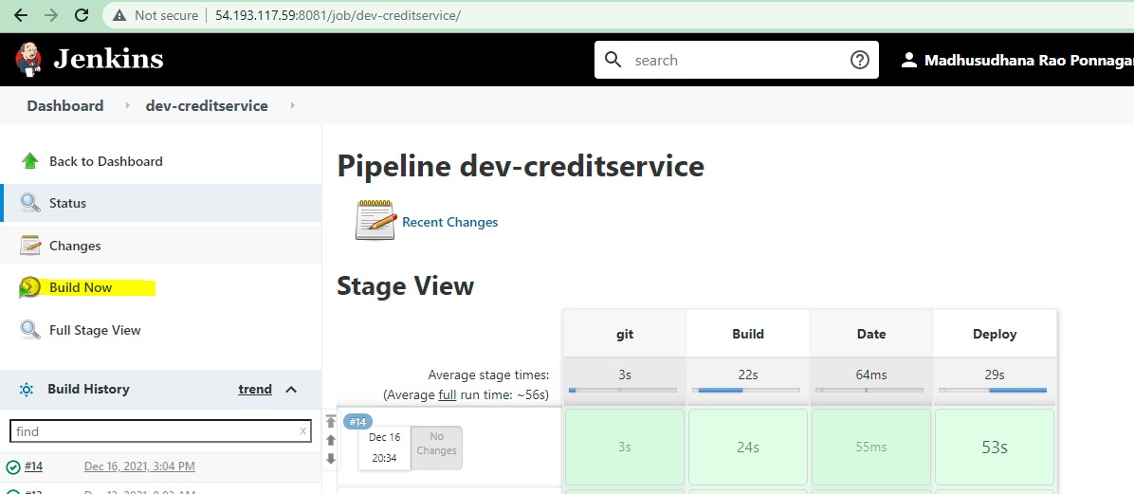

Step:8

------------

Select console to check the logs. if it is success go to swagger url and check.

https://d8q0y44gux1dn.cloudfront.net/creditservice/swagger-ui.html#/

if it success

25-01-2022

--------------------

Sivakumar.Kalimuthu@ATMECSINLT-819 MINGW64 /c/CreditRepair50/creditservice (master)

$ git status

On branch master

Your branch is up to date with 'origin/master'.

Changes not staged for commit:

(use "git add <file>..." to update what will be committed)

(use "git restore <file>..." to discard changes in working directory)

modified: pom.xml

modified: src/main/java/com/nic/creditservice/Entity/CreditReportAddress.java

modified: src/main/java/com/nic/creditservice/controller/TUDisputeController.java

modified: src/main/java/com/nic/creditservice/transUnionHelper/PythonRestHelper.java

modified: src/main/resources/application.properties

modified: src/main/resources/messages/creditservice.properties

Untracked files:

(use "git add <file>..." to include in what will be committed)

src/main/java/com/nic/creditservice/Entity/NotificationConfiguration.java

src/main/java/com/nic/creditservice/beans/python/DisputeStatusResponse.java

src/main/java/com/nic/creditservice/controller/NotificationController.java

src/main/java/com/nic/creditservice/repository/

src/main/java/com/nic/creditservice/service/NotificationConfigurationService.java

no changes added to commit (use "git add" and/or "git commit -a")

Sivakumar.Kalimuthu@ATMECSINLT-819 MINGW64 /c/CreditRepair50/creditservice (master)