FUNCTIONAL DOCUMENT
Zoho Contract &
KYC Management System

Complete Lifecycle: Onboarding · KYC · Contracts · Termination · Handover

Document Type | Functional Specification
Version | 1.0
Status | Draft – Internal Review
Module | Zoho CRM / Customer Portal Integration
Prepared By | Contract & Operations Team

1. Overview
This document defines the functional specification for the Zoho Contract & KYC Management System. The system manages the complete customer contract lifecycle, including customer onboarding, KYC collection and verification, contract preparation and signing, amendment handling, termination processing, and automated data handover.

The system integrates three operational layers:
- Customer Dashboard – self-service portal for KYC submission, contract viewing, and termination requests
- Internal Contract Management Portal – used by the Contract Team, Sales, Operations, and Accounts teams
- Automated Infrastructure Layer – executes scheduled deactivation, backup, and handover tasks

2. Contract Team Dashboard
The Contract Team Dashboard provides a centralised, real-time view of all contract-related activities. It serves as the primary workspace for the Contract Team to monitor and act on customer records.

2.1 Customer View – Status Segments
The dashboard groups customers by their current contract status. Each segment is filterable and searchable:
- Contract Sent – customers who have been issued a contract awaiting signature
- Contract Signed – customers with a fully executed contract on record
- Contract Pending – customers in progress (KYC approved; contract not yet dispatched)
- Termination Requested – customers who have initiated a termination request
- Contract Terminated – customers whose contracts have been fully closed

2.2 Dashboard Features
- View and download customer-related documents (KYC files, signed contracts)
- Track contract status changes with timestamps
- View KYC approval history and verification notes
- Review amendment history per customer
- Access notification logs for all system-triggered communications
- Support Team Dashboard – Terminated customer records (customer name, contract end date, termination reason, final status) must be displayed on the Support Team Dashboard so that support agents can handle post-termination queries correctly and identify terminated customers in real time

3. Customer Onboarding & KYC Workflow

3.1 Onboarding Fee Payment
The KYC workflow is triggered automatically once the customer completes the onboarding fee payment. No manual intervention is required from the Contract Team at this stage.

Process Flow
- Customer completes onboarding fee payment via the payment gateway
- System validates payment confirmation
- System generates a secure, time-limited KYC form link
- System sends the KYC form link to the customer via Email and WhatsApp (optional)
- System updates the customer status to KYC Form Sent
- System dispatches an internal notification to required staff

Status Updated
KYC Form Sent

3.1A KYC Expiry – Email Notification to Expired Customers
The Contract Team Dashboard must provide a bulk email option for customers whose KYC has expired or is approaching the expiry date.
Process
- Dashboard displays a filterable list of KYC-Expired customers
- Contract Team selects one or more expired-KYC customers using a multi-select checkbox
- Contract Team clicks “Send KYC Renewal Email” to dispatch renewal reminder emails in bulk
- System sends individual renewal emails to each selected customer with a fresh KYC form link
- All bulk email actions are recorded in the audit log with acting user, timestamp, and recipient list

3.2 Secure KYC Form Access
The KYC form must be accessed via an authenticated, secure link to protect customer data and prevent unauthorised submissions.

Security Requirements
- One-time secure URL – each link is valid for a single access session
- Time-limited expiry – links expire after a configurable period
- KYC Expiry Date / Next Renewal Date – Contract Team must set an Expiry Date or Next Renewal Date on each KYC Form at time of issuance. This date is mandatory and tracked by the system. Records approaching or past expiry are flagged on the Contract Team Dashboard.
- Customer identity verification via registered Email or Mobile OTP before form access
- All document uploads must be encrypted in transit and at rest
- Audit log entry created on each link access attempt

ℹ Expired or reused links must display a clear error message and prompt the customer to contact support.

3.3 KYC Form Submission
Once authenticated, the customer completes the KYC form and uploads all required documents.

Customer Actions
- Fill all mandatory KYC fields
- Upload required supporting documents

Required Documents (Configurable)
- Trade Licence
- Passport Copy
- Emirates ID
- VAT Certificate
- Address Proof
- Other supporting documents (as configured per customer type)

System Actions on Submission
- Update customer status to KYC Submitted
- Notify the Contract Management Team via internal notification
- Store all uploaded files securely in the document repository

Status Updated
KYC Submitted

4. KYC Verification & Approval

4.1 Internal Verification Workflow
Upon receiving a KYC Submitted notification, the Contract Team reviews the customer's information and uploaded documents within the portal.

Contract Team Actions
- Review all KYC fields and uploaded documents
- Verify document authenticity and completeness
- Request corrections or additional documents if required
- Approve or Reject the KYC submission

KYC Status Lifecycle
KYC Pending | Under Review | Approved | Rejected | Re-submission

Notifications Triggered
- Customer notified on Approval or Rejection with reasons
- Internal users notified on KYC Approval for contract preparation

5. Contract Management

5.1 Common Contract Template – Customer Dashboard
A standard contract template is available for customers to preview at any time via the Customer Dashboard. This allows customers to familiarise themselves with contract terms before the formal contract is issued.
- Display the common contract template in read-only format
- Allow customers to download a copy of the template for reference

5.2 Customer-Specific Amendments
Before dispatching the final contract for signature, the Contract Team may add customer-specific amendments. These amendments are unique per customer and are appended to the standard template.

Amendment Examples
- Custom pricing or discount terms
- Special service conditions or SLAs
- Additional clauses for regulated industries
- Service-specific conditions based on the subscribed product

ℹ Amendments must be recorded in the Amendment History log with the author and timestamp.

6. Contract Sending Workflow
The system supports two configurable approaches for sending contracts to customers. The active approach is configured per deployment or can be overridden by authorised users.

Approach 1 – Send Contract After Subscription Payment
This is the default approach. The contract is issued only after subscription payment is confirmed, ensuring the customer is commercially committed before signing.

1 | Subscription payment is received and validated by the system
2 | System updates status to Ready for Contract
3 | Contract Team is notified to dispatch the contract
4 | Contract is sent to the customer for digital signature
5 | Status updated to Contract Sent

Ready for Contract | Contract Sent

Approach 2 – Send Contract Before Subscription Payment
An override option allows authorised users to send the contract prior to receiving subscription payment. This approach requires a mandatory disclaimer to be included in the contract.

⚠ Mandatory Disclaimer (Approach 2)
"This contract shall become effective only upon the customer going live and once the subscription payment is successfully completed."

- Override option is available for authorised Contract Team users only
- All override actions are recorded in the audit log

6.1 Internal Notifications on Contract Dispatch
When a contract is ready to be sent, the system dispatches notifications to all required internal stakeholders and updates the contract status.

Event | Recipient(s) | Channel
Contract to be sent | Contract Team | Portal + Email
Contract to be sent | Sales Team | Email
Contract to be sent | Operations Team | Email
Contract to be sent | Accounts Team (optional) | Email
Contract Sent | Customer | Email + Portal

7. Contract Signing
Once the contract is dispatched, the customer receives a secure link to review and digitally sign the agreement.

Customer Experience
- Customer receives a secure signing link via email
- Customer reviews the contract including any customer-specific amendments
- Customer applies a digital signature

System Actions After Signing
- Contract status updated to Contract Signed
- Signed contract displayed in the Customer Dashboard for future reference
- Internal stakeholders (Contract Team, Sales, Operations) notified
- Audit trail entry created with signing timestamp

Contract Signed

8. Contract Termination

8.1 Termination Request – Customer Action
Customers may submit a contract termination request directly through the Customer Dashboard. The request is routed to the Contract Team for review.

System Actions on Request
- Notify Contract Team of incoming termination request
- Create a termination request ticket in the internal system
- Update contract status to Termination Requested

Termination Requested

8.2 Termination Approval Workflow
The Contract Team reviews the request, verifies outstanding obligations, and approves or rejects the termination.
30-Day Notice Period: Upon raising a termination request, the system enforces a mandatory 30-day notice period before the Automated Termination Process is executed. The termination date is automatically calculated as Today + 30 days. An authorised Contract Team member may override the 30-day window with a custom date and must provide a documented justification. All override actions are recorded in the audit trail.

1 | Contract Team reviews termination request and verifies pending obligations
2 | Contract Team approves or rejects the termination request
3 | On approval: System sends email to customer with termination date, details, and data handover information
4 | Contract status progresses through the termination lifecycle

Termination Status Lifecycle
Requested | Under Review | Approved | Scheduled | Completed

9. Automated Termination Process
On reaching the agreed termination date, the system automatically executes the following four steps without requiring manual intervention. All steps are logged in the audit trail.
Accounts Clearance Gate: Before the Automated Termination Process is triggered, the Accounts Team must provide explicit Accounts Clearance confirming all dues are settled. If the customer has any pending amount, the system blocks automated termination, raises an alert to the Contract Team, and sets the status to “Termination – Accounts Pending”. An authorised override option is available for exceptional cases; the override requires a reason to be recorded and is fully audit-logged.

Step 1 | DATA HANDOVER PREPARATION Gather all customer data files, compress into a ZIP archive, store to Blob Storage, and generate a time-limited secure download URL.
Step 2 | DATABASE BACKUP & CLEANUP Create a full backup of the customer database, store the backup to Blob Storage, and permanently delete the live customer database after successful backup verification.
Step 3 | IIS APPLICATION DEACTIVATION Inactivate the customer-specific IIS application instance and stop all associated application services.
Step 4 | CORE URL DEACTIVATION Disable the customer's domain or subdomain access and inactivate all core application URLs associated with the customer account.

10. Accounts Settlement & Data Handover

10.1 Settlement Clearance – Accounts Team
Before the data handover email is sent to the customer, the Accounts Team must confirm that all pending dues and financial obligations have been settled.

Accounts Team Actions
- Verify all pending invoices and outstanding dues
- Approve settlement clearance in the portal

Settlement Pending | Settlement Cleared

10.2 Data Handover Email
Once the Accounts Team approves settlement clearance, the system sends the data handover email to the customer.
Customer-Only Access Restriction: The data download link is exclusively for the customer. No internal user (Contract Team, Accounts Team, Sales, or Support) may open or utilise the link. The system must enforce customer-identity verification (e.g. OTP or registered email authentication) before permitting any download. Any internal access attempt must be blocked and recorded in the audit log as an access violation.

Email Content
- Secure download link for the customer's data ZIP archive
- Link expiry date and time
- Download instructions and support contact

ℹ The download link is time-limited. If the link expires before the customer downloads their data, the Accounts Team can regenerate and resend the link (see Section 11).

11. Resend Download Link Feature
To handle cases where the original download link has expired, the Accounts Team is provided a self-service feature to regenerate and resend the handover link.

Process
- Accounts Team identifies the expired link in the customer's record
- Accounts Team triggers "Resend Download Link" action in the portal
- System generates a new secure token and a fresh time-limited URL
- Old link is automatically invalidated
- System sends the new data handover email to the customer

Security Controls
- Each resend action generates a brand-new token – old links cannot be reactivated
- All resend actions are recorded in the audit log with the acting user and timestamp
- Resend access is restricted to authorised Accounts Team members only

12. Notifications Matrix

Event | Recipient(s) | Channel
KYC Form Sent | Customer + Internal Users | Email / WhatsApp
KYC Submitted | Contract Team | Portal + Email
KYC Approved | Customer + Internal Users | Email
KYC Rejected | Customer | Email
Contract Ready to Send | Internal Team | Portal + Email
Contract Sent | Customer + Internal Team | Email
Contract Signed | Internal Team | Portal + Email
Termination Requested | Contract Team | Portal + Email
Termination Approved | Customer | Email
Settlement Cleared | Accounts Team | Portal
Data Handover Link Sent | Customer | Email
Link Resent | Customer | Email
Termination Approved / Key Termination Milestones | Assigned Salesperson | Email + Portal Notification

13. Status Flow Summary

Module | Status Progression
KYC | Pending → Form Sent → Submitted → Under Review → Approved / Rejected
Contract | Draft → Amendments Added → Ready → Sent → Signed
Termination | Requested → Under Review → Approved → Scheduled → Completed
Settlement | Pending → Cleared
Handover | Pending → Link Sent → Downloaded / Expired → Resent (if required)

14. Security Requirements
- Secure token-based authentication for all customer-facing actions
- One-time and time-limited URLs for KYC forms and data download links
- Encrypted document storage at rest and in transit
- Role-based access control (RBAC) for all internal portal actions
- Audit logs maintained for all activities (KYC, contracts, amendments, termination, downloads)
- Multi-level approval workflow for contract dispatch and termination
- Automatic link invalidation on resend or expiry

15. Audit & Logs
The system must maintain comprehensive, tamper-evident logs for all of the following event categories:
- KYC form submissions and document uploads
- KYC verification decisions (approved / rejected / correction requested)
- Contract creation, amendment, and dispatch events
- Digital signature events (timestamp, IP, signer identity)
- Notification delivery records
- Termination request, approval, and execution events
- Automated deactivation steps (data ZIP, DB backup, IIS stop, URL deactivation)
- Download link generation, access, expiry, and resend events
- All portal user actions (login, record access, status updates)

— End of Functional Document —
Zoho Contract & KYC Management System | Version 1.0 | Confidential

WORKFLOW DIAGRAM
Phase 1 — Onboarding & KYC: from fee payment through KYC verification and approval.
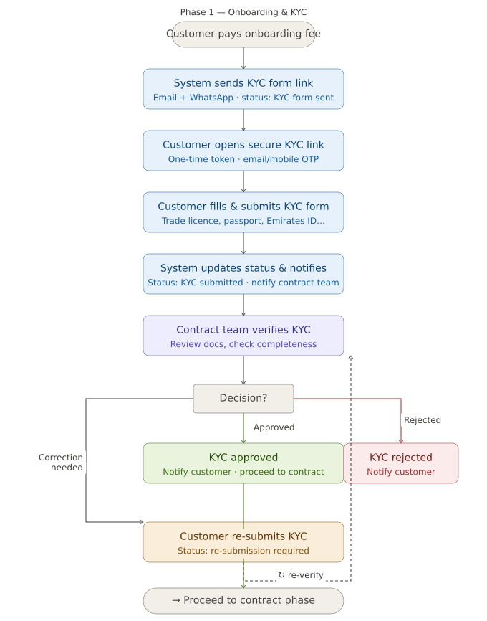
Phase 2 — Contract preparation, sending & signing: from KYC approval through amendments, the two dispatch approaches, and final signature.

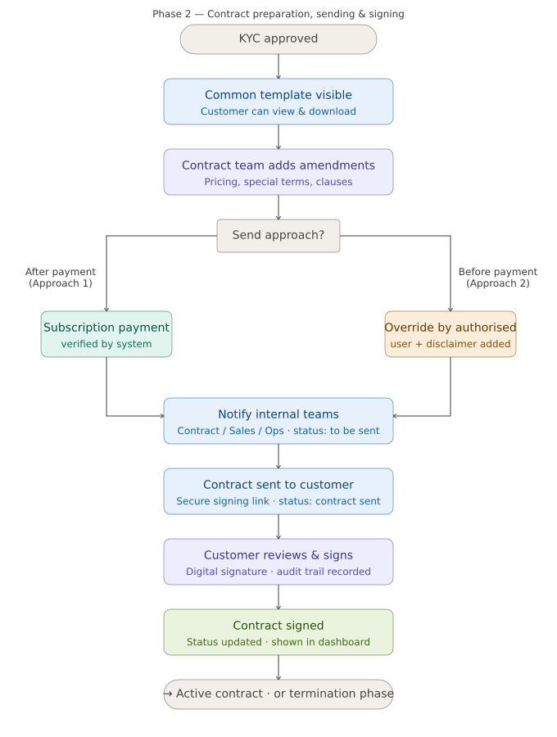
Phase 3 — Termination, automated deactivation & data handover: from the customer's termination request all the way to the final data download link.

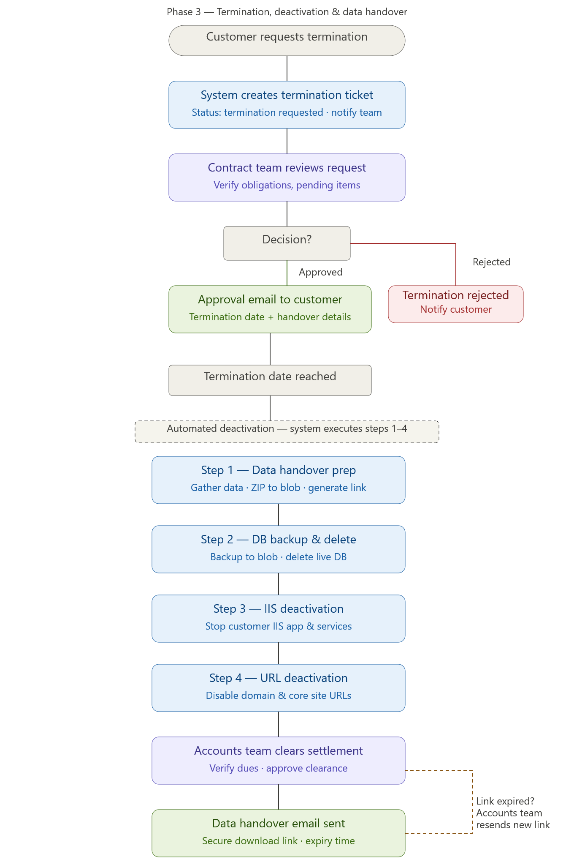
Here's a summary of how the three phases connect:
Phase 1 — Onboarding & KYC starts with the customer's fee payment, dispatches a secure one-time KYC form link, collects documents, and routes through the Contract Team's approval decision — with a re-submission loop if corrections are needed.
Phase 2 — Contract & Signing picks up after KYC approval. The team adds customer-specific amendments, then follows one of two paths: send after subscription payment (Approach 1) or send immediately with a disclaimer (Approach 2, authorised override). Once signed, the contract is stored and displayed in the dashboard.
Phase 3 — Termination & Handover handles the full off-boarding lifecycle: request → review → approval → four automated system steps (data ZIP, DB backup, IIS stop, URL disable) → accounts settlement clearance → data handover email with a time-limited download link. If the link expires, the Accounts Team can regenerate and resend it without manual dev work.
Discussion Call -18-05-2026
->Call-Off Termination -With Remark any stage
->Download link - with device details
->Send Mail To Customer - For Data Deletion Confirmation
->Read Me-For Data-

Discussion Call Notes – Paragraph Drafts
Call-off termination should be supported as a controlled action at any stage of the termination workflow, based on authorised internal review. When this action is used, the user must enter a mandatory remark explaining the reason for stopping, cancelling, or reversing the termination flow. The system should record the remark, acting user, date, and current stage in the audit log so that the termination history remains fully traceable.

The customer data download link should capture device-related access details whenever the link is opened or used. This includes information such as device type, browser, IP address, access timestamp, and download status, subject to system availability and security policy. These details should be stored in the audit trail to strengthen traceability, support security monitoring, and help validate that the handover link was accessed only by the intended customer.

After the data handover process is completed, the system should send an email to the customer requesting confirmation for data deletion. This communication should clearly state that the customer data has been made available for download, specify the confirmation action required from the customer, and define the expected response timeline if applicable. Once the customer confirms, the system should update the record accordingly and maintain the confirmation event in the audit log for compliance and reference purposes.

A read-me file or guidance note should be included as part of the customer data handover package to help the customer understand the delivered files. This note should briefly explain the folder structure, file categories, backup contents, access considerations, and any important usage instructions relevant to the handed-over data. Providing this guidance will reduce confusion, improve usability of the delivered package, and support a smoother closure process during termination.

