pragma solidity ^0.6;



contract banking

{

 mapping(address=>uint) public user_account;

 mapping(address=>bool) public user_exists;

 function create_account() public payable returns(string memory)

 {

 require(user_exists[msg.sender]==false,'Account already created');

 if(msg.value==0)

 {

user_account[msg.sender]=0;

user_exists[msg.sender]=true;

 return "Account created";

 }

 require(user_exists[msg.sender]==false,"Account already created");

user_account[msg.sender]=msg.value;

user_exists[msg.sender]=true;

 return "Account created";

 }

 function deposit() public payable returns(string memory)

 {

 require(user_exists[msg.sender]==true,"Account not created");

 require(msg.value>0,"Value for deposit is Zero");

user_account[msg.sender]=user_account[msg.sender]+msg.value;

 return "Deposited Successfully";

 }

 function withdraw(uint amount) public payable returns(string memory)

 {

 require(user_account[msg.sender]>amount,"Insufficient Balance");

 require(user_exists[msg.sender]==true,"Account not created");

 require(amount>0,"Amount should be more than zero");

user_account[msg.sender]=user_account[msg.sender]-amount;

msg.sender.transfer(amount);

 return "Withdrawl Successful";

 }

 function transfer(address payable userAddress, uint amount) public returns(string memory)

 {

 require(user_account[msg.sender]>amount,"Insufficient balance in Bank account");

 require(user_exists[msg.sender]==true,"Account is not created");

 require(user_exists[userAddress]==true,"Transfer account does not exist");

 require(amount>0,"Amount should be more than zero");

user_account[msg.sender]=user_account[msg.sender]-amount;

user_account[userAddress]=user_account[userAddress]+amount;

 return "Transfer Successful";

 }



 function send_amt(address payable toAddress, uint256 amount) public payable returns(string



memory)

 {

 require(user_account[msg.sender]>amount,"Insufficeint balance in Bank account");

 require(user_exists[msg.sender]==true,"Account is not created");

 require(amount>0,"Amount should be more than zero");

user_account[msg.sender]=user_account[msg.sender]-amount;

toAddress.transfer(amount);

 return "Transfer Success";

 }

 function user_balance() public view returns(uint)

 {

 return user_account[msg.sender];

 }

 function account_exist() public view returns(bool)

 {

 return user_exists[msg.sender];

 }

}

**Deploying Contract:**

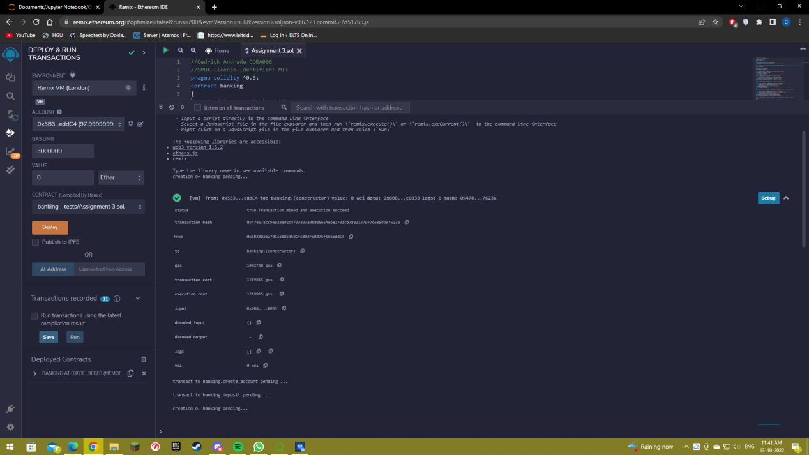



**Deposit Failure due to no Account creation:**

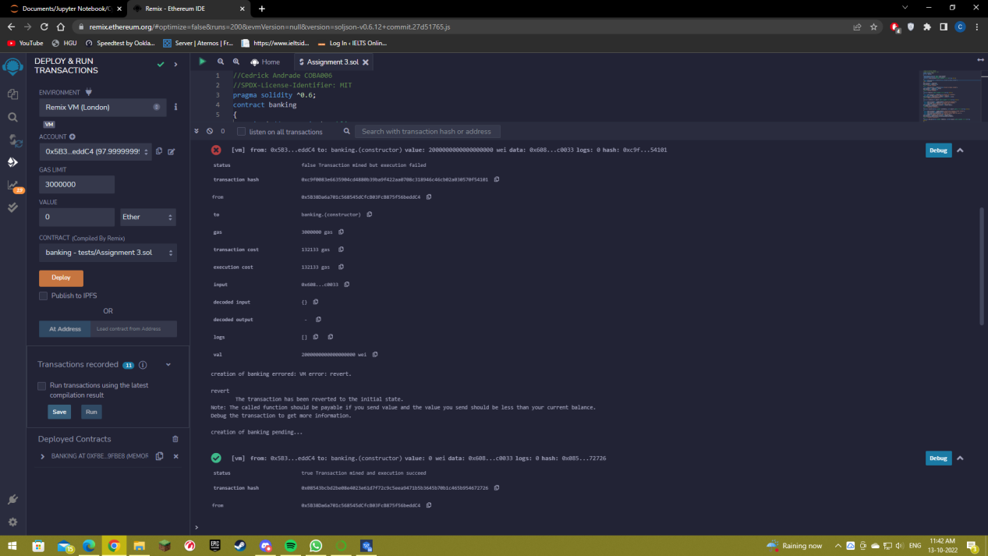

**Account Creation:**

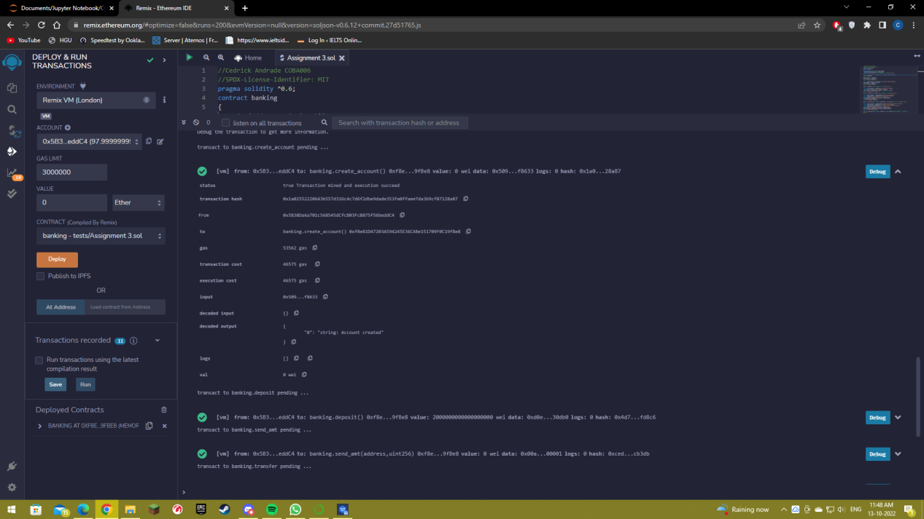



**Deposit Success:**

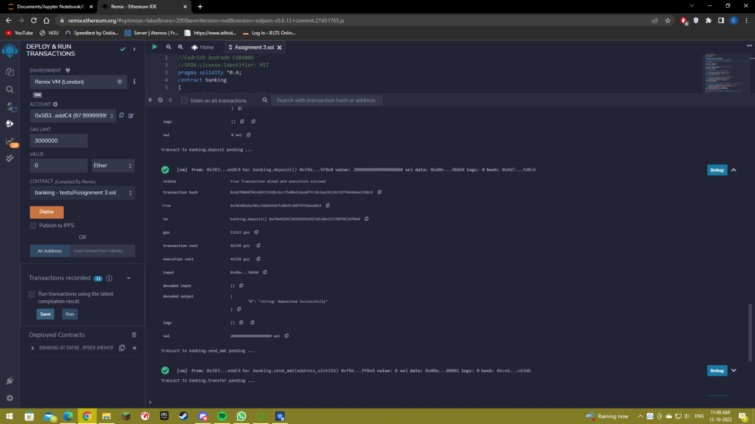

**Send Amount:**

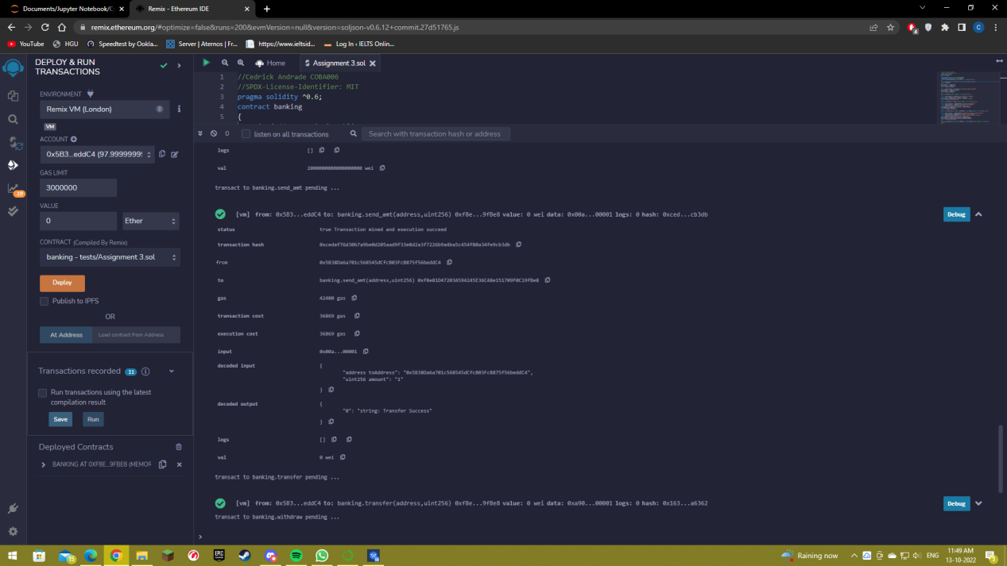



**Transfer:**

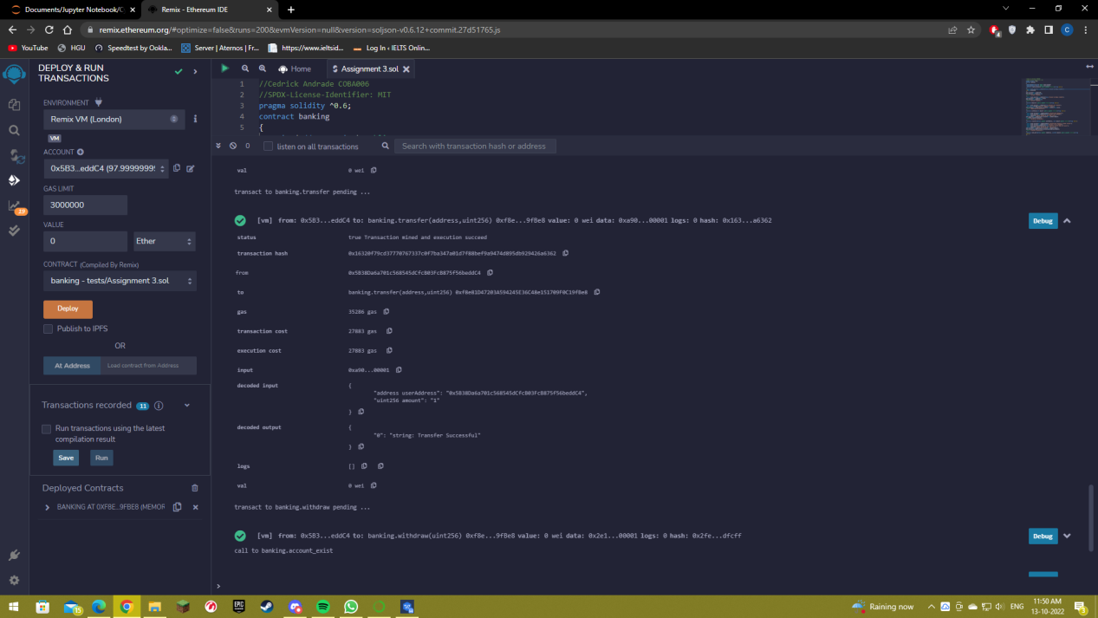

**Withdraw:**

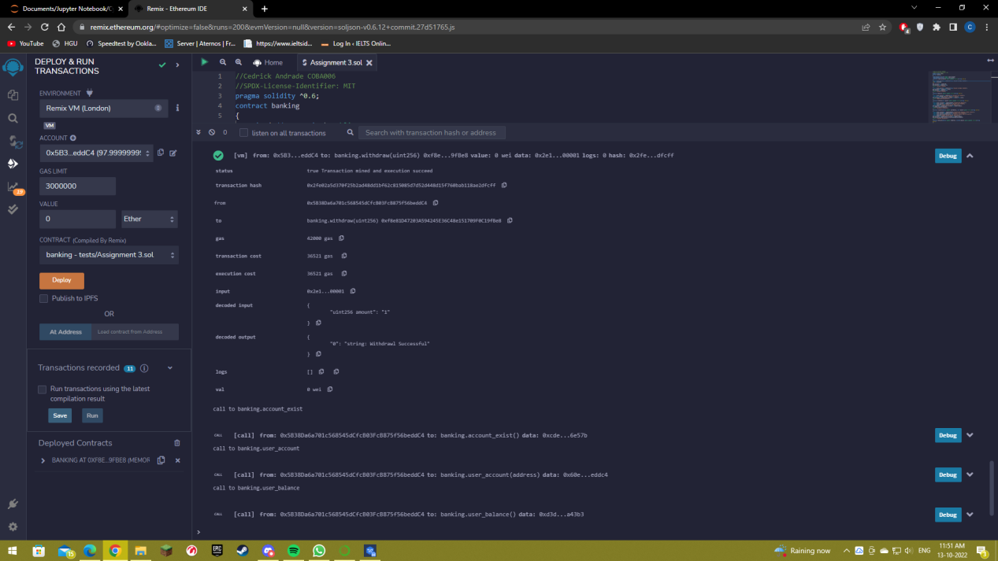



**User account exist and bank exist functions:**

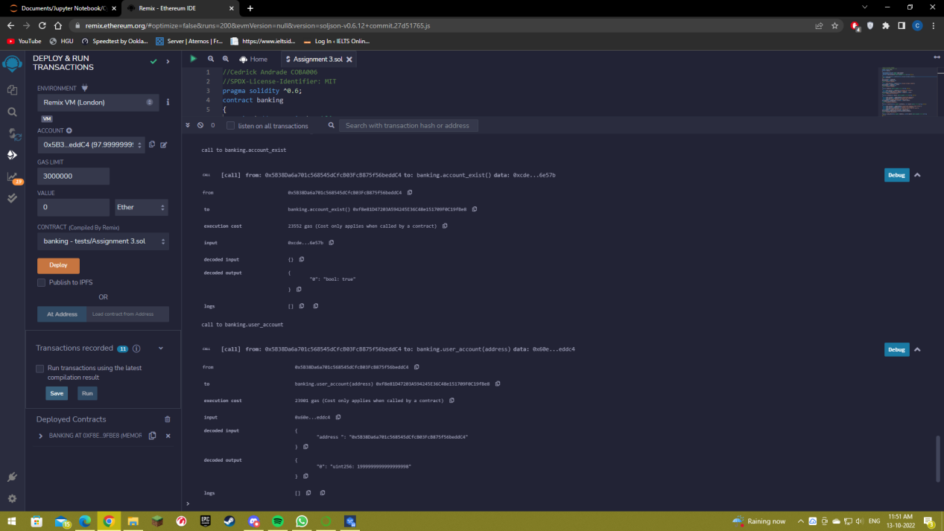

**User Balance and Exist:**

