PROJECT PLAN — PROOF OF CONCEPT

AR Field Assistant with a
Self-Hosted LLM
A buildable proof-of-concept: DIY glasses + body-worn edge + private remote inference
Recommended arena: Enterprise / industrial (hands-free maintenance & inspection assistant)
Scope: Working POC — reparable and cost-effective over miniaturized or market-ready
Date: June 2026 Indicative duration: ~14–19 weeks (small team)
Tooling and model recommendations reflect the state of the art as of mid-2026 and will move quickly; treat specific models as swappable.

Contents

1. Executive Summary
This plan turns the idea — an AR product powered by self-hosted LLMs — into a concrete, buildable proof-of-concept: do-it-yourself glasses driven by a body-worn single-board computer, talking over a mobile connection to open-weight models running on infrastructure you control.
Recommended arena. Of the three AR arenas, enterprise / industrial is the best fit for this hardware and hosting choice, and the strongest place to build a durable position. A body-worn compute pack is normal in industrial AR; the “repairable and cost-effective” ethos suits a POC; and “self-hosted but remote” inference maps directly onto how enterprises already prefer to keep data on their own private cloud or on-prem servers. It also sidesteps the two hardest paths — consumer miniaturization and social acceptability on one side, defense certification and air-gapping on the other — while keeping the door open to both later.
What we will build. A hands-free AI field assistant: a technician wearing the glasses can ask spoken questions and get answers grounded in the organization’s own manuals and procedures, point the camera at equipment and ask “what is this / what’s the next step / what looks wrong,” follow step-by-step guided procedures shown on the display, and capture notes or work-order fields by voice. The language/vision model is the brain and runs on your remote server; the wearable is deliberately a low-power, repairable input/output device.
Why self-hosting is the point. Running open-weight models on infrastructure you control means proprietary manuals, captured video, and worker data never leave your environment — the central advantage over a third-party cloud API, and a genuine moat in regulated and IP-sensitive industries. The plan treats privacy, data residency, and a private network tunnel as architecture, not afterthoughts.
Headline numbers. Roughly 14–19 weeks for a 2–4-person team; hardware capex on the order of US$1,200–$3,500 for one wearable unit plus a modest GPU server (less if you rent cloud GPU and tether to a phone). The single biggest risk is connectivity and latency, which the design mitigates throughout.

2. Recommended Use Case & POC Scope
The POC is a hands-free maintenance / inspection / remote-expert assistant. Concrete capabilities, in priority order:
- Grounded voice Q&A. Ask a spoken question; get a concise answer drawn from your manuals/SOPs via retrieval (RAG), with source citations.
- Visual question answering. The camera sends what the worker sees to the vision-language model: “What part is this?”, “Is this assembled correctly?”, “What’s the next step?”
- Guided procedures. Step-by-step checklists rendered on the display, advanced hands-free by voice, with the model adapting to what the camera sees.
- Hands-free capture. Dictate notes or fill structured work-order fields by voice; the model formats and files them.
- Remote-expert call (stretch). Escalate to a human expert with shared live video when the assistant cannot resolve an issue.
Explicitly out of scope for the POC: miniaturization, industrial design, certification, multi-device fleet management, and on-device large-model inference. The goal is to prove the end-to-end experience and the self-hosted architecture, cheaply and reparably.

3. System Architecture
Three wearable-side tiers plus a self-hosted remote brain, joined by a mobile link. Heavy reasoning lives on the server; the wearable handles capture, speech, display, and resilience.

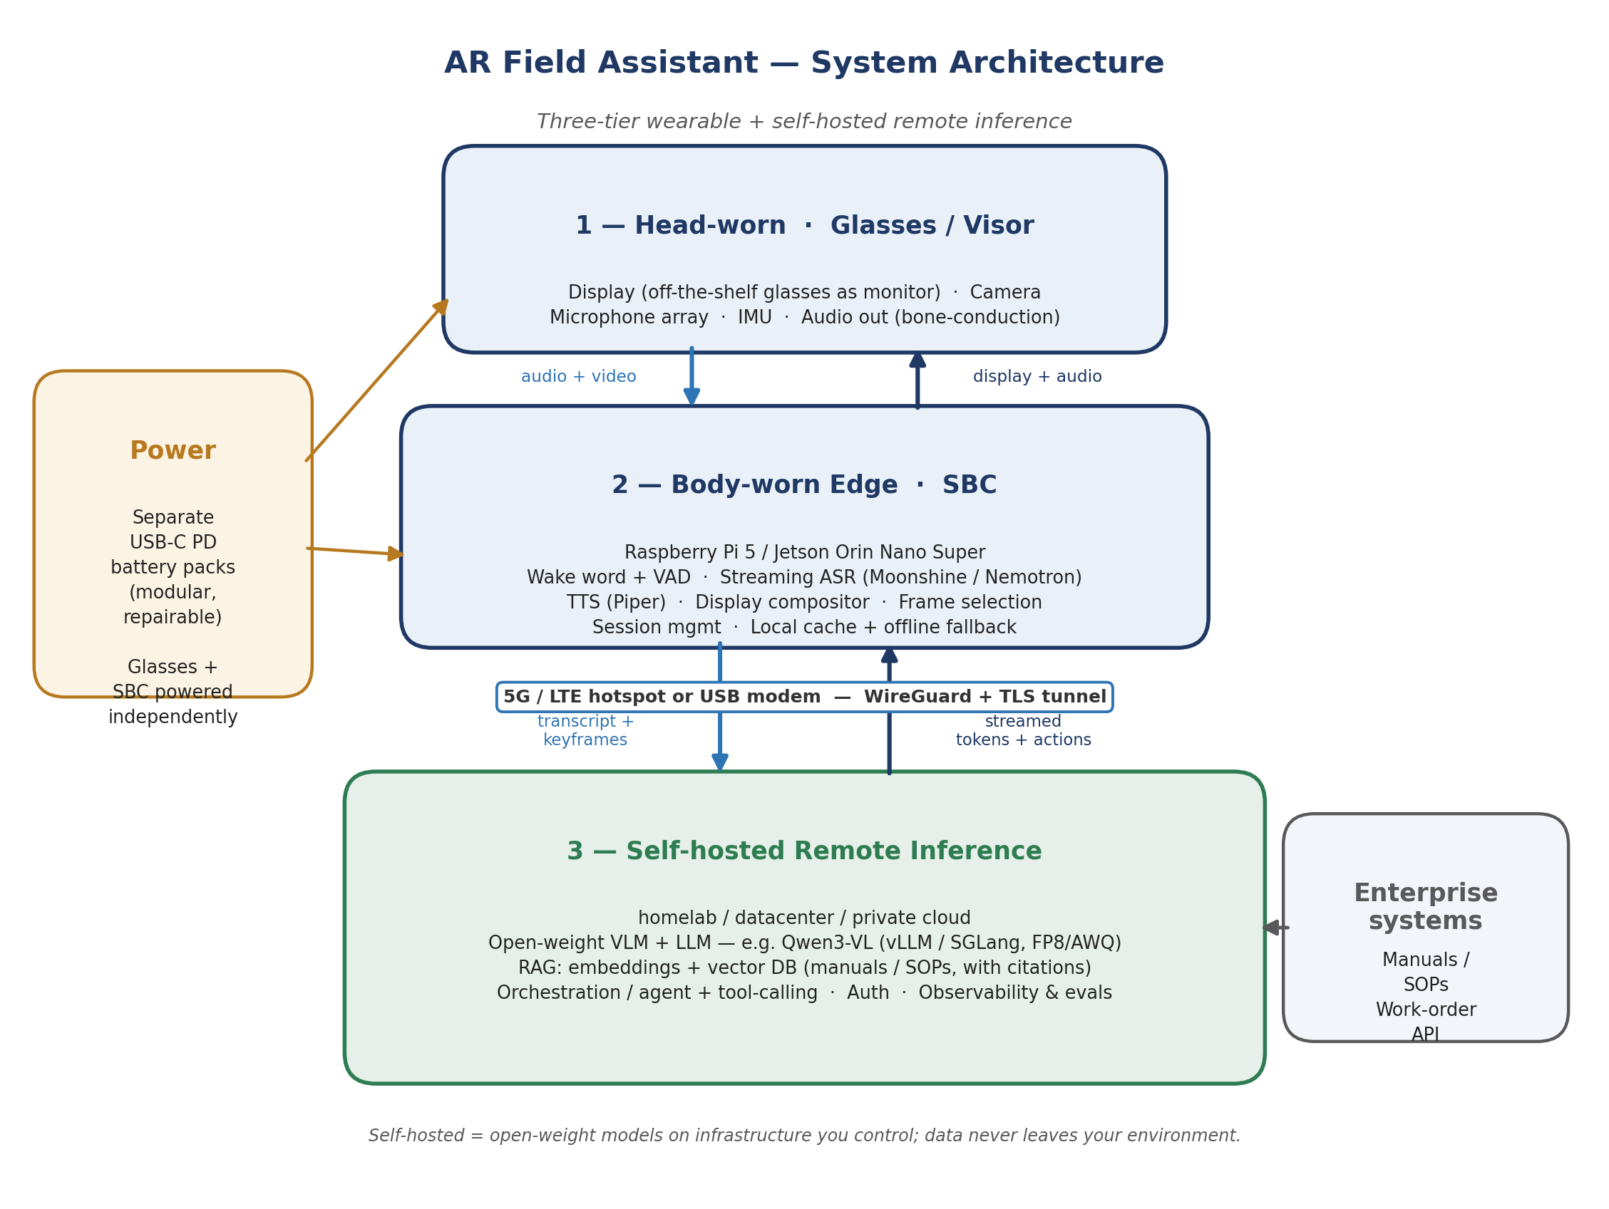
Figure 1 — Three-tier wearable with self-hosted remote inference.

Data flow, end to end
- Voice query: wake word → voice-activity detection → streaming speech-to-text on the edge → transcript (plus a recent camera keyframe, if relevant) sent over the tunnel → model retrieves from your manuals and answers → tokens stream back → edge renders text and speaks the reply, beginning before the full answer arrives.
- Visual query: the edge selects and compresses a keyframe → sends it with the question → the vision-language model reasons over the image → streamed answer + optional on-display annotations.
- Resilience: if the link drops, the edge falls back to cached procedures and on-device speech, queues actions, and resyncs when connectivity returns.

Components

Layer | Role | Key elements
Head-worn glasses | Input / output only; low power | Display, camera, mic array, IMU, audio out
Body-worn edge (SBC) | Capture, speech, compositing, orchestration, resilience | Wake word, VAD, streaming ASR, TTS, session mgmt, cache/offline
Connectivity | Private link to the brain | 5G/LTE hotspot or USB modem; WireGuard VPN + TLS
Remote inference | Reasoning and knowledge | Open-weight VLM+LLM, RAG vector DB, agent/orchestration, auth, evals
Power | Independent, repairable | Separate USB-C PD battery packs for glasses and SBC
Enterprise systems | Source of truth | Manuals/SOPs (for RAG), work-order API

4. Technology Stack (state of the art, mid-2026)
Recommendations reflect the current open-weight landscape. Specific models move monthly — keep them swappable behind an OpenAI-compatible interface so you can upgrade without rework.

Layer | Recommended | Alternatives | Why
Vision-language model | Qwen3-VL (e.g. 30B-A3B or a dense 7–8B), quantized | InternVL3, Llama 4 multimodal, Pixtral, Phi-4-multimodal | Strong open multimodal; FP8 builds; Apache-2.0
Inference serving | vLLM or SGLang (OpenAI-compatible) | Ollama / llama.cpp (simplest early on) | Continuous batching, streaming, throughput
Quantization | FP8 or AWQ (server); GGUF for CPU/edge | GPTQ, INT8 | Fit a 24–48GB GPU; cut latency/cost
Retrieval (RAG) | Open embeddings + vector DB (Qdrant / pgvector) | Milvus, Weaviate; LlamaIndex for glue | Grounded answers with citations; data stays local
Speech-to-text (edge) | Moonshine v2 (Pi) / NVIDIA Nemotron-Streaming or Parakeet (Jetson) | Whisper Turbo / distil-whisper (multilingual) | Streaming, low-latency, on-device
Wake word + VAD | openWakeWord + Silero VAD | porcupine; WebRTC VAD | Cheap on-edge gating; fewer round-trips
Text-to-speech (edge) | Piper (offline, low-latency) | Kokoro, XTTS (server) | Fast spoken replies; works offline
Orchestration / agent | Thin FastAPI service + tool-calling | LangGraph (only if needed) | Avoid over-frameworking a POC
Observability / evals | Langfuse or Phoenix + a task eval set | Custom tracing | Evals are the steering wheel
Networking / security | WireGuard tunnel + TLS + token auth | Tailscale; mTLS | Private endpoint; data never public

5. Hardware Bill of Materials
Indicative mid-2026 prices for a single wearable unit plus one remote server. Reparability favored: off-the-shelf, modular, 3D-printed mounts.

Component | Recommended option | Est. cost | Notes
Display / optical engine | Off-the-shelf display glasses driven as a monitor (XReal/Rokid/Viture class) | $200–$500 | Fastest, lowest-risk; swappable unit
— DIY alternative | Monocular micro-OLED module + combiner | $80–$200 | More “self-built”; higher effort
Edge SBC (primary) | Raspberry Pi 5 (8GB) + cooler + NVMe | ~$120 | Low power; LLM is remote, so no GPU needed
— SBC alternative | Jetson Orin Nano Super dev kit | ~$249 | On-edge GPU for offline fallback / local vision
Camera | USB UVC or Pi camera module | $25–$50 | Feeds the vision model
Microphone array | USB mic array (e.g. ReSpeaker) | $30–$70 | Far-field voice in noise
Audio out | Bone-conduction headset / earbuds | $20–$50 | Hands-free, ears-open
Connectivity | 5G/LTE hotspot or USB modem (or phone tether) | $0–$250 | Plus a data SIM; phone tether = $0
Power | USB-C PD power bank(s) | $30–$80 | Separate packs; hot-swappable
Mounts / cables / harness | 3D-printed mounts, adapters, belt rig | $50–$120 | Repairable; documented
Remote GPU server | Own 24–48GB GPU (e.g. used RTX 3090/4090) or rent | $0–$2,000 | Rent = ~$0.5–$2/hr, no capex

Indicative total: ~US$1,200–$3,500 for one unit + a modest owned GPU; substantially less if you rent the GPU hourly and tether to an existing phone.

6. State-of-the-Art Techniques & Design Principles

Latency is the product
A hands-free assistant feels broken if it waits, interrupts awkwardly, or misses the end of a thought. Hide latency aggressively: do wake-word, VAD, and end-pointing on the edge; stream tokens to the display as they generate and begin speaking partial replies; send compressed keyframes, not video; keep a persistent websocket/gRPC session; and cache frequent answers. Target first spoken token within ~1–2 seconds of the user finishing speaking.

Right-size and quantize the model
Bigger is not better here. A quantized mid-size VLM (e.g. Qwen3-VL ~30B-A3B, or a dense 7–8B) served with vLLM/SGLang on a 24–48GB GPU gives strong multimodal quality at workable latency and cost. Reserve larger models for offline evaluation only.

Ground every answer (RAG with citations)
Index the organization’s manuals and SOPs into a local vector database; retrieve relevant passages at query time and require the model to cite them. This is what makes answers trustworthy and domain-correct — and, because retrieval runs on your infrastructure, proprietary content never leaves it.

Structured tool-calling and a tight agent loop
Use function-calling for actions (retrieve, file a work order, call an expert) with a small state machine for guided procedures and explicit confirmations before anything consequential. Resist heavyweight agent frameworks in a POC; a thin orchestrator is easier to debug and to make safe.

Design for degraded and offline operation
Field connectivity is unreliable. Cache the active procedure and recent context on the edge, keep speech I/O working locally, queue captured data, and resync on reconnect. On a Jetson, a small local model can provide a basic offline fallback.

Privacy and security by design
The wearable talks only to a private endpoint over a WireGuard tunnel with TLS and token auth; the model and all data live on infrastructure you control; captured imagery and PII are handled under a clear retention policy. This is the concrete realization of the self-hosting rationale.

Evaluation-driven development
Stand up observability (request tracing) and a small evaluation set of representative tasks from day one. Track task-success rate, end-to-end latency (p50/p95), speech word-error-rate, and retrieval accuracy. Improve against the eval set, not vibes.

Hands-free UX patterns
Glanceable, low-density display; clear “listening / thinking / speaking” states; voice + a single physical button for confirmation; never overload the visual field; fail safe and visibly when the link drops.

7. Phased Delivery Plan
Sequencing principle: de-risk the AI brain before touching hardware. Prove model quality and the self-hosted stack against a laptop client first, then bring up the wearable, then layer in multimodal and workflows, then harden and field-test.

Phase | Focus | Duration | Exit criteria
0 — Foundations | Finalize use case & KPIs; procure hardware; stand up remote server; pick models; repo + observability | ~2 wks | Server serving a model via API; eval harness scaffolded
1 — Remote brain | Serve VLM+LLM; build RAG over sample manuals; expose API; validate on a laptop client | 3–4 wks | Grounded Q&A + visual Q&A pass the eval set on a laptop
2 — Edge bring-up | Assemble glasses + SBC + power + connectivity; display, camera, mic, audio; edge speech; end-to-end voice loop | 3–4 wks | Ask aloud, see/hear an answer over the network
3 — Multimodal & workflows | Camera→VLM; guided procedures; hands-free capture; remote-expert call (stretch) | 3–4 wks | A full inspection task completed hands-free
4 — Hardening & field test | Latency, offline fallback, battery/thermal, security (WireGuard/TLS/auth); real technician trial | 2–3 wks | KPIs met in a realistic field test
5 — Evaluate & decide | Assess vs success criteria; document learnings; go/no-go + next steps | ~1 wk | Decision memo and recommendation

Total: ~14–19 weeks. Phases 1 and 2 can partially overlap once hardware arrives, since the brain (Phase 1) is validated independently of the wearable.

8. Workstreams & Team
A POC needs 2–4 people; roles can be combined for a leaner build.

Role | Responsibilities | Allocation
ML / LLM engineer | Model serving, quantization, RAG, agent loop, evals | Full-time
Embedded / edge engineer | SBC, Linux, audio/video I/O, speech pipeline, power, networking | Full-time
AR / UX (part-time) | Display UI, hands-free interaction, field ergonomics | ~0.5
PM + domain SME (part-time) | Use case, content (manuals/SOPs), field test, KPIs | ~0.5

9. Risk Register

Risk | Likelihood | Impact | Mitigation
Connectivity / latency in the field | High | High | Edge speech + streaming + keyframes + caching; offline fallback; set latency KPIs early
Battery life / thermal on the wearable | Med | Med | Separate hot-swappable packs; low-power SBC; offload heavy work to server
Display readability / ergonomics | Med | Med | Start with proven off-the-shelf optics; low-density glanceable UI; field test early
ASR accuracy in noise | Med | Med | Mic array + VAD; domain vocabulary; measure WER on representative audio
Model quality / hallucination | Med | High | RAG with citations; confirmations on actions; eval set; human-in-the-loop for stretch
Security of remote link | Low | High | WireGuard + TLS + token auth; private endpoint; retention policy
Hardware scope creep | Med | Med | Off-the-shelf first; POC, not product; freeze the BOM after Phase 0
Hands-free safety | Low | Med | Confirmations for consequential steps; fail-safe on link loss; clear states

10. Success Criteria & KPIs
Illustrative targets — calibrate to your use case and environment during Phase 0.

Metric | Target (illustrative) | How measured
Voice query → first spoken token (p95) | < 2 s | Instrumented end-to-end traces
Task success rate (N representative tasks) | > 80% | Scored runs against an eval set
Speech word-error-rate (field audio) | < 10% | WER on representative recordings
Retrieval accuracy (answer cites correct source) | > 90% | Human review on eval set
Battery runtime (continuous use) | > 3 h | Field measurement
Technician usability | SUS > 70 / task completion | Field test survey + observation
Field-test uptime | > 95% of session | Session logs

11. Budget & Timeline Summary
- Timeline: ~14–19 weeks (~3.5–4.5 months) for a 2–4-person team.
- Hardware capex: ~US$1,200–$3,500 for one wearable unit + a modest owned GPU; near-zero capex if renting cloud GPU and tethering to a phone.
- Recurring: cloud GPU rental (if used, ~$0.5–$2/hr while running) and a data SIM; negligible if self-hosting on owned hardware in a homelab.
- Biggest cost lever: own vs. rent the GPU, and the display choice (off-the-shelf glasses vs. DIY optics).

12. Next Steps & Decision Gate
At the end of Phase 5, assess the POC against the KPIs and decide go/no-go. If it works, the strategic question — from the market analysis — is which durable layer to own next: the assistant/workflow software (most defensible, and hardware-agnostic), a private-LLM deployment capability for regulated industries, or a productized field-service offering. The POC is deliberately structured so the durable value (the self-hosted model + RAG + workflow layer) is reusable regardless of which hardware path you ultimately choose, and regardless of whether you later move on-prem/air-gapped for regulated customers.
Immediate first actions (Week 1): confirm the target use case and a sample manual set with a domain SME; order the SBC, display unit, camera, mic, and battery; stand up the GPU server and serve a quantized VLM behind an OpenAI-compatible API; create the repo and observability; draft the eval task list.

Appendix A. Glossary & Key References
LLM / VLM — Large language model / vision-language model (accepts images + text). The POC’s “brain.”
Self-hosted — Running open-weight models on infrastructure you control (homelab, datacenter, or private cloud) rather than a third-party API.
RAG — Retrieval-augmented generation — grounding answers in your own documents, with citations.
ASR / TTS — Automatic speech recognition (speech→text) / text-to-speech (text→speech).
VAD / wake word — Voice-activity detection / a trigger phrase — on-edge gating to cut round-trips.
SBC — Single-board computer (Raspberry Pi 5, NVIDIA Jetson Orin Nano Super) — the body-worn edge.
Quantization — Compressing model weights (FP8, AWQ, GGUF) to fit smaller GPUs and reduce latency.
vLLM / SGLang / Ollama — Open inference servers; vLLM/SGLang for throughput, Ollama for simplicity.
WireGuard — A modern VPN; here, the private tunnel from the wearable to your inference server.
OpenXR / TAK — Open XR standard / military situational-awareness software (relevant if you later target defense).

Current-as-of-mid-2026 tooling referenced: Qwen3-VL and other open VLMs (InternVL3, Llama 4 multimodal, Pixtral, Phi-4-multimodal); serving via vLLM / SGLang / Ollama; edge ASR via Moonshine v2, NVIDIA Nemotron-Streaming, or Parakeet; TTS via Piper; SBCs Raspberry Pi 5 and Jetson Orin Nano Super. These are fast-moving — re-check before procurement and keep models swappable.

