**Certificate of Donation**

Container #${containerNumber} Seal #${sealNumber}

${date}

**Shipment paid for:**

Partners In Health

888 Commonwealth Ave; 3rd Floor

Boston, MA 02215

EIN#04-3567502

**Consignee:**

Zanmi Lasante

Attn: Loune Viaud

6, rue Mayard

Christ Roi

Port au Prince, HAITI

509-3687-7382

**Contents:** Humanitarian relief supplies

Total shipment value, provided for customs purposes only, is ${value}.

The items contained in this shipment constitute a humanitarian donation to Zanmi Lasante, and are not for resale. These commodities were from the United States. In accordance with the export administration regulations diversion contrary to United States Laws is prohibited.

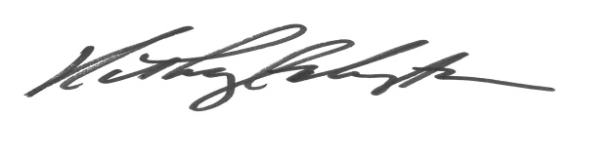

Kathryn G. Kempton

Director of Procurement

**Packing List**

Container #${containerNumber} Seal #${sealNumber}

${date}

**Shipment paid for:**

Partners In Health

888 Commonwealth Ave; 3rd Floor

Boston, MA 02215

EIN#04-3567502

**Consignee:**

Zanmi Lasante

Attn: Loune Viaud

6, rue Mayard

Christ Roi

Port au Prince, HAITI

509-3687-7382

**Contents:**