Module 2 : Git Assignment – 1

Tasks To Be Performed

1. Based on what you have learnt in the class, do the following steps:

a. Create a new folder
b. Put the following files in the folder
● Code.txt
● Log.txt
● Output.txt

c. Stage the Code.txt and Output.txt files
d. Commit them
e. And finally push them to GitHub

2. Please share the commands for the above points

Steps

1. Using Ubuntu
2. Navigate to terminal
3. Type the command > sudo mkdir devops
4. New directory is created
5. Install git > sudo apt install git
6. In the terminal enter the command git –version

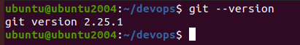

7. devops is the folder created and there no files in it.

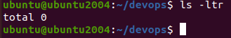

8. I will create 3 (three) text files using the touch or nano or vi command from the terminal

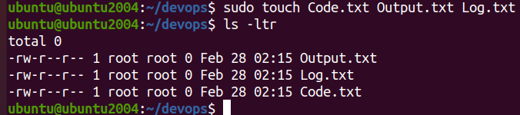
9. There are no contents in the txt files

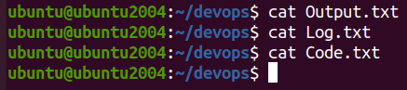
10. Now I will initialize the devops folder using the command > git init
11. Unless initialized , it will not be a git repository. You can use the command git status and you will get an error
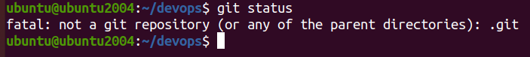
12. Navigate to the devops folder and enter the command git init

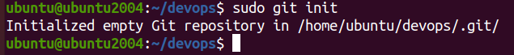
13. Now enter the command git status in the terminal

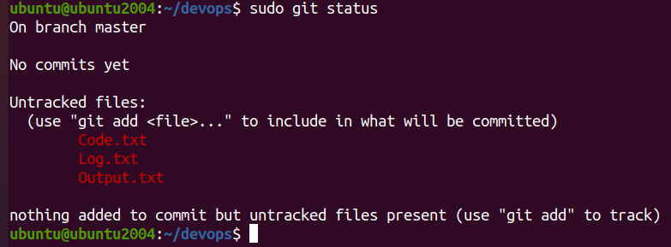
14. You can see that the files are in untracked status or not committed.

15. If you want to track all the files in the devops folder we can type the command git add.

16. The requirement is only code and output text files to be staged

17. Now we will use the command git add and the file name to be staged

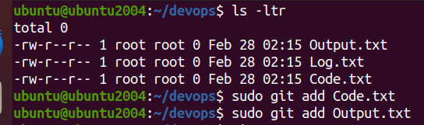
18. Refer the screen shot and you can see that the Code and Output text files are staged. The log text files shows as Untracked files.

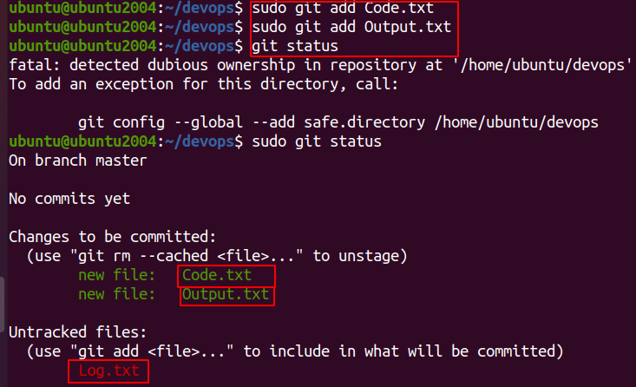
19. Now we are going to commit the staged files that is Code and Output files with a message “My First Commit”

20. Go to the terminal and type the command git commit -m “My First Commit – Code and Output Text Files”.

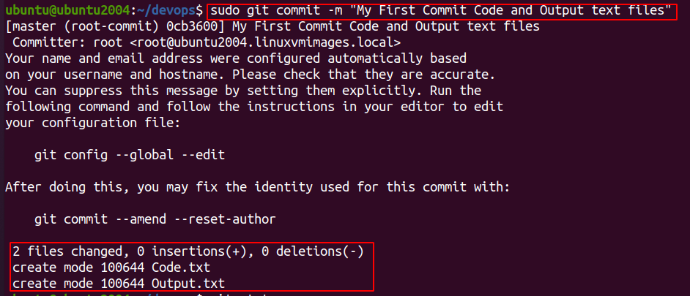
21. Now type git status and shows only Log.txt as the only file which is in untracked status.

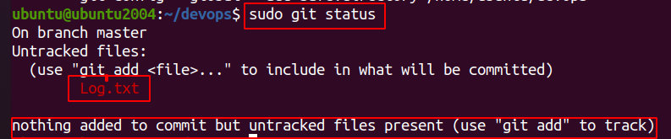

22. I already have a github account and I will create a new repository devops_git_assignment. It is a public profile.



23. In the homepage of the newly created repo you can find the URL needed to push the text files from local to remote.

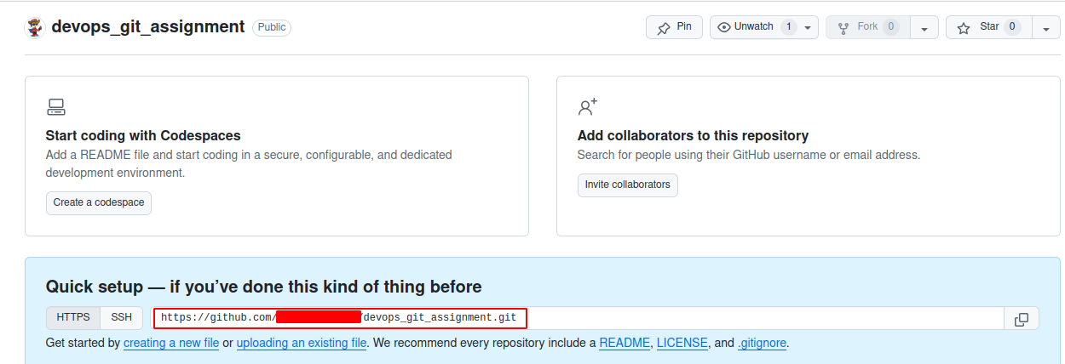
24. I will add my local repo to the Github repo which is remote
25. The command to be used is
26. git remote add origin <github url>. The address of the remote address.
27. So when we send the content from local to remote it is call push.

28. Now in the terminal type ls -lsa

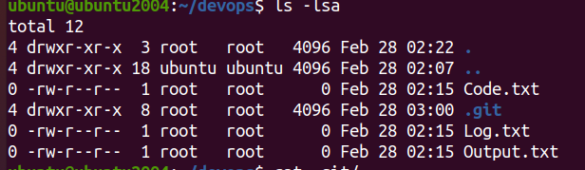
29. Navigate to the hidden folder .get
30. type cat config and you can see the remote URL added to the config file

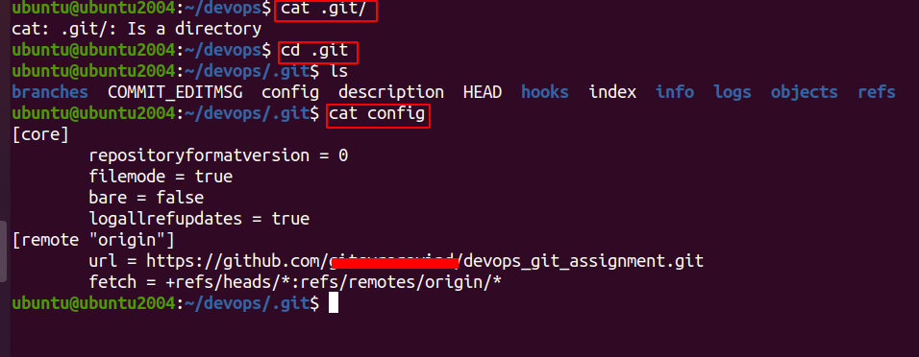
the remote URL has been added in the configuration file. Now I will try to push the text files from the master branch into the github repository.

31. I am getting an error when I try to push the files from the master branch.

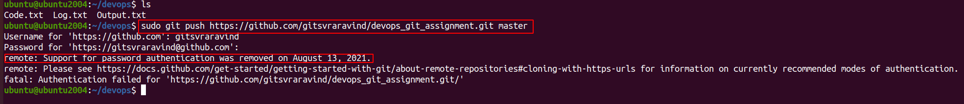
32. So we need a token to be setup. Navigate to github repository.
33. Click on the top right hand corner icon


34. Click on Setting

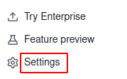
35. Scroll and locate Developer Settings


36. Click on Personal Access Tokens > Tokens (Classic)

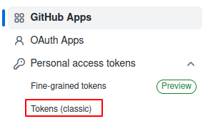
37. Click on Generate New Tokens

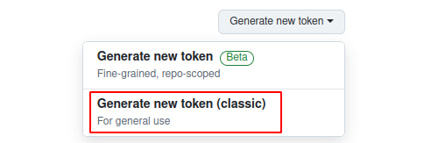
38. Give a name in the Note Field and set the expiration date and click on the access. Since it is a demo click on all the checkboxes and click on generate token. Copy the token in a safe place.
39. Copy the token and run the same commands and in the password field paste the token

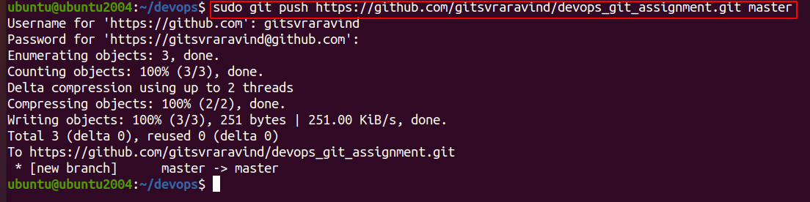
40. Navigate to the repo and you will find the text files

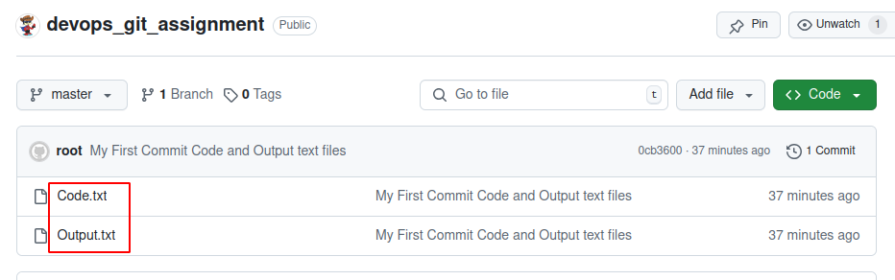
41. there is only one master branch and you can see which is the branch you are in. The asterix command will indicate in which branch you are in

