Module 2 - Git Assignment 2

Tasks To Be Performed:

1. Create a Git working directory with feature1.txt and feature2.txt in the
master branch

2. Create 3 branches develop, feature1 and feature2

3. In develop branch create develop.txt, do not stage or commit it

4. Stash this file and check out to feature1 branch

5. Create new.txt file in feature1 branch, stage and commit this file

6. Checkout to develop, unstash this file and commit

7. Please submit all the Git commands used to do the above steps

Steps

1. Navigate to the Ubuntu terminal

2. Create a new directory git2 using the command sudo mkdir git2 or use the same directory created during assignment 1

3. Initialize the folder using git init if a new directory is created

4. I will use the same folder what I created earlier in assignment 1

5. The folder devops is already initialized and I will not re-run the command.

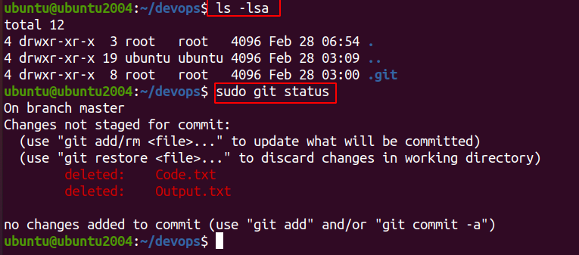
6. I will create two text files feature 1 and feature 2 using the terminal

7. sudo touch feature1.txt feature2.txt

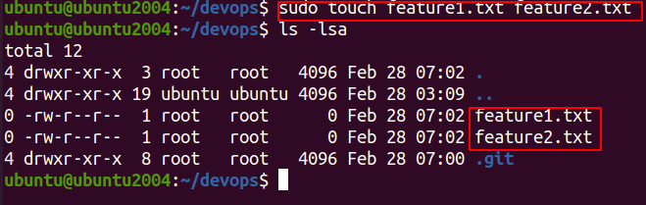

8. Now I will run the command git add . The . Will include all the files in the folder to be committed or we can do individually as in assignment 1.

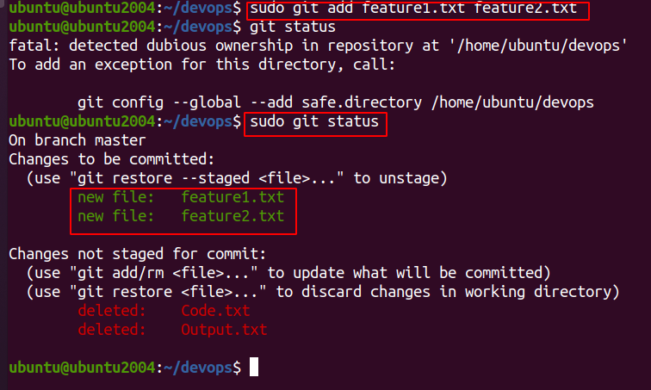

9. Now I will commit the files – feature1.txt and feature2.txt

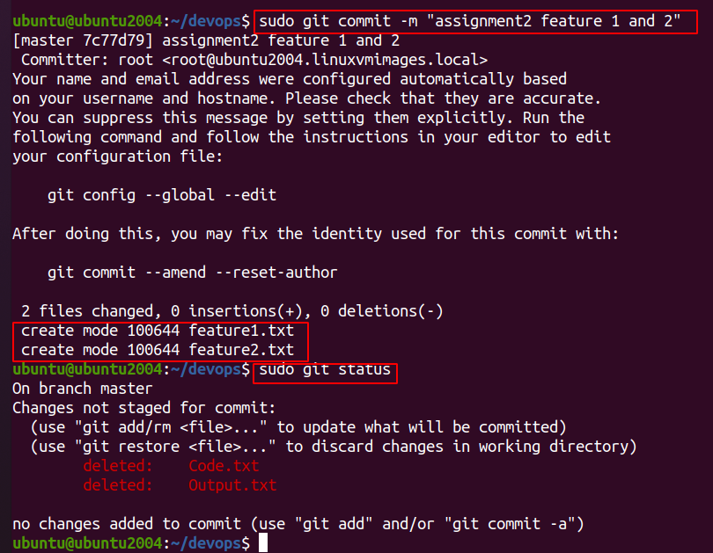
10. Now we need to create a branch
1. branch – develop
2. branch – feature1
3. branch – feature2

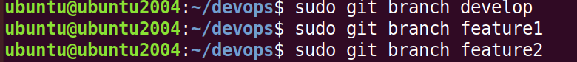
11. The branches are created and run the command sudo git branch and you can see the branches created.

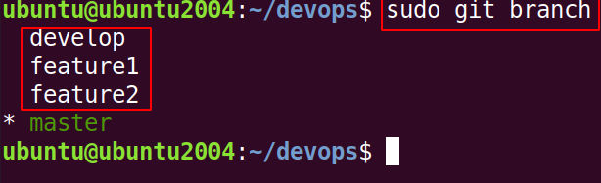
12. Notice the asterix and we are currently in the master branch. We need to chekout to the develop branch and create a text file called develop.txt. No need to stage or commit it.

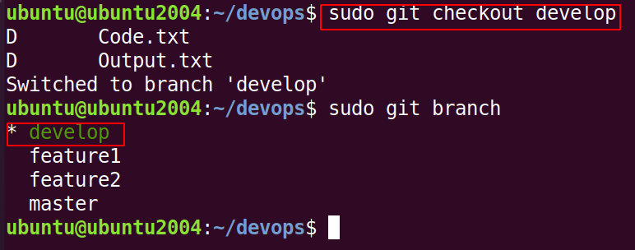
13. The next requirement is not to stage or commit but to stash the file. So we will create a text file in the develop branch and stash it . The command to stash is git stash

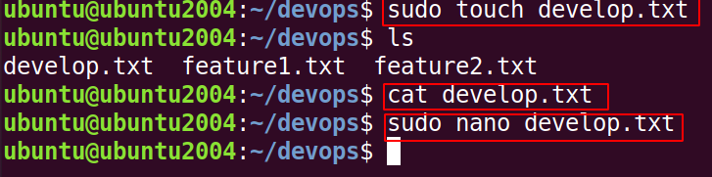
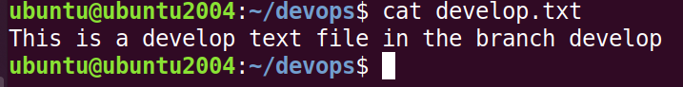

14, Now checkout to the branch feature1 and create a new.txt file and the new.txt file will be staged and committed.
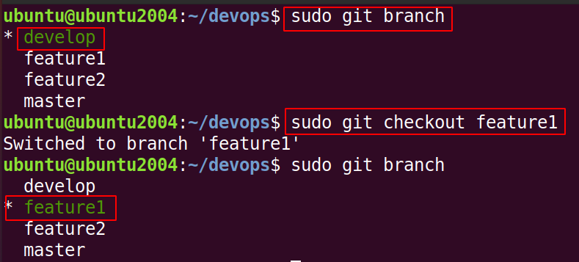
15. In the branch feature1 we will create a text file called new.txt and add content.

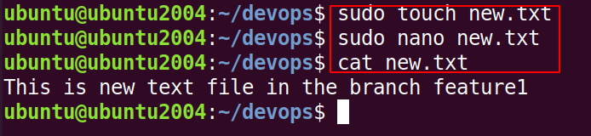
16. Follow the commands in the screen shot
17. for staging the file new.txt type git add
18. For committing the file type the command git commit -m “comments”

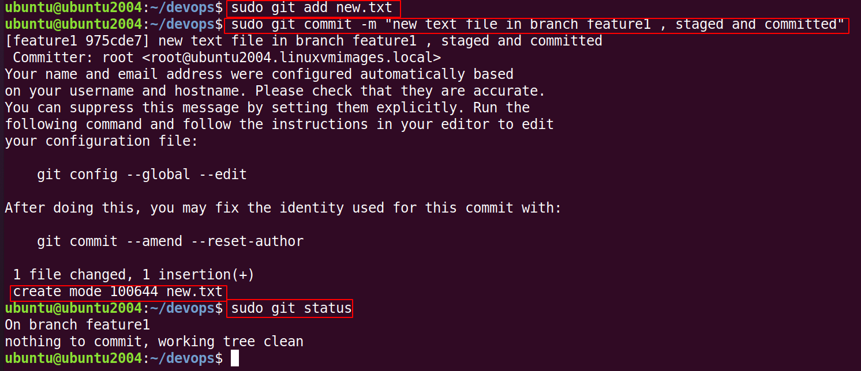
19. Type the command git stash list and you can see on develop branch it shows WIP

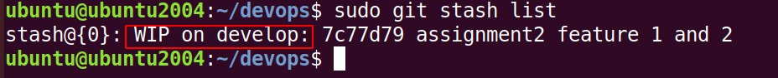
WIP stands for work in progress

20. Now we will checkout to the develop branch

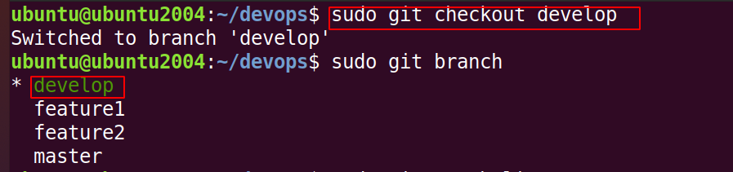
21. Now you want to work on the file in the develop branch and we will use the command git stash pop You can see that now we will be able to stage the file and commit it.

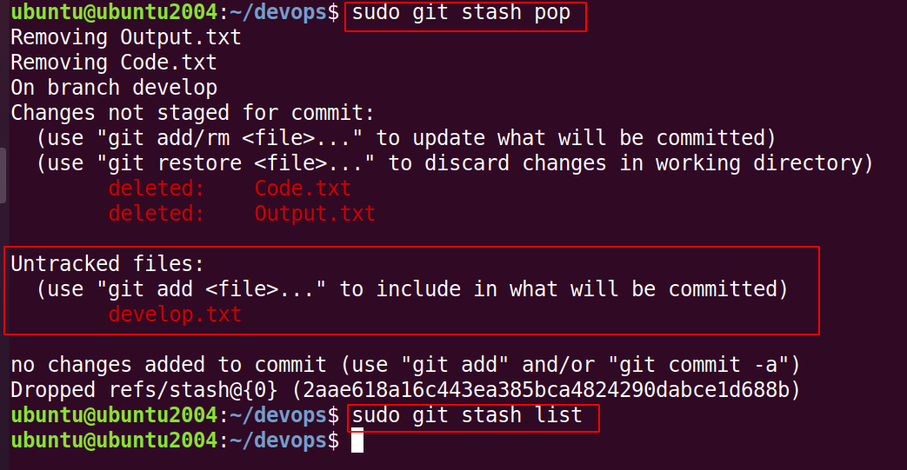
22. Now type the command git status and you can see the develop text file is untracked and can be tracked using the git add command and committed.

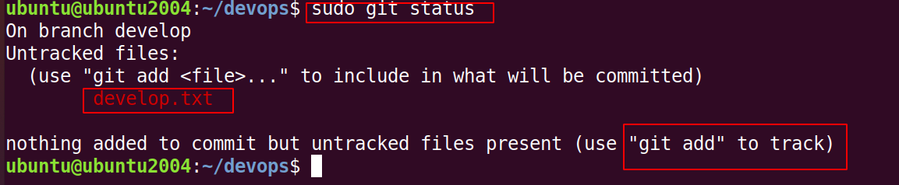
23. The develop file has been commited.

