# Technical Requirements

OpenORPG relies on the following technology to build:

* C# 4.0+
* Windows Server
* HTML5 compatible browser
* TypeScript
* Visual Studio 2012 or higher

# Mapping in OpenORPG

OpenORPG uses the Tiled editor to do most of the mapping in game. The client reads JSON files and the server reads the TMX files. Things to note:

* Anything above the “Entities” tilemap layer is drawn above all entities in the game
* An object layer named ‘MobSpawns’ is used for spawning monsters

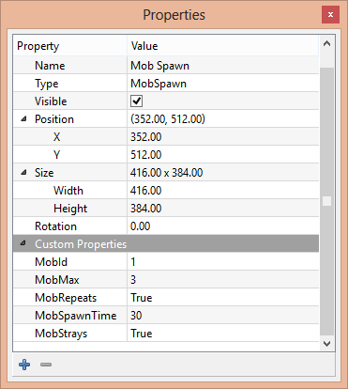

Figure An example of some properties that can be set

**MobId***:* This is the ID of the mob to spawn inside this spawning rectangle

**MobMax:** The maximum amount of mobs that can come out of this spawn at any given time.

**MobRepeats:** This is a flag that indicates whether or not more mobs will continue to spawn even after **MobMax** has been exhausted once.

**MobSpawnTime:** The amount of time (in seconds) it takes to spawn a single mob.

**MobStrays:** Not currently used, but required to be set!

# Skills

# Quests