CSE 5236

Project2 – Yun Ma

Narratives:

Application introduction

This mobile application, a kind of a calories measurement, helps user follow their daily calories and plan on their health. It consists of many functions such as calculating total calories of food, listing normal food’s calories and reminding the goals for users.

Target population

This application works well for the group of people who care about the intake and consumed calories every day and record them to reach their goals. Females who pursue beauty and males who love exercises and eating should use this application.

Goal

This application could provide people a clear measurement of their calories and remind them about the goal. People can choose the best diets for themselves to lose weight or gain weight, in order to achieve their health goals.

Sketches:

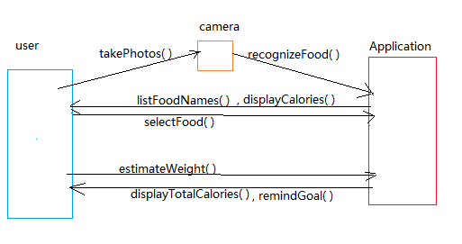

Lists of use cases:

|  |  |  |  |
| --- | --- | --- | --- |
| Use Case | Actors | Purpose | Description |
| 1. Take food pictures | user | Record food with mobiles’ camera | User uses camera to photo their foods. |
| 1. Recognize food | app | Learn the food types in the photos | Application receives the photos user provided and recognizes the food through some spot tools inside it. |
| 1. List food names | app | Provide several food names for user to choose | Application shows a list of food name after learning from the photos |
| 1. Select food | user | Select exact food | Users clicks on the right name in the food list |
| 1. Display food calories | app | Provide food’s calories value | Application will find the value of calories of the food in the database and output it to user |
| 1. Estimate food weight | user | Give an estimated value of food weight | User measures the weight of food and input it into the application. |
| 1. Estimate total calories | app | Give a result of total calories of food | Application calculates the total calories with the weight the user provided. |
| 1. List a list of calories | app | Show user a list of calories of common food | Application stores a list of common food calories for users to check |
| 1. Remind goals | app | Remind user of the expected calories value | Application reminder records the calories value of the user intake and consumed, and reminds user of their calories goal. |