MIEIC-LDSO-2015-16 Architectural Guidelines
This is a simple template to provide MIEIC-LDSO-2015-16 students some basic guidelines to help them develop their own reports.
The writing should be concise, short, but trying to completely cover the project at hands. Although the first two levels of headings are mandatory (for evaluation normalization reasons), the structure inside them (below level 2) is free, and innovation is highly appreciated. But don’t over-innovate! ☺

1. Introduction
The software architecture encompasses the set of key decisions about the overall organization of a software system. Documenting the architecture of a software system requires describing the decomposition of the system in their parts (high-level components), its basic building blocks (classes, database tables, web pages, libraries, etc.), and the specification of the key behaviors and collaborations (mechanisms) between different parts of the system.
In this report you should start by shortly describing the overall components of the project, their interrelations and the key architectural principles followed to design the system.
Explain then what this report is about, what is its purpose, what it contains, and how it should be read.

2. Technological architecture
This section should describe the technologies considered and technically justify the selection made. Examples of technologies relevant for LDSO are modern frameworks for agile web development and mobile applications, such as jQuery, Ajax, CSS3, HTML5, Javascript, Ruby on Rails, Scala, Django, iOS, Android, Windows Phone, etc.

3. Logical architecture
The purpose of this section is to document the high-level logical structure of the software system (shared responsibility), using a UML diagram with logical packages, packages of classes (including classes for modeling the key domain concepts and user interfaces) and dependencies between packages without the worry of allocating classes to components, processes or machines.
The system can be presented either in a horizontal or vertical decomposition, or both simultaneously (preferred if the dimension permits).
Horizontal decomposition can define layers and implementation concepts such as the user interface, business logic and concepts, usually in a relatively independent way of features.
Vertical decomposition can define a hierarchy of subsystems, each subsystem corresponding to a group of features and covering all layers of implementation.
Here is one example of such a diagram:

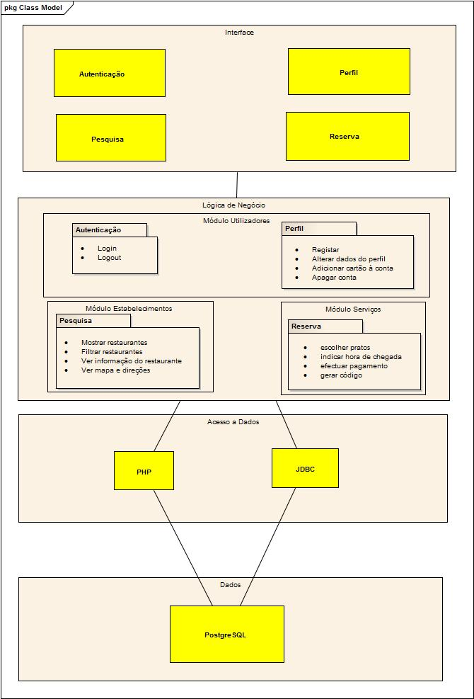

4. Physical architecture
The goal is to document the high-level physical structure of the software system (machines, connections, software components installed, and dependencies between the components) using UML deployment diagrams and component diagrams (separate or integrated), showing the physical structure of the system.
In this section, it is useful to describe the various physical components used, usually corresponding to files (libraries, executable files, HTML files, scripts, etc.), and to provide a short textual description for each one.
In the architectural phase only the high-level component and packages must be defined. It should be mentioned the technologies selected to implement each package or component. It should also be defined which components run in the same process or in separate processes.

5. Key design decisions
Software development is very repetitive, involving the resolution of recurring problems, many having already well known good and proven solutions.
The decision about whether to solve a recurring problem it is important to better understand the architecture of a system.
Software patterns (architectural patterns and design patterns) document proven solutions to recurring problems, for which there is a vast literature that should be consulted before devising "new" solutions, and maybe reinventing the wheel.
Some examples of recurring problems are: organization in layers (Layers pattern), separation of views and their controllers data (patterns Model-View-Controller, Observer), passing data between layers, mapping between objects in memory and database (Object Relational Access Layer), etc.
Other aspects to mention in this section are decisions regarding: authentication and authorization, logging and error handling, transaction management, security, application configuration, etc.

References
A list of the key references used to develop the report, technical or project related.

