# Chicago wood puzzle

This program search solutions for the puzzle that have the following topology:

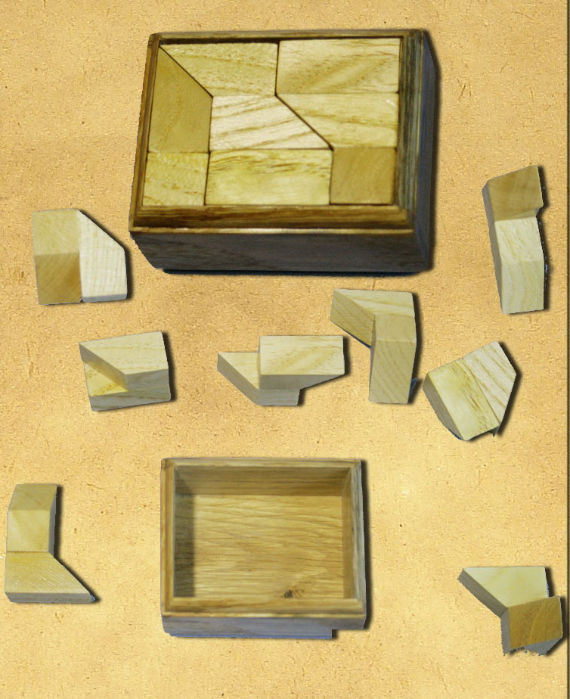

From program run results I state that such puzzle parts couldn’t be built up into the box at the top. It seems that puzzle mas glued in a wrong way!

The link to the puzzle is <http://www.divoshop.com/index.php?productID=14503>

Closely related puzzle is there <http://cherdak.ua/product/2783>

Its image:

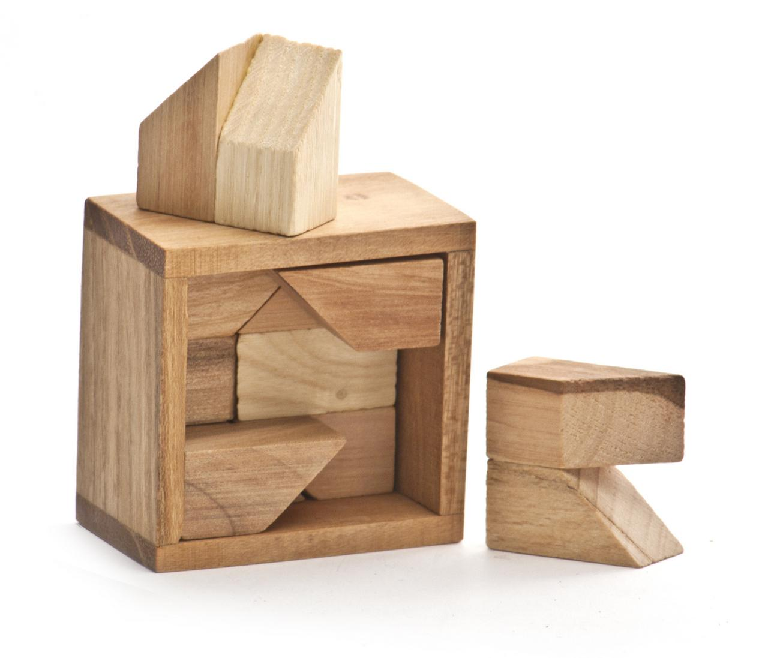

In program puzzles enumerated in the following way:

