Increased Network Path Efficiency from Combined Central Control and Distributed Routing
Abstract—For finding the best path to route data in a network, distributed routing offers robustness but has poor flexibility. In software-defined networks, central control can slow error recovery. The Fibbing architecture can run distributed routing protocols on software-defined networks and has both robustness and flexibility, but the cost of the paths it chooses can be reduced further. The 2 main steps of Fibbing’s process are (1) compute a path that is safe for the network according to the network topology and the network request, and (2) add fake nodes and fake links to augment the network topology according to the distributed routing protocol and the path computed in the first step. In this paper, we propose a coordinate algorithm for Fibbing to determine a best path. Our algorithm accommodates safety, fake nodes, and fake links when computing the path. Our experiments show that our algorithm can reduce the number of links and fake nodes and the total cost of the path.
Keywords—algorithm; central control; coordinate; distributed routing; Fibbing; SDN; software-defined network

Introduction
Routing is the process of selecting paths in a network. In distributed routing,^{[1, 2]} a network device shares routing information with other network devices and configures its forwarding behavior so the network flow will be transmitted along a good path. For instance, interior gateway protocols (IGPs)^{[3]} belong to distributed routing protocols. Specific examples of IGPs include the routing information protocol (RIP),^{[4]} open shortest path first (OSPF),^{[5, 6]} and intermediate system to intermediate system (IS-IS).^{[7]} Distributed routing is widely used in the networks of large companies, universities, and banks.
Some researchers introduced distributed routing to break through the performance limits of routers. Instead of the best route being determined at the data plane level, distributed routing solves the problem at the control plane.^{[8]}
A different way to select routing paths and share routing information is central control.^{[9]} Software-defined networks (SDNs)^{[10–12]} universally use central control.
SDNs and distributed routing each have their own advantages:
(1) Distributed routing can recover quickly from failures through the distributed routing protocols working in the network, but the central control of an SDN makes failure recovery difficult and slow.
(2) The computation and management of forwarding paths through an SDN are more convenient and flexible than through distributed routing, because its central control can do global operations from a global view of the network. If 2 source nodes are both connected to a router and the corresponding 2 sink nodes are both connected to another router, distributed routing must transmit the 2 flows along the same path, but SDN can easily transmit them along different paths.
(3) When installing the computed paths in the network devices, an SDN controller should send the paths to every device by itself, which is slow. But distributed routing protocols can guide the devices to send the paths to one another quickly.
The advantages and disadvantages of the 2 methods have prompted many researchers to try to combine SDN with distributed routing. An architecture called Fibbing^{[13]} has been proposed, which could allow networks to combine the benefits of SDN and distributed routing and has therefore attracted much research attention in recent years. A Fibbing network has a central controller, and distributed routing protocols also work in the network. Fibbing can recover quickly from failures, because of the distributed routing protocols. Computing and managing forwarding paths are very convenient and flexible, because the Fibbing controller can do global operations from a global view of the network, and the distributed routing protocols working in a Fibbing network can guide devices to send the computed paths to one another quickly so the computed paths can be installed in a short time.
Fibbing works as follows:
In the beginning, there is a network topology. When a network request arrives, the Fibbing controller^{[13]} does some computation to determine a feasible path to transmit the network flow while keeping the network safe. Then, accounting for the computed path and the distributed routing protocols working in the network, the Fibbing controller adds some fake nodes and fake links^{[13]} to the network topology to augment it. Guided by the augmented topology, the distributed routing protocols determine a path the same as the one the Fibbing controller already determined.
However, we found that the process has a weakness. The core of the process comprises 2 steps:
1. The Fibbing controller computes a feasible path according to the network topology and the network request.
2. The Fibbing controller adds some fake nodes and links to augment the network topology according the computed path and the distributed routing protocols.
The 2 steps together greatly affect the performance of the network. But Vissicchio et al.^{[13]} considered the 2 steps separately and discussed only the algorithms and the optimization of Step 2. We found that if the algorithms and the optimization were designed for both steps, the performance would improve further.
In this paper we discuss a coordinate algorithm based on minimum-cost flow problem^{[14]} algorithms. Consider the network shown in Fig. 1a. In the network topology, the link between the nodes 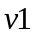 and 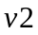 has a remaining bandwidth of 6, and the cost of 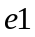 is 2; we can obtain the state of the other links in the same way.
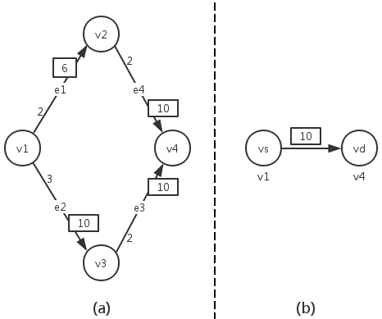
Fig. 1. Initial topology and network request
Now a network request arrives. It requests that the source node of the network flow be and the sink node be 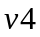, and it requires a bandwidth of 10, as shown in Fig. 1b.
An augmented topology to get a feasible flow is shown in Fig. 2. The cost of the links is 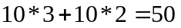, with one fake node.
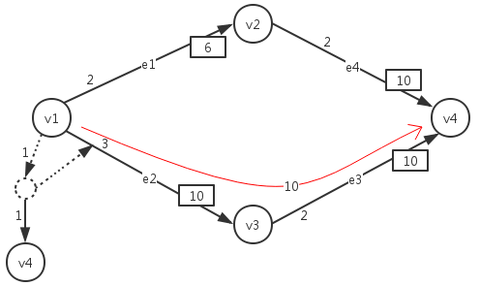
Fig. 2. Augmented topology 1
An augmented topology to get a minimum-cost flow is shown in Fig. 3. The link cost is , with 5 fake nodes.
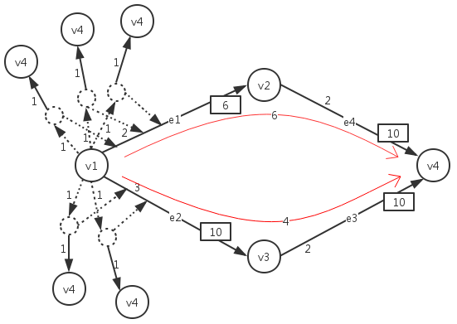
Fig. 3. Augmented topology 2
If the cost of a fake node is set as 1 (the cost is easily changed by changing the conditions in our algorithm), the augmented topology our algorithm constructs is shown in Fig. 4. The link cost is 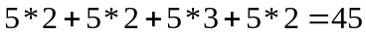, but with only one fake node.
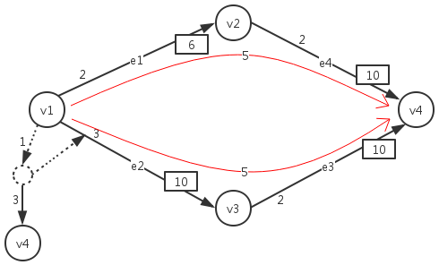
Fig. 4. Augmented topology 3
A comparison of the 3 algorithms when the cost of a fake node is 1 is shown in Table 1. We can see that the total cost was decreased by using our algorithm.
Table 1. Cost comparison of the 3 algorithms
Algorithm | Link cost | Fake-node cost | Total cost
Feasible-flow | 50 | 1 | 51
Minimum-cost flow | 44 | 5 | 49
Proposed | 45 | 1 | 46

The total cost of our algorithm is obviously less than that of either the feasible-flow algorithm or the minimum-cost flow algorithm, because our algorithm reduced the number of fake nodes while keeping the link cost close to that of the minimum-cost flow algorithm.

Related Work
Some other studies have been made to combine distributed routing and SDN.
[14] built Cardigan, a distributed router using OpenFlow,^{[9]} which combined SDN and distributed routing to reduce network operational complexity and overcome some limitations of earlier OpenFlow implementations.
[15] also devised a scheme to combine SDN and distributed routing. They partitioned a network into some subdomains. The border nodes of the subdomains were controlled by SDN, and the nodes in the subdomains were controlled by distributed routing. Their scheme successfully improved the performance of the network.
[13] described the process of Fibbing.
To achieve an augmented topology via a distributed routing protocol, a network topology, and a network request, the Fibbing controller should take 2 steps. Step 1 should compute
a path that is safe for the network according to the network topology and the network request. Step 2 should
add fake nodes and fake links to augment the network topology according to the distributed routing protocol and the path computed in Step 1.
Step 2 comprises 2 tasks: per-destination augmentation, and optimization across destinations. Fibbing has 2 algorithms to do per-destination augmentation: Simple^{[13]} and Merger^{[13]}. Simple can compute augmented topologies quickly, but they will be large. Simple adds fake nodes for every router to changes its next-hop. Merger can compute smaller augmented topologies but takes more time to do it. Merger can use one fake node to change the next-hop of more than one router. When optimizing across destinations, the Fibbing controller checks to determine which fake nodes can be optimized, and finally changes the costs of the fake links.
[16] discussed 2 abilities of Fibbing: the ability to program multiple paths on a per-destination with little control-plane overhead, and the ability to enforce uneven load-balancing among those paths with no data-plane overhead. Based on the 2 abilities they used Fibbing to solve the traffic surge problem^{[17, 18]} in video delivery.
However, we found a weakness in the Fibbing process. Steps 1 and 2 have common effects on network performance. But [13] considered them as separate elements rather than as a whole. They discussed the algorithms and optimizations of Step 2, but did not discuss Step 1.
In this paper, we discuss a coordinate algorithm combining the 2 steps to improve network performance.

Description of the Network and Algorithm
We denoted the network by a directed graph 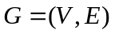, where  was the set of nodes and  was the set of links. We used 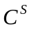 to denote the set of the cost (such as the distance) of the links, and we used 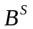 to denote the set of the rest of the bandwidth of the links. We used 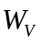 for the number of nodes in , 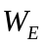 for the number of links in , 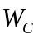 and 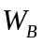 for the number of elements in and , and = = . 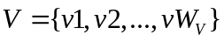, and 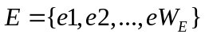. If is a link in , 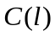 is the cost of , and 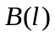 is the rest of the bandwidth of . 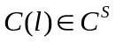 and 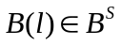. For every 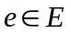, 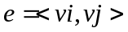, 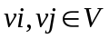, and 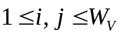.
Every network flow (network request) had its requirement. We denoted the requirement as 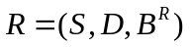, where is the source node of the flow,  is the sink node of the flow, and 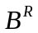 is the required bandwidth of the flow.
Our objective was to minimize 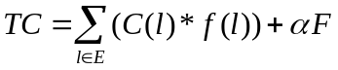. It contained the cost of the links and the fake nodes. is a link in , is the cost of , 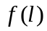 is the occupied bandwidth of , and  is the number of fake nodes that needed to be added to the network topology. We discuss the algorithm to compute in Computation 2, Input 5 below. is a weighted coefficient. It refers the cost of a fake node, and through it we could strike a balance between the cost of the links and the cost of the fake nodes.

We needed to get the paths the network flows transmit on from the network topology, the requirement, and the objective. To achieve that, we needed to use Lingo^{[19]} to make the following 2 computations.
Computation 1
Input 1: A group of linear equations
The number of these equations is − 2. Every linear equation describes the balance of flows at a node that is neither the source node nor the sink node. This is because for each node the bandwidth of the flows that come to it should equal the bandwidth of the flows that leave it.
The linear equations can be expressed as follows:
for every node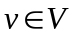, where is neither the source nor the sink node,
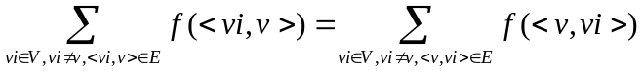. (1)
Input 2: A group of linear equations
The number of these equations is 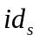 + 1, where is the in-degree of the source node. They describe that the flow bandwidths of the links whose head end is adjacent to the source node should be 0, and the flow bandwidths of the links whose tail ends are adjacent to the source node should total .
The linear equations can be expressed as
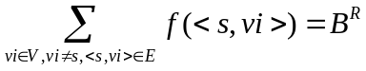, (2)
where is the source node, and for every link 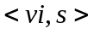, if 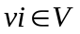, 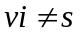, and 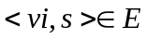, then 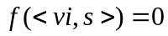.

Input 3: A group of linear equations
The number of these equations is 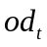 + 1, where is the out-degree of the sink node. They describe that the flow bandwidths of the links whose tail end is adjacent to the sink node should be 0, and the flow bandwidths of the links whose head ends are adjacent to the sink node should total .
The linear equations can be expressed as
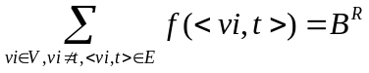, (3)
where is the sink node, and for every link 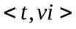, if , 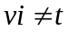, and 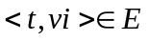, then 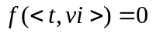.

Input 4: Objective
The objective was to minimize 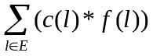 .
In the first computation with Lingo, was not considered in the network; the path was computed with the assumption that the bandwidths of the links were unlimited, and the link in the path whose tail end was adjacent to the source node was recorded. Then, every node in the network was seen in turn, except the sink node as a temporary “source node.” The paths were computed with the assumption that the bandwidths of the links were unlimited, and the links in the paths whose tail ends were adjacent to every temporary “source node” was recorded.
Computation 2

Inputs 1, 2, 3, and 4: A group of linear equations that were the same as those in

Computation 1
Input 4: A group of linear inequations
The number of the inequations was . They described that the bandwidth of the flows on the links cannot be larger than the remaining bandwidths of the links.
The linear inequations can be expressed as
For every 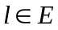, 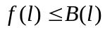 . (4)
Input 5: Objective
The objective was to minimize .

Now the algorithm to compute is discussed. Fake nodes were added to the network to cheat the distributed routing protocol into computing a different path. The possible places to add fake nodes were around the nodes whose out-degrees were equal to or greater than 2, except for the sink node.
For a node whose out-degree was equal to or greater than 2, is the link that was in the path we computed in Computation 1 in the assumption that the bandwidths of the links were unlimited. The source node of the path to which belongs is , and the tail end of is adjacent to . We set as . In the logic of Lingo, the algorithm is as follows:
Algorithm to compute
Initialize: A node whose out-degree is equal to or greater than 2; The link computed in Computation 1 related to ; 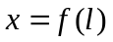
if
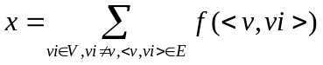
then
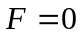
else
if 
then
if
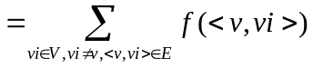
then
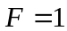
else
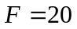
else
if
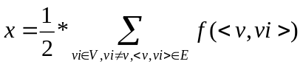
If
then
else
else

The reason that in some conditions it was assumed that 20 fake nodes should be added is that in those conditions too many fake nodes would probably be added. Those paths would be chosen only if the costs in other paths were all very high.
It was assumed that the probability that there was a link between every two nodes was 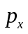, the time complexity of Computation 1 was 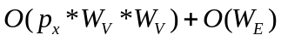, and the time complexity of Computation 2 was , so the time complexity of our algorithm was .

Evaluation
In this section, we evaluate our algorithm by comparing it with the feasible-flow and minimum-cost flow algorithms. We present our methodology and the evaluation results next.

Methodology
The evaluations were done on a PC running Windows 7 Ultimate with a 2.6 GHz Intel Pentium CPU and 8 GB of memory. We ran GT-ITM^{[20]} in Network Simulator version 2,^{[21]} Python 2.7 in a virtual machine running linux-image-3.2.0-29-generic-pae, and Lingo 11 in Windows 7 Ultimate.
We used GT-ITM to randomly generate 26 network topologies. The number of the nodes in every network topology was 4, 6, 8, 10, or 12. The probability that there was a link between every 2 nodes ranged from 0.05 to 0.15. For every network topology, we used a Python program to randomly generate 10 cases. In every case, for every link the Python program generated the remaining bandwidth and the cost when a unit of data flowed in the link, and it generated a network requirement. The remaining bandwidth of every link was from 10 to 40, and followed a Poisson distribution.^{[22]} The cost of every link ranged from 3 to 15, and also followed a Poisson distribution. The source node and the sink node of every network requirement were selected randomly from the nodes in the network topology. The required bandwidth of every network was from 10 to 30, and followed a Poisson distribution. There were 260 cases in total.
Then we used Lingo to run the feasible-flow algorithm, the minimum-cost flow algorithm, and our algorithm in every case to find a path to transmit the data flow separately, and we compared the total costs and the numbers of fake nodes of every path.

Evaluation Results
Our evaluation results show the benefits of our algorithm in various network topologies. We present our evaluation results from 2 viewpoints:
(1) Our algorithm can reduce the number of fake nodes.
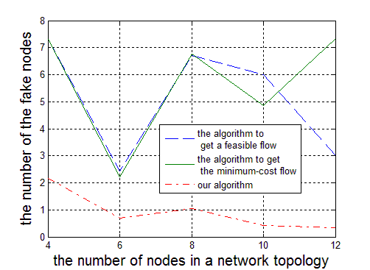
Fig. 5. The average number of fake nodes of the 3 algorithms in various network topologies
Figure 5 shows that in all network topologies tested, the average number of fake nodes in our algorithm’s paths was much lower than that of the paths generated by the other algorithms. Our algorithm’s average number of fake nodes was lower than 1, and that of the feasible-flow and minimum-cost flow algorithms was greater than 5. Our algorithm reduced the number of generated paths by more than 80%.
(2) Our algorithm can reduce the total cost.
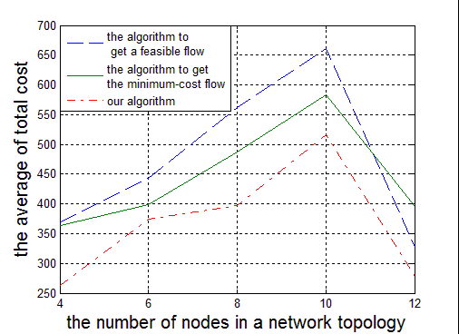
Fig. 6. Average total costs of the 3 algorithms in various network topologies
Figure 6 shows that in all network topologies tested, the average total costs of the paths generated by our algorithm were notably less than those of the paths generated by the other 2 algorithms. Our algorithm’s average total cost was 365.58, the feasible flow algorithm’s was 472.36, and the minimum-cost flow algorithm’s was 445.72. Our algorithm reduced the total cost of the generated paths by 17.98% compared to the minimum-cost flow algorithm, and by 22.61% compared with the feasible-flow algorithm.

Conclusion
Distributed routing and SDN have their own advantages in finding a path to transmit data. The paper Central Control Over Distributed Routing^{[13]} proposed the Fibbing architecture to combine the advantages of distributed routing and SDN. However, the paper examined the 2 key steps of the process separately and discussed the algorithms and optimizations of only the second step—to add fake nodes and reduce the number of the fake nodes for a generated path. Therefore, we considered the 2 key steps together to design an algorithm for a Fibbing network to determine the best path to transmit data.
This paper introduces our algorithm in detail. The proposed algorithm can choose better paths in the first key step: computing a path according to the network topology and the network request. We also present the results of our experiment and show that our algorithm can markedly reduce the number of fake nodes and the total cost of the path.

