

**3rd NATIONAL CONFERENCE**

**ON EARTHQUAKE ENGINEERING - NEPAL**

**6th MAGH 2079, BHAKTAPUR, NEPAL**

Effect of Soil-Structure Interaction on Performance of Sliding Low-Cost Base Isolators

Nabin Kalauni1, Dipesh Banjade2, and Dr. Kshitij C. Shrestha3

1Pulchowk Campus, [075bce083.nabin@pcampus.edu.np](mailto:075bce083.nabin@pcampus.edu.np)

2Pulchowk Campus, [075bce053.dipesh@pcampus.edu.np](mailto:075bce053.dipesh@pcampus.edu.np)

3Pulchowk Campus, [kshitij.shrestha@pcampus.edu.np](mailto:kshitij.shrestha@pcampus.edu.np)

**Keywords:** *Sliding base isolation; Pure-friction (PF); Soil-structure interaction (SSI); Inter-story Drift Ratio (IDR); Peak Sliding Displacement (PSD)*

# Introduction

Base isolation has developed as an effective solution to minimize structural damage under severe seismic excitations. Elastomeric isolators, in particular, have been studied extensively in the past. However, their high cost and bulkiness make them unsuitable for rural masonry buildings (Hu et al., 2022). Sliding base isolators of the pure-friction (PF) type have emerged as a viable alternative since they adopt a cheap light-weight sliding interface between the superstructure and foundation (Nanda et al., 2016). They have also been shown to perform well over a wide range of earthquake frequencies and provide a high degree of acceleration isolation(Jangid, 2005).

Soil-structure interaction (SSI), the interaction between dynamic ground motion and structural motion, generally increases the period of the structure and hence are often ignored in structural analysis. However, it is well-documented that SSI could have significant effects on low-rise buildings on soft soils(Spyrakos et al., 2009). Since PF base isolation is mostly geared towards low-rise rural buildings, there is a need for a detailed study of SSI on PF base isolation. Moreover, most studies on SSI involve finite element analyses of massive grids, so they are too computationally involved to carry out a detailed parametric study. Hence, in this paper, we aim to present a simple, continuous, analytical model and conduct a parametric study of the effect of SSI on PF isolators over a wide range of near-fault and far-fault records.

Since the Coulomb’s dry friction model involves two sets of equations for sliding and non-sliding phase Eq.*(2)*, we approximated it with the arctangent approximation to obtain a continuous model Eq.*(3)* (Leine and Nijmeijer, 2006).

(1)

Where the actual discontinuous model is:

(2)

The smooth arctangent approximation gives:

(3)

A 4-DOF structural model was developed as shown in Fig. 1. The equations of motion were derived using Lagrangian mechanics and solved using the Backward Differentiation Formula (BDF). The system was solved for 20 earthquake records, 10 near-fault and 10 far-fault, all of them scaled to 10 PGAs from 0.1g to 1.0g. The response variables of interest were chosen to be Inter-story Drift Ratio (IDR) and Peak Sliding Displacement (PSD) since they are critical in the design of sliding base isolation.

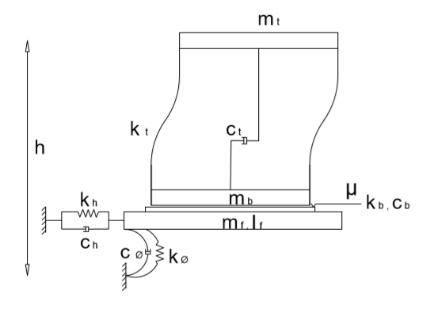

**Fig. 1** Analytical model of base-isolated structure including soil impedance

The parametric plot of PSD in different PGAs, both with and without SSI considerations are shown in Fig. 2. Comparison of IDR in base isolated and fixed base structures for near fault and far fault earthquakes are shown in ***Fig. 3*** and ***Fig. 4***. In order to highlight the role of SSI in IDR, percentage reduction of IDR due to SSI is plotted for all earthquakes in Fig. 5.

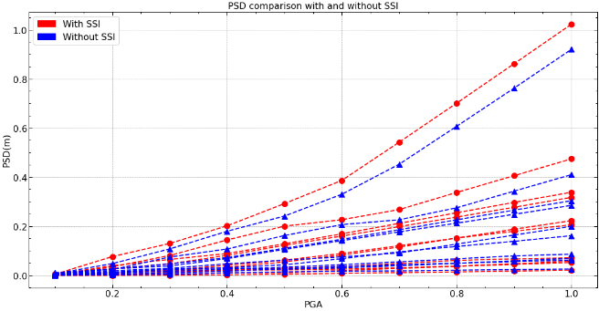

**Fig. 2** Comparison of PSD with and without SSI

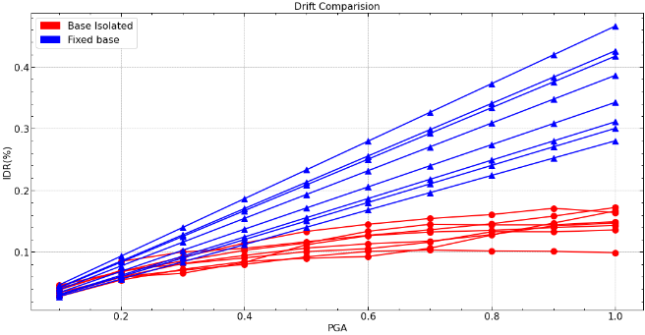

**Fig. 3** Effect of base isolation on IDR in near fault earthquakes

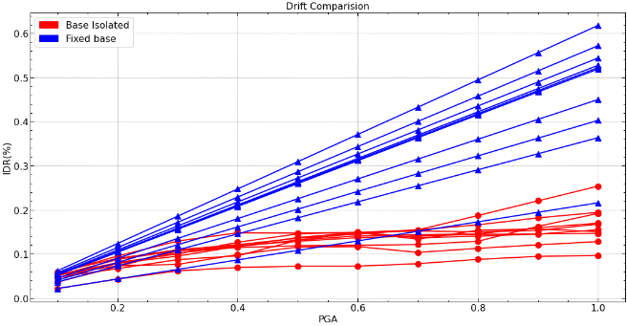

**Fig. 4** Effect of base isolation on IDR in far fault earthquakes

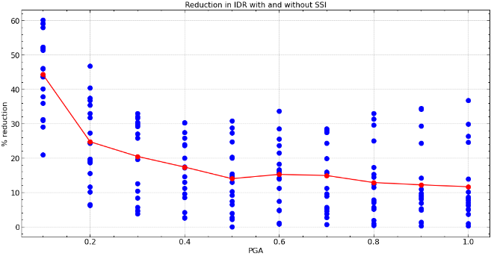

**Fig. 5** Reduction in IDR due to SSI for different PGAs

# Conclusions

After the analysis of system for a wide range of near fault and far fault earthquake we concluded, (1) When SSI is not considered in design the PSD will be underestimated. (2) The % response reduction in IDR due to base isolation is more for far fault earthquakes vs near fault earthquakes. (3) The response of a building considering SSI is not always smaller than that without considering SSI. (4) SSI effects are much more pronounced in short buildings on sot soils. (5) The effect of SSI is greater in lower PGAs as compared to higher PGAs. Hence, it can be concluded that the practice of ignoring SSI because it adds additional damping to structural response is not always justified and it is crucial that SSI is included in the analysis and design of PF isolators.

# References

Hu, H.-S., Lin, F., Xu, L.-W., Gao, Y.-C., Guo, Z.-X., 2022. Peak Sliding Displacements of Sliding Base Structures Subjected to Earthquake Excitation. J. Struct. Eng. 148, 04021286. https://doi.org/10.1061/(ASCE)ST.1943-541X.0003276

Jangid, R. s., 2005. Computational numerical models for seismic response of structures isolated by sliding systems. Struct. Control Health Monit. 12, 117–137. https://doi.org/10.1002/stc.59

Leine, R., Nijmeijer, H., 2006. Dynamics and Bifurcations of Non-Smooth Mechanical Systems. Springer Science & Business Media.

Nanda, R.P., Shrikhande, M., Agarwal, P., 2016. Low-Cost Base-Isolation System for Seismic Protection of Rural Buildings. Pract. Period. Struct. Des. Constr. 21, 04015001. https://doi.org/10.1061/(ASCE)SC.1943-5576.0000254

Spyrakos, C., Maniatakis, C., Koutromanos, I., 2009. Soil–structure interaction effects on base-isolated buildings founded on soil stratum. Eng. Struct. - ENG STRUCT 31, 729–737. https://doi.org/10.1016/j.engstruct.2008.10.012