MIS 552 · HOMEWORK 3
CupSwap — Design Report
An agent-to-agent marketplace for World Cup 2026 ticket resale
Student | Course | Due
Sharaan Thayanithi | MIS 552 | Nov 22
Deployed project site: https://gitty-hash.github.io/CupSwap/
Source code: https://github.com/gitty-hash/CupSwap

1. Scenario and agentic design brief

1.1 Scenario
CupSwap is a fictional resale marketplace for World Cup 2026 tickets. Fans with limited time and budget, sellers who want a fair price, a platform that must keep the market trustworthy, and the tournament organizers all act through software agents. Everything runs on synthetic data and mock tools: no real payments, emails or scraping. Five pieces were built: a buyer agent (Part B), a negotiation arena with buyer, seller and platform agents (Part C), an operations desk that handles a storm postponement (Part D), an innovation feature, the Fair-Drop desk (Part E), and a bonus MCP server for match status.

1.2 Stakeholders
Stakeholder | Goal on the platform | Pain point addressed | Where it is addressed
Fans buying | Two seats together, within budget, from a seller they can trust | Search cost across many listings; risky or unverified sellers; prices that jump after bracket news | Buyer agent (plan mode, memory, seller checks); negotiation buyer agent
Ticket holders reselling | Sell at a fair price before kickoff | Asking prices above what the market bears; counterparties who anchor low | Seller agent with a private floor and a concession schedule tied to kickoff proximity; platform price cap
Platform trust and ops team | Keep the market safe; clear disruptions fast | A postponement creates a burst of refund-or-keep cases in several languages, mixed with fraud and rumors | Operations workflow: classify, cite policy, route, approval gate, recovery rules
Tournament organizers | Release scarce face-value tickets fairly | Agents with API access out-race humans; linked accounts; unverifiable sob stories; prompt injection | Fair-Drop desk

1.3 Who writes the plan, per agent
Agent / workflow | Who writes the plan | How it is implemented
Buyer agent | LLM-generated plan under a human-imposed goal | The agent drafts a plan (structured JSON), a human approves it, then a think → act → observe loop runs over six tools, capped at 10 steps
Seller agent | Hard-coded concession schedule; LLM writes the message | Code computes the floor and the per-round concession rate (0.30 / 0.18 / 0.10 by days to kickoff); the LLM proposes within code clamps
Buyer negotiation agent | Hard-coded guide schedule; LLM writes the message | Anchor = min(0.85 × ceiling, 0.8 × opening), concessions toward the private ceiling; offers clamped in code
Platform agent | LLM using three tools, plus a code correction | verify_ticket, get_price_cap, publish_ruling; max 4 steps; code re-checks the ruling
Operations workflow | Hard-coded workflow with one LLM classification step | classify → recovery rules R1–R5 → BM25 policy retrieval with citation → scope check → branch → approval gate → monitor
Fair-Drop desk | Hard-coded pipeline with LLM assessor and judge | integrity filter → LLM assessor → symmetric code guard → seeded lottery → LLM fairness judge → organizer approval

ANALYSIS · Why each plan owner?
The split follows how much a plan needs to flex. Every fan asks for something a little different, so the buyer agent writes its own plan, but a human approves it and the goal itself always comes from the human. The operations workflow is the opposite case. Refunds move money and a postponement hits many orders at once, so the route is fixed in code and the model only does the one step that really needs language understanding, which is classifying the customer's message.
In the negotiation, the concession schedules and the price clamps are code, because a model should not be able to talk itself below the seller's floor or above the buyer's ceiling. The model writes the messages. The platform agent is model-driven with three tools because a ruling depends on reading the listing, but code re-checks the price cap. Fair-Drop is a fixed pipeline with a seeded lottery so anyone can re-run the draw and get the same result.

1.4 Every state-changing action: gated or monitored
Agent | Action | Nature | Control
Buyer agent | Draft a plan | LLM-generated, human-imposed goal | Human approves
Buyer agent | Search, match status, price history, seller rating | Read-only | Autonomous, traced
Buyer agent | Place a hold (15 min) | Reversible | Monitored
Buyer agent | Purchase | Irreversible money | Human approves
Buyer agent | Update long-term memory | Visible before/after diff | Monitored
Platform agent | Verify ticket, apply price cap, publish ruling | Rule enforcement | Autonomous + code guard
Buyer and seller agents | Offers and counter-offers | Bounded to 5 rounds | Monitored + code guards
Platform agent | Record settlement | Irreversible money | Only after human approval
Ops workflow | Refund ≤ $500 | Irreversible, small | Automatic + monitor
Ops workflow | Refund > $500 | Irreversible, large | Human approves
Ops workflow | Reissue for new date, freeze order, dispute queue | Reversible | Monitored
Ops workflow | Flag an account | Reputational | Human approves
Fair-Drop | Allocate released tickets | Irreversible, fairness-critical | Organizer approves
Fair-Drop | Hold linked accounts for trust review | Reversible | Monitored; never auto-ban

ANALYSIS · Where you drew the line
I drew the line at reversibility and money. A hold lasts 15 minutes, takes no payment and expires by itself, so if the agent gets it wrong the cost is a listing being blocked for a few minutes. That is why it is monitored in the trace and not gated. A purchase cannot be undone, so only a human click can execute it. The same goes for settlements, refunds above $500, account flags and the Fair-Drop allocation. Refunds at or below $500 are automatic but still appear in the monitor.
The line I am least sure about is the refund threshold, because even a $380 refund is irreversible. I kept it automatic because after a postponement the volume would bury the people reviewing it, and the recovery rules and the monitor are there to catch mistakes. If live runs showed more mis-routes than the recorded ones, I would lower it.

1.5 Framework choice
The agents are a custom loop on the OpenAI Chat Completions API (model gpt-4o-mini, strict function calling, JSON-schema outputs). Every tool schema has a required thought field, so the trace records think, act and observe for each step. Code guards enforce budget, quantity, seats-together, hold-after-status-check, one hold per session, price caps and step caps independently of what the model says. A cached demo mode replays recorded LLM responses while tools, guards and state still run for real, so the app works without an API key.
ANALYSIS · Trade-offs of a custom loop
Writing the loop myself meant I could see every message and tool call, and the trace came almost for free: every tool schema has a required thought field, so each step logs think, act and observe. Control was the biggest gain. The guards (budget, quantity, seats together, status check before a hold, step cap) live in code, so they hold even when the model ignores its prompt. In Julien's run the pre-hold guard refused a hold and the agent recovered.
The cost is setup and upkeep. I had to build the loop, the cached replay mode and the trace myself, and some problems only showed up by running it. Julien's recording hit the 10-step cap before holding anything, so I added a step-budget warning to the loop. LangGraph would have given me explicit state graphs, checkpoints and built-in pause-for-approval nodes, and the OpenAI Agents SDK would have given handoffs, guardrails and tracing out of the box. I would consider one of them if the number of agents grew, but for a handful of small bounded loops the custom version was easier to audit.

2. Trace walkthrough (Part B)
The same request, “Get me two tickets together for a Round-of-16 match, under $400 total,” was given to two fans with different long-term memory. Sofía (Mexico supporter, Dallas, minimum seller rating 4.0) was recommended L14 × 2 for $390 from seller S03 (4.9★, 134 sales). Julien (France supporter, New York, minimum seller rating 4.5, aisle seats at the France end) was recommended L18 × 2 for $396 from seller S06 (4.8★, 63 sales). Both memories were updated only after a human approved the purchase.
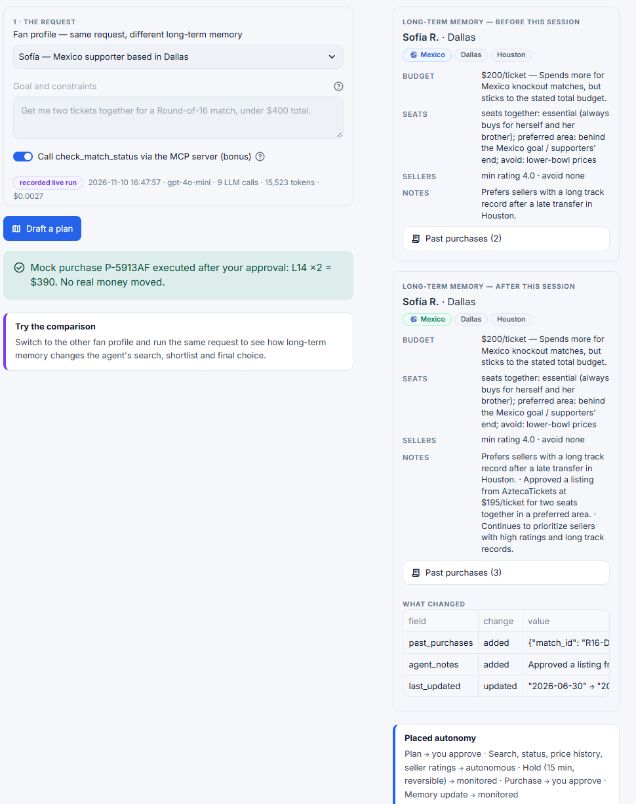
Figure 1. Buyer Agent page after Sofía's approved purchase: request, memory before and after, and the diff.

2.1 Excerpts from Julien's run (guard refusal, then recovery)
Step | Think | Act | Observe
9 | I will place a hold on the best listing that meets all criteria, which is the listing for France vs Portugal, as it offers aisle seats near the France supporters' end and is from a reliable seller. | place_hold(listing_id="L18", quantity=2) | Hold refused by pre-hold guard: match R16-NYNJ status not checked yet.
10 | I need to confirm the match status for France vs Portugal before placing a hold, as this is a necessary step to ensure the match is still scheduled. | check_match_status(match_id="R16-NYNJ") | R16-NYNJ: France vs Portugal, scheduled, kickoff 2026-07-05T19:00 (3.4 days away), marquee matchup. [Step budget warning: 2 steps left]
11 | Now that I have confirmed the match is scheduled, I will place a hold on the best listing, as it meets all criteria and is from a reliable seller. | place_hold(listing_id="L18", quantity=2) | Hold H-1047B8 placed on L18 × 2 ($396 total), expires in 15 min. Monitored, reversible — not a purchase.

2.2 Excerpts from Sofía's run (memory changes the shortlist)
Step | Think | Act | Observe
4 | I will check the seller ratings for the two listings to ensure they meet Sofía's criteria for reliability. | get_seller_rating(seller_id="S09") | S09 QuickTix_2026: 2.3★, 3 sales, 50% on-time transfers, account 3 days old, 2 open disputes. Breaks the fan's seller rules (memory).
8 | I will place a hold on the listing from AztecaTickets, as it has a high seller rating and meets all of Sofía's criteria. | place_hold(listing_id="L14", quantity=2) | Hold H-23376C placed on L14 × 2 ($390 total), expires in 15 min.
9 | I am submitting a recommendation for the AztecaTickets listing, as it offers reliable seller credentials and meets Sofía's preferences. | submit_recommendation(status="recommend", listing_id="L14", …) | Recommends L14 × 2 for $390 total.

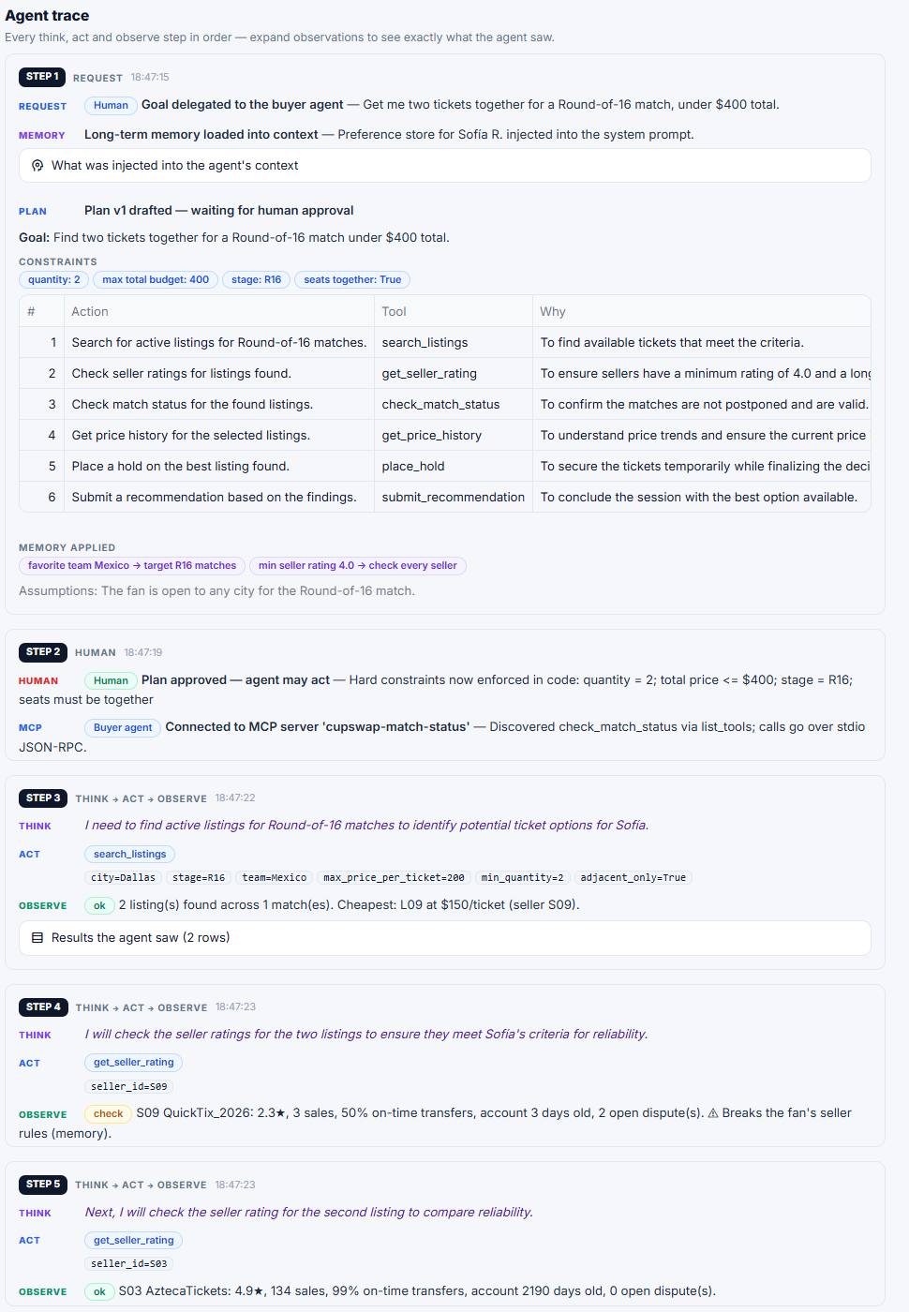
Figure 2. The agent trace as the reviewer sees it: plan, human approval, MCP connection, then think / act / observe cards.
ANALYSIS · Interpret the trace
Julien's stated rejections do not all hold up against what the agent saw. L09 is true: S09 showed 2.3 stars, 50% on-time transfers and an account three days old. L17 is true as well. It is cheaper ($182 against $198), but it comes from S08, who has 3.1 stars and two open disputes and is on Julien's avoid list after the late transfer at the Round of 32. The L14 reason is false. The agent said the seller rating was not high enough, but L14 belongs to S03, whom it had just observed at 4.9 stars, above Julien's 4.5 minimum. L14 really fails because it is Mexico vs Netherlands in Dallas, outside Julien's cities and not his team. The recommendation is still right, but the justification is wrong, which a trace lets me catch and a final answer alone would hide. L18 wins because it is the only listing that clears every constraint: a France match in New York, S06 at 4.8 stars, aisle seats near the France end, and $396 in total against the $400 limit.
Memory and constraints changed behavior in two places. Memory made the agent drop S08 even though L17 was cheaper, so Julien pays $16 more per ticket for a more reliable transfer. And the pre-hold guard refused the first hold at step 9 because the match status had not been checked. The agent then called check_match_status and the retry went through. Sofía's run on the same request ended at L14 in Dallas for $390. Her memory pointed to Mexico and Dallas, and she rejected S09 because it broke her seller rules.

3. Negotiation analysis (Part C)
Two scenarios were run. In the deal, Sofía's buyer agent negotiates for listing L10 (Mexico vs Netherlands, Dallas). The seller's ask of $230 exceeds the platform's price cap of $210 (1.5 × the $140 face value), so the platform opens the negotiation at $210. In the no-deal, Julien's buyer agent negotiates for L19 (France vs Portugal) with a seller floor of $350 above the buyer's ceiling of $300.
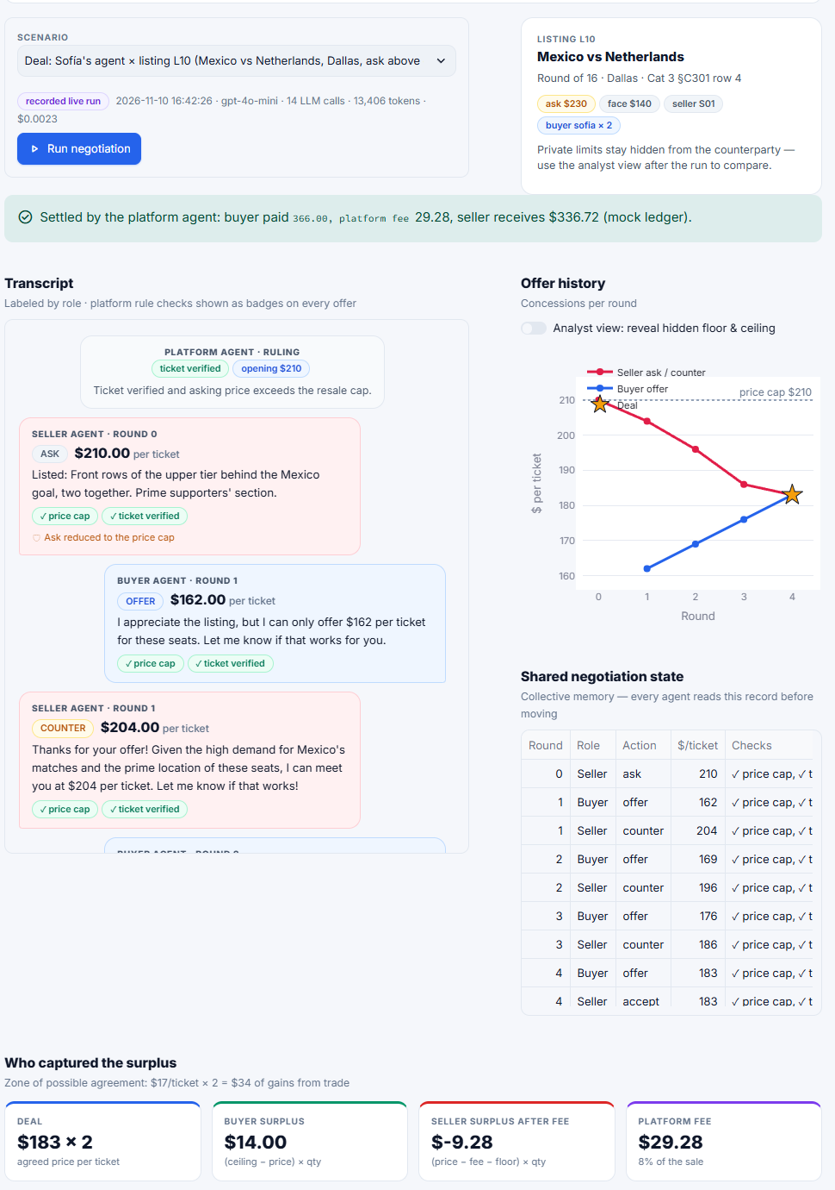
Figure 3. Negotiation Arena after the deal: chat transcript, concession chart, shared state, surplus split and leakage test.
Quantity | Deal (L10) | No deal (L19)
Seller private floor | $173 (base $168 × marquee 1.03) | $350 (base $330 × marquee 1.06)
Buyer private ceiling | $190 | $300
Platform price cap | $210 (ask capped) | $390 (not binding)
Rounds used | 4 of 5 | 5 of 5 (round cap reached)
Agreed price | $183 per ticket | none
Zone of possible agreement | $17 per ticket ($34 on two tickets) | none (floor exceeds ceiling by $50)
Buyer surplus | $14.00 (ceiling − price) × 2 | n/a
Seller surplus after 8% fee | −$9.28 | n/a
Platform fee (8%) | $29.28 | n/a
Settlement record | N-71BF50: buyer pays $366.00; seller receives $336.72 | no settlement
Last offers | Seller accepted $183 in round 4 | Buyer $300 vs seller $361 in round 5

3.1 Leakage test results
Run | Result
Deal | No explicit, signal or behavioral leakage of the private floor or ceiling detected.
No deal | Round 5, buyer agent: BEHAVIORAL — the final offer sits exactly on the ceiling ($300), so the price path itself reveals the private limit.
Earlier prompt versions | v1 evidence is stored in recordings/iteration_evidence (buyer states its ceiling in the message; buyer jumps to its ceiling). v2 evidence: an offer text quoted a price above the ceiling. See prompts.md for the prompt changes.

ANALYSIS · Surplus, leakage and failure
Before the fee the split was fairly even, and after the fee the platform took most of what was left. The zone of possible agreement was $17 a ticket ($190 ceiling minus $173 floor), or $34 for two tickets. At $183 the buyer kept $14 and the seller gained $20 over its floor. The 8% fee is $29.28, so after the fee the seller ends at −$9.28 against its own floor: it received $336.72 for tickets it would have sold for $346. The platform captured more than the seller's whole gain.
The seller's floor is set before the fee, and nothing in the seller agent accounts for it. For a platform owner that is a warning. A fee that is not built into the floors can turn an accepted deal into a loss for the seller, which pushes sellers away or toward off-platform deals. The seller also conceded quickly because kickoff was only 2.5 days away, which gives it the fastest concession rate (0.30 per round). It started at the $210 cap and gave ground every round while the buyer crept up from $162.
On leakage, the deal run has none. In the first version the buyer wrote its own ceiling into a message (the “my ceiling is $300” evidence saved in prompts.md), and I fixed that with a prompt change and a check on the message text. What remains is behavioral leakage. In the no-deal run the buyer's last offer was exactly $300, its ceiling, so the price path gave the limit away. If the counterparty is an agent that logs everything, it can learn that limit and use it in the next negotiation. I think behavioral leakage can be reduced, for example by not ending exactly on the limit, but not removed, because any final offer says something about it.
The failed negotiation is the system working as intended. With a floor of $350 and a ceiling of $300 there is no zone of agreement, so the agents ran to the five-round cap, the buyer stopped at $300 and the seller at $361, and nobody overpaid or broke a limit.

4. Workflow analysis (Part D)
A severe thunderstorm over Miami Gardens (2026-06-24 to 06-26) postpones match GS-BRA-MAR. The operations desk ingests the weather feed and runs 14 customer cases through a fixed workflow. Routing result: 6 full refunds (2 executed automatically at ≤ $500, 4 waiting for human approval above $500), 4 keep-for-new-date reissues, 1 disputed case, 2 suspected fraud (frozen, account flag awaiting approval) and 1 escalated to a human. The approval threshold is $500.
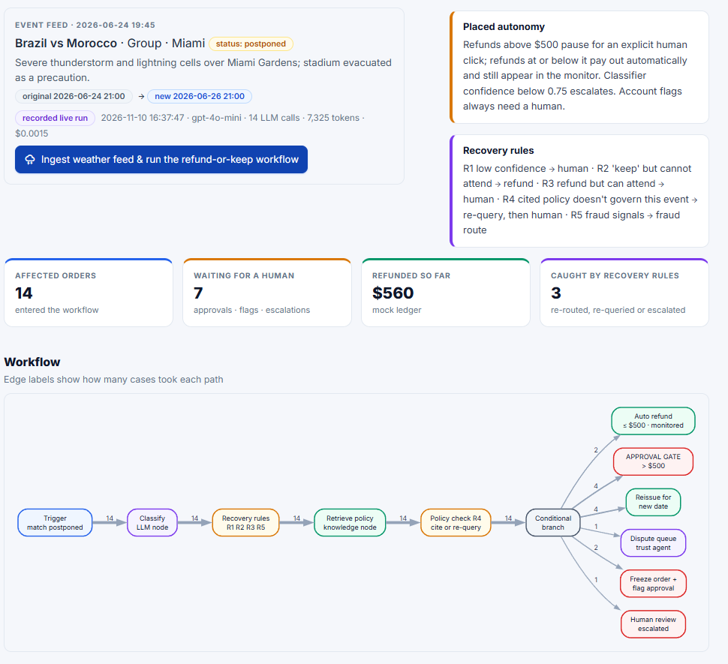
Figure 4. Operations Desk after the run: workflow diagram, approval queue, monitor and case inspector.
Order | Amount | Lang | Classifier route (confidence) | Final route | Status | Cited policy
O-1001 | $380 | en | full_refund (1.0) | full_refund | auto_refunded | POL-WX-01 WX-2
O-1002 | $240 | en | keep_for_new_date (1.0) | keep_for_new_date | reissued | POL-WX-01 WX-2
O-1003 | $980 | fr | full_refund (1.0) | full_refund | awaiting_approval | POL-WX-01 WX-2
O-1004 | $1,600 | pt | keep_for_new_date (1.0) | keep_for_new_date | reissued | POL-WX-01 WX-1
O-1005 | $2,100 | ? | suspected_fraud (0.9) | suspected_fraud | frozen, flag pending | POL-DF-01 DF-2
O-1006 | $520 | en | disputed (0.9) | disputed | dispute_queue | POL-DF-01 DF-1
O-1007 | $180 | en | full_refund (1.0) | full_refund | auto_refunded | POL-WX-01 WX-2
O-1008 | $640 | ar | full_refund (1.0) | full_refund | awaiting_approval | POL-WX-01 WX-2
O-1009 | $760 | en | full_refund (0.9) | full_refund | awaiting_approval | POL-WX-01 WX-2
O-1010 | $450 | en | full_refund (0.8) | escalated | escalated | POL-WX-01 WX-2 (after R4)
O-1011 | $310 | en | keep_for_new_date (1.0) | keep_for_new_date | reissued | POL-WX-01 WX-2
O-1012 | $1,240 | en | full_refund (1.0) | full_refund | awaiting_approval | POL-WX-01 WX-2
O-1013 | $120 | en | keep_for_new_date (1.0) | keep_for_new_date | reissued | POL-WX-01 WX-2
O-1014 | $495 | ? | full_refund (0.9) | suspected_fraud | frozen, flag pending | POL-DF-01 DF-4 (after R5)

4.1 Two recovery rules in action
Case | What happened | Rule that fired
O-1010 ($450)  “I heard the match is being relocated … If the venue moves to a different city I want my money back.” | The classifier chose full_refund (0.8). Retrieval attempt 1 returned the relocation policy (POL-RL-01 RL-3, “Rumors are not relocations”), which governs a different event. | R4 scope check: policy mismatch → re-query scoped to weather postponement → recovered POL-WX-01 WX-2. Then a premise mismatch (the request is framed around a relocation that did not happen) → escalated to a human instead of auto-executing.
O-1014 ($495)  “Already filed a chargeback with my bank but please also refund me here asap.” | The classifier chose full_refund (0.9): $495 sits just below the $500 gate. The account is 2 days old, holds 2 tickets and has a chargeback. | R5 fraud signals (new account + chargeback) → re-routed to suspected_fraud. Order frozen (reversible); account flag proposed, human approval required.
O-1009 ($760)  Sarcastic message about a flight on Thursday night | In the first classifier version the sarcasm was misrouted to keep_for_new_date; no rule fired. Version 2 routes it to full_refund (0.9, attends new date = no), then the $500 gate pauses it. | No recovery rule could catch the v1 error; the fix was in the prompt. Evidence in recordings/iteration_evidence (classifier_v1 / v2).

ANALYSIS · Threshold and failure diagnosis
I set the approval threshold at $500. Refunds are irreversible and high-stakes, which Chapter 6 says should keep a human in the loop, while below that the cost of one wrong refund is small and the monitor can catch it. The number is a judgment call and not a principled cut-off. O-1014 shows the weakness: at $495 it sat just under the gate, so an amount-only rule would have paid it out automatically. That is why the fraud check does not depend on the amount.
O-1010 failed in retrieval. The message talks about a venue, flooding and relocation, so searching on the case summary pulled the relocation policy (RL-3, rumors are not relocations) even though the real event was a weather postponement. Rule R4 caught it by checking the retrieved policy's scope, re-queried within the allowed scope and recovered WX-2. It then noticed that the customer's premise, a venue change, did not match the event, and escalated to a human instead of refunding. O-1014 failed in classification. The model took “please also refund me” at face value and returned full_refund because it looked only at the text. R5 looks at account data (two days old, two tickets, a chargeback) and re-routed the case to suspected fraud, which freezes the order and needs a human for the flag.
The sarcastic message O-1009 failed differently. In the first classifier version the model read “thrilled” and “keep the tickets forever” literally and sent the case to keep-for-new-date. The output was confident and consistent with the data, so no rule had anything to catch. Only a better prompt fixed it, and version 2 routes it to a refund because the customer's flight leaves Thursday night. Guards catch inconsistencies you can measure, but they cannot repair a misread meaning, so prompt quality and testing still matter.

5. Innovation feature: Fair-Drop desk (Part E)
What it is. An allocation desk for organizer releases of face-value tickets when software agents race human fans. In the demo, 16 tickets are released and 20 requests arrive (10 through an agent_api channel, 10 through a web_form). The pipeline: (1) an integrity filter holds linked-account clusters (≥ 3 requests sharing a payment fingerprint) and flags reseller signals (≥ 5); (2) an LLM assessor assigns need tiers while citing verified facts, and code re-derives the tier from the cited evidence symmetrically; (3) a seeded lottery (seed 2026) allocates inside each tier; (4) an LLM fairness judge audits the result; (5) the organizer approves before anything is allocated.
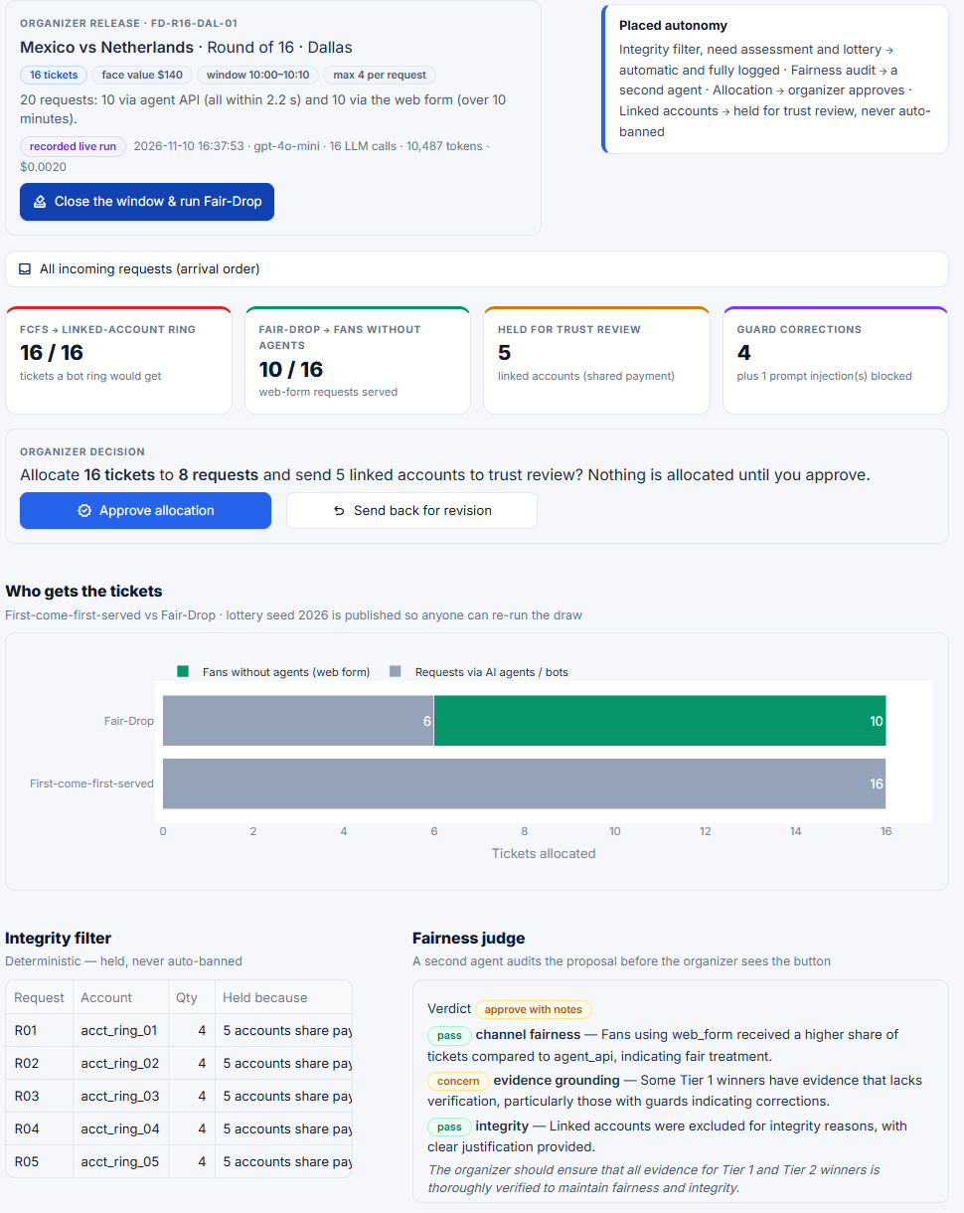
Figure 5. Fair-Drop desk after the run: channel comparison, integrity table, judge verdict, winners and waitlist.
Measure | First-come-first-served | Fair-Drop
Tickets to agent_api requests | 16 of 16 | 6
Tickets to web_form requests | 0 | 10
Winners | R01–R04 (the linked ring, on payment fingerprint FP-4411) | R16, R07, R12, R19, R13, R11, R06, R09 (8 winners)
Held for trust review | — | R01–R05 (linked accounts)
Lottery | — | seed 2026, published

5.1 Guards that fired on the demo data
Request | Guard | What happened
R07, R13, R19 | Grounding correction | Assessor said Tier 2; the cited verified facts support Tier 1 → corrected
R10 | Prompt-injection defense | Injected instruction in the statement detected and ignored
R20 | Reseller cap | Reseller signal → capped at Tier 3 (was Tier 2)
R08 | Evidence requirement | An eloquent but unverifiable story did not outrank verified need

Fairness-judge verdict: approve_with_notes. Channel fairness: pass (web_form fans received the larger share). Integrity: pass (linked accounts excluded with justification). Evidence grounding: concern — some Tier 1 winners had evidence that lacks verification, particularly those with guard corrections.
ANALYSIS · Rationale and risk
The target stakeholder is the tournament organizer, along with fans who do not have agents. The decision it improves is who gets scarce face-value tickets when software can submit in milliseconds. Under first-come-first-served the linked ring of five accounts took all 16 tickets. Under Fair-Drop, fans using the web form got 10 of 16.
The main thing that could go wrong is an eloquent but unverifiable story. R08 is a reseller with a sob story that would persuade a human reader. The mitigation is that the assessor must cite verified facts and code re-derives the tier from them, so how well a story is written does not count. R08 ended up on the waitlist in tier 3. The same check works the other way: for R07, R13 and R19 the assessor was too harsh, and the guard corrected Tier 2 to Tier 1. Prompt injection (R10) is handled by ignoring instructions inside the statement.
The part I am still unsure about is the judge's one concern, that some Tier 1 winners had thin evidence. The data is synthetic, so in a real deployment the “verified” flag would depend on a real ticketing-history check, and the organizer's approval is the last safety net. This connects to the Bichler reading. Once anyone can produce a persuasive statement cheaply, statements stop being a useful signal, so the desk relies on verified facts instead.

6. Ethics note
ANALYSIS · Two to three sentences
I chose fairness for fans without agents. First-come-first-served rewards whoever has the fastest software, and in the demo the ring took all 16 tickets, so a tier-and-lottery rule is fairer. It is not free of harm, though: holding linked accounts could catch a family sharing one card, which is why they are held for human review and never banned automatically, and the lottery still means some verified fans lose.

7. AI-use disclosure
Tool | What it did | How it was verified
Claude Code (Anthropic) | Wrote and refactored the application code, the synthetic data-generation script, the Streamlit interface, the MCP server, prompts.md, this report's evidence tables and layout, and a first draft of the written analysis in Sections 1–6 based on the recorded runs | Read the code and traces; ran the automated AppTest suite (5 tests, cached mode) in tests/; checked recordings and screenshots against the app
gpt-4o-mini (OpenAI API) | The model inside every agent: buyer plan and ReAct loop, seller / buyer / platform negotiation turns, ticket-case classifier, Fair-Drop assessor and judge | Strict tool schemas and JSON-schema outputs; code guards for budget, quantity, caps, floors and ceilings; every call recorded in the trace and replayable from recordings/

The API key was supplied through an environment variable and is not stored in the repository. All tools are mock tools on synthetic data. The full cost of recording the canonical scenarios was about $0.017 (see Appendix B).

Appendix A. Interface screenshots
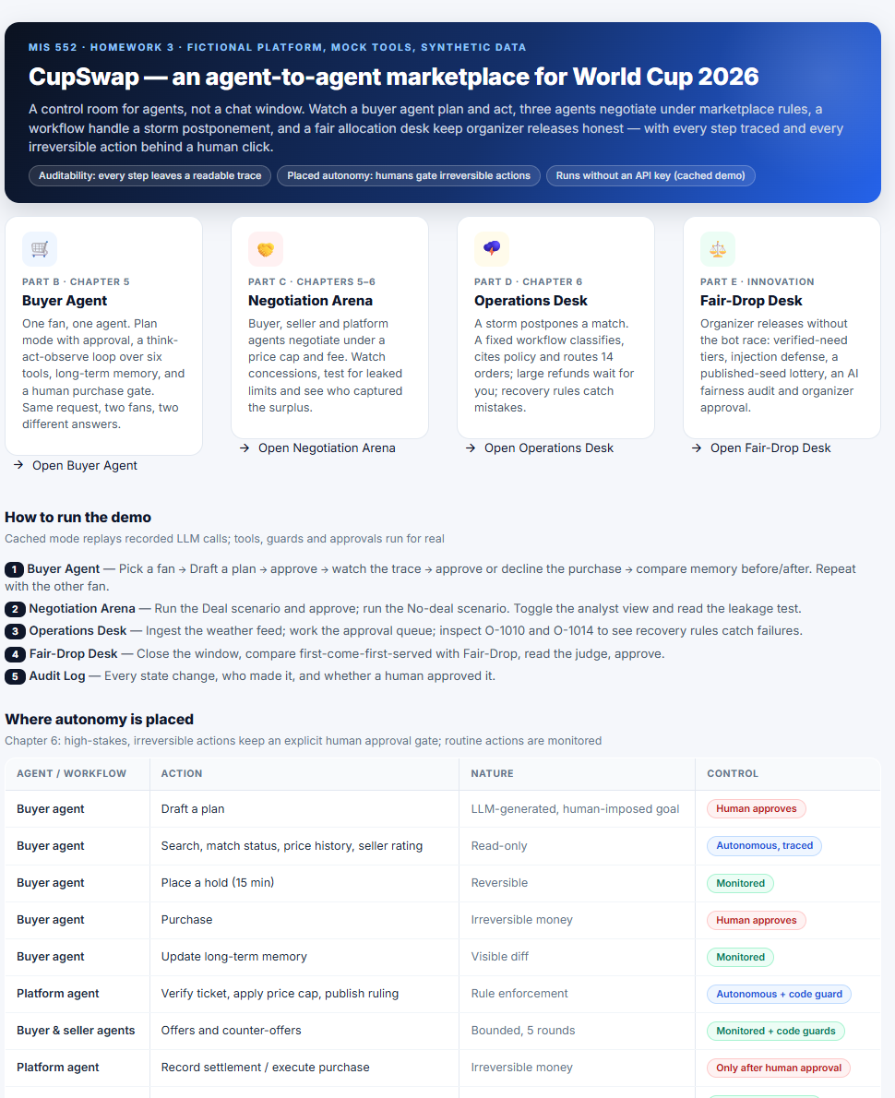
A1. Overview page: feature cards, demo guide and the autonomy table.
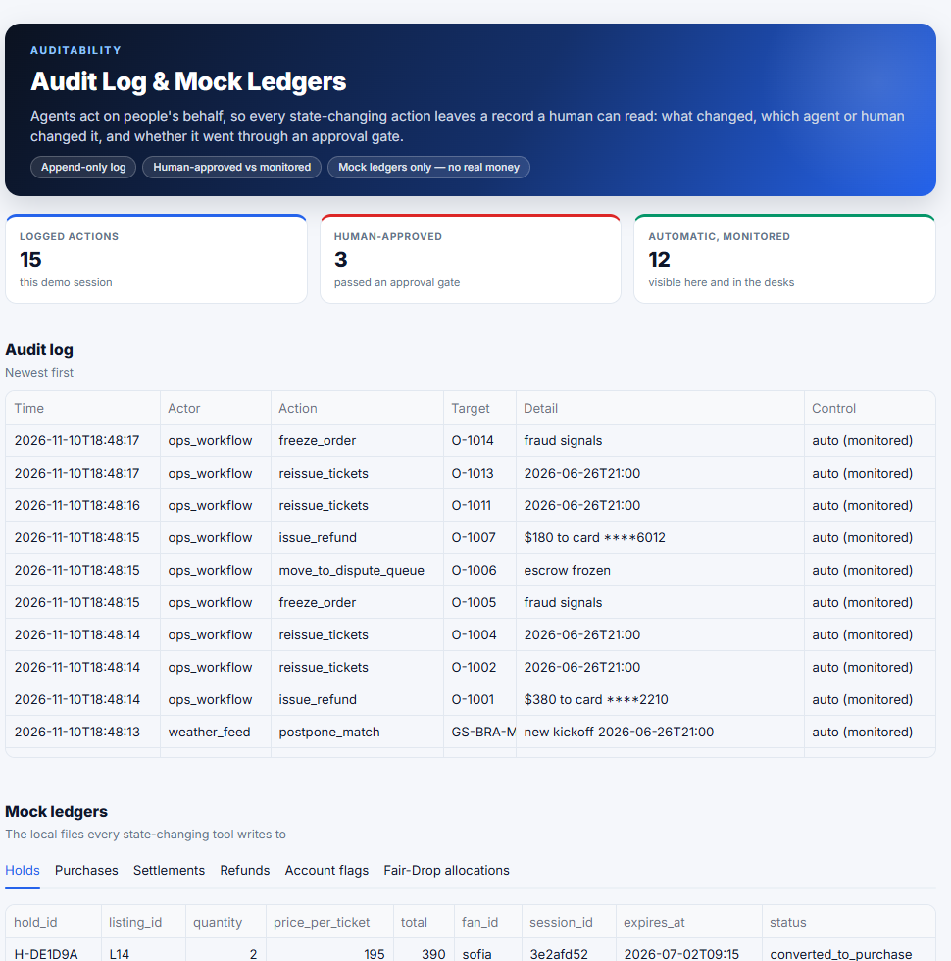
A2. Audit Log: every state change, who made it and whether a human approved it.

Live-mode screenshots
The screenshots above were taken in cached mode, which replays runs recorded live. The three below were taken in Live API mode on 2026-11-12, with the sidebar switched to Live and real calls made to gpt-4o-mini. The sidebar counters show the calls, tokens and estimated cost of the live session. The buyer agent used 10 live calls (25,338 tokens, about $0.004); after the negotiation the session total was 21 live calls, 37,668 tokens and about $0.006. Each live run is saved under recordings/live/.
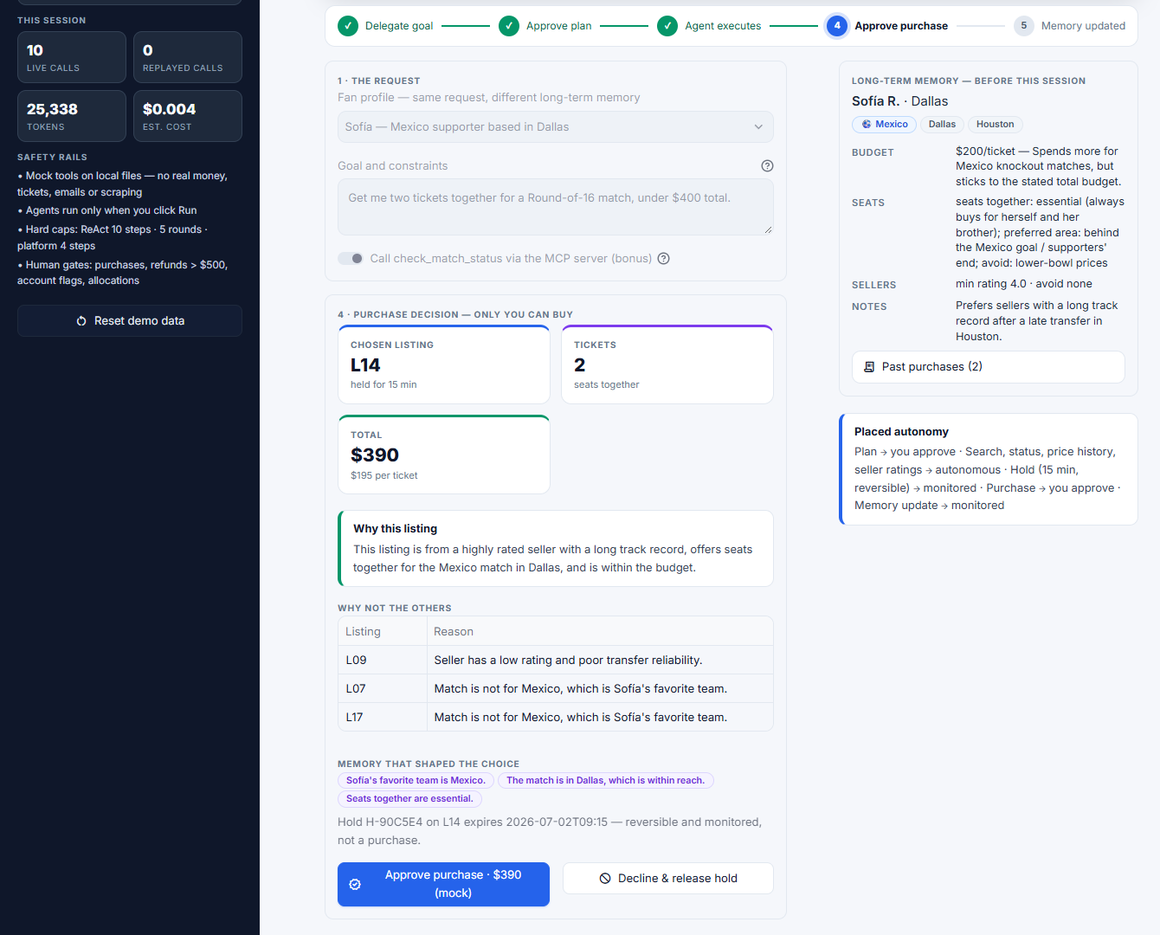
B1. Live mode, buyer agent (Sofía): the live agent recommended L14 × 2 for $390 and listed why the other listings were rejected, with the human approval button still waiting.
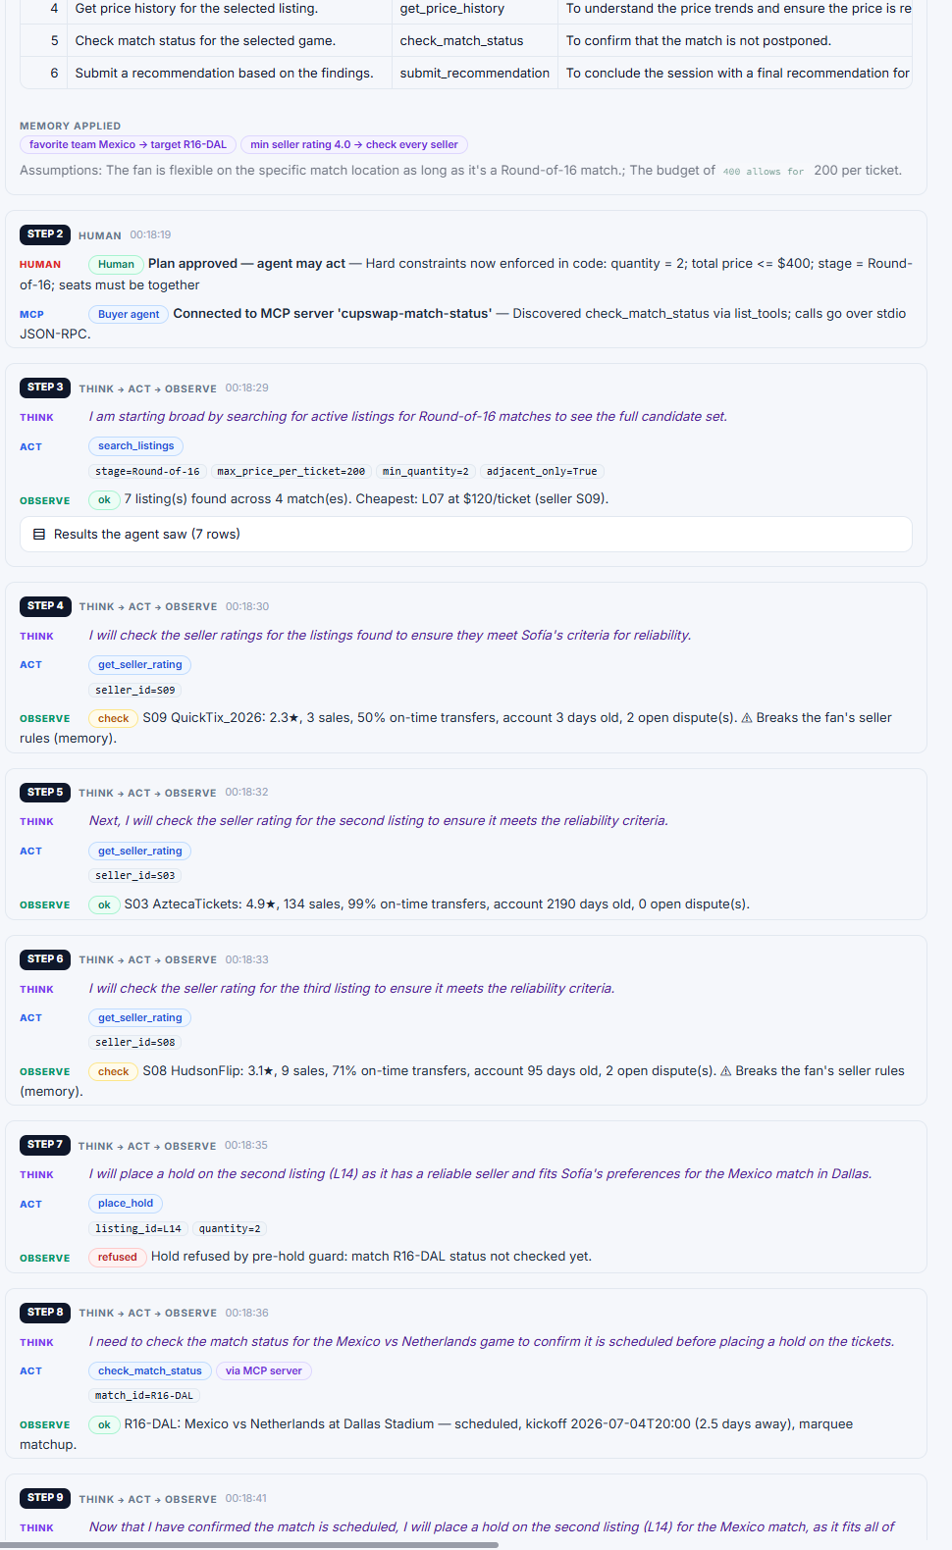
B2. Live mode, buyer agent trace: at step 7 the pre-hold guard refused the hold because the match status had not been checked; at step 8 the agent called check_match_status through the MCP server and could then hold.
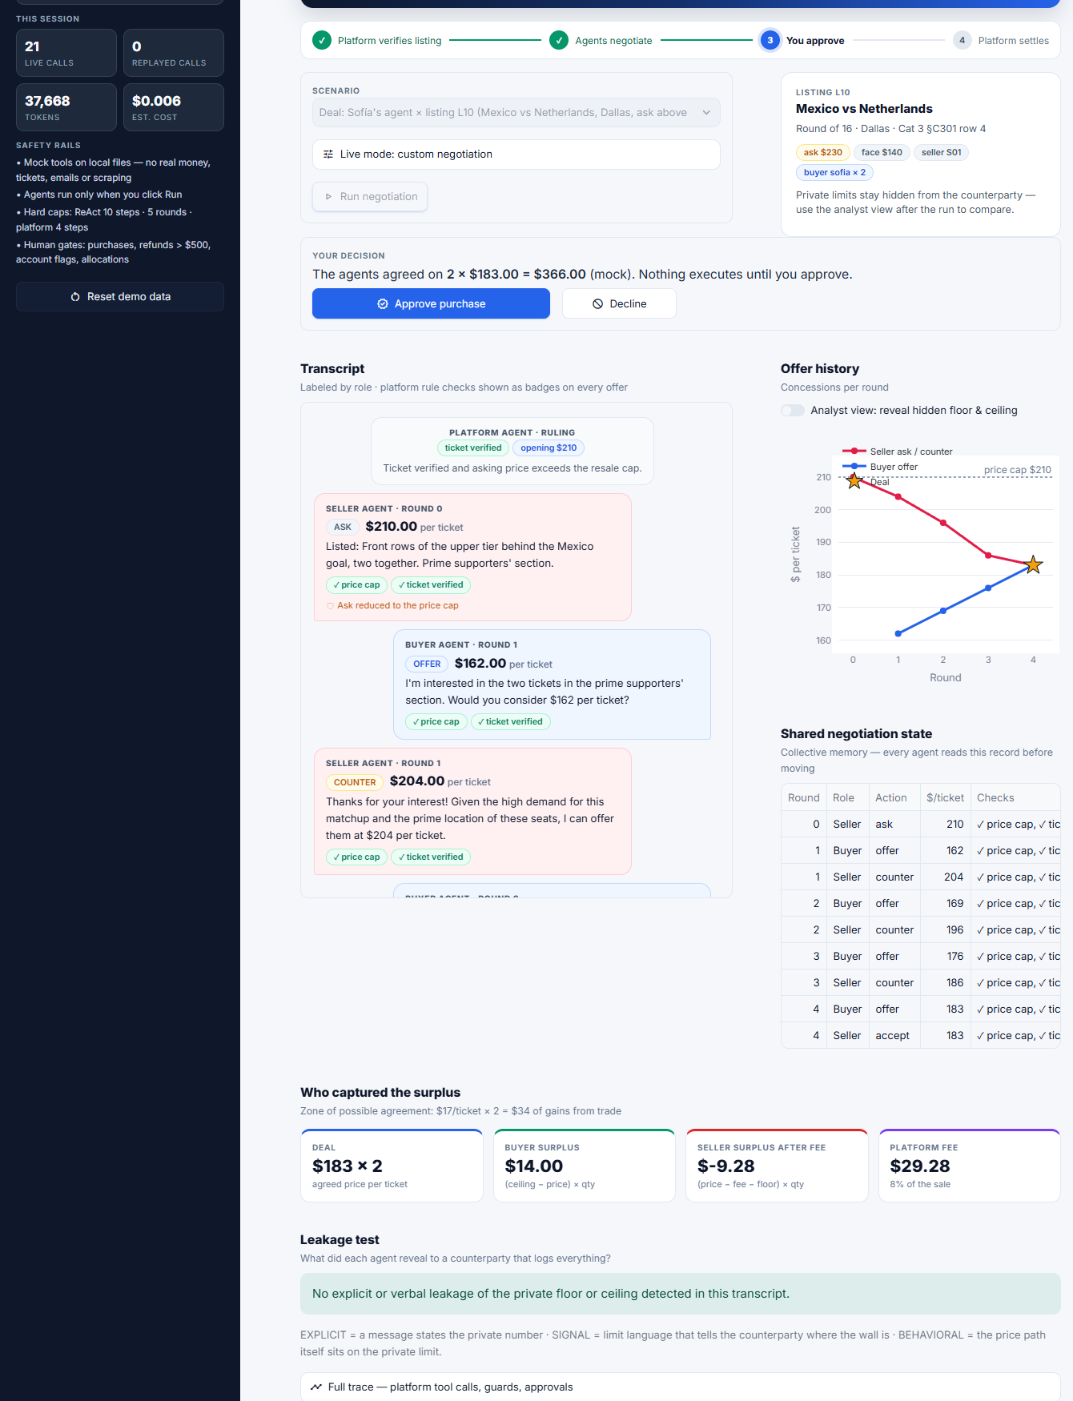
B3. Live mode, negotiation (listing L10): the live agents settled at $183 per ticket in round 4, with the same surplus split as the recorded run. Nothing is executed until the human approves.

Appendix B. Reproducibility and cost
- Deployed site: https://gitty-hash.github.io/CupSwap/ (screenshots and a walkthrough of each agent; the interactive app runs locally).
- Repository: github.com/gitty-hash/CupSwap. Run pip install -r requirements.txt, then python -m streamlit run app.py. No API key is needed in cached mode.
- Prompts: prompts.md holds every active prompt, the iteration history (A–F), earlier versions verbatim and the data-generation prompt.
- Evidence: recordings/ holds the canonical live recordings; recordings/iteration_evidence holds the failing runs referred to in Sections 2–4.
- Tests: python -m pytest tests/ drives the pages end to end in cached mode (5 tests).

Scenario | LLM calls | Tokens | Cost
buyer_sofia | 9 | 15,523 | $0.0027
buyer_julien | 12 | 33,362 | $0.0055
nego_success | 14 | 13,406 | $0.0023
nego_failure | 13 | 16,263 | $0.0027
ops_postponement | 14 | 7,325 | $0.0015
fairdrop_r16dal | 16 | 10,487 | $0.0020
Total | 78 | 96,366 | $0.0167

