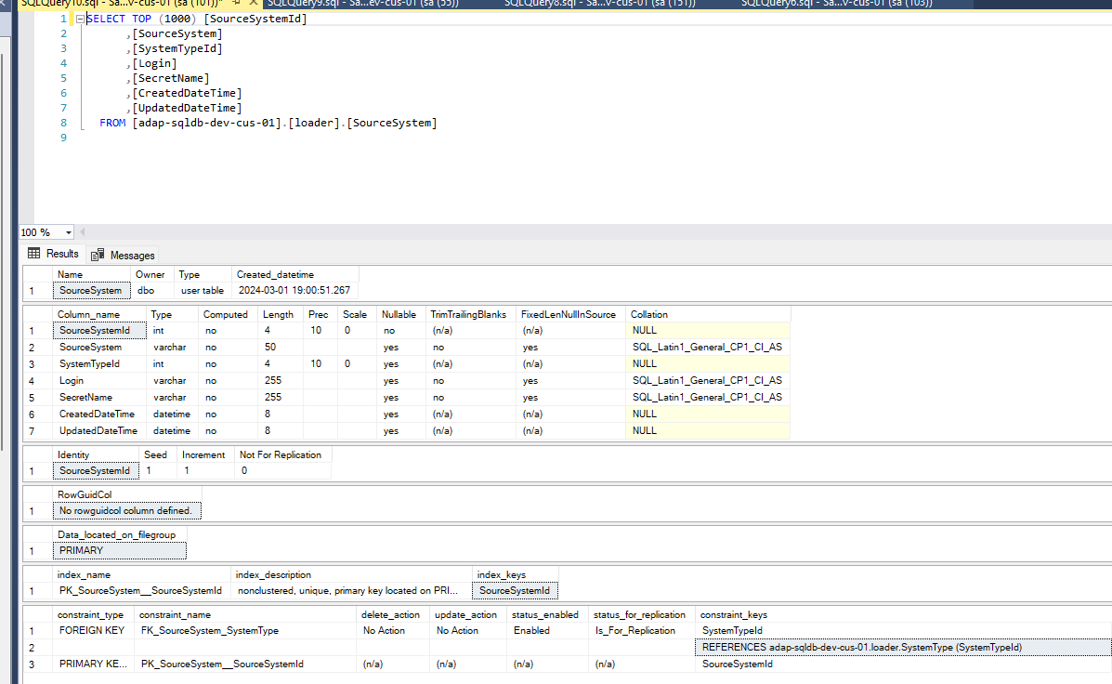
CREATE TABLE [loader].[SourceSystem](
[SourceSystemId] [int] IDENTITY(1,1) NOT NULL,
[SourceSystem] [varchar](50) NULL,
[SystemTypeId] [int] NULL,
[Login] [varchar](255) NULL,
[SecretName] [varchar](255) NULL,
[CreatedDateTime] [datetime] NULL,
[UpdatedDateTime] [datetime] NULL,
CONSTRAINT [PK_SourceSystem__SourceSystemId] PRIMARY KEY NONCLUSTERED
(
[SourceSystemId] ASC
)WITH (PAD_INDEX = OFF, STATISTICS_NORECOMPUTE = OFF, IGNORE_DUP_KEY = OFF, ALLOW_ROW_LOCKS = ON, ALLOW_PAGE_LOCKS = ON, OPTIMIZE_FOR_SEQUENTIAL_KEY = OFF) ON [PRIMARY]
) ON [PRIMARY]
GO
ALTER TABLE [loader].[SourceSystem] WITH CHECK ADD CONSTRAINT [FK_SourceSystem_SystemType] FOREIGN KEY([SystemTypeId])
REFERENCES [loader].[SystemType] ([SystemTypeId])
GO
ALTER TABLE [loader].[SourceSystem] CHECK CONSTRAINT [FK_SourceSystem_SystemType]
GO

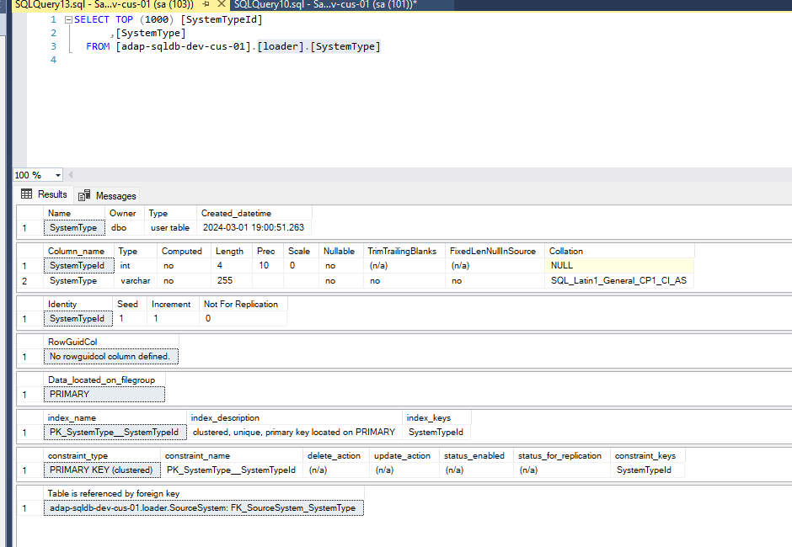
/****** Object: Table [loader].[System Type] Script Date: 11/11/2024 4:25:16 PM ******/
SET ANSI_NULLS ON
GO
SET QUOTED_IDENTIFIER ON
GO
CREATE TABLE [loader].[SystemType](
[SystemTypeId] [int] IDENTITY(1,1) NOT NULL,
[SystemType] [varchar](255) NOT NULL,
CONSTRAINT [PK_SystemType__SystemTypeId] PRIMARY KEY CLUSTERED
(
[SystemTypeId] ASC
)WITH (PAD_INDEX = OFF, STATISTICS_NORECOMPUTE = OFF, IGNORE_DUP_KEY = OFF, ALLOW_ROW_LOCKS = ON, ALLOW_PAGE_LOCKS = ON, OPTIMIZE_FOR_SEQUENTIAL_KEY = OFF) ON [PRIMARY]
) ON [PRIMARY]
GO

