AAVA 3.0 - Generic Flow
Goal: Single page experience. Absolutely simple wiring.

The One-Screen rule
AAVA 3.0 is a single screen. Nothing navigates away, nothing opens in a new page, no routes, no page reloads.
Three arrangements - Start, Conversation, Split. The user moves between them in place. Sidebar, header and composer are present in all three and never move or re-render. Only the area between them changes.
One page whose sections rearrange. Not three pages.
Chat always holds the left. Everything else - task cards, playground, artifacts - comes in on the right. This never flips between arrangements.

Screen A: Start
The first thing Dev sees after login.
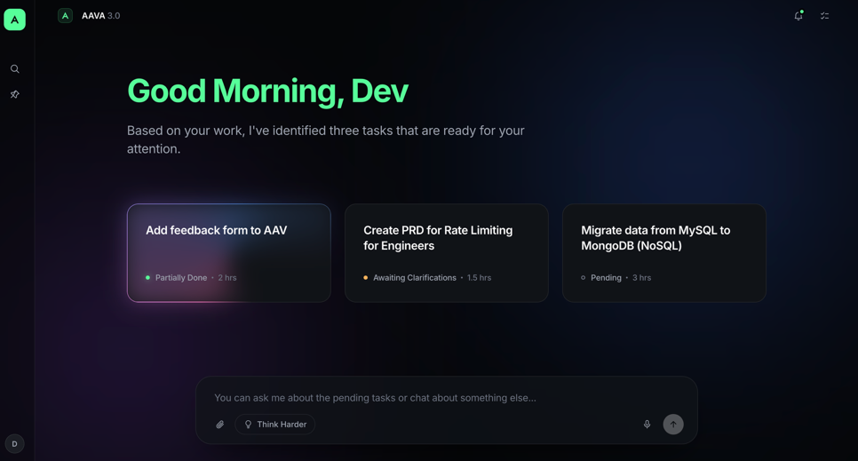
Element | Detail
Sidebar | 70px, ultra minimal. Icons not decided yet. Profile/avatar sits at the bottom.
Header | Left: AAVA 3.0 logo and action bar.  Right: notifications, tasks.  Both contextual - a notification opens wherever it can be acted on; tasks opens the split where task collaboration happens.
Greeting | Good Morning, Dev - hero message
Subtext | Contextual. If there are tasks, it summarizes them. If not, something generic.
Task cards | Exactly three, equal size: title, status, estimate, priority, dependency
Composer | This is the chatbot  Full width of the content column. Attachment, Think Harder, voice, send.

The recommended card
Card 1 needs attention before the other two. It is signaled by an animated aurora border.
- Same size as the others. Do not enlarge it.
- No badge, no star, no label, no different background.
- Pink → purple → blue, rotating slowly, with a soft bloom behind the card.
- The ring is the entire affordance. If a reviewer asks for a badge, the ring has failed and should be fixed, not supplemented.

The fork
Two things a user can do from here:
1. Type into the composer → Flow 1. Ask how the day looks, ask what the tasks are, or ignore the tasks entirely and do something else. Free flow.
2. Pick a task card → Flow 2. Choose a task, collaborate with AAVA, hand it over.
Everything below follows from this fork. Both are one click away; neither is privileged in the layout.

Flow 1 - User types
Trigger: Dev types and sends. Enter sends, Shift+Enter is a line break.
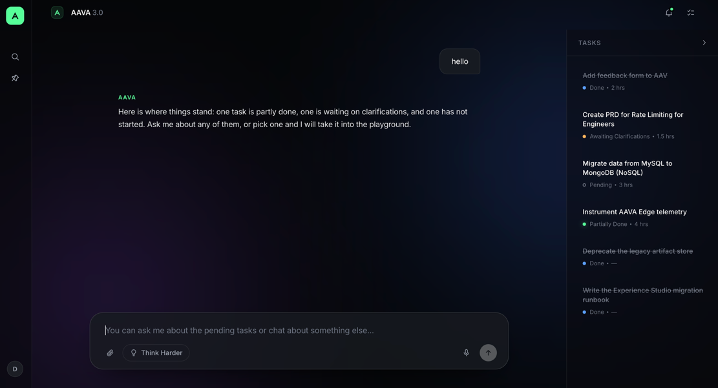
- Greeting and cards clear; the conversation takes their place.
- Chat on the left. Task cards collapse to the right. They don't disappear - they relocate.
- The right panel closes on demand. Tasks remain reachable from the task icon, top right.
- The composer does not move, resize or animate. It is the anchor of the screen.

Reply behavior
- Three-dot typing indicator first, then the text - roughly 600ms. Never instant; the pause is what reads as thinking rather than lookup.
- Smooth scroll to the newest message.
- Long replies break into paragraphs. Only user messages get a container - replies are plain text, no bubbles.
- Chat can produce artifacts. Artifacts open in the right-side view.
- Each chat is a session. Memory is saved and the session can be reopened.

Flow 2 - User picks a task
Three triggers, identical behavior: a task card on Screen A, a row in the task rail, a row in the task window.
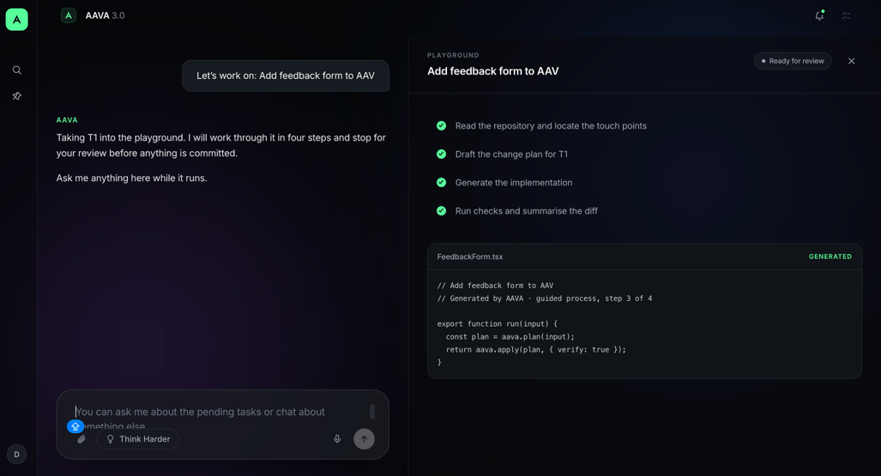
- Left: the conversation about the task.
- Right: the interactive playground.
The playground is a set of standard components that arrange themselves contextually per scenario. Sub-journeys, when we model them, affect this section only - nothing else in the screen changes.
Rules
- While a task is executing, no jumping into another task.
- Each task is also saved as a thread. Reopen it from the sidebar and resume where it was left.
- The playground carries an info rail - context and evidence about the task in hand.

Screen C - Task window
Opens over everything, from the tasks icon in the header.
- Shows tasks as a lean kanban.
- Clicking a task other than the one executing is either blocked, or opens as a separate chat thread. To be decided.

Open calls
# | Question
1 | Clicking another task mid-execution — blocked, or a new thread? (§5)
2 | Sidebar icons — undecided.

