Experiment 3
Dimensional Modeling and Star Schema Design using Microsoft Power BI

Aim
To design and implement a dimensional data model using Microsoft Power BI by transforming transactional data from the Global Superstore dataset into a Star Schema consisting of Fact and Dimension tables for efficient reporting and analytical processing.

Tools / Software Required
- Microsoft Power BI Desktop
- Global Superstore Dataset.xlsx
- Power Query Editor
- DAX (Data Analysis Expressions)
Dataset Source: Global Superstore Dataset (Kaggle) — https://www.kaggle.com/datasets/apoorvaappz/global-super-store-dataset

Theory
Dimensional Modeling is a data warehouse design technique used in Business Intelligence systems to support analytical processing. It organizes data into Fact Tables and Dimension Tables.
Fact Tables contain measurable business events such as Sales, Profit, Quantity, and Discount.
Dimension Tables contain descriptive attributes such as Customer, Product, Region, and Date.
A Star Schema consists of a central Fact Table connected to multiple Dimension Tables. It improves query performance, simplifies reporting, and enhances scalability in BI environments.

Conduct

Part A: Load Dataset
Step 1–2: Open Power BI Desktop and import Global Superstore Dataset.xlsx.
Home > Get Data > Excel Workbook → Select Global Superstore Dataset.xlsx
Step 3: Select the Orders, Returns, and People worksheets.
The Navigator window lists all three worksheets inside the workbook; Orders, People, and Returns are ticked for import, with the Returns preview shown on the right (Returned, Order ID, Region).
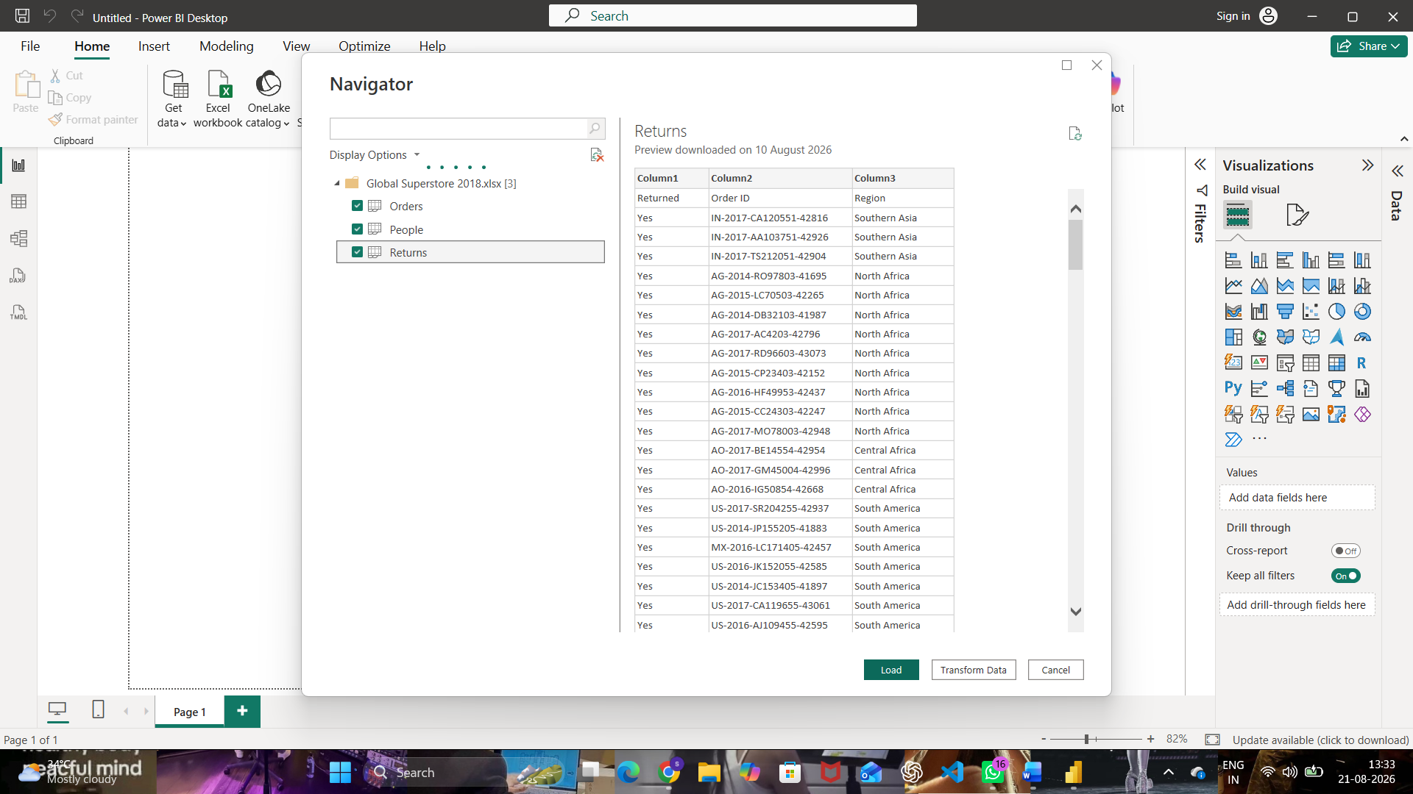
Fig. 1 — Navigator: Orders, People, and Returns worksheets selected for import
Step 4: Click Load and verify the imported tables.
After loading, duplicate references of each table (Orders (2), People (2), Returns (2)) were created in the Queries pane alongside the originals — these duplicates are used as the working copies for building the dimension and fact tables in Part C and Part D, so the original imported tables stay untouched.
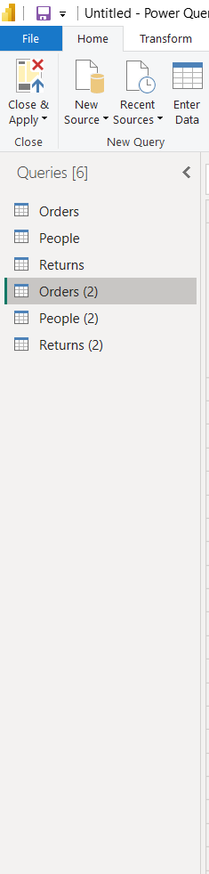
Fig. 2 — Queries pane after Load, showing the original tables plus duplicate references

Part B: Identify Fact and Dimension Tables
Step 5–7: Categorize the source columns.
The Orders table was analyzed to separate measurable business events from descriptive attributes:
- Fact measures: Sales, Profit, Quantity, Discount
- Dimension attributes: Customer (ID, Name, Segment), Product (ID, Name, Category, Sub-Category), Region (City, State, Country, Region), Date (Order Date, Year, Quarter, Month)

Part C: Create Dimension Tables
Step 8: Create Dim_Customer using Customer ID, Customer Name, and Segment.
Home > Choose Columns → keep Customer ID, Customer Name, Segment
Step 12 (duplicate removal) applied here: before deduplication the three selected columns held repeated customer rows (449 distinct Customer IDs out of many more rows, since each customer appears once per order). Running Remove Rows → Remove Duplicates collapses this to one row per customer.
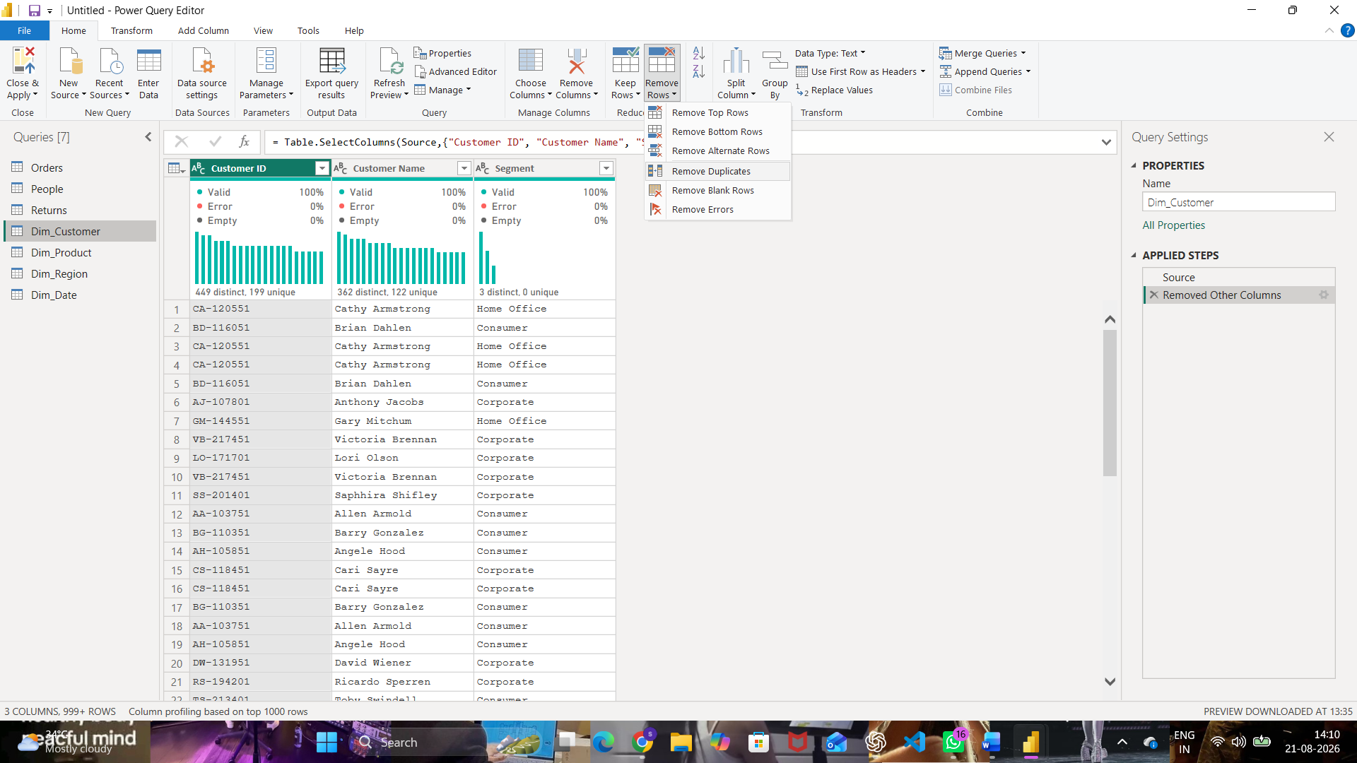
Fig. 3 — Dim_Customer before deduplication — Remove Duplicates being applied
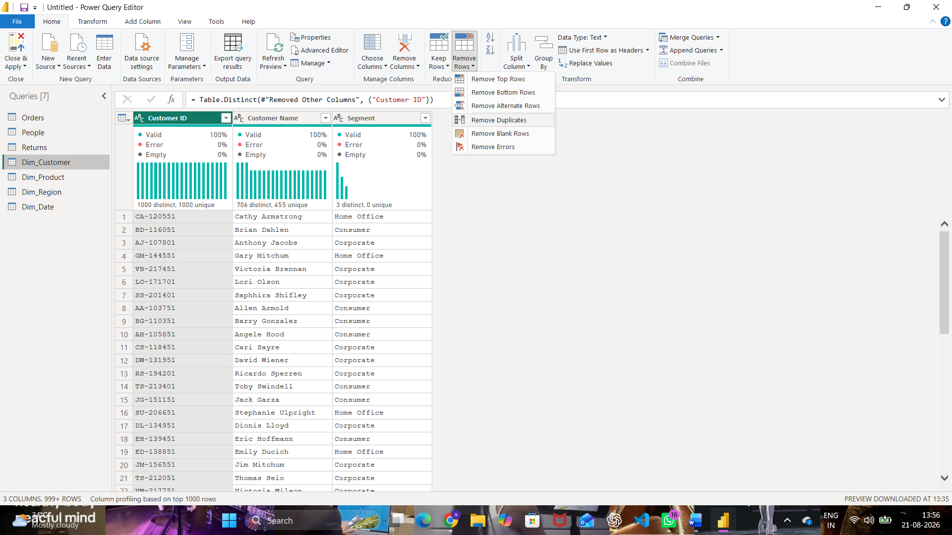
Fig. 4 — Dim_Customer after deduplication — 1,000 distinct / 1,000 unique Customer IDs
Step 9: Create Dim_Product using Product ID, Product Name, Category, and Sub-Category.
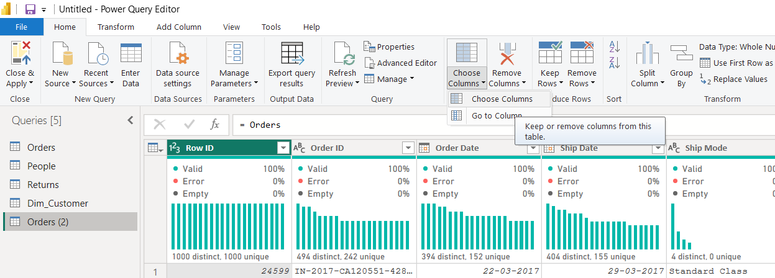
Fig. 5 — Choose Columns command used to build the Dim_Product query
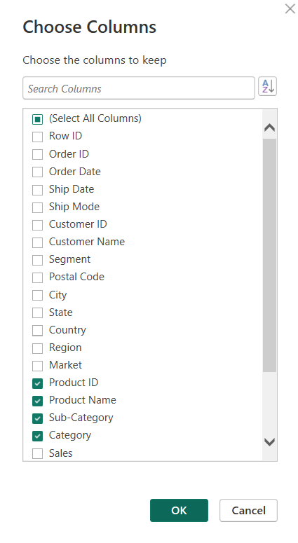
Fig. 6 — Choose Columns dialog — Product ID, Product Name, Sub-Category, and Category kept
Step 10: Create Dim_Region using Region, Country, State, and City.
The City, State, Country, and Region columns were kept from the source table. Before deduplication the preview still shows repeated city rows (e.g. Herat and Kabul appearing multiple times).
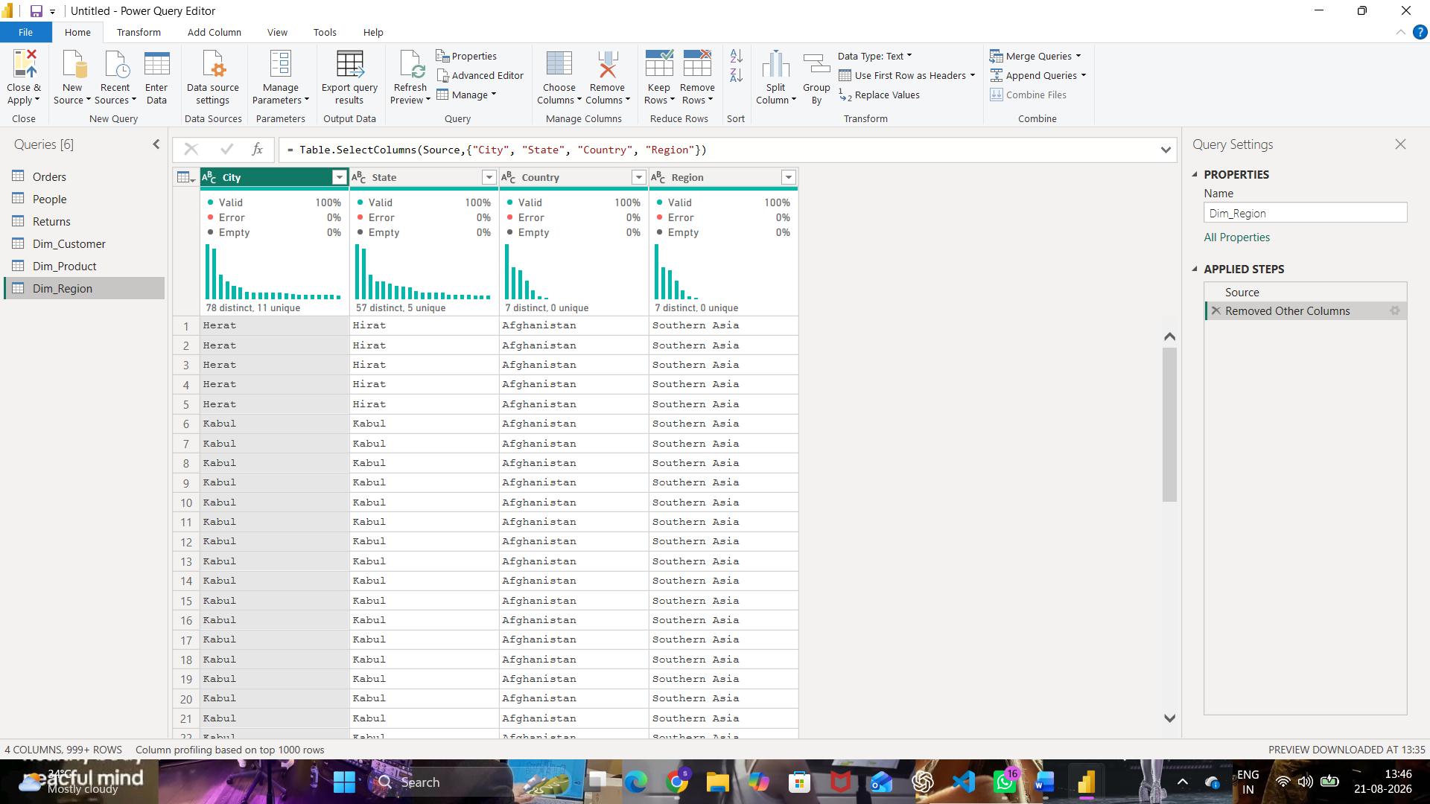
Fig. 7 — Dim_Region query with City, State, Country, and Region columns
Step 11: Create Dim_Date using Order Date, Year, Quarter, and Month.
Order Date was kept from the source table and Year, Quarter, and Month columns were extracted from it using Add Column → Date → Year / Quarter / Month, following the same Choose Columns → clean → deduplicate pattern used for the other dimensions.
Step 12: Remove duplicate records from all dimensions.
The same Remove Duplicates step demonstrated for Dim_Customer (Fig. 3–4) was applied to Dim_Product, Dim_Region, and Dim_Date so that each dimension table holds one row per unique entity.

Part D: Create Fact Table
Step 13: Create Fact_Sales containing Order ID, Customer ID, Product ID, Region, Order Date, Sales, Quantity, Profit, and Discount.
Fact_Sales was built from the duplicated Orders (2) query (Fig. 2) by keeping only the key and measure columns — Order ID, Customer ID, Product ID, Region, Order Date, Sales, Quantity, Profit, and Discount — using the same Choose Columns command shown in Fig. 5–6.
Step 14: Verify all key columns required for relationships.
Order ID, Customer ID, Product ID, City/Region, and Order Date were confirmed present in Fact_Sales so that a relationship could be built to each dimension table.

Part E: Build Star Schema
Step 15: Open Model View.
Step 16–17: Create relationships between Fact_Sales and all Dimension Tables, configured as Many-to-One.
In the New relationship dialog, Fact_sales (Customer ID) was related to Dim_Customer (Customer ID) with cardinality Many to one (*:1) and a single cross-filter direction.
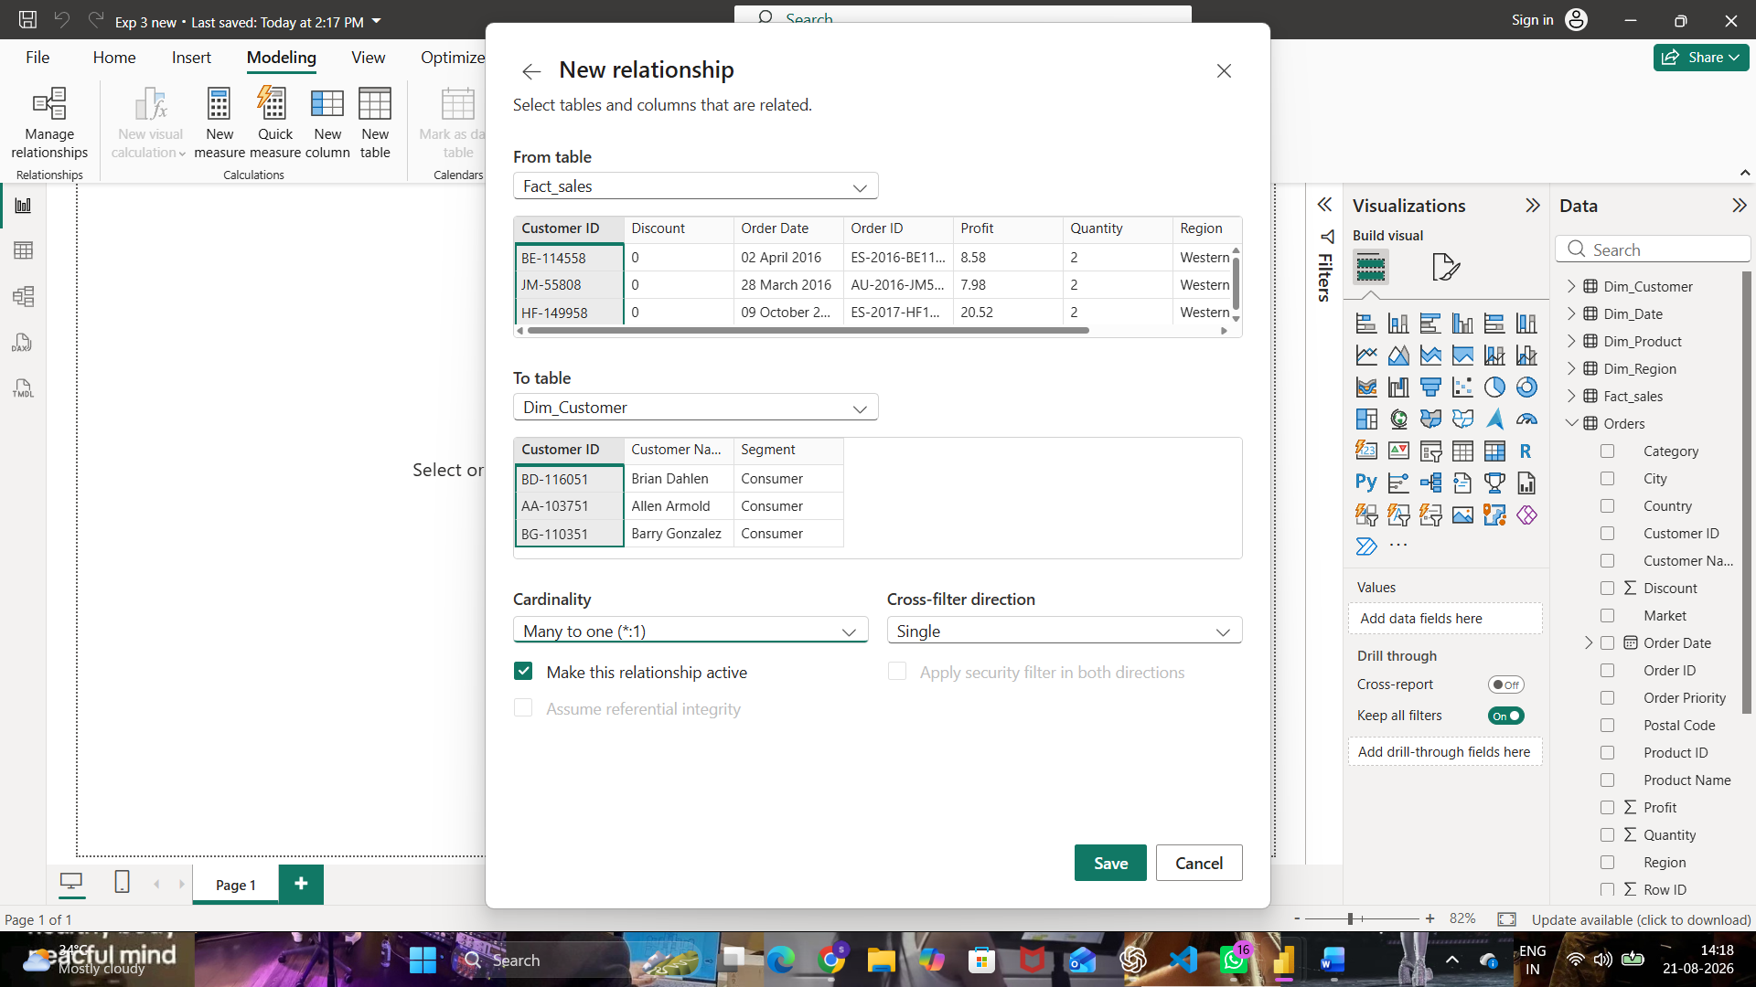
Fig. 8 — New relationship: Fact_sales → Dim_Customer on Customer ID, Many to one
Step 18: Arrange the tables visually into a Star Schema layout.
Manage Relationships confirms three active many-to-one relationships radiating from the Orders/Fact_sales tables out to Dim_Region (City), Fact_sales (Order ID), and Dim_Product (Product ID) — the spokes of the star schema.
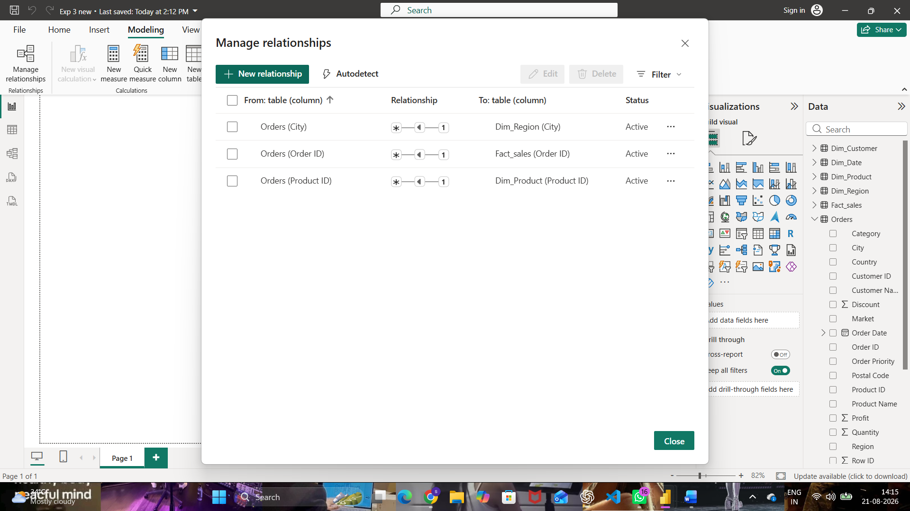
Fig. 9 — Manage relationships — active many-to-one relationships forming the star schema

Part F: Validate Model
Step 19: Create visualizations such as Sales by Category, Profit by Region, and Sales Trend by Year.
A clustered bar chart of Sum of Sales by Region was built first from the Fact_sales and Dim_Region fields.
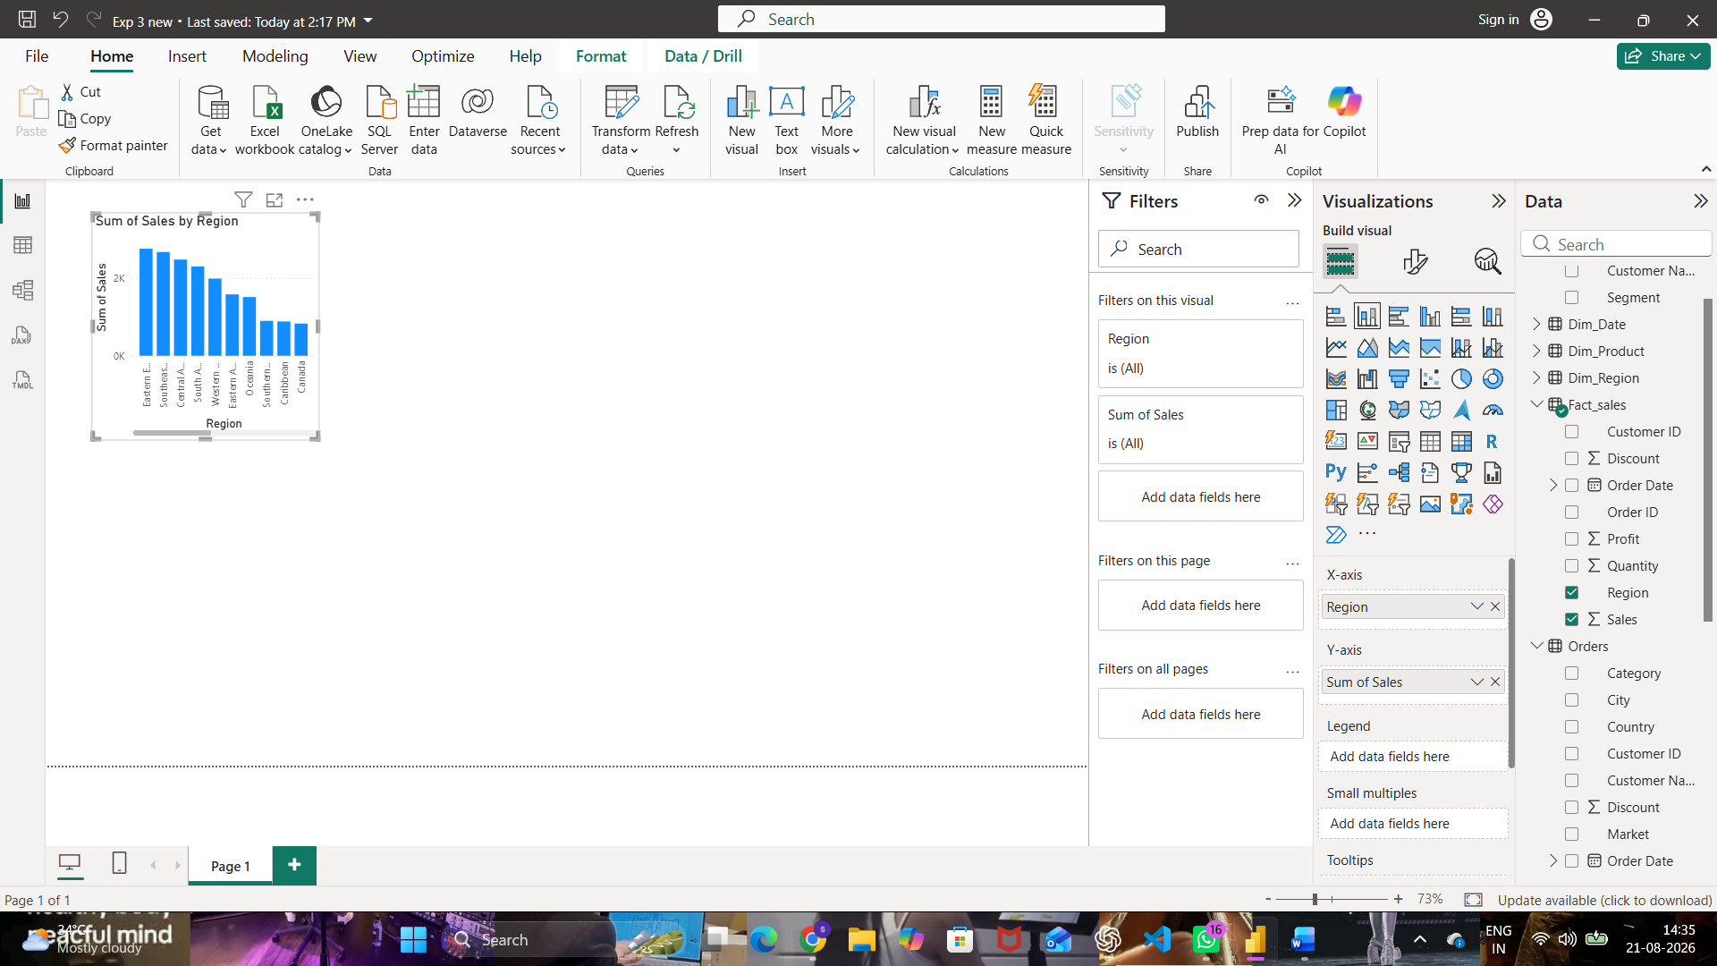
Fig. 10 — Sum of Sales by Region visual built from the star schema
The report page was then extended with a Sum of Profit by Region bar chart and a Sum of Year and Sum of Sales column chart alongside it, confirming the dimensions filter the fact table correctly across multiple visuals.
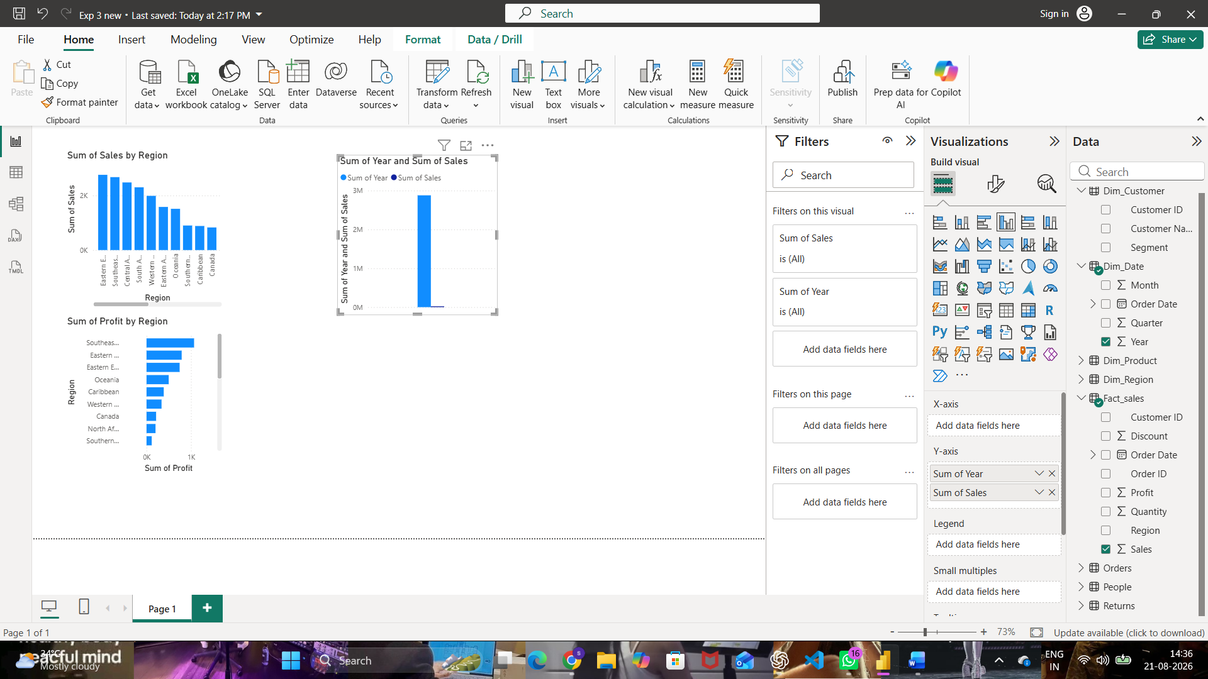
Fig. 11 — Validation dashboard: Sales by Region, Profit by Region, and Year vs Sales
Step 20: Create DAX measures.
- Total Sales = SUM(Fact_sales[Sales])
- Total Profit = SUM(Fact_sales[Profit])
- Profit Margin = DIVIDE([Total Profit], [Total Sales])
- Average Order Value = DIVIDE([Total Sales], DISTINCTCOUNT(Fact_sales[Order ID]))
Step 21: Verify that dimensions correctly filter fact data.
Slicing the Sales and Profit visuals by Region (Fig. 11) confirmed that filtering on a dimension table correctly propagates through the many-to-one relationships to filter the Fact_sales measures, validating the star schema.

Result
A dimensional model was successfully designed and implemented using Microsoft Power BI. A Star Schema was created consisting of one Fact Table (Fact_Sales) and four Dimension Tables (Dim_Customer, Dim_Product, Dim_Region, Dim_Date). Relationships and DAX measures were successfully implemented and validated using reports.

Learning Outcomes
After completing this experiment, students will be able to:
- Explain dimensional modeling concepts and Star Schema architecture.
- Differentiate between Fact and Dimension tables.
- Design dimensional models using real-world business datasets.
- Create and validate Star Schemas in Power BI.
- Develop DAX measures for analytical reporting.

