Experiment 4
OLAP Operations (Slice, Dice, Drill-up & Drill-down) using Microsoft Power BI

Aim
To perform Online Analytical Processing (OLAP) operations using Microsoft Power BI by creating multidimensional reports and applying Slice, Dice, Drill-down, and Drill-up operations on the Global Superstore dataset for analytical decision-making.

Tools / Software Required
- Microsoft Power BI Desktop
- Global Superstore Dataset.xlsx
- Power Query Editor
- DAX (Data Analysis Expressions)
Dataset Source: Global Superstore Dataset (Kaggle) — https://www.kaggle.com/datasets/apoorvaappz/global-super-store-dataset

Theory
Online Analytical Processing (OLAP) is a Business Intelligence technique used for multidimensional analysis of business data. OLAP enables users to analyze information from different perspectives and perform complex analytical queries efficiently.
Common OLAP operations include:
- Slice: Selecting a single dimension value from a dataset.
- Dice: Selecting multiple dimensions and values simultaneously.
- Drill-down: Moving from summarized data to detailed data.
- Drill-up: Moving from detailed data to summarized data.
Power BI supports OLAP-style analysis through hierarchies, filters, slicers, visual interactions, and drill functionality.

Conduct

Part A: Load Dataset and Build Report
Step 1–2: Open Power BI Desktop and open the model created in Experiment 3.
The star schema built in Experiment 3 — Fact_Sales related to Dim_Customer, Dim_Product, Dim_Region, and Dim_Date — was reused as the base model for this experiment instead of re-importing the dataset from scratch. The full build history from Experiment 3 is shown below to confirm the model in use.
The Global Superstore Dataset.xlsx workbook was originally connected via the Navigator, with Orders, People, and Returns worksheets selected for import.
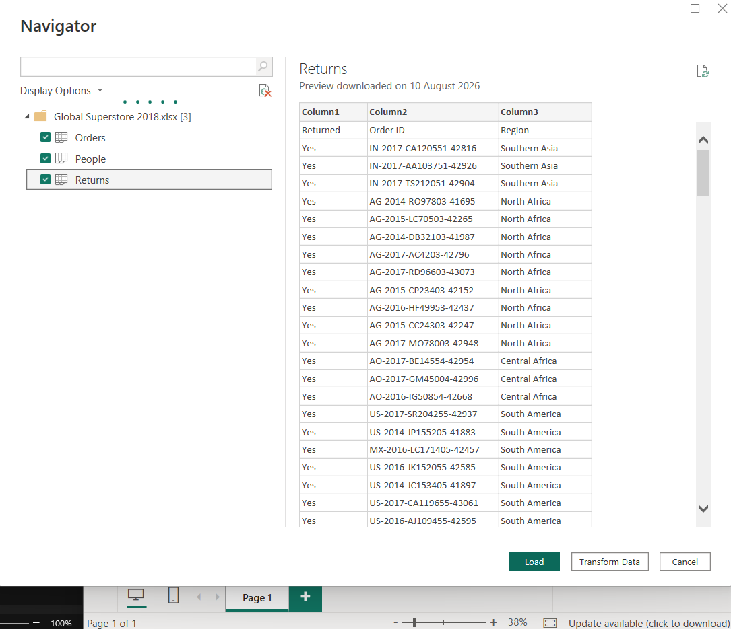
Fig. 1 — Navigator: Global Superstore Dataset.xlsx worksheets selected for import
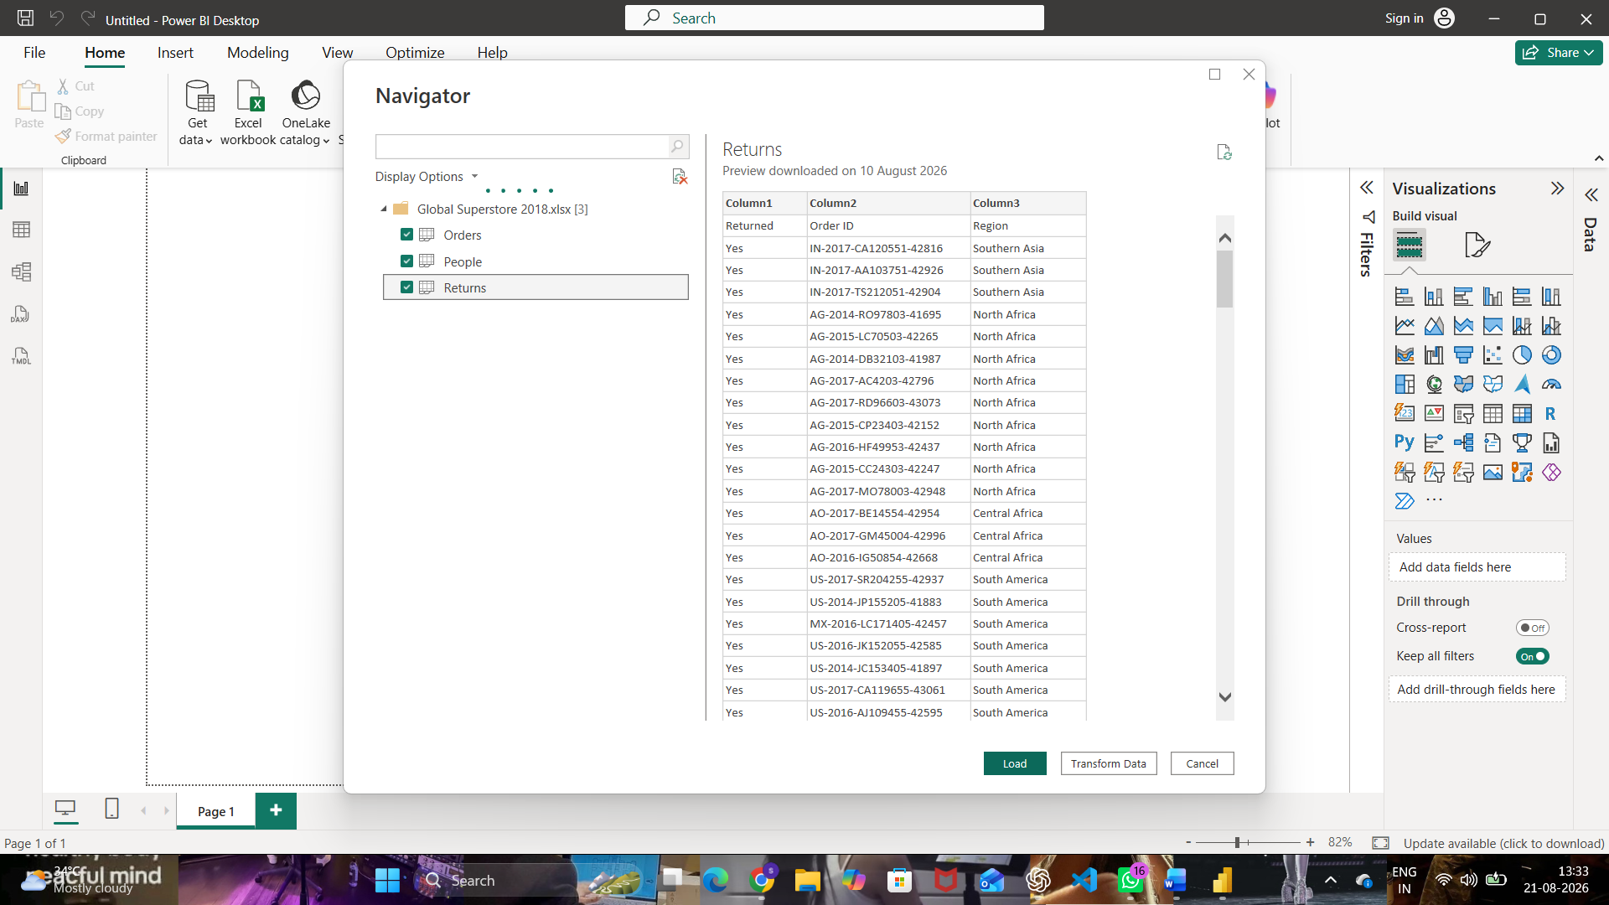
Fig. 2 — Navigator: Orders, People, and Returns worksheets, with the Returns preview shown
Duplicate references of each table (Orders (2), People (2), Returns (2)) were created in the Queries pane to serve as working copies for building the dimension and fact tables, leaving the original imported tables untouched.
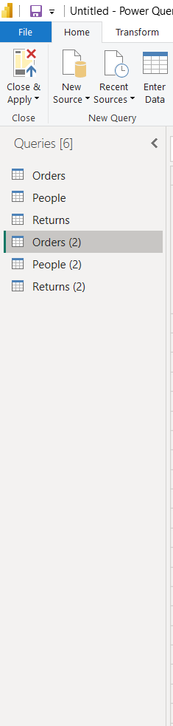
Fig. 3 — Queries pane after Load, showing the original tables plus duplicate references
Dim_Product was built from the duplicated Orders query using the Choose Columns command, keeping only Product ID, Product Name, Sub-Category, and Category.
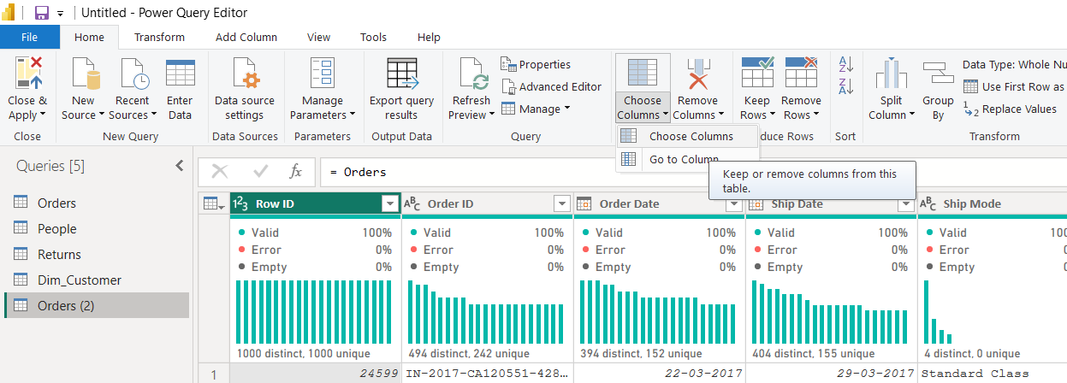
Fig. 4 — Choose Columns command used to build the Dim_Product query
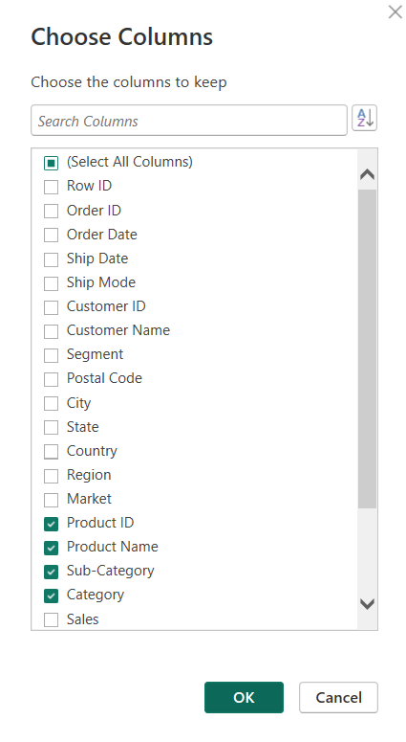
Fig. 5 — Choose Columns dialog — Product ID, Product Name, Sub-Category, and Category kept
Dim_Region was built by keeping City, State, Country, and Region.
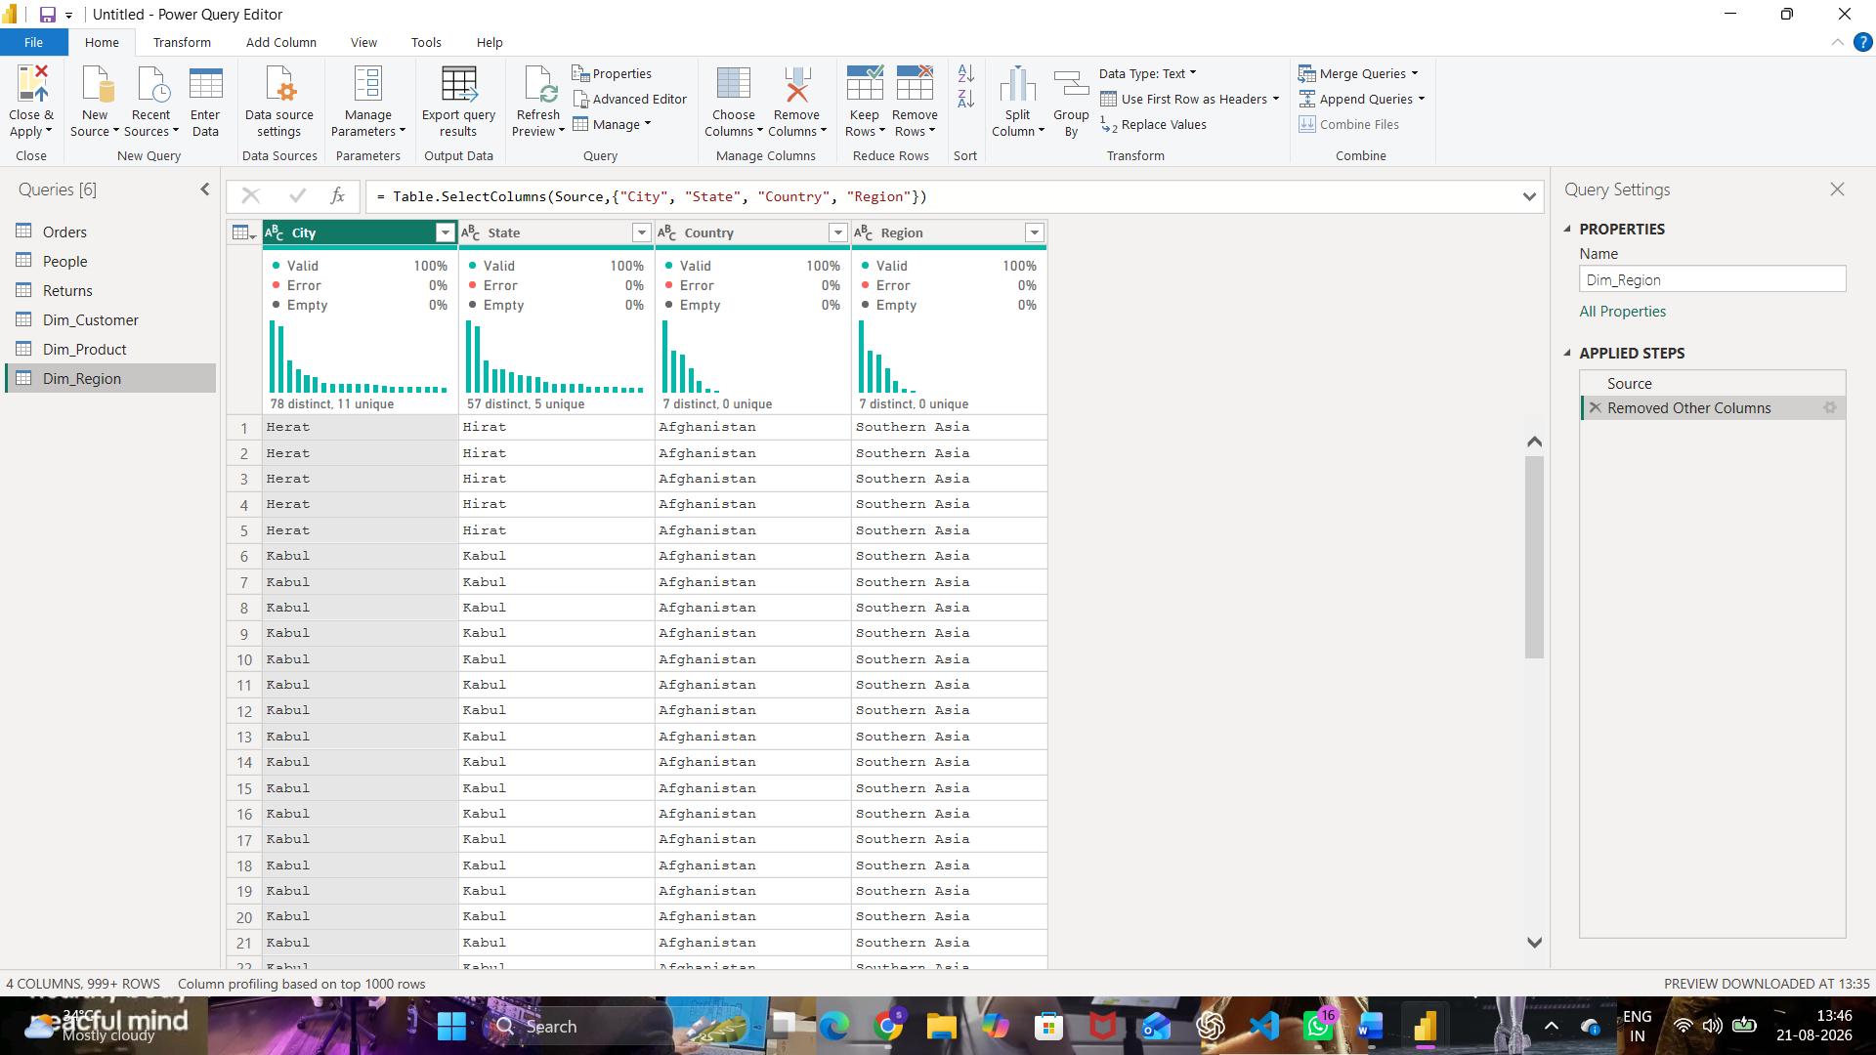
Fig. 6 — Dim_Region table with City, State, Country, and Region columns
Dim_Customer was built by keeping Customer ID, Customer Name, and Segment, then removing duplicate rows so each customer appears only once.
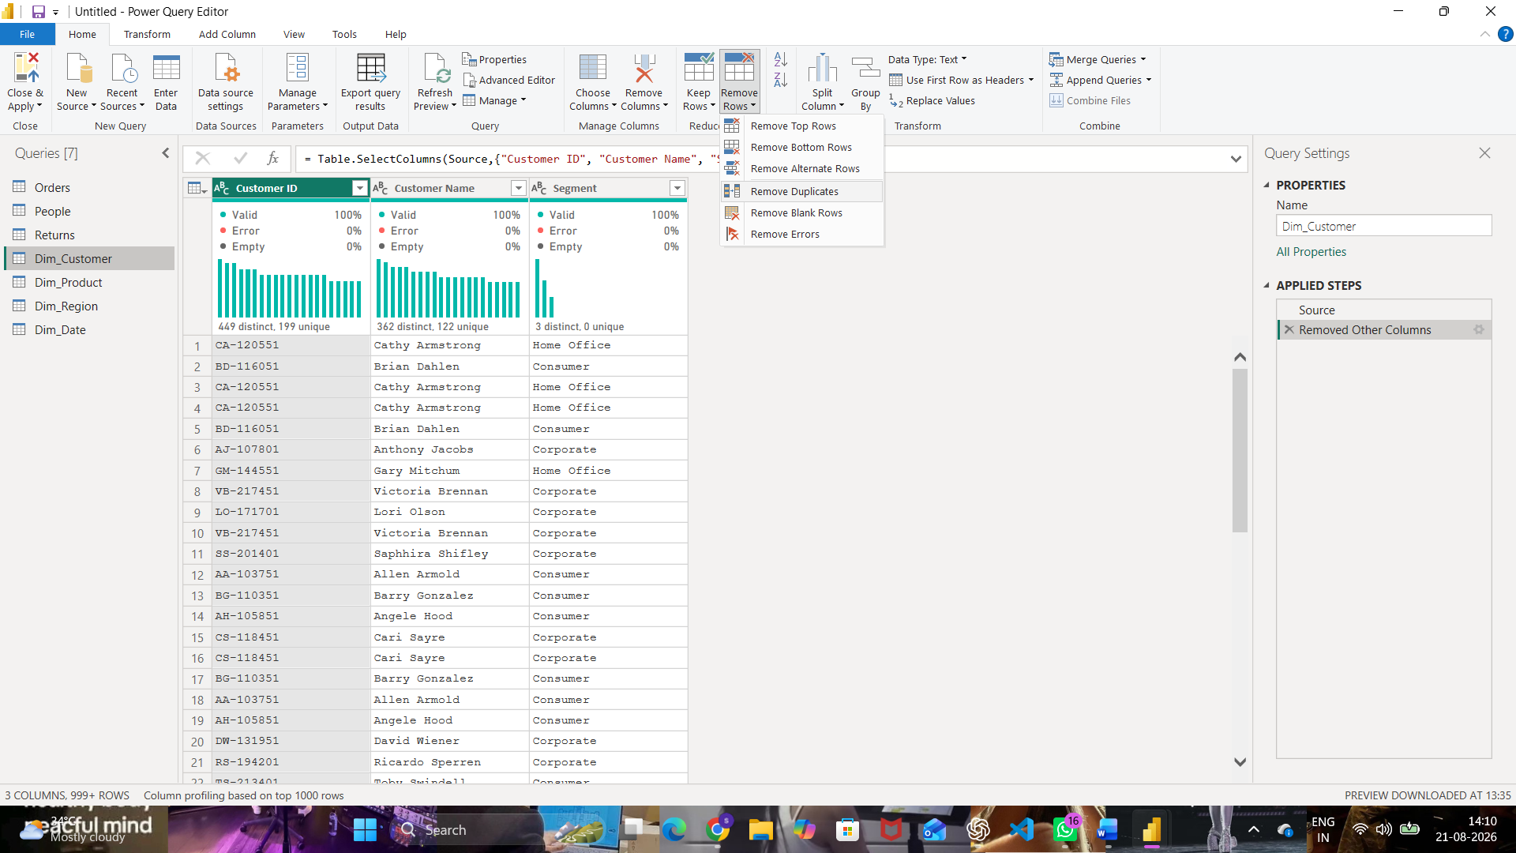
Fig. 7 — Dim_Customer before deduplication — Remove Duplicates being applied
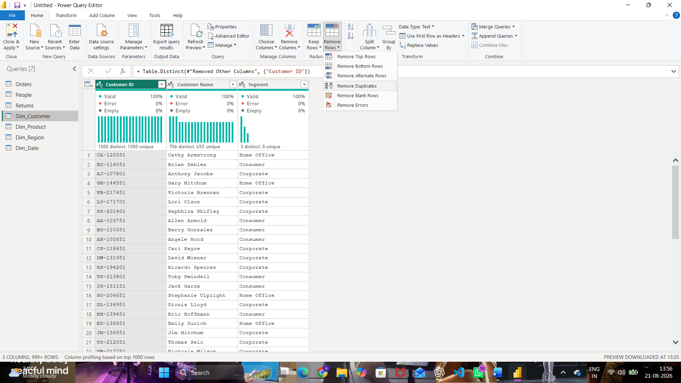
Fig. 8 — Dim_Customer after deduplication — 1,000 distinct / 1,000 unique Customer IDs
Step 3: Verify relationships between the tables.
Manage Relationships confirms the active many-to-one relationships carried over from Experiment 3, and the New relationship dialog shows the Fact_sales → Dim_Customer link on Customer ID with cardinality Many to one — confirming the model was intact before building the OLAP report.
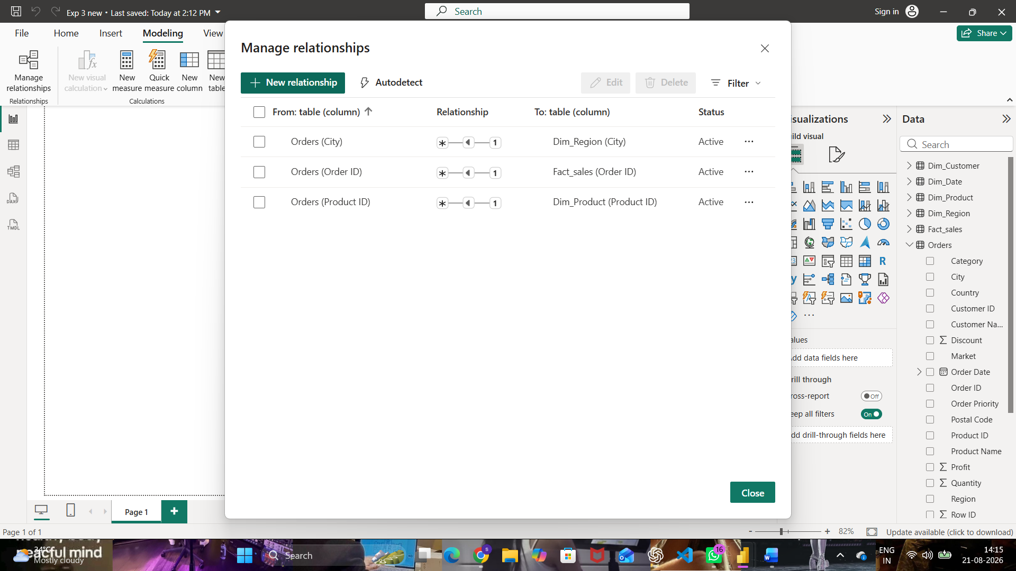
Fig. 9 — Manage relationships — relationships carried over from Experiment 3
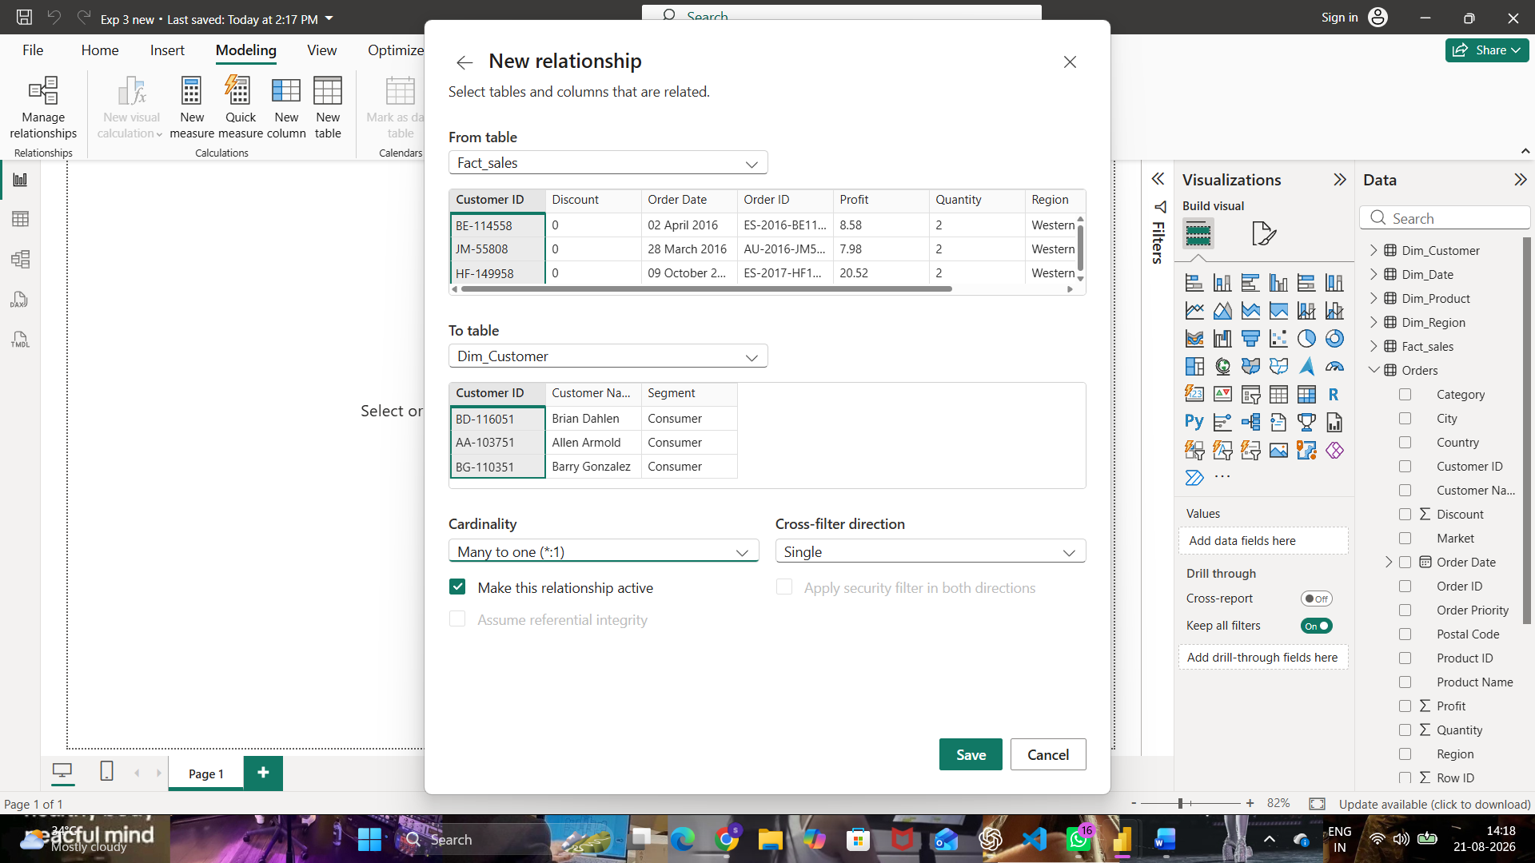
Fig. 10 — Fact_sales → Dim_Customer relationship (Customer ID, Many to one)
Step 4: Create report visuals — Sales by Region, Profit by Region, and Sales Trend by Year.
A Sum of Sales by Region bar chart was built first from the star schema fields.
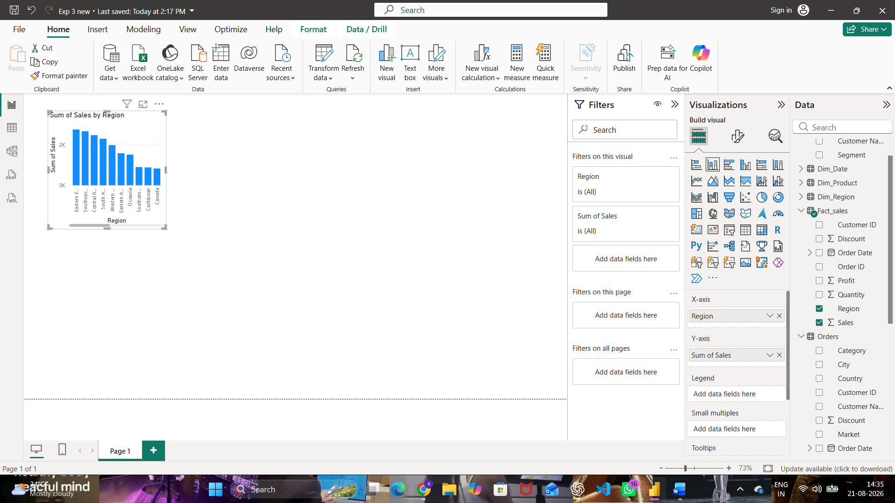
Fig. 11 — Sum of Sales by Region visual built from the star schema
The report page was then extended with a Sum of Profit by Region bar chart and a Sum of Year and Sum of Sales column chart alongside it, giving three complementary views of the business data to apply OLAP operations against.
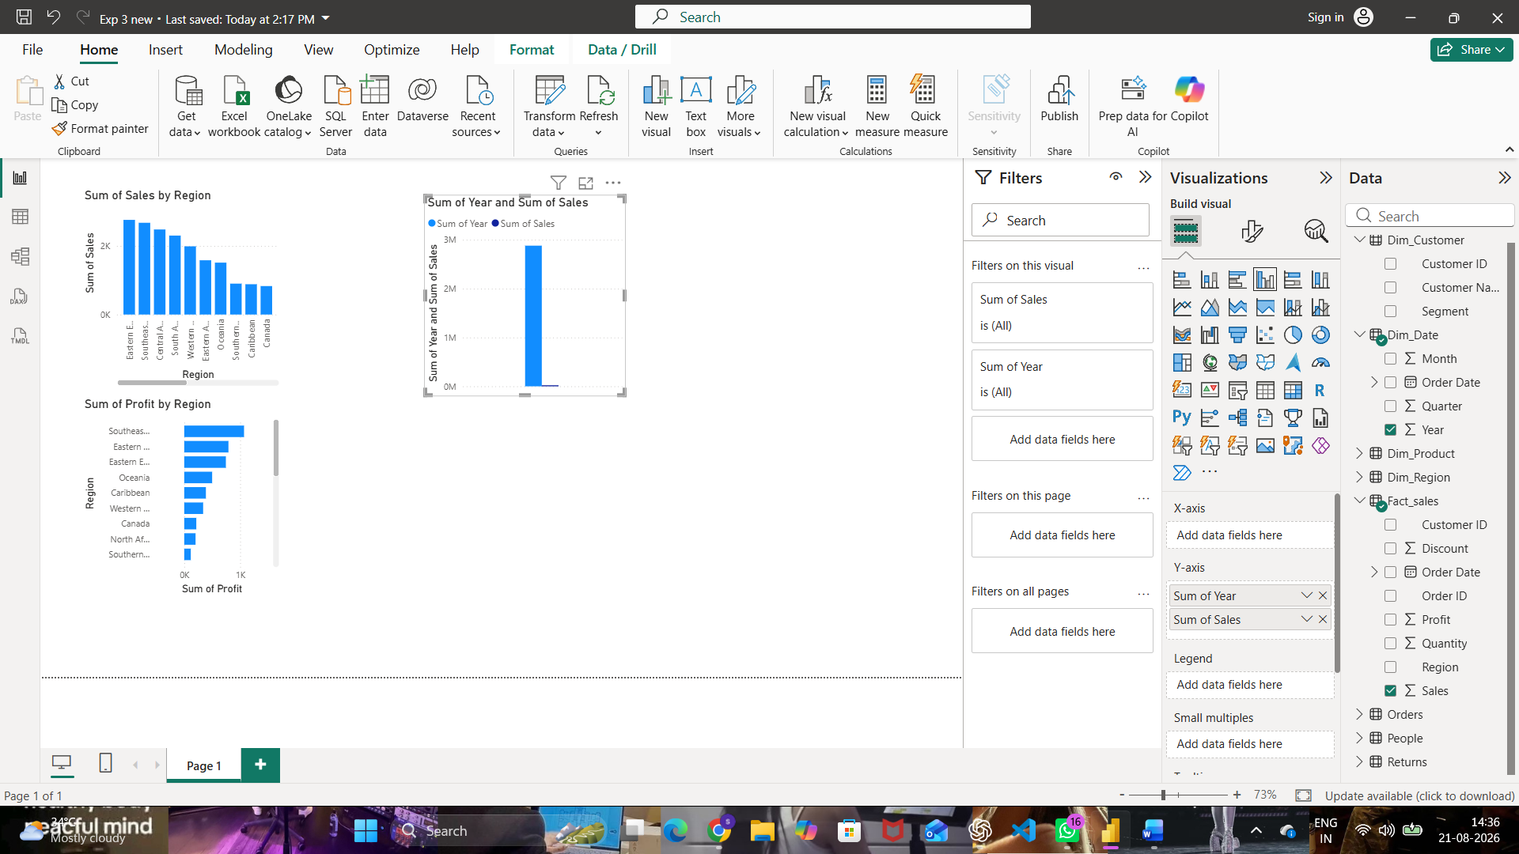
Fig. 12 — Base report visuals: Sales by Region, Profit by Region, and Year vs Sales

Part B: Slice Operation
Step 5–6: Add a Region slicer and select a single Region.
Insert > Slicer → Field: Region → select a single value
Step 7–8: Observe changes and capture screenshot evidence.
With the Region slicer sliced down to a single value (Central US), the Sum of Profit by Category, Sum of Sales by Segment, and Sum of Sales by Region visuals all recalculated to show only that region's figures — a single dimension value applied across every visual on the page, which is the Slice operation.
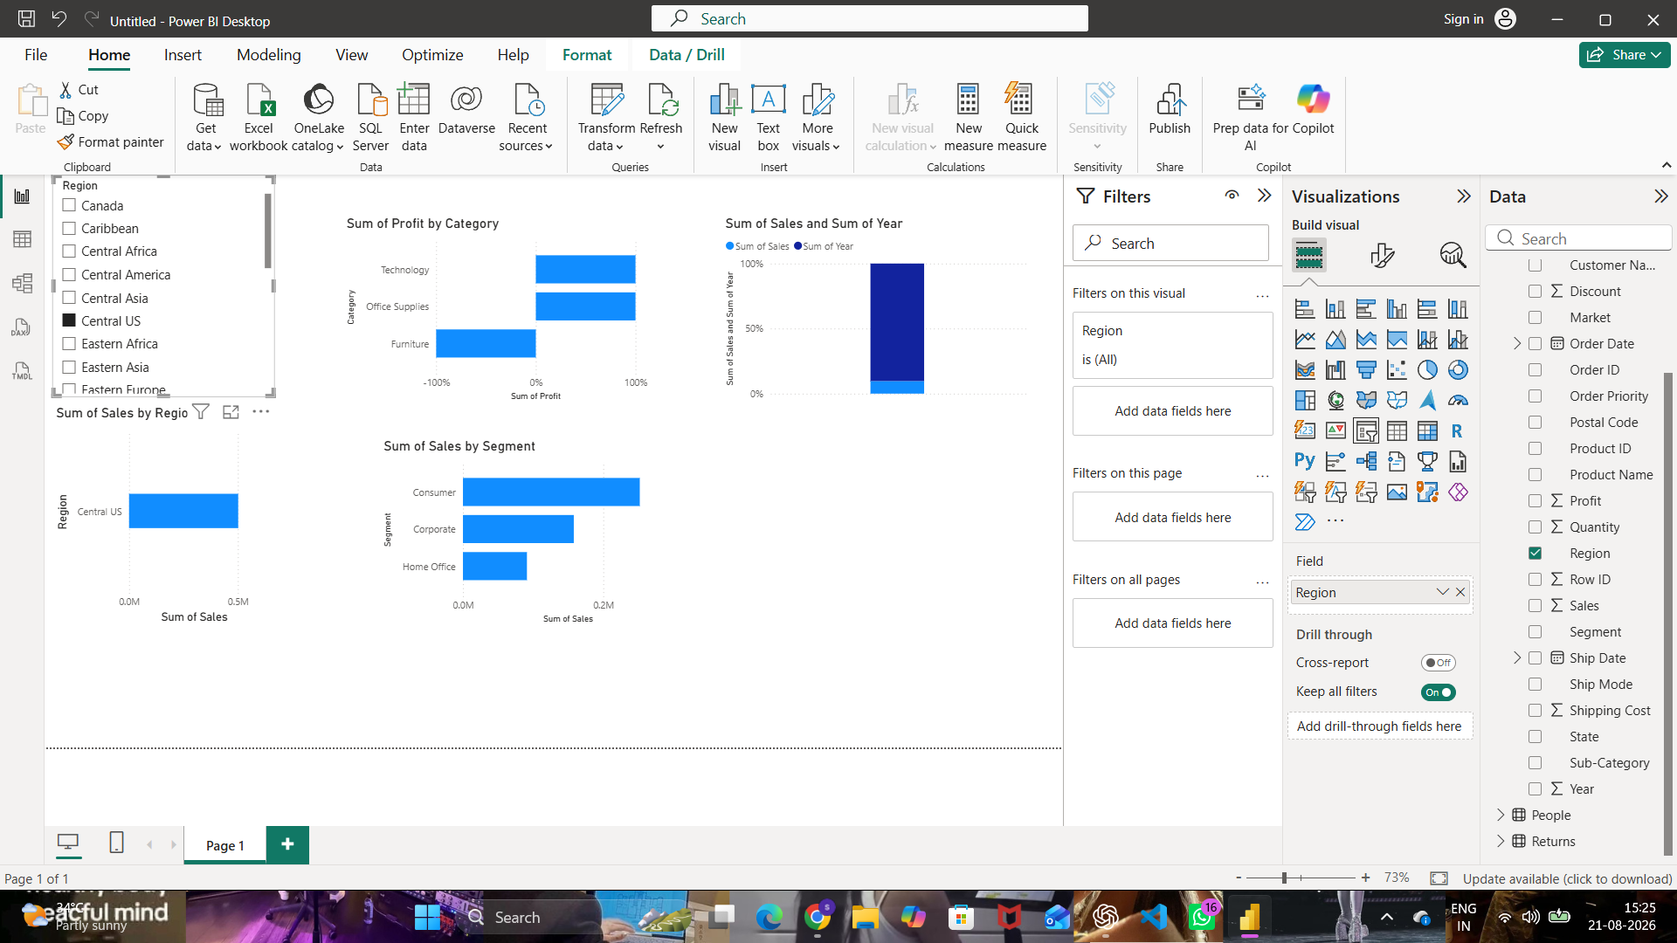
Fig. 13 — Slice: Region sliced to a single value (Central US) filtering all visuals on the page

Part C: Dice Operation
Step 9: Apply multiple filters simultaneously (Region, Category, and a Year range).
Step 10–11: Analyze filtered business metrics and capture screenshots.
A second page combined a Region selection (Central Africa) with a Category filter (Technology) and a Year range slicer (2015–2017) applied together. Slicing on more than one dimension at once, and reading the resulting Sales, Segment, and Year breakdowns, is the Dice operation.
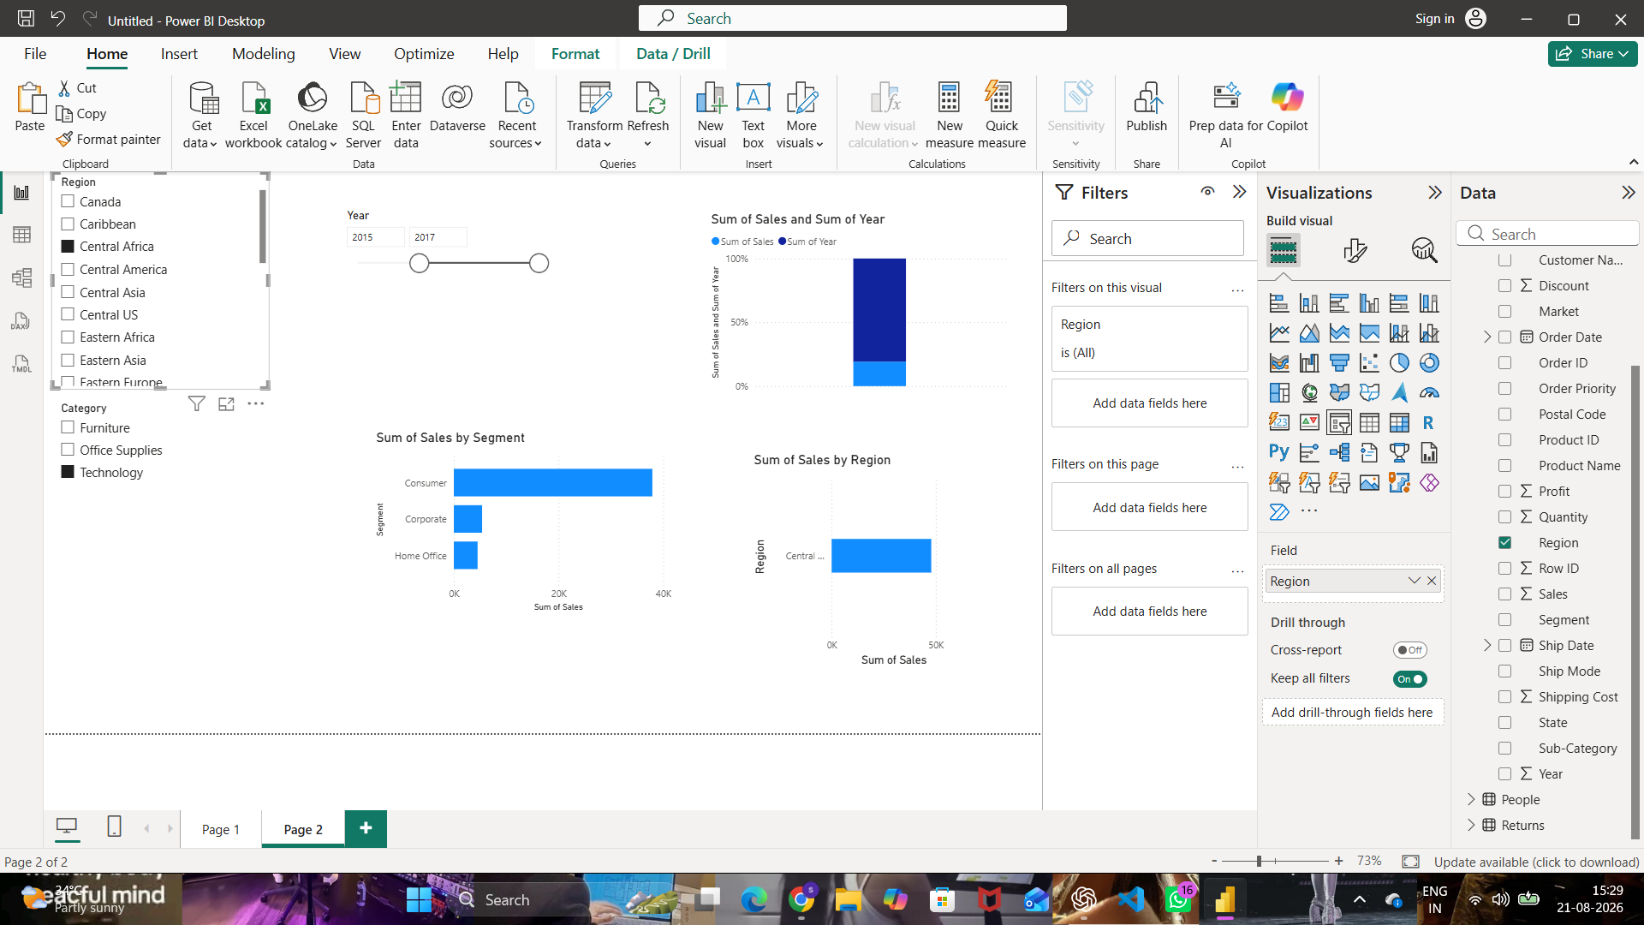
Fig. 14 — Dice: Region, Category, and Year range filters applied together

Part D: Drill-down Operation
Step 12–13: Create a Region → State → City hierarchy and build a bar chart from it.
A Region Hierarchy (Region, State, City) was added to the Y-axis of the Sum of Sales bar chart. At the top level the chart shows Sum of Sales by Region, with the drill controls and a “Click to turn on Drill down” tooltip available on the visual.
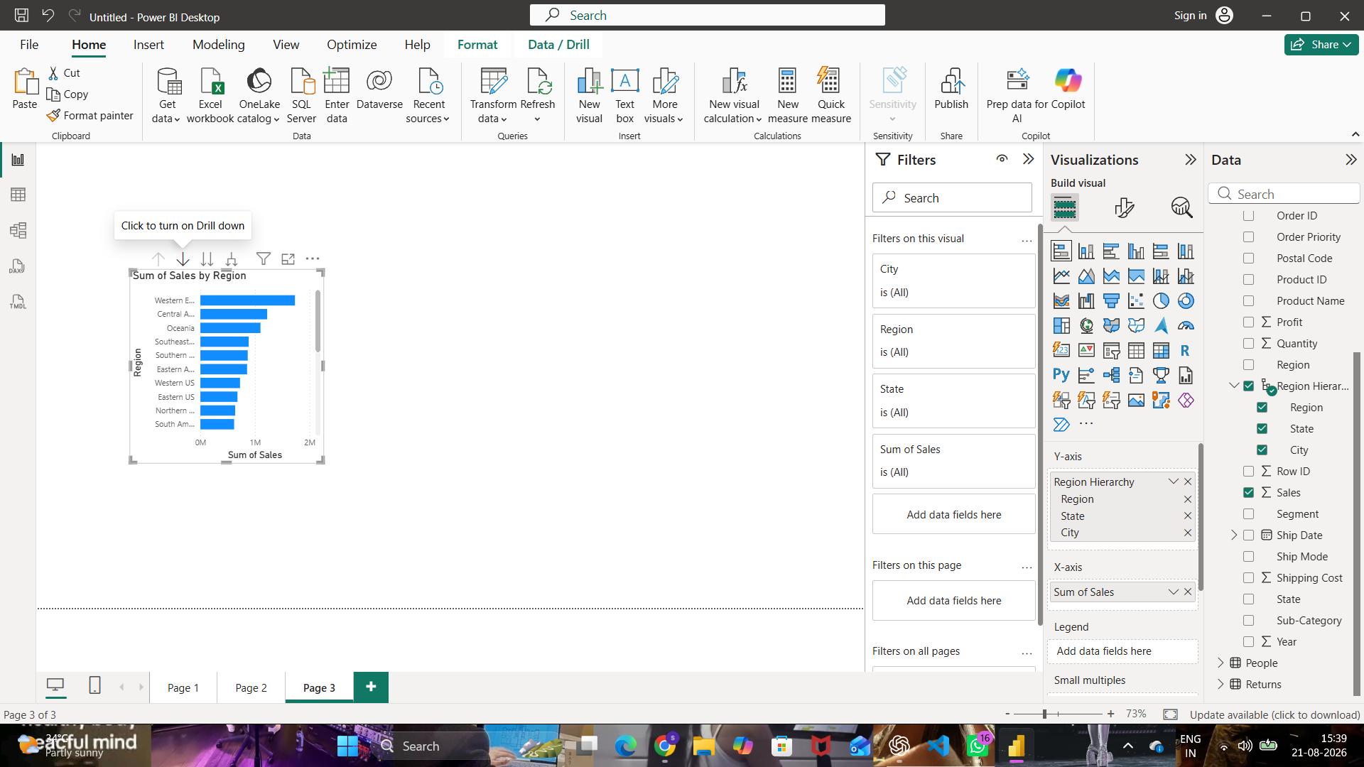
Fig. 15 — Region Hierarchy on the Sales chart, ready to drill down from Region level
Step 14–15: Drill down from Region to State, then State to City, and observe detailed patterns.
Drilling down one level shows Sum of Sales by State (England, California, Texas, etc.). Drilling down a second level reaches the City level, showing Sum of Sales by City (New York, Los Angeles, Manila, Seattle, and so on) — the most detailed view in the hierarchy.
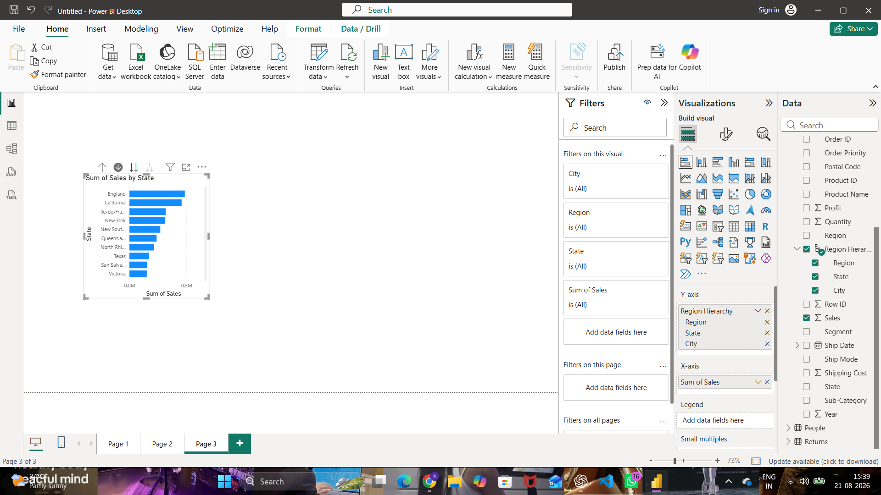
Fig. 16 — Drilled down one level: Sum of Sales by State
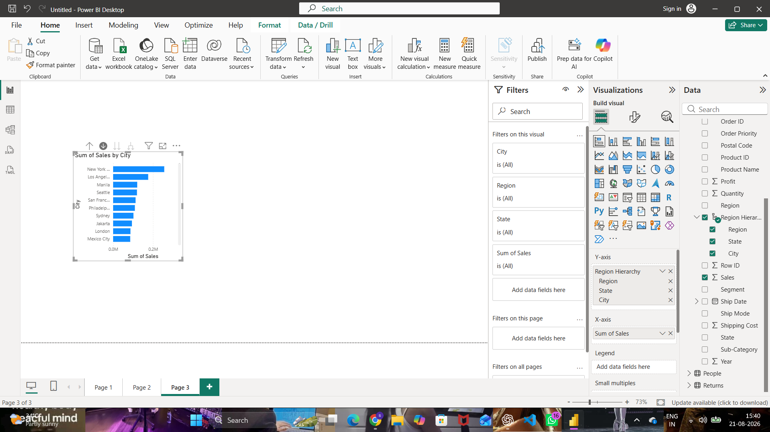
Fig. 17 — Drilled down to the City level: Sum of Sales by City
Step 16: Screenshot evidence captured at each drill level (Figs. 15–17).

Part E: Drill-up Operation
Step 17: Navigate back from City level to State level and then Region level.
Using the Drill up control, the chart was collapsed back from the City-level detail to the top Region level, once again showing Sum of Sales by Region as the aggregated view.
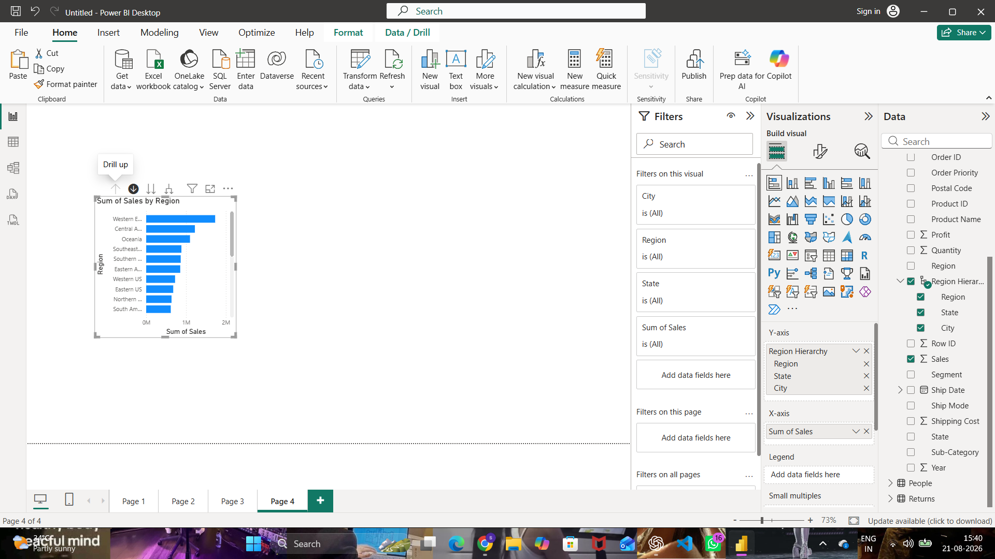
Fig. 18 — Drill up: chart collapsed back to the Region-level summary
Step 18–20: Compare aggregated values at each level and record observations.
Moving back up the hierarchy re-aggregates the City-level figures into their parent State totals, and the State-level figures into their parent Region totals, confirming that Drill-up simply reverses Drill-down without losing any underlying data.

Part F: OLAP Analysis
Step 21–23: Compare operations and summarize observations.
Operation | What was done | Key observation
Slice | Region slicer set to a single value (Central US) | All visuals on the page recalculate for one dimension value at a time
Dice | Region, Category, and Year range filtered together | Combining filters across multiple dimensions narrows the data to a specific business question
Drill-down | Region Hierarchy used to go Region → State → City | Summarized totals break out into progressively more detailed rows
Drill-up | Hierarchy collapsed back from City → State → Region | Detailed rows re-aggregate back into their parent totals with no data loss
Slice and Dice help analysts filter a report down to the exact segment relevant to a decision (e.g. one region, or one region-category-year combination), while Drill-down and Drill-up let them move fluidly between a high-level summary and the underlying detail behind it — together giving business users a flexible, multidimensional view of the same underlying star schema.

Result
OLAP operations including Slice, Dice, Drill-down, and Drill-up were successfully performed using Microsoft Power BI. Multidimensional analysis was carried out on the Global Superstore dataset, enabling detailed and summarized views of business performance from multiple perspectives.

Learning Outcomes
After completing this experiment, students will be able to:
- Explain OLAP concepts and multidimensional analysis.
- Perform Slice and Dice operations using filters and slicers.
- Create hierarchies and perform Drill-down and Drill-up analysis.
- Interpret analytical insights generated through OLAP operations.
- Design interactive analytical reports for business users.

