Business Intelligence — Assignment 1
Data Cleaning, Dimensional Modeling, and Decomposition Tree Analysis using Microsoft Power BI

Aim
To clean and transform raw e-commerce data using Power Query in Microsoft Power BI, build a dimensional model around an Amazon product-reviews dataset, and produce an interactive report using decomposition tree visuals for multi-level business analysis.

Tools / Software Used
- Microsoft Power BI Desktop
- amazon.csv — Amazon product, pricing, and review dataset
- A secondary stock-price dataset (WMT) used for an independent data-cleaning exercise
- Power Query Editor

Theory

Data Cleaning
Raw datasets pulled from the web or exported from source systems typically contain blank rows, duplicate records, inconsistent text casing, and unnecessary columns. Power Query's Home ribbon provides built-in commands — Remove Rows, Remove Columns, Remove Duplicates, and text-formatting transforms such as Capitalize Each Word — to bring a dataset to a clean, analysis-ready state before it is loaded into the data model.

Dimensional Modeling
Once cleaned, a wide table can be split into smaller, purpose-built dimension tables by duplicating or referencing the source query and using Choose Columns to keep only the fields relevant to that dimension (e.g. pricing fields for dim_price, review fields for dim_review). Relationships are then defined between these tables in Model View so that filtering one table correctly filters the others.

Decomposition Tree
The decomposition tree is a Power BI visual that lets users break down a measure across multiple dimensions in any order they choose, drilling into a hierarchy such as user → product → category interactively rather than following a fixed drill path. It is well suited to open-ended, ad-hoc exploration of “what's driving this number” questions.

Conduct

Part A: Data Cleaning — amazon.csv
Step 1: Import amazon.csv via Get Data.
Home > Get Data > Text/CSV → Browse to amazon.csv → Transform Data
The raw file loads with columns including product_id, product_name, category, discounted_price, actual_price, discount_percentage, rating, rating_count, and review fields.
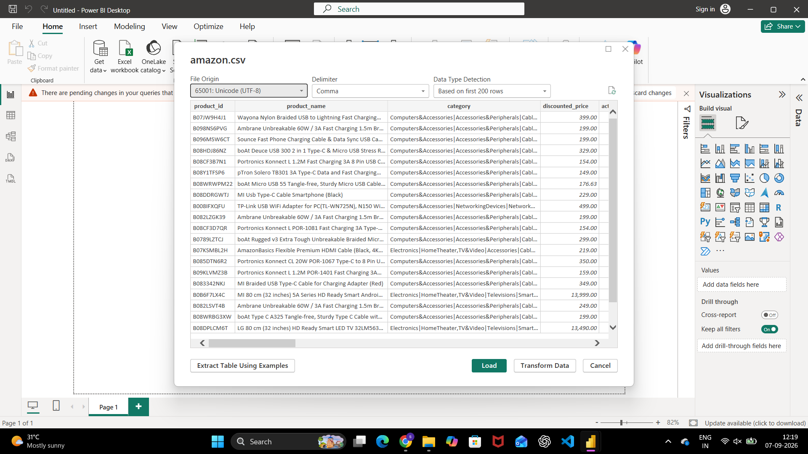
Fig. 1 — Get Data preview of the raw amazon.csv file
Step 2: Set column data types.
Column types were changed (text, number) so that price and rating fields could be aggregated correctly, bringing the query to 16 columns before any cleanup.
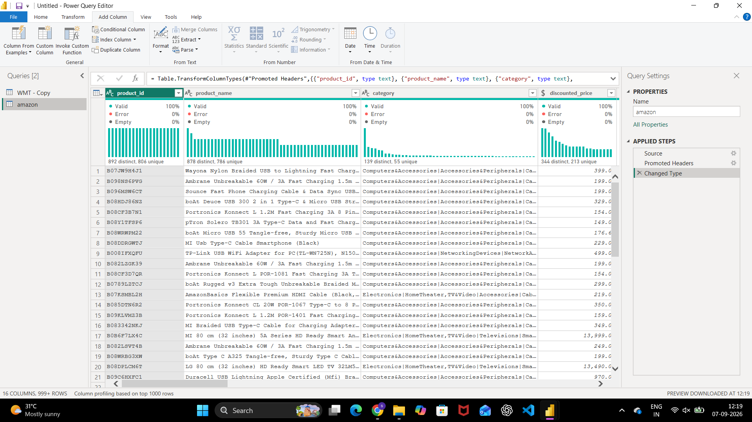
Fig. 2 — Changed Type applied to the amazon query (16 columns)
Step 3: Remove unnecessary columns.
Columns not needed for analysis — such as the raw product_link field — were removed using Remove Columns / Remove Other Columns.
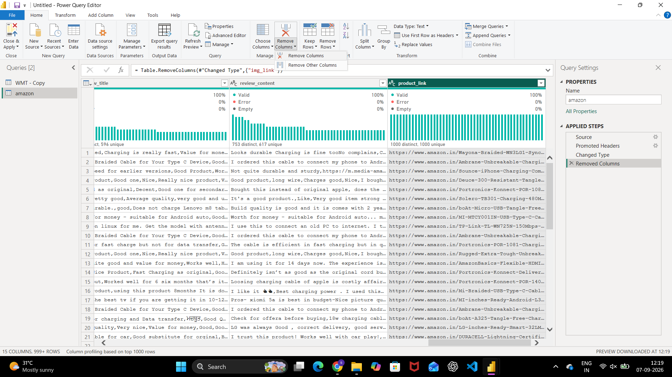
Fig. 3 — Remove Columns command used to drop unneeded fields
Step 4: Remove blank rows and duplicate records.
Rows with no meaningful values across every column were removed via Remove Rows → Remove Blank Rows, and exact duplicate rows were removed via Remove Duplicates.
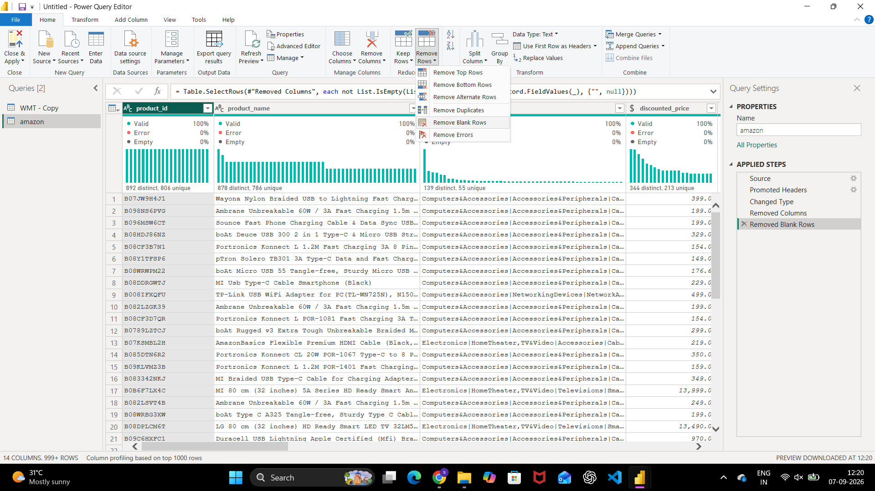
Fig. 4 — Remove Rows menu — Removed Blank Rows step applied
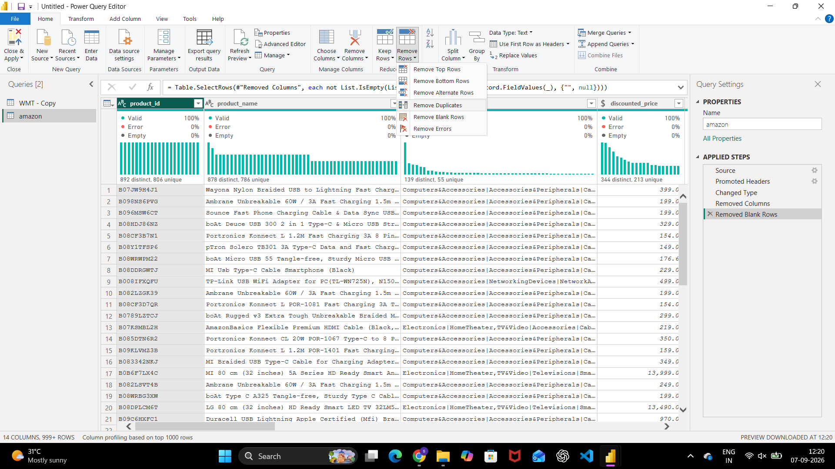
Fig. 5 — Remove Rows menu shown again after cleanup, confirming the option
Step 5: Standardize text casing.
product_name values were run through Format → Capitalize Each Word so that inconsistent casing (e.g. “USB” vs “Usb”) reads consistently across the dataset.
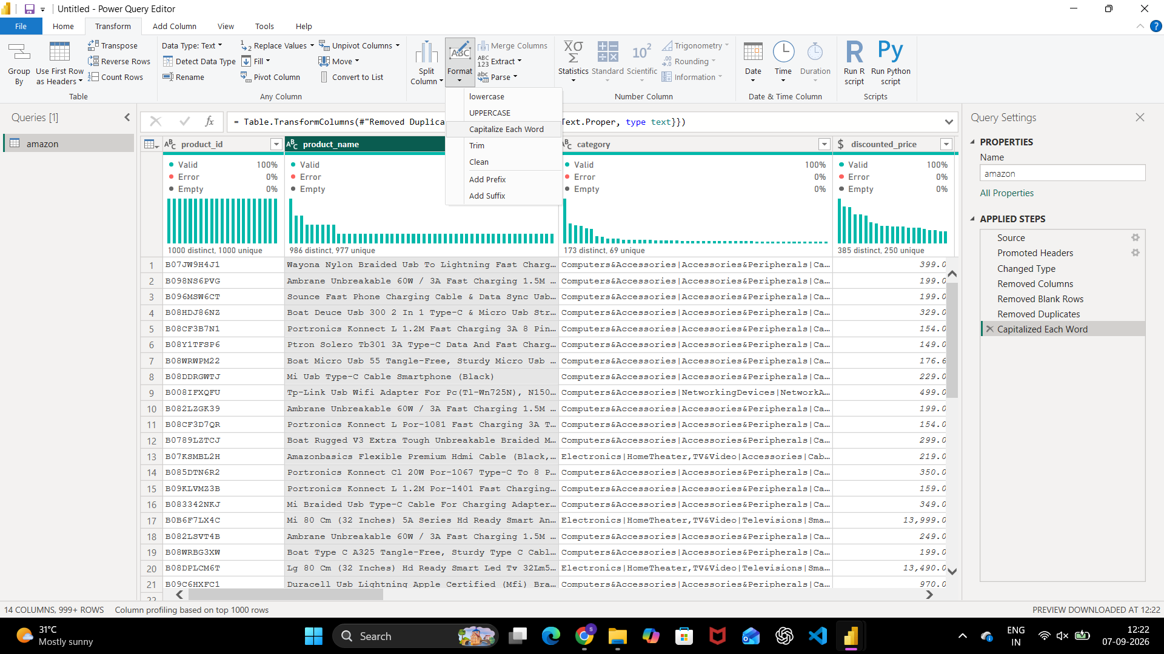
Fig. 6 — Capitalize Each Word applied to product_name

Part B: Data Cleaning — Secondary Dataset (WMT stock prices)
As a separate exercise, a stock-price dataset (Date, Open, High, Low, Close, Adj Close, Volume) was cleaned using the same Power Query techniques.
Step 6: Set correct data types and remove duplicate rows.
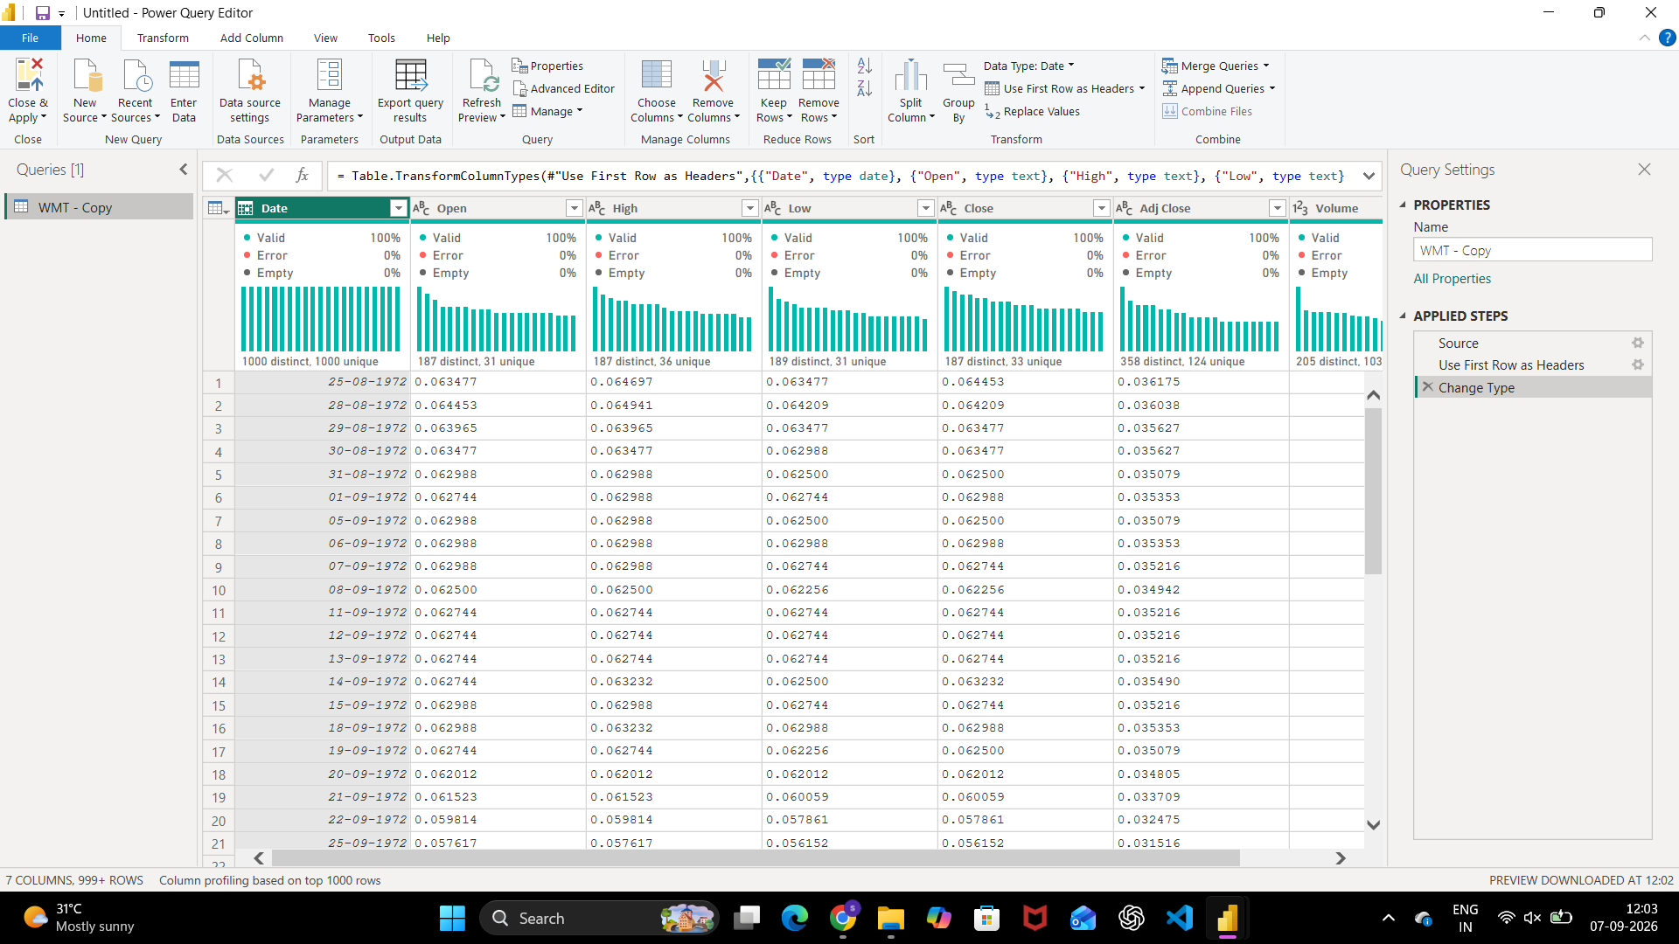
Fig. 7 — WMT – Copy query after Change Type
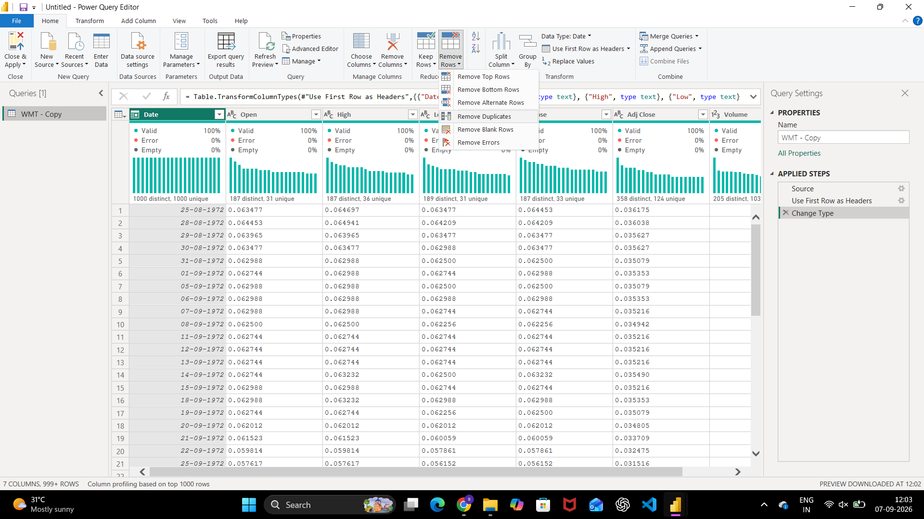
Fig. 8 — Remove Rows → Remove Duplicates applied to the WMT – Copy query
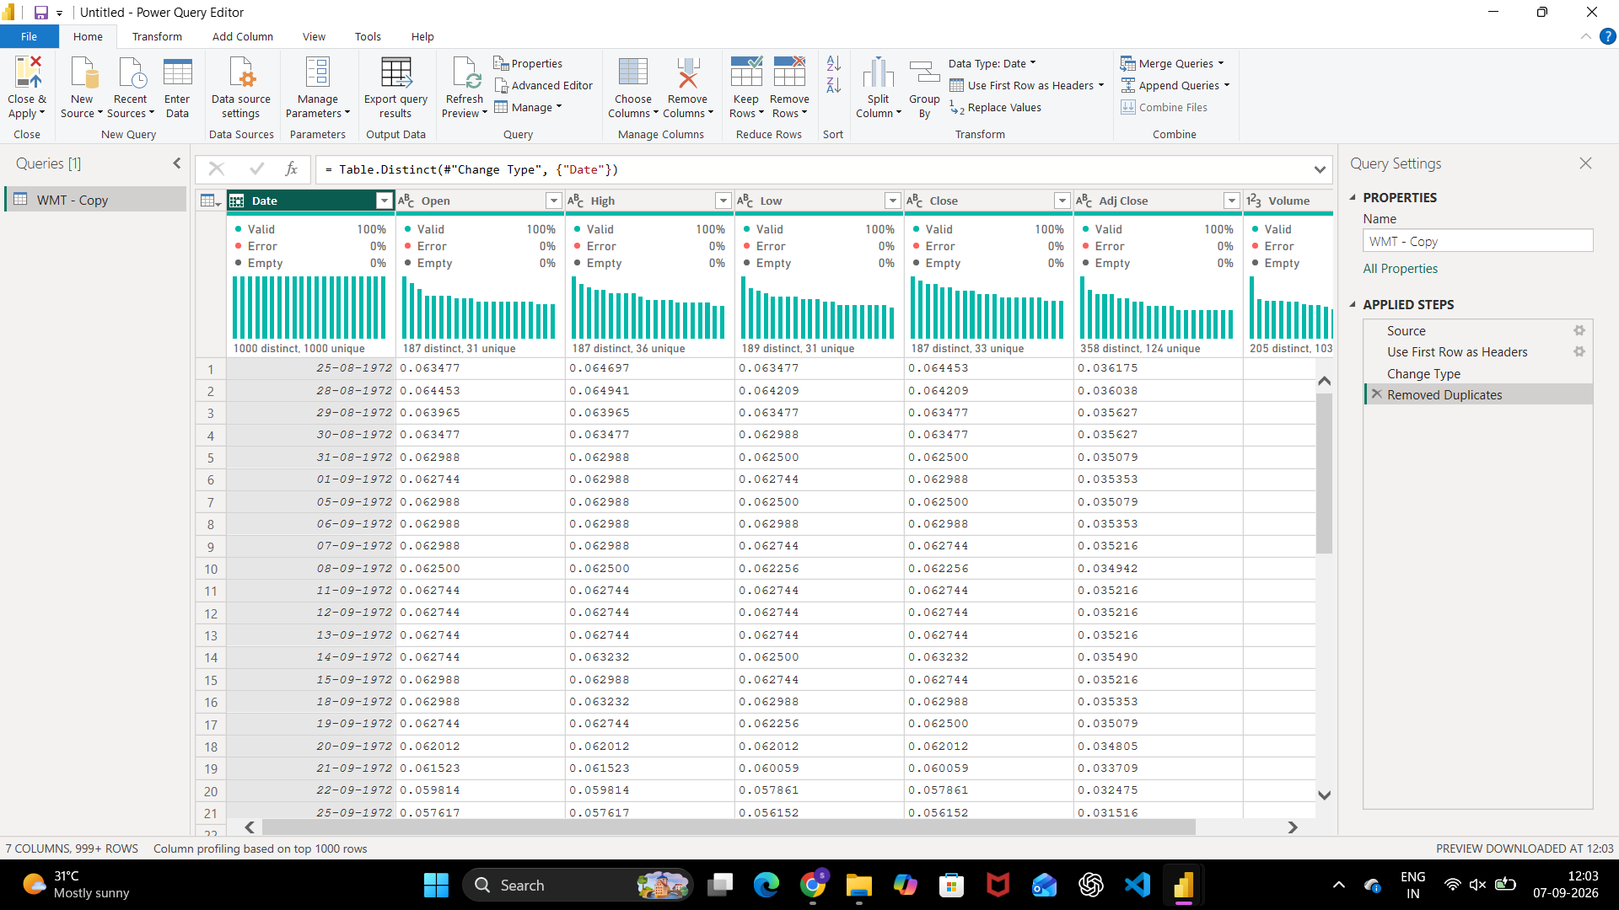
Fig. 9 — WMT – Copy query after deduplication, all 1,000 rows unique on Date
Step 7: Extract Year from the Date column.
Add Column → Date → Year was used to insert a Year column, with Month available the same way for further time-based analysis.
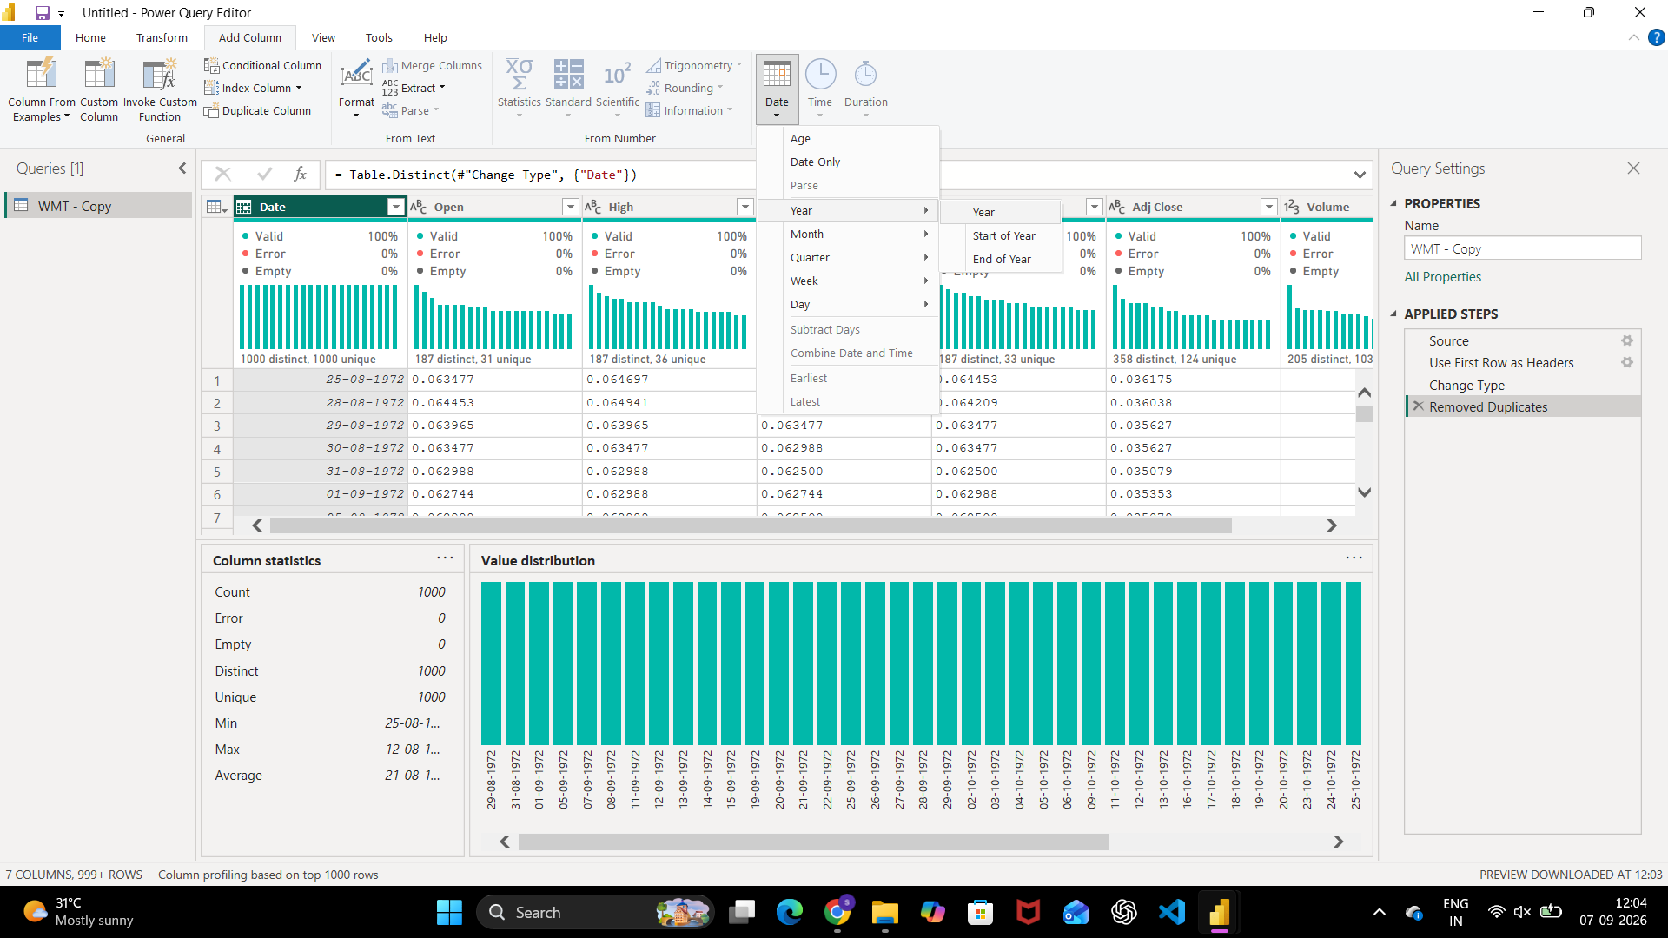
Fig. 10 — Date → Year submenu on the Date column
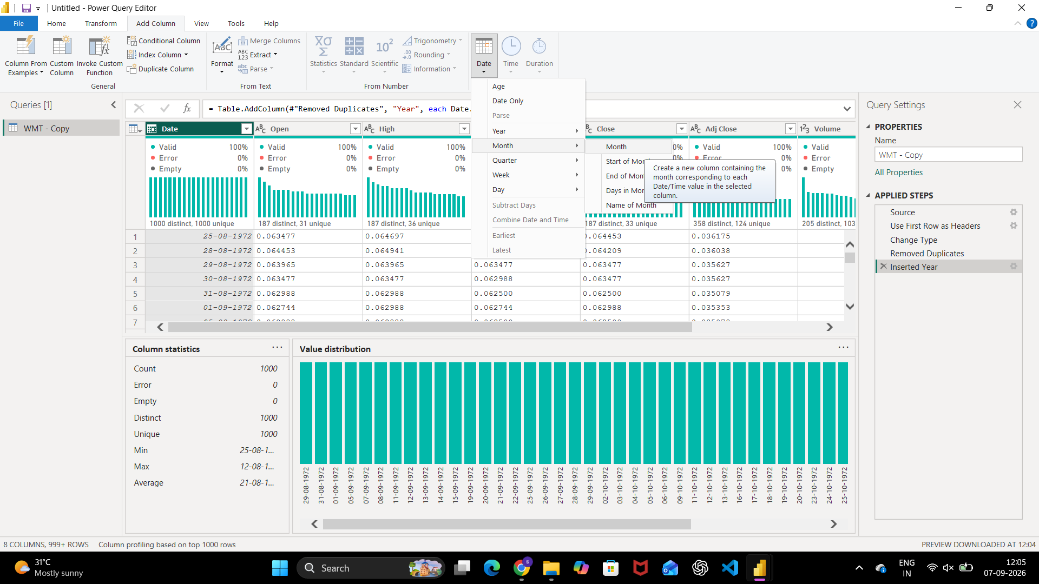
Fig. 11 — Date → Month option, with the Year column already inserted

Part C: Building Dimension Tables
Step 8: Duplicate the cleaned amazon query to create working copies.
Right-clicking the amazon query and choosing Duplicate (or Reference) created amazon (2), used as the source for each dimension table without altering the original cleaned query.
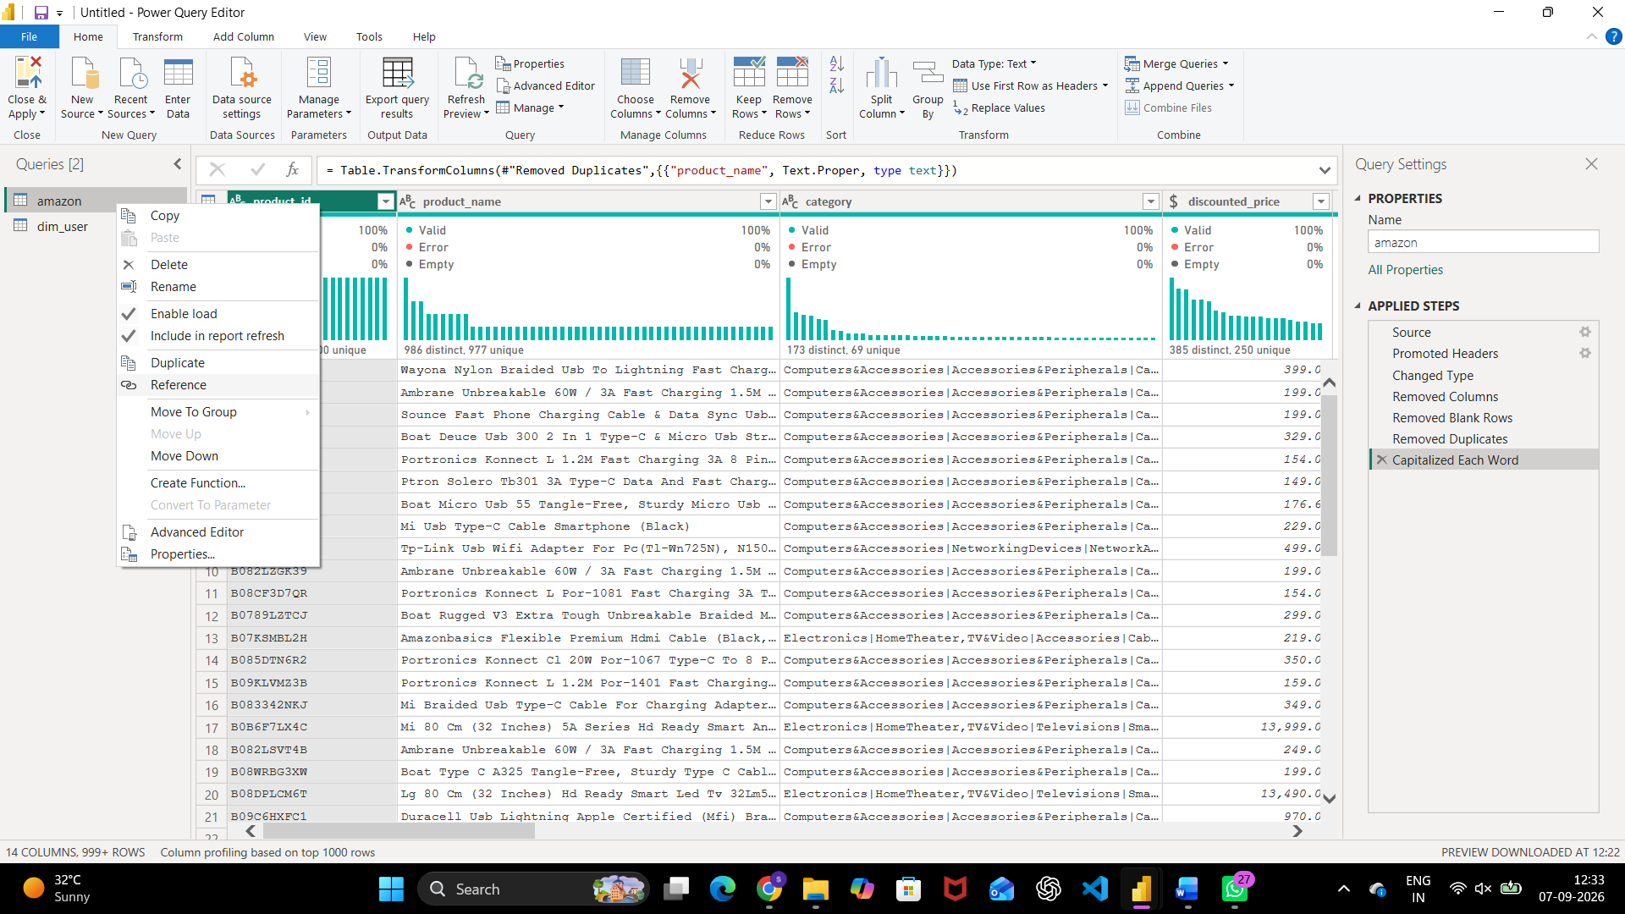
Fig. 12 — Duplicate / Reference options on the amazon query
Step 9: Use Choose Columns to build dim_price.
Right-click column header > Choose Columns → keep product_id, discounted_price, actual_price, discount_percentage
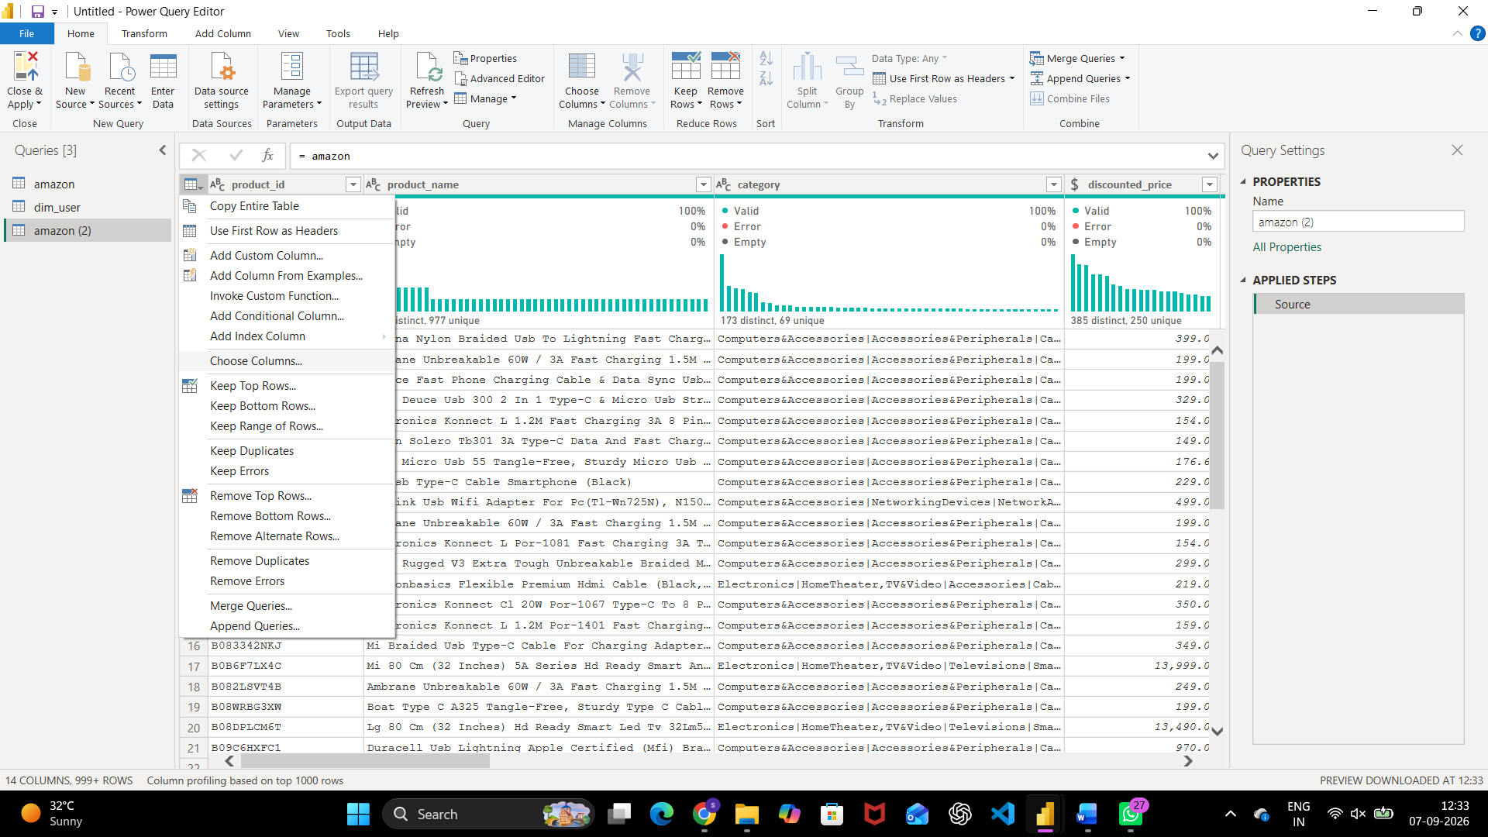
Fig. 13 — Choose Columns command on the amazon (2) query
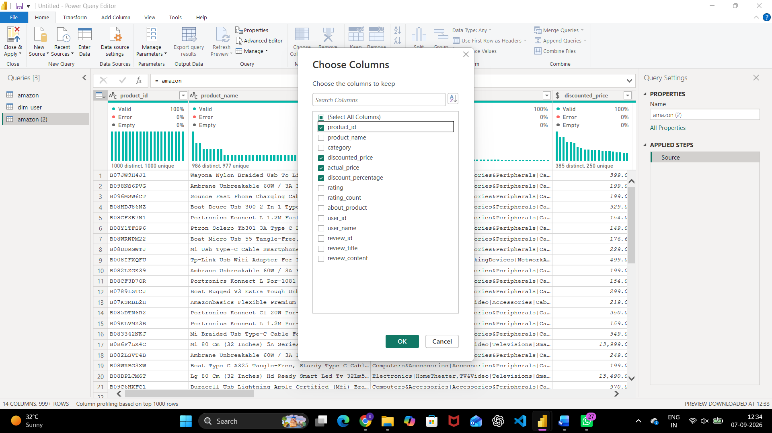
Fig. 14 — Choose Columns dialog — product_id, discounted_price, actual_price, and discount_percentage kept for dim_price
Step 10: Repeat the pattern to build dim_review and dim_user.
The same duplicate-then-Choose-Columns pattern was repeated to build dim_review, keeping product_id, product_name, rating, rating_count, user_id, review_id, and review_title, and dim_user, keeping the user identity fields.
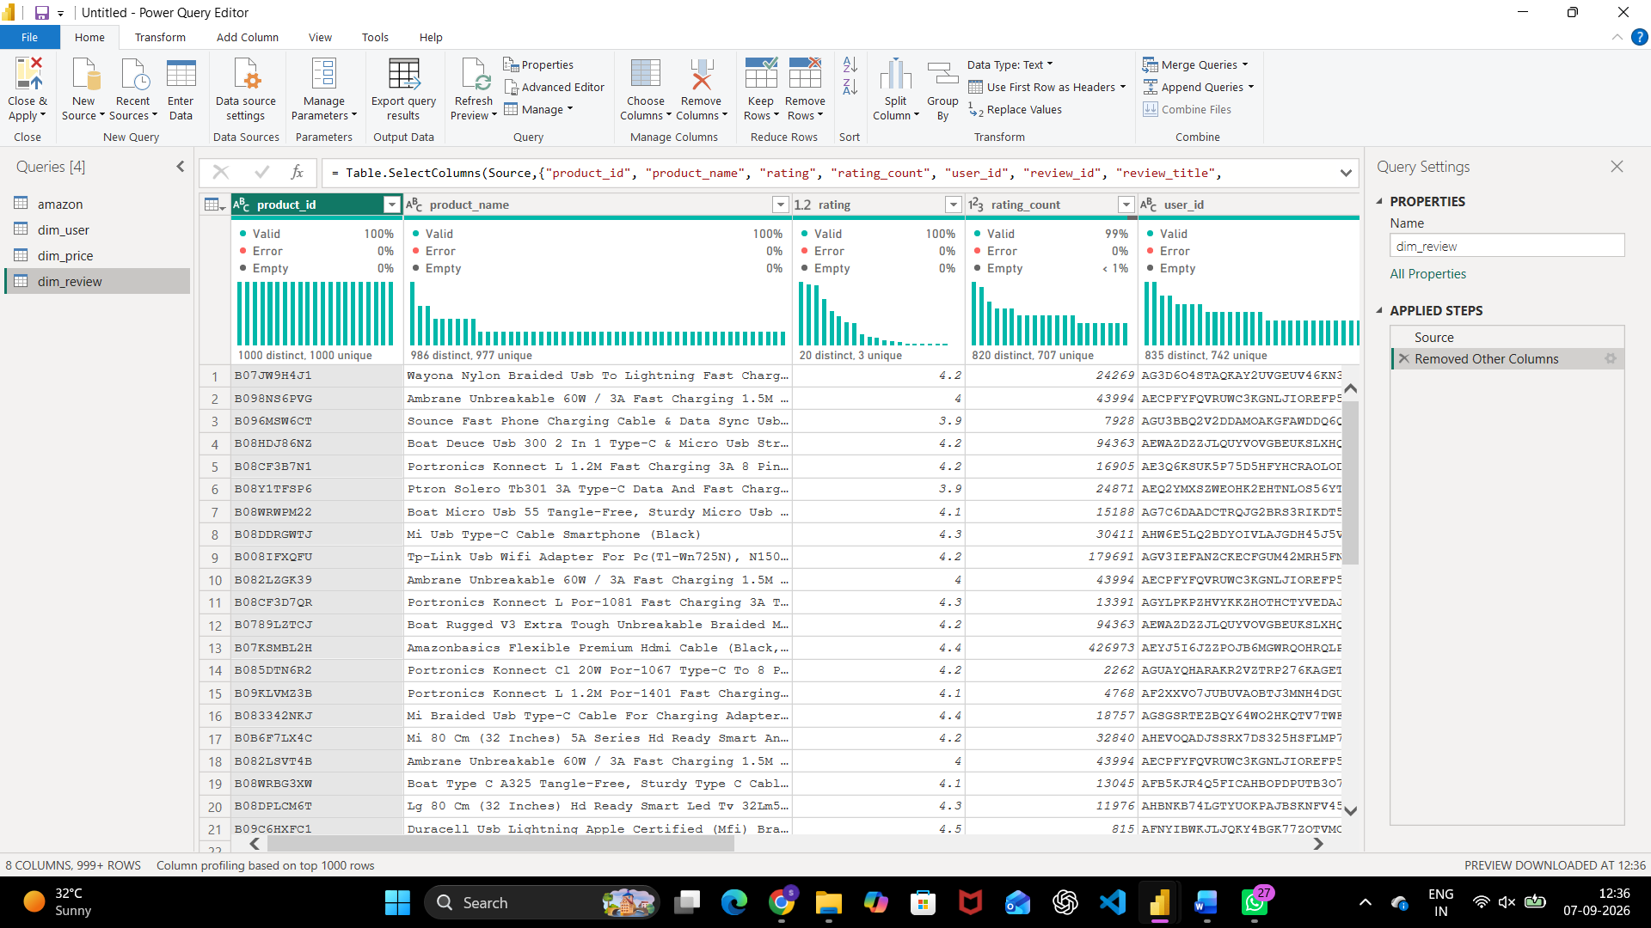
Fig. 15 — dim_review query — product, rating, and review fields kept

Part D: Relationships
Step 11: Relate each dimension table back to product_id.
A new relationship was defined from dim_price to dim_review on product_id, set to Many to one.
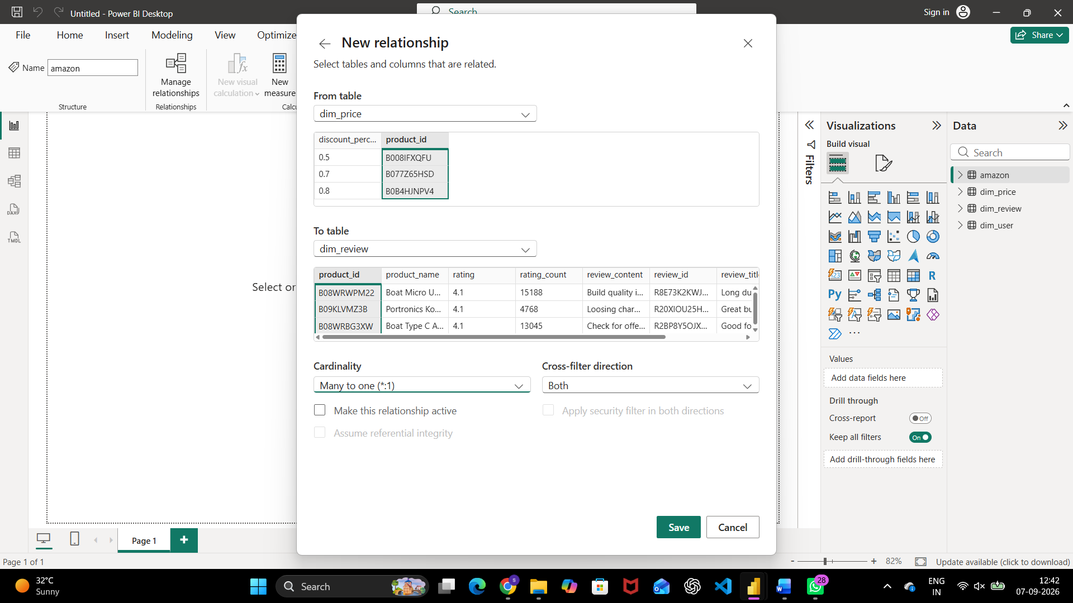
Fig. 16 — New relationship: dim_price → dim_review on product_id, Many to one
Step 12: Review all relationships in Manage Relationships.
Manage Relationships shows dim_price, dim_review, and dim_user each related to the central amazon table on product_id (Active, one-to-one), with additional inactive many-to-one paths available between the dimension tables themselves for alternate analysis paths.
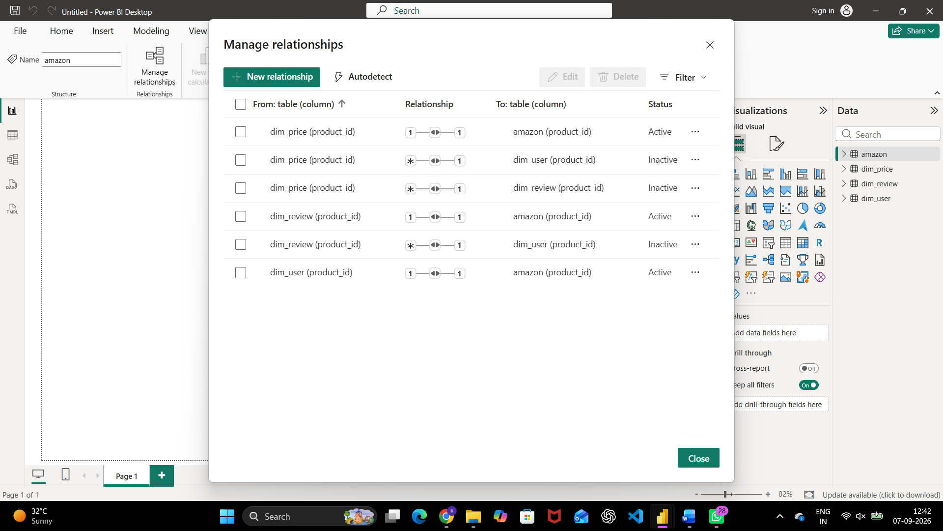
Fig. 17 — Manage relationships — dim_price, dim_review, and dim_user related to the amazon table

Part E: Decomposition Tree Reporting
Step 13: Build a decomposition tree of discount_percentage and actual_price by user and product.
A decomposition tree was added with Sum of discount_percentage and Sum of actual_price as the analyzed measures, broken down by user_name and product_name, alongside a bar chart of the same measures.
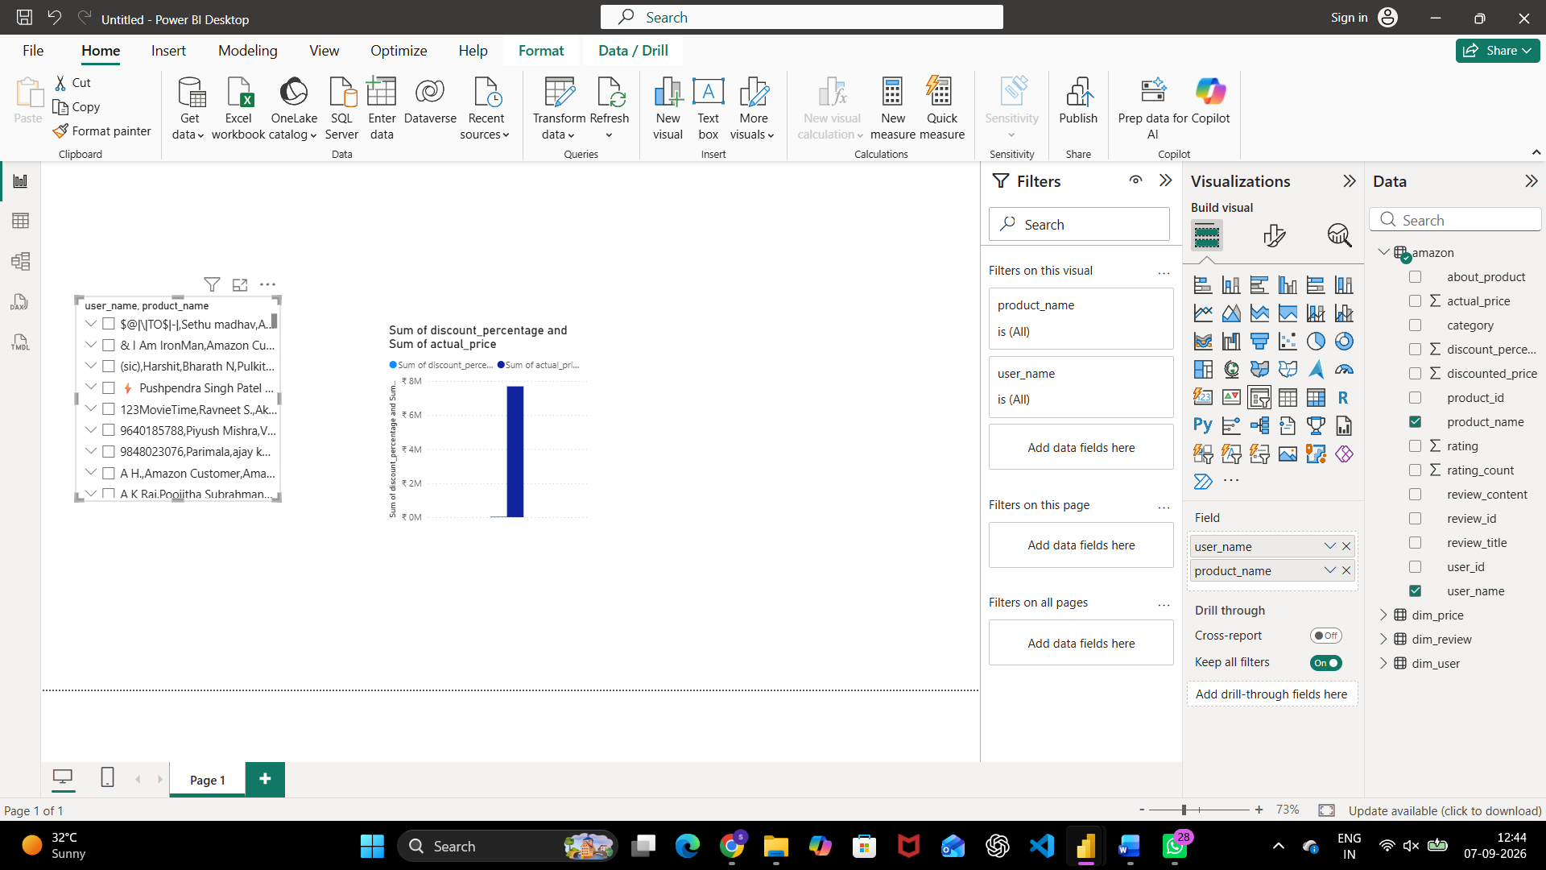
Fig. 18 — Page 1: decomposition tree and bar chart, initial scale
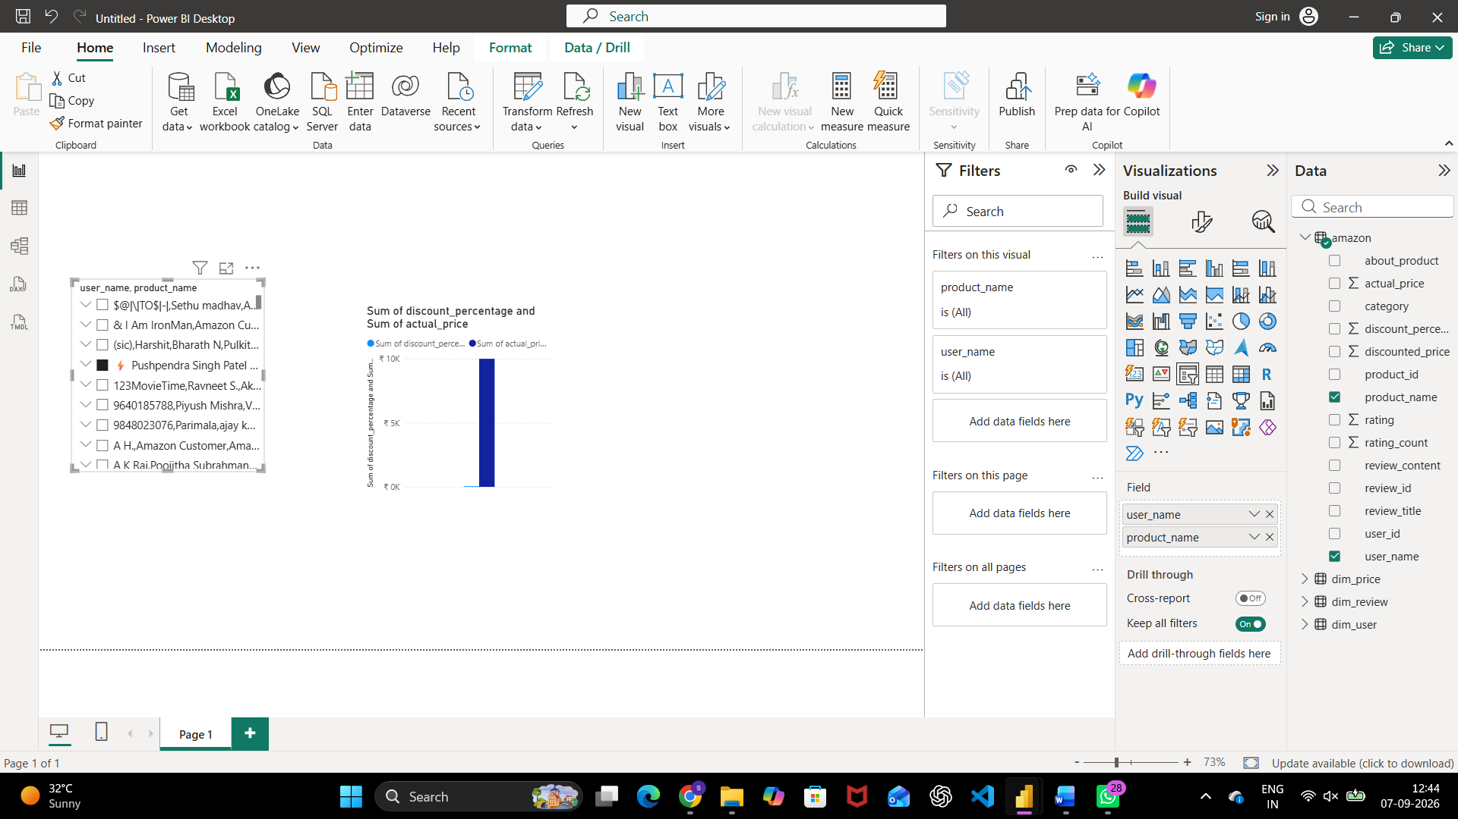
Fig. 19 — Page 1: same visuals after the underlying values were recalculated
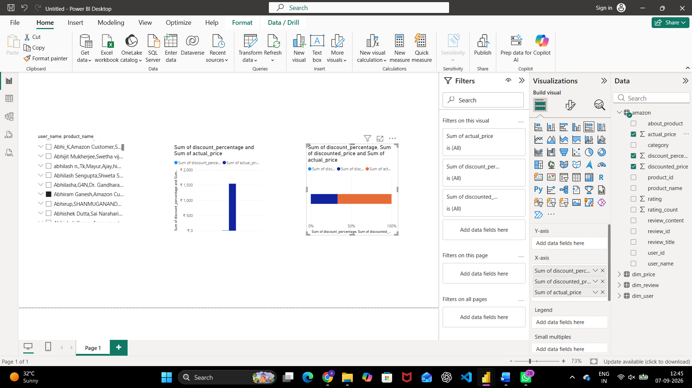
Fig. 20 — Page 1 finished: decomposition tree, bar chart, and a 100% stacked bar of discount_percentage, discounted_price, and actual_price
Step 14: Decompose user_id by user_name on a second page.
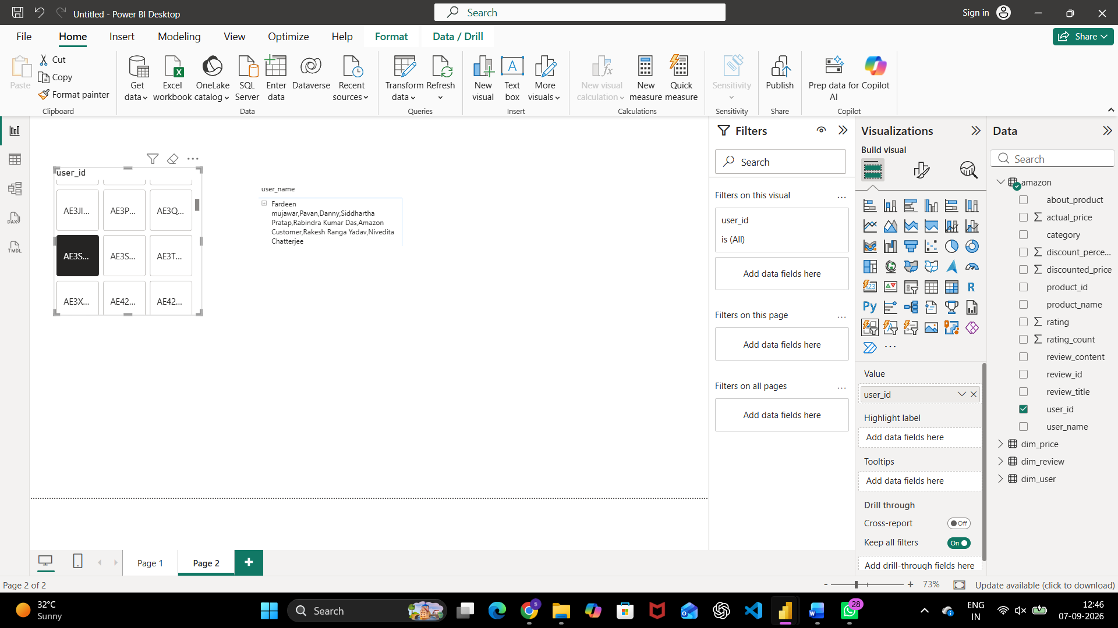
Fig. 21 — Page 2: decomposition tree of user_id expanded by user_name
Step 15: Add a product/review decomposition tree with an actual_price filter.
Page 3 combines a decomposition tree of product_id, user_id, product_name, and review_id with an actual_price range card, letting the analysis be scoped to a specific price band.
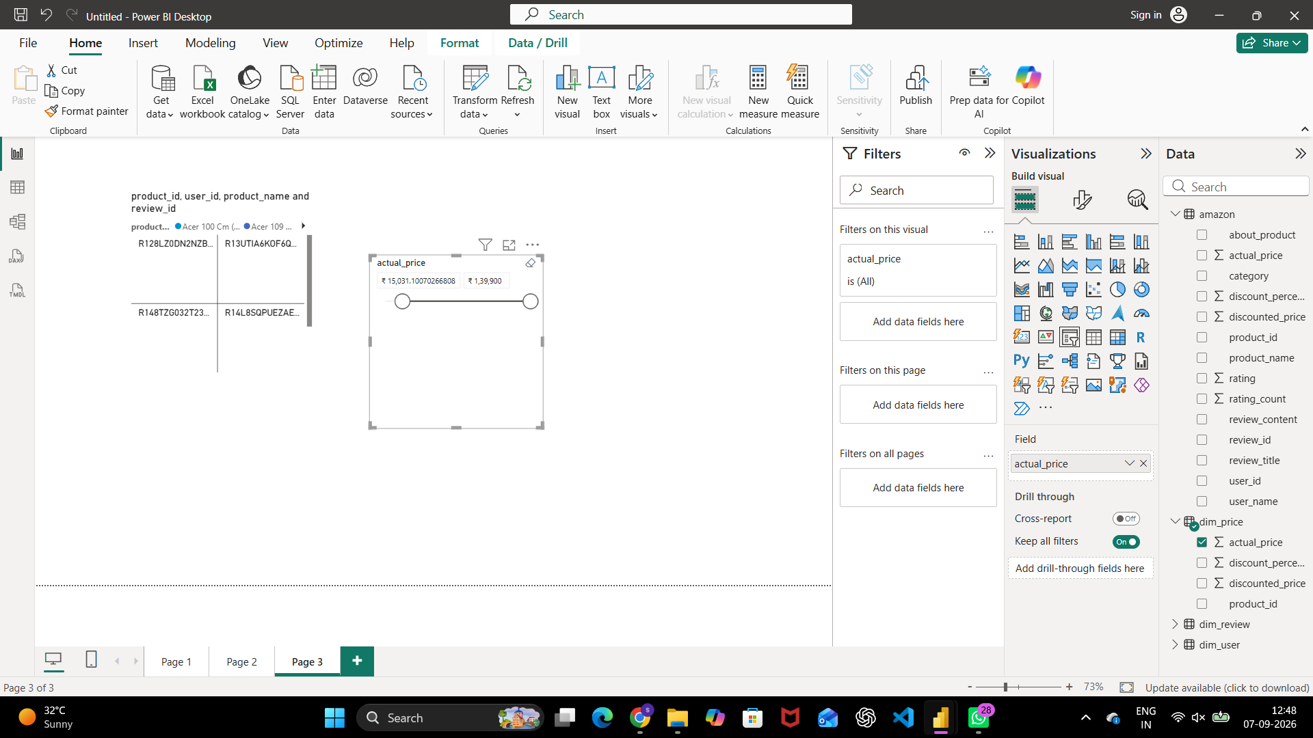
Fig. 22 — Page 3: product/review decomposition tree with an actual_price range slicer
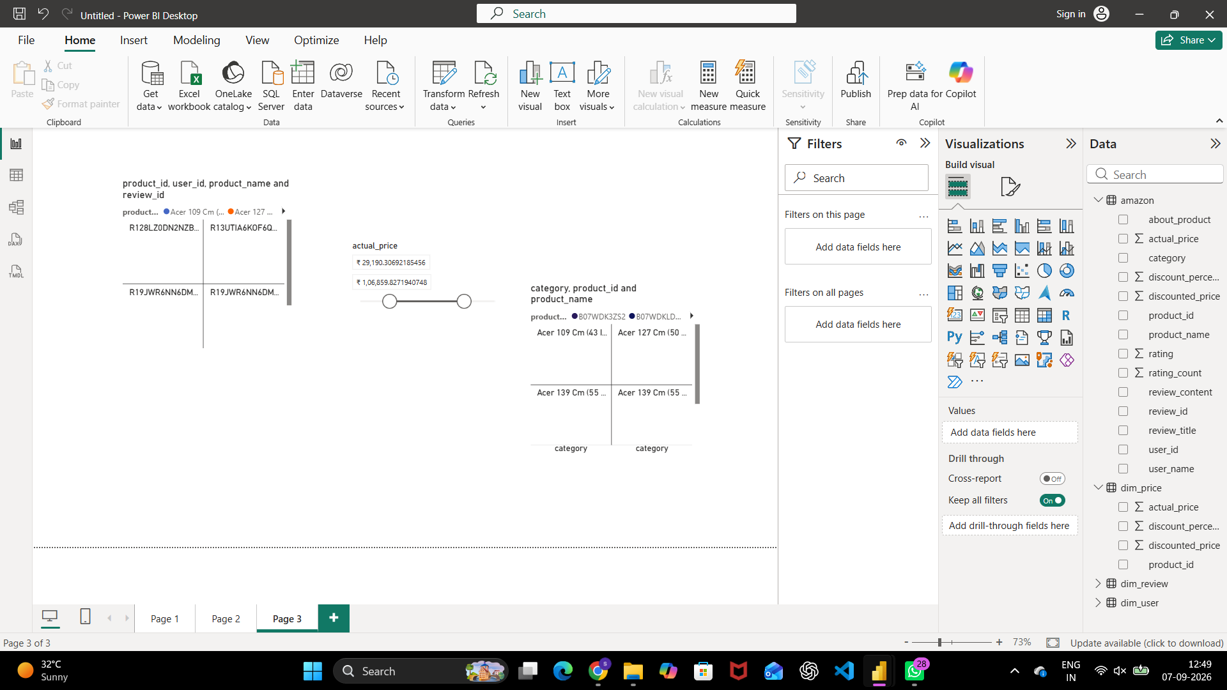
Fig. 23 — Page 3: a second decomposition tree breaking down category, product_id, and product_name
Step 16: Add a user/review decomposition tree on a fourth page.
Page 4 decomposes user_id, user_name, and review_id together, letting an analyst trace a specific review back to the user and product it belongs to.
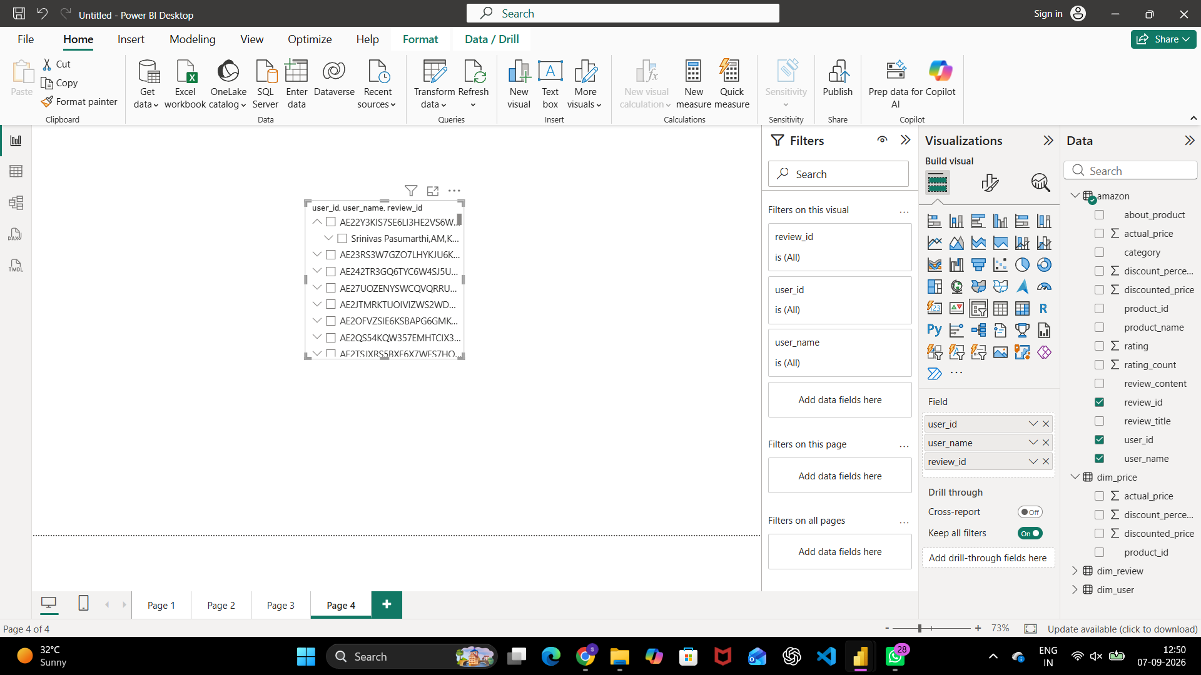
Fig. 24 — Page 4: decomposition tree of user_id, user_name, and review_id
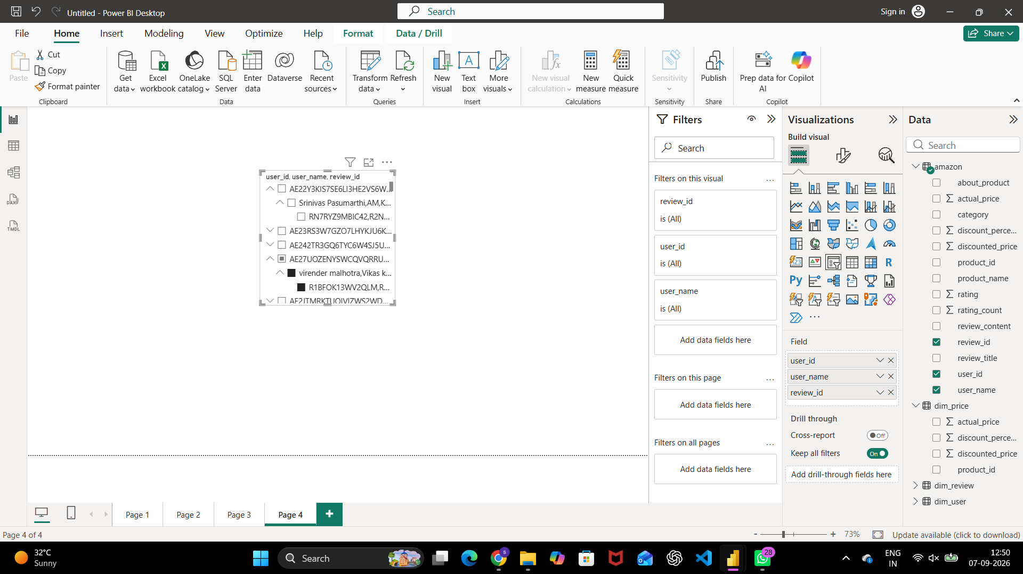
Fig. 25 — Page 4: the same tree with additional user rows expanded

Result
The Amazon product dataset was successfully cleaned in Power Query — removing blank rows, duplicate records, and unnecessary columns, and standardizing text casing — and a similar cleaning pass was carried out independently on a stock-price dataset. Three dimension tables (dim_price, dim_review, dim_user) were built from the cleaned data and related back to the main amazon table, and a four-page interactive report using decomposition tree visuals was produced to explore discount, pricing, and review patterns by user and product.

Learning Outcomes
After completing this assignment, students will be able to:
- Apply Power Query data-cleaning techniques — removing blanks, duplicates, and unwanted columns, and standardizing text.
- Build dimension tables from a single wide table using duplication and Choose Columns.
- Define and review relationships between fact and dimension tables in Power BI.
- Design decomposition tree visuals for open-ended, multi-dimensional analysis.
- Produce a multi-page interactive report for business exploration of a real-world dataset.

