**DOCKER - SIMPLE CALCULATOR DEPLOYMENT**

**Introduction**

This report provides a step-by-step guide for deploying a **Simple Calculator** web application (built with HTML, CSS, and JavaScript) using Docker. The process involves containerizing the application, running it in a Docker container, and optionally pushing it to Docker Hub for sharing.

**Step 1:** Create a Dockerfile

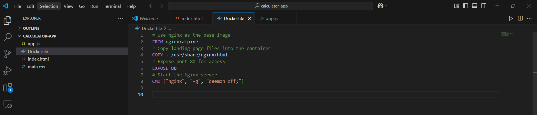

A Dockerfile is needed to define the environment for running the landing page. Below is the content of the Dockerfile:

# Use Nginx as the base image

FROM nginx:alpine

# Copy landing page files into the container

COPY . /usr/share/nginx/html

# Expose port 80 for access

EXPOSE 80

# Start the Nginx server

CMD ["nginx", "-g", "daemon off;"]

**Step 2:** Build the Docker Image

To create a Docker image from the project directory containing the Dockerfile, execute the following command:

**docker build -t simple-calculator .**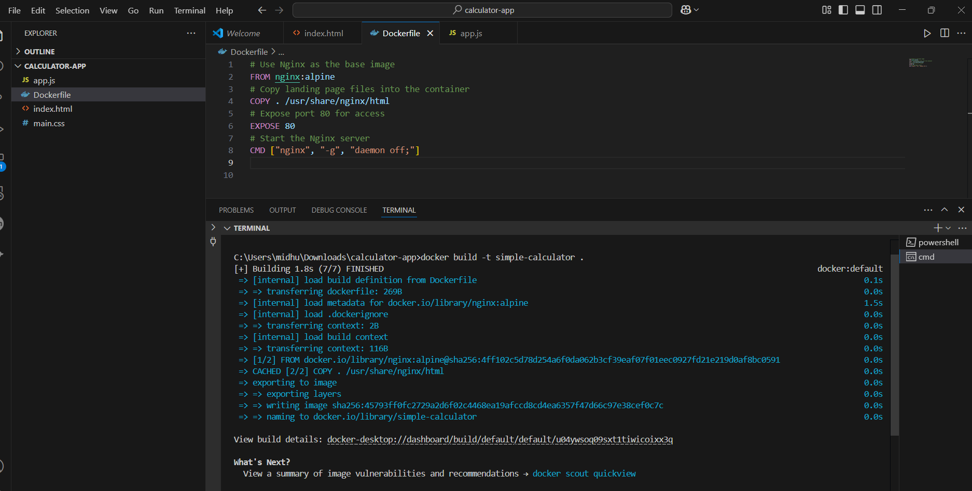

This command builds an image named my-landing-page with the tag latest.

**Step 3:** Run the Docker Container

To deploy and access the landing page, start a Docker container using:

**docker run -d -p 9000:80 simple-calculator:latest**



-d: Runs the container in detached mode.

-p 9000:80: Maps port 9000 on the host to port 80 inside the container.

**Step 4:** Verify Deployment

Open a web browser and navigate to:

**http://localhost:9000**

If deployed successfully, the landing page should be displayed.

**Step 5:** Push the Image to Docker Hub (Optional)

To share the image, push it to Docker Hub by following these steps:

* Login to Docker Hub:
* docker login
* Tag the image for Docker Hub:
* docker tag my-landing-page:latest your-dockerhub-username/my-landing-page:latest
* Push the image:
* docker push your-dockerhub-username/my-landing-page:latest
* To pull and run the image, others can use:
* docker run -d -p 9000:80 your-dockerhub-username/my-landing-page:latest

**Step 6:** Stop and Remove the Container (If Needed)

**To stop a running container:**

docker ps # Identify the container ID

docker stop <container-id>

**To remove a stopped container:**

docker rm <container-id>

**To remove the image:**

docker rmi my-landing-page:latest

**Conclusion**

This report outlined the process of deploying a Simple Calculator using Docker, from building an image to running a container and optionally pushing the image to Docker Hub. Following these steps ensures an efficient, scalable, and portable deployment process.