**PRINCIPLE OF DEVOPS**

**Name:** Krittika V

**Roll No:** 22BCS053

**Experiment No. 1**

**Exploring Git Commands through Collaborative Coding.**

**Experiment Steps:**

**Step 1: Setting Up Git Repository**

* Open the command-line interface on your computer.
* Navigate to the directory where you want to create your Git repository.
* Run the following commands:

***git init***

* This initialises a new Git repository in the current directory.

**Step 2: Creating and Committing Changes**

* Create a new text file named "example.txt" using any text editor.
* Add some content to the "example.txt" file.
* In the command-line interface, run the following commands:

***git status***

* This command shows the status of your working directory, highlighting untracked files.

***git add example.txt***

* This stages the changes of the "example.txt" file for commit.

***git commit -m "Add content to example.txt"***

* This commits the staged changes with a descriptive message.

**Step 3: Exploring History**

Modify the content of "example.txt."

Run the following commands:

***git status***

* Notice the modified file is shown as "modified."

***git diff***

* This displays the differences between the working directory and the last commit.

***git log***

* This displays a chronological history of commits.

**Step 4: Branching and Merging**

Create a new branch named "feature" and switch to it:

***git branch feature***

***git checkout feature***

or shorthand:

***git checkout -b feature***

* Make changes to the "example.txt" file in the "feature" branch.
* Commit the changes in the "feature" branch.
* Switch back to the "master" branch:

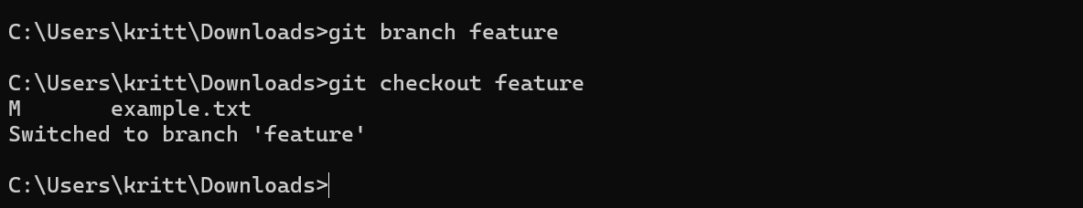

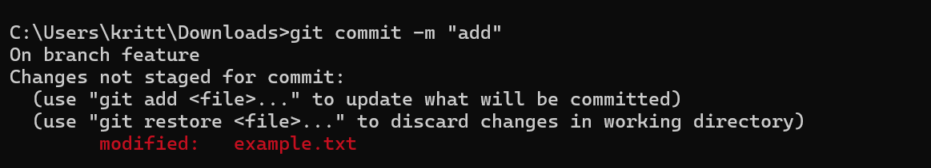

***git checkout master***

***git merge feature***

* Merge the changes from the "feature" branch into the "master" branch:

**Step 5: Collaborating with Remote Repositories**

* Create an account on a Git hosting service like GitHub (https://github.com/).
* Create a new repository on GitHub.
* Link your local repository to the remote repository:

***git remote add origin <repository_url>***

* Push your local commits to the remote repository:

***git push origin master***



