**PRINCIPLE OF DEVOPS**

**Name:** Krittika V

**Roll No :** 22BCS053

**Experiment No. 2**

**Implement GitHub Operations using Git.**

**Experiment Steps:**

**Step 1: Cloning a Repository**

* Sign in to your GitHub account.
* Find a repository to clone (you can use a repository of your own or any public repository).
* Click the "Code" button and copy the repository URL.
* Open your terminal or command prompt.
* Navigate to the directory where you want to clone the repository.
* Run the following command

**git clone <repository_url>**

* Replace <repository_url> with the URL you copied from GitHub.
* This will clone the repository to your local machine.

**Step 2: Making Changes and Creating a Branch**

Navigate into the cloned repository:

**cd <repository_name>**

* Create a new text file named "example.txt" using a text editor.
* Add some content to the "example.txt" file.
* Save the file and return to the command line.
* Check the status of the repository:

**git status**

* Stage the changes for commit

**git add example.txt**

* Commit the changes with a descriptive message:

**git commit -m "Add content to example.txt"**

* Create a new branch named "feature"

**git branch feature**

* + Switch to the "feature" branch:

**git checkout feature**

**Step 3: Pushing Changes to GitHub`**

* Add Repository URL in a variable

**git remote add origin <repository_url>**

* Replace <repository_url> with the URL you copied from GitHub.
* Push the "feature" branch to GitHub

**git push origin feature**

* Check your GitHub repository to confirm that the new branch "feature" is available.

**Step 4: Collaborating through Pull Requests**

* Create a pull request on GitHub:
* Go to the repository on GitHub.
* Click on "Pull Requests" and then "New Pull Request."
* Choose the base branch (usually "main" or "master") and the compare branch ("feature").
* Review the changes and click "Create Pull Request."
* Review and merge the pull request:
* Add a title and description for the pull request.
* Assign reviewers if needed.
* Once the pull request is approved, merge it into the base branch.

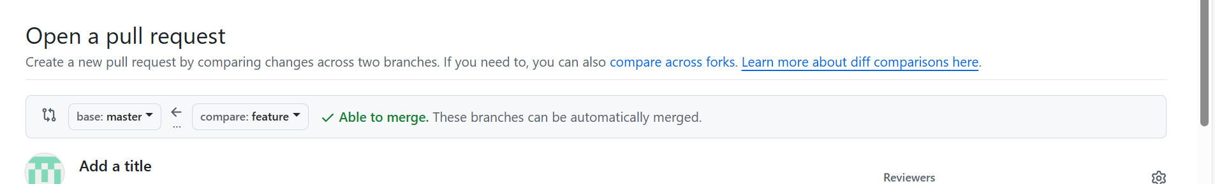

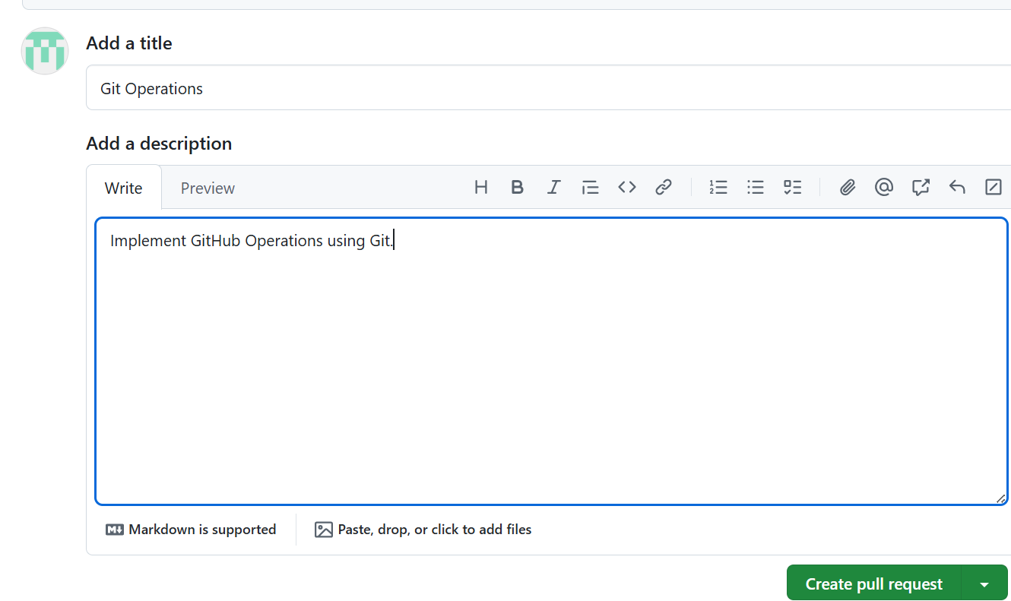

**Step 5: Syncing Changes**

* After the pull request is merged, update your local repository

**git checkout main**

**git pull origin main**

