[GVK BIO](http://www.gvkbio.com/)

Requirement Specification Document

**Tracker**

GVK Biosciences Private Limited

Informatics Division

Plot No: 79, Nacharam,

IDA Mallapur, Hyderabad – 500076, India.

Tel: +91 40 6736 6200 / 6736 6300

Fax: +91 40 67366444

Table of Contents

1 Introduction 5

1.1 Overview 5

1.2 Purpose 6

1.3 Intended audience 6

2 Business Process Understanding 6

2.1 System Functional Overview 7

2.1.1 *Hi*gh Level System Context 7

2.1.2 Technology Overview 9

2.1.3 System interfaces Overview 9

2.1.4 Data Model 10

3 Business Requirements 11

3.1 Application Scope and Boundary 11

3.2 Users of the Application 12

4 Application Flow 12

4.1 Create New Account 14

4.2 Login 15

4.3 Dashboard 15

*4.3.1* *My Activities* 15

*4.3.2* *All Activities* 15

*4.3.3* *My Franchise(s)* 15

*4.3.4* *My Line Function Team* 15

4.4 Activity 15

*4.4.1* *Create New Activity* 15

*4.4.2* *View Activity* 15

*4.4.3* *Edit/Update Activity* 15

*4.4.4* *Complete Activity* 15

*4.4.5* *Clone Activity* 15

*4.4.6* *Create Multiple Versions* 15

*4.4.7* *View Revisions* 15

*4.4.8* *Request Update* 15

*4.5* Reports 15

*4.5.1* *Standard Reports* 15

*4.5.2* *Saved Reports* 15

*4.5.3* *Scheduled Reports* 15

*4.5.4* *My Scheduled Reports* 15

4.6 Activities Dashboard 15

4.7 Associate Dashboard 15

4.8 Resource Management 15

4.9 Search 15

*4.9.1* *Global Search* 15

*4.9.2* *Advanced Search* 16

4.10 Alerts/View All Alerts 16

4.11 My Account 16

4.12 Admin 16

*4.12.1* *Manage Users* 16

*4.12.2* *System Configurations* 16

*4.12.3* *Manage File Uploads* 16

*4.12.4* *Role Based Permissions* 16

*4.12.5* *User Based Permissions* 16

*4.12.6* *Administer Metadata* 16

*4.12.7* *Audit Trail Log* 16

*4.12.8* *ClinAdmin Connection* 16

*4.12.9* *Manage API* 16

*4.12.10* *Run Cron Tasks* 16

4.13 Create New Account 16

4.13.1 Create Activity 17

4.13.2 View Users 19

4.13.3 User Editing 19

4.13.4 User Deleting 20

4.13.5 Create & View Role: 20

4.13.6 Assign User Roles: 21

4.13.7 Role based application access: 22

4.13.8 Problem in sign in 23

4.14 Search 26

4.14.1 Login: 26

4.14.2 Search Page: 29

4.14.3 Summary View 35

4.14.4 View Studies 41

4.14.5 Results View 44

4.14.6 View saved queries 66

4.14.7 View Archived data: 69

4.14.8 Create Template 71

4.14.9 ViewTemplates 82

4.14.10 View Specification: 85

4.14.11 IndicationSummary 91

5 System Requirements 93

5.1 Application Architecture 93

5.2 Architecture Requirements 93

5.2.1 Miscellaneous System Requirements 94

5.2.2 Pending decisions and Risks 94

6 Data Migration Requirements 94

7 Backup & Data Recovery Requirements 94

8 Special User Requirements 94

8.1 Security 94

8.2 Reliability 94

8.3 Audit Trial 95

8.4 User Training 95

8.5 User Manual & Help 95

9 Risk 95

10 Document References 95

11 Open Issues 95

12 Review and Sign Off 95

Document Revision History

|  |  |  |  |  |  |
| --- | --- | --- | --- | --- | --- |
| **Ver #** | **Date** | **Author** | **Reviewer** | **Description of Changes** | **Comments** |
|  | 26thAug 2013 | GVKBIO | Group Review |  | Initial Draft |
|  | 06th Sep 2013 | GVKBIO |  | Removed “Tracking Versions of the data” since this functionality is not in the scope of application development | Section 1.1- Overview |

REQUIREMENTS SPECIFICATIONS

# Introduction

## Overview

*As there is high attrition rate, high development costs and time involve in the process of drug discovery, there is a need to have efficient drug discovery process. In order to achieve the effective drug development there should be ability to access the data*

* *Quickly*
* *Securely*
* *Share& Explore*
* *Analyzecomprehensive*
* *Integrated*
* *Up-to-date clinical efficacy and safety data*

*There is abundant clinical trial outcomes information available in public domain. This data can beleveraged to address the high attrition rate involved in and expedite the drug developmentprocess with the help of quantitative development techniques like Model-based meta-analysis*

*(MBMA)*

*In order to have the information to hand when required, published literature data needs to beextracted, normalized and stored in a meaningful way. It must be possible to query the data ina variety of ways when required. Furthermore, it is very important that the users of the datahave confidence in that data and that time is not lost verifying that data.*

*The simplest approach is to record the data in an excel spreadsheet. While this is straightforwardto implement, there are some limitations like*

* *Querying the data*
* *Preventing duplication of data*
* *Automating the validation of the input data*
* *Quality control*
* *Data loading*
* *Relational search*

*To overcome the above said limitations as well as providing a much better platform for searching, extracting, exchanging and usingthe data, the data has to be stored in a relational database structure, which can provide more effective and extendible platform for querying and extracting thedata. Such a solution being offered is* ***Clinical Trial Outcomes Database (CTOD)*** *application*

## Purpose

*Purpose is to develop a web application that facilitates efficient retrieval and usage of the data by user groups (Pharmacometricians, Clinical trial protocol development groups, Health outcome research groups etc.) and subsequently support quantitative decision making.*

***Modules that constitute a comprehensive application are***

1. *Admin and Meta data management*
2. *Data Development life cycle (Extraction/Rev/QC)*
3. *Querying platform to retrieve the data and export in multiple formats*
4. *View and generate exportable standard and customized Reports*
5. *Graphical data visualizations*

*While all the above modules are essential, a modular approach can be adapted to develop the comprehensive platform. This version of the document covers the development of below mentioned modules:*

1. ***Search :*** *Querying platform to retrieve the data and export in multiple formats*
2. ***Reporting :*** *View and generate exportable standard and customized Reports*
3. ***Visualization:*** *Graphical data visualizations*
4. ***User Management:*** *Managing the user & roles*

## Intended audience

*The objective of this toolis to support Pharmacometricians, Clinical trial protocol development groups, Health outcome research groups etc. to search,retrieve and use the data.*

# Business Process Understanding

*In the CTOD application the key entity is the clinical trial assessment time course data or study endpoint. The database should store the information of clinical trial outcomes at a summary level extracted from external published literature.*

*There can be several publications for the same clinical trial. Trials in a particular disease area of interest e.g. diabetes, should be clustered together and be searchable using the appropriate search terms.*

## System Functional Overview

* *User management*
* *Search on complete data*
* *Reporting&VisualizationExport*

### *Hi*gh Level System Context



Figure 1

***Application Work flow***



Flow Diagram 1

### Technology Overview



Figure 2

### System interfaces Overview

*There will be no interaction with external systems.*

### Data Model

The Below figure depicts high level illustration of the data model.  
Figure 3

**

*Note: The flow and design may change based on the final SRS document.*

# Business Requirements

Below are the list of requirements, these requirements are categorized as per the business criticality like:

* P1 : High
* P2: Medium
* P3: Low

| **Req. ID** | **Requirement Description** | **Business Criticality** | **Comment** |
| --- | --- | --- | --- |
|  |  |  |  |

## Application Scope and Boundary

Scope of the application is to provide search and visualizationas mentioned below. CTOD data development (Curation/Review/QC) is out of scope for this version of application.

**CTOD Search & Visualization:**

* ***Data Model:*** *Create data model that can be easily scalable to multiple diseases areas.*
* ***Admin:*** *Purpose of Admin is to manage all the admin related activities like user management, metadata management, definition & maintenance of data group& task management.*
* ***Search:****Search the database by the selecting the defined fields and user inputs.*
* ***Reporting:*** *Retrieving the data from the database as per the selected criteria.*
* ***Visualization:*** *Display the search results data in graphical representation*

## Users of the Application

Below are the users of the ModTracker Application:

| **Role** | **Responsibilities** |
| --- | --- |
| Associate |  |
| Franchise Leader |  |
| Project Manager |  |
| Line Function Head |  |
| Senior Mentor |  |
| Programmer |  |
| Assistant |  |
| Reviewer |  |

# Application Flow

Application flow is categorized into different modules as below

* **Create New Account**
* **Login**
* **Dashboard**
  + **My Activities**
  + **All Activities**
  + **My Franchise(s)**
  + **My Line Function Team**
  + **Types of Activities**
* **Activity**
  + **Create New Activity**
  + **View Activity**
    - Audit Trail
  + **Edit/Update Activity**
    - Audit Trail
  + **Complete Activity**
  + **Clone Activity**
  + **Create multiple versions**
  + **View Revisions**
  + **Request Update**
* **Reports**
  + **Standard Reports**
    - Run
    - Customize
    - Schedule
  + **Saved Reports**
    - Run
    - Customize
    - Schedule
    - Delete
  + **Scheduled Reports**
    - Delete
  + **My Scheduled Reports**
  + **Export Report**
  + **Reports Help**
* **Activities Dashboard**
* **Associate Dashboard**
* **Resource Management**
* **Search**
  + **Global Search**
  + **Advanced Search**
* **Alerts/View All Alerts**
* **My Account**
* **Admin**
  + **Manage Users**
    - View
    - Edit
    - Activate/Deactivate
  + **System Configurations**
  + **Manage file uploads**
  + **Role based permissions**
  + **User based permissions**
  + **Administer metadata**
    - Create
    - Edit
    - Delete
  + **Audit Trail Log**
  + **ClinAdmin Connection**
  + **Manage API**
    - Create
    - Edit
    - Delete
  + **Run Cron Tasks**

## Create New Account

Any new users must be registered to get access to the application. User may have multiple roles to access the application.

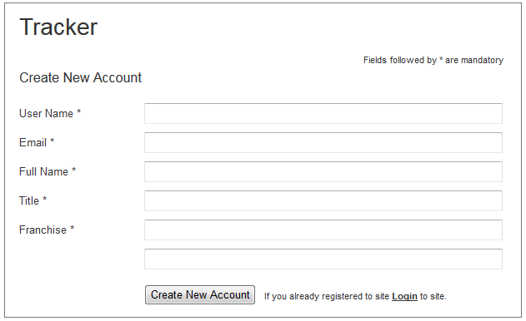

|  |  |  |  |
| --- | --- | --- | --- |
| Screen field details: | | | *FT = Field Type *DT= Data Type |
| **Field** | **Type** | **Validation/Restrictions** | **Description** |
| User Name | FT: Textbox DT: NVarchar | Mandatory Length: 15 Special characters allowed: “_”(underscore) and “.”(dot) | User name required to login into the application |
| Email Address | FT: Textbox DT: NVarchar | Mandatory/Unique Length:50 | User valid email id, activation email will be sent to this email Id |
| Full Name | FT: Textbox DT: NVarchar |  |  |
| Title | FT: Textbox DT: NVarchar |  |  |
| Franchise | FT: Textbox DT: NVarchar | Mandatory Length:12 | User date of birth |
| **Action Items** | | | |
| |  |  |  |  | | --- | --- | --- | --- | | **Control Name** | **Control Type** | **Event** | **Action** | | Create New Account | Button | Click | **Actions:**   * Do Client side validation * Do Server side validation * Save data * Send auto email to users email id   **Client Side Validations:**   * Mandatory fields * Validate captcha text * Validate proper email Id * Validate user name with min length should be 3 * Validate user name format (check field details) * Show proper error messages   **Server Side Validations:**   * Check for unique user name * Check for unique email id * Generate random password * Save user details with password * Send auto email to Id activation * Show success message and inform user to check email and activate his account | | Reset | Button | Click | **Actions:**   * Clear all the values in the form | | | | |

## Login

This feature will give the user a secure and simple login screen. While clicking on “Login” button, login credentials will be validated on both client side and server side. The user will be redirected/logged in only when the credentials are satisfied.

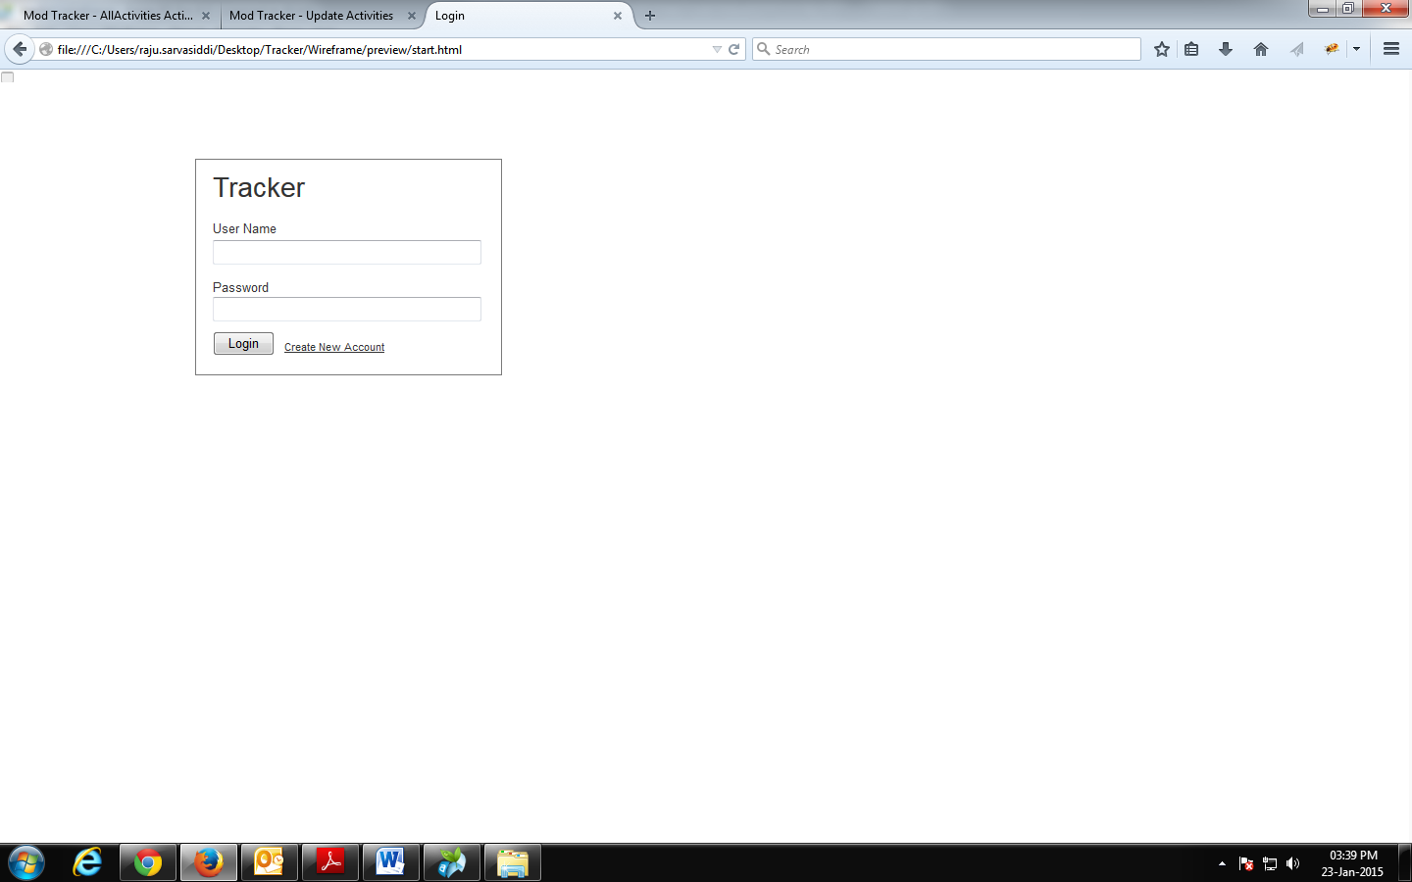

## Dashboard – All Activities

On successful login, user is redirected to dashboard page. This page gives an overview of the activities created by the logged in user and other users of the application.User can view activities as per the activity status under four categories as mentioned below.

Activity Categories:

* My Activities: Activities that are created by the logged user are displayed under this category. By default “My Activities” are displayed in dashboard.
* All Activities:
* My Franchise(s):
* My Line Function Team:

Activity Status: Dashboard displays Activities which are segregated as per the Activity status under the selected category.

Below are the list of activity status:

* **Active:** This tab displays activities with status as “Active” as per selected category.
* Planned
* On Hold
* Completed
* Stopped
* All

Mock Screen:

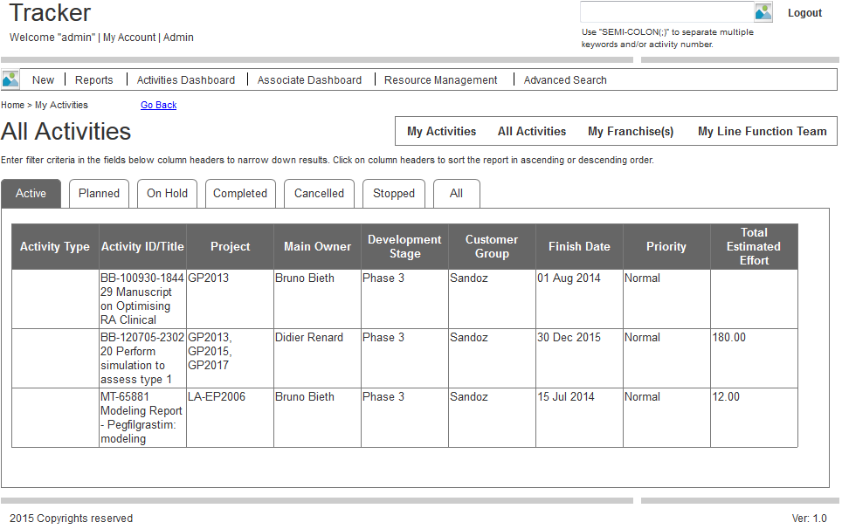

|  |  |  |  |
| --- | --- | --- | --- |
| Screen field details: | | | *FT = Field Type *DT= Data Type |
| **Field** | **Type** | **Validation/Restrictions** | **Description** |
| Activity Type | FT: Dropdown List | NA | * Displays list of activity types. * Default activity type is “All” |
|  |  |  |  |
|  |  |  |  |
|  |  |  |  |
|  |  |  |  |
| **Action Items** | | | |
| |  |  |  |  | | --- | --- | --- | --- | | **Control Name** | **Control Type** | **Event** | **Action** | |  |  |  |  | |  |  |  |  | | | | |

## Activity

### *Create New Activity:*

### Based on the selected “Activity Type” the tab names changes in the “Create New Activity” page. If the selected activity is “Modeling” then the “Create Activity”page appears.

### 

### *View Activity:* User can view the existing activities, which were created by the logged in user or other users.

### *Edit/Update Activity: User can edit/update activity’s title, type, priority, M&S Status, etc. editing an activity is limited to his own activities. Admin can change activities which were created by any user.*

### Audit Trail: *It gives user a glimpse of the activity like log information, edit, update, cron jobs, mail received/sent, etc.*

### *Complete Activity: This marks the activity as a completed activity. It means, user has filled up all the required fields and provided sufficient data. Finally, confirming the activity as completed.*

### *Clone Activity: User can clone an existing activity. By cloning, user makes changes accordingly, without affecting the actual/original activity.*

### *Create Multiple Versions: User can make multiple versions of an activity. It helps in making analysis by comparing multiple versions.*

### *View Revisions: When an activity has multiple versions, user can view those by clicking “View Revisions”button to check the changes are made between the versions.*

### *Request Update: If a user wants to have updates of an activity, user can raise “Request Update”. Request goes to the owner of the activity. From now, user and the owner of the activity will communicate in the chosen way.*

## Reports Report can be used to generate the information based on the user’s requirement in a readable and easilyunderstandable format.

### *Standard Reports: Lists out all the available report types e.g.: “Activity Summary, Compound Summary, Platform Activities, Associate, etc.” User can perform “Run, Customize, and Schedule”.*

### *Saved Reports: After the user run the chosen report, he/she can save the query.The saved query will be displayed under “Saved Reports”.*

### *Scheduled Reports: User’s scheduled reports from “Standard Reports” will be displayed.*

### *My Scheduled Reports: User’s scheduled reports from “Saved Reports” will be displayed.*

## Activities Dashboard: It comes with two graphs as categorized into 1. No. of activities finished by month grouped by priorities 2. No. of activities finished by month grouped by Line Function User can customize the report by changing values of “Franchise, start and end dates”. The data available for the activities under “Activities dashboard” will be displayed under the graphs in tabular format.

## Associate Dashboard: Number of activities and Franchise will be displayed as graph. User can customize the dates of the activities, and the graph will be updated and the data will be displayed in Gantt chart. Graph related data will be displayed year wise under the “My associated activities” section.

## Resource Management: Provides resources status in Gantt chart view. User can choose the data to be displayed by Franchisee, Project, Line Function, Start date, and End date.

## Search: User can search for activities by the Activity Id or by providing keywords.

### *Global Search: If the user knows the Activity ID, he/she can enter the same and can search for it. User can separate the keywords by using Semi-colon “;”.*

### *Advanced Search: User could perform search by providing values for multiple fields under “Activity, Metadata, Specification Variables, and Specification Events”. User can include the activities which are archived.*

## Alerts/View All Alerts

## My Account: *User can check his/her account information like User Name, Full Name, Franchise, Group, Roles, etc. As well, helps user in configuring the Notification settings, Pagination Limit setting, (My activities, All Activities, My Franchise(s) and My Team screen), Query Panel – columns to display.*

## Admin: *This option is available for the Admin user(s) only. Under this section Admin could access tools like “Manage users, change system configurations, manage file uploads, manage role based permissions, user based permissions, administer metadata, audit trail log, ClinAdmin connection, manage API, run cron tasks”.*

### *Manage Users: Admin can manage the users like View all the users, edit details of the user(s), set status to activate/deactivate.*

### *System Configurations: Using this tool, admin can change system configurations like “Auto complete fetch limits, Notification settings, and Archived data”.*

### *Manage File Uploads: Could set file extensions, change maximum file upload count at a time, and size of the file.*

### *Role Based Permissions: Admin can change permissions for roles by checking/unchecking roles.*

### *User Based Permissions: At any point of time, admin could change permissions for a particular user. User can allow permissions by checking/unchecking.*

### *Administer Metadata: It will be populated with a list of sections. Here, admin can Add new items under of these categories. As well, he/she can modify the existing item under category. Also, admin can delete any of the items. Note: Deletion will be a soft delete. It will not be removed from the database.*

### *Audit Trail Log: It helps admin to check log of any action by“user, operation type, by report, activity id, and timestamp”.*

### *ClinAdmin Connection: a*

### *Manage API: API helps other applications to access data of this application. But, it should go through the credentials, which has to be generated by the application. It creates and provides “key, consumer secret, and status of the key”. Admin can change these values at any point of time and also can delete the key.*

### Run Cron Tasks: *This tool helps user to set up and maintain software environments use cron to schedule jobs. By default, it comes with a set of cron jobs which were already scheduled. To run any of these jobs, just click on the respective cron job. Some of the cron jobs cannot run all the times due to impact on the performance.*

# System Requirements

GVK will use the current infrastructure to host and maintain the Application and Database server, no equipment will be purchased under the work order. (*Ref: WO 1 - Signature Pending.pdf*)

## Application Architecture

Figure 4

## Architecture Requirements

* *The application should be hosted by GVK and used the clients thru internet network.*
* *Database server will be Oracle version 11r2 standard database engine.*
* *Application server will be Apache Tomcat 7 running on a Linux Server (Red hat 6.0)*
* *Web application will be developed with browser compatibility ofIE9 &Chrome.*
* *Application should be developed using Java EE 6 standards with backend Oracle11r2.*

### Miscellaneous System Requirements

* **Operating System**: LINUX
* **Database:** Oracle 11r2 is the standard database engine that has to be used.
* **Browser Compatibility**:
  + **Primary**: IE 9 and Google Chrome
* **Web Server:** Apache tomcat 7 as web server on Linux(Red hat6.0) OS
* **Logs:** CTOD Application
* **User Log:** User log(user login activities) is implemented at backend level
* **System Log:** System log (Error log) is implemented at application level.

### Pending decisions and Risks

* *Registering the public domain name – Need to request BMGF*
* *Server on which application and database will be hosted and maintained – GVK should maintain the application and is BioIT call*

# Data Migration Requirements

*Data migration would be required under the below scenarios:*

* ***Data developed in excel sheet:*** *If data developed in excel sheet then that data has to be imported into CTOD search database thru automated scripts. This importing of data will be done whenever the data is developed in excel.*
* ***Data developed in curation tool:*** *If data developed in curation tool then that data will be migrated to CTOD search database using database scripts.*

# Backup & Data Recovery Requirements

*Data backup will be taken regularly on periodic intervals as mentioned below. There will be automation system to take the backups.*

* *Daily*
* *Weekly*
* *Monthly*

# Special User Requirements

## Security

* *User Authentication: User authentication will be done in application level.*
* *Access will be restricted as per the role assigned to user when creating new user.*

## Reliability

No Reliability requirements are defined

## Audit Trial

No Audit Trial Requirements are defined.

## User Training

Training will be provided thru Web-Ex for a team of 8 to 10 members, and will be done by GVK SME team.

## User Manual & Help

User manual will be prepared as per the application flow.

# Risk

Below are few risks identified

|  |  |  |  |  |  |
| --- | --- | --- | --- | --- | --- |
| Sl.no | Risk | Probability | Impact | Mitigation | Comments |
| 1 |  | TBD | TBD | TBD |  |
| 2 |  | TBD | TBD | TBD |  |
| 3 |  | TBD | TBD | TBD |  |

*

# Document References

Referred to the following Documents for Requirements

* CTOD application v0.1.pdf
* Queries_CTOD_0.4.xlsx`
* ClinPharm Data models comparision 27Nov12.xlsx
* Search Page model_v2.0.xlsx
* Customized Template.xlsx
* WO 1 - Signature Pending.pdf
* CTOD global tool Prototype Rev comments_TRS_SP_TRS2.xls

# Open Issues

NA

# Review and Sign Off