

Requirement Specification Document

Nano Health
Phase -1

GVK Biosciences Private Limited
Informatics Division
Plot No: 79, Nacharam,
IDA Mallapur, Hyderabad – 500076, India.
Tel: +91 40 6736 6200 / 6736 6300
Fax: +91 40 67366444
Table of Contents
1 Introduction 5
1.1 Overview 5
1.2 Purpose 5
1.3 Scope 5
1.4 Out of scope 6
1.5 System Functional Overview 6
1.5.1 High Level System Context 7
1.5.2 Technology Overview 9
1.6 Users of the Application 9
1.7 Application Flow: 10
1.8 User Management 11
1.8.1 Login Screen 11
1.8.2 Create User 12
1.8.3 View Users: 14
1.8.4 Create & View Role 16
1.8.5 Add Care Manager 17
1.8.6 Add Doctor 20
1.9 Metadata Management 23
1.9.1 Add Location: 23
1.9.2 Add Category 25
1.9.3 Add Hospital 26
1.9.4 Asset management 27
1.9.5 Add Asset 28
1.9.6 Asset Allocation Report 29
1.9.7 Asset Availability Report 31
1.10 Patient Management 32
1.10.1 Patient Enrolment 32
1.10.2 Patient Management by care manager 42
1.10.3 Patient Management by Doctor 50
1.11 Training 53
1.12 Patient Search 57
1.13 Miscellaneous Business Requirements: 61
1.14 Program Budget approval - Admin 61
1.15 Program Budget creation - Manager 61
1.16 Program Resource Allocation 62
2 System Requirements 62
2.1 Application Architecture 62
2.2 Architecture Requirements 62
2.2.1 Pending decisions and Risks 62
3 Backup & Data Recovery Requirements 63
4 Special User Requirements 63
4.1 Security 63
4.2 Reliability 63
4.3 Audit Trial 63
4.4 User Training 63
5 Risk 63
6 Document References 63
7 Open Issues 64
8 Review and Sign Off 64
9 Appendix 64

Document Revision History

Ver # | Date | Author | Reviewer | Description of Changes | Comments
1.1 | 23-Dec-14 | GVK |  |  | Initial Draft
1.2 | 31-Dec-14 | GVK | Nano Health | - Section 1.6: Added two roles Regional manager and Training Manager with responsibilities  - Updated Login screen, login button as “Login”  - Section 1.8.5: Updated care manager id field in the mock screen and field details.  - Section 1.8.6: Added Clinic/Hospital name field in mock screen and field details. Added Physician id format details in screen field details table  - Section 1.9.1: Added city manager field to location mock screen and screen field details table  - Section 1.10.1: Added enrollment status details in patient enrollment mock screen and screen field details table  - Updated patient questionnaire and diagnostic information screen as per tablet json file  - Added patient enrollment in bulk option in page 44  - Section 1.13: Added “Miscellaneous business requirements” section.
1.3 | 07-Jan-15 | GVK | Nano Health | - Section 1.5.1 Added Nano Health to Heart platform data flow diagram  - Section 1.6 Updated roles and responsibilities as per NanoHealth_HEART_Roles_06Jan15.ppt document  - Section 1.10.1-New Patient questionnaire: Added location co-ordinates in mock screen and screen field details  - Section 1.10.2-Add New Diagnosis: Added location co-ordinates in mock screen and screen field details  - Section 1.12 Added Complaint module as per review comments

REQUIREMENTS SPECIFICATIONS

Introduction

Overview
Nano Health care management utility tool deals with non-communicable diseases. This application will be developed for those diseases which are manageable and measureable. So, initially it will be developed for CVD (Cardio Vascular Diseases) and diabetes.

Purpose
As the age of patient increases, proportionally health care cost also increases. In other words, age of patient is directly proportional to his health care cost. Since no control on reduction of age, efforts should be put on to reduce health care cost. The main objective of Nano health is to reduce the health care cost by using electronic intervention. Health care professionals are the main users of application. Doctors and KOLs are the contributors to the system.
Patient, Payers, Govt & Pharmaceutical companies are the one who pays for it.
Since health cost has direct impact on payers (insurance companies), they would like to use the system for patients health for reducing health cost.

System will use variety of data sources which includes

Internal GVK database
- GOSTAR
- GOBIOM
- CTOD
- DRUG REPURPOSING DB
- Others (if any)

External data sources
- Evidence based medicinal database
- Hospital data sources
- Others

Scope
Due to human life style disorders, 70% of whole world diseases are related to CVD and Diabetics.

- The development scope of Nano Health tool will be for these two diseases.
- Health cost can be reduced by using electronic intervention for changing the life style or reminding the health care (food habits, medicine reminder or timely health measurement and uploading the same to system etc.).

Using these methodology, end stage can be delayed or patient health will be improved.
There are few routine cares which has major impact:
- Healthy food habits,
- Regular exercise,
- Timely medicine without missing a single dose,
- Routine check-ups

Application will be compatible with IE9&10 and Chrome browsers

Out of scope
- Except for CVD and diabetes diseases, other disease areas are out of scope for the system.
- Nano Tab application development & maintenance
- SMS management

System Functional Overview
- User Management
- Meta data Management
- Patient management
- Training

High Level System Context
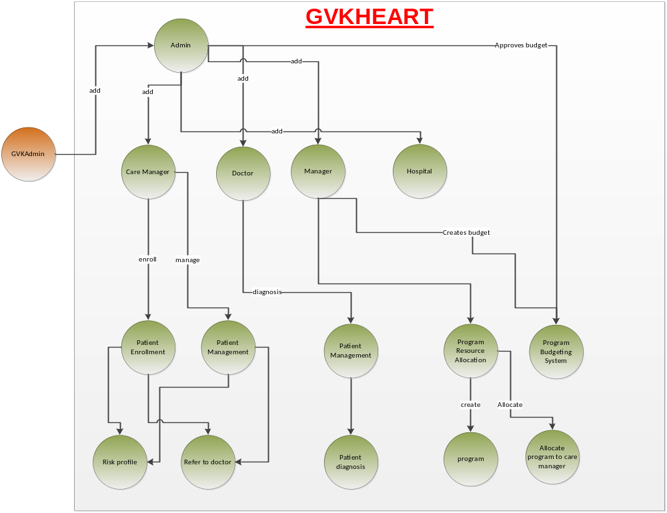
Figure 1

Application Work flow
HEART Platform:
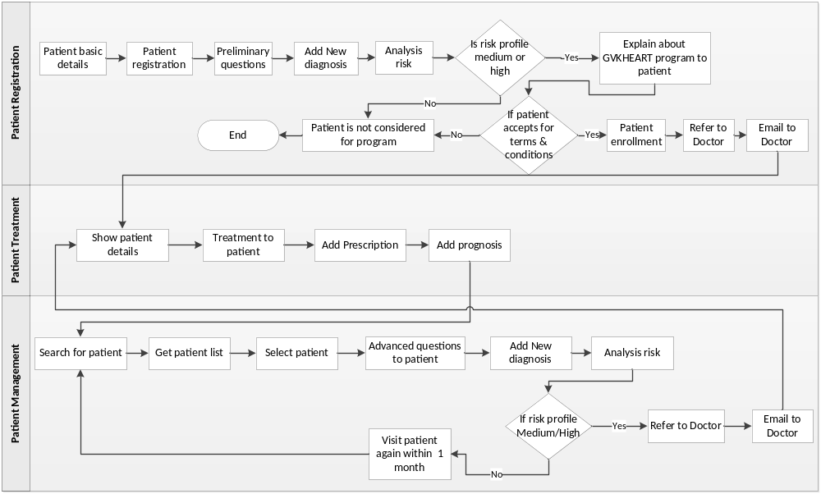
Figure 2
Nano Health to HEART Platform:
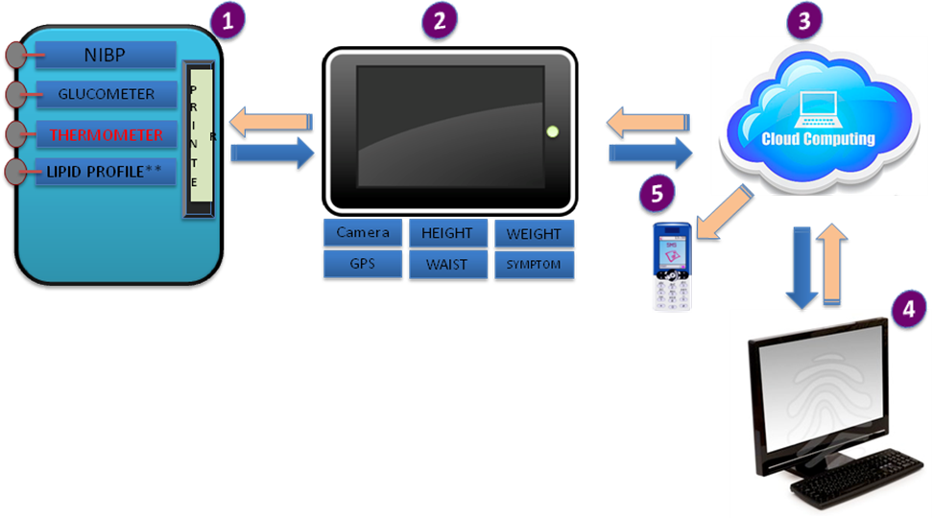
Figure 3

Technology Overview
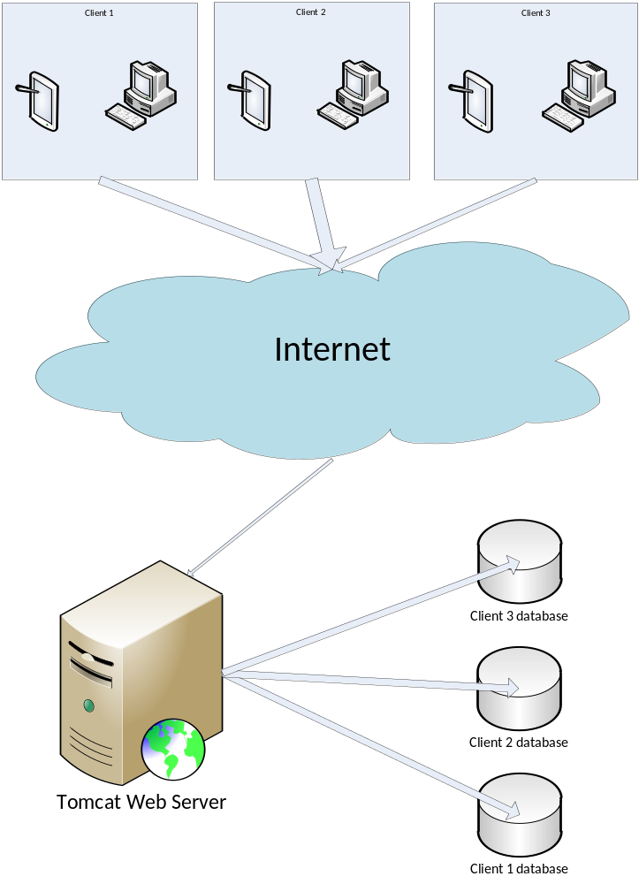
Figure 4

Users of the Application
Below are the users of the Nano health Application:
Role | Responsibilities
GVKAdmin | - Creates the Admin user
Admin | - Creates Care Manager, Manager, Doctor  - Assign login access to the above users  - Approves the Program budgeting
Program Manager | - Manages PRA & PBS systems  - Creates program budgeting
Care Manager(SAATHI) | - Patient enrollment and patient management  - Calculating patient health risk
City Manager | - Creates Trainings  - Manages Care Manager/SAATHIs  - Patient enrollment
Regional Manager | - Manages and Creates Training sessions for allocated region  - Allocate SAATHIs to the trainings
Training Manager | - Creates Training sessions  - Allocate SAATHIs to the trainings
Doctor | - View the patient health reports  - Diagnosis patients  - Create/Update prescriptions
Patient | - View the health reports

Application Flow:
- User Management
  - User Creation, Editing & Delete
  - View Users
  - Role Creation, Editing & Deleting
  - View Roles
  - Add Care Manager
  - Add Doctor
  - Add Sponsor
  - Problem in sign in
  - Change Password
- Metadata Management
  - Add Location
  - Add Category
  - Add Asset
  - Add Hospital

- Patient Management
  - Patient Enrolments
  - Patient Management by Care Manager
  - Patient Management by Doctor
- Training
  - Create Training
  - View Training
  - Add Trainees

User Management

Login Screen
Login screen will contain user name, password and roles drop down. Upon entering correct credentials along with correct role, then user role specific landing page will be displayed.
Mock Screen:

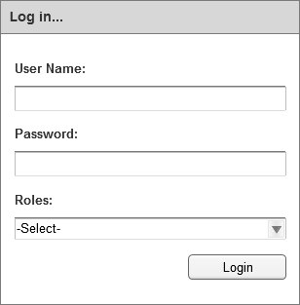
Screen 1

Field | Type | Validation/Restrictions | Description
User name | Text field | Mandatory | User name
Password | Text field | Mandatory | Password of the user
Roles | Drop down | Mandatory | Application user roles
Action Items
Control Name | Control Type | Event | Action
Log In | Button | Click | Actions:  - Do Client side validation  Client Side Validations:  - User name should not be empty  - Password should not be empty  - Role should be selected  Server Side Validations:  - As most of the data is shown from the database, login should be validated for user’s effective date.

Create User
This feature enabled to admin user, using this feature admin user can create new users and assign required role to the new user. User has to provide all required fields for creating new user.
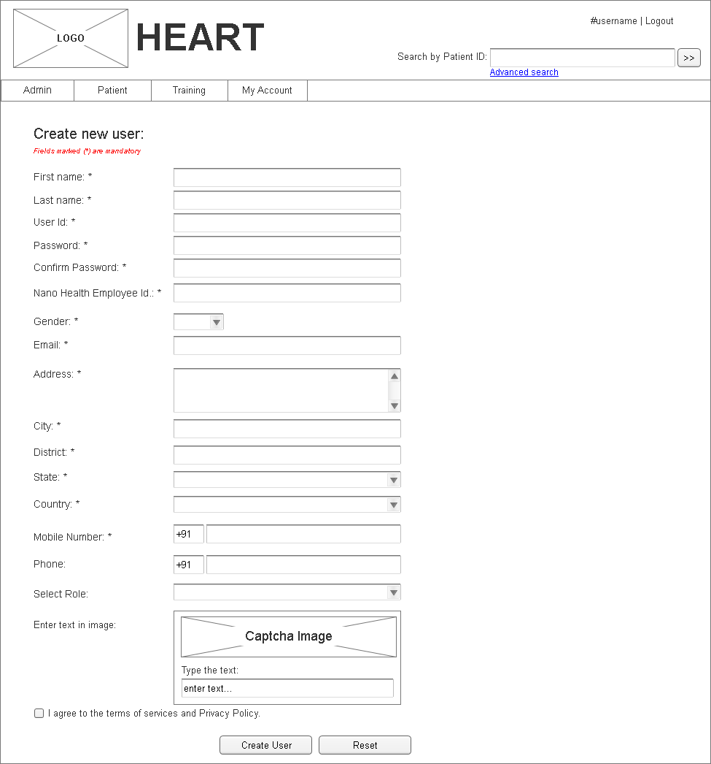
Screen 2
Screen field details:
Field | Type | Validation/Restrictions | Description
First Name | Text field | Mandatory | First name of new user
Last Name | Text field | Mandatory | Last name of new user
User ID | Text field | Mandatory | Input field to enter unique user id
Password | Text field | Mandatory | Input field to enter user password
Confirm Password | Text field | Mandatory | Input field to confirm password
Nano Health Employee Id | Text field | Mandatory | Input field to enter Nano Health employee id
Gender | Dropdown list | Mandatory | Option to select gender
Email | Text field | Mandatory | Enter valid email id
Address | Text field | Mandatory | Input field to enter address
City | Text field | Mandatory | Option to select city
District | Text field | Mandatory | Option to select district
State | Text field | Mandatory | Option to select state
Country | Text field | Mandatory | Option to select country
Mobile Number | Text field | Mandatory | Input field to enter mobile number
Phone | Text field | Optional | Input field to enter land line number or alternate mobile number
Select Role | Dropdown List | Mandatory | Option to select role
Action Items
Control Name | Control Type | Event | Action
Create User | Button | Click | Actions:  - Validates the form data  - Validates for unique user id  - Saves data  Client Side Validations:  - Validate for mandatory fields  Server Side Validations:  - Validate for unique user id
Reset | Button | Click | Actions:  - Clears the form values  Client Side Validations:  NA  Server Side Validations:  NA

View Users:
View users option allows user to view the list of users available in the database. This feature allows user to Edit and Delete any existing user.

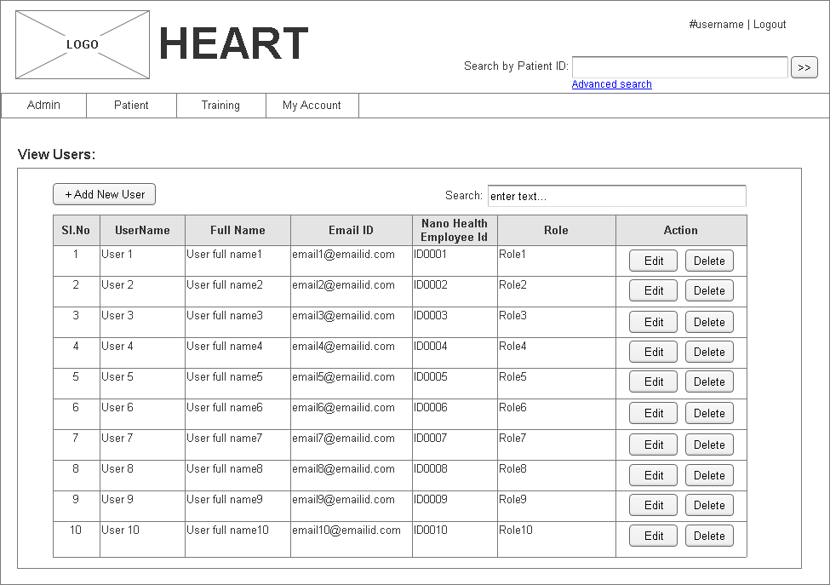
Screen 3
Screen field details:
Field | Type | Validation/Restrictions | Description
User details | Grid | NA | Lists the users list registered in the application
Search | Text field | Optional | Input field to enter keyword to search the data from below table
Action Items
Control Name | Control Type | Event | Action
Add New User | Button | Click | Actions:  - Navigates the user to “Create user” page  Client Side Validations:  - NA  Server Side Validations:  - NA
Edit | Button | Click | Actions:  - Navigates to “Edit User” page  Client Side Validations:  NA  Server Side Validations:  NA
Delete | Button | Click | Actions:  - Deactivates the selected user in the database.

Create & View Role
This feature is enabled only to admin user. Using this feature admin user can create new roles in the application. This page also displays the list of roles available in the application. User will have option to “Edit” or “Delete” existing role. Deletion will be a soft delete.
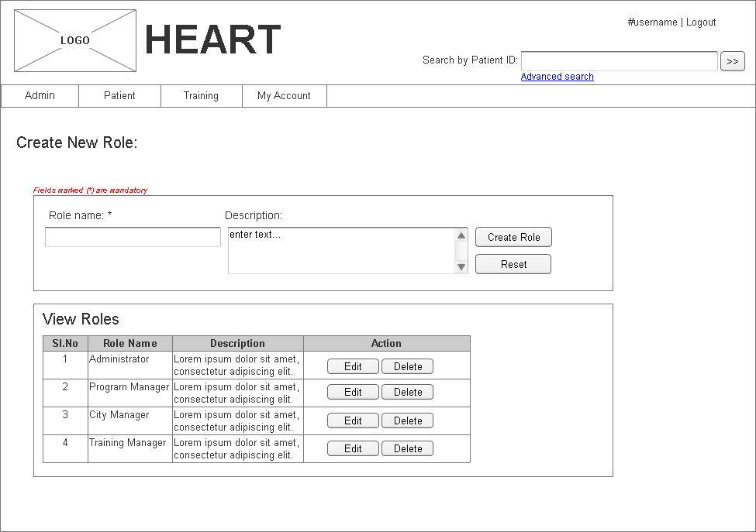
Screen 4
Screen field details:
Field | Type | Validation/Restrictions | Description
Role Name | Text field | Mandatory | Input field to enter role name
Description | Text field | Optional | Input field to enter description of the new role
Action Items
Control Name | Control Type | Event | Action
Create Role | Button | Click | Actions:  - Validates the form  - Saves the data to database.  Client Side Validations:  - Mandatory field validation  Server Side Validations:  - Validate for duplicate role
Reset | Button | Click | Actions:  - Clears form data  Client Side Validations:  NA  Server Side Validations:  NA

Add Care Manager
This feature is enabled only to the admin user. In the “Add” Menu, a new menu item i.e “Add Care Manager” will be added which creates the Care Manager details to the system. Upon clicking this new link, a new screen appears which takes the Care Manager details.
Admin user will enter all the details of the Care Manager user and also enters temporary user name and temporary password and care manager email id. Upon clicking “Add Care Manger” button, an email will be sent to particular care manager email in-box with the registration activation process. Care Manager will open email and will click on the link provided in the email and then complete the registration process. Once registration is complete, Care Manager is activated to access the application.
Mock Screen:
u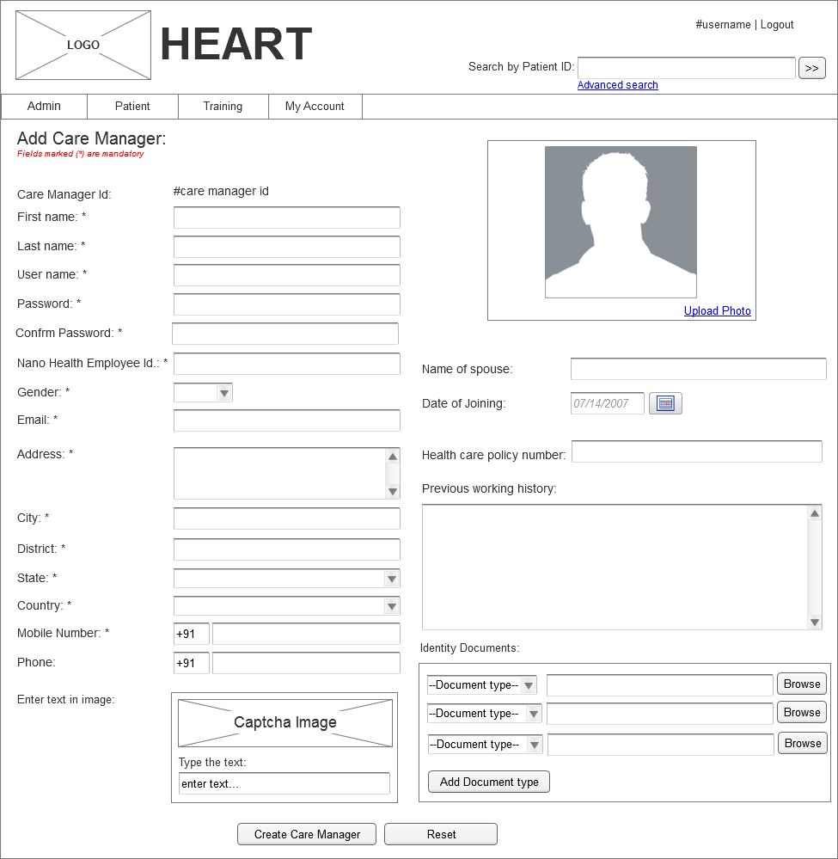
Screen 5
Screen field details:
Field | Type | Validation/Restrictions | Description
Care Manager ID | Label | NA | System generated id for care manager.  Format of the id : CRMINHYD1000  CRM → First 3 characters of short name identification ( Care manager, City Manager, Training ID, Doctor id, Administrator ID or Training Manager id.  IN → First two characters of country (INDIA)  HYD → First three characters of City (HYDERABAD)  1000 → 4 digit sequence id of user ids
First Name | Text field | Mandatory | First name of care manager
Last Name | Text field | Mandatory | Last name of care manager
User ID | Text field | Mandatory | Input field to enter unique user id
Password | Text field | Mandatory | Input field to enter user password
Confirm Password | Text field | Mandatory | Input field to confirm password
Nano Health Employee Id | Text field | Mandatory | Input field to enter Nano Health employee id
Gender | Dropdown list | Mandatory | Option to select gender
Email | Text field | Mandatory | Enter valid email id
Address | Text field | Mandatory | Input field to enter address
City | Text field | Mandatory | Option to select city
District | Text field | Mandatory | Option to select district
State | Text field | Mandatory | Option to select state
Country | Text field | Mandatory | Option to select country
Mobile Number | Text field | Mandatory | Input field to enter mobile number
Phone | Text field | Optional | Input field to enter land line number or alternate mobile number
Name of spouse | Text field | Mandatory | Input field to enter spouse name
Date of Joining | Text field | Mandatory | Option to select joining date
Health care policy number | Text field | Optional | Input field to enter health care policy number
Previous working history | Text field | Optional | Input field to enter previous working history
Identity documents: | Text field | Optional | Option to select multiple identity documents like Aadhar card, PAN card, voter card, etc.
Action Items
Control Name | Control Type | Event | Action
Add Document type | Button | Click | Actions:  - Adds a new row to existing documents list.  Client Side Validations:  - NA  Server Side Validations:  - NA
Create Care Manager | Button | Click | Actions:  - Validates the input data.  - Saves data into database  - Generates care manager id  Client Side Validations:  - Valid Email validation  Server Side Validations:  NA

Add Doctor
This feature is enabled only to the admin user. In the Add Manu, a new menu item i.e “Add Doctor” will be added which creates the Doctor details to the system. Upon clicking this new link, a new screen appears which take the Doctor details.
Mock Screen:
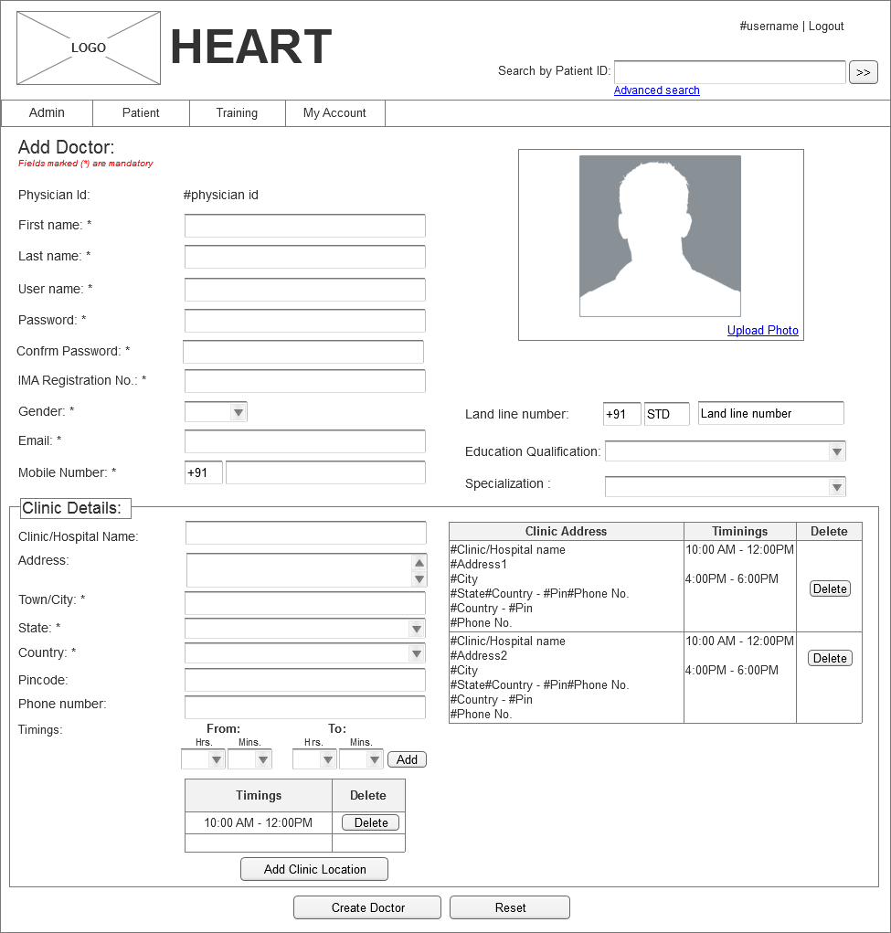
Screen 6
Screen field details:
Field | Type | Validation/Restrictions | Description
Physician Id | Label | NA | System generated id for care manager.  Format of the id : DOCINHYD1000  CRM → Short name identification for roles (Care manager, City Manager, Training ID, Doctor id, Administrator ID or Training Manager id.  IN → First two characters of country (INDIA)  HYD → First three characters of City (HYDERABAD)  1000 → 4 digit sequence id of user ids
First Name | Drop down | Mandatory | Doctor first name
Last Name | Text field | Mandatory | Doctor last name
User ID | Text field | Mandatory | Input field to enter unique user id
Password | Text field | Mandatory | Input field to enter user password
Confirm Password | Text field | Mandatory | Input field to confirm password
IMA Registration No. | Text field | Mandatory | Input field to enter IMA registration number of a Doctor
Gender | Dropdown list | Mandatory | Option to select gender
Email | Text field | Mandatory | Enter valid email id
Mobile Number | Text field | Mandatory | Input field to enter mobile number
Land line number | Text field | Option | Phone number of the doctor
Education Qualification | Text field | Mandatory | Doctor qualification
Specialization | Text field | Mandatory | Specialization of the doctor
Clinic/Hospital Name | Text field | Mandatory | Doctors clinic/ Hospital name
Address | Text field | Mandatory | Doctors clinic address
Town/City | Text field | Mandatory | City details
State | Drop down | Mandatory | List of states
Country | Drop down | Mandatory | List of countries
Pin code | Text field | Optional | Zip code details
Clinic phone number | Text field | Optional | Phone number of the doctor
Timings | Dropdown list | Mandatory | Option fields to select from timings and to timings of the doctor’s visit to the clinic
Action Items
Control Name | Control Type | Event | Action
Add Clinic Location | Button | Click | Actions:  - Validates input data  - Adds clinic data to doctor details  Client Side Validations:  - All the mandatory fields validation.  - Show proper error messages  Server Side Validations:  - NA
Create Doctor | Button | Click | Actions:  - Validates input data  - Saves doctors data into database  - Generates doctor id  Client Side Validations:  - All the mandatory fields validation.  - Show proper error messages  Server Side Validations:  - Validates duplicate Doctor

Metadata Management

Add Location:
This feature is enabled only to the admin user. In the Asset Management Menu, a new menu item i.e. “Add Location” is added which creates the location details to the system. Upon clicking this link user is navigated to “Add Location” as shown in below screen

Mock Screen:
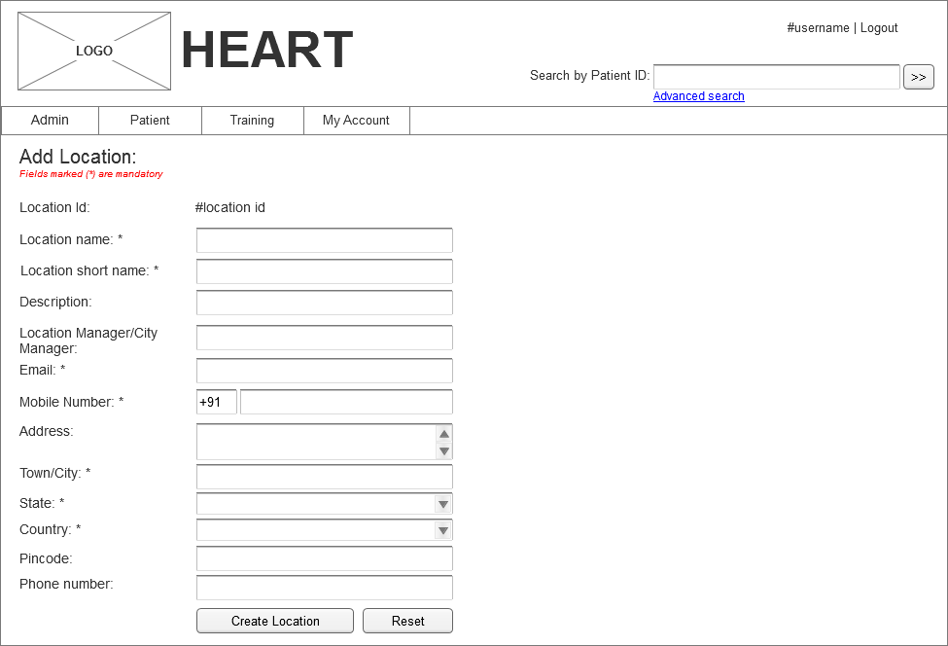
Screen 7
Field | Type | Validation/Restrictions | Description
Location Id Code | Label | NA | System generated location id
Location Name | Text field | Mandatory | Name of the location
Location short name | Text field | Mandatory | Short name of location
Description | Text field | Mandatory | Branch description
Location Manager/City Manager | Text field | Mandatory | Responsible or in charge of this location. Auto complete textbox which populates list of users.
Email | Text field | Mandatory | Email of location manager or location
Mobile Number | Text field | Mandatory | Mobile number of location manager
Address | Text field | Mandatory | Branch address
Town/City | Text field | Mandatory | City of location
State | Dropdown list | Mandatory | List of states
Country | Text field | Mandatory | Contact email address
Pin code | Text field | Optional | Address pin code
Phone number | Text Field | Optional | Location phone number
Action Items
Control Name | Control Type | Event | Action
Create Location | Button | Click | Actions:  - Upon clicking this button, location details will be added to the system.  Client Side Validations:  - All the mandatory fields validation.  - Show proper error messages  Server Side Validations:  - As most of the data is shown from the database, there is no need to validate at server side.

Add Category
This feature is enabled only to the admin user. In the Asset Management Menu, a new menu item i.e “Add Category” is added which creates the category details to the system. Upon clicking this link user will be navigated to “Add Category” as shown in below screen.
Mock screen:
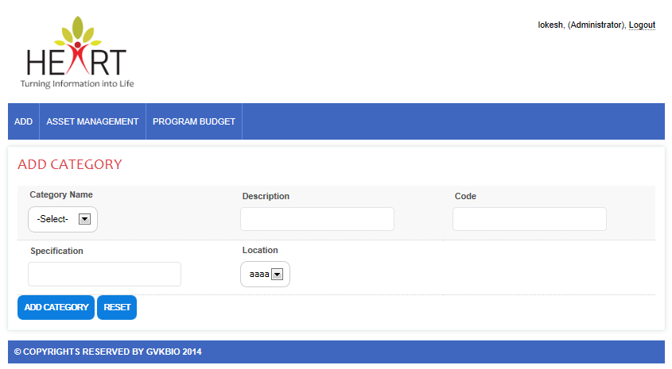
Screen 8

Field | Type | Validation/Restrictions | Description
Category Name | Drop down | Mandatory | List of defined category names.  User selects category to add for a selected branch.
Description | Text field | Mandatory | Category description
Code | Text field | Mandatory | User defined category code for easy identification
Specification | Text field | Mandatory | Category specification/configuration for a selected branch
Location | Drop down | Mandatory | List of created location names.  User selects location name for the category
Action Items
Control Name | Control Type | Event | Action
Add Category | Button | Click | Actions:  - Upon clicking this button, category details will be added to the system.  Client Side Validations:  - All the mandatory fields validation.  - Show proper error messages  Server Side Validations:  - As most of the data is shown from the database, there is no need to validate at server side.
Reset | Button | Click | Actions:  - Upon clicking this button, form fields are reset.

Add Hospital
This feature is enabled only to the admin user. In the Add Manu, a new menu item i.e “Add Hospital” will be added which creates the Hospital details to the system. Upon clicking this new link, a new screen appears which take the Hospital information.
Mock Screen:
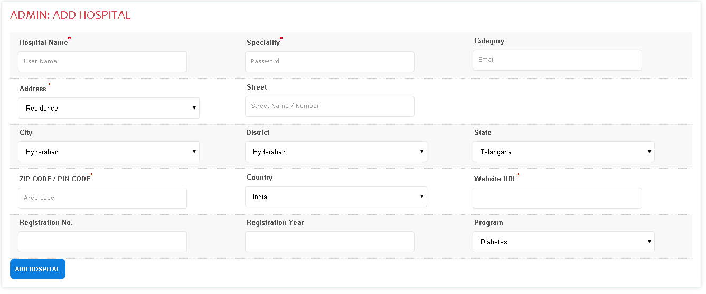
Screen 9
Screen field details:
Field | Type | Validation/Restrictions | Description
Hospital Name | Text field | Mandatory | Temporary user name of the care manger
Specialty | Text field | Mandatory | Temporary password of the care manger
Address | Text field | Mandatory | Care manager’s email id
Street | Text field | Mandatory | Street information
City | Drop down | Mandatory | List of Cities
District | Drop down | Mandatory | List of district
State | Drop down | Mandatory | List of states
Zip code | Text field | Mandatory | ZIP code
Country | Drop down | Mandatory | Country list
Registration Number | Text field | Mandatory | Hospital registration number
Program | Drop down | Mandatory | Program name
Action Items
Control Name | Control Type | Event | Action
Add Hospital | Button | Click | Actions:  - Upon clicking this button, Hospital details will be added to the system.  Client Side Validations:  - All the mandatory fields’ validation.  - If program drop down is empty, hospital will not be added.  - Show proper error messages  Server Side Validations:  - As most of the data is shown from the database, there is no need to validate at server side.

Asset management
Asset management functionality will be accessible only to the Admin users. In the Asset management module, Admin will create branch, location for a program. Asset categories will be defined for a branch. Asset items are added to the system for created categories in single or in bulk. Admin will add all the required (approved in PBS IT infrastructure) assets which are needed for the program. Once assets are added, they are allocated to resource for specified period.

Add Asset
This feature is enabled only to the admin user. In the Asset Management Menu, a new menu item i.e “Add Asset” is added which creates a single asset detail to the system. Upon clicking this link, below screen appears which take the asset details.
Mock screen:
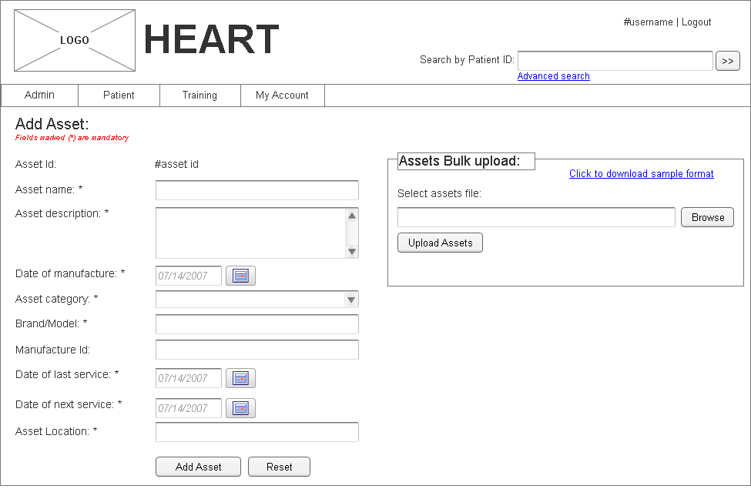
Screen 10

Field | Type | Validation/Restrictions | Description
Asset Id | Label | NA | Displays Asset Id which is generated after saving the data
Asset Name | Text field | Mandatory | Name of the asset
Asset Description | Text field | Mandatory | Asset description
Date of manufacture | Date | Mandatory | Option to select manufacturing date of asset
Category | Dropdown list | Mandatory | Displays list of categories.
Brand/Model | Text field | Mandatory | Brand or model name of the asset
Manufacture Id | Text field | Optional | Manufacture details of the asset
Date of last service | Date | Mandatory | Asset last serviced date
Date of next service | Date | Mandatory | Asset next service date
Asset location | Dropdown list | Mandatory | List of locations.
Select assets file | Text field | Optional | Bulk uploading of assets
Action Items
Control Name | Control Type | Event | Action
Add Asset | Button | Click | Actions:  - Upon clicking this button, asset details will be added to the system.  Client Side Validations:  - All the mandatory fields’ validation.  - Asset addition validation against PBS IT_INFRASTRUCTURE items for the asset  - Show proper error messages  Server Side Validations:  - As most of the data is shown from the database, there is no need to validate at server side.
Reset | Button | Click | Actions:  - Upon clicking this button, form fields are reset.
Upload Assets | Button | Click | Actions:  - Validates selected file.  - Reads asset details from file  - Saves assets details to database  Client Side Validations:  - Validates selected file  Server Side Validations:  - Validates duplicate asset.

Asset Allocation Report
This feature is enabled only to the admin user. In the Asset Management Menu, a new menu item i.e “Asset Allocation Report” is added which allows user to view allocation details of a location. Upon clicking this link, below screen appears which shows allocation details.
Mock screen:
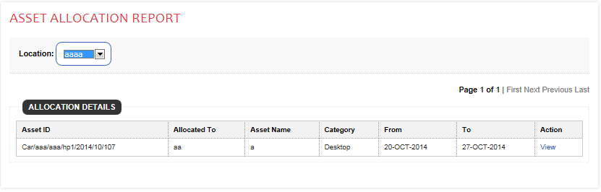
Screen 11

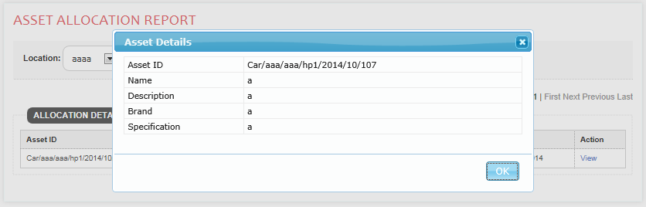
Screen 12

Field | Type | Validation/Restrictions | Description
Location | Drop down | Mandatory | List of created location names.  User selects location name for the category
Asset ID | Text | NA | Displays Asset ID of a asset
Allocated To | Text | NA | Displays the user name to whom asset is allocated
Asset Name | Text | NA | Displays the name of the asset
Category | Text | NA | Displays the category name of the asset
From | Text | NA | Displays the allocation start date of the asset
To | Text | NA | Displays the allocation end date of the asset
Action | Text/Link | NA | Displays the link to view asset specific detail
Action Items
Control Name | Control Type | Event | Action
Location | Drop down | Change | Actions:  - Upon changing option from the drop down button, selected location allocation details will be displayed.  Client Side Validations:  - No client side validation required  Server Side Validations:  - As most of the data is shown from the database, there is no need to validate at server.
View | Button | Click | Actions:  - Upon clicking this button, asset details are displayed in popup window.

Asset Availability Report
This feature is enabled only to the admin user. In the Asset Management Menu, a new menu item i.e “Asset Availability Report” is added which allows user to view asset availability details of a location for a given period. Upon clicking this link, below screen appears which shows asset availability details.

Mock screen: 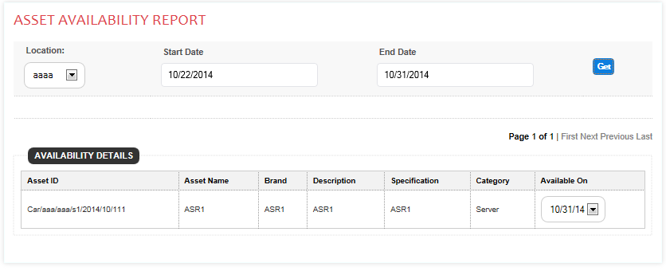
Screen 13
Field | Type | Validation/Restrictions | Description
Location | Drop down | Mandatory | List of created location names.  User selects location name for the categorya
Start Date | Text field | Mandatory | Start date for asset availability
End Date | Text field | Mandatory | End date for asset availability
Asset ID | Text | NA | Displays Asset ID of a asset
Asset Name | Text | NA | Displays the name of the asset
Brand | Text | NA | Displays the brand of the asset
Description | Text | NA | Displays the description of the asset
Specification | Text | NA | Displays the specification of the asset
Category | Text | NA | Displays the category of the asset
Available on | Drop down | NA | Displays the asset’s availability dates
Action | Text/Link | NA | Displays the link to view asset specific detail
Action Items
Control Name | Control Type | Event | Action
Get | Button | Click | Actions:  - Upon clicking on button, availability details will be displayed for a given period.  Client Side Validations:  - All the mandatory fields’ validation.  - Show proper error messages  Server Side Validations:  - As most of the data is shown from the database, there is no need to validate at server.
View | Button | Click | Actions:  - Upon clicking this button, asset details are displayed in popup window.

Patient Management

Patient Enrolment
Patient Enrollment screen will be displayed only for the care manager login. Care manager will take the partial details of the patient at the time of the registration and then complete the enrollment at the second time visit. In the second time visit, care manager will collect all the complete details of the patient and calculates the patient risk. During this process, patient needs to answer many questions i.e. social, marital, personal etc., and also patient diagnosis details will be collected and patient risk profile is calculated.
If risk profile is low, then that patient will not be considered for the program and hence patient enrollment will not happen to the system. If patient risk profile is medium or high, then care manager will explain about the program and upon acceptance of the patient, care manger will enroll the patient and also refer to the corresponding doctor for immediate diagnosis.
Mock Screen:
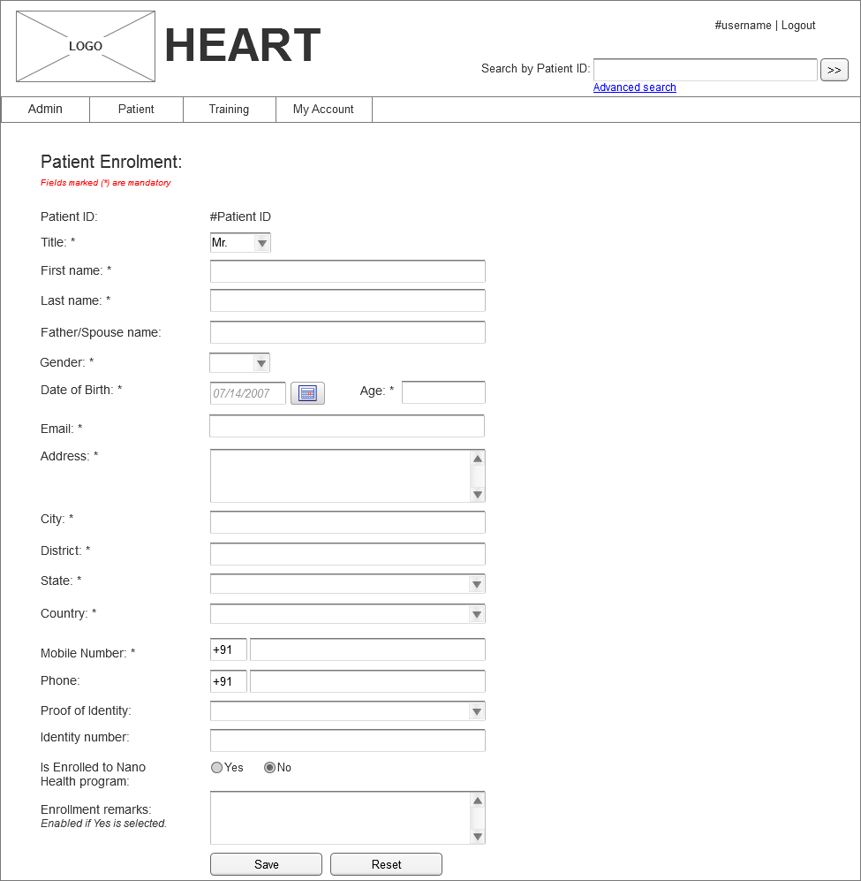
Screen 14

Field | Type | Validation/Restrictions | Description
Patient Id | Label | NA | Auto generated by system once patient data is saved.  Patient ID will be generated in below format:  Patient Id - KM26681INHYD00110000  KM → First characters of first name & last name. (Krishna Mohan)  26681 → Last five digits of mobile number  IN → First two characters of country (INDIA)  HYD → First three characters of City (HYDERABAD)  001 → There digit sub area code based on city location Full list will be in master list  00001 → 5 digit sequence count of patients incremented for each subarea which will help identify how many patients exists in each location
First Name | Text field | Mandatory | Patient first name
Last Name | Text field | Mandatory | Patient last name
Father/Spouse Name | Text field | Mandatory | Input field to enter father or spouse name
Age | Text field | Mandatory | Patient age.
Gender | Drop down | Mandatory | Patient gender
Address Type | Drop down | Mandatory | Patient address type
Address | Text field | Mandatory | Patient address
Street | Text field | Mandatory | Patient street details
City | Text field | Mandatory | Patient city details
District | Text field | Mandatory | Patient district details
State | Text field | Mandatory | Patient state details
Zip code | Text field | Mandatory | Patient Zip code details
Country | Text field | Mandatory | Patient Country details
Primary Email | Text field | Mandatory | Patient email details
Mobile phone number | Text field | Mandatory | Patient mobile details
Proof of identity | Drop down | Mandatory | Identity proof details
Identity number | Text field | Mandatory | Patient Identity details
Is Enrolled | Radio button | Mandatory | Option to select if patient is enrolled for Nano health program. Default is set to No.
Enrollment Remarks | Text field | Optional | Remarks field is enabled only if “Is Enrolled” is selected as Yes.
Action Items
Control Name | Control Type | Event | Action
Save | Button | Click | Actions:  - Do Client side validation for mandatory fields  - Save Patient data  - Generate Patient Id.  - If Is Enrolled is Yes then  - Capture enrolled date and enrolled user  Client Side Validations:  - If date of birth provided, then automatically age should be calculated  - If age is provided, then date of birth should disable  - If the program drop down is not present, then patient will not be registered.  Server Side Validations:  - As most of the data is shown from the database, there is no need to validate at server side.
Proceed |  |  | Actions:  - On clicking of this button sub sequence questions screen will appear.  Client Side Validations:  - Data needs to be provided for all the fields except text boxes.  Server Side Validations:  - As most of the data is shown from the database, there is no need to validate at server side.
I agree and register the patient now | Button |  | Actions:  - This button gets enables only after user check the “I have read and understood the agreement” check box.

Patient Questionnaire:
Upon successfully registration of the patient, then patient will be questioned with few pre-defined questions related to past history. Along with questions patient is also diagnosed with some preliminary tests as shown in below screen. This data will be used to perform risk analysis.
Mock Screen

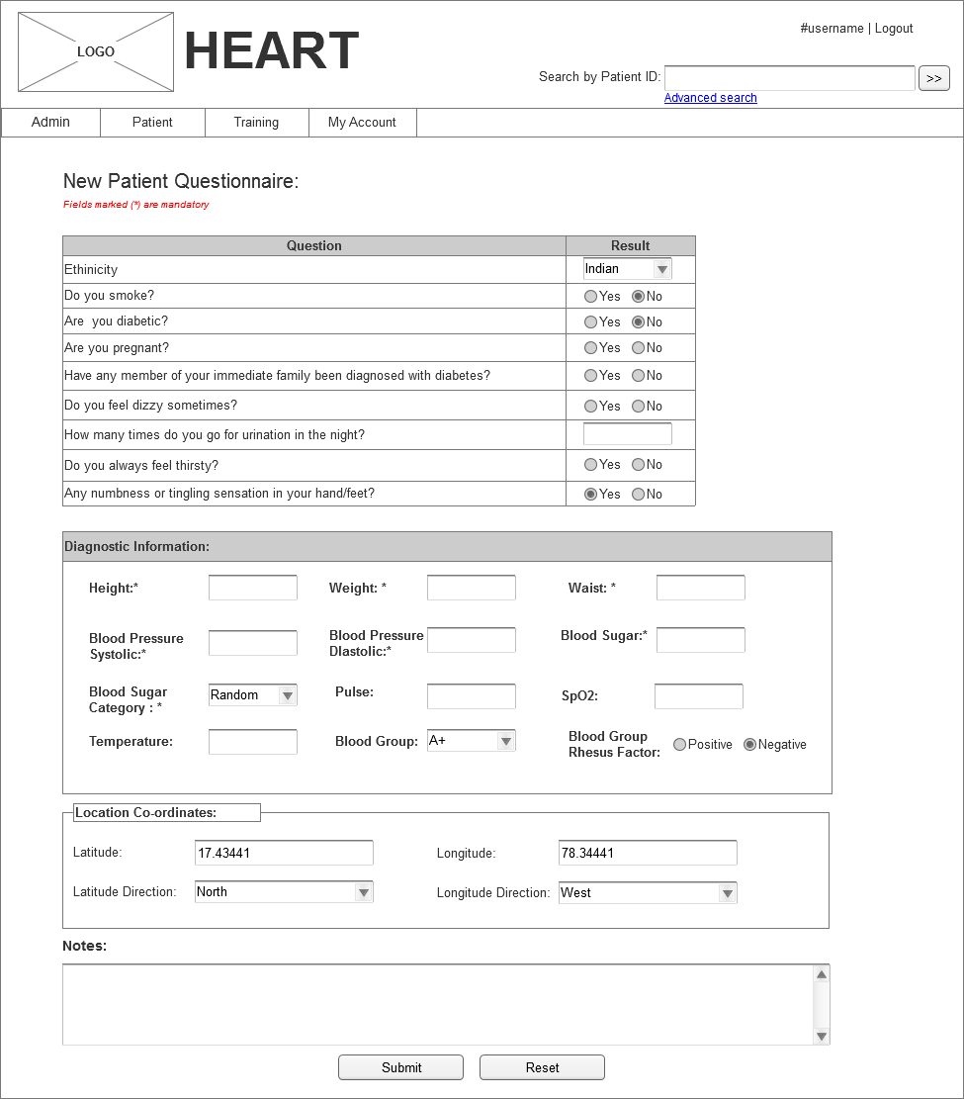
Screen 15
Screen field details:
Field | Type | Validation/Restrictions | Description
Patient Questionnaire | List | Click | List of questions that will be asked to patient and update the result as per response by patient
Diagnostic Information
Height | Text field | Mandatory | Input field to enter height of patient  Should accept only decimal value
Weight | Text field | Mandatory | Input field to enter weight of patient  Should accept only decimal value
Waist | Text field | Mandatory | Input field to enter waist size of patient  Should accept only decimal value
Blood Pressure Systolic | Text field | Mandatory | Input field to enter BP systolic
Blood Pressure Diastolic | Text field | Mandatory | Input field to enter BP diastolic
Blood Sugar | Text field | Mandatory | Input field to enter Blood sugar
Blood Sugar Category | Text field | Mandatory | Displays list of blood sugar categories like Random/Fasting/Post Prandial
Pulse | Text field | Mandatory | Input field to enter pulse
SpO2 | Text field | Mandatory | Input field to enter SpO2
Temperature | Text field | Mandatory | Input field to enter temperature
Blood Group | Dropdown list | Mandatory | Displays list of blood groups
Blood Group Rhesus Factor | Text field | Mandatory | Input field for blood group RH factor
Location Co-ordinates
Latitude | Text field | Optional | Input field to enter location latitude from where diagnosis is taken
Latitude Direction | Text field | Optional | Input field to enter location latitude from where diagnosis is taken
Longitude | Text field | Optional | Input field to enter location latitude from where diagnosis is taken
Longitude Direction | Text field | Optional | Input field to enter location latitude from where diagnosis is taken
Notes | Text field | Optional | Input field to enter patient details
Action Items
Control Name | Control Type | Event | Action
Submit | Button | Click | Actions:  - Upon clicking this button, diagnosis data is saved  Client Side Validations:  - Check if Latitude and Longitude value is between 0 to 90  - Latitude direction should be North/South  - Longitude direction should be East/West  Server Side Validations:  - NA

Patient Risk Meter analysis:
Once user questionnaire answers and diagnostic information is caputred, this data is sent to risk meter. As per the patient data risk meter analyses the patient condition and provides the risk meter score. This score helps care manager to inform the patient about his health condition and next steps. After risk meter analysis care manager will have option to
- Add new diagnosis
- Analyse risk
- Refer to a Doctor

Mock Screen
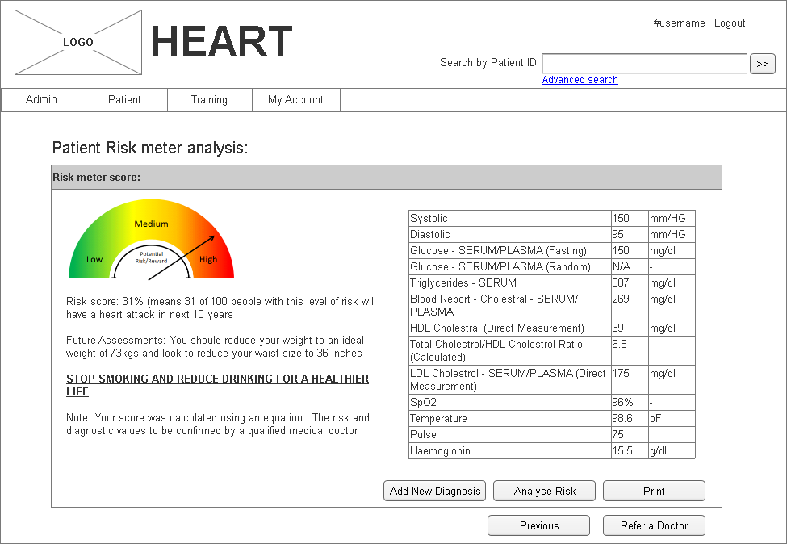
Screen 16

Field | Type | Validation/Restrictions | Description
Risk meter analysis | Label | NA | Provides risk meter analysis details as per the questionnaire and diagnostic information provided by the care manager
Action Items
Control Name | Control Type | Event | Action
Add New Diagnosis | Button | Click | Actions:  - Upon clicking this button, a new screen appears which sync the patient diagnosis details.  Client Side Validations:  - If patient risk is medium or high, then only save button and refer to the doctor buttons get enabled  - Show proper error messages  Server Side Validations:  - As most of the data is shown from the database, there is no need to validate at server side.
Analyze Risk | Button | Click | Actions:  - Upon clicking this button, patient risk profile will be calculated and displayed to the patient.  Client Side Validations:  - If risk profile is medium or high, then refer to the doctor button gets enabled.  Server Side Validations:  - As most of the data is shown from the database, there is no need to validate at server side.
Refer to the doctor | Button |  | Actions:  - Upon clicking this button, all the available doctor list will be presented and then patient is referred to a particular doctor.  - Selected doctors gets an email about the patient details.  Client Side Validations:  - If risk profile is medium or high, then refer to the doctor button gets enabled.  Server Side Validations:  - As most of the data is shown from the database, there is no need to validate at server side

Patient Enrollment in bulk:
This option allows user to update the enrollment status to “Yes” in bulk. Details of the patients who are getting enrolled to the program must be listed in an pre-defined excel format available in the application.
Once the updated excel file is provided, application reads the mobile numbers and updates the Is enrolled status to YES. If application does not find the mobile number than an error message is displayed to user as shown in below screen
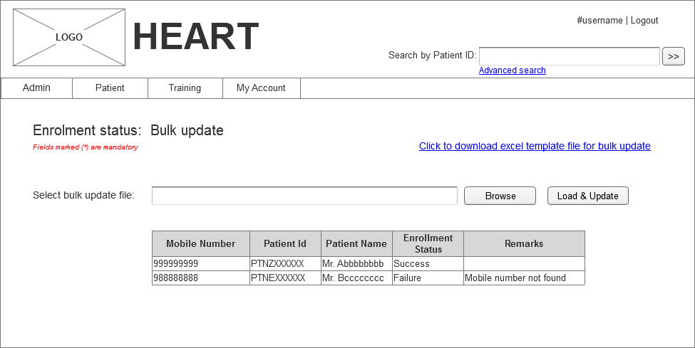
Screen 17

Patient Management by care manager
Upon clicking on the patient Id in the patient search results page, below patient management screen will be displayed for the care manger login. In this patient management screen, care manager will collect advanced questions, and then collect the new diagnosis details and then calculates the risk profile of the patient. Based on the patient risk profile, care manger will refer the patient to the doctor. In this process, corresponding doctor will get an email from the care manger which will have complete details of the patient.
Patient management allows the care manager to
- Add New Diagnosis
- Advance questions
- Add New Diagnosis
- Refer to a Doctor
- Add Prescription
Mock Screen for care manger:
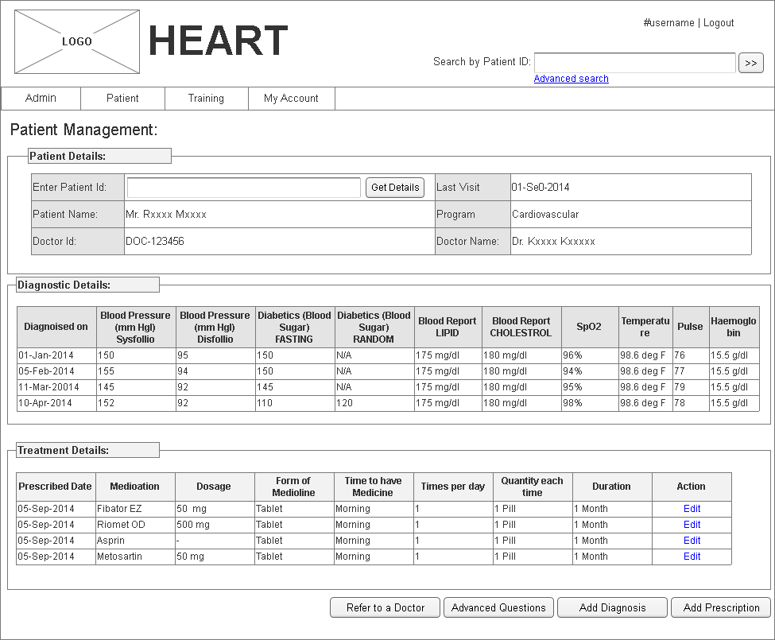
Screen 18

Add New Diagnosis:
In patient management screen, care manager can view the patient details and add new diagnosis details if required. On clicking “Add Diagnosis” button user will be redirected to respective page as shown in below screen.
Mock Screen:

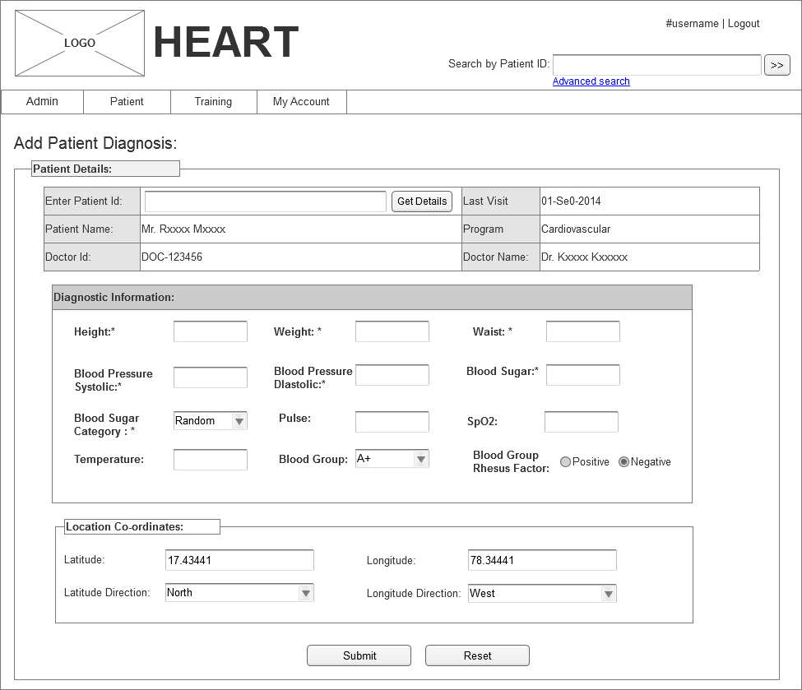
Screen 19
Field | Type | Validation/Restrictions | Description
Patient ID | Text field | Mandatory | Input field to enter patient id to retrieve patient details
Last visit | Label | NA | Displays patient last visit date
Patient Name | Label | NA | Displays patient name
Program | Label | NA | Displays program name
Doctor Id | Label | NA | Displays doctor id
Doctor Name | Label | NA | Displays doctor name
Diagnostic Information
Height | Text field | Mandatory | Input field to enter height of patient  Should accept only decimal value
Weight | Text field | Mandatory | Input field to enter weight of patient  Should accept only decimal value
Waist | Text field | Mandatory | Input field to enter waist size of patient  Should accept only decimal value
Blood Pressure Systolic | Text field | Mandatory | Input field to enter BP systolic
Blood Pressure Diastolic | Text field | Mandatory | Input field to enter BP diastolic
Blood Sugar | Text field | Mandatory | Input field to enter Blood sugar
Blood Sugar Category | Text field | Mandatory | Displays list of blood sugar categories like Random/Fasting/Post Prandial
Pulse | Text field | Mandatory | Input field to enter pulse
SpO2 | Text field | Mandatory | Input field to enter SpO2
Temperature | Text field | Mandatory | Input field to enter temperature
Blood Group | Dropdown list | Mandatory | Displays list of blood groups
Blood Group Rhesus Factor | Text field | Mandatory | Input field for blood group RH factor
Location Co-ordinates
Latitude | Text field | Optional | Input field to enter location latitude from where diagnosis is taken
Latitude Direction | Text field | Optional | Input field to enter location latitude from where diagnosis is taken
Longitude | Text field | Optional | Input field to enter location latitude from where diagnosis is taken
Longitude Direction | Text field | Optional | Input field to enter location latitude from where diagnosis is taken
Notes | Text field | Optional | Input field to enter patient details
Action Items
Control Name | Control Type | Event | Action
Submit | Button | Click | Actions:  - Upon clicking this button, diagnosis data is saved  Client Side Validations:  - Check if Latitude and Longitude value is between 0 to 90  - Latitude direction should be North/South  - Longitude direction should be East/West  Server Side Validations:  - NA

Advance Questions:
In patient management, care manager has option to ask more advanced questions and take response from the patient. These questions help the doctor to understand the patient condition. Advanced questions will be displayed to the care manager as shown in below screen.
Mock Screen:
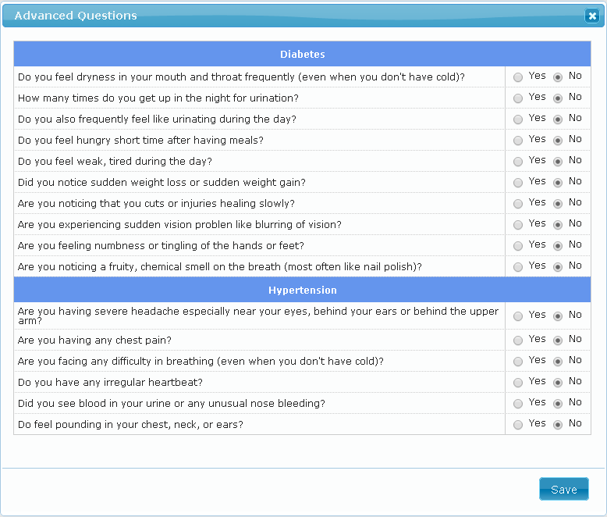
Screen 20
Refer to Doctor:
After analyzing the patient details, care manager has option to refer the patient to a Doctor available in nearby location. Upon clicking “Refer to Doctor” user will be redirected to page as shown in below screen.
Mock Screen:
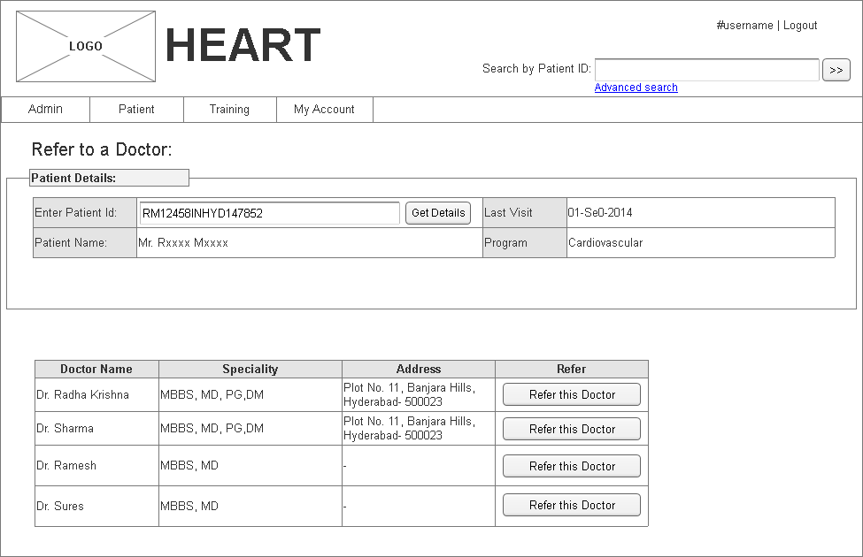
Screen 21
Add Prescription:
Add prescription feature enables the care manager to digitize the details of the prescription written by the docotr. Once the patient is referred to doctor, then doctor writes a note about patient condition and medicines that need to be taken in the prescription. Patient has to provide Doctor prescribed prescription to care manager for digitizing. Upon clickin on “Add Prescription” button, user will be navigated to a page as shown in below screen.

Mock Screen:
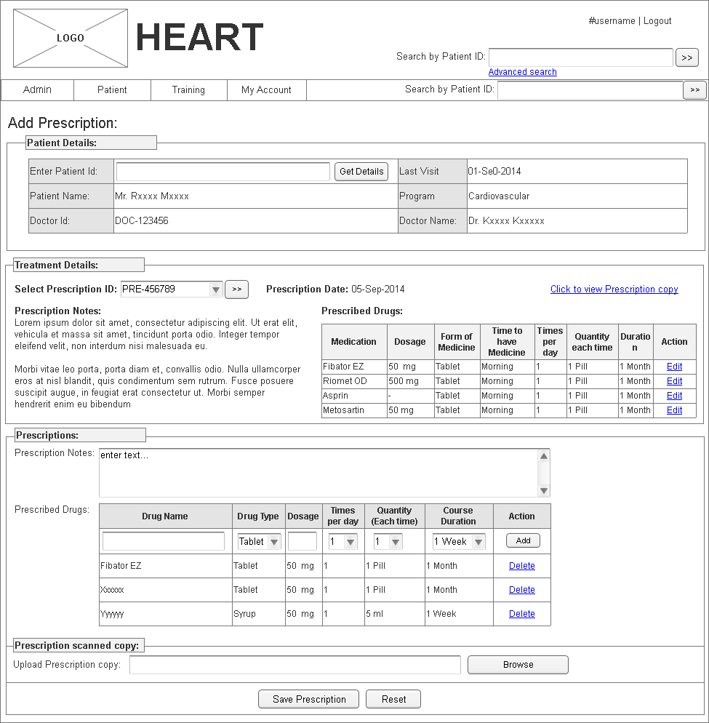
Screen 22
Screen field details:
Field | Type | Validation/Restrictions |  | Description
Treatment Details | Text | NA |  | Displays treatment details prescribed by doctor for the selected patient.
Select Prescription ID | Dropdown list | Mandatory |  | List of prescription Ids for selected patient ID.
Prescription Details | Text | NA |  | Displays Doctor prescribed prescription details for selected prescription Id
Action Items
Control Name | Control Type | Event | Action
Get Details | Button | Click | Actions:  - Retrieves patient details for entered patient id.  Client Side Validations:  - Validates Mandatory fields  Server Side Validations:  - NA
Click to view prescription copy | Hyperlink | Click | Actions:  - Displays scanned copy of the prescription written by doctor.  Client Side Validations:  NA.  Server Side Validations:  NA
Save Prescription | Button | Click | Actions:  - Saves prescription details to database  Client Side Validations:  - Validates for mandatory fields  Server Side Validations:  - NA

Patient Management by Doctor
Doctors who have login access will login to the application and diagnosis the patient. In the doctor home page, all the patients who are waiting for the doctor will be displayed as a list. Upon clicking on the patient id link, corresponding patient details will be displayed in the next screen where doctor will provide diagnosis details, can enter medicine details and also provide prognosis.
Mock Screen:
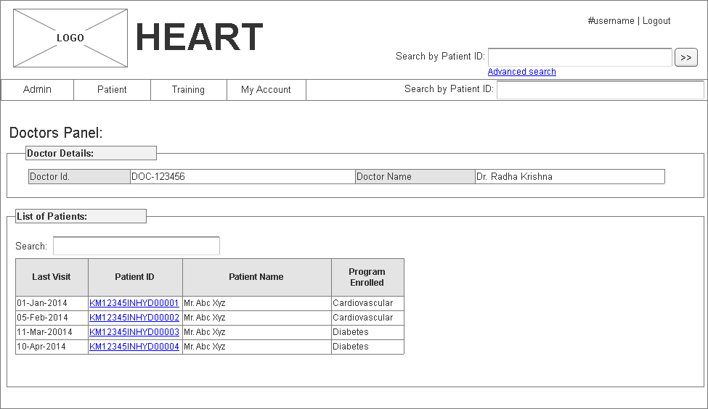
Screen 23
Doctor will have option to search Patient details using below options available in doctors landing page.
- Patient ID search
- Patient advanced search
If doctor has the patient id, then they can directly enter the patient ID in the provided text field and then click on the search button, upon clicking search button, matching patients will be displayed in the same screen.
If doctor does not know patient ID, then they will go for advanced search. Upon clicking on the Advanced Search link, a new screen will be displayed where in more details of the patient can be entered. Upon clicking of the search button, then matching patients will be displayed in the patient search results screen. In either of above cases, upon clicking of the particular patient ID link in the search results page, then corresponding patient management screen will be displayed and this is different for care manger and doctor roles. In the care manager patient management screen, only doctor diagnosis details will be displayed and they are only view purpose. Whereas doctor patient management screen, doctor will provide prognosis and diagnosis details of the patient.
Mock Screen:
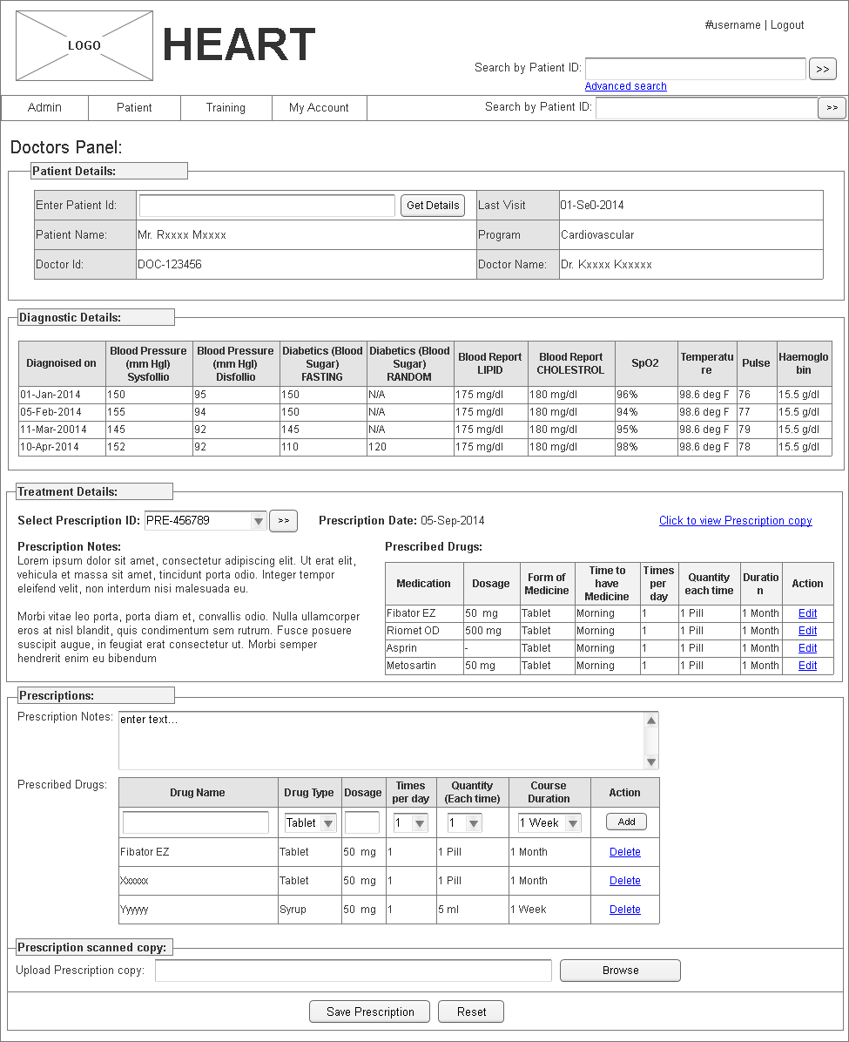
Screen 24
Screen field details:
Field | Type | Validation/Restrictions |  | Description
Treatment Details | Text | NA |  | Displays treatment details prescribed by doctor for the selected patient.
Select Prescription ID | Dropdown list | Mandatory |  | List of prescription Ids for selected patient ID.
Prescription Details | Text | NA |  | Displays Doctor prescribed prescription details for selected prescription Id
Action Items
Control Name | Control Type | Event | Action
Get Details | Button | Click | Actions:  - Retrieves patient details for entered patient id.  Client Side Validations:  - Validates Mandatory fields  Server Side Validations:  - NA
Click to view prescription copy | Hyperlink | Click | Actions:  - Displays scanned copy of the prescription written by doctor.  Client Side Validations:  NA.  Server Side Validations:  NA
Save Prescription | Button | Click | Actions:  - Saves prescription details to database  Client Side Validations:  - Validates for mandatory fields  Server Side Validations:  - NA

Training
Training module allows the user to capture the trainings that will be conducted in different locations. This module will be managed by City manager / care manager. Using this feature user can
- Create training
- Assign team for training
Create Training:
Create training option allows user to create new training for the team for a location. Once the training is created, care manager will have option to add the team who will be attending these trainings. User can access “Create Training” menu available in Training menu.
Mock Screen:
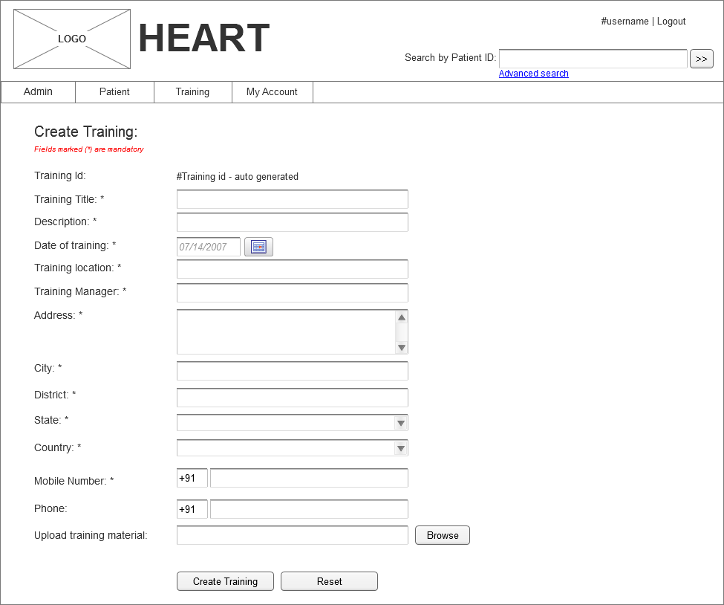
Screen 25
View Trainings:
This feature allows user to view the list of trainings that are planned. This feature is enabled to city manager and care manager.
Mock Screen:
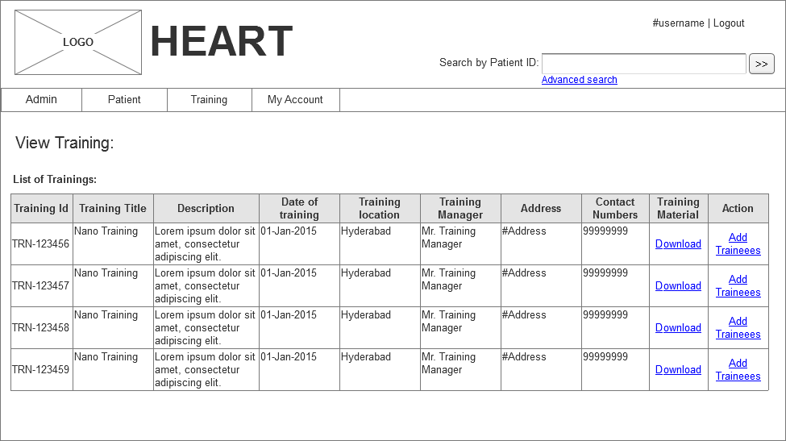
Screen 26
Add Trainee:
Once the trainings are created for a location, then city manager/care manager willl have option to add trainees for the planned training using this option. In View trainings list there will be a link “Add Trainees” under Action column. Upon clicking this link, user will be redirected to “Add Trainees” page as shown in below screnn.
Mock Screen:
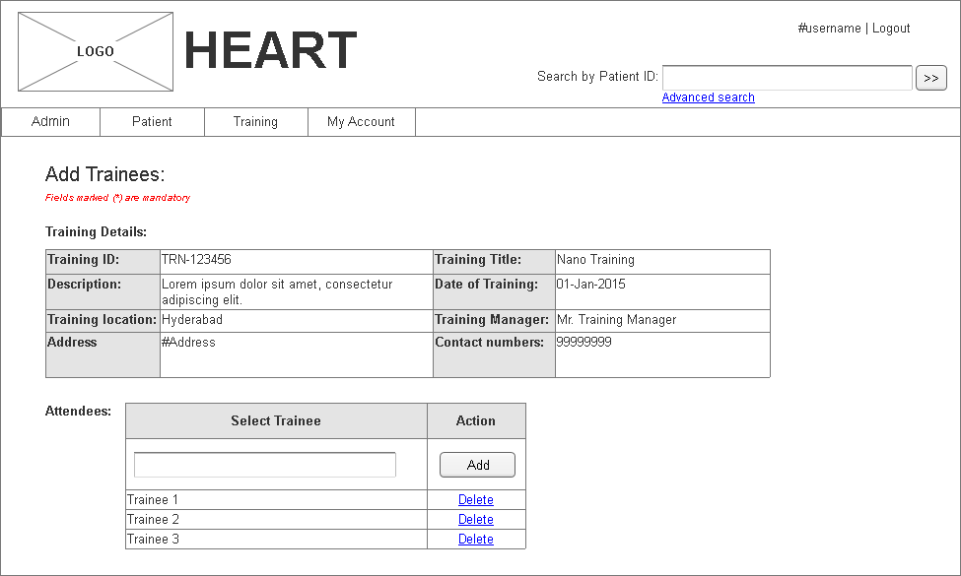
Screen 27

Complaint:
Complaint module allows user to log complaint on SAATHIs, Doctors, etc., This module is accessible to all users who have logged into application.
- Create complaint
- View complaint
Mock Screen: Create complaint
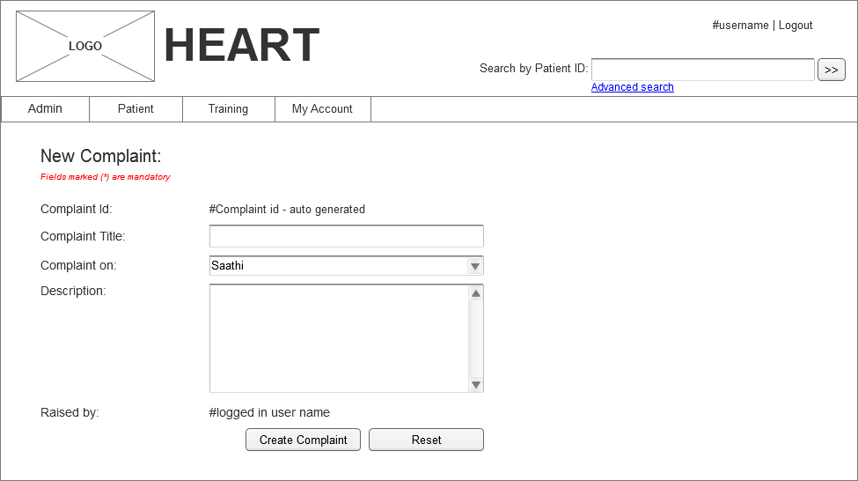
Screen 28
Mock Screen : View Complaints
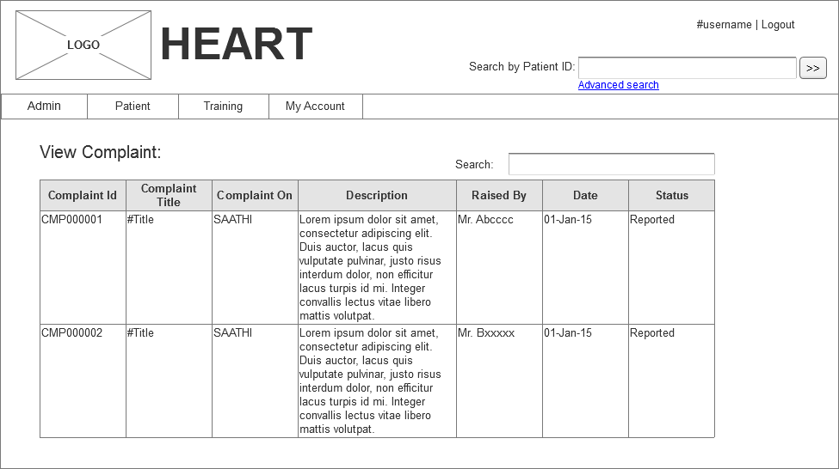
Screen 29

Patient Search:
Care Managers and Doctor who are given login access to the application will search for the patient. Patient search can be done in two ways.
- Patient ID search
- Patient advanced search
If care manger knows the patient id, then they can directly enter the patient ID in the provided text field and then click on the search button, upon clicking search button, matching patients will be displayed in the same screen.
If care manger does not know patient ID, then they will go for advanced search. Upon clicking on the Advanced Search link, a new screen will be displayed where in more details of the patient can be entered, upon clicking of the search button, then matching patients will be displayed in the patient search results screen. In either of above cases, upon clicking of the particular patient ID link in the search results page, then corresponding patient management screen will be displayed and this is different for care manger and doctor roles. In the care manager patient management screen, only doctor diagnosis details will be displayed and they are only view purpose. Whereas doctor patient management screen, doctor will provide prognosis and diagnosis details of the patient.
Mock Screen - Patient ID search:
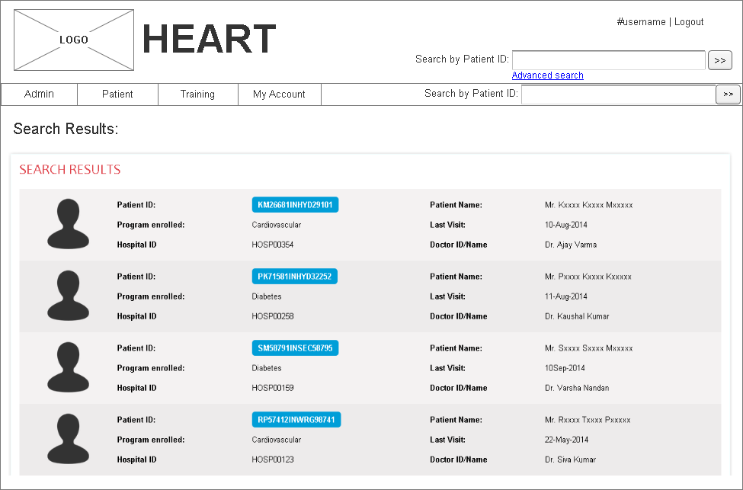
Screen 30

Field | Type | Validation/Restrictions | Description
Search by Patient ID | Text field | Mandatory | Patient Id information
Action Items
Control Name | Control Type | Event | Action
Search | Button | Click | Actions:  - Do Client side validation  Client Side Validations:  - Patient ID will be provided  - Show proper error messages  Server Side Validations:  - As most of the data is shown from the database, there is no need to validate at server side.

Advanced Search:
Advanced search allows the user to search the patient details by providing any of the field data available in search form. Search is performed on the combination of the inputs provided by the user. Advances search screen will have fields related to patients as shown in below screen.
Mock screen: patient advanced search
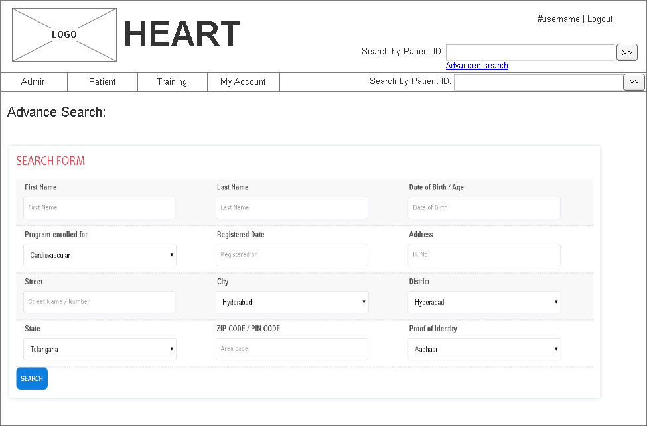
Screen 31
Mock Screen:
Screen 32
Screen field details:
Field | Type | Validation/Restrictions | Description
First Name | Text field | Mandatory | Patient First name
Last Name | Text field | Mandatory | Patient last name
Age | Text field | Mandatory | Patient age
Program enrolled for | Drop down | Mandatory | List of the program to which patient has enrolled for
Action Items
Control Name | Control Type | Event | Action
Search | Button | Click | Actions:  - Do Client side validation  Client Side Validations:  - All the mandatory fields validation.  - Show proper error messages  Server Side Validations:  - As most of the data is shown from the database, there is no need to validate at server side.

Miscellaneous Business Requirements:
- Application should generate the IDs for the users as per the format mentioned below:
- Care Manager ID - CRMINHYD1000
- City Manager ID - CMGINHYD1000
- Training ID - TRINHYD1000
- doctor ID - DOCINHYD1000
- Administrator ID - ADMINHYD1000
- Training Manager ID - TRMINHYD1000

Format description:
- Format of the id : CRMINHYD1000
- CRM → First 3 characters of short name identification ( Care manager, City Manager, Training ID, Doctor id, Administrator ID or Training Manager id.
- IN → First two characters of country (INDIA)
- HYD → First three characters of City (HYDERABAD)
- 1000 → 4 digit sequence id of user ids
- Patient Id - KM26681INHYD00110000
- KM → First characters of first name & last name. (Krishna Mohan)
- 26681 → Last five digits of mobile number
- IN → First two characters of country (INDIA)
- HYD → First three characters of City (HYDERABAD)
- 001 → There digit sub area code based on city location Full list will be in master list
- 00001 → 5 digit sequence count of patients incremented for each subarea which will help identify how many patients exists in each location
- Application should generate web services to sync the data between Nano tablet and GVK HEART platform

Program Budget approval - Admin
Only Admin user will approve the budget to the program. Please refer to the PBS tool approval functionality

Program Budget creation - Manager
Only Manger user will create the budget to the program. Please refer to the PBS tool create budget functionality

Program Resource Allocation
Please refer to the PRA tool for more functionality.

System Requirements
GVK will use the current infrastructure to host and maintain the Application and Database server.

Application Architecture
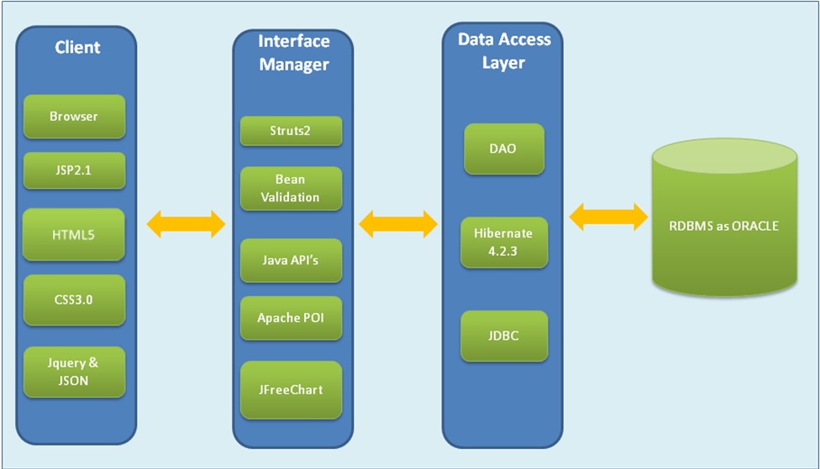

Architecture Requirements
- The application should be hosted by GVK and used the clients thru internet network.
- Database server will be Oracle version 11r2 standard database engine.
- Webserver will be Apache Tomcat 7 running on a Linux Server (Red Hat Enterprise 6)
- Web application will be developed with browser compatibility of IE9 & 10 and Chrome and Tablet devices.
- Application should be developed using Java EE 6 standards with backend Oracle11r2.

Pending decisions and Risks
- Registering the public domain name for each client
- Server on which application and database will be hosted and maintained

Backup & Data Recovery Requirements
Data backup will be taken regularly on periodic intervals as mentioned below. There will be automation system to take the backups.
- Daily
- Weekly
- Monthly

Special User Requirements

Security
- User Authentication: User authentication will be done in application level.
- Access will be restricted as per the role assigned to user when creating new user.

Reliability
No Reliability requirements are defined

Audit Trial
No Audit Trial Requirements are defined. As the application progress, we will try to implement audit trial.

User Training
Training will be provided thru Web-Ex for a team of 8 to 10 members, and will be done by GVK SME team.

Risk
Below are few risks identified?
Sl.no | Risk | Probability | Impact | Mitigation | Comments
1 | Resource availability to complete development tasks | TBD | TBD | TBD
2 | Last minute changes to the requirement | TBD | TBD | TBD
*

Document References
Referred to the following Documents for Requirements
- NanoHealth_Feedback_3Dec2014.ppt
- NanoHealth_Technical Architecture_3Dec2014.ppt
- Tablet_Json_File_Explanation_30Dec2014.xls

Open Issues
NA

Review and Sign Off

annexure
Sl.No | Particulars
1 | Section 1.9.5: Add Asset  As Asset will be assigned to the user, added another field “Assigned To” field. This is autocomplete field lists the users.  Updated mock screen:  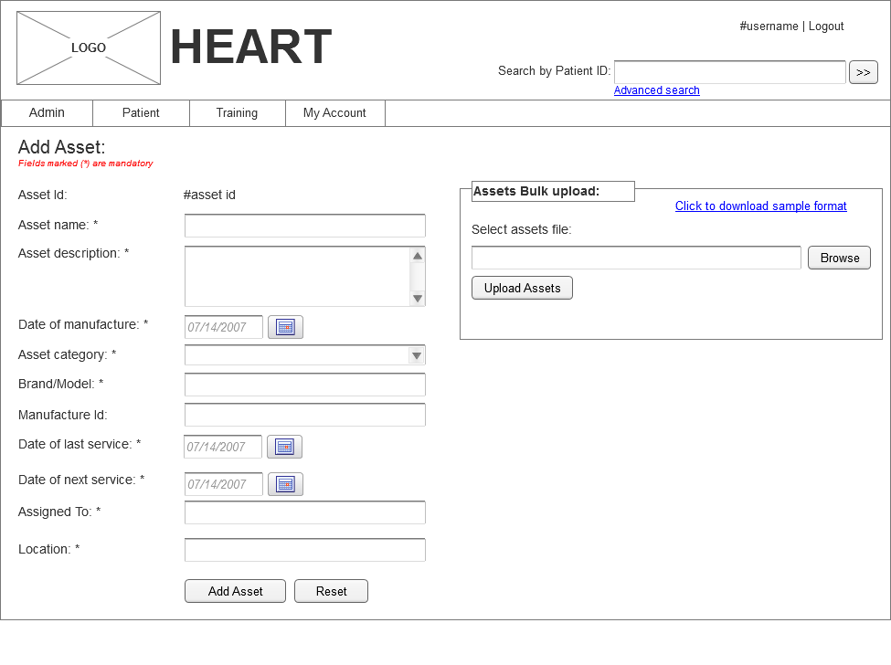
2 | Section 1.10.1 : Patient Questionnaire &  Section 1.10.2: Patient management by care manager → Add new diagnosis  Discussed to remove Pulse, Spo2, Temperature, Bloog group and Blood Group Rheses Factor from diagnosis information.  Updated mock screen:  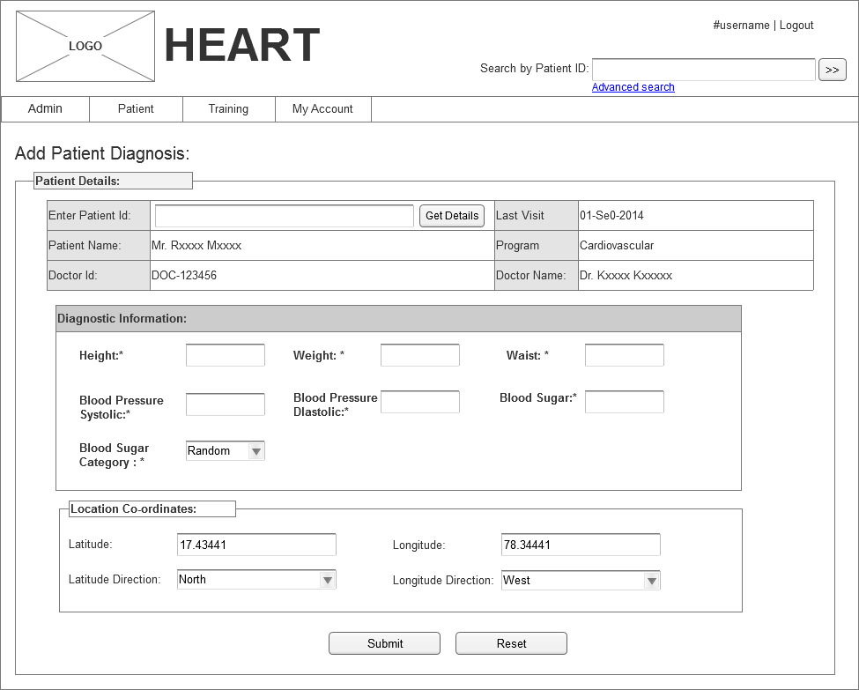
3 | Section 1.10.2: Patient management by care manager  Removed “Advance question” button in patient management by care manager, as there will not be any advance questions for Nano.  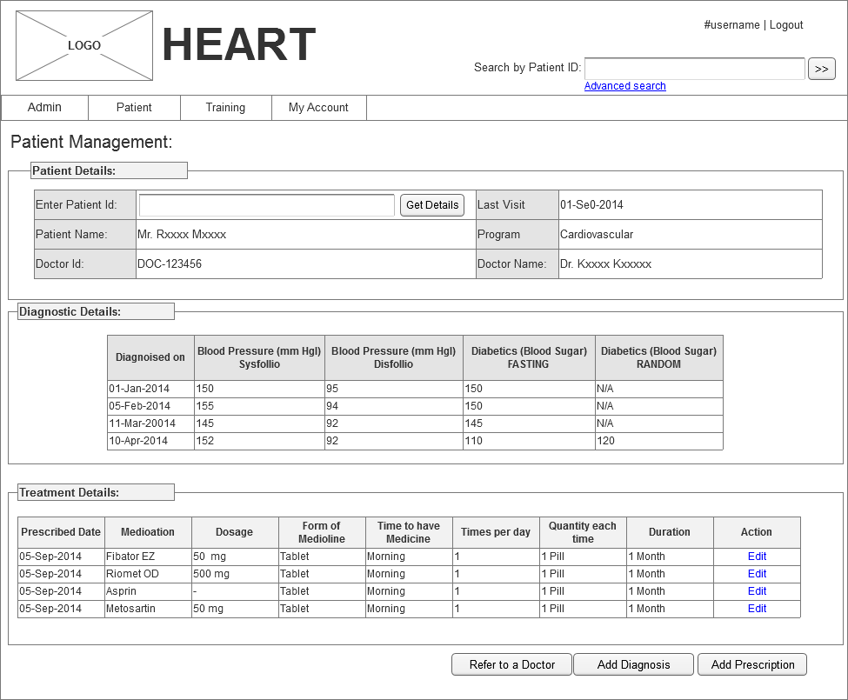  Advance Questions: This section is not required as “Advance questions” button is removed  Add Prescription:
4

