Project 1
Factor A: Gridded precipitation | Factor B: DC observations
NOAA MRMS | DC water-level gauges

NOAA MRMS
The National Oceanic and Atmospheric Administration (NOAA) is a US scientific and regulatory agency in the United States Department of Commerce. It is concerned with weather forecasting and monitoring oceanic and atmospheric conditions, among other things. The Multi-Radar Multi-Sensor (MRMS) system was deployed in 2014 at the National Weather Service's National Centers for Environmental Prediction (NCEP). It releases products every two minutes based on combining data streams from multiple radars, satellites, surface observations, upper air observations, lightning reports, rain gauges, and numerical weather prediction models.

DC water-level gauges

Code
See GitHub

Data source references
https://mtarchive.geol.iastate.edu/YYYY/MM/DD/mrms/ncep/PrecipRate/
USGS
cocorahs
Data availability report

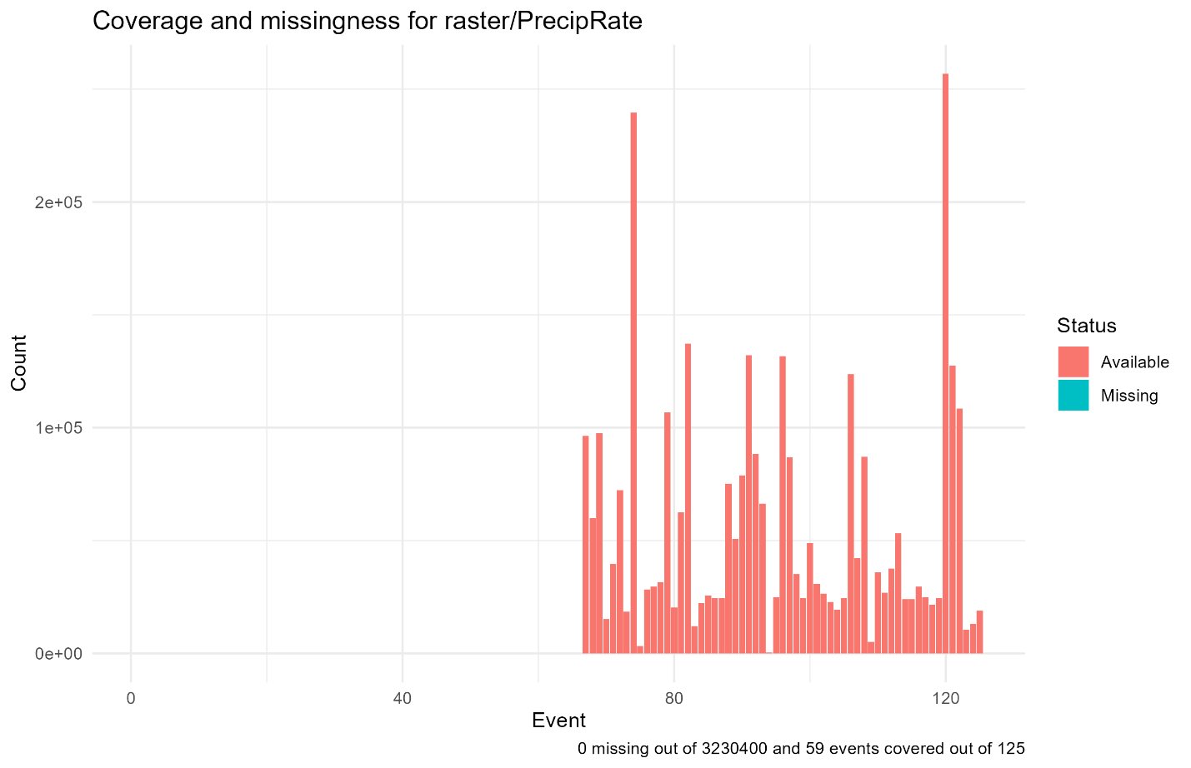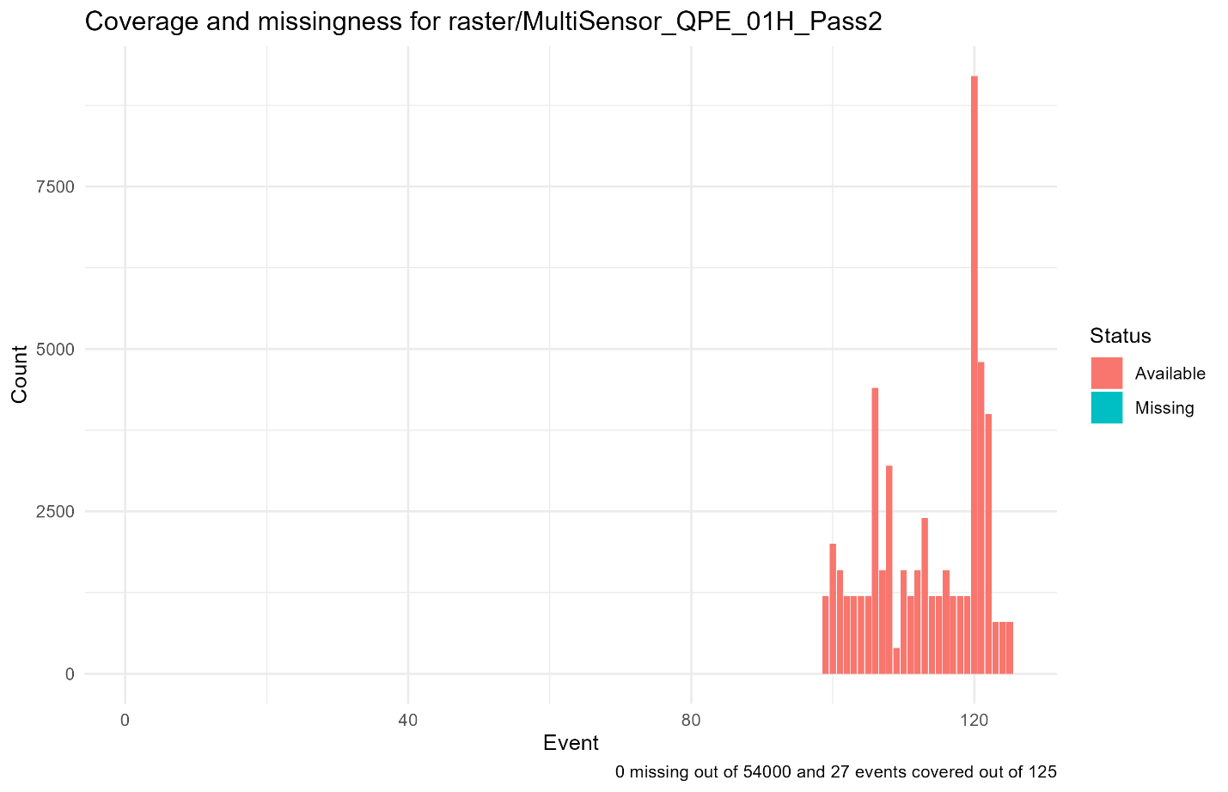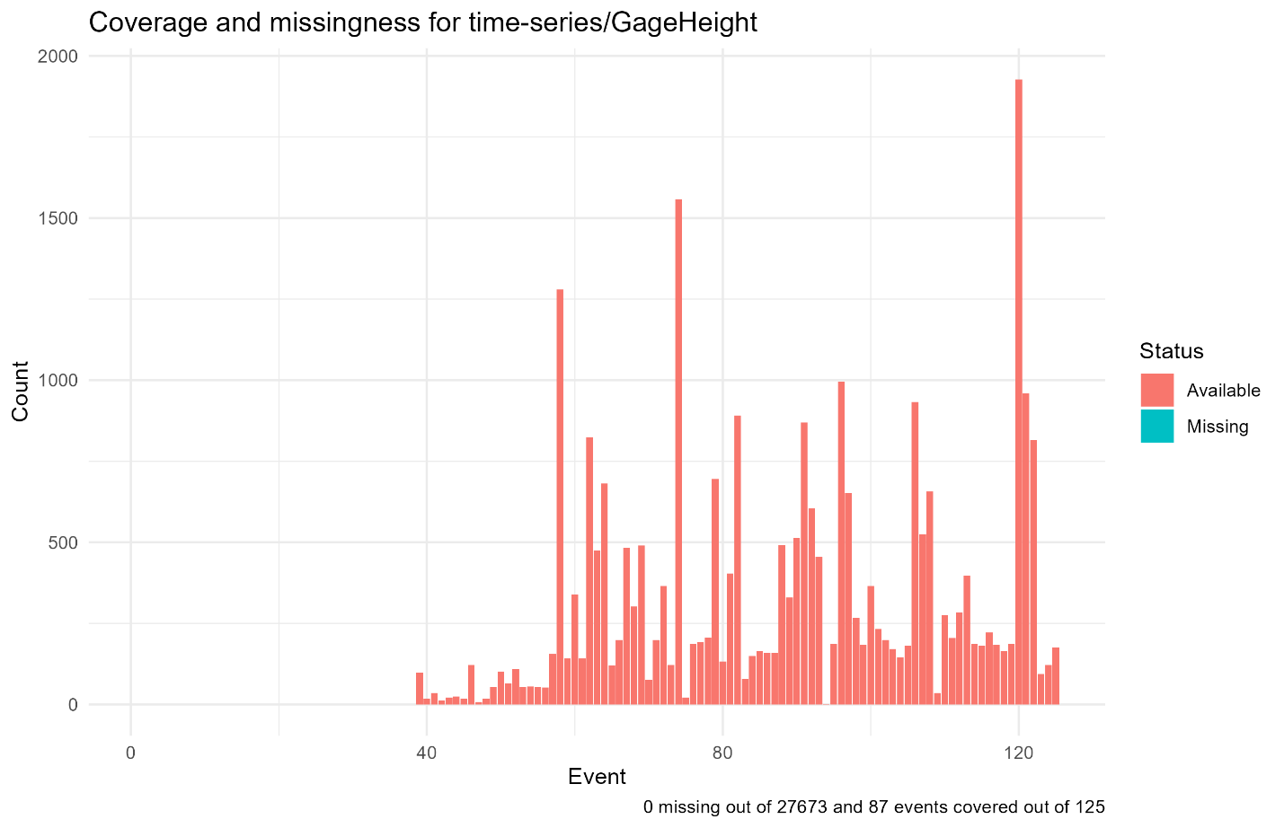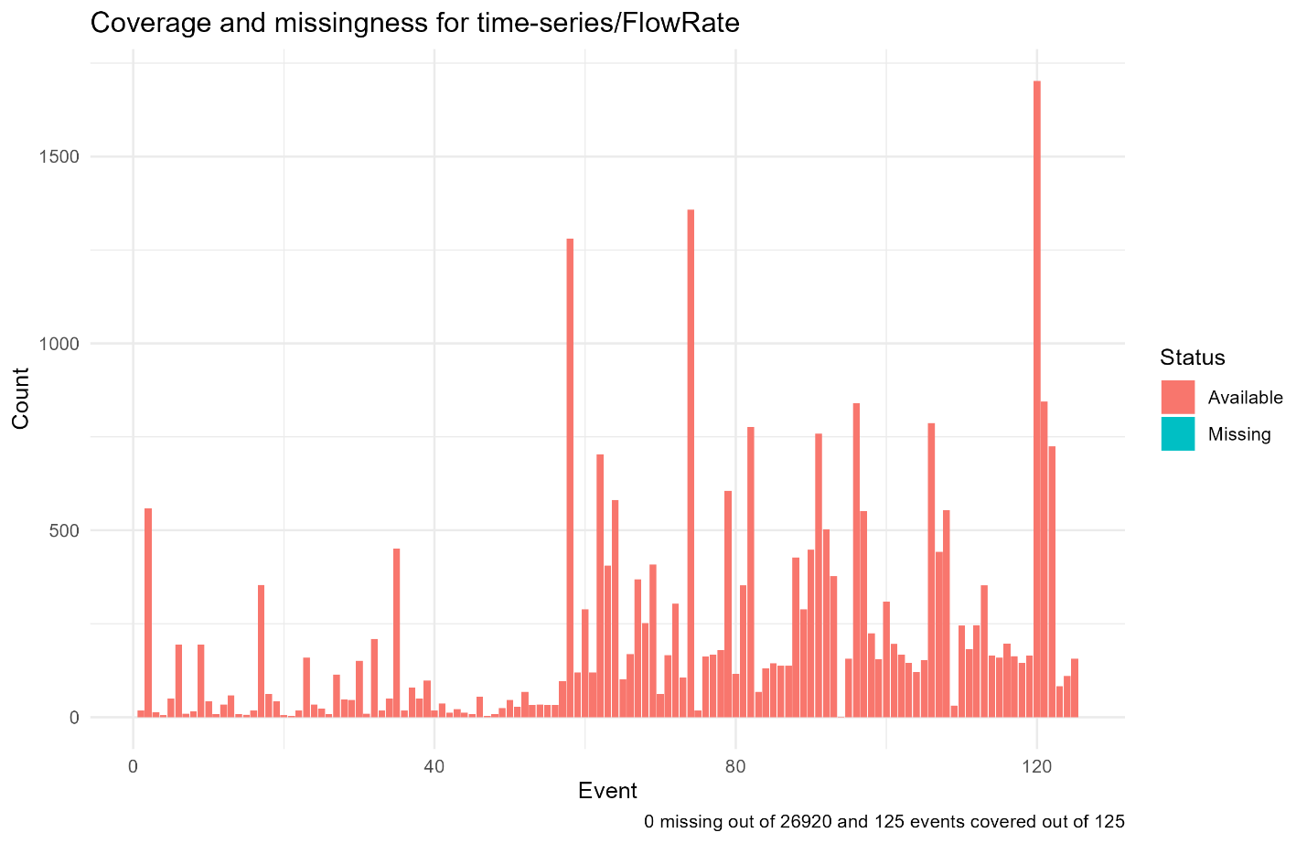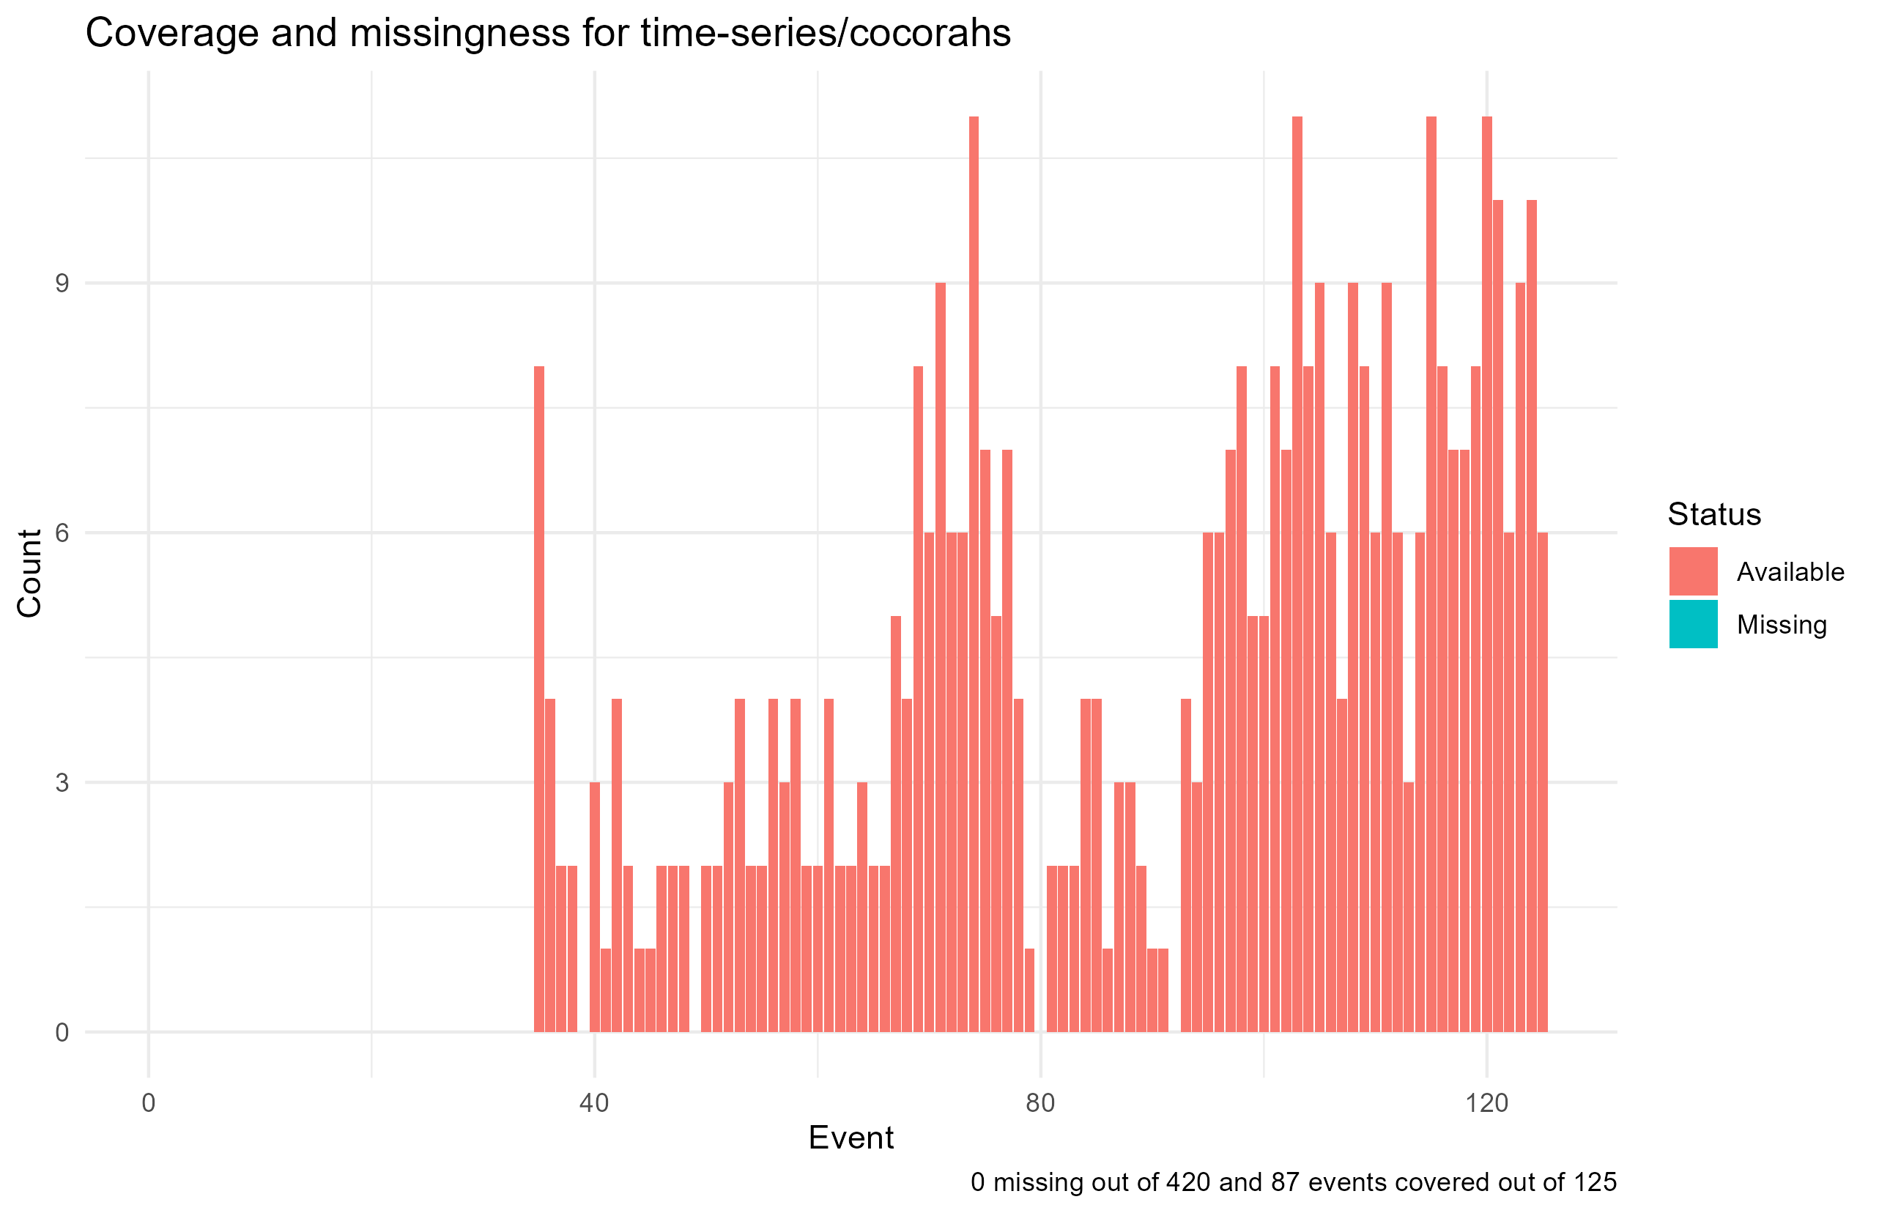
Instructions to regenerate HDF5 database
Use and acknowledgement of AI
Artificial intelligence tools (ChatGPT and Google) were used to brainstorm potential data sources and identify relevant R packages for data retrieval. All suggested packages and methods were evaluated and the most appropriate selected and implemented and if necessary, verified with other documentation, such as R package documentation.

