Rohit Hooda

500110652  DevOps -B2

ADBMS LAB EXPERIMENT-1

1. Table name: CLIENT_MASTER

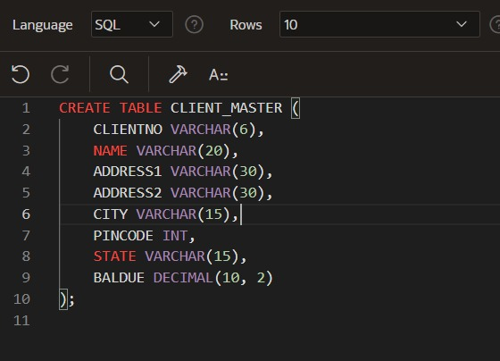

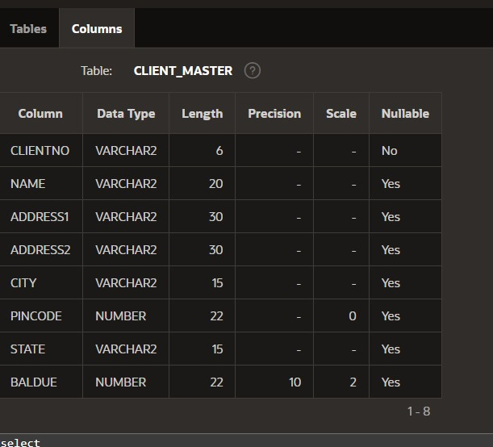

1. Table Name: PRODUCT_MASTER

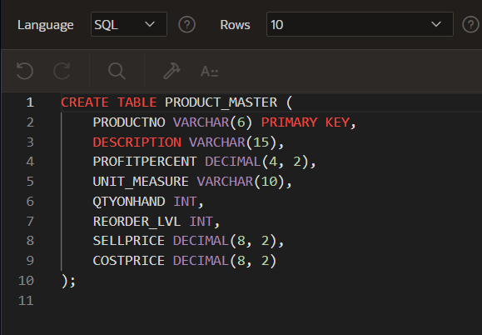

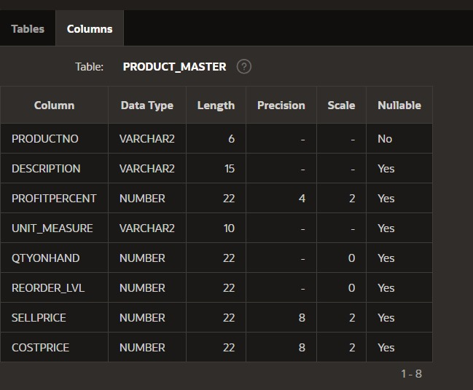

1. Table Name: SALESMAN_MASTER

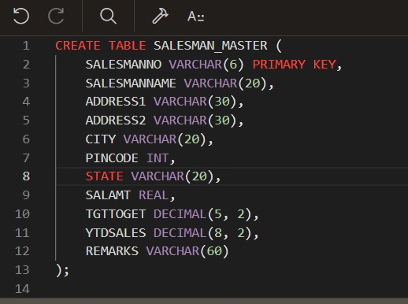

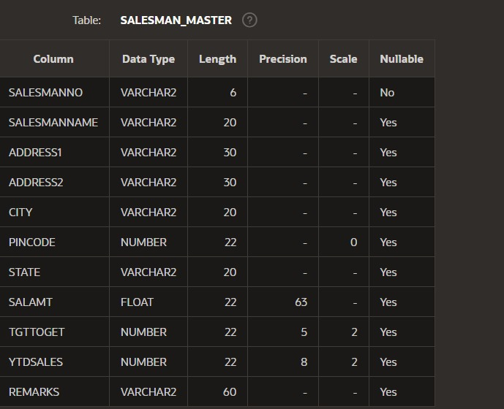

2.a) Data for CLIENT_MASTER table:

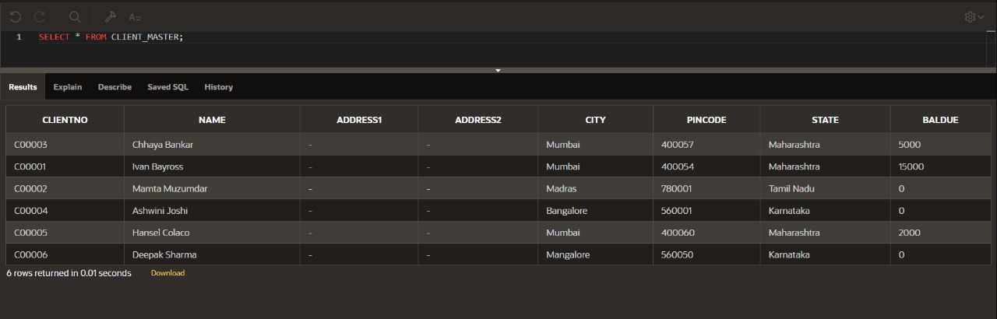

2.b) Data for PRODUCT_MASTER table:

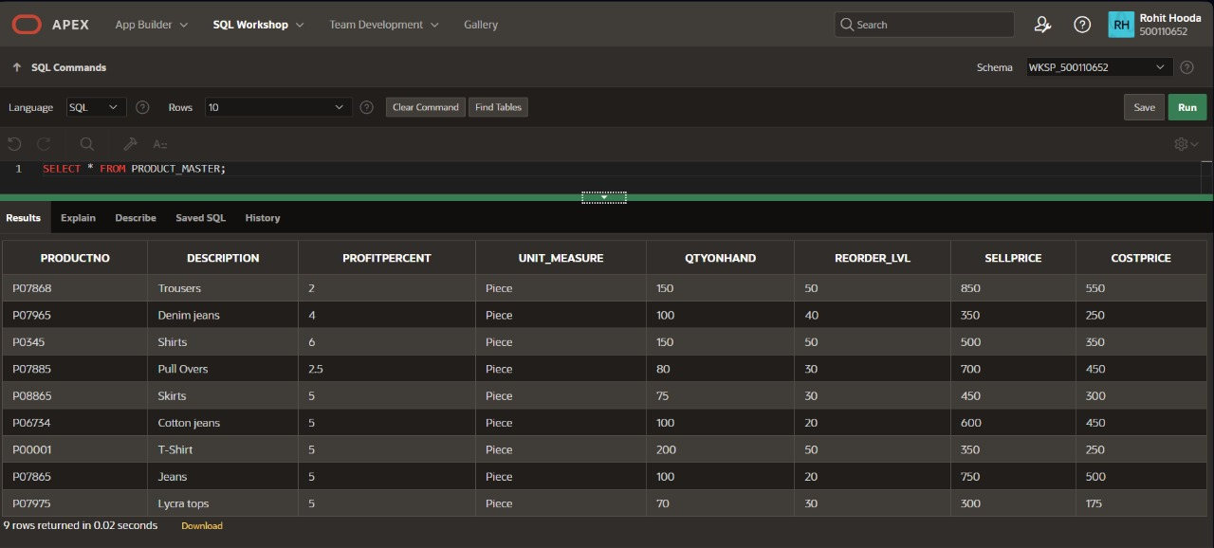

2.c) Data for SALESMAN_MASTER table:

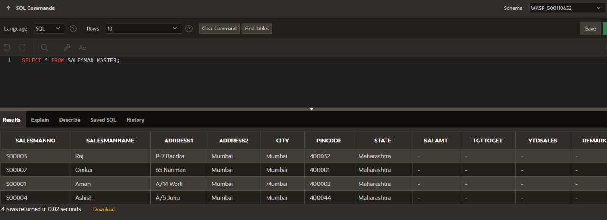

3.a) Find out the names of all the clients.

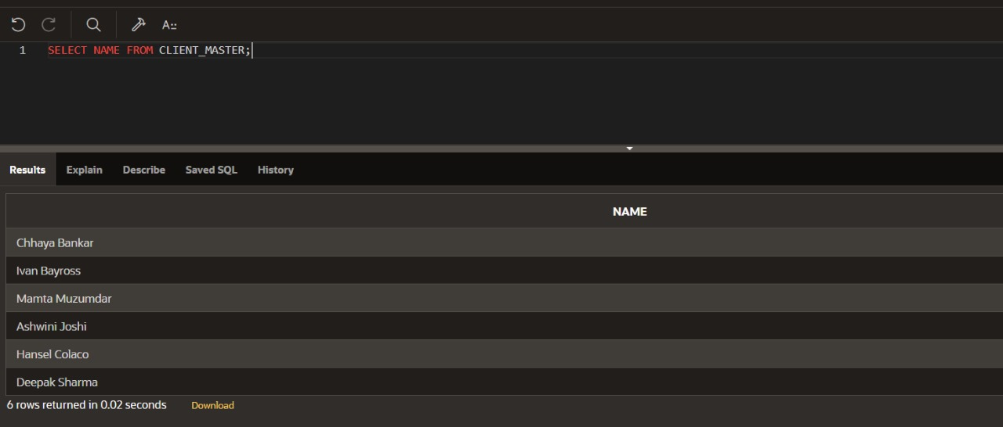

3.b) Retrieve the contents of the Client_Master table.

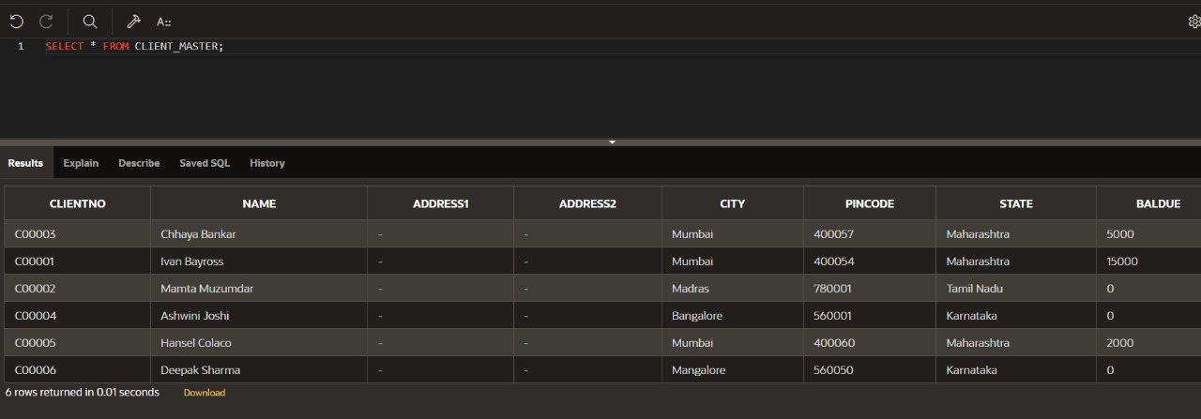

3.c) Retrieve the list of names, city and the state of all the clients.

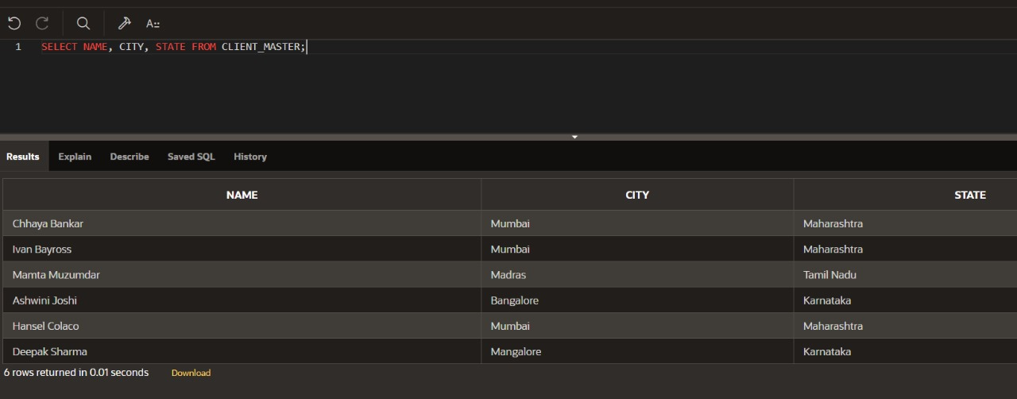

3.d) List the various products available from the Product_Master table.

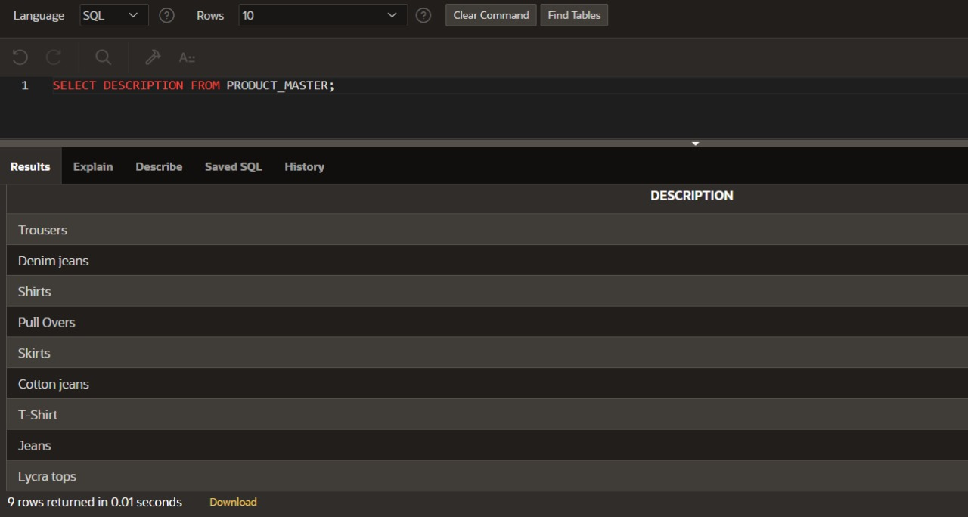

3.e) List all the clients who are located in Mumbai.

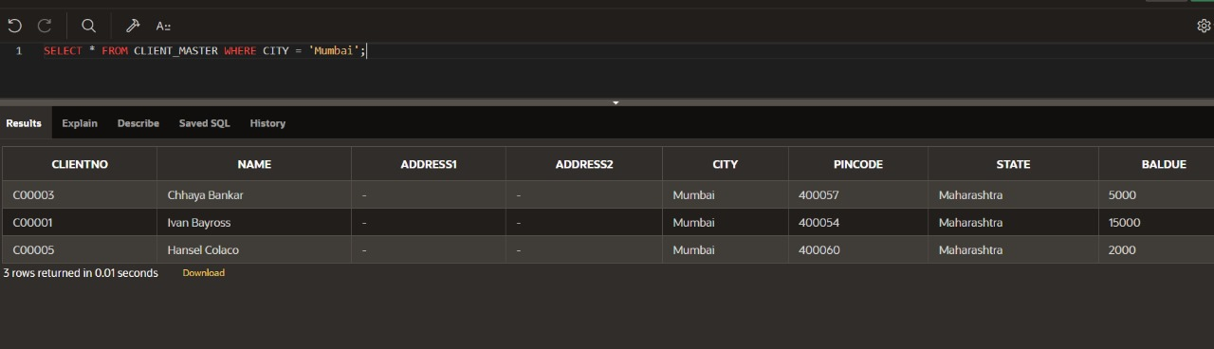

3.f) Find the names of salesman who have a salary equal to Rs.3000.

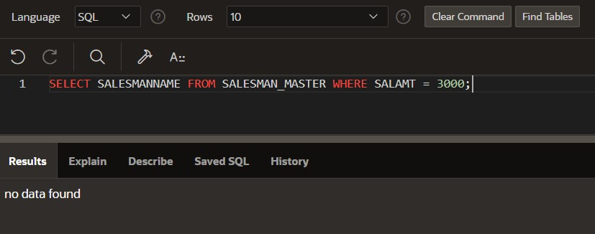

4.a) Change the city of ClientNo ‘C00005’ to ‘Bangalore’.

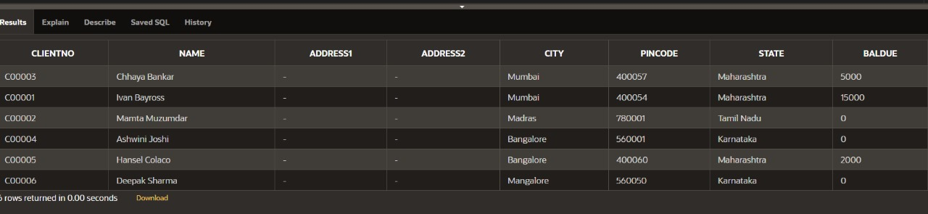

4.b) Change the BalDue of ClientNo ‘C00001’ to Rs.1000.

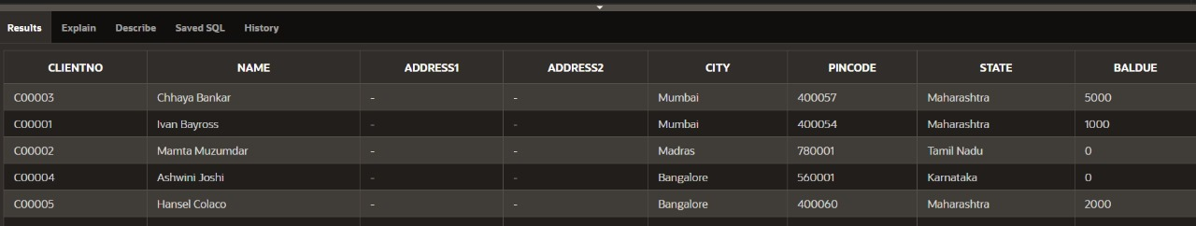

4.c) Change the cost price of ‘Trousers’ to rs.950.00.

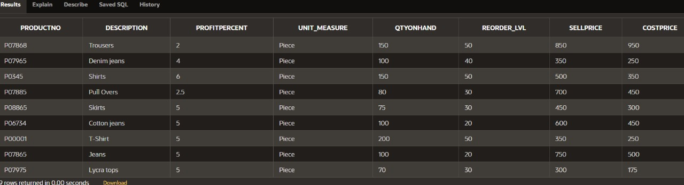

4.d) Change the city of the salesman to Pune.

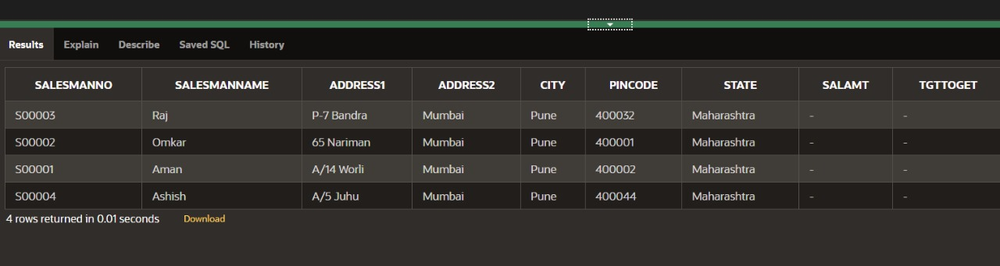

5.a) Delete all salesman from the Salesman_Master whose salaries are equal to Rs.3500.

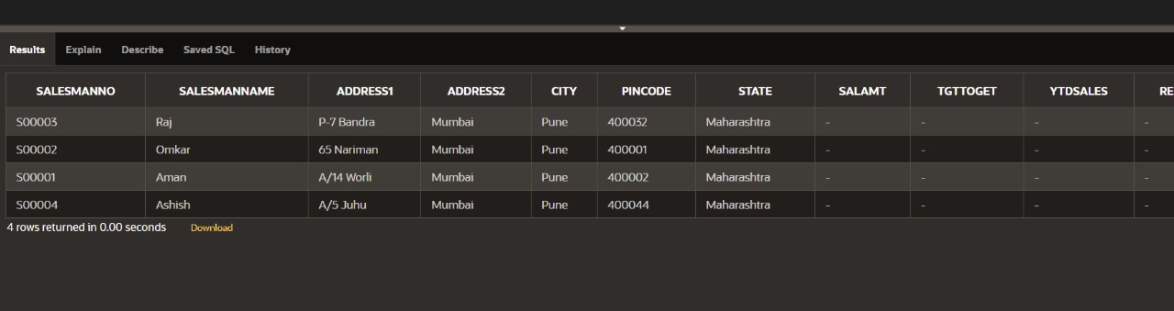

5.b) Delete all products from Product_Master where the quantity on hand is equal to 100.

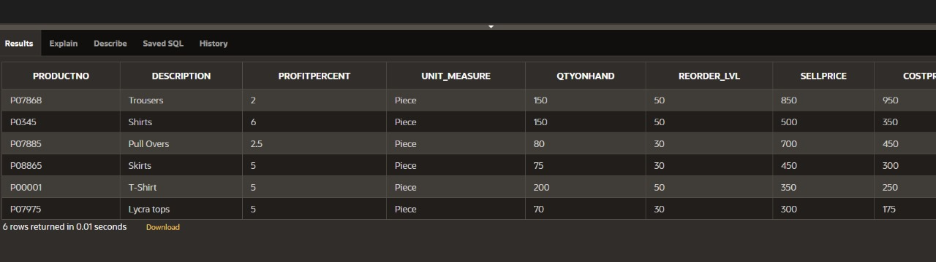

5.c) Delete from Client_Master where the column state holds the value ‘Tamil Nadu’.

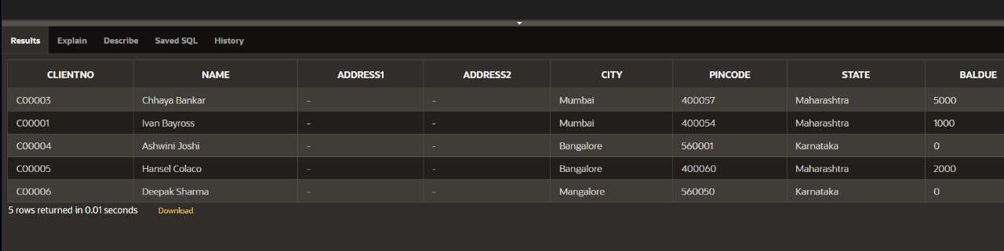

6.a) Add a column called ‘Telephone’ of data type integer to the Client_Master table.

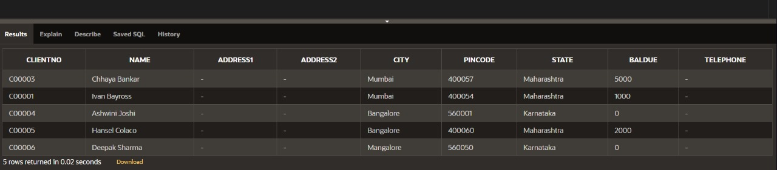

7.a) Destroy the table Client_Master along with its data.

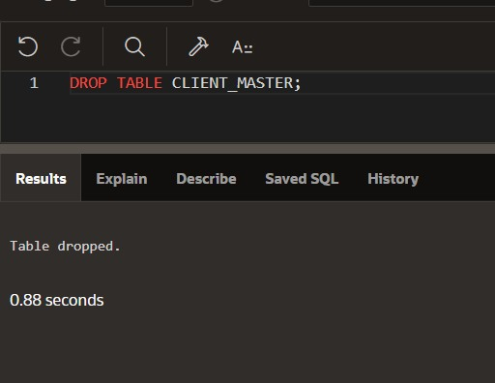

8.a) Change the name of the Salesman_Master to sman_mast.

