ML / Report

Integration
Data Transformation
DB
Data warehouse
Ingestion

Infrastructure
Compute Engine | Storage | Network

Compute Engine
- VM, a machine on the cloud
- App Engine, a vm with runtime installed [Autoscaling]
- K8, Cloud Run, a container deployed on a VM/ serverless
- Cloud Function
Storage
- DB
  - SQL
    - Cloud SQL
    - Cloud Spanner
  - NoSQL
    - Big Table | Firestore
- Blob/ objects | Google cloud storage
- BigQuery

Data Engineer/ Analytic Related
- ETL | Data Flow (both batch and streaming), Data Fusion, | Dataproc
- Data warehouse | Big Query
Messaging
- Pubsub
- EVENTARC
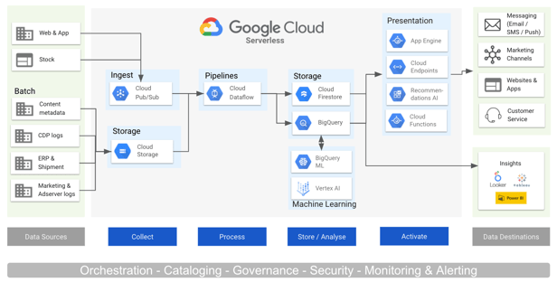

https://www.youtube.com/watch?v=8p-qLtqlJpQ

Free cloud features and trial offer | Google Cloud Free Program | Google Cloud Documentation
Introduction to Google Cloud
Introduction to Google Cloud
https://www.youtube.com/watch?v=lvZk_sc8u5I&t=481s

Compute Engine
Storage
Service
- Cloud Shell
IAM
VPC

Choosing storage
Choosing compute engine/ service

From app engine to cloud run - GKE

