1. 1 2 3 4 5 6 7 8

0 0 4 999 999 999 999 999 8 999

1 4 0 8 999 999 999 999 11 999

2 999 8 0 7 999 4 999 999 2

3 999 999 7 0 9 14 999 999 999

4 999 999 999 9 0 10 999 999 999

5 999 999 4 14 10 0 2 999 999

6 999 999 999 999 999 2 0 1 6

7 8 11 999 999 999 999 1 0 7

8 999 999 2 999 999 999 6 7 0

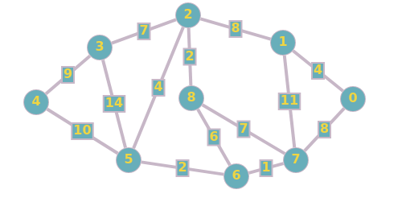

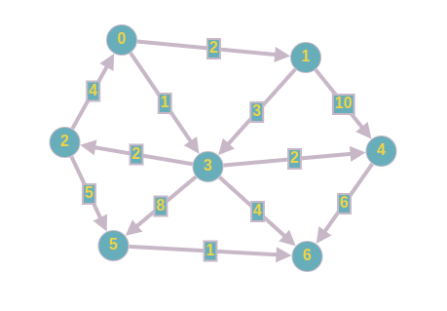

1. 1 2 3 4 5 6
2. 0 2 999 1 999 999 999
3. 999 0 999 3 10 999 999
4. 4 999 0 999 999 5 999
5. 999 999 2 0 2 8 4
6. 999 999 999 999 0 999 6
7. 999 999 999 999 999 0 1
8. 999 999 999 999 999 999 0