**从以下3个表中组合数据然后存入另一个表中**

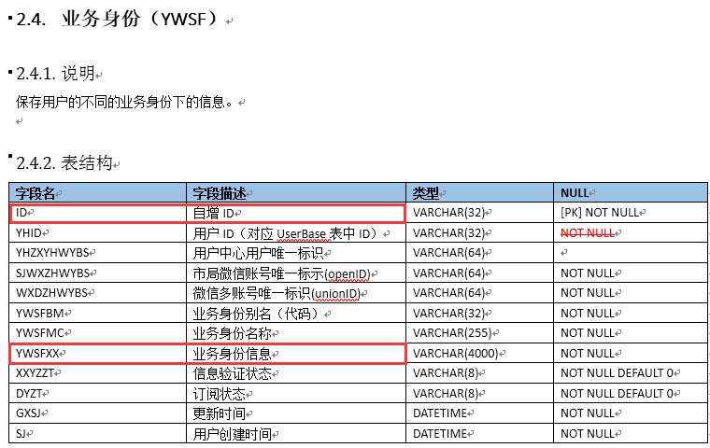

**YWSFXX字段里面含有车牌信息，ID作为唯一用户标识可以与其他表关联起来**

**YWSFMC里面有驾驶证业务一项**

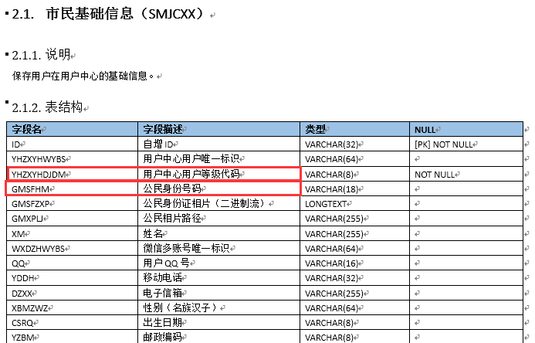

**YHZXYHDJDM不为空表示是实名用户**

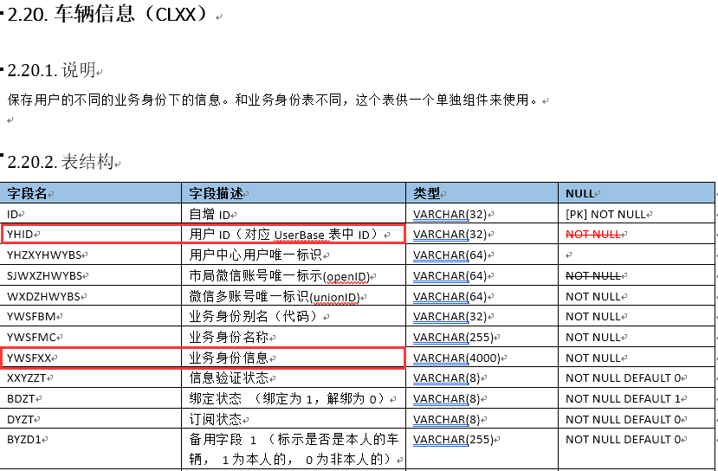

**YWSFXX里面有驾照信息，比如A/B/C照等信息**

**需求：**

**以用户ID来关联，查出该用户的车牌，驾照，身份证，姓名信息**

**解决方案如下：**

**业务身份：**

**YWSF**

**市民基础信息：**

**SMJCXX**

**车辆信息：**

**CLXX**

**oracle数据库先将两张表关联查询，得到的结果再和第三张表关联查询:**

CREATE TABLE `clxx_ab` (

`XM` varchar(255) CHARACTER SET utf8 NOT NULL,

`GMSFHM` varchar(18) CHARACTER SET utf8 NOT NULL,

`YWSFXX` varchar(4000) CHARACTER SET utf8 NOT NULL,

`ID` varchar(32) CHARACTER SET utf8 NOT NULL,

UNIQUE KEY `id` (`id`)

) ENGINE=InnoDB;

INSERT INTO CLXX_AB (XM, GMSFHM, YWSFXX, ID) SELECT SMJCXX.XM, SMJCXX.GMSFHM, CLXX.YWSFXX, SMJCXX.ID FROM CLXX, SMJCXX where CLXX.YHID = SMJCXX.ID and SMJCXX.YHZXYHDJDM is not null;

SELECT CLXX_AB.ID, CLXX_AB.XM, CLXX_AB.GMSFHM, CLXX_AB.YWSFXX, YWSF.YWSFXX FROM CLXX_AB, YWSF where YWSF.YHID = CLXX_AB.ID;

INSERT INTO CLXX_CD(XM, GMSFHM, YWSFXX, ID, XSSFXX) select CLXX_AB.XM, CLXX_AB.GMSFHM, CLXX_AB.YWSFXX, CLXX_AB.ID, YWSF.YWSFXX FROM CLXX_AB, YWSF where YWSF.YHID = CLXX_AB.ID and YWSF.YWSFMC = '驾驶证业务'; //单引号

按如下方式，一下关联三张表进行查询太慢：

SELECT c.ID, c.XM, c.GMSFHM, c.YWSFXX, YWSF.YWSFXX FROM (SELECT SMJCXX.XM, SMJCXX.GMSFHM, CLXX.YWSFXX, SMJCXX.ID FROM CLXX, SMJCXX where CLXX.YHID = SMJCXX.ID and SMJCXX.YHZXYHDJDM is not null) c, YWSF where YWSF.YHID = c.ID;

然后对数据表中的数据进行筛选，具体查看文件 sql.php