Table of Contents

LinkedIn thought-leadership series: the enterprise GenAI stack, layer by layer
Author: Bing Zhang · Drafted: 9 October 2026 · Status: complete draft. An introduction post (Post 0, a few days before week 1), 24 posts (weeks 1–12), a week-13 buffer note and 3 reactive templates. Posts #19–#24 are drawn from the Stage C synthesis.

Series introduction
Purpose. A 13-week series that turns the Enterprise GenAI Full-Stack Architecture Review into a public body of work. Each week pairs one stack layer with the control that makes it safe in production. The aim is to show judgement rather than vendor knowledge: the trade-offs, the operating-model decisions and the evidence a regulated firm needs. One generic worked example runs through every post: an agent that drafts the monthly Brinson-style performance-attribution commentary for a multi-asset fund, with a portfolio manager approving every draft.
Cadence. Two posts a week, on whichever days suit the audience: no day of the week is fixed, and no post names one. The first post of each week is the stack post and the second is the control post that pairs with it. The series starts after CP5 sign-off; dates are planned in the content calendar, and each post below is labelled “Week N”. Week 13 is a buffer for a reactive post or a slipped week.
How to use the anecdote slots. - Each full post has one bracketed line, [Anecdote slot: …], where the “honest part” goes. It is sized for one or two sentences (about 25–35 words), so replacing it keeps the post within 220–300 words. - Use only a real experience of your own: a mistake you own, or credit to the people who did the work. The prompt under each post says what kind of story fits. Keep it free of internal system names, client details and real internal metrics. - If you have no suitable story, post the fallback version. It is complete as it stands and needs no personal story. - The short variant also stands alone. Use it for a lighter week or a repost. - Hashtags are listed separately. Add them as the last line of whichever version you post.
The worked example, built post by post. The commentary agent is not just an illustration: each post adds one piece of its design (work/stageC2/worked_example_build.json). The first comment of every post states the step: what it adds, what now works and what the agent must never do. A strip at the foot of every visual shows how far the build has come, with the current piece in gold. Posts 1–18 add the layers and controls in the series’ teaching order; Post 19 assembles them into one request trace; Post 20 sets out the real build order (governance and evaluation first) and the minimum go-live; Posts 21–24 settle build or buy, interfaces, lock-in and the final selection. The table at the end of this document lists every step.
Compliance note (applies to every post). - These are personal views. They do not imply employer endorsement or describe any firm’s actual vendor choices. - No confidential or internal information: no internal systems, client data, programme names or real internal metrics. - The worked example is generic and illustrative. It does not describe any real firm’s platform. - Post bodies are vendor-neutral. Vendor and product names appear only in the first comment, and every vendor is treated in the same factual way. - No pre-clearance is needed (CP4b), but keep the per-post compliance check.
Conflict of interest. The drafts were prepared with help from an AI model made by Anthropic. Post bodies name no vendor. In first comments, Anthropic products (Claude, the Claude Agent SDK, MCP’s origin, Agent Skills) are listed in the same way as every other vendor’s. Whether to say in the first comment of post #1 that you used AI drafting assistance is your choice. A suggested line is given there.
Sourcing. Every fact in a post traces to a chapter of the review (work/stageB/<layer>/section.md), to the synthesis (work/stageC/synthesis.md, posts #19–#24), or to Enterprise_GenAI_Stack_Oct2026/05_Data/regulatory_facts.json. The section and source IDs are in each first comment. Numbers marked as targets are starting points from the review’s KPI tables, not industry benchmarks. Illustrative scenarios from the chapters are not used as if they were real incidents.
Re-verify before posting. Over three months, versions, ownership, prices and regulatory dates move. Check each post’s “Re-verify” list in the week before it goes out.
Word counts. Each full post and fallback version is 220–300 words, including the anecdote slot as drafted. Each short variant is 120–150 words. Reactive templates are 220–300 words (short variants 120–150), with their bracketed fields counted as drafted. These were checked with a script (see the end of this file).

Calendar, weeks 1–13
Week | Stack post (first of the week) | Control post (second of the week)
0 | #0 Series introduction (a few days before week 1)
1 | #1 L1 Foundation models | #2 C6 AI FinOps
2 | #3 L2 Inference and access | #4 C1 AI gateway
3 | #5 L3 Orchestration | #6 C2 Guardrails
4 | #7 L4 Tools and protocols | #8 C4 Agent identity and access
5 | #9 L5 Memory | #10 Regulated reality: EU AI Act and DORA
6 | #11 L6 Retrieval stores | #12 C7 AI security
7 | #13 L7 Embeddings and reranking | #14 C5 Prompt and configuration management
8 | #15 L8 Ingestion | #16 C3 DLP and PII
9 | #17 L9 Evaluation and observability | #18 C8 Model risk, governance and audit
10 | #19 The worked example, end to end | #20 Start small
11 | #21 Build vs buy | #22 Where not to abstract
12 | #23 Which lock-in is acceptable | #24 Close: what I’d select, and what I’d deliberately not select
13 | Buffer (slipped post or reactive template) | Buffer
Reactive templates R1 (model launch), R2 (acquisition) and R3 (regulatory milestone) can go into week 13 or replace a control-post slot when timing matters.

Week 0: series introduction

Post 0 · Week 0 · Series introduction: the enterprise GenAI stack, layer by layer
Pair: Post 1 (L1, Week 1). Bridge: The series starts where every architecture starts: the models, and how not to bet the firm on one of them.
Theme and source: Why the series exists, what it covers and how it runs. work/stageD/method.md (evidence base), work/stageC/synthesis.md (Part I finding 1, Part XII), Enterprise_GenAI_Stack_Oct2026/05_Data/what_changed.xlsx.
Tension: The logos move faster than any diagram; the controls around them are what last.

Full post
Over the next twelve weeks I am going to take the enterprise GenAI stack apart, one layer at a time.
Most of us have shared some version of the popular stack diagram: nine layers, rows of product logos. It is a useful map. But by the end of Q3 2026, 39 of its 80 tiles needed a correction. Acquired, renamed, mispositioned, superseded. The logos move faster than any diagram can.
So I asked a narrower question. What would a regulated asset manager actually need to run GenAI safely in production?
The answer became a review of 140 products across nine layers and eight cross-cutting controls, built on 1,255 logged sources and checked by two independent verifiers. The finding that shaped everything else: the architecture that matters is the control plane around the products, not the products themselves.
The series follows that shape. Each week takes one layer of the stack, from foundation models to evaluation, and then the control that makes it safe. One worked example runs throughout: an agent that drafts the monthly performance-attribution commentary for a multi-asset fund, with a portfolio manager approving every draft.
The posts share judgement, not vendor rankings. No vendor is named in the post itself; sources sit in the first comment.
[Anecdote slot: one or two sentences on a time a vendor map or stack diagram you relied on turned out to be out of date, and what it taught the team.]
If one of these weeks saves you a quarter of rework, the series will have done its job. The first post is on foundation models.

Short variant
Over the next twelve weeks I am going to take the enterprise GenAI stack apart, one layer at a time.
The popular stack diagram is a useful map, but by the end of Q3 2026, 39 of its 80 tiles needed a correction. The logos move faster than any diagram.
So I asked a narrower question: what does a regulated asset manager need to run GenAI safely in production? The answer became a review of 140 products, nine layers and eight controls, built on 1,255 sources.
Each week, one layer, then the control that makes it safe. One worked example throughout: an agent drafting a fund’s monthly attribution commentary, with a portfolio manager approving every draft.
Judgement, not vendor rankings. The first post is on foundation models.

Anecdote slot
- Where: the bracketed line before the closing paragraph.
- Prompt: a moment when a reference diagram, vendor landscape or “approved tools” list the team relied on was out of date, and what it cost or taught you. Credit whoever noticed; own it if you were the one still using the old map.
- Fits: “turning external deadlines into refresh mandates”, and making invisible work visible.
- Avoid: naming the diagram’s author, any vendor, or any internal tool list.

Fallback version
Over the next twelve weeks I am going to take the enterprise GenAI stack apart, one layer at a time.
Most of us have shared some version of the popular stack diagram: nine layers, rows of product logos. It is a useful map. But by the end of Q3 2026, 39 of its 80 tiles needed a correction. Acquired, renamed, mispositioned, superseded. The logos move faster than any diagram can.
So I asked a narrower question. What would a regulated asset manager actually need to run GenAI safely in production?
The answer became a review of 140 products across nine layers and eight cross-cutting controls, built on 1,255 logged sources and checked by two independent verifiers. The finding that shaped everything else: the architecture that matters is the control plane around the products, not the products themselves.
The series follows that shape. Each week takes one layer of the stack, from foundation models to evaluation, and then the control that makes it safe. One worked example runs throughout: an agent that drafts the monthly performance-attribution commentary for a multi-asset fund, with a portfolio manager approving every draft.
The posts share judgement, not vendor rankings. No vendor is named in the post itself; sources sit in the first comment.
The honest caveat: parts of this will date. Versions, owners and prices move monthly, so each post is re-checked in the week it goes out, and where I get something wrong I will say so.
If one of these weeks saves you a quarter of rework, the series will have done its job. The first post is on foundation models.

Suggested visual
Series map: the nine layers (L1 → L9) as a stack on the left, each paired by a connector with its control or theme on the right, labelled with week numbers 1–9. Weeks 10–12 (worked example, start small, build vs buy, where not to abstract, lock-in, close) as a strip beneath. A banner across the top: “the control plane around the products is the architecture”. Footer: “24 posts · 12 weeks · one worked example”. Source: the calendar above and synthesis Part I.
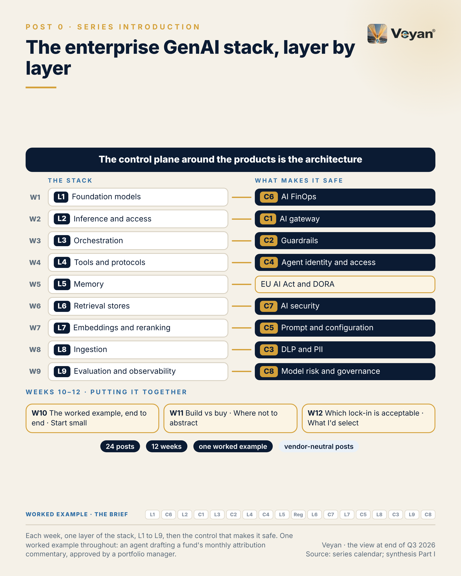
Visual: 08_Graphic/linkedin/P00.png (1080 × 1350, LinkedIn portrait); editable source P00.md, also as .html and .pdf.

First comment
Personal views; not a description of any firm’s platform or vendor choices. Sources: the Enterprise GenAI Stack review (the view at end of Q3 2026). - Scope and evidence: 140 product records (138 scored), 20 regulatory and standards records and 1,255 logged sources, checked by two adversarial verifiers (review method, “Evidence base”). - The 39 of 80 tiles: the review’s “What changed since the popular stack diagram” table (9 acquired, 9 mispositioned, 8 renamed, 8 with a wrong version label, 6 not publicly verifiable, 4 duplicated, 3 superseded, 2 deprecated; some tiles carry more than one flag). - Disclosure: I used an AI model made by Anthropic to help research and draft the review and these posts. Anthropic products are treated like every other vendor’s, and an independent alternative is named wherever one is recommended. - Format: each week, one stack layer, then the control that makes it safe. - Worked example: the brief. The use case and its boundary: the agent writes words around numbers it is given; it never produces a number, and a named portfolio manager approves every draft. Each post adds one piece of the design; the strip at the foot of every visual shows how far the build has come. The series teaches the stack in layer order; the real build order (evaluation and governance first) comes in Post 20.

Hashtags
#GenerativeAI #EnterpriseArchitecture

Re-verify before posting
- The counts (140 products, 1,255 sources, 39 of 80 tiles) against the final published edition
- The planned date of Post 1 (set in the content calendar)

Compliance check
- Personal views; no statement about any firm’s platform or vendor choices: yes
- Body vendor-neutral; the diagram’s author is not named or criticised: yes
- AI-assistance disclosure in the first comment: yes

Week 1

Post 1 · Week 1 · L1 Foundation models
Pair: Post 2 (C6, Week 1). Bridge: A portfolio of models needs a way to choose between them on cost without fooling yourself; the control post supplies the metric.
Theme and source: A small, governed model portfolio with a qualified second vendor. work/stageB/L1/section.md (executive summary, §1.2, §1.3, §1.9, §1.11–§1.13), with the CP4-1 tier decision.
Tension: Treat models as a portfolio, not a bet.

Full post
Treat foundation models as a portfolio, not a bet.
Every major vendor now sells a tiered family rather than a single model, and lifetimes are short. One generally available model version released in August 2026 is already scheduled to retire in January 2027. Earlier this year, one leading vendor’s top tier was withdrawn for nearly three weeks before being restored.
A firm that hard-codes one vendor cannot respond to either. Nor can a firm whose “fallback model” is a line in a design document that was never tested on the real workload.
A portfolio does not need to be large. Two mid-tier models from unrelated vendors, a small model for high-volume classification, and one open-weight model the firm can run itself. All of them called through the gateway, pinned to exact versions rather than “latest”, and each qualified on the same evaluation suite.
The signal is qualified-alternative coverage: the share of production use cases with a second model, from a different vendor, that passed the same evaluation within the last quarter. For an important business service the target is 100%.
The leadership move is to keep the frontier tier switched off until an evaluation shows the mid tier fails a named use case. And to remember that no model, at any tier, is fit to produce authoritative figures. Numbers come from the system of record.
[Anecdote slot: one or two sentences on a supplier change, withdrawal or end-of-life that tested your contingency plan, and what the team learned from it.]
Capability changes every quarter. The ability to change your mind safely is the asset worth building.

Short variant
Treat foundation models as a portfolio, not a bet.
Vendors sell tiered families, and lifetimes are short. One generally available model released in August 2026 is due to retire in January 2027. This year, one leading vendor’s top tier was withdrawn for nearly three weeks.
A portfolio need not be large: two mid-tier models from unrelated vendors, a small model, and one open-weight model you can run yourself. All behind the gateway, pinned to exact versions, qualified on the same evaluation suite.
The signal is qualified-alternative coverage: use cases with a second-vendor model that passed the same evaluation in the last quarter. For important business services, 100%.
Keep the frontier tier off until evaluation shows a need. And no model, at any tier, produces authoritative figures.
The ability to change your mind safely is the asset worth building.

Anecdote slot
- Where: the bracketed line before the closing paragraph.
- Prompt: a supplier, product or platform that was withdrawn, changed its terms or reached end of life, and how ready the fallback really was. Credit the people who had qualified the alternative; own it if the “fallback” turned out to be untested.
- Fits: “turning external deadlines into refresh mandates” and resilience.
- Avoid: naming the supplier or implying anything about current vendor relationships.

Fallback version
Treat foundation models as a portfolio, not a bet.
Every major vendor now sells a tiered family rather than a single model, and lifetimes are short. One generally available model version released in August 2026 is already scheduled to retire in January 2027. Earlier this year, one leading vendor’s top tier was withdrawn for nearly three weeks before being restored.
A firm that hard-codes one vendor cannot respond to either. Nor can a firm whose “fallback model” is a line in a design document that was never tested on the real workload.
A portfolio does not need to be large. Two mid-tier models from unrelated vendors, a small model for high-volume classification, and one open-weight model the firm can run itself. All of them called through the gateway, pinned to exact versions rather than “latest”, and each qualified on the same evaluation suite.
The signal is qualified-alternative coverage: the share of production use cases with a second model, from a different vendor, that passed the same evaluation within the last quarter. For an important business service the target is 100%.
The leadership move is to keep the frontier tier switched off until an evaluation shows the mid tier fails a named use case. And to remember that no model, at any tier, is fit to produce authoritative figures. Numbers come from the system of record.
The honest caveat: a portfolio multiplies validation and contract work. The answer is to keep it small and let the evaluation suite do the re-qualification, not to give up the second vendor.
Capability changes every quarter. The ability to change your mind safely is the asset worth building.

Suggested visual
Portfolio grid: four roles (primary mid tier, fallback mid tier from a different vendor, small classifier, self-hosted open weight) as rows, with columns “pinned version”, “region”, “qualified on eval suite (date)”, “retirement runway”. All rows feed one gateway. A “frontier tier: off by default” tile sits above. Source: L1 §1.9 and §1.12 (shown without vendor names).
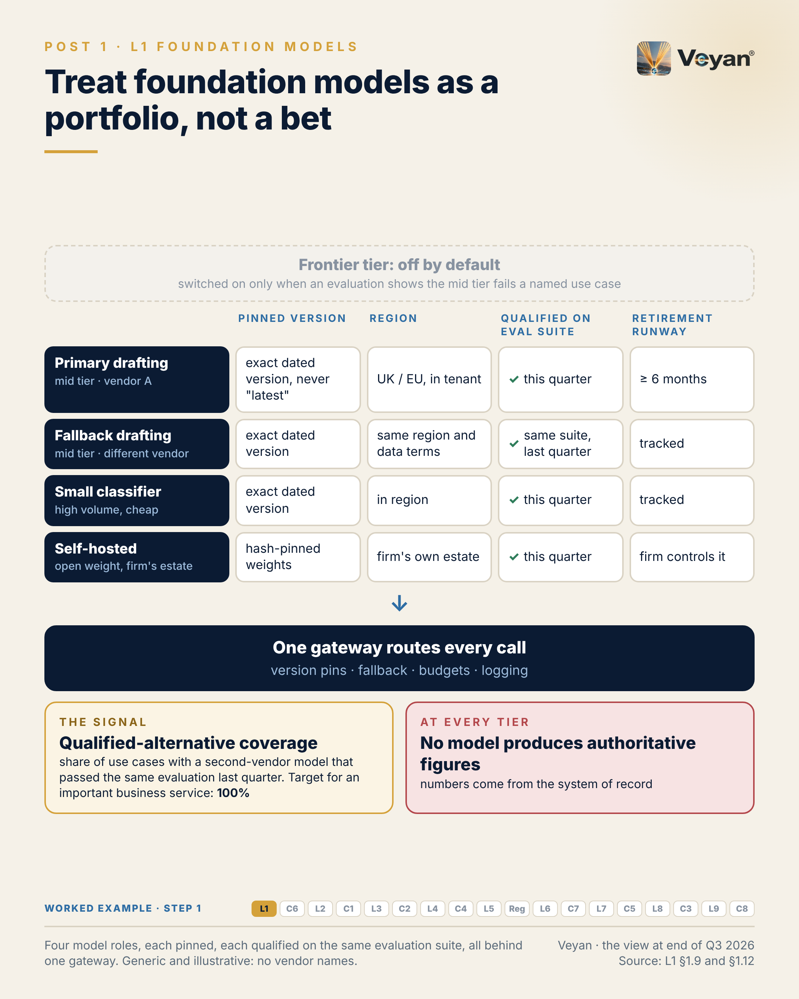
Visual: 08_Graphic/linkedin/P01.png (1080 × 1350, LinkedIn portrait); editable source P01.md, also as .html and .pdf.

First comment
Personal views. Sources: the Enterprise GenAI Stack review, L1 Foundation models (§1.2, §1.3 KPIs, §1.9, §1.11, §1.12), with the CP4-1 tier decision. - The two events: a Gemini Flash version released on 13 August 2026 retires on 28 January 2027 [B-L1-S003]; Anthropic’s Claude Fable 5 was unavailable from 12 June 2026 and restored from 1 July 2026 [V2-S004]. - Tiered families: OpenAI GPT-6 (Astra, Sol, Luna) and GPT-6.1 Sol; Anthropic Claude Fable 5.1 above Opus, Sonnet and Haiku 5.5; Google Gemini 3.x with a restricted Gemini 4 Argon [A5-S002, A5-S004, A5-S010, A5-S019, A5-S030, A5-S031]. - Review tiers: OpenAI, Anthropic and Mistral Strategic for the mid tier (Anthropic re-scored to neutral rubric values at CP4); Gemini Strategic where Google Cloud is the primary cloud; Gemma 4 Strategic as the small self-hosted tier. Chinese-origin open weights (DeepSeek, Qwen, Kimi, GLM) only by explicit policy, self-hosted or in-tenant. Conflict of interest: these drafts were prepared with an Anthropic model, and an independent alternative is named wherever a Claude model is recommended. - Vendor benchmarks, including Anthropic’s, were not used as decision inputs. - Worked example, step 1 (models). Adds: Four model roles, each pinned to an exact version: a primary drafting model, a fallback from a different vendor, a small classifier for reviewer edits, and a self-hosted open-weight model for anything touching unmasked client data. Now: The agent has a primary and a qualified fallback in the approved region. Never: No alias or preview model, and no model ever generates, rounds or corrects a figure.

Hashtags
#FoundationModels #VendorRisk

Re-verify before posting
- The Gemini Flash retirement date and the Claude Fable 5 suspension dates (both cited in the first comment)
- Current model families and versions, which change monthly
- CP4 tier decisions as published in the final document

Compliance check
- Personal views; no statement about any firm’s model choices: yes
- Body vendor-neutral; both example events are attributed evenly in the first comment: yes
- No vendor criticised beyond the cited facts: yes

Post 2 · Week 1 · C6 AI FinOps
Pair: Post 1 (L1, Week 1). Bridge: A model portfolio is only as good as the cost metric used to choose within it, and cost per token is the wrong one.
Theme and source: Cost per task, metered at the gateway and joined to traces. work/stageB/C6/section.md (executive summary, §C6.2, §C6.3, §C6.9, §C6.11–§C6.13).
Tension: Cost per task, not cost per token, is the metric executives understand.

Full post
Cost per token is the number on the price list. Cost per task is the number executives understand, and the one that tells you whether a change saved anything.
A cheaper token that needs three retries and a longer human review is not cheaper. Teams that optimise price per token can move to a smaller model and lose more in regeneration and review time than they saved.
The previous post argued for a portfolio of models. This is how to choose between them on cost without fooling yourself. Meter every call at the gateway, tagged by use case and run. Join those records to the traces so that failed and regenerated attempts count. Reconcile monthly against provider bills. Keep the result in a dataset the firm owns, shaped to the open billing standard.
In the illustrative cost model for this series’ worked example, a monthly fund commentary at current list prices, tokens come to well under a dollar per approved commentary. Reviewer time is the real cost. So the signal I would report is cost per approved output, counting every failed and regenerated draft, alongside the regeneration rate.
Budgets need teeth. The FinOps Foundation puts it plainly: a budget without a quota is a number, not a control. Every cap needs an enforcement point that fails closed, so a runaway agent loop stops itself long before the invoice arrives.
The leadership move is to send cost optimisations through the same change control and evaluation gate as any other change.
[Anecdote slot: one or two sentences on a cost saving that turned out to cost more elsewhere, and what the team measured next time.]
What a task costs is a design question. The invoice only reports the answer.

Short variant
Cost per token is the number on the price list. Cost per task is the one executives understand.
A cheaper token that needs three retries and a longer review is not cheaper.
Meter every call at the gateway, tagged by use case and run. Join to traces so failed and regenerated attempts count. Reconcile monthly against bills, in a dataset the firm owns.
In this series’ illustrative worked example, tokens come to well under a dollar per approved commentary. Reviewer time is the real cost. So report cost per approved output, alongside the regeneration rate.
Give budgets teeth. As the FinOps Foundation puts it, a budget without a quota is a number, not a control. Fail closed, so a runaway loop stops itself.
What a task costs is a design question. The invoice only reports the answer.

Anecdote slot
- Where: the bracketed line before the closing paragraph.
- Prompt: a cost-reduction decision (cheaper tool, smaller team, lower tier) whose hidden costs appeared elsewhere (rework, review time, incidents), or one where measuring the whole task showed the saving was real. Let the numbers you are permitted to share stand plainly; if none are shareable, keep it qualitative. Credit whoever built the measure.
- Fits: “let the numbers do the bragging” and making invisible work visible to executives.
- Avoid: real budget figures, vendor spend or internal cost centres.

Fallback version
Cost per token is the number on the price list. Cost per task is the number executives understand, and the one that tells you whether a change saved anything.
A cheaper token that needs three retries and a longer human review is not cheaper. Teams that optimise price per token can move to a smaller model and lose more in regeneration and review time than they saved.
A portfolio of models needs a fair way to choose between them on cost. Meter every call at the gateway, tagged by use case and run. Join those records to the traces so that failed and regenerated attempts count. Reconcile monthly against provider bills. Keep the result in a dataset the firm owns, shaped to the open billing standard.
In an illustrative cost model for a monthly fund commentary, at current list prices, tokens come to well under a dollar per approved commentary. Reviewer time is the real cost. So the signal to report is cost per approved output, counting every failed and regenerated draft, alongside the regeneration rate.
Budgets need teeth. The FinOps Foundation puts it plainly: a budget without a quota is a number, not a control. Every cap needs an enforcement point that fails closed, so a runaway agent loop stops itself long before the invoice arrives.
The leadership move is to send cost optimisations through the same change control and evaluation gate as any other change.
The honest caveat: the open billing standard does not yet have a first-class column for input and output tokens, so part of the mapping is still the firm’s own.
What a task costs is a design question. The invoice only reports the answer.

Suggested visual
Side-by-side bars for one approved commentary (illustrative): “token cost” (small) versus “reviewer time” (large), with a third bar “regenerations” that multiplies the token cost. Beneath, the data flow: gateway meter (tags: use case, fund, run ID) → join to trace → monthly reconciliation to invoice → firm-owned cost dataset. Label clearly as illustrative. Source: C6 §C6.9 and §C6.12.
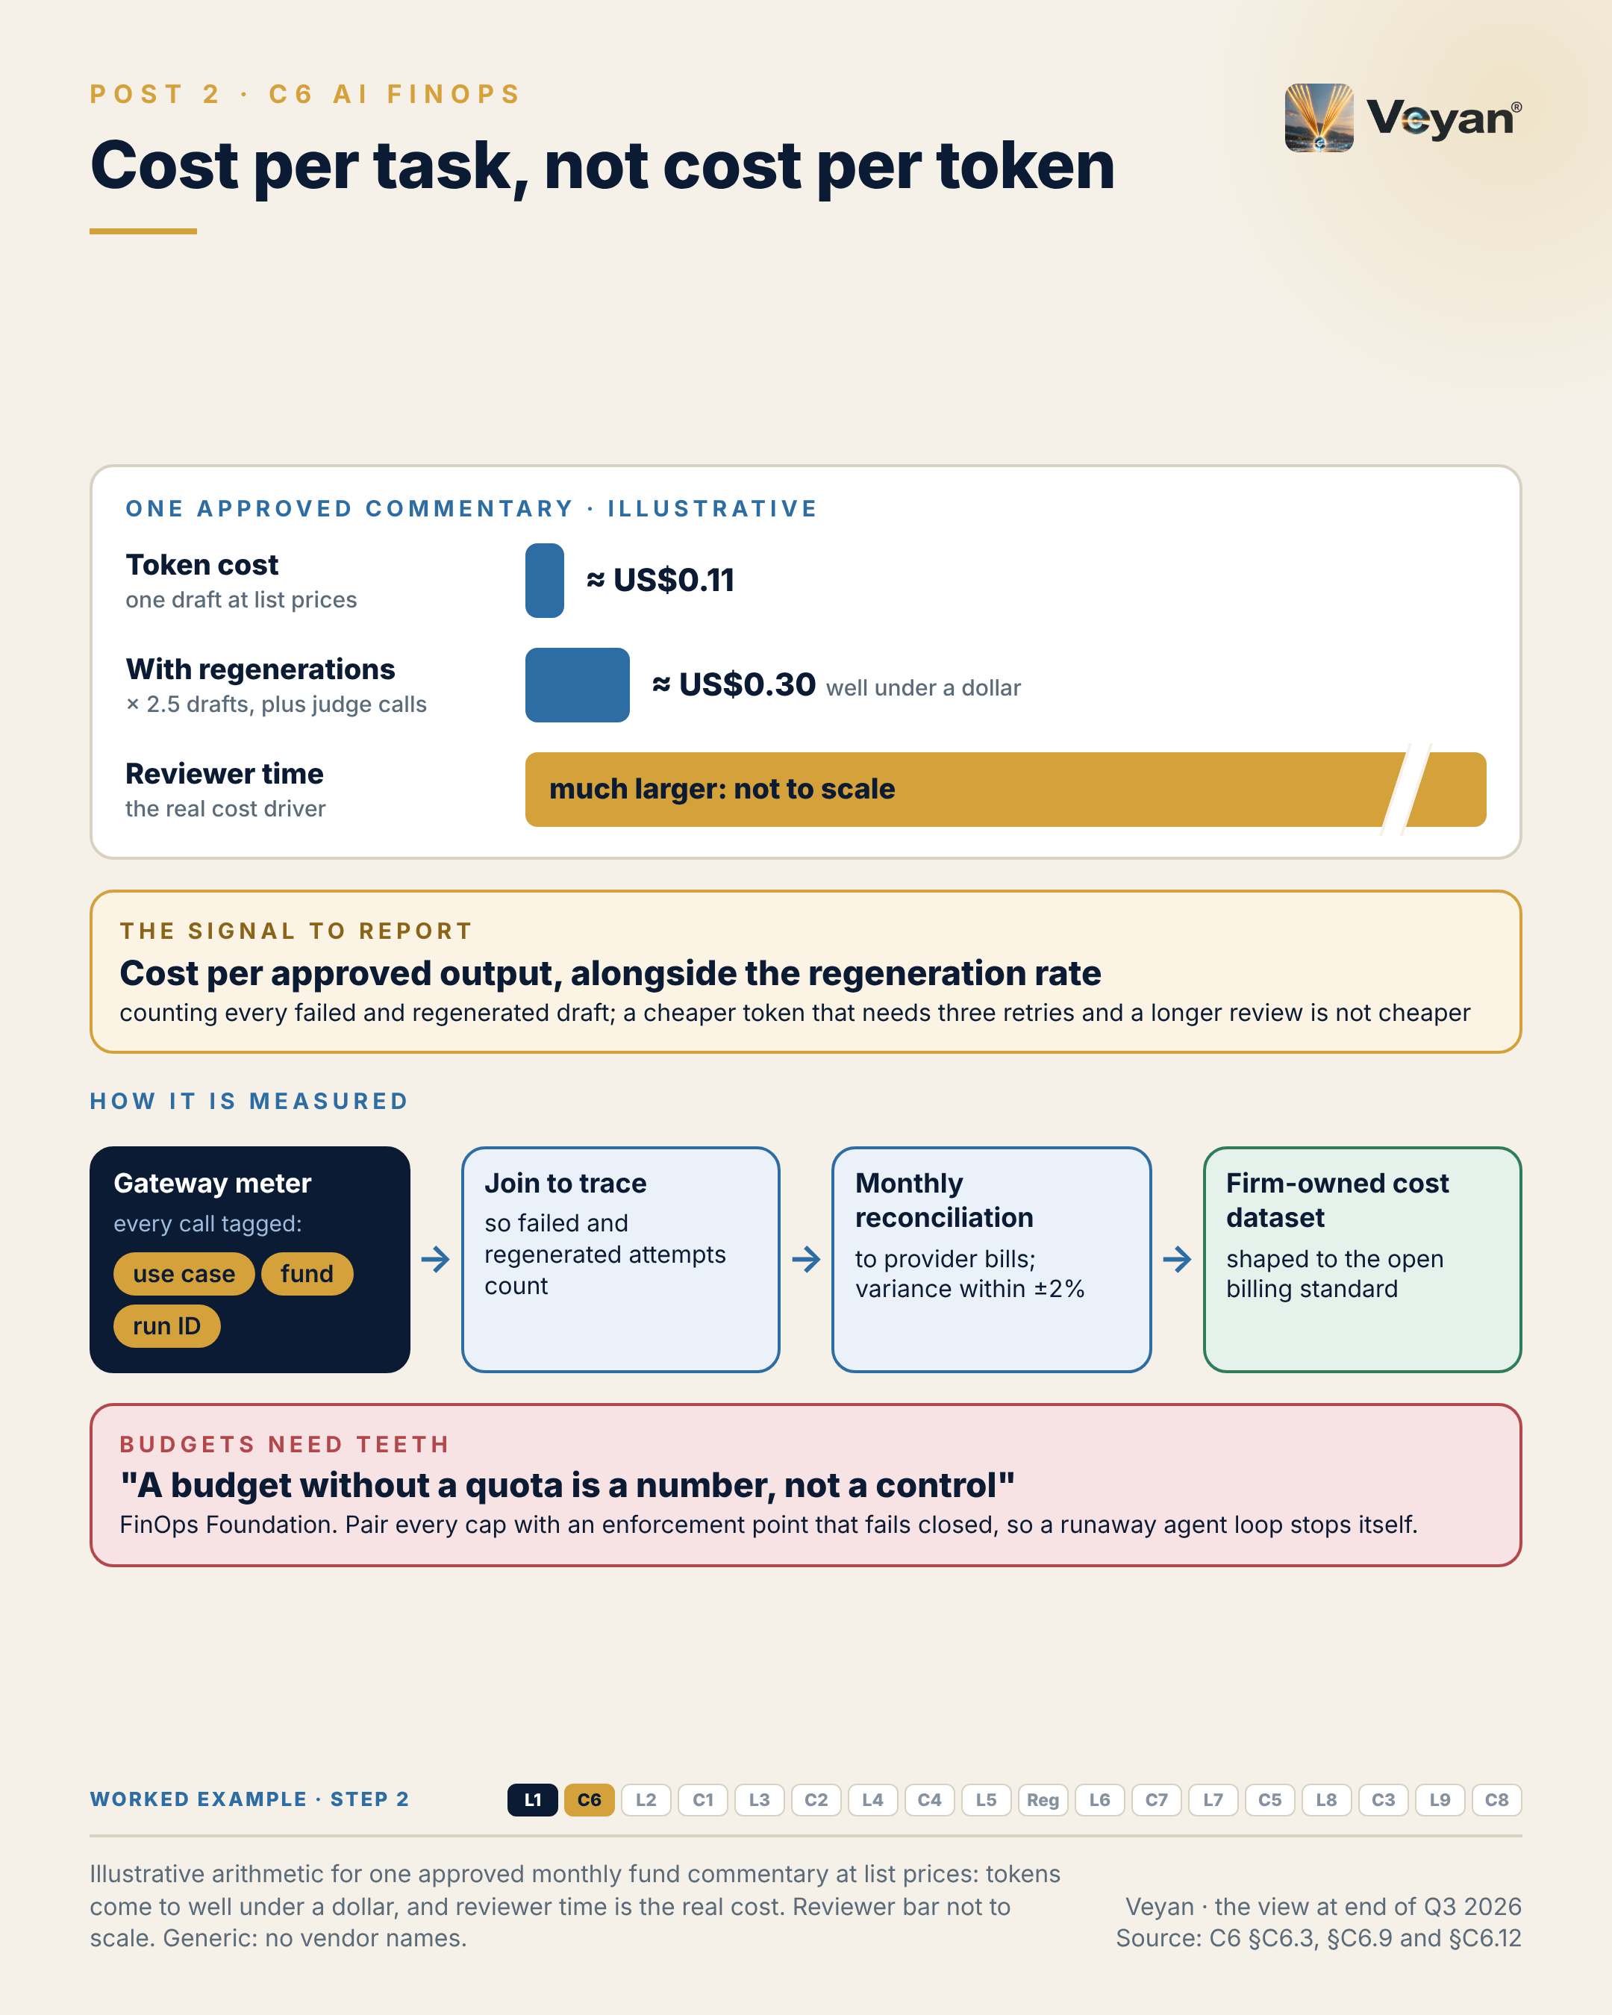
Visual: 08_Graphic/linkedin/P02.png (1080 × 1350, LinkedIn portrait); editable source P02.md, also as .html and .pdf.

First comment
Personal views. Sources: the Enterprise GenAI Stack review, C6 AI FinOps (§C6.2, §C6.3 KPIs, §C6.9, §C6.12, §C6.13). - The worked-example arithmetic (illustrative, author’s own): about 40,000 input and 3,000 output tokens per draft at US$2 / US$10 per million tokens (the list price of both Claude Sonnet 5.5 and gpt-6.1-sol as of 7 October 2026 [A5-S011, A5-S004]), about 2.5 drafts per approved commentary, gives roughly US$0.30 per approved commentary. - FinOps Foundation: “Pair every financial cap with an engineering enforcement point. A budget without a quota is a number, not a control.” Its tokenomics guidance: baseline for 30–60 days, budget at 110–120%, alerts at 80% and 100% [A7-S115]. - FOCUS 1.4 ratified 4 June 2026; 1.5 adds model identity, and a token-type column was deferred [V2-S046, A7-S116]. - Tools: gateway metering (LiteLLM, Cloudflare, Azure API Management, Apigee, Kong); Vantage and CloudZero as optional reporting layers; Helicone (acquired by Mintlify, maintenance mode) not recommended [A7-S112]. - Worked example, step 2 (cost). Adds: A run ID on every call, tagged with use case and fund, joined to the trace; a monthly budget set from two month-end cycles; a per-run ceiling on model calls and tokens. Now: Cost is reported per approved commentary and per fund, not per token. Never: A runaway loop fails the run instead of the budget.

Hashtags
#FinOps #UnitEconomics

Re-verify before posting
- List prices used in the illustrative arithmetic (they change often; “well under a dollar” should still hold)
- FOCUS 1.5 ratification status

Compliance check
- Personal views; arithmetic labelled illustrative and generic: yes
- No real firm cost data: yes
- Vendor prices cited evenly for two vendors in the first comment: yes

Week 2

Post 3 · Week 2 · L2 Inference, serving and model access
Pair: Post 4 (C1, Week 2). Bridge: The stack post makes managed access the default; the control post shows the gateway is what keeps that choice reversible.
Theme and source: Serving, optimisation and access as three distinct jobs. work/stageB/L2/section.md (executive summary, §2.2, §2.3, §2.9, §2.11–§2.13).
Tension: Self-hosting is a capacity and operating-model decision, not just a cost decision.

Full post
Self-hosting a model is a capacity and operating-model decision. It is only partly a cost decision.
The usual case for it is a spreadsheet: GPU hours against per-token prices. What the spreadsheet leaves out is the team that patches inference engines monthly, runs on-call, keeps weights scanned and pinned, and re-qualifies every change of engine version or quantisation, because each of those can change outputs.
Inference is really three jobs: serving engines that run the model, an optional optimisation layer for firms with their own GPU fleets, and model access through managed services. For regulated workloads the sensible default is managed access in an approved region, through the cloud estate you already operate, called only through the firm’s gateway. A private open-weight route earns its place where capacity, residency or exit planning justify it.
Two details catch people out. Where a prompt is processed is a property of the endpoint, not the model: the same model can run in one geography or anywhere, depending on the deployment type. And overflow from reserved capacity can silently cross a residency boundary if the default allows it.
The signal is capacity headroom at peak: reserved throughput minus observed demand in the month-end window, when every fund’s draft is requested at once. It should be positive, with a margin, before go-live.
The leadership move is to write the peak, the reserved amount, the overflow behaviour and the degraded mode into one capacity plan.
[Anecdote slot: one or two sentences on a time capacity, not cost, turned out to be the real constraint, and who saw it coming.]
The cheapest token is irrelevant if it arrives late, or in the wrong country.

Short variant
Self-hosting a model is a capacity and operating-model decision. It is only partly a cost decision.
The spreadsheet compares GPU hours with token prices. It leaves out the team that patches engines monthly, runs on-call and re-qualifies every engine or quantisation change.
For regulated workloads, the sensible default is managed access in an approved region, through the cloud you already run, behind the firm’s gateway. Keep a private open-weight route where capacity, residency or exit planning justify it.
Watch two details: processing location belongs to the endpoint, not the model, and reserved-capacity overflow can silently leave the region.
The signal is capacity headroom at peak, measured in the month-end window when every draft is requested at once.
The cheapest token is irrelevant if it arrives late, or in the wrong country.

Anecdote slot
- Where: the bracketed line before the closing paragraph.
- Prompt: a platform or infrastructure decision where the business case was made on unit cost but the real constraint was peak capacity, patching or on-call. Credit the engineer or SRE who raised it; own the assumption you made, if you made one.
- Fits: platform modernisation and turning external deadlines (month-end, quarter-end) into design inputs.
- Avoid: real volumes, GPU counts or provider names.

Fallback version
Self-hosting a model is a capacity and operating-model decision. It is only partly a cost decision.
The usual case for it is a spreadsheet: GPU hours against per-token prices. What the spreadsheet leaves out is the team that patches inference engines monthly, runs on-call, keeps weights scanned and pinned, and re-qualifies every change of engine version or quantisation, because each of those can change outputs.
Inference is really three jobs: serving engines that run the model, an optional optimisation layer for firms with their own GPU fleets, and model access through managed services. For regulated workloads the sensible default is managed access in an approved region, through the cloud estate already in place, called only through the firm’s gateway. A private open-weight route earns its place where capacity, residency or exit planning justify it.
Two details catch people out. Where a prompt is processed is a property of the endpoint, not the model: the same model can run in one geography or anywhere, depending on the deployment type. And overflow from reserved capacity can silently cross a residency boundary if the default allows it.
The signal is capacity headroom at peak: reserved throughput minus observed demand in the month-end window, when every fund’s draft is requested at once. It should be positive, with a margin, before go-live.
The leadership move is to write the peak, the reserved amount, the overflow behaviour and the degraded mode into one capacity plan.
The honest caveat: managed access concentrates dependence on one cloud. The answer is a small portfolio, the primary cloud’s service plus one qualified second route, not a retreat into running everything yourself.
The cheapest token is irrelevant if it arrives late, or in the wrong country.

Suggested visual
L2 split into three stacked sub-layers (serving engines; optimisation, marked “only if you run GPU fleets”; model access), with the gateway lifted out into the control plane. Beside it, a month-end demand curve against a reserved-capacity line, showing headroom and an “overflow stays in region” arrow. Source: L2 §2.3, §2.9 step 3, §2.13 H1 view.
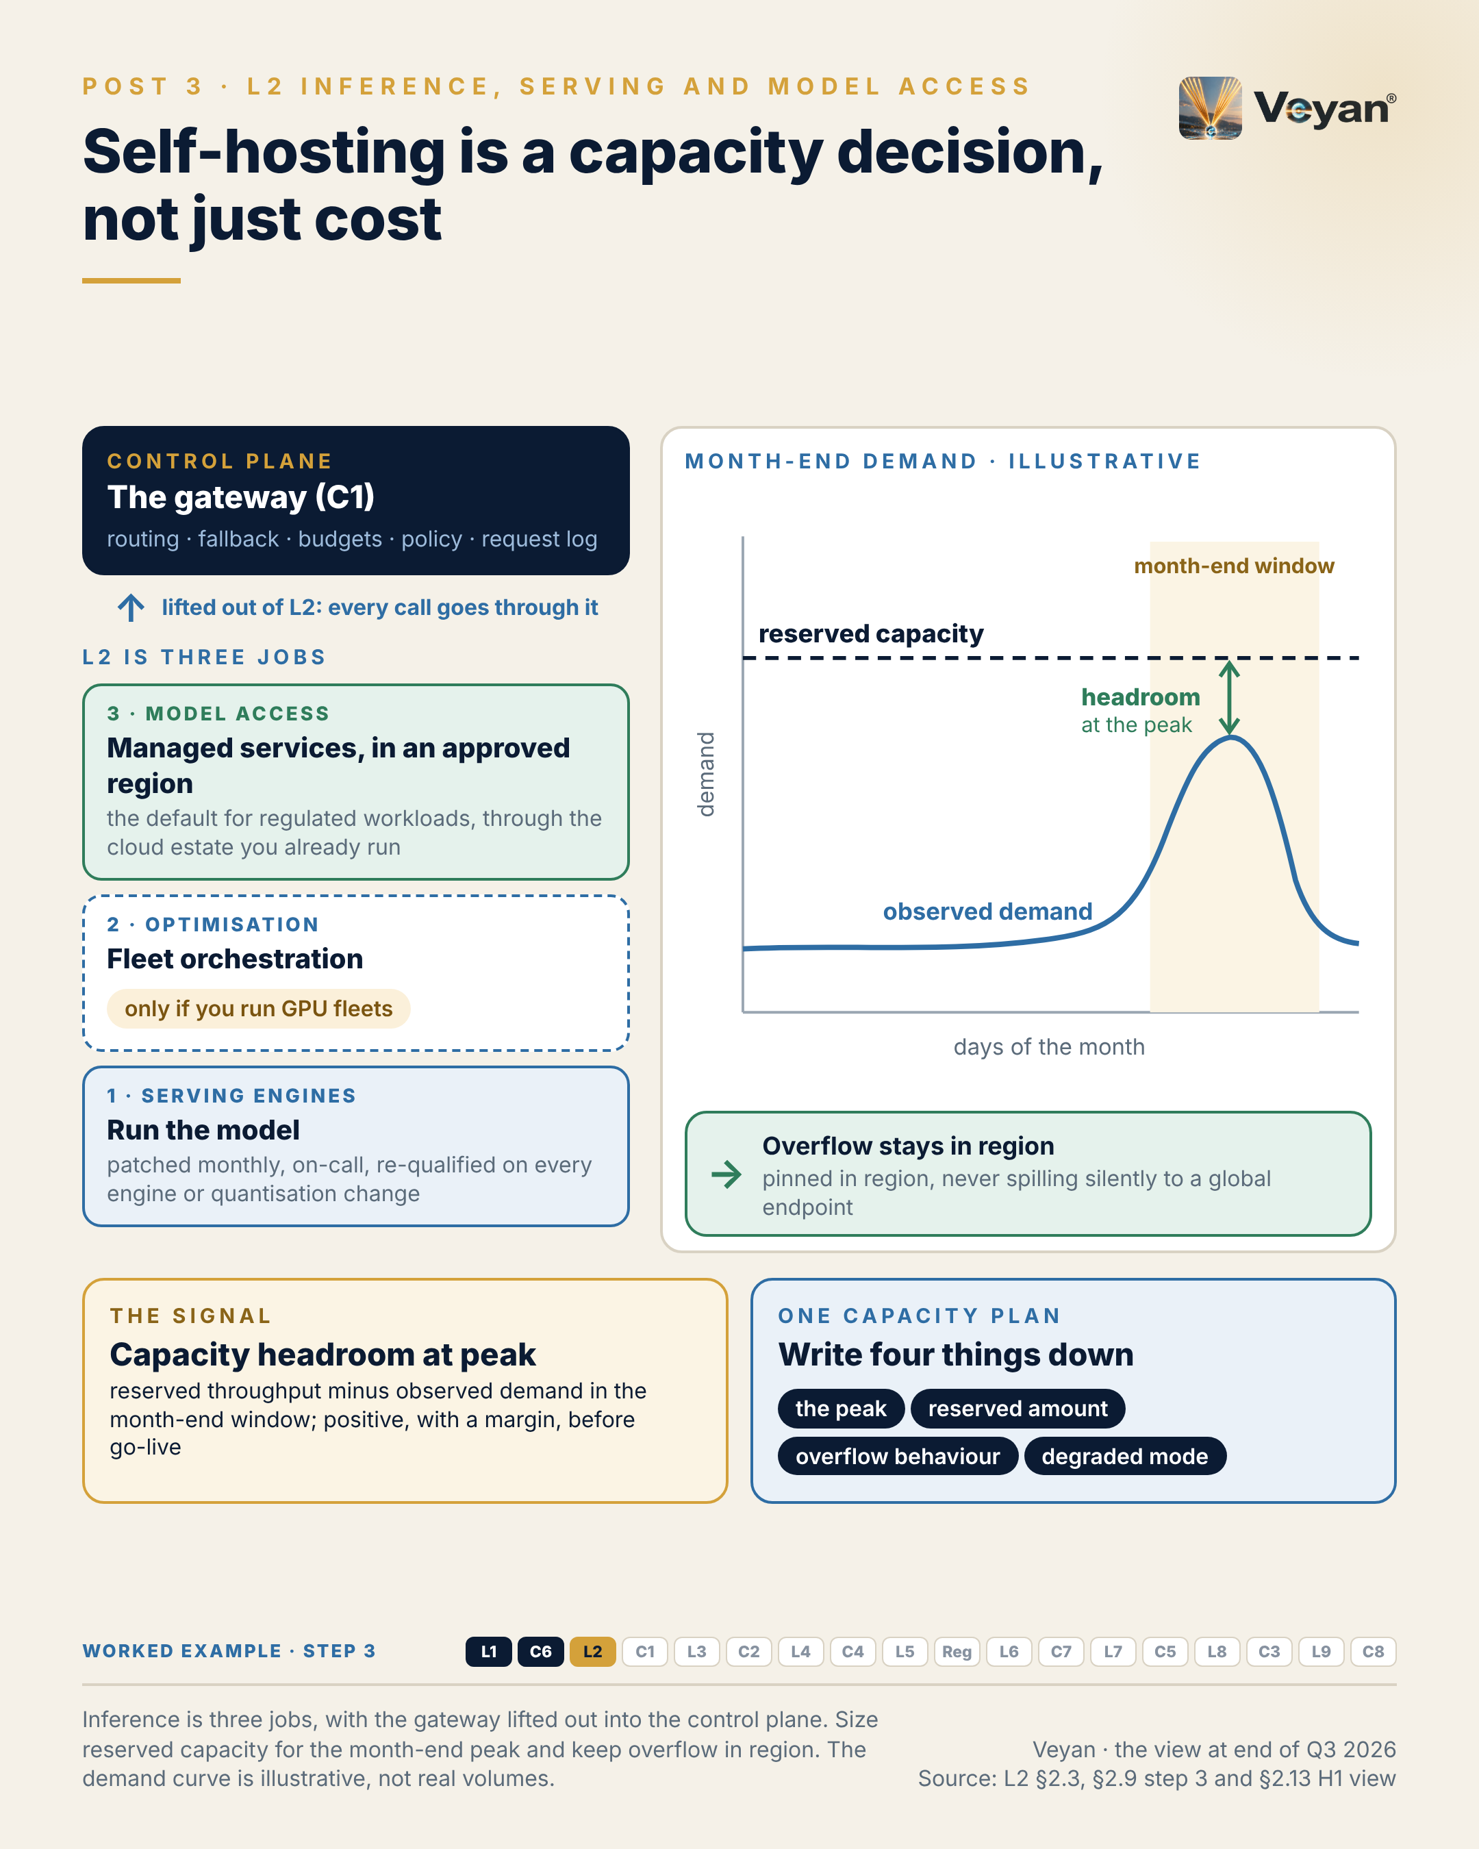
Visual: 08_Graphic/linkedin/P03.png (1080 × 1350, LinkedIn portrait); editable source P03.md, also as .html and .pdf.

First comment
Personal views. Sources: the Enterprise GenAI Stack review, L2 Inference, serving and model access (§2.2, §2.3 KPIs, §2.9, §2.11 on residency and capacity, §2.12). - Processing location by deployment type: Microsoft Foundry Global deployments may process prompts anywhere; Bedrock geographic profiles move prompts within a geography [B-L2-S006, B-L2-S005]. Vertex AI overflow beyond Provisioned Throughput goes to the global endpoint by default unless overridden [B-L2-S008]. - Engines: vLLM (PyTorch Foundation-hosted) as the default, SGLang as a qualified alternative once its open advisory is confirmed fixed (CP4-4) [A4-S009, A4-S010, B-L2-S009]. Optimisation layers: NVIDIA Dynamo, llm-d (pilot only). - Access: Amazon Bedrock, Microsoft Foundry, Google Cloud as defaults; Together AI, Fireworks AI (Strategic, conditional, once ISO certificates are confirmed, CP4-4), Cerebras, Hugging Face Inference Endpoints; routers OpenRouter (Stripe acquisition pending) and Hugging Face Inference Providers. - Worked example, step 3 (model access). Adds: Drafting through the primary cloud’s in-region model service, with capacity sized for the month-end peak and an open-weight route kept ready as the stressed exit. Now: Every fund’s draft can be produced in the narrow month-end window. Never: No router or provider that cannot guarantee region and retention.

Hashtags
#LLMInference #MLOps

Re-verify before posting
- Overflow and residency behaviour statements for each hyperscaler
- OpenRouter–Stripe closing; SGLang advisory status

Compliance check
- Personal views; no statement about any firm’s capacity or providers: yes
- Vendors only in the first comment: yes

Post 4 · Week 2 · C1 AI / LLM gateway
Pair: Post 3 (L2, Week 2). Bridge: Managed access is only a safe default if you can leave it; the gateway is what makes leaving a configuration change.
Theme and source: The gateway as the control point that makes exit plans executable. work/stageB/C1/section.md (executive summary, §C1.2, §C1.3, §C1.9, §C1.11–§C1.13).
Tension: The most boring component is the one that makes model switching, and exit plans, possible.

Full post
The most boring component in the AI stack is the one that makes an exit plan real.
UK supervisors expect documented and tested exit plans for material outsourcing, including a stressed exit. Without a gateway, provider SDKs and keys spread through application code, and switching model becomes a programme of code changes. The plan exists on paper; it cannot be carried out in the time a stressed exit allows.
The previous post argued for managed model access by default. The gateway keeps that choice reversible. Every model call, and now every tool and agent call, passes through one firm-controlled point that owns routing, fallback, budgets, policy and the request log. Guardrails, data protection, identity checks and cost attribution are all invoked there.
That concentration cuts both ways. In March 2026, malicious releases of a popular open-source gateway were published to a public package index. A component that holds every provider key is a prime target. So run it like payments infrastructure: two independent deployments, pinned and signed builds, and budgets, guards and fallbacks that fail closed.
The signal is time to switch provider: how long it takes to move a route to a pre-qualified alternative by configuration alone. Hours, not weeks, and drilled at least once a year.
The leadership move is to treat “add a provider” as a third-party risk event, not a configuration tweak. From 18 March 2027, UK firms must notify material third-party arrangements before entering them.
[Anecdote slot: one or two sentences on an exit, migration or failover that was only possible because someone had rehearsed it, and who did.]
Neutrality is a design property. It has to be built, and then rehearsed.

Short variant
The most boring component in the AI stack is the one that makes an exit plan real.
Without a gateway, provider SDKs and keys spread through application code, and switching model becomes a programme of code changes. A stressed exit cannot wait for that.
The gateway is one firm-controlled point for every model, tool and agent call: routing, fallback, budgets, policy and the log. That concentration cuts both ways. In March 2026, malicious releases of a popular open-source gateway reached a public package index. Run it like payments infrastructure: two deployments, signed builds, everything failing closed.
The signal is time to switch provider by configuration alone: hours, not weeks, drilled at least yearly.
Treat “add a provider” as a third-party risk event.
Neutrality is a design property. It has to be built, and then rehearsed.

Anecdote slot
- Where: the bracketed line before the closing paragraph.
- Prompt: a disaster-recovery test, supplier exit, data-centre move or failover drill that worked because it had been rehearsed, or that taught a lesson because it had not. Credit the team that ran the drills; own any drill you once let slip.
- Fits: “talent systems as the real disaster-recovery plan” and resilience leadership.
- Avoid: naming the supplier, the outage or the business service.

Fallback version
The most boring component in the AI stack is the one that makes an exit plan real.
UK supervisors expect documented and tested exit plans for material outsourcing, including a stressed exit. Without a gateway, provider SDKs and keys spread through application code, and switching model becomes a programme of code changes. The plan exists on paper; it cannot be carried out in the time a stressed exit allows.
Managed model access is a sensible default only if it stays reversible. Every model call, and now every tool and agent call, passes through one firm-controlled point that owns routing, fallback, budgets, policy and the request log. Guardrails, data protection, identity checks and cost attribution are all invoked there.
That concentration cuts both ways. In March 2026, malicious releases of a popular open-source gateway were published to a public package index. A component that holds every provider key is a prime target. So run it like payments infrastructure: two independent deployments, pinned and signed builds, and budgets, guards and fallbacks that fail closed.
The signal is time to switch provider: how long it takes to move a route to a pre-qualified alternative by configuration alone. Hours, not weeks, and drilled at least once a year.
The leadership move is to treat “add a provider” as a third-party risk event, not a configuration tweak. From 18 March 2027, UK firms must notify material third-party arrangements before entering them.
The honest caveat: ownership matters. Several gateways now belong to security, payments or platform companies, and a gateway that is not neutral weakens the one component meant to keep you neutral.
Neutrality is a design property. It has to be built, and then rehearsed.

Suggested visual
Hub diagram: applications on the left, one “AI traffic gateway” in the centre (routing, fallback, budgets, policy, log; C2, C3, C4 and C6 plugged in), providers on the right, with a dashed “pre-qualified alternative” route and a stopwatch labelled “time to switch: hours”. Below: “two independent deployments, fail closed”. Source: C1 §C1.3, §C1.9, §C1.13 H1 view.
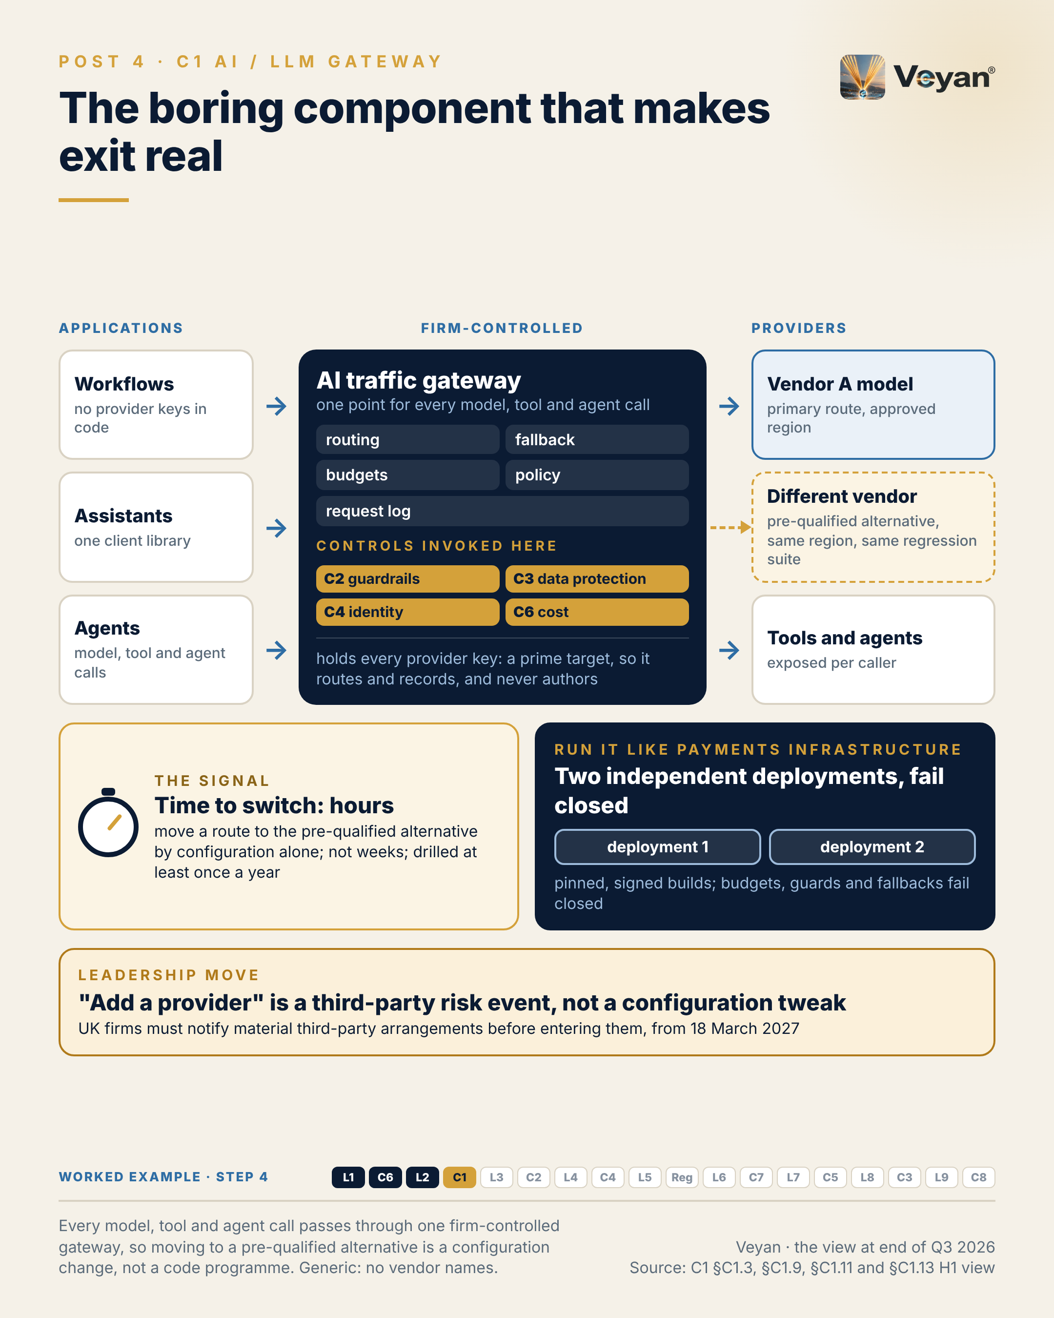
Visual: 08_Graphic/linkedin/P04.png (1080 × 1350, LinkedIn portrait); editable source P04.md, also as .html and .pdf.

First comment
Personal views. Sources: the Enterprise GenAI Stack review, C1 AI / LLM gateway (§C1.2, §C1.3 KPIs, §C1.9, §C1.11, §C1.12). - The March incident: malicious LiteLLM 1.82.7 and 1.82.8 published to PyPI on 24 March 2026; clean 1.83.0 after a rebuilt pipeline [A6-S008, A6-S009, V2-S027]. - Exit plans: PRA SS2/21 expects documented, tested exit plans including stressed exit [R-PRA-SS221: A8-S048]. PRA PS7/26 and FCA PS26/2: material third-party notifications from 18 March 2027 [R-PRA-SS221, R-FCA-SYSC8: A8-S062, V2-S053]. - Gateways assessed: LiteLLM (hardened, Enterprise-licensed), Kong AI Gateway, Apigee, Azure API Management AI policies (the AI Gateway tier itself is preview), AWS AgentCore Gateway, Cloudflare AI Gateway, agentgateway. Ownership: Palo Alto Networks completed its acquisition of Portkey on 29 May 2026 [A6-S011, V2-S025]; Stripe agreed to acquire OpenRouter, with closing pending [V1-S059, V1-S060]. - Worked example, step 4 (gateway). Adds: One gateway route, attribution-commentary-draft: the workflow calls the route with its own identity and never holds a provider key; residency, fallback, budgets and inline guards live on the route. Now: Switching to the qualified fallback is a configuration change, drilled in hours. Never: If both models are unavailable, the route fails closed and the analyst is told the draft is delayed.

Hashtags
#AIGateway #OperationalResilience

Re-verify before posting
- The PS7/26 / PS26/2 effective date (18 March 2027)
- Ownership status of Portkey and OpenRouter
- Azure APIM AI Gateway tier status

Compliance check
- Personal views; no reference to any firm’s exit plans: yes
- Regulatory dates stated without legal advice: yes
- Vendors only in the first comment: yes

Week 3

Post 5 · Week 3 · L3 Agent frameworks and orchestration
Pair: Post 6 (C2, Week 3). Bridge: The stack post decides how much autonomy a process gets; the control post explains why guardrails cannot make up for a wrong answer to that question.
Theme and source: Deterministic workflows versus autonomous agents, on a durable substrate. work/stageB/L3/section.md (executive summary, §3.2, §3.3, §3.9, §3.11–§3.13).
Tension: Most enterprise “agents” should be deterministic workflows with one judgement step.

Full post
Most of the enterprise “agents” I would approve are not agents at all. They are deterministic workflows with one judgement step.
The trap is handing a task with a known sequence to an autonomous loop. Each run takes a slightly different path, so evaluation results stop transferring between runs and validation can no longer cover the space of behaviours. When something goes wrong, the behaviour turns out to be a property of that run, not of the design.
Every major framework now ships both modes, a workflow graph and an agent loop, so this is a design choice rather than a vendor choice. Make it before choosing a framework. If the steps are known in advance, even with branches, build a graph. Let the model draft, classify or judge inside a bounded step; do not let it choose the next tool.
Two things sit underneath. Durable execution, so a crash resumes from a checkpoint instead of re-running and mixing two versions of the data. And an approval step that only a named, authorised person can release.
The signal is path conformance: the share of runs whose executed steps match the approved graph. For a regulated workflow the target is 100%, and any deviation is a defect.
The leadership move is to treat autonomy as a budget that is declared, approved and owned for each use case. Often the right number is zero or one.
[Anecdote slot: one or two sentences on a process where adding flexibility made it harder to trust, and what restoring structure did for the team.]
Autonomy is a tool, not a maturity level. The best agent design is often the least agentic one that does the job.

Short variant
Most of the enterprise “agents” I would approve are not agents at all. They are deterministic workflows with one judgement step.
Hand a known sequence to an autonomous loop and each run takes a different path. Evaluation results stop transferring between runs, and validation cannot cover the behaviour.
Every major framework now ships both modes, so this is a design choice, not a vendor choice. If the steps are known, build a graph. Let the model draft or judge inside a bounded step; do not let it choose the next tool. Add durable execution and an approval step only a named person can release.
The signal is path conformance: runs matching the approved graph, at 100% for regulated workflows.
Treat autonomy as a declared, owned budget. Often the right number is zero or one.
Autonomy is a tool, not a maturity level.

Anecdote slot
- Where: the bracketed line before the closing paragraph.
- Prompt: a process (release, reporting, reconciliation, onboarding) where more flexibility or discretion made outcomes harder to predict or audit, and what happened when structure was put back. Own the original choice if it was yours; credit the people who redesigned it.
- Fits: operating-model design and “developing leaders through delivery”.
- Avoid: suggesting any current production AI system at your firm.

Fallback version
Most enterprise “agents” worth approving are not agents at all. They are deterministic workflows with one judgement step.
The trap is handing a task with a known sequence to an autonomous loop. Each run takes a slightly different path, so evaluation results stop transferring between runs and validation can no longer cover the space of behaviours. When something goes wrong, the behaviour turns out to be a property of that run, not of the design.
Every major framework now ships both modes, a workflow graph and an agent loop, so this is a design choice rather than a vendor choice. Make it before choosing a framework. If the steps are known in advance, even with branches, build a graph. Let the model draft, classify or judge inside a bounded step; do not let it choose the next tool.
Two things sit underneath. Durable execution, so a crash resumes from a checkpoint instead of re-running and mixing two versions of the data. And an approval step that only a named, authorised person can release.
The signal is path conformance: the share of runs whose executed steps match the approved graph. For a regulated workflow the target is 100%, and any deviation is a defect.
The leadership move is to treat autonomy as a budget that is declared, approved and owned for each use case. Often the right number is zero or one.
The honest caveat: autonomous harnesses are moving fastest, and some open-ended tasks genuinely need them. Isolate them as one sandboxed sub-step with read-only tools rather than banning them.
Autonomy is a tool, not a maturity level. The best agent design is often the least agentic one that does the job.

Suggested visual
The worked example’s L3 graph as a flow: authorise → fetch attribution snapshot (read-only) → retrieve style and prior commentary → one LLM drafting step → evaluation gate → human approval interrupt → release service. Mark “autonomy budget = 1” on the drafting node and show the checkpoint store beneath the graph. Side panel: three stacked concerns (workflow orchestration, bounded agent steps, durable execution). Source: L3 §3.12 and §3.13.
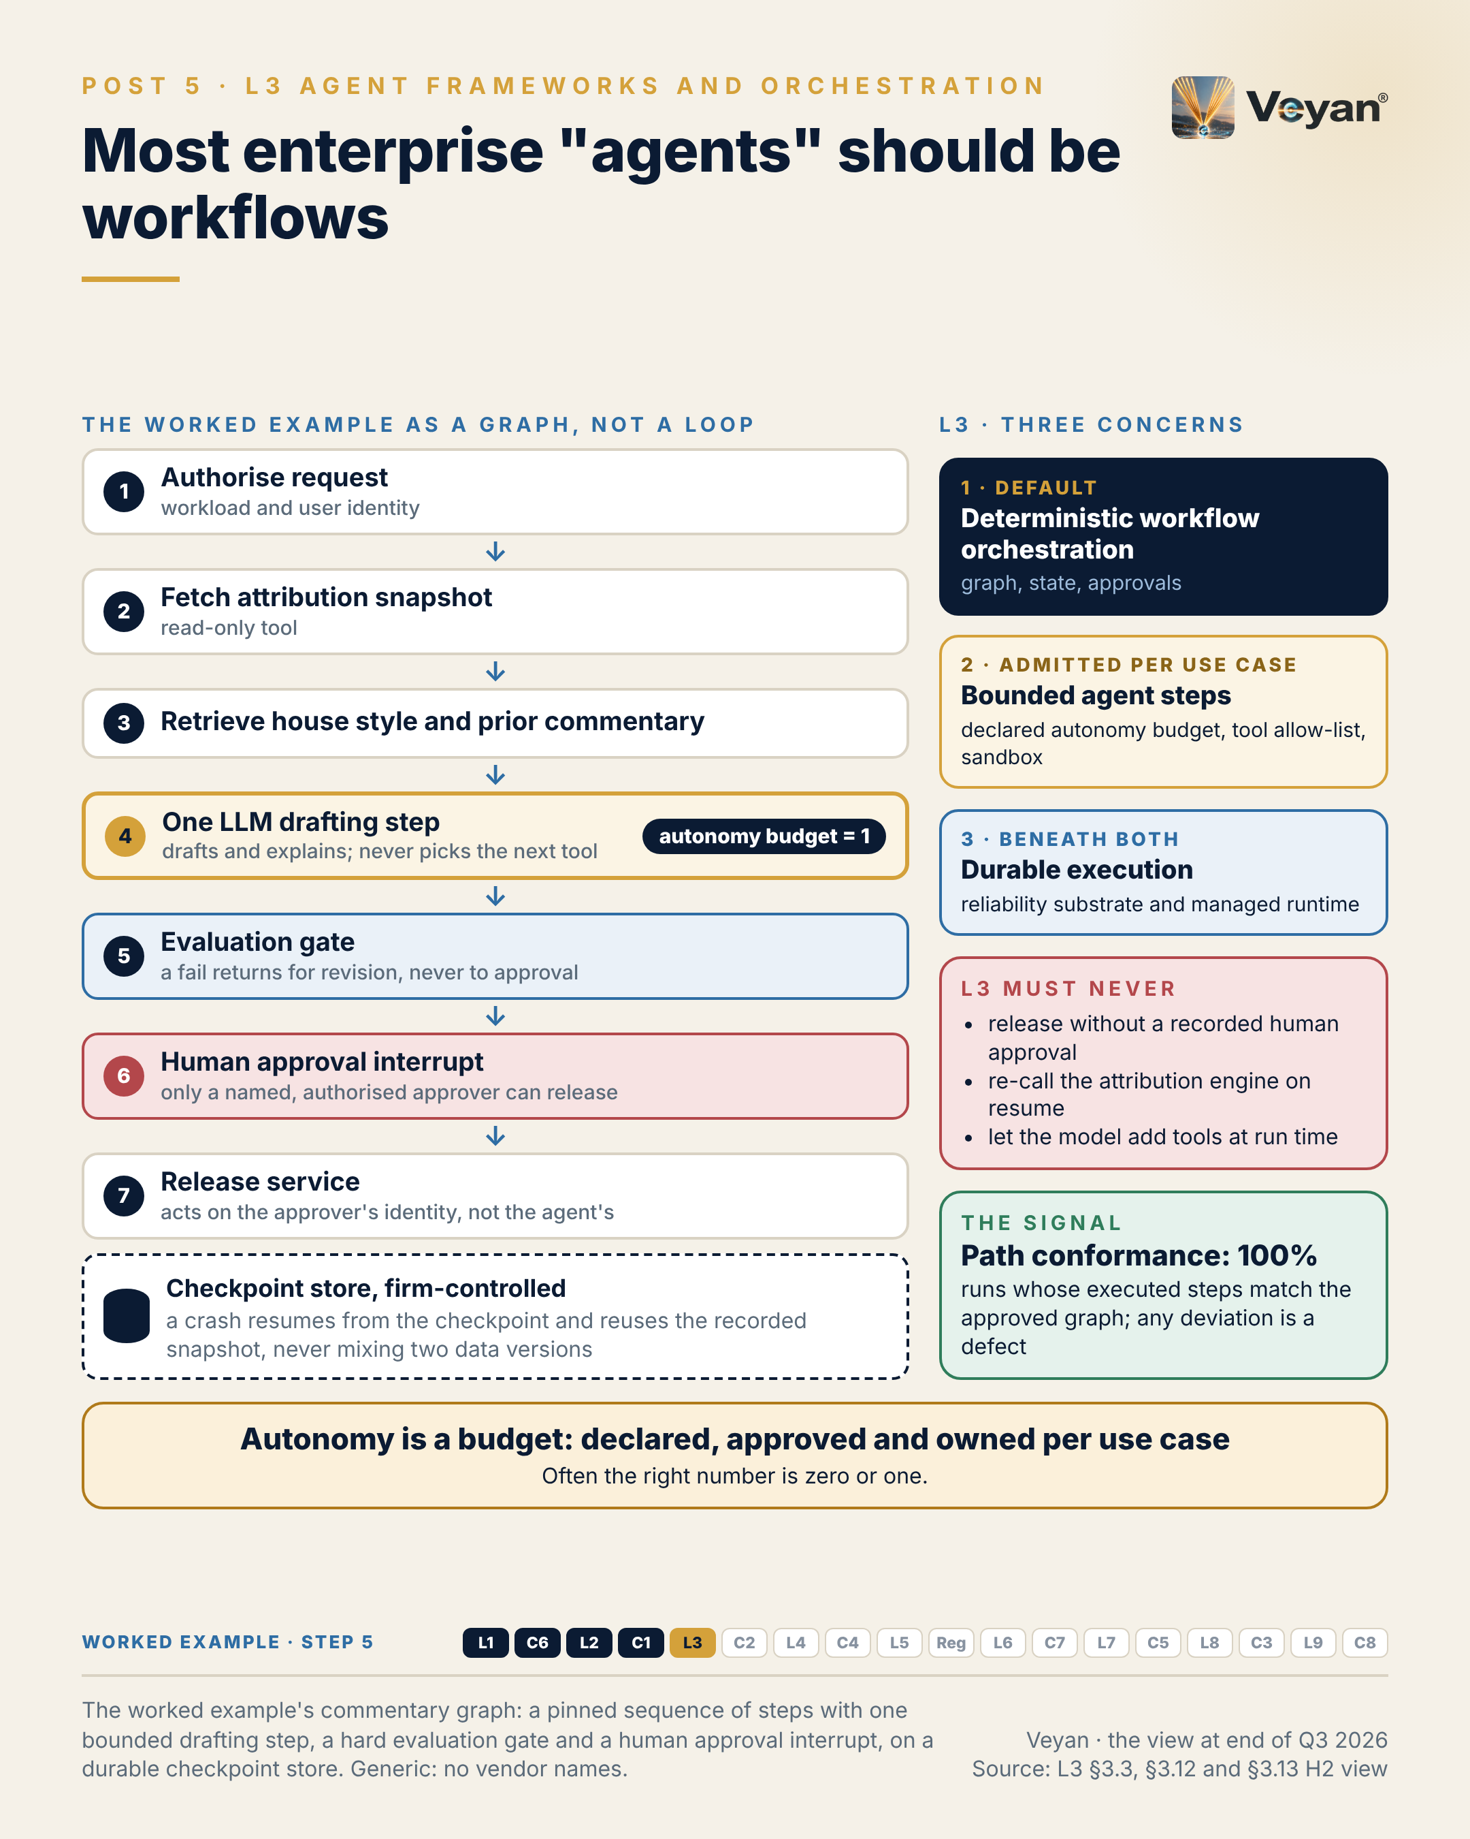
Visual: 08_Graphic/linkedin/P05.png (1080 × 1350, LinkedIn portrait); editable source P05.md, also as .html and .pdf.

First comment
Personal views. Sources: the Enterprise GenAI Stack review, L3 Agent frameworks and orchestration (§3.2, §3.3 KPIs, §3.9, §3.12, §3.13). - Both modes in every major framework: LangGraph, Microsoft Agent Framework (Agents versus Workflows; GA 2 April 2026 as successor to Semantic Kernel and AutoGen), CrewAI (Flows versus Crews), Google ADK 2.0 Workflow Runtime [A4-S039, A4-S066, A4-S008, A4-S050, A4-S114]. Anthropic’s own guidance separates workflows from agents in the same terms [A4-S030]. - Durability is separating out: Pydantic AI v2, the OpenAI Agents SDK and Mistral Workflows delegate to Temporal or DBOS [A4-S045, A4-S052, A4-S058]. - Autonomous harnesses (OpenAI Agents SDK, Claude Agent SDK, Mistral Agents API) are recommended only as sandboxed sub-steps. The Claude Agent SDK is rated Experimental and the OpenAI Agents SDK Tactical; both pre-1.0 SDKs score maturity 2 (CP4-9). Conflict of interest noted. - OpenAI’s Agent Builder shuts down on 30 November 2026 [A4-S054, V1-S051]. - Worked example, step 5 (workflow). Adds: A pinned workflow graph: authorise, fetch the attribution snapshot, retrieve style and prior commentary, one drafting step, an evaluation gate, a human approval interrupt, then release by a separate service. Now: Every run follows the same path; a failed run resumes from its checkpoint with the same numbers. Never: Autonomy budget of one: the model drafts, but never chooses tools or order.

Hashtags
#AgenticAI #WorkflowAutomation

Re-verify before posting
- Framework GA and version status; the Agent Builder shutdown date if posting near it
- CP4-9 tier statements if any SDK reaches 1.0

Compliance check
- Personal views (“I would approve” is an opinion, not a claim about any deployment): yes
- Vendors only in the first comment, including Anthropic on the same terms: yes

Post 6 · Week 3 · C2 Guardrails
Pair: Post 5 (L3, Week 3). Bridge: The stack post’s deterministic design does most of the safety work; guardrails are the second line, not a licence for more autonomy.
Theme and source: Layered guardrails as a second line of defence. work/stageB/C2/section.md (executive summary, §C2.2, §C2.3, §C2.9, §C2.11–§C2.13).
Tension: Guardrails cannot fix a workflow that should never have been autonomous.

Full post
Guardrails cannot fix a workflow that should never have been autonomous.
A guardrail is a filter on a stream of actions. It lowers the chance that a bad action passes; it does not reduce the number of actions an agent is allowed to attempt. If an agent has write access to a client-facing system, a content filter on its output is not a control over that access.
The previous post argued for deterministic workflows with one judgement step. That design does most of the safety work. Guardrails are the second line, and they fail in predictable ways. They screen only the user’s prompt while retrieved documents pass unchecked. A content-safety classifier is asked to catch a business error it was never trained for, such as a reversed sign. Or a guard times out and the request goes through.
So layer them by mechanism. Deterministic rules first, for business invariants such as figures, signs and forbidden phrases. Small classifiers next, including on every retrieved chunk. Model-based judges only where nothing simpler can decide, and never as the only check on numbers. Everything fails closed.
The signal I would watch is the false-positive rate on a labelled set of real, approved finance text, for example below 1% on a drafting route. Over-sensitive filters block legitimate vocabulary, people route around them, and the control quietly disappears.
The leadership move is to own the guardrail policy and its test sets, whichever detectors you buy.
[Anecdote slot: one or two sentences on a control that looked strong on paper but was weakened by false alarms or workarounds, and what fixed it.]
A guardrail is evidence of care. It is not a substitute for deciding what the system may do.

Short variant
Guardrails cannot fix a workflow that should never have been autonomous.
A guardrail lowers the chance that a bad action passes. It does not reduce the actions an agent may attempt. If an agent can write to a client-facing system, an output filter is not a control over that access.
Decide autonomy first; guardrails are the second line. Layer them by mechanism: deterministic rules for figures, signs and forbidden phrases; small classifiers, including on every retrieved chunk; model judges only where nothing simpler can decide, never alone on numbers. Everything fails closed.
The signal is the false-positive rate on real, approved finance text. Over-sensitive filters get routed around, and the control disappears.
Own the policy and its test sets, whichever detectors you buy.
A guardrail is evidence of care, not a substitute for deciding what the system may do.

Anecdote slot
- Where: the bracketed line before the closing paragraph.
- Prompt: an alerting, monitoring or approval control that produced so many false positives that people stopped trusting it, and what restored it (tuning against a labelled set, an owner, fewer but sharper checks). Credit whoever did the tuning; own any period where the noise was tolerated.
- Fits: “making invisible prevention work visible”.
- Avoid: naming the control, the system or the volume of alerts.

Fallback version
Guardrails cannot fix a workflow that should never have been autonomous.
A guardrail is a filter on a stream of actions. It lowers the chance that a bad action passes; it does not reduce the number of actions an agent is allowed to attempt. If an agent has write access to a client-facing system, a content filter on its output is not a control over that access.
Deterministic workflows with one judgement step do most of the safety work. Guardrails are the second line, and they fail in predictable ways. They screen only the user’s prompt while retrieved documents pass unchecked. A content-safety classifier is asked to catch a business error it was never trained for, such as a reversed sign. Or a guard times out and the request goes through.
So layer them by mechanism. Deterministic rules first, for business invariants such as figures, signs and forbidden phrases. Small classifiers next, including on every retrieved chunk. Model-based judges only where nothing simpler can decide, and never as the only check on numbers. Everything fails closed.
The signal worth watching is the false-positive rate on a labelled set of real, approved finance text, for example below 1% on a drafting route. Over-sensitive filters block legitimate vocabulary, people route around them, and the control quietly disappears.
The leadership move is to own the guardrail policy and its test sets, whichever detectors you buy.
The honest caveat: several open-source guardrail components have slowed or changed hands. Using two detectors from different owners is a concentration control as well as a security one.
A guardrail is evidence of care. It is not a substitute for deciding what the system may do.

Suggested visual
A three-tier pyramid: deterministic rules (base, widest), small classifiers (middle), model-based judges (narrow top), with “fail closed” running down the side. Beside it, “Step 0: decide autonomy first (L3)” as a gate in front of the pyramid. Inset: the worked example’s inline numeric-grounding guard. Source: C2 §C2.9 and §C2.12.
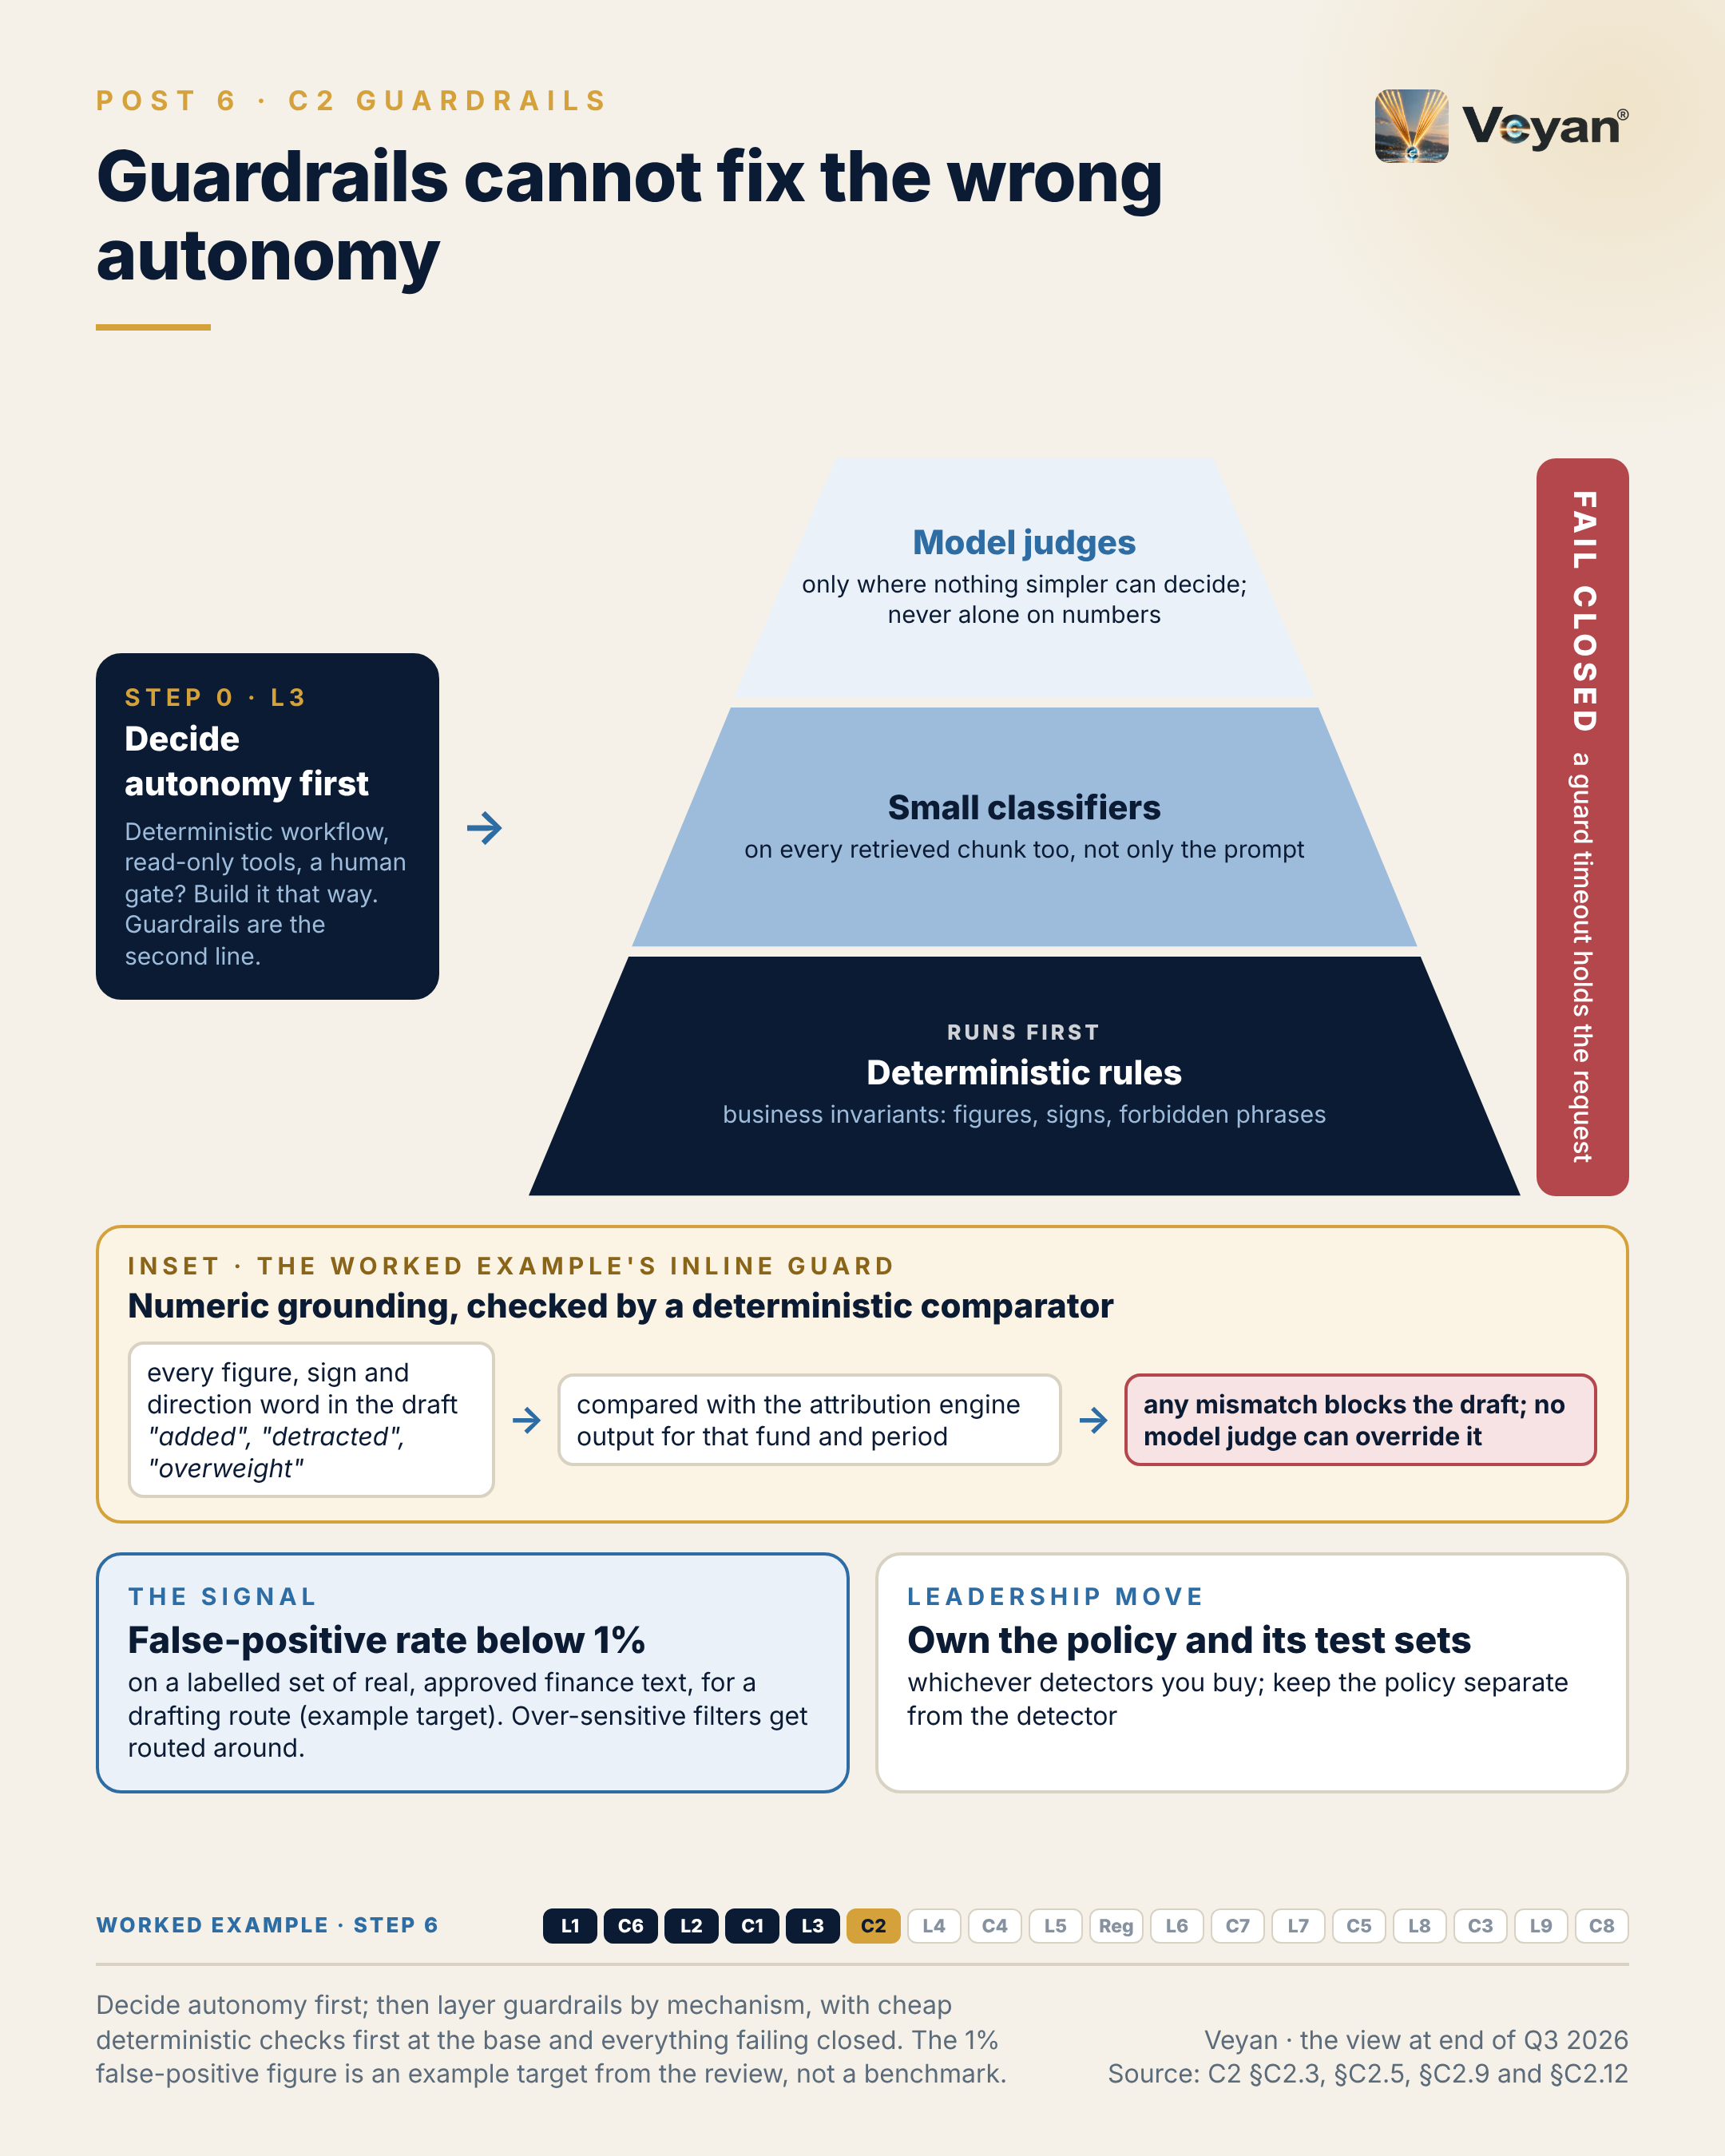
Visual: 08_Graphic/linkedin/P06.png (1080 × 1350, LinkedIn portrait); editable source P06.md, also as .html and .pdf.

First comment
Personal views. Sources: the Enterprise GenAI Stack review, C2 Guardrails (§C2.2, §C2.3 KPIs, §C2.9, §C2.12, §C2.13). - Managed services assessed: Amazon Bedrock Guardrails, Azure AI Content Safety (Prompt Shields GA; Task Adherence in preview), Google Model Armor [A6-S072, A6-S055, A6-S067]. Each is Strategic only where that cloud is your primary cloud. - Open source: NVIDIA NeMo Guardrails is still 0.x Beta [A6-S003]; Meta has released no new Llama Guard, Prompt Guard or LlamaFirewall since May 2025 [A6-S006, A6-S107]; Harvey announced its acquisition of Guardrails AI on 9 September 2026 [A6-S028, V2-S026]. Check Point (Lakera) is a second-detector option (see C7). - ESMA expects “ex-ante input controls and frequent ex-post output controls” [R-INTL-AI-ASSETMGMT: A8-S059]. - The 1% false-positive figure is an example target from the review, not a benchmark. - Worked example, step 6 (guardrails). Adds: A deterministic numeric comparator on every draft, injection screening of retrieved text, a PII check on output and denied topics (forecasts, advice). Now: A draft with any figure, sign or direction word that disagrees with the engine is blocked before a human sees it. Never: Guardrails back up the design; they never license more autonomy.

Hashtags
#AIGuardrails #ResponsibleAI

Re-verify before posting
- NeMo Guardrails version; any new Meta guardrail releases
- Preview or GA status of Azure Task Adherence

Compliance check
- Personal views: yes
- No description of any firm’s guardrail configuration: yes
- Vendors only in the first comment: yes

Week 4

Post 7 · Week 4 · L4 Tools, protocols and agent connectivity
Pair: Post 8 (C4, Week 4). Bridge: The stack post puts a gateway in front of every tool; the control post decides who is allowed through it, and on whose behalf.
Theme and source: A tool-governance sub-layer between the agent and its tools. work/stageB/L4/section.md (executive summary, §4.2, §4.3, §4.9, §4.11–§4.13).
Tension: Open tool protocols made connecting tools easy, and that is exactly why tool governance now matters.

Full post
Open tool protocols have made it easy to connect an agent to almost anything. That is exactly why tool governance now matters.
A badly governed tool layer turns every weakness of a language model into an action. Prompt injection becomes exfiltration when the agent holds a token that can send email. A hallucinated argument becomes a wrong instruction when a write tool is exposed. A tool description becomes an attack vector when the client trusts whatever a third-party server says about itself.
This is not theoretical. A benchmark published at AAAI 2026 tested tool-poisoning attacks against 45 live tool servers and 20 models. The average attack success rate was 36.5%, and more capable models were often more susceptible.
The protocols have made room for enterprise controls, but authorisation is still optional in the leading specification. So enforcement has to live outside it: one firm-owned tool gateway with mandatory authorisation, a private allow-listed registry, and every reviewed tool definition pinned by hash.
The signal is tool-definition drift: descriptions or schemas that changed since review. Zero unreviewed changes should reach production. A server that quietly updates its own description is a supply-chain change.
The leadership move is to expose authoritative data through read-only tools owned by the system’s team, and to make every write a separate tool, a separate approval and a human confirmation.
[Anecdote slot: one or two sentences on an integration that was easy to connect and hard to govern, and what the team put in front of it.]
Connecting tools is now the easy part. Deciding what each one may do, and on whose behalf, is the architecture.

Short variant
Open tool protocols have made it easy to connect an agent to almost anything. That is exactly why tool governance matters.
Prompt injection becomes exfiltration when the agent holds a token that can send email. A tool description becomes an attack vector when the client trusts whatever a server says about itself. A benchmark at AAAI 2026 found an average tool-poisoning success rate of 36.5% across 20 models.
Authorisation is still optional in the leading specification, so enforcement lives outside it: a firm-owned tool gateway, a private allow-list, and reviewed tool definitions pinned by hash.
The signal is tool-definition drift. Zero unreviewed changes should reach production.
Expose authoritative data through read-only tools, and make every write a separate tool with its own approval.
Connecting tools is the easy part. Deciding what each may do is the architecture.

Anecdote slot
- Where: the bracketed line before the closing paragraph.
- Prompt: an integration, API or automation that was quick to connect and later needed governance retrofitted (scopes narrowed, a gateway added, a shared account removed). Own the speed-over-control call if it was yours; credit whoever did the retrofit.
- Fits: platform and integration leadership; agentic transformation in a regulated environment.
- Avoid: naming internal systems, tool vendors or affected data.

Fallback version
Open tool protocols have made it easy to connect an agent to almost anything. That is exactly why tool governance now matters.
A badly governed tool layer turns every weakness of a language model into an action. Prompt injection becomes exfiltration when the agent holds a token that can send email. A hallucinated argument becomes a wrong instruction when a write tool is exposed. A tool description becomes an attack vector when the client trusts whatever a third-party server says about itself.
This is not theoretical. A benchmark published at AAAI 2026 tested tool-poisoning attacks against 45 live tool servers and 20 models. The average attack success rate was 36.5%, and more capable models were often more susceptible.
The protocols have made room for enterprise controls, but authorisation is still optional in the leading specification. So enforcement has to live outside it: one firm-owned tool gateway with mandatory authorisation, a private allow-listed registry, and every reviewed tool definition pinned by hash.
The signal is tool-definition drift: descriptions or schemas that changed since review. Zero unreviewed changes should reach production. A server that quietly updates its own description is a supply-chain change.
The leadership move is to expose authoritative data through read-only tools owned by the system’s team, and to make every write a separate tool, a separate approval and a human confirmation.
The honest caveat: a gateway in front of every tool adds latency and a new critical dependency. It has to be run like one, with the same resilience as anything else on the request path.
Connecting tools is now the easy part. Deciding what each one may do, and on whose behalf, is the architecture.

Suggested visual
Layer diagram: agent workflow (L3) → tool-governance sub-layer (gateway, private registry, hash-pinned definitions, policy decision, audit) → tools. Tools are colour-coded read-only (green) versus write (amber, “separate approval”). Callout: “45 servers · 20 models · 36.5% average attack success” with the source. Source: L4 §4.2, §4.9 step 0, §4.13 H3 view.
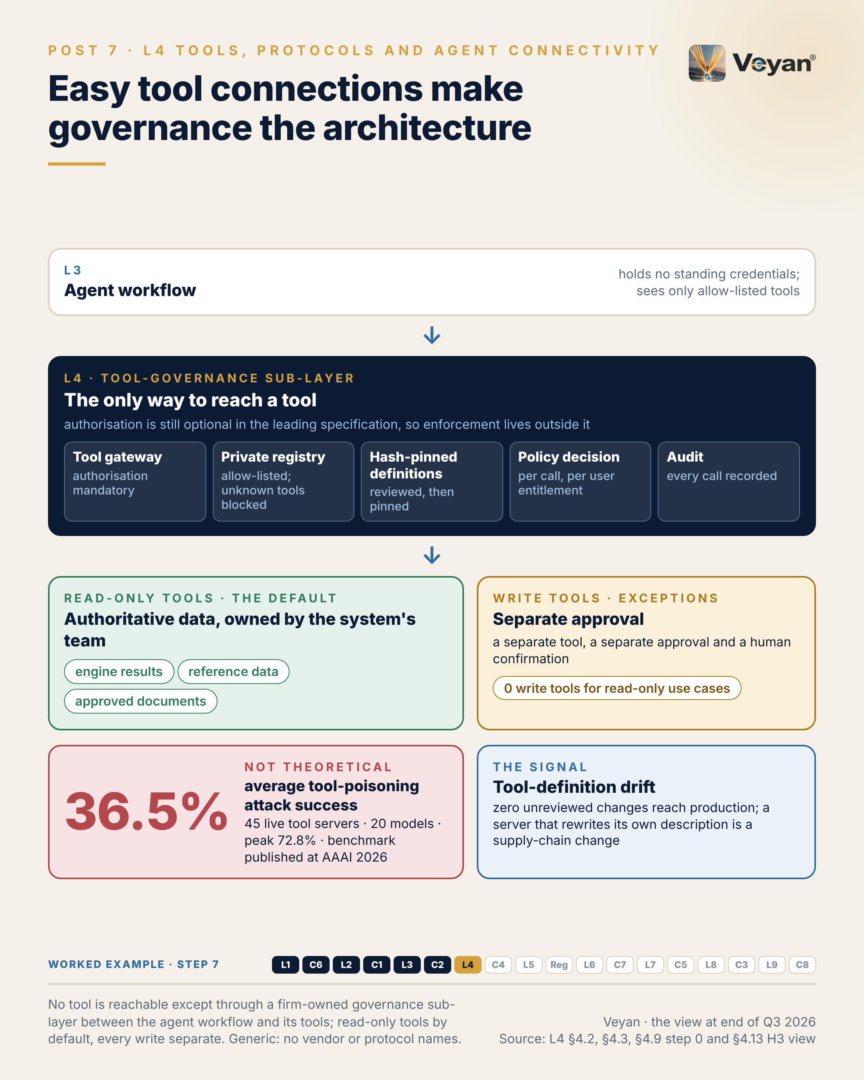
Visual: 08_Graphic/linkedin/P07.png (1080 × 1350, LinkedIn portrait); editable source P07.md, also as .html and .pdf.

First comment
Personal views. Sources: the Enterprise GenAI Stack review, L4 Tools, protocols and agent connectivity (§4.2, §4.3 KPIs, §4.9, §4.12, §4.13). - MCPTox benchmark (AAAI 2026): 45 live MCP servers, 20 models, 36.5% average and 72.8% peak attack success [A3-S023]. - The protocols: the Model Context Protocol (MCP), which originated at Anthropic and was donated to the Agentic AI Foundation under the Linux Foundation on 9 December 2025 [A3-S018, V1-S038], and A2A 1.0, which joined AAIF in August 2026 [A3-S079, A3-S116]. MCP’s 2026-07-28 specification still leaves authorisation optional [A3-S055]. Both MCP Lead Maintainers are Anthropic staff [A3-S082]. Independent alternatives: OpenAPI-described tools behind a gateway; A2A for agent delegation. Conflict of interest noted: these drafts were prepared with an Anthropic model. - Tool vendors assessed: Exa, Tavily (Nebius-owned since 19 February 2026), Browserbase, E2B, Composio (disclosed a token-exposure incident in May 2026 [B-L4-S007]); managed gateway option: AWS AgentCore Gateway. - Worked example, step 7 (tools). Adds: Four tools behind the tool gateway: read-only attribution results with a snapshot hash, read-only fund reference data, a sandboxed calculator for derived figures, and retrieval of approved commentary. Now: Every figure in the draft traces to a snapshot ID and hash. Never: No write, publish or e-mail tool exists, so none can be misused.

Hashtags
#AgenticAI #APISecurity

Re-verify before posting
- Whether a newer MCP specification makes authorisation mandatory
- AAIF governance status of MCP and A2A
- MCPTox figures (cite the paper directly if challenged)

Compliance check
- Personal views: yes
- Protocol named only in the first comment, with the conflict of interest stated: yes
- No reference to internal integrations: yes

Post 8 · Week 4 · C4 Identity and access for agents
Pair: Post 7 (L4, Week 4). Bridge: Once every tool sits behind a gateway, the question is who the agent is, and whose authority it carries.
Theme and source: Agent identity, delegation and least privilege for non-human actors. work/stageB/C4/section.md (executive summary, §C4.2, §C4.3, §C4.9, §C4.11–§C4.13).
Tension: “Who did this?” needs an answer when the actor is an agent.

Full post
“Who did this?” is the first question in every incident review. When the actor is an agent, many logs can answer only with the name of a shared service account.
Agents turn identity mistakes into actions. A person with excessive access usually does nothing with it. An agent with excessive access can be steered into using it by text it reads, which is why the OWASP list for agentic applications names identity and privilege abuse alongside goal hijack and tool misuse.
The previous post put a gateway in front of every tool. This one decides who is allowed through it. Five properties hold up. The agent has its own registered identity with a named sponsor. Where a person started the work, it acts on that person’s behalf. Its permissions are the intersection of that person’s and the agent’s own ceiling. It holds no standing secrets, only short-lived tokens scoped to the task. And every action is attributable to both.
The signal is attribution completeness: the share of audit events recording user, agent, tool, an argument hash, the policy decision and a trace ID. Aim for 99.9% or better. A gap is a question you cannot answer later.
The leadership move is to carry segregation of duties across unchanged. An agent may draft; it may not approve. The approver is a different, entitled person. And a write tool the agent never calls should still not be reachable.
[Anecdote slot: one or two sentences on a time an access review or audit trail answered, or failed to answer, “who did this?”, and what changed.]
Accountability does not disappear when work is automated. It needs a name, and the system has to record it.

Short variant
“Who did this?” is the first question in every incident review. For an agent, many logs can only name a shared service account.
Agents turn identity mistakes into actions: an agent with excessive access can be steered into using it by text it reads.
Five properties hold up. The agent has its own identity and a named sponsor. It acts on behalf of the person who started the work. Its permissions are the intersection of theirs and its own ceiling. It holds no standing secrets. Every action is attributable to both.
The signal is attribution completeness: audit events recording user, agent, tool, decision and trace ID, at 99.9% or better.
Carry segregation of duties across unchanged. An agent may draft; it may not approve.
Accountability does not disappear when work is automated. It needs a name.

Anecdote slot
- Where: the bracketed line before the closing paragraph.
- Prompt: an access review, joiner-mover-leaver gap or shared-credential clean-up that taught you something about accountability for automated work (batch jobs, bots, service accounts). Who did the unglamorous work of untangling it? Credit them.
- Fits: “audit outcomes as a symptom of operating-model design”.
- Avoid: real findings, account names, or anything implying a current control weakness.

Fallback version
“Who did this?” is the first question in every incident review. When the actor is an agent, many logs can answer only with the name of a shared service account.
Agents turn identity mistakes into actions. A person with excessive access usually does nothing with it. An agent with excessive access can be steered into using it by text it reads, which is why the OWASP list for agentic applications names identity and privilege abuse alongside goal hijack and tool misuse.
A tool gateway decides what can be called. Identity decides who is allowed through it. Five properties hold up. The agent has its own registered identity with a named sponsor. Where a person started the work, it acts on that person’s behalf. Its permissions are the intersection of that person’s and the agent’s own ceiling. It holds no standing secrets, only short-lived tokens scoped to the task. And every action is attributable to both.
The signal is attribution completeness: the share of audit events recording user, agent, tool, an argument hash, the policy decision and a trace ID. Aim for 99.9% or better. A gap is a question you cannot answer later.
The leadership move is to carry segregation of duties across unchanged. An agent may draft; it may not approve. The approver is a different, entitled person. And a write tool the agent never calls should still not be reachable.
The honest caveat: no rule yet names an accountable person for an agent. Mapping every agent to a sponsor, and through the business to a senior manager, is a judgement worth making before anyone asks.
Accountability does not disappear when work is automated. It needs a name, and the system has to record it.

Suggested visual
“One attribution chain” graphic: analyst signs in → token exchange (on behalf of analyst, read-only scope, minutes TTL) → agent identity (sponsor named) → gateway policy decision → tool → audit event (user · agent · tool · args hash · decision · trace ID) → evidence pack. A separate lane shows the approver (different person, step-up authentication). Source: C4 §C4.12.
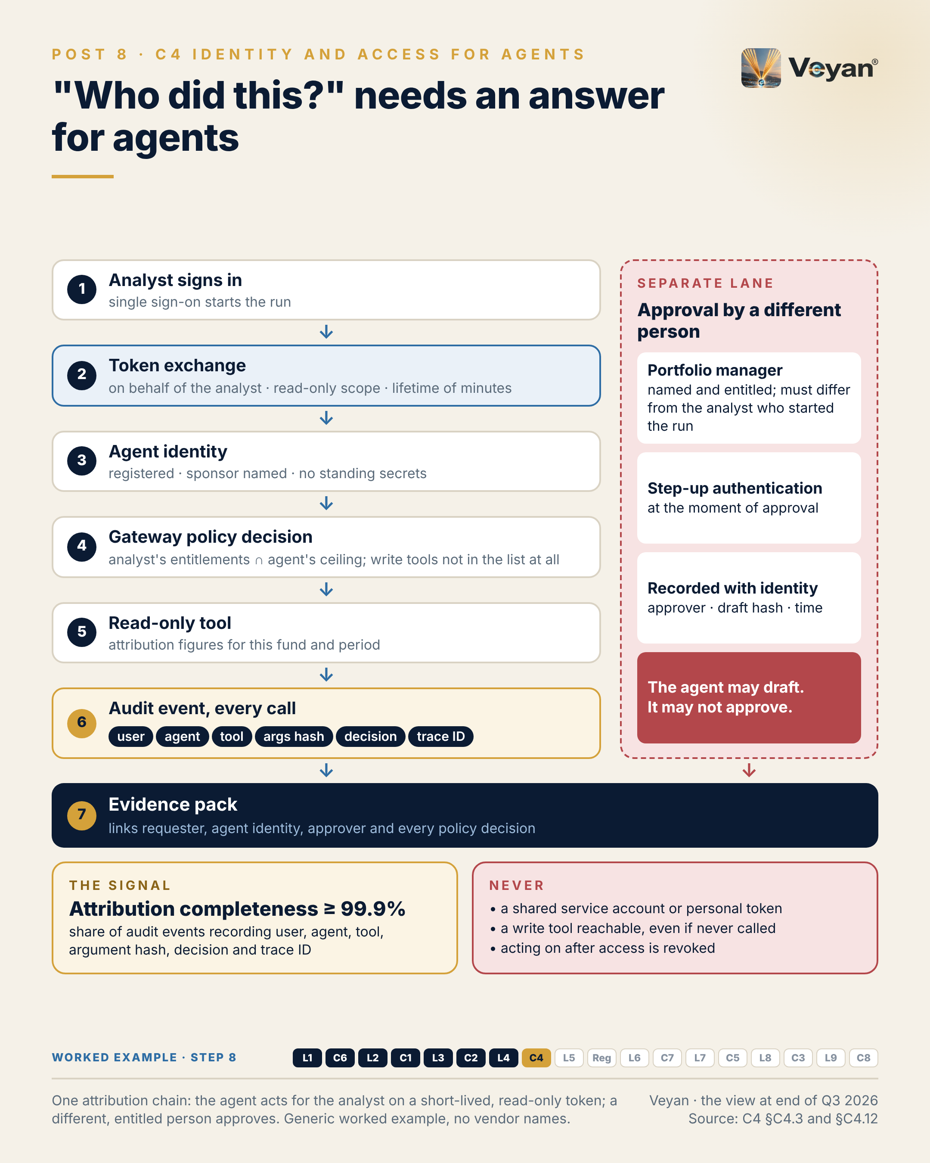
Visual: 08_Graphic/linkedin/P08.png (1080 × 1350, LinkedIn portrait); editable source P08.md, also as .html and .pdf.

First comment
Personal views. Sources: the Enterprise GenAI Stack review, C4 Identity and access for agents (§C4.2, §C4.3 KPIs, §C4.9, §C4.11, §C4.12). - OWASP Top 10 for Agentic Applications for 2026: ASI01 Agent Goal Hijack, ASI02 Tool Misuse and Exploitation, ASI03 Identity & Privilege Abuse [B-C4-S005, R-OWASP-AGENTIC: A8-S042]. - Agent identity products now GA: Microsoft Entra Agent ID (April 2026) [A6-S058, V2-S032]; Okta for AI Agents (30 April 2026) and Okta Agent SSO / Cross App Access (24 August 2026) [A6-S100, V2-S035]; Auth0 for AI Agents (19 November 2025) [A6-S097]. Policy engines: OPA (CNCF graduated) and Cedar-based Amazon Bedrock AgentCore Policy (GA 3 March 2026) [A6-S046, A6-S026]. Workload identity: SPIFFE/SPIRE [A6-S087]. - MCP authorisation (Enterprise-Managed Authorization) is stable but optional in the specification [A6-S033]; MCP originated at Anthropic (conflict of interest noted). - UK: the FCA relies on existing frameworks including SM&CR [R-UK-AI-STATEMENTS: A8-S055]. - Worked example, step 8 (identity). Adds: A registered agent identity with a named sponsor; it acts on behalf of the analyst with a read-only, minutes-long token; a different portfolio manager approves with step-up authentication. Now: Every action answers ‘who did this, on whose behalf, under which policy’. Never: The agent holds no standing credentials and can never approve.

Hashtags
#IAM #AgenticAI

Re-verify before posting
- Product names and GA status for Entra Agent ID and Okta Agent SSO
- Whether any UK or EU rule now names accountability for AI agents

Compliance check
- Personal views; no description of the firm’s IAM: yes
- Vendors only in the first comment: yes

Week 5

Post 9 · Week 5 · L5 Memory
Pair: Post 10 (Regulated reality, Week 5). Bridge: Memory is where governance gets personal (erasure, retention, reproducibility); the control post steps back to the regulations that frame all of it.
Theme and source: Agent memory as a governed record class, built last. work/stageB/L5/section.md (executive summary, §5.2, §5.3, §5.9, §5.11–§5.13); plan §12.6 build order.
Tension: What an agent remembers is a governance question before it is a technical one, which is why memory comes last.

Full post
Memory is the layer I would build last, on purpose. What an agent remembers is a governance question before it is a technical one, and it is the layer I would build last.
Memory is the one part of the stack that writes its own inputs. A mistaken “fact” extracted from one conversation can be recalled in hundreds of later ones. A stale preference can override a newer instruction. An injected instruction that lands in memory keeps working long after the original input has gone, which is why the OWASP list for agentic applications now names memory and context poisoning as a risk of its own.
It also creates a regulatory object that did not exist before: a growing store of extracted personal and business information with no natural expiry. Several memory products keep long-term records indefinitely unless the firm sets a limit.
So the design starts with a question: does this use case need long-term memory at all? Often session state plus retrieval of approved knowledge is enough. In the worked example, what looks like memory, such as fund terminology and the portfolio manager’s preferred phrasing, is better held as a versioned style file, with recurring edits proposed as changes and approved by a person.
The signal is erasure completion time: from request to deletion confirmed across the store, its indexes, revisions and backups. Within the one-month statutory window, with an internal target well inside it.
The leadership move is to treat memory as a governed record class with an approved write path.
[Anecdote slot: one or two sentences on a time data was easy to collect and hard to delete, and who made the clean-up possible.]
Forgetting is a feature. In a regulated firm, it has to be engineered.

Short variant
Memory is the layer I would build last, on purpose. What an agent remembers is a governance question before it is a technical one.
Memory writes its own inputs. A mistaken “fact” from one conversation can be recalled in hundreds of later ones, and an injected instruction stored in memory keeps working long after the input has gone.
It also creates a new regulatory object: extracted personal and business information with no natural expiry.
So ask first whether the use case needs long-term memory at all. Often session state plus approved retrieval is enough. Style and terminology belong in a versioned file a person approves.
The signal is erasure completion time across the store, its indexes, revisions and backups, within the one-month statutory window.
Forgetting is a feature. In a regulated firm, it has to be engineered.

Anecdote slot
- Where: the bracketed line before the closing paragraph.
- Prompt: a data-retention, archive or deletion exercise (a subject access request, a decommissioning, a records-policy refresh) that showed how much easier it is to collect data than to remove it. Credit the people who built the deletion capability; own any “keep everything” default you once accepted.
- Fits: platform modernisation and regulated-environment themes.
- Avoid: any real data-subject request, volume or client.

Fallback version
Memory is the layer I would deliberately build last. What an agent remembers is a governance question before it is a technical one.
Memory is the one part of the stack that writes its own inputs. A mistaken “fact” extracted from one conversation can be recalled in hundreds of later ones. A stale preference can override a newer instruction. An injected instruction that lands in memory keeps working long after the original input has gone, which is why the OWASP list for agentic applications now names memory and context poisoning as a risk of its own.
It also creates a regulatory object that did not exist before: a growing store of extracted personal and business information with no natural expiry. Several memory products keep long-term records indefinitely unless the firm sets a limit.
So the design starts with a question: does this use case need long-term memory at all? Often session state plus retrieval of approved knowledge is enough. In the worked example, what looks like memory, such as fund terminology and the portfolio manager’s preferred phrasing, is better held as a versioned style file, with recurring edits proposed as changes and approved by a person.
The signal is erasure completion time: from request to deletion confirmed across the store, its indexes, revisions and backups. Within the one-month statutory window, with an internal target well inside it.
The leadership move is to treat memory as a governed record class with an approved write path.
The honest caveat: the independent memory products are moving fast and in different directions, while the platforms absorb the feature. Owning the memory interface in front of them keeps that churn survivable.
Forgetting is a feature. In a regulated firm, it has to be engineered.

Suggested visual
The build-order roadmap (plan §12.6) as a horizontal timeline: governance → evaluation and observability → model access (gateway first) → retrieval → workflows → tools → memory (highlighted) → optimisation. Inset: a memory write path with a policy gate (DLP screen, allow-list, approval), a subject index and a “forget-by-subject” arrow reaching store, vectors, revisions and backups. Source: L5 §5.9 and §5.12.
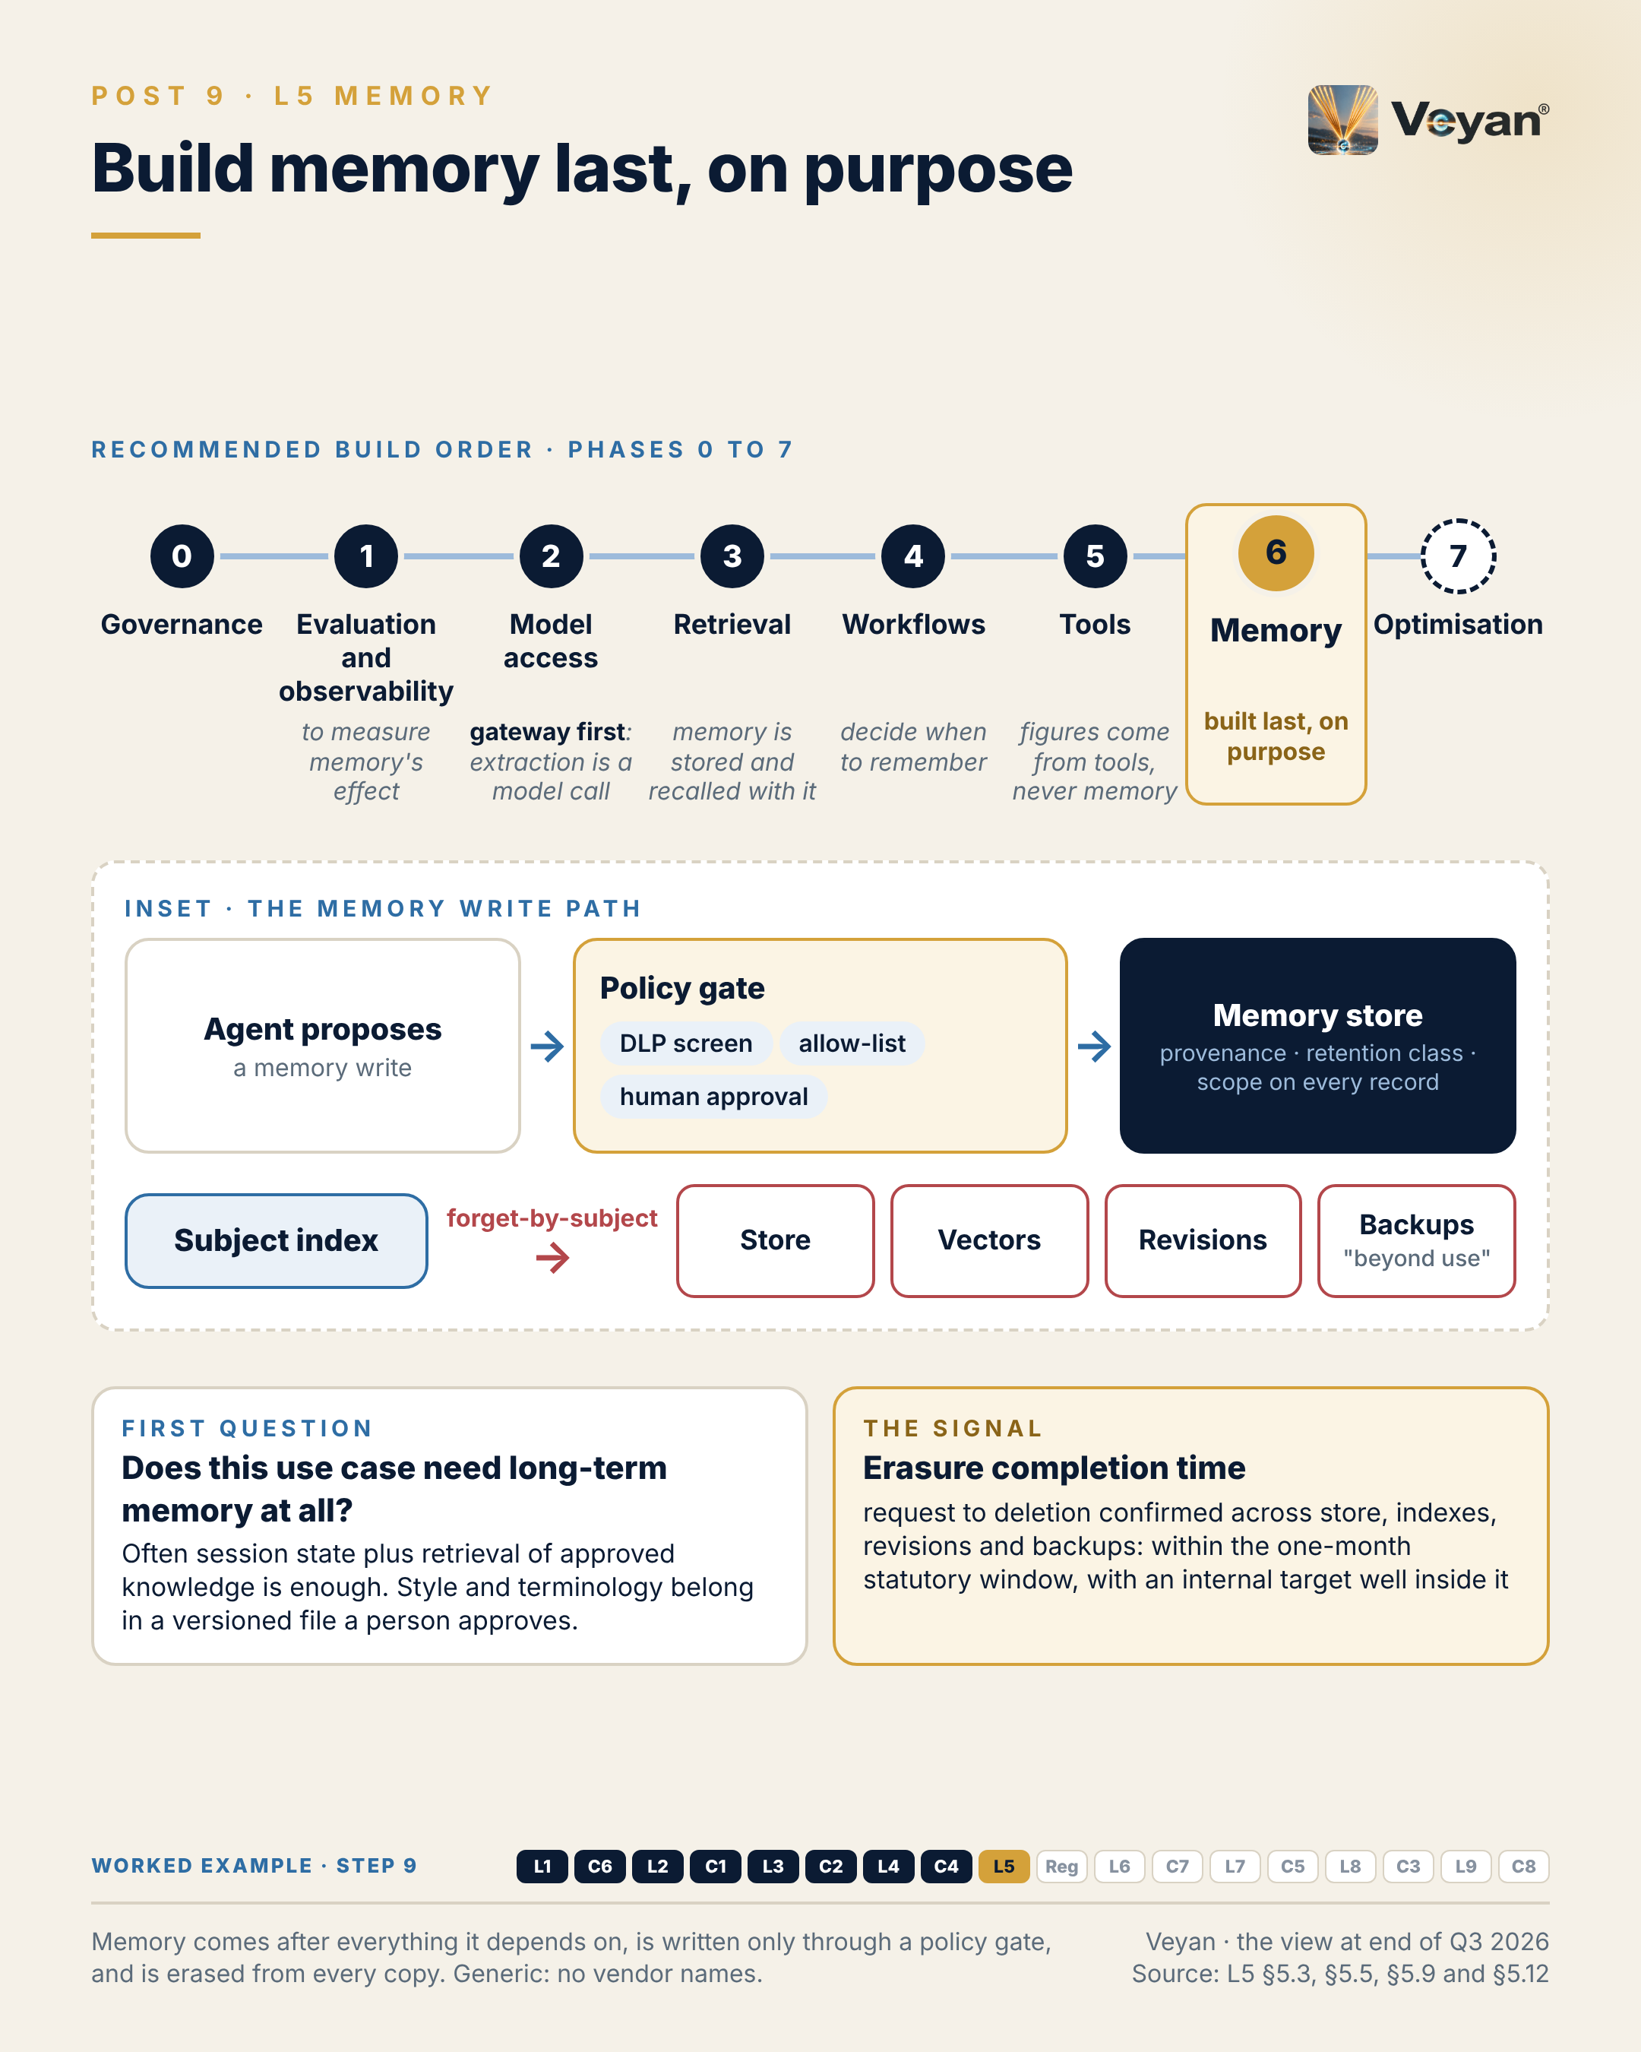
Visual: 08_Graphic/linkedin/P09.png (1080 × 1350, LinkedIn portrait); editable source P09.md, also as .html and .pdf.

First comment
Personal views. Sources: the Enterprise GenAI Stack review, L5 Memory (§5.2, §5.3 KPIs, §5.9, §5.11 on erasure and retention, §5.12), and the plan’s day-one build order. - OWASP Top 10 for Agentic Applications for 2026: ASI06 memory and context poisoning [B-L5-S001]. - Defaults that run against storage limitation: no long-term time limit in Amazon Bedrock AgentCore Memory (AWS recommends a pruner) [A3-S111]; no default TTL in Google’s Memory Bank [A3-S109]; ADD-only accumulation in Mem0 open source [A3-S081]; invalidation rather than deletion in Graphiti [A3-S003]. - ICO erasure expectations, including backups put “beyond use” and a one-month response [B-L5-S005]; storage limitation [B-L5-S006]. - Market: Mem0 removed external graph stores from open source; Zep deprecated its Community Edition (Graphiti remains); Letta pivoted to an agent harness; LangMem has had no release since 27 October 2025 [A3-S081, A3-S059, A3-S093, A3-S006]. Model vendors also ship memory features (Anthropic’s memory tool, OpenAI’s Conversations API) [A3-S069, A3-S110]. - Worked example, step 9 (memory). Adds: Deliberately little: a versioned glossary and style rules per fund, changed only by an approved pull request, recalled by version hash. Now: Any commentary can be regenerated with exactly the memory it used. Never: The agent may propose memory, never write it; no client identifiers in memory.

Hashtags
#AgentMemory #DataProtection

Re-verify before posting
- ICO guidance (under review following the Data (Use and Access) Act)
- Memory product defaults (TTL and pruning) and LangMem release status

Compliance check
- Personal views; “the layer I would build last” refers to a recommended build order, not to any firm: yes
- No real erasure request or data described: yes
- Vendors only in the first comment: yes

Post 10 · Week 5 · Regulated reality: EU AI Act and DORA
Pair: Post 9 (L5, Week 5). Bridge: Halfway through the layers, the regulatory frame explains why multi-vendor design and retained evidence stop being optional.
Theme and source: The 2026–27 regulatory frame for GenAI in asset management. work/stageB/C8/section.md §C8.11 (with §C8.13), work/stageB/L1/section.md §1.11 (concentration), and Enterprise_GenAI_Stack_Oct2026/05_Data/regulatory_facts.json (R-US-MRM, R-EUAIA, R-EU-OMNIBUS-AI, R-DORA, R-UK-CTP, R-PRA-SS221, R-FCA-SYSC8, R-INTL-AI-ASSETMGMT).
Tension: Concentration risk turns multi-vendor from a preference into a requirement.

Full post
Concentration risk is turning multi-vendor AI from a preference into something close to a requirement.
Four facts frame it. In the US, SR 26-2 replaced the long-standing model-risk guidance in April 2026 and placed generative and agentic AI outside its scope, so firms write their own standard. In the EU, enforcement of the AI Act’s duties on general-purpose model providers began in August 2026, while the high-risk duties for Annex III uses moved to 2 December 2027. For most asset-management uses, today’s live duties are literacy and transparency. Under DORA, and the UK’s new critical third parties regime, the providers designated for direct oversight are hyperscalers and infrastructure firms; no model vendor is on either list. And from 18 March 2027, UK firms must notify material third-party arrangements before entering or significantly changing them.
Read together, oversight of a direct model-vendor contract rests largely on the firm. No rule says “use two model vendors”. But a tested stressed-exit plan for a model behind an important business service needs a second route that already works: qualified on the same evaluation suite, through the same gateway, in an approved region. International supervisors now name concentration on a few AI providers as a risk in itself.
The signal is a concentration ratio: the share of production usage, or of important services, served by the largest single model vendor, reported to the risk committee against a ceiling the firm sets.
The leadership move is to use these deadlines as a mandate, building the evidence once.
[Anecdote slot: one or two sentences on a regulatory deadline you turned into a broader refresh, and who carried it.]
Regulation rarely tells you what to build. It tells you what you will have to prove.

Short variant
Concentration risk is turning multi-vendor AI from a preference into something close to a requirement.
The frame: SR 26-2 leaves GenAI governance to US firms themselves. The EU AI Act’s general-purpose model duties have been enforceable since August 2026; Annex III high-risk duties apply from 2 December 2027. DORA and the UK critical third parties regime designate hyperscalers, not model vendors. UK third-party notifications start on 18 March 2027.
So oversight of a direct model contract rests on the firm. No rule demands two vendors, but a tested stressed exit needs a second route that already works.
The signal is a concentration ratio: usage served by the largest model vendor, reported against a ceiling the firm sets.
Use the deadlines as a mandate. Regulation rarely tells you what to build. It tells you what you will have to prove.

Anecdote slot
- Where: the bracketed line before the closing paragraph.
- Prompt: an external deadline (a regulation, an end-of-support date, a market change) that you used to fund or justify a wider modernisation, and what made the case land with executives. Credit the team that delivered it.
- Fits: the signature theme “turning compressed external deadlines into refresh mandates”.
- Avoid: naming regulators’ interactions with your firm or any supervisory finding.

Fallback version
Concentration risk is turning multi-vendor AI from a preference into something close to a requirement.
Four facts frame it. In the US, SR 26-2 replaced the long-standing model-risk guidance in April 2026 and placed generative and agentic AI outside its scope, so firms write their own standard. In the EU, enforcement of the AI Act’s duties on general-purpose model providers began in August 2026, while the high-risk duties for Annex III uses moved to 2 December 2027. For most asset-management uses, today’s live duties are literacy and transparency. Under DORA, and the UK’s new critical third parties regime, the providers designated for direct oversight are hyperscalers and infrastructure firms; no model vendor is on either list. And from 18 March 2027, UK firms must notify material third-party arrangements before entering or significantly changing them.
Read together, oversight of a direct model-vendor contract rests largely on the firm. No rule says “use two model vendors”. But a tested stressed-exit plan for a model behind an important business service needs a second route that already works: qualified on the same evaluation suite, through the same gateway, in an approved region. International supervisors now name concentration on a few AI providers as a risk in itself.
The signal is a concentration ratio: the share of production usage, or of important services, served by the largest single model vendor, reported to the risk committee against a ceiling the firm sets.
The leadership move is to use these deadlines as a mandate, building the evidence once.
The honest caveat: the DORA list is updated every year, and nothing guarantees a direct model API stays outside the perimeter.
Regulation rarely tells you what to build. It tells you what you will have to prove.

Suggested visual
A timeline from April 2026 to December 2027: 17 Apr 2026 SR 26-2 (GenAI out of scope); 13 Jul 2026 UK CTP designations in force; 2 Aug 2026 GPAI enforcement and Article 50 transparency; 18 Mar 2027 UK material third-party notifications; 2 Dec 2027 EU AI Act Annex III. Beneath it, a two-column panel: “designated for direct oversight: hyperscalers and infrastructure” versus “not designated: model vendors (oversight rests on the firm)”. Source: regulatory_facts.json and C8 §C8.11.
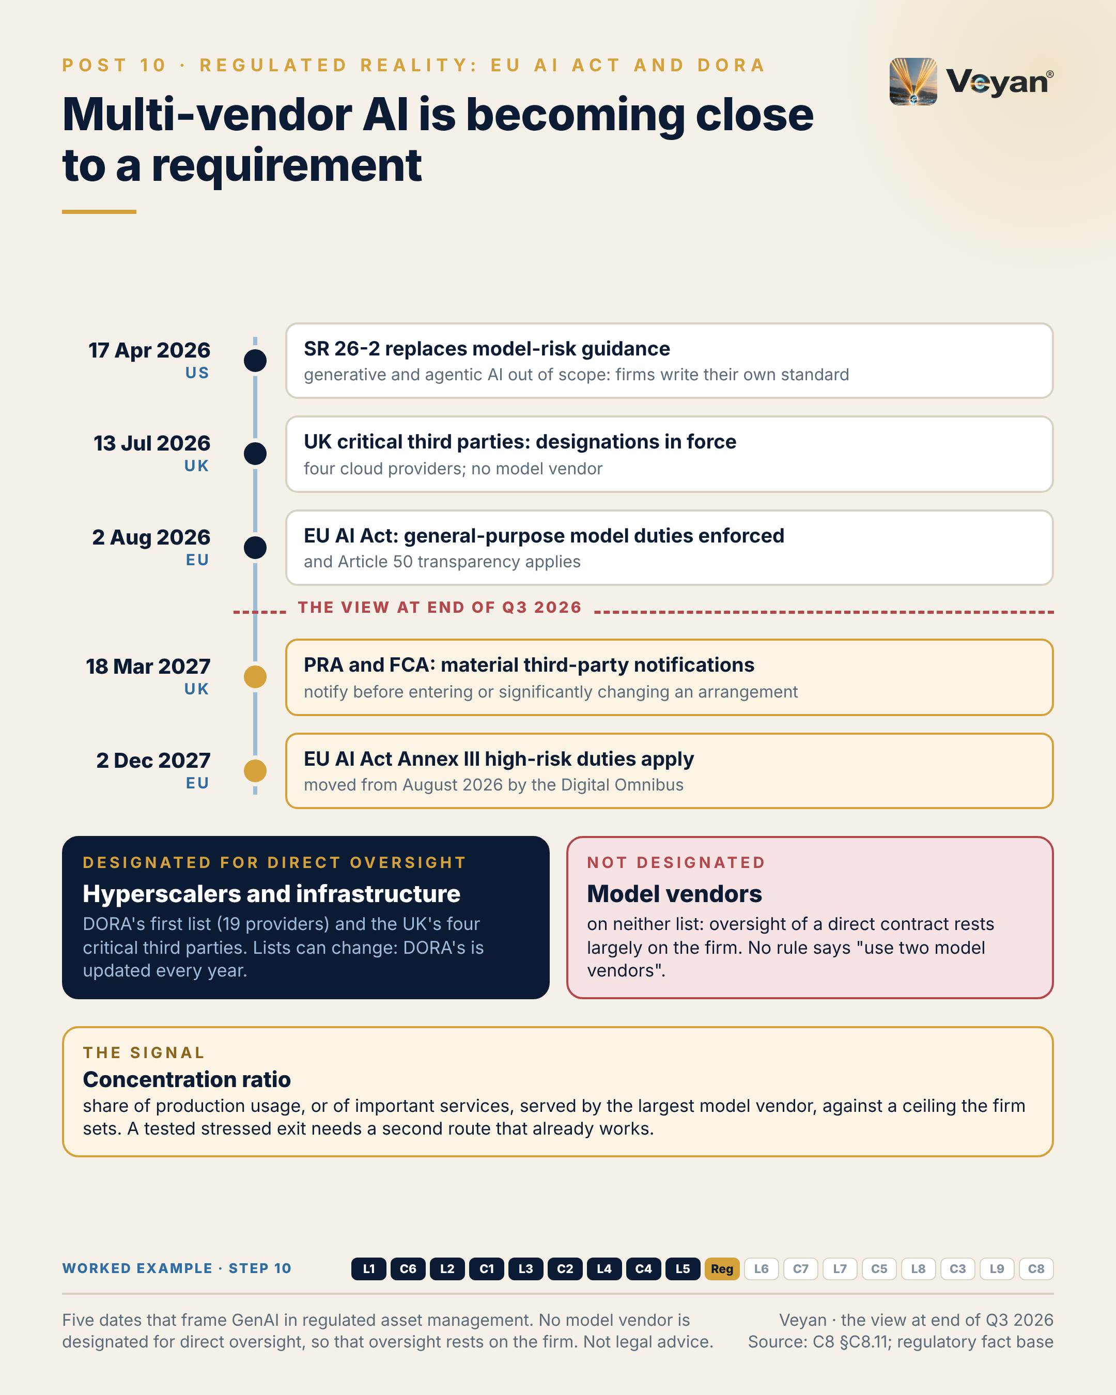
Visual: 08_Graphic/linkedin/P10.png (1080 × 1350, LinkedIn portrait); editable source P10.md, also as .html and .pdf.

First comment
Personal views; not legal advice. Sources: the Enterprise GenAI Stack review, C8 §C8.11 and L1 §1.11, and the regulatory fact base. - SR 26-2 / OCC Bulletin 2026-13 / FDIC FIL-15-2026, 17 April 2026: supersedes SR 11-7; generative and agentic AI expressly out of scope; a planned AI request for information not published as of 7 October 2026 [R-US-MRM: A8-S001, A8-S002, A8-S003, V2-S049]. - EU AI Act: Commission enforcement powers over GPAI from 2 August 2026; Article 50 transparency from 2 August 2026; Annex III moved to 2 December 2027 and Annex I to 2 August 2028 by Regulation (EU) 2026/1744 (in force 27 July 2026) [R-EUAIA, R-EU-OMNIBUS-AI: A8-S011, A8-S019, V2-S050]. GPAI Code of Practice signatories include Amazon, Anthropic, Google, IBM, Microsoft, Mistral AI and OpenAI [R-EU-GPAI-COP: A8-S015]. - DORA: first CTPP list 18 November 2025, 19 providers including AWS, Google Cloud, Microsoft, Oracle, IBM, SAP, Bloomberg and LSEG; no AI model provider; updated annually [R-DORA: A8-S020, A8-S021, V2-S051]. UK CTPs in force 13 July 2026: AWS, Google Cloud, Microsoft, Oracle; no model vendor [R-UK-CTP: A8-S023, V2-S052]. - PRA PS7/26 and FCA PS26/2: material third-party notifications and an annual register from 18 March 2027 [R-PRA-SS221, R-FCA-SYSC8: A8-S062, V2-S053]. SS2/21 stressed-exit expectations [A8-S048]. - IOSCO Supervisory Toolkit (FR/02/2026) flags concentration risk from reliance on few AI providers [R-INTL-AI-ASSETMGMT: A8-S058]. - Worked example, step 10 (regulation). Adds: The regulatory mapping: not an Annex III use; transparency and literacy duties; model vendors as material outsourcing with exit plans; the agent recorded in the model inventory. Now: The design is defensible to a regulator, not only to an architect. Never: Never assume a vendor’s oversight covers the firm’s duties.

Hashtags
#EUAIAct #DORA

Re-verify before posting
- Any update to the DORA CTPP list or new UK CTP designations (especially any model vendor)
- Whether the US agencies’ AI request for information has been published
- EU AI Act dates (any further Omnibus changes) and the PS7/26 effective date
- “For most asset-management uses, today’s live duties are literacy and transparency” is a judgement; keep it phrased as such

Compliance check
- Personal views and “not legal advice” stated in the first comment: yes
- No statement about the firm’s regulatory status or engagement: yes
- Vendors named only in the first comment, from the official lists: yes

Week 6

Post 11 · Week 6 · L6 Retrieval and knowledge stores
Pair: Post 12 (C7, Week 6). Bridge: The stack post is about retrieving the right passages under real permissions; the control post is about the passages someone else wrote for you.
Theme and source: Retrieval stores as derived, entitlement-filtered, rebuildable indexes. work/stageB/L6/section.md (executive summary, §6.2, §6.3, §6.9, §6.11–§6.13).
Tension: You may not need a vector database, but you do need retrieval you can measure.

Full post
You may not need a vector database. You do need retrieval you can measure.
The category has quietly turned into a feature. General-purpose databases, search engines and even object storage now offer vector search, and hybrid retrieval, lexical plus semantic, is standard rather than advanced. For most regulated asset-management corpora, the database or search platform you already run will do the job.
That matters because every extra store is another copy of confidential content to secure, retain, back up and eventually exit. So the first question is not which engine; it is whether a load test on your own data gives you a reason for one. Three reasons hold up: filtered latency or recall fails the budget, tenants must be isolated at a scale schemas cannot manage, or the corpus makes the existing platform’s cost disproportionate.
The signal is filtered recall@k: recall measured with production-like entitlement filters applied, not on the open index. A store that looks excellent unfiltered can collapse once a restrictive filter leaves too few candidates. The tempting fix, retrying without the filter, is how another client’s material reaches a draft.
The leadership move is to treat the store as a derived index, never the system of record. If you can rebuild it from approved sources, with a pinned embedding model, inside a tested time, it is also your backup and your exit plan.
[Anecdote slot: one or two sentences on a time a “temporary” store or prototype quietly became critical, and what it took to put it under control.]
Retrieval is judged by what it returns under real permissions. An open-index benchmark answers a different question.

Short variant
You may not need a vector database. You do need retrieval you can measure.
Vector search is now a feature of the databases, search engines and object stores firms already run, and hybrid retrieval is standard. Every extra store is another copy of confidential content to secure, retain and exit, so adopt a dedicated engine only when a load test on your own data demands it.
The signal is filtered recall@k: recall with production-like entitlement filters applied. A store that shines unfiltered can collapse under a restrictive filter, and retrying without the filter is how another client’s material reaches a draft.
Treat the store as a derived index, never the system of record. If you can rebuild it from approved sources in a tested time, it is also your exit plan.
Retrieval is judged by what it returns under real permissions.

Anecdote slot
- Where: the bracketed line before the closing paragraph.
- Prompt: a prototype, spreadsheet or “temporary” data store that became business-critical without anyone deciding it should, and what it took to give it an owner, a backup and an exit. Credit the person who raised the flag.
- Fits: platform-modernisation and “talent and systems as the real resilience plan” themes.
- Avoid: naming the system or the business it supported.

Fallback version
You may not need a vector database. You do need retrieval you can measure.
The category has quietly turned into a feature. General-purpose databases, search engines and even object storage now offer vector search, and hybrid retrieval, lexical plus semantic, is standard rather than advanced. For most regulated asset-management corpora, the database or search platform already in place will do the job.
That matters because every extra store is another copy of confidential content to secure, retain, back up and eventually exit. So the first question is not which engine; it is whether a load test on your own data gives you a reason for one. Three reasons hold up: filtered latency or recall fails the budget, tenants must be isolated at a scale schemas cannot manage, or the corpus makes the existing platform’s cost disproportionate.
The signal is filtered recall@k: recall measured with production-like entitlement filters applied, not on the open index. A store that looks excellent unfiltered can collapse once a restrictive filter leaves too few candidates. The tempting fix, retrying without the filter, is how another client’s material reaches a draft.
The leadership move is to treat the store as a derived index, never the system of record. If you can rebuild it from approved sources, with a pinned embedding model, inside a tested time, it is also your backup and your exit plan.
The honest caveat: dedicated engines still earn their place on filtered search, tenant isolation and scale. The point is to arrive at one with evidence, not by default.
Retrieval is judged by what it returns under real permissions. An open-index benchmark answers a different question.

Suggested visual
Decision-tree graphic (L6 §6.9): Step 0 non-negotiables (filters inside the search, no unfiltered fallback, rebuild tested) → Step 1 “use what you run” (relational database, search engine, document database, object-store tier) → Step 2 three triggers → Step 3 dedicated engine. A side panel contrasts “filter after ranking + fallback = leakage” with “filter inside search + hard empty result”.
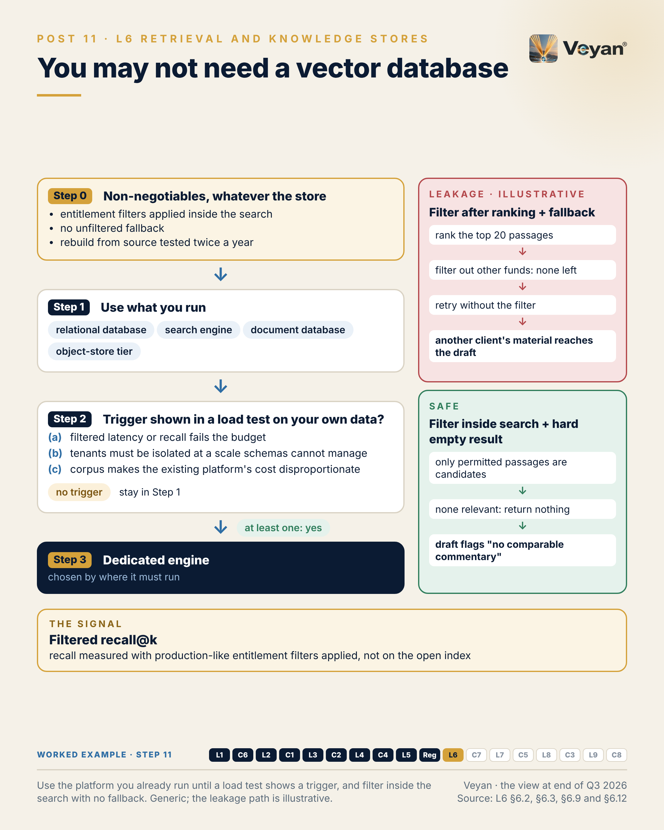
Visual: 08_Graphic/linkedin/P11.png (1080 × 1350, LinkedIn portrait); editable source P11.md, also as .html and .pdf.

First comment
Personal views. Sources: the Enterprise GenAI Stack review, L6 Retrieval and knowledge stores (§6.2, §6.3 KPIs, §6.9, §6.12, §6.13). - Hybrid is standard: turbopuffer, Chroma Cloud, Milvus, Elasticsearch, MongoDB, Qdrant and Pinecone all fuse lexical and vector retrieval [A2-S056, A2-S060, A2-S054, A2-S133, A2-S141, A2-S103, A2-S101]. - Databases absorbed the feature: pgvector 0.8.7 (1 October 2026) [V1-S020, V1-S022]; MongoDB Vector Search GA on self-managed editions [A2-S137, V1-S035]. Object storage: Amazon S3 Vectors GA since December 2025 [A2-S081, V1-S030]. Pinecone now sells Nexus, a “knowledge engine for agents” [A2-S073, V1-S029]. - Recommended starting point in the review: vectors in the database or search engine you already operate; Qdrant or Milvus only when a load test justifies a dedicated engine. Weaviate is Tactical while its licence position settles. turbopuffer reports Anthropic as a customer [R: A2-S126]; noted for completeness. - Worked example, step 11 (retrieval store). Adds: One store already run by the firm, with three collections (prior commentaries, style guide, approved market notes) and fund-level entitlement filters applied inside the search. Now: Context arrives only from documents the analyst is entitled to see. Never: No unfiltered fallback: no permitted result means an empty result.

Hashtags
#VectorSearch #RAG

Re-verify before posting
- pgvector version and any new CVEs
- Pinecone Nexus and Weaviate licence status

Compliance check
- Personal views: yes
- No reference to any firm’s data estate: yes
- Vendors only in the first comment, evenly: yes

Post 12 · Week 6 · C7 AI security
Pair: Post 11 (L6, Week 6). Bridge: Retrieval brings back passages; some were written by someone who wants your agent to act on them.
Theme and source: Capability separation and layered defence for agents. work/stageB/C7/section.md (executive summary, §C7.2, §C7.3, §C7.9, §C7.11–§C7.13).
Tension: Every retrieved document is untrusted input. Indirect prompt injection is a supply-chain problem.

Full post
A language model follows instructions it finds in any text it reads. Give it tools, and those instructions become actions.
That is why every retrieved document is untrusted input. The previous post was about retrieving the right passages. This one is about passages someone else wrote for you. A broker note, a web page or an email can carry hidden text, and it arrives through the same pipeline as the firm’s own knowledge. Indirect prompt injection is a supply-chain problem, not a chat problem.
The supply chain is literal too. In March 2026, malicious releases of a widely used open-source model gateway were published to a public package index using stolen release credentials. The component that holds every provider key was itself the target.
The first design rule needs no product: no agent should hold untrusted input, sensitive data and an outbound channel at the same time. Remove any one of the three and an injected instruction has nowhere to go.
The signal is simple to count: the number of agents that combine all three. The target is zero, unless there is a documented exception with a named owner.
Then layer the rest so no single detector has to be right: secrets brokered outside the model, short-lived credentials per request, pinned and hashed dependencies, retrieved text marked as data, and a runtime detector behind the gateway as a replaceable part, not the foundation. The leadership move is to buy detection last.
[Anecdote slot: one or two sentences on a security lesson where the design, not a tool, made the difference, and who championed it.]
A design that depends on a filter catching everything is a hope. One that leaves an attacker nothing to call is an architecture.

Short variant
A language model follows instructions it finds in any text it reads. Give it tools, and those instructions become actions.
So every retrieved document is untrusted input. A broker note or web page can carry hidden text through the same pipeline as your own knowledge: indirect prompt injection is a supply-chain problem.
The first rule needs no product. No agent should hold untrusted input, sensitive data and an outbound channel at once. Remove one and an injected instruction has nowhere to go.
The signal: the number of agents combining all three. Target zero, unless an exception is documented and owned.
Then layer the rest: brokered secrets, short-lived credentials, pinned dependencies, retrieved text marked as data, and a replaceable detector behind the gateway. Buy detection last.
A design that depends on a filter catching everything is a hope.

Anecdote slot
- Where: the bracketed line before the closing paragraph.
- Prompt: a security or resilience improvement that came from removing a capability or a path (a privilege, a connection, a shared credential) rather than adding a tool. Who argued for it? Credit them; own any resistance you had to it at first.
- Fits: “making invisible prevention work visible to executives”.
- Avoid: any real vulnerability, incident, threat actor or security control at your firm.

Fallback version
A language model follows instructions it finds in any text it reads. Give it tools, and those instructions become actions.
That is why every retrieved document is untrusted input. Retrieval is about finding the right passages; security is about passages someone else wrote for you. A broker note, a web page or an email can carry hidden text, and it arrives through the same pipeline as the firm’s own knowledge. Indirect prompt injection is a supply-chain problem, not a chat problem.
The supply chain is literal too. In March 2026, malicious releases of a widely used open-source model gateway were published to a public package index using stolen release credentials. The component that holds every provider key was itself the target.
The first design rule needs no product: no agent should hold untrusted input, sensitive data and an outbound channel at the same time. Remove any one of the three and an injected instruction has nowhere to go.
The signal is simple to count: the number of agents that combine all three. The target is zero, unless there is a documented exception with a named owner.
Then layer the rest so no single detector has to be right: secrets brokered outside the model, short-lived credentials per request, pinned and hashed dependencies, retrieved text marked as data, and a runtime detector behind the gateway as a replaceable part, not the foundation. The leadership move is to buy detection last.
The honest caveat: marking retrieved text as data and screening it reduces the risk; it does not remove it. Capability separation is what turns a successful injection into a non-event.
A design that depends on a filter catching everything is a hope. One that leaves an attacker nothing to call is an architecture.

Suggested visual
Venn diagram with three circles: untrusted input, sensitive data, outbound channel. The centre is marked “never in one agent”. Around it, a defence-in-depth ring for the worked example: deterministic workflow, numeric check, data marking, chunk screening, canary documents, human approval. Source: C7 §C7.9 step 0 and §C7.12.
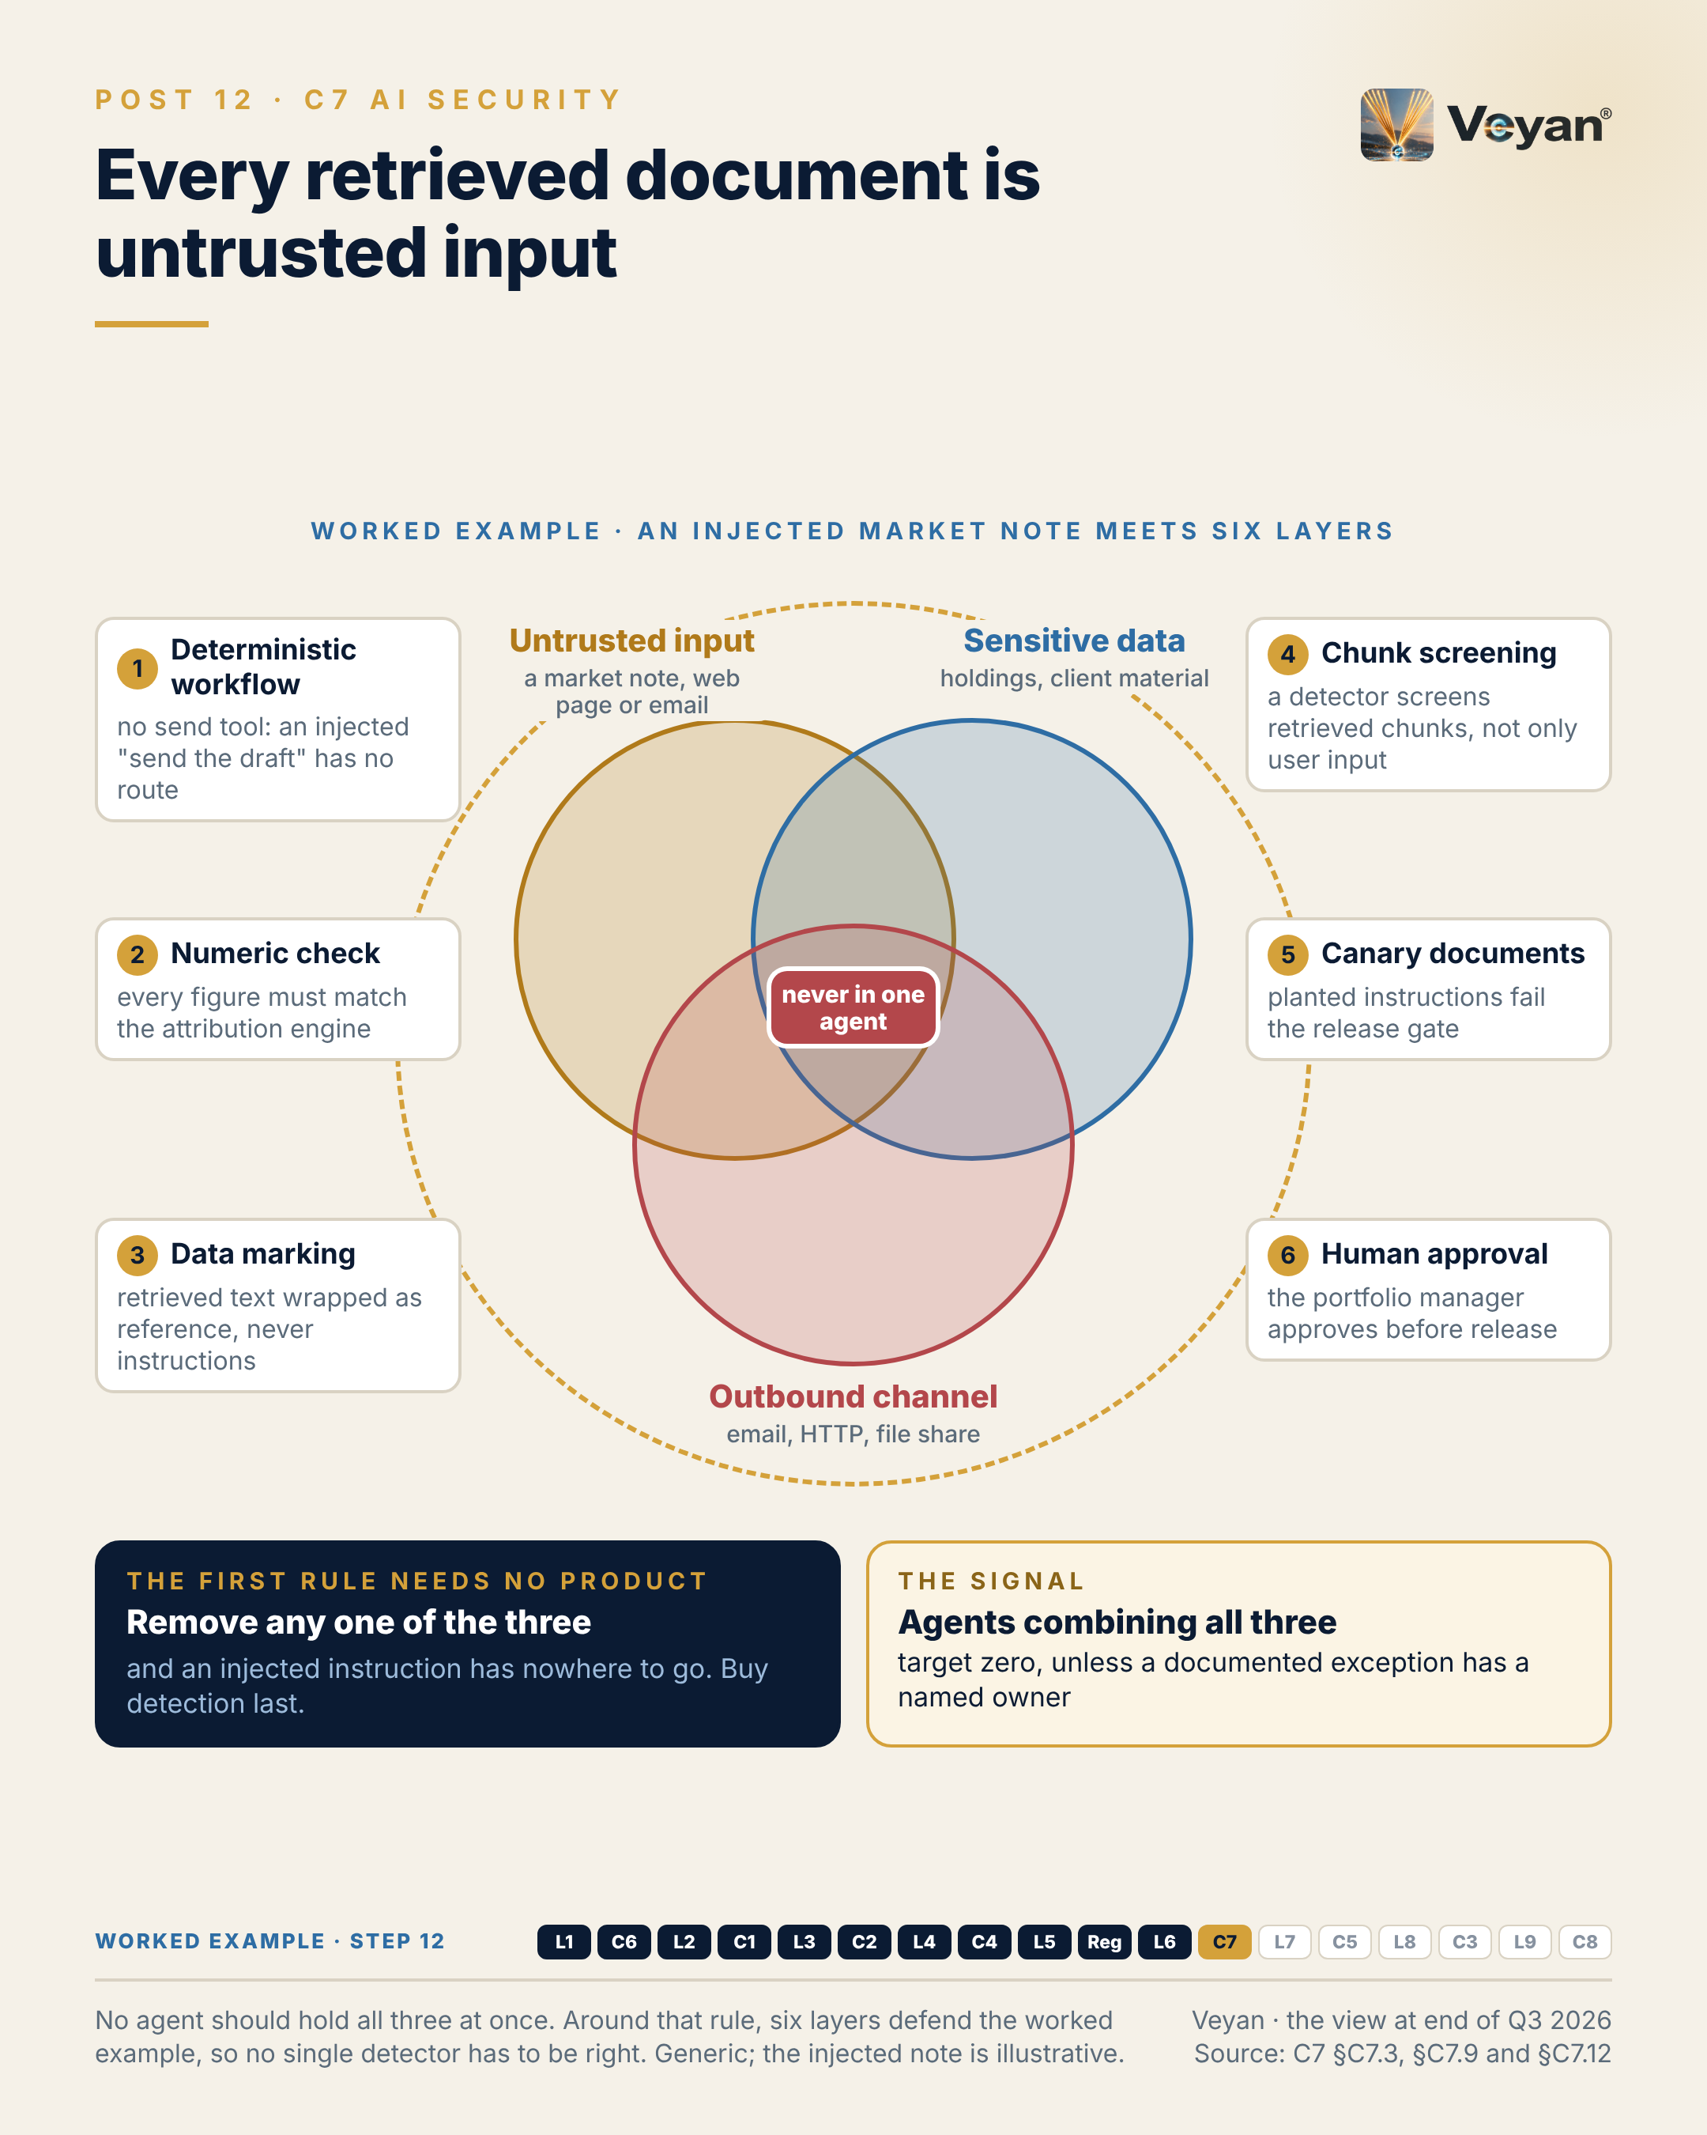
Visual: 08_Graphic/linkedin/P12.png (1080 × 1350, LinkedIn portrait); editable source P12.md, also as .html and .pdf.

First comment
Personal views. Sources: the Enterprise GenAI Stack review, C7 AI security (§C7.2, §C7.3 KPIs, §C7.9, §C7.12, §C7.13). - The gateway incident: malicious LiteLLM releases 1.82.7 and 1.82.8 were published to PyPI on 24 March 2026 using stolen release credentials; LiteLLM attributes the theft to a compromised scanner in CI, other reports describe a hijacked maintainer account; the first clean rebuilt release was 1.83.0 [A6-S008, A6-S009, A6-S010, V2-S027, V2-S028]. - Consolidation: Lakera to Check Point, Protect AI to Palo Alto Networks, Prompt Security to SentinelOne, CalypsoAI to F5, Pangea to CrowdStrike; HiddenLayer is the main independent in this set [A7-S012, A7-S014, A7-S018, A7-S019, A7-S020, A7-S017]. - OWASP Top 10 for Agentic Applications for 2026 opens with ASI01 Agent Goal Hijack [R-OWASP-AGENTIC: A8-S042]. - Secrets and agent credentials: HashiCorp Vault (IBM-owned, BUSL) or the cloud’s native secrets service. - Worked example, step 12 (ai security). Adds: Defence in depth against a poisoned market note: nothing to hijack, numbers that cannot be rewritten, retrieved text marked as data, chunk screening, canary documents and human approval. Now: No single control has to catch an injected instruction. Never: Untrusted input, sensitive data and an outbound channel never meet in one agent.

Hashtags
#AISecurity #PromptInjection

Re-verify before posting
- Any new findings on the March 2026 package compromise (intrusion vector is reported two ways)
- Acquisition statuses in the security list

Compliance check
- Personal views; no reference to the firm’s security posture: yes
- Incident described from public sources only, without attribution claims: yes
- Vendors only in the first comment: yes

Week 7

Post 13 · Week 7 · L7 Embeddings and reranking
Pair: Post 14 (C5, Week 7). Bridge: The stack post ends on “the embedding version is production configuration”; the control post extends that to prompts and every other setting that changes outputs.
Theme and source: Retrieval optimisation as one governed, two-stage service. work/stageB/L7/section.md (executive summary, §7.2, §7.3, §7.9, §7.11–§7.13).
Tension: Retrieval quality is a two-stage problem, and it is easy to tune only one stage.

Full post
Retrieval quality is a two-stage problem, and it is easy to tune only one stage.
The first stage casts a wide net: embed the question and pull back fifty or a hundred candidates. The second stage reorders them, so the handful the model actually reads are the right ones. Teams swap the embedding model to fix answers a reranker should have fixed, or add a reranker to rescue a first stage that never found the right passage.
So measure the stages separately. For the first, the signal is recall@k: the share of questions in an in-domain golden set whose relevant passage appears anywhere in the candidates. A starting target is 0.95. Ranking quality after the reranker is a second number, and only then worth tuning.
There is a quieter point underneath. The embedding model version is production configuration. Change it and the whole corpus must be re-embedded. Mix two versions in one index and the scores stop being comparable, with no error to tell you. Tag every vector with its model version, refuse queries that would mix versions, and migrate by building a second index behind a regression gate.
The leadership move is to choose models by your own evaluation, not by leaderboard or vendor claim. One to three hundred labelled questions, written by the analysts who will use the system, will tell you more than any published benchmark.
[Anecdote slot: one or two sentences on a time a team optimised the wrong stage of a problem, and who spotted it by measuring.]
Most retrieval problems are measurement problems first. Once both stages are visible, the fixes are usually plain.

Short variant
Retrieval quality is a two-stage problem, and it is easy to tune only one stage.
The first stage pulls back fifty or a hundred candidates. The second reorders them so the few the model reads are right. Teams swap embedding models to fix ranking problems, or add rerankers to rescue a first stage that never found the passage.
Measure them separately. Stage one: recall@k on an in-domain golden set, with 0.95 as a starting target. Ranking quality comes second.
Underneath sits a quieter rule. The embedding model version is production configuration. Change it and the corpus must be re-embedded; mix versions and scores silently stop being comparable. Tag every vector and migrate by dual index.
Choose models by your own evaluation, written by the analysts who will use the system. Most retrieval problems are measurement problems first.

Anecdote slot
- Where: the bracketed line before the closing paragraph.
- Prompt: a performance, search or data problem where effort went into the wrong part of the pipeline until someone measured each stage separately. Credit the person who insisted on measuring; own the time spent tuning the wrong thing if that was your call.
- Fits: any engineering-leadership story about measurement before optimisation.
- Avoid: real recall or latency figures from an internal system.

Fallback version
Retrieval quality is a two-stage problem, and it is easy to tune only one stage.
The first stage casts a wide net: embed the question and pull back fifty or a hundred candidates. The second stage reorders them, so the handful the model actually reads are the right ones. Teams swap the embedding model to fix answers a reranker should have fixed, or add a reranker to rescue a first stage that never found the right passage.
So measure the stages separately. For the first, the signal is recall@k: the share of questions in an in-domain golden set whose relevant passage appears anywhere in the candidates. A starting target is 0.95. Ranking quality after the reranker is a second number, and only then worth tuning.
There is a quieter point underneath. The embedding model version is production configuration. Change it and the whole corpus must be re-embedded. Mix two versions in one index and the scores stop being comparable, with no error to tell you. Tag every vector with its model version, refuse queries that would mix versions, and migrate by building a second index behind a regression gate.
The leadership move is to choose models by your own evaluation, not by leaderboard or vendor claim. One to three hundred labelled questions, written by the analysts who will use the system, will tell you more than any published benchmark.
The honest caveat: dual-index migration means running two indexes for a while, at roughly twice the storage. That is small next to an unplanned re-embed under time pressure.
Most retrieval problems are measurement problems first. Once both stages are visible, the fixes are usually plain.

Suggested visual
Funnel diagram: “corpus → stage 1 (embed, k = 50–100, measure recall@k) → stage 2 (rerank, measure nDCG@10) → top passages to the model”. Below it, a small “version tag” icon on each vector and a two-index migration strip (old index live, new index shadow, regression gate, cut-over). Source: L7 §7.3 and §7.9 step 6.
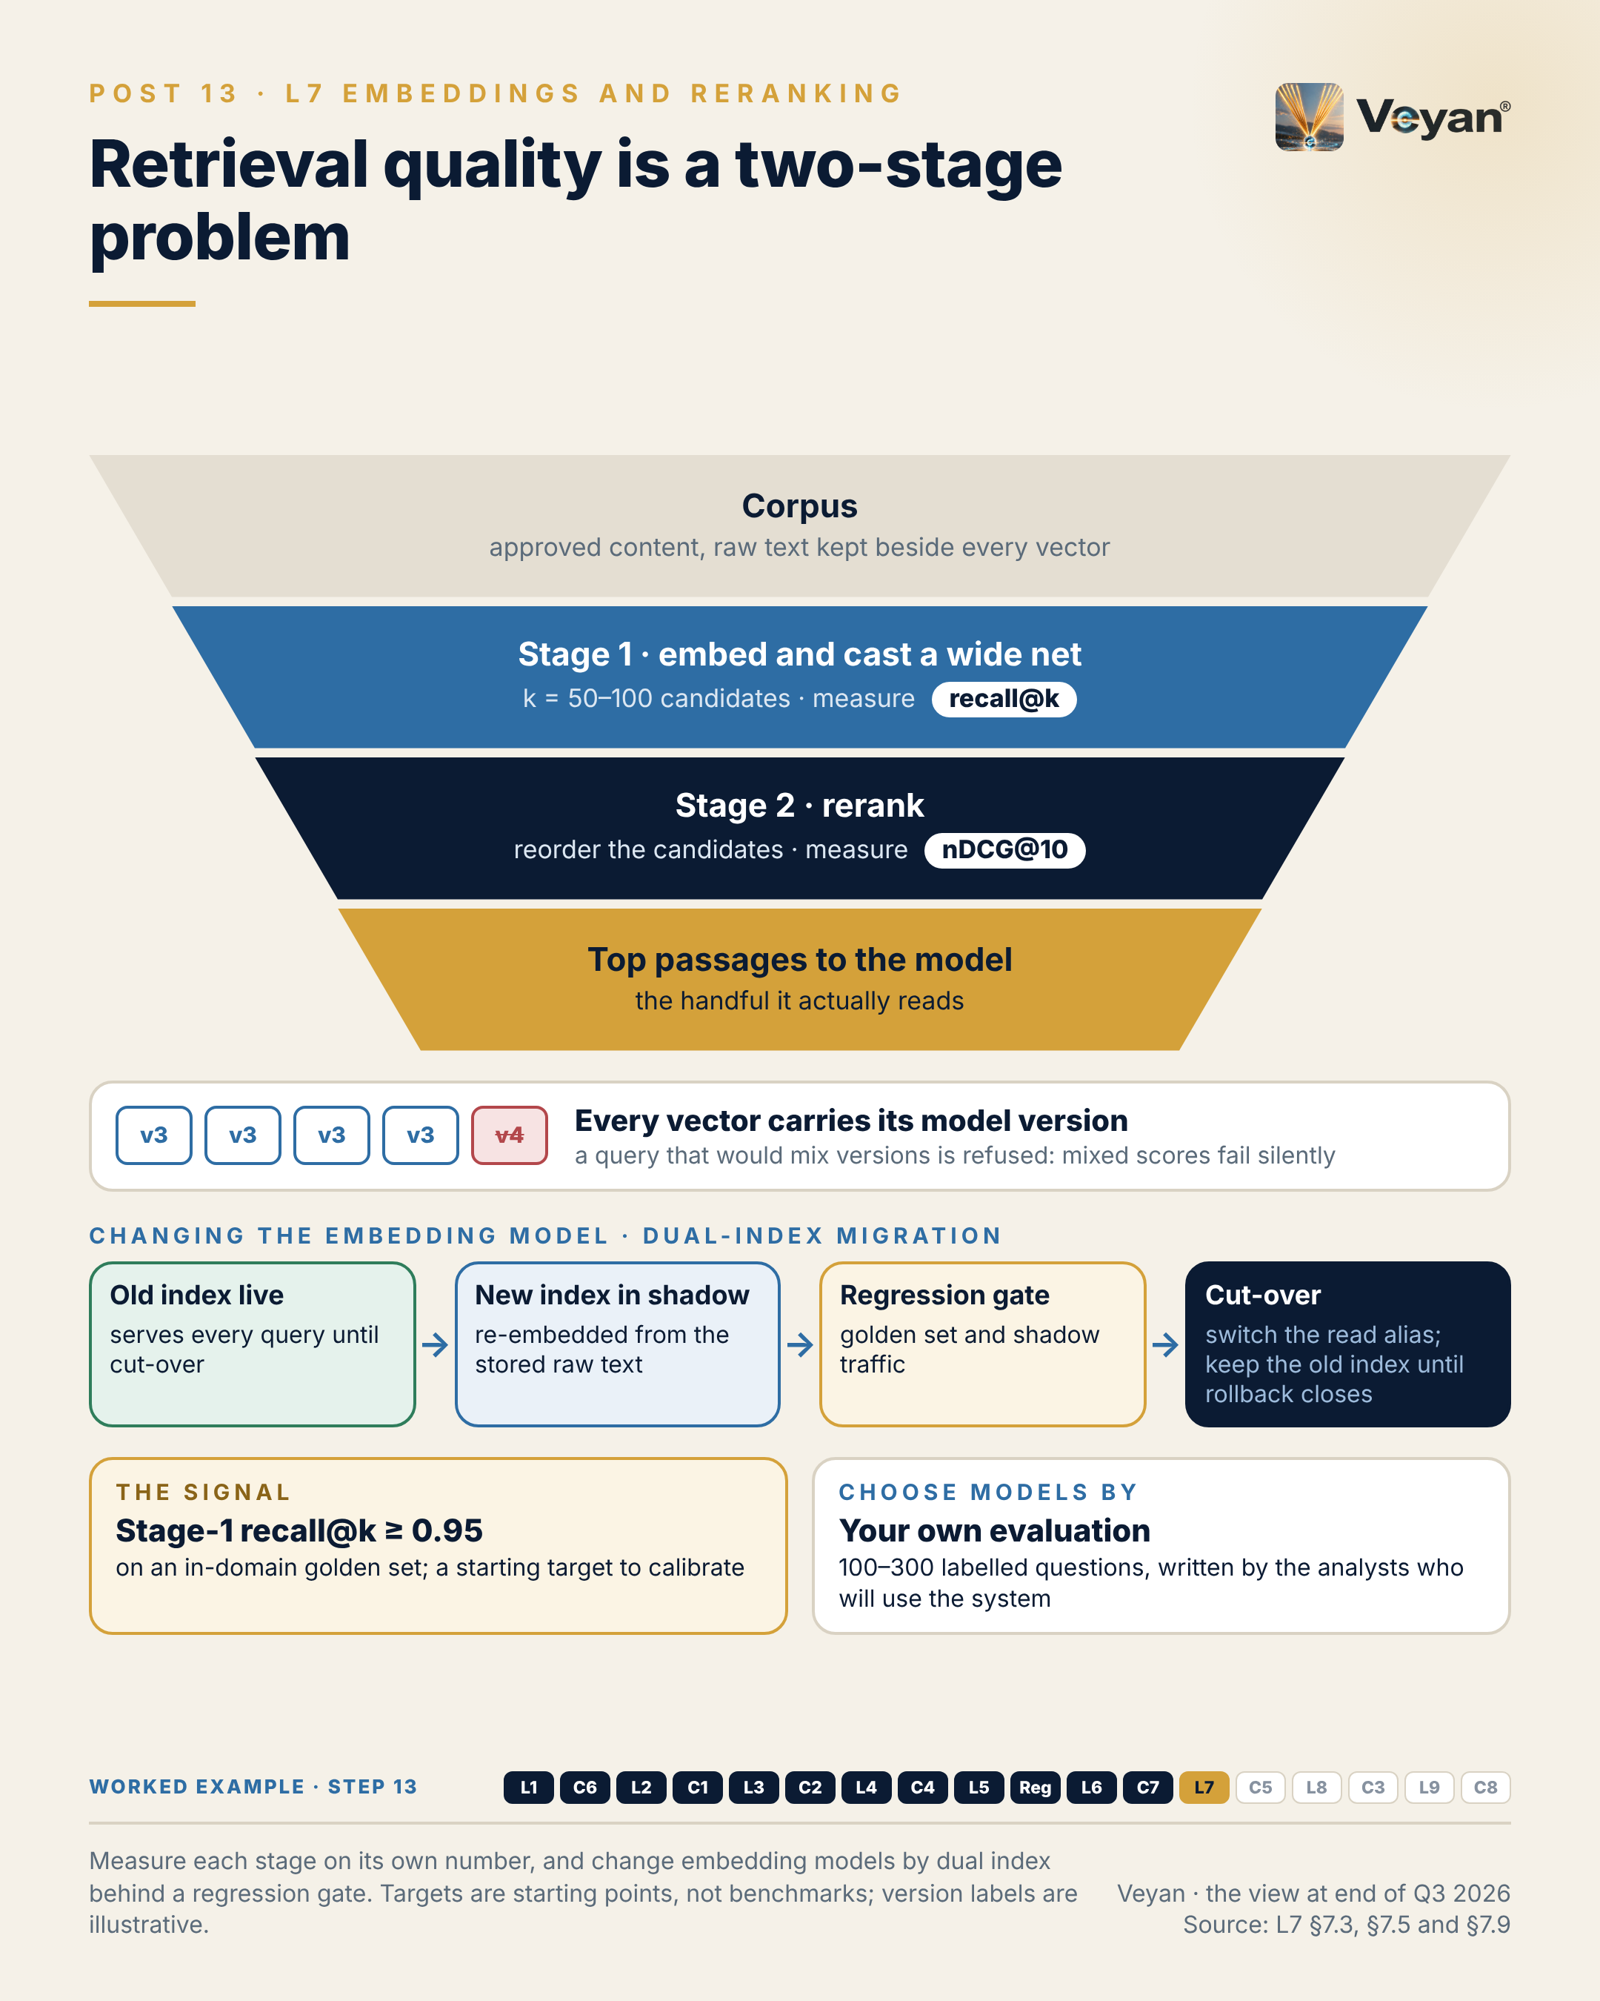
Visual: 08_Graphic/linkedin/P13.png (1080 × 1350, LinkedIn portrait); editable source P13.md, also as .html and .pdf.

First comment
Personal views. Sources: the Enterprise GenAI Stack review, L7 Embeddings and reranking (§7.2, §7.3 KPIs, §7.9, §7.12, §7.13). - Every model vendor in this layer except OpenAI offers both an embedding model and a reranker; Google’s reranker is a separate Vertex ranking API [A2-S012, A2-S010, A2-S006, A2-S034, A2-S025, A2-S020, B-REV-S026]. - Ownership: Voyage AI is part of MongoDB (17 February 2025) [A2-S033, V1-S023]; Jina AI is part of Elastic (9 October 2025) [A2-S023, V1-S025]. - Options assessed: OpenAI text-embedding-3, Gemini Embedding 2, Voyage 4, Cohere Embed 5 and Rerank 4, Qwen3 Embedding and Reranker, Jina v5, Sentence Transformers, NVIDIA NeMo Retriever. - Targets (0.95 recall@k; 100–300 labelled queries for a bake-off) are the review’s starting points, not industry benchmarks. - Worked example, step 13 (retrieval quality). Adds: Two-stage retrieval of comparable past commentary (embed and rerank), with both model versions pinned and tagged on every vector. Now: The draft follows the fund’s own style and comparable months. Never: A mixed-version index is refused; migration runs as a shadow index behind a regression gate.

Hashtags
#InformationRetrieval #RAG

Re-verify before posting
- “Every vendor except OpenAI offers both” (check for a new OpenAI reranker)
- Current model versions if any are named in replies

Compliance check
- Personal views: yes
- Targets labelled as starting points: yes
- Vendors only in the first comment: yes

Post 14 · Week 7 · C5 Prompt and configuration management
Pair: Post 13 (L7, Week 7). Bridge: If the embedding version is production configuration, so is the prompt, and both need versioning, review and rollback.
Theme and source: Git as the system of record for prompts and configuration. work/stageB/C5/section.md (executive summary, §C5.2, §C5.3, §C5.9, §C5.11–§C5.13).
Tension: Embedding versions and prompts are both production configuration, so they need versioning, review and rollback.

Full post
A one-sentence edit to a prompt can change outputs as much as a model upgrade. Few organisations would let a model upgrade ship without review. Many let prompts change in a web console.
Prompt registries are sold on exactly that convenience: update the text, no deployment needed. That is useful while iterating. On a regulated output, it means one person can write, approve and release a change that nobody can later trace.
The previous post argued that the embedding model version is production configuration. So is the prompt. So are the model version, the retrieval settings, the tool list and the guardrail policy. Each can change what a client reads; each needs versioning, review, an evaluation gate and a way back.
The pattern I would defend is plain. Source control is the system of record. Every approved prompt and setting goes into one pinned release manifest, approved by pull request with a second reviewer and gated by the regression suite. A registry may deliver approved versions at run time and stamp each trace with the version that produced it, but only the release pipeline moves the production label.
The signal is rollback time: from the decision to revert to the previous approved version serving all traffic. Minutes, not a release cycle. Drill it twice a year.
The leadership move is to decide which configuration changes are material, and therefore trigger re-validation, before the first one happens.
[Anecdote slot: one or two sentences on a small, unreviewed change that had an outsized effect, and the change-control habit that came out of it.]
If a change can alter what a client reads, it deserves the same discipline as code.

Short variant
A one-sentence prompt edit can change outputs as much as a model upgrade. Few firms would ship a model upgrade unreviewed. Many let prompts change in a web console.
Registries sell that convenience: no deployment needed. Useful while iterating; on a regulated output, it means one person can write, approve and release an untraceable change.
The prompt is production configuration. So are the model version, retrieval settings, tool list and guardrail policy.
The pattern: source control as the system of record, one pinned release manifest, a pull request with a second reviewer, and the regression suite as the gate. Only the release pipeline moves the production label.
The signal is rollback time: minutes, not a release cycle, drilled twice a year.
If a change can alter what a client reads, it deserves the same discipline as code.

Anecdote slot
- Where: the bracketed line before the closing paragraph.
- Prompt: a configuration, parameter or wording change, made quickly and with good intent, that had an effect nobody expected. What habit or control came out of it: a second reviewer, a manifest, a rollback drill? Own your part; credit whoever designed the fix.
- Fits: release-engineering and change-management experience from any platform.
- Avoid: the specific system, the client impact, or anything that reads as an incident report.

Fallback version
A one-sentence edit to a prompt can change outputs as much as a model upgrade. Few organisations would let a model upgrade ship without review. Many let prompts change in a web console.
Prompt registries are sold on exactly that convenience: update the text, no deployment needed. That is useful while iterating. On a regulated output, it means one person can write, approve and release a change that nobody can later trace.
The embedding model version is production configuration. So is the prompt. So are the model version, the retrieval settings, the tool list and the guardrail policy. Each can change what a client reads; each needs versioning, review, an evaluation gate and a way back.
The pattern worth defending is plain. Source control is the system of record. Every approved prompt and setting goes into one pinned release manifest, approved by pull request with a second reviewer and gated by the regression suite. A registry may deliver approved versions at run time and stamp each trace with the version that produced it, but only the release pipeline moves the production label.
The signal is rollback time: from the decision to revert to the previous approved version serving all traffic. Minutes, not a release cycle. Drill it twice a year.
The leadership move is to decide which configuration changes are material, and therefore trigger re-validation, before the first one happens.
The honest caveat: this adds friction to prompt iteration, and teams will feel it. The answer is a fast path for experiments on separate keys, not a weaker path to production.
If a change can alter what a client reads, it deserves the same discipline as code.

Suggested visual
A “release manifest” card for the worked example (illustrative values): prompt set version, drafting model pinned to a dated version, fallback model, embedding and reranker versions, top-k, read-only tool list, guardrail policy version, eval threshold set. Arrows show pull request → second approver → eval gate → tagged release → registry label → trace stamped with version. Source: C5 §C5.12.
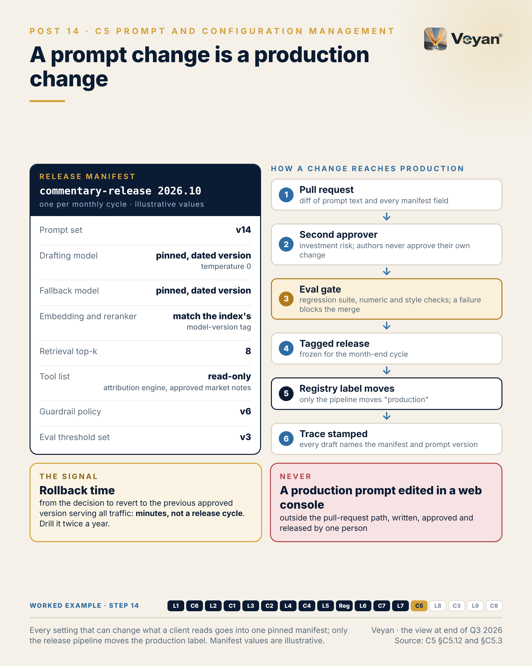
Visual: 08_Graphic/linkedin/P14.png (1080 × 1350, LinkedIn portrait); editable source P14.md, also as .html and .pdf.

First comment
Personal views. Sources: the Enterprise GenAI Stack review, C5 Prompt and configuration management (§C5.2, §C5.3 KPIs, §C5.9, §C5.11 on segregation of duties and Article 25, §C5.12). - Registries assessed: Langfuse and LangSmith prompt management (inside their L9 platforms) [A7-S071, A7-S076]; LaunchDarkly AI Configs, renamed AgentControl in 2026 [A7-S117, V2-S045]; PromptLayer [A7-S004]. Prompts-as-code formats: Prompty and Dotprompt [A7-S067, A7-S066]. - Ownership: ClickHouse announced its acquisition of Langfuse (16 January 2026) [A7-S075, V2-S041]; OpenAI announced its acquisition of Promptfoo (9 March 2026) [V2-S042]. - Under EU AI Act Article 25, changing a system’s intended purpose so that it becomes high-risk can make a deployer a provider; a system prompt is the easiest place to do that [R-EUAIA: A8-S011]. - Worked example, step 14 (configuration). Adds: A release manifest per monthly cycle (prompt set, model pins, retrieval settings, tool list, guard policy, eval thresholds), approved by pull request with a second approver and gated by the eval suite. Now: Every setting that can change what a client reads is versioned and reversible. Never: No production prompt is ever edited in a console.

Hashtags
#LLMOps #ChangeManagement

Re-verify before posting
- LaunchDarkly product name (AgentControl)
- Langfuse and Promptfoo ownership status

Compliance check
- Personal views: yes
- Release-manifest values illustrative and generic: yes
- Vendors only in the first comment: yes

Week 8

Post 15 · Week 8 · L8 Data extraction and ingestion
Pair: Post 16 (C3, Week 8). Bridge: The stack post shows that quality is decided at ingestion; the control post shows that residency and privacy are decided there too.
Theme and source: Ingestion as a control plane around commodity parsers. work/stageB/L8/section.md (executive summary, §8.2, §8.3, §8.9, §8.11–§8.13).
Tension: Some of the most convincing “hallucinations” in enterprise retrieval start in a PDF table parser, not in the model.

Full post
Some of the most convincing “hallucinations” in enterprise retrieval systems are not the model’s fault. They start in a table parser.
A merged header cell shifts a column one place to the left. Parsing succeeds, chunks are indexed, retrieval works, and the model faithfully repeats a figure that was never the figure it claimed to be. Nothing fails, so nobody looks.
Ingestion is usually drawn as a shelf of parsers. The parsers are close to commodity now; the value is in the envelope around them. Every chunk should carry its source, version, access permissions, classification, the parser and version that produced it, and a lineage run ID. No envelope, no index. Of the ten ingestion products assessed in this review, only one carried access-control metadata into the pipeline, and none emitted lineage. The envelope is something you build.
The signal I would watch is table cell exact-match against a golden set of your own documents: value, sign, unit, row and column. A starting target is 99.5%, and 100% for any table that feeds a published number, re-run on every parser or model change.
The leadership move is a boundary. Numbers parsed from documents are context, never the authority. Authoritative figures come from the system of record through a tool, and the evaluation checks the draft against that, not against parsed text.
[Anecdote slot: one or two sentences on a data problem that looked like a downstream failure but started at ingestion, and who traced it back.]
If retrieved answers look wrong, look upstream first. The model is often just the messenger.

Short variant
Some of the most convincing “hallucinations” in enterprise retrieval are not the model’s fault. They start in a table parser.
A merged header cell shifts a column. Parsing succeeds, retrieval works, and the model repeats the wrong figure fluently. Nothing fails, so nobody looks.
The parsers are close to commodity. The value is the envelope around them: every chunk carries its source, version, permissions, classification, parser version and lineage ID. No envelope, no index. Few products provide it, so it is yours to build.
The signal: table cell exact-match against a golden set of your own documents, re-run on every parser change, with 100% for any table that feeds a published number.
And one boundary: parsed numbers are context, never the authority. Authoritative figures come from the system of record.
If retrieved answers look wrong, look upstream first.

Anecdote slot
- Where: the bracketed line before the closing paragraph.
- Prompt: a problem that presented as a reporting, analytics or model error but whose root cause was upstream: a file format change, a parser or feed upgrade, a mapping that drifted. Who found the real cause? Credit them. What did you change so the next one would be caught at the source?
- Fits: data-infrastructure or platform-modernisation experience; it need not involve AI.
- Avoid: naming internal feeds, vendors or affected funds.

Fallback version
Some of the most convincing “hallucinations” in enterprise retrieval systems are not the model’s fault. They start in a table parser.
A merged header cell shifts a column one place to the left. Parsing succeeds, chunks are indexed, retrieval works, and the model faithfully repeats a figure that was never the figure it claimed to be. Nothing fails, so nobody looks.
Ingestion is usually drawn as a shelf of parsers. The parsers are close to commodity now; the value is in the envelope around them. Every chunk should carry its source, version, access permissions, classification, the parser and version that produced it, and a lineage run ID. No envelope, no index. Of the ten ingestion products assessed in this review, only one carried access-control metadata into the pipeline, and none emitted lineage. The envelope is something you build.
The signal worth watching is table cell exact-match against a golden set of your own documents: value, sign, unit, row and column. A starting target is 99.5%, and 100% for any table that feeds a published number, re-run on every parser or model change.
The leadership move is a boundary. Numbers parsed from documents are context, never the authority. Authoritative figures come from the system of record through a tool, and the evaluation checks the draft against that, not against parsed text.
The honest caveat: dual parsing and reconciliation cost compute and engineering time, and every parser upgrade becomes a tested change. That is the price of being able to say which documents a defect touched.
If retrieved answers look wrong, look upstream first. The model is often just the messenger.

Suggested visual
Pipeline diagram: source register → acquisition → classification/DLP → parser (drawn as a swappable cartridge) → “metadata envelope” stamped on each chunk (source, version, ACL, classification, parser manifest, lineage ID) → index gate (“no envelope, no index”). A red side-path shows “parsed numbers = context only”; a green path shows “authoritative figures via read-only tool”. Source: L8 §8.9 and the six-component control plane in §8.13.
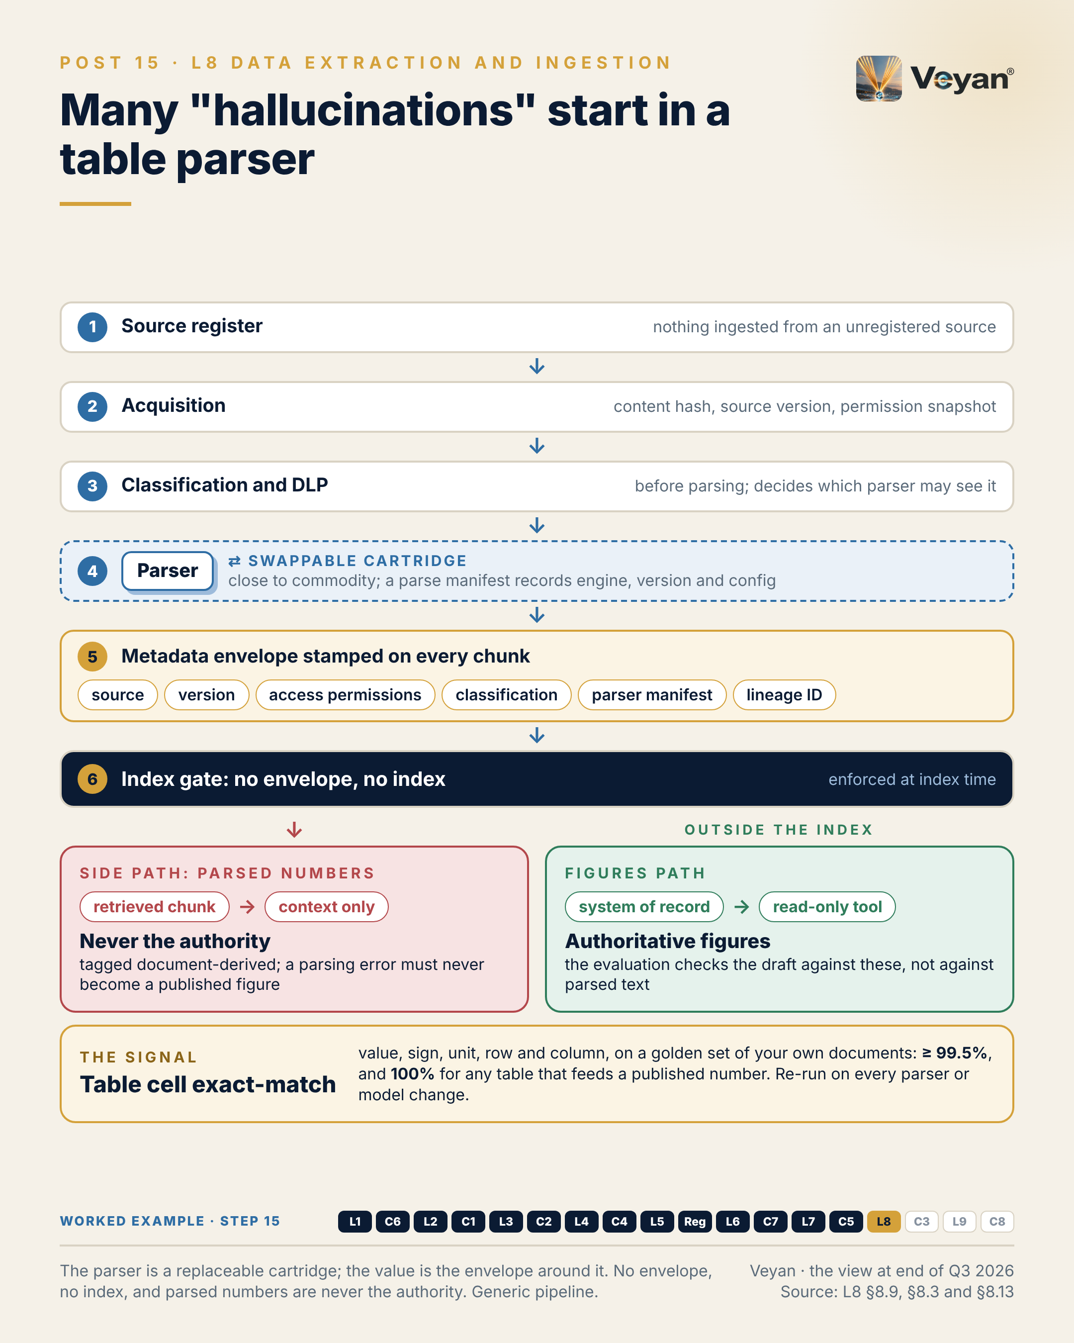
Visual: 08_Graphic/linkedin/P15.png (1080 × 1350, LinkedIn portrait); editable source P15.md, also as .html and .pdf.

First comment
Personal views. Sources: the Enterprise GenAI Stack review, L8 Data extraction, ingestion and web (§8.2, §8.3 KPIs, §8.12 worked example, §8.13). - Only Unstructured’s open-source connectors carry access-control metadata into the pipeline; no L8 product emits lineage [A1-S094, A1-S096]. OpenLineage has no GenAI-specific facets [A7-S042]. - Market moves: Docling graduated within LF AI & Data in August 2026 [V1-S091]; Mistral OCR 4.0 retired on 30 September 2026 [A1-S130, V1-S014]; LlamaParse now names LlamaIndex’s whole document platform [A1-S080]; Firecrawl’s server is AGPL-3.0 [A1-S053]. - Products assessed: Docling, Unstructured, LlamaParse, Reducto, Mistral OCR, Google Document AI, MinerU, Firecrawl, Crawl4AI, Apify. - ESMA’s expectation of “ex-ante input controls” [R-INTL-AI-ASSETMGMT: A8-S059] is where ingestion sits in a regulated firm. - Worked example, step 15 (ingestion). Adds: Three corpora ingested under a control envelope: dual-parsed factsheet tables reconciled to the engine, prior commentaries with their permissions, and market notes from the approved register only. Now: Every chunk carries its source, version, permissions, classification and lineage. Never: No envelope, no index; parsed numbers are context only, never figures.

Hashtags
#RAG #DataQuality

Re-verify before posting
- “Ten products assessed; only one carries ACL metadata; none emits lineage” (check for new lineage features)
- Mistral OCR and Docling version status if mentioned in replies

Compliance check
- Personal views; no reference to any firm’s document estate: yes
- 99.5% and 100% are review targets, not firm metrics: yes
- Worked example generic: yes
- Vendors only in the first comment: yes

Post 16 · Week 8 · C3 DLP and PII protection
Pair: Post 15 (L8, Week 8). Bridge: If quality is decided at ingestion, so are residency and privacy; a filter at the prompt arrives too late.
Theme and source: One firm-owned privacy service called from every enforcement point. work/stageB/C3/section.md (executive summary, §C3.2, §C3.3, §C3.9, §C3.11–§C3.13).
Tension: Data residency and PII decisions are made at ingestion, not at the prompt.

Full post
One analyst question can place the same client identifier in seven places: a prompt, a retrieved chunk, a tool result, a provider’s processing region, a trace store, an evaluation dataset and a memory record.
Each copy has its own retention, location and access model. Each is somewhere an erasure request or a breach investigation has to reach.
The common trap is a single checkpoint: a filter at the prompt. By then the document may already have been parsed by a third party and indexed without its classification, and no prompt-level control can undo that. The previous post argued that ingestion is where data quality is decided. It is also where residency and privacy are decided.
The pattern that holds up is one firm-owned privacy service — detect, transform and, under policy, re-identify — called from every enforcement point: ingestion, prompts, tool results, outputs, memory writes and trace export. One policy, six call sites, rather than a different detector bought for each layer.
The signal is detection recall per entity class, measured on a labelled test set of your own identifiers: client codes, account numbers, mandate references. Report it per class, not averaged. An average hides the identifier that matters.
The leadership move is to fund tokenisation, not blunt redaction. “[REDACTED] outperformed [REDACTED]” gets the control switched off. Consistent placeholders let the model write a useful draft without ever seeing who the client is.
[Anecdote slot: one or two sentences on a time a privacy or data-handling control was bypassed because it got in the way, and what made the fixed version usable.]
Privacy controls fail quietly when they sit in one place. They hold when data cannot move without passing them.

Short variant
One analyst question can place the same client identifier in seven places: prompt, retrieved chunk, tool result, provider region, trace store, evaluation set and memory.
Each copy is somewhere an erasure request or breach investigation must reach. A filter at the prompt arrives too late: by then the document may already be parsed and indexed without its classification.
The pattern that holds up is one firm-owned privacy service, called at six points: ingestion, prompts, tool results, outputs, memory writes and trace export. One policy, not a detector per layer.
The signal is detection recall per entity class, on your own identifiers, reported per class rather than averaged.
And fund tokenisation over blunt redaction. “[REDACTED] outperformed [REDACTED]” gets a control switched off. Placeholders let the model draft without seeing the client.
Privacy holds when data cannot move without passing it.

Anecdote slot
- Where: the bracketed line before the closing paragraph.
- Prompt: a control (privacy, security, approval) that users routed around because it damaged their work, and what changed when it was redesigned to keep the work useful. Own the original design call if it was yours; credit whoever proposed the better one.
- Fits: “making invisible prevention work visible” and operating-model themes.
- Avoid: describing any actual data incident, client or regulator interaction.

Fallback version
One analyst question can place the same client identifier in seven places: a prompt, a retrieved chunk, a tool result, a provider’s processing region, a trace store, an evaluation dataset and a memory record.
Each copy has its own retention, location and access model. Each is somewhere an erasure request or a breach investigation has to reach.
The common trap is a single checkpoint: a filter at the prompt. By then the document may already have been parsed by a third party and indexed without its classification, and no prompt-level control can undo that. Ingestion is where data quality is decided. It is also where residency and privacy are decided.
The pattern that holds up is one firm-owned privacy service — detect, transform and, under policy, re-identify — called from every enforcement point: ingestion, prompts, tool results, outputs, memory writes and trace export. One policy, six call sites, rather than a different detector bought for each layer.
The signal is detection recall per entity class, measured on a labelled test set of your own identifiers: client codes, account numbers, mandate references. Report it per class, not averaged. An average hides the identifier that matters.
The leadership move is to fund tokenisation, not blunt redaction. “[REDACTED] outperformed [REDACTED]” gets the control switched off. Consistent placeholders let the model write a useful draft without ever seeing who the client is.
The honest caveat: detectors miss things, and the leading open-source one says so in its own documentation. Design for a second-pass scan and a residual-leakage measure, not a perfect first pass.
Privacy controls fail quietly when they sit in one place. They hold when data cannot move without passing them.

Suggested visual
“Seven copies” diagram: one client identifier at the centre with arrows to seven stores (prompt, chunk, tool result, provider region, trace store, eval set, memory). Overlay six numbered enforcement points (E1 ingestion to E6 trace export) all calling one “privacy service” box. Inset: a draft showing CLIENT_A / MANDATE_1 placeholders instead of names. Source: C3 §C3.2, §C3.9 step 0, §C3.12.
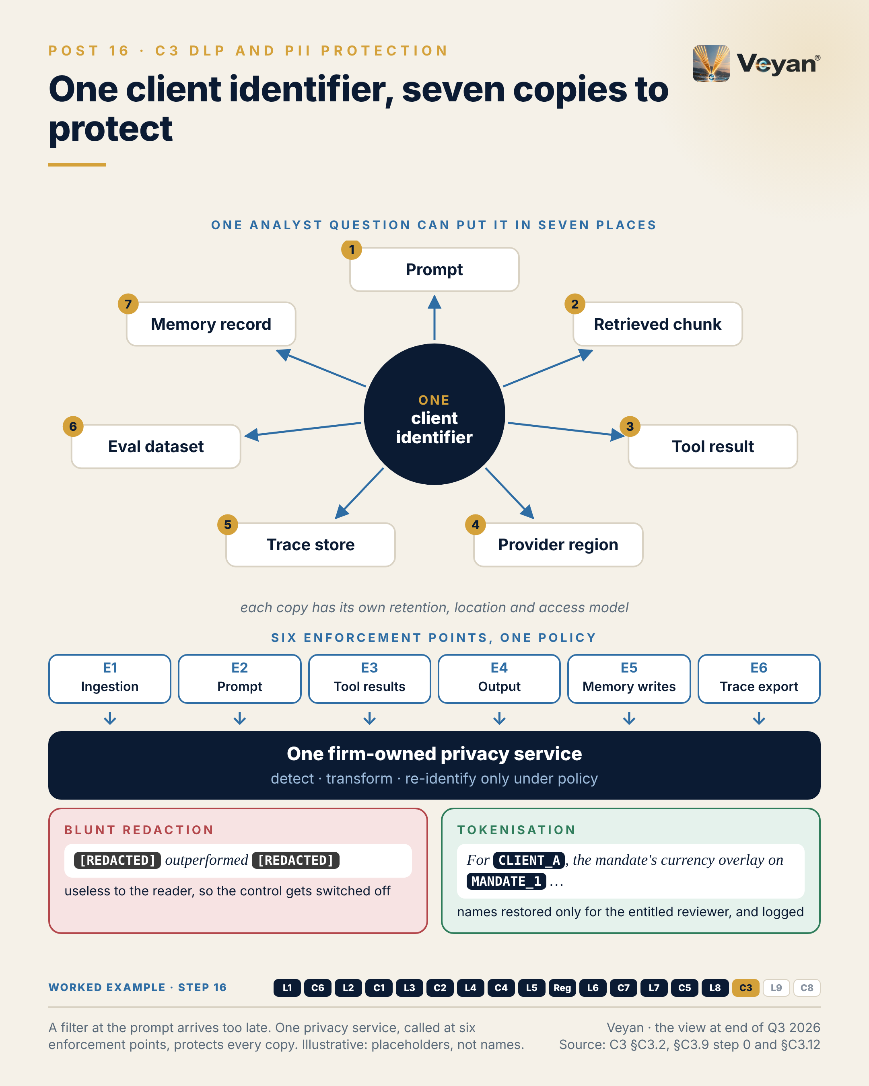
Visual: 08_Graphic/linkedin/P16.png (1080 × 1350, LinkedIn portrait); editable source P16.md, also as .html and .pdf.

First comment
Personal views. Sources: the Enterprise GenAI Stack review, C3 DLP and PII protection (§C3.2, §C3.3 KPIs, §C3.9, §C3.12). - Presidio is now community-governed under the Data Privacy Stack organisation, MIT-licensed [A6-S040, V2-S030]; its README warns detection is not guaranteed to find all sensitive data [A6-S068]. - Microsoft folded DSPM for AI into unified Purview DSPM (GA May 2026) [A6-S090, A6-S091]; Google Sensitive Data Protection underpins Model Armor’s screening [A6-S066, A6-S067]; Protegrity AI Team Edition is Tech Preview [A6-S093]; Skyflow offers an LLM Privacy Vault with EU vaults [A6-S095]. DLP also appears inside Cloudflare AI Gateway, Kong AI Gateway, Bedrock Guardrails and Model Armor [A6-S052, A6-S016, A6-S072, A6-S067]. - Processing location is now a priced contract item at least at one first-party model API (Anthropic’s US-only inference option) [A8-S036]; other providers’ equivalents are covered in the L1 and L2 chapters. - EU–US transfers: the Data Privacy Framework appeal C-703/25 P is pending [R-DATA-TRANSFERS: A8-S053]. - Worked example, step 16 (privacy). Adds: One privacy service called at six points: client names and mandates tokenised before any model call, detected again in output, re-identified only for the reviewing manager. Now: The model writes about ‘the mandate’ without ever seeing whose it is. Never: A clear-text identifier not in the approved inputs blocks the draft.

Hashtags
#DataProtection #PrivacyEngineering

Re-verify before posting
- Status of the DPF appeal C-703/25 P
- Presidio governance and licence
- Purview DSPM licensing statement

Compliance check
- Personal views; no real incident described: yes
- Placeholder example is generic: yes
- Vendors only in the first comment, listed evenly (including Anthropic): yes

Week 9

Post 17 · Week 9 · L9 Evaluation and observability
Pair: Post 18 (C8, Week 9). Bridge: The stack post argues that evaluation must exist from day one; the control post shows that the same eval suite, run independently and kept, is the validation evidence a model-risk function needs.
Theme and source: Evaluation and observability as a cross-cutting plane, not a downstream box. work/stageB/L9/section.md (executive summary, §9.2, §9.3, §9.9, §9.11–§9.13).
Tension: The layer that ages slowest is the one most teams build last, and evals added after go-live measure the damage, not the quality.

Full post
Most diagrams of the AI stack put evaluation in the last box. It is the layer that ages slowest — and the one most teams build last.
That ordering is the trap. Evals added after go-live measure the damage, not the quality. When a drafted figure turns out to be wrong, the question becomes which outputs were affected, and nobody can answer it if the prompt version was never recorded and the traces expired on a vendor’s free tier.
Over the next three months I will walk through the enterprise GenAI stack one layer at a time, each paired with the control that makes it safe in production. I am starting here deliberately.
Evaluation and observability are not a box at the end. They are a plane across the whole stack. Instrument once, on an open telemetry standard, and keep the evaluation harness and the evidence store in your own hands. The products on top are replaceable: five of the eleven assessed in this space now belong to, or are being bought by, larger platform vendors.
The one signal I would start with is numeric faithfulness: the share of figures in a generated draft that match the authoritative source under an agreed rounding rule. The target is 100%, and any miss blocks the release. A language-model judge does not get a vote on numbers.
The leadership move is sequencing. Fund the eval suite before the first feature, and run it on every change of model, prompt or index.
[Anecdote slot: one or two sentences on a quality problem that surfaced late because nobody was measuring it, and what you or the team changed afterwards.]
Diagrams keep changing. What you measured, and can still prove, is what lasts.

Short variant
Most diagrams of the AI stack put evaluation in the last box. It is the layer that ages slowest, and the one most teams build last.
Evals added after go-live measure the damage, not the quality. When a drafted figure turns out to be wrong, the real question is which outputs were affected. Without recorded prompt versions and retained traces, nobody can answer it.
Treat evaluation as a plane across the stack, not a downstream box. Instrument once, on an open standard. Own the eval harness and the evidence store; the tools on top are replaceable.
The signal I would start with is numeric faithfulness: every figure in a draft matches the authoritative source, or the release is blocked.
Fund the eval suite before the first feature. Diagrams keep changing. What you measured, and can still prove, is what lasts.

Anecdote slot
- Where: the bracketed line before the closing paragraph (the “honest part”).
- Prompt: a time a quality or data problem was found late, by a user, an auditor or a reviewer, because measurement was added after launch. What did it cost to reconstruct what had happened? What did you change: an earlier test, a retained record, a release gate? Own the decision you would make differently, or credit the person who pushed for measurement first.
- Fits: a delivery or platform story from any era, not necessarily AI. A reporting, data-quality or release-testing lesson works well.
- Avoid: internal system names, real defect counts, client impact details.

Fallback version
Most diagrams of the AI stack put evaluation in the last box. It is the layer that ages slowest — and the one most teams build last.
That ordering is the trap. Evals added after go-live measure the damage, not the quality. When a drafted figure turns out to be wrong, the question becomes which outputs were affected, and nobody can answer it if the prompt version was never recorded and the traces expired on a vendor’s free tier.
This series walks the enterprise GenAI stack in layer order, one layer a week, each paired with the control that makes it safe in production. Evaluation is last in the numbering and first in the build order.
Evaluation and observability are not a box at the end. They are a plane across the whole stack. Instrument once, on an open telemetry standard, and keep the evaluation harness and the evidence store in your own hands. The products on top are replaceable: five of the eleven assessed in this space now belong to, or are being bought by, larger platform vendors.
The one signal worth starting with is numeric faithfulness: the share of figures in a generated draft that match the authoritative source under an agreed rounding rule. The target is 100%, and any miss blocks the release. A language-model judge does not get a vote on numbers.
The leadership move is sequencing. Fund the eval suite before the first feature, and run it on every change of model, prompt or index.
The honest caveat: the shared telemetry conventions for GenAI are still marked as in development. That is an argument for owning the harness, not for waiting.
Diagrams keep changing. What you measured, and can still prove, is what lasts.

Suggested visual
Two-panel diagram. Left: the popular nine-layer stack diagram with “Evals and observability” as the last box. Right: the same stack with evaluation and observability redrawn as a vertical plane running alongside every layer, labelled “firm-owned telemetry and evidence spine”, with products drawn as replaceable plug-ins. A small callout shows the one metric: “Numeric faithfulness: 100%, any miss blocks.” Source: L9 §9.13 and the H8 provisional view.
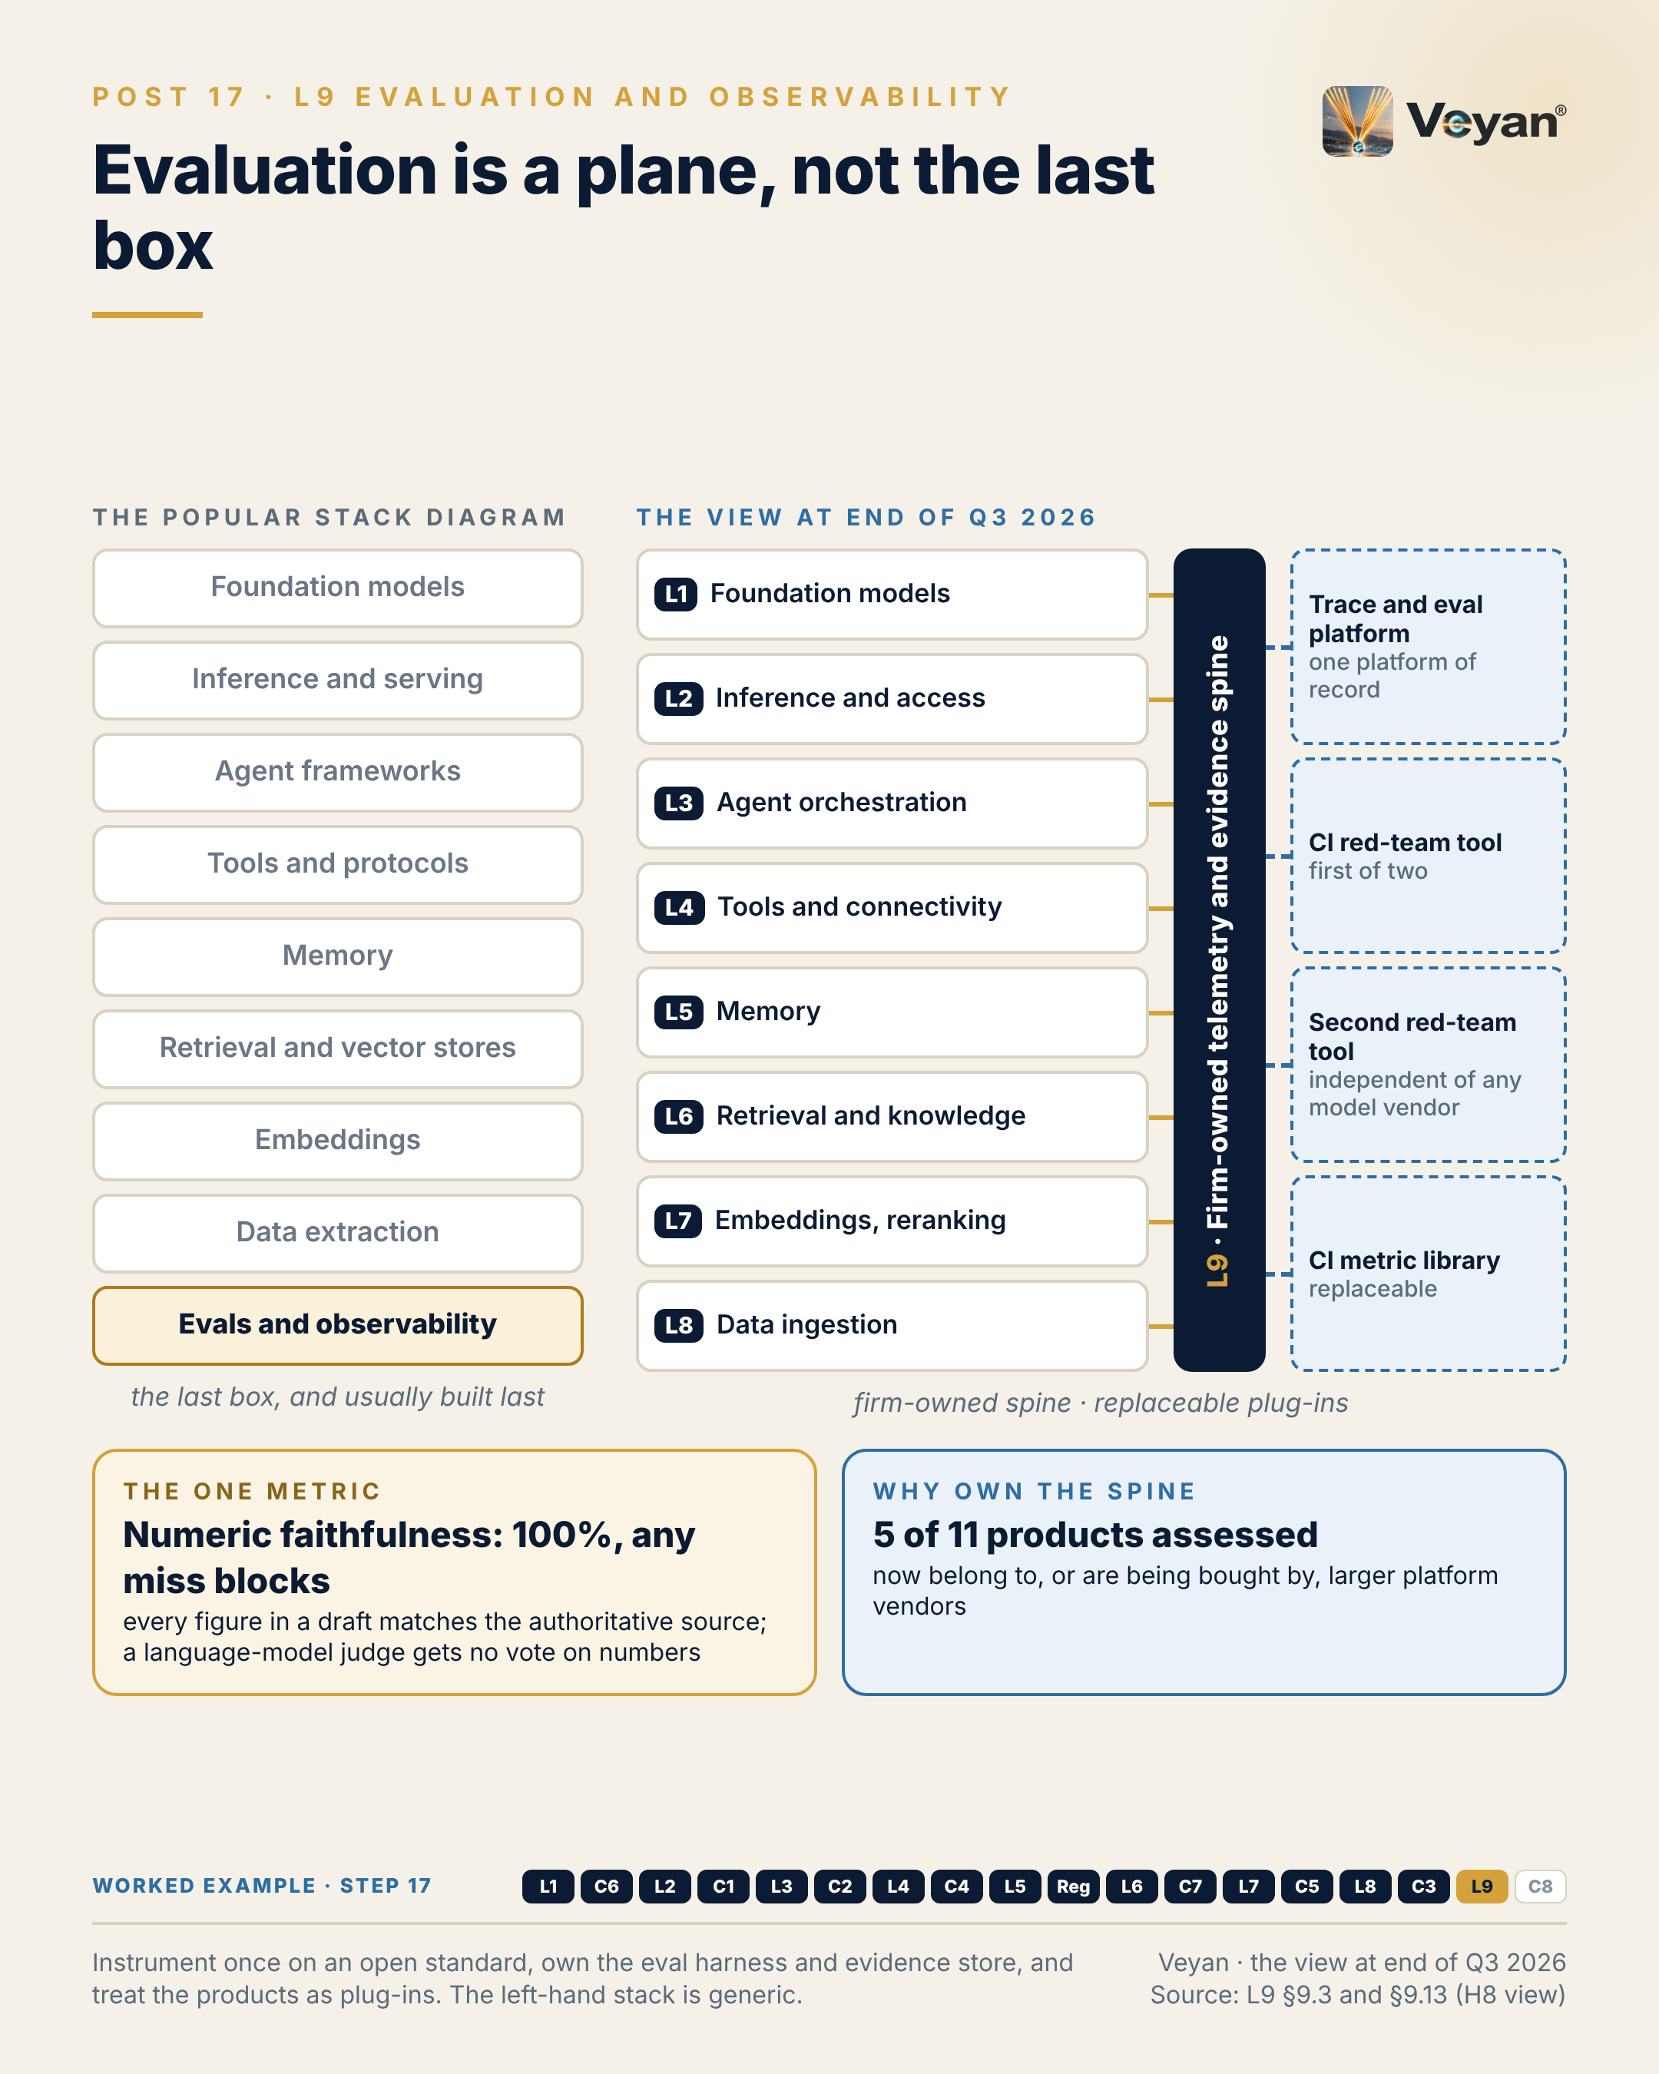
Visual: 08_Graphic/linkedin/P17.png (1080 × 1350, LinkedIn portrait); editable source P17.md, also as .html and .pdf.

First comment
Personal views. Notes and sources for this post: the Enterprise GenAI Stack review, L9 Evaluation and observability (executive summary, §9.3 KPIs, §9.9 decision tree, §9.13). - Ownership changes behind “five of the eleven”: Dynatrace completed its acquisition of Arize (Phoenix and AX) on 1 October 2026 [A1-S045, V1-S005]; ClickHouse announced its acquisition of Langfuse on 16 January 2026 [A1-S021, V2-S041]; OpenAI announced its acquisition of Promptfoo on 9 March 2026, with no closing date published [A1-S024, V1-S006]; W&B Weave has been part of CoreWeave since 5 May 2025 [A1-S131]. - OpenTelemetry GenAI semantic conventions are at “Development” status [A1-S058]. - Products assessed in this layer: Langfuse, LangSmith, MLflow, Braintrust, Arize Phoenix and AX, DeepEval, Promptfoo, Opik, Datadog Agent Observability, W&B Weave. The pattern matters more than the pick: one platform of record, plus two CI red-team tools, one of them independent of any model vendor. - Optional disclosure line: “I used an AI drafting assistant (Anthropic’s Claude) to help structure this series; the views and the edits are mine.” - Worked example, step 17 (evaluation). Adds: The evaluation plane: numeric faithfulness (blocking), groundedness, style, trajectory, and a regression suite of 24 to 36 months of approved commentaries, all on one firm-owned telemetry spine. Now: Every change of model, prompt, index or judge is tested before it reaches a client. Never: Any numeric miss blocks; no human is asked to catch what code can check.

Hashtags
#AIEvaluation #LLMOps

Re-verify before posting
- Arize/Dynatrace completion and the Langfuse/ClickHouse status
- Whether OpenAI’s Promptfoo acquisition has closed
- OpenTelemetry GenAI conventions still at “Development”
- The “five of the eleven” count, against the final L9 table

Compliance check
- Personal views, no employer reference: yes
- No internal systems or metrics; the 100% target is a review KPI, not a firm figure: yes
- Worked example generic: yes
- Vendors named only in the first comment, with ownership facts stated neutrally: yes

Post 18 · Week 9 · C8 Model risk, governance and audit
Pair: Post 17 (L9, Week 9). Bridge: The stack post’s eval suite becomes the control post’s validation evidence, but only if someone independent challenges it, it is versioned, and it is retained.
Theme and source: Model-risk governance for LLM systems after SR 26-2’s carve-out. work/stageB/C8/section.md (executive summary, §C8.2, §C8.3, §C8.9, §C8.11–§C8.13).
Tension: Your eval suite is your validation evidence. What model-risk discipline means when the “model” is an agent and the main US guidance has stepped aside.

Full post
In April, the US supervisory guidance that had shaped model risk management since 2011 was replaced. Its successor, SR 26-2, places generative and agentic AI expressly outside its scope.
It is tempting to read that as relief. It is the opposite. The governance burden has not gone; it has moved to the firm. Each firm now has to write its own standard for LLM systems, and the UK’s SS1/23, which is technology-agnostic and covers vendor models, is the most complete benchmark to write it against.
Here is what makes it tractable. Much of the validation evidence already exists if the evaluation work in the previous post is done properly. The eval suite is the validation evidence, on three conditions: someone independent of the developers challenges and extends it; it is versioned with the results it produced; and it is kept beyond any vendor’s retention tier. A developer’s test suite on its own is development testing, not validation.
The signal I would put in front of a risk committee is validation currency: the share of material use cases whose validation covers the model, prompt, index and tool versions running today. Below 100% means an approval that no longer describes production.
The leadership move is choosing the governed unit. Not the model — the use case, with the foundation model recorded as a vendor component and every version pinned. That one decision makes the inventory, re-validation triggers and audit evidence line up.
[Anecdote slot: one or two sentences on an audit or validation request that exposed a gap between what was approved and what was running, and who closed it.]
Regulation will catch up. The evidence you keep in the meantime is what it will ask for.

Short variant
In April, the US guidance that had shaped model risk management since 2011 was replaced. Its successor, SR 26-2, places generative and agentic AI outside its scope.
That is not relief. The burden has moved to the firm, which now writes its own standard. The UK’s SS1/23 is the most complete benchmark to write it against.
Much of the evidence already exists. The eval suite is the validation evidence, if someone independent challenges it, it is versioned with its results, and it outlives any vendor’s retention tier.
The signal for a risk committee is validation currency: the share of material use cases whose validation covers the versions actually running. Anything below 100% is an approval that no longer describes production.
Govern the use case, not the model. Regulation will catch up; the evidence you keep meanwhile is what it will ask for.

Anecdote slot
- Where: the bracketed line before the closing paragraph.
- Prompt: an audit, validation or regulatory request where the approved artefact and the running system had drifted apart: a different version, a missing record, an approval by email. Who noticed, and who did the work to close it? Credit them by role. If the drift happened on your watch, say what you changed in the operating model rather than in the tooling.
- Fits: the “audit outcomes as a symptom of operating-model design” theme. Any technology domain works.
- Avoid: audit ratings, finding counts, regulator names linked to your firm.

Fallback version
In April, the US supervisory guidance that had shaped model risk management since 2011 was replaced. Its successor, SR 26-2, places generative and agentic AI expressly outside its scope.
It is tempting to read that as relief. It is the opposite. The governance burden has not gone; it has moved to the firm. Each firm now has to write its own standard for LLM systems, and the UK’s SS1/23, which is technology-agnostic and covers vendor models, is the most complete benchmark to write it against.
Here is what makes it tractable. Much of the validation evidence already exists if the evaluation work is done properly. The eval suite is the validation evidence, on three conditions: someone independent of the developers challenges and extends it; it is versioned with the results it produced; and it is kept beyond any vendor’s retention tier. A developer’s test suite on its own is development testing, not validation.
The signal worth putting in front of a risk committee is validation currency: the share of material use cases whose validation covers the model, prompt, index and tool versions running today. Below 100% means an approval that no longer describes production.
The leadership move is choosing the governed unit. Not the model — the use case, with the foundation model recorded as a vendor component and every version pinned. That one decision makes the inventory, re-validation triggers and audit evidence line up.
The honest caveat: on public evidence, no governance platform yet does this end to end. The inventory schema and the evidence store are things a firm owns, whatever it buys.
Regulation will catch up. The evidence you keep in the meantime is what it will ask for.

Suggested visual
One-page “evidence pack” graphic for the worked example: eight tiles (prompt version, model version, data snapshot, tool calls, eval results, approver identity, timestamps, final output), all keyed to one trace ID and feeding an immutable archive. A side panel shows “governed unit = use case” with the model as a vendor component. Source: C8 §C8.12.
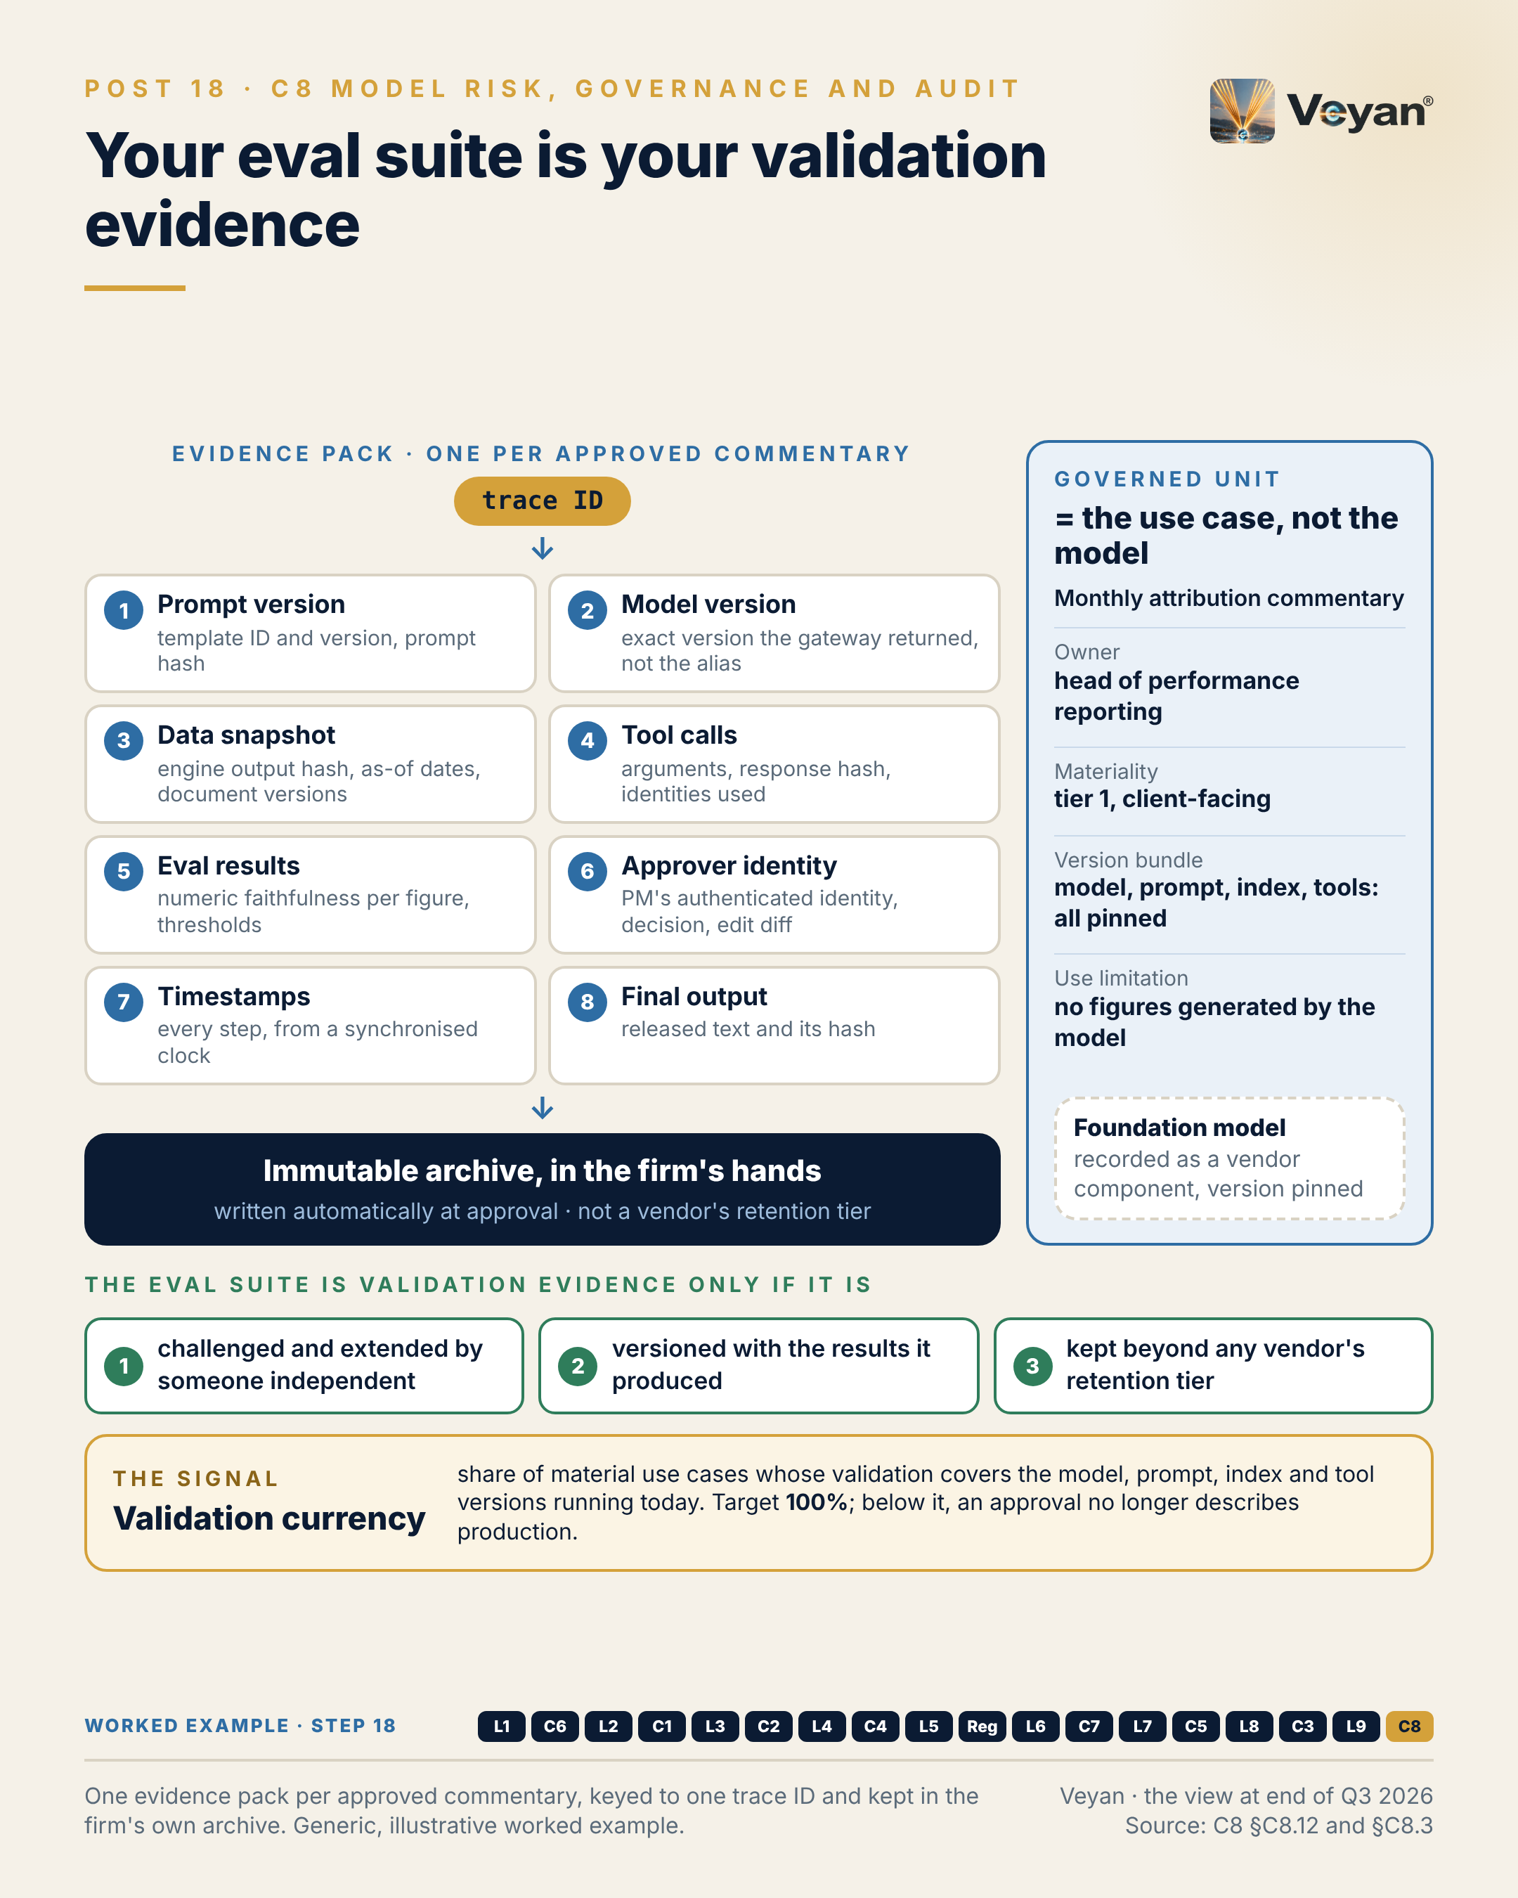
Visual: 08_Graphic/linkedin/P18.png (1080 × 1350, LinkedIn portrait); editable source P18.md, also as .html and .pdf.

First comment
Personal views. Sources: the Enterprise GenAI Stack review, C8 Model risk, governance and auditability (§C8.3 KPIs, §C8.11 regulated FS lens, §C8.12 worked example). - SR 26-2 / OCC Bulletin 2026-13 / FDIC FIL-15-2026, issued 17 April 2026, supersede SR 11-7 and exclude generative and agentic AI [R-US-MRM: A8-S001, A8-S002, V2-S049]. The agencies’ planned AI request for information had not been published as of 7 October 2026 [A8-S003, A8-S007]. - PRA SS1/23: technology-agnostic, covers vendor models, five principles [R-PRA-SS123: A8-S008, A8-S061]. - Governance workflow tools assessed (none reaches Strategic on public evidence): ValidMind, IBM watsonx.governance, Credo AI, Collibra AI Governance (trail ML acquisition announced 5 October 2026), ModelOp. OpenLineage is the recommended lineage standard. - Worked example, step 18 (governance). Adds: The inventory entry for the use case and an evidence pack per approved commentary, keyed by one trace ID, written to an immutable archive. Now: Any approved commentary can be explained and re-performed on request. Never: The governed unit is the use case; the model is a vendor component inside it.

Hashtags
#ModelRisk #AIGovernance

Re-verify before posting
- SR 26-2 status, and whether the agencies’ AI/GenAI request for information has been published (update the post if it has)
- SS1/23 scope statements
- Collibra–trail ML completion

Compliance check
- Personal views; no statement about any firm’s MRM framework: yes
- No internal audit details: yes (anecdote prompt warns against them)
- Worked example generic: yes
- Vendors named only in the first comment, evenly: yes

Week 10

Post 19 · Week 10 · The worked example, end to end
Pair: Post 20 (Start small, Week 10). Bridge: The stack post shows the full worked example and its “never” list; the control post shows the minimum platform needed to run it, and what to leave out.
Theme and source: The performance-attribution commentary agent, end to end, with its boundaries and evidence pack. work/stageC/synthesis.md Part VI (VI.1 request trace, VI.3 boundaries, VI.4 evidence pack).
Tension: What the attribution-commentary agent must never do matters more than what it can do.

Full post
For nine weeks one example has run underneath this series: an agent that drafts the monthly performance-attribution commentary for a multi-asset fund, with a portfolio manager approving every draft. It is generic and illustrative. Here it is in one place.
What it may do is short. Draft narrative around figures it is given. Explain allocation, selection and currency effects in the house style. Cite approved market context. Propose wording, and propose new style rules for a person to approve.
What it must never do is longer, and matters more. Never generate, round or “correct” a number. Never treat a figure from retrieved text, memory or a parsed document as data. Never present inference as source. Never publish without a recorded human approval. Never call a write, email or web tool. Never send client identifiers outside the approved route. Never run on an unpinned model.
The useful discipline is that every “never” names the component that enforces it. Read-only tools and a deterministic numeric check stop invented figures. A workflow with no outbound tool stops exfiltration. An approval step that only a named person can release stops unreviewed publication. A “never” without an enforcing component is a hope written into a policy.
The signal is evidence-pack completeness: the share of approved commentaries with a complete record of prompt version, model version, data snapshot, tool calls, evaluation results, approver, timestamps and final text. The target is 100%.
The leadership move is to write the “never” list first, and let it shape the design.
[Anecdote slot: one or two sentences on a time defining what a system must not do clarified the whole design, and who insisted on it.]
Capability is what a system can do. Trust comes from what it provably cannot.

Short variant
One example has run under this series: an agent drafting the monthly attribution commentary for a multi-asset fund, with a portfolio manager approving every draft.
What it may do is short: draft narrative around figures it is given, explain the effects in house style, cite approved context, propose wording.
What it must never do matters more. Never generate or “correct” a number. Never treat retrieved or remembered figures as data. Never publish without recorded approval. Never call a write, email or web tool. Never run on an unpinned model.
Each “never” names the component that enforces it. Without one, it is a hope written into a policy.
The signal is evidence-pack completeness: every approved commentary with its full record. Target 100%.
Write the “never” list first. Trust comes from what a system provably cannot do.

Anecdote slot
- Where: the bracketed line before the closing paragraph.
- Prompt: a project where agreeing the boundaries (“this system will never…”) early made the design simpler or the approval faster: a risk partner, a control owner or an engineer who pushed for it. Credit them by role. Own it if the boundaries came late and cost rework.
- Fits: agentic transformation in a regulated environment; “developing leaders through delivery”.
- Avoid: suggesting that this agent exists at your firm. It is a generic illustration.

Fallback version
For nine weeks one example has run underneath this series: an agent that drafts the monthly performance-attribution commentary for a multi-asset fund, with a portfolio manager approving every draft. It is generic and illustrative. Here it is in one place.
What it may do is short. Draft narrative around figures it is given. Explain allocation, selection and currency effects in the house style. Cite approved market context. Propose wording, and propose new style rules for a person to approve.
What it must never do is longer, and matters more. Never generate, round or “correct” a number. Never treat a figure from retrieved text, memory or a parsed document as data. Never present inference as source. Never publish without a recorded human approval. Never call a write, email or web tool. Never send client identifiers outside the approved route. Never run on an unpinned model.
The useful discipline is that every “never” names the component that enforces it. Read-only tools and a deterministic numeric check stop invented figures. A workflow with no outbound tool stops exfiltration. An approval step that only a named person can release stops unreviewed publication. A “never” without an enforcing component is a hope written into a policy.
The signal is evidence-pack completeness: the share of approved commentaries with a complete record of prompt version, model version, data snapshot, tool calls, evaluation results, approver, timestamps and final text. The target is 100%.
The leadership move is to write the “never” list first, and let it shape the design.
The honest caveat: this design gives up flexibility on purpose. Each new capability should arrive with its own enforcing control, not a broader prompt.
Capability is what a system can do. Trust comes from what it provably cannot.

Suggested visual
Two-column “may / must never” table for the worked example. Each “never” row has its enforcing component in a coloured chip (read-only tool, numeric comparator, approval interrupt, allow-list, tokenisation, entitlement filter, version pin). Beneath it, the eight-tile evidence pack keyed to one trace ID. Source: synthesis VI.3 and VI.4. Label: “generic, illustrative”.
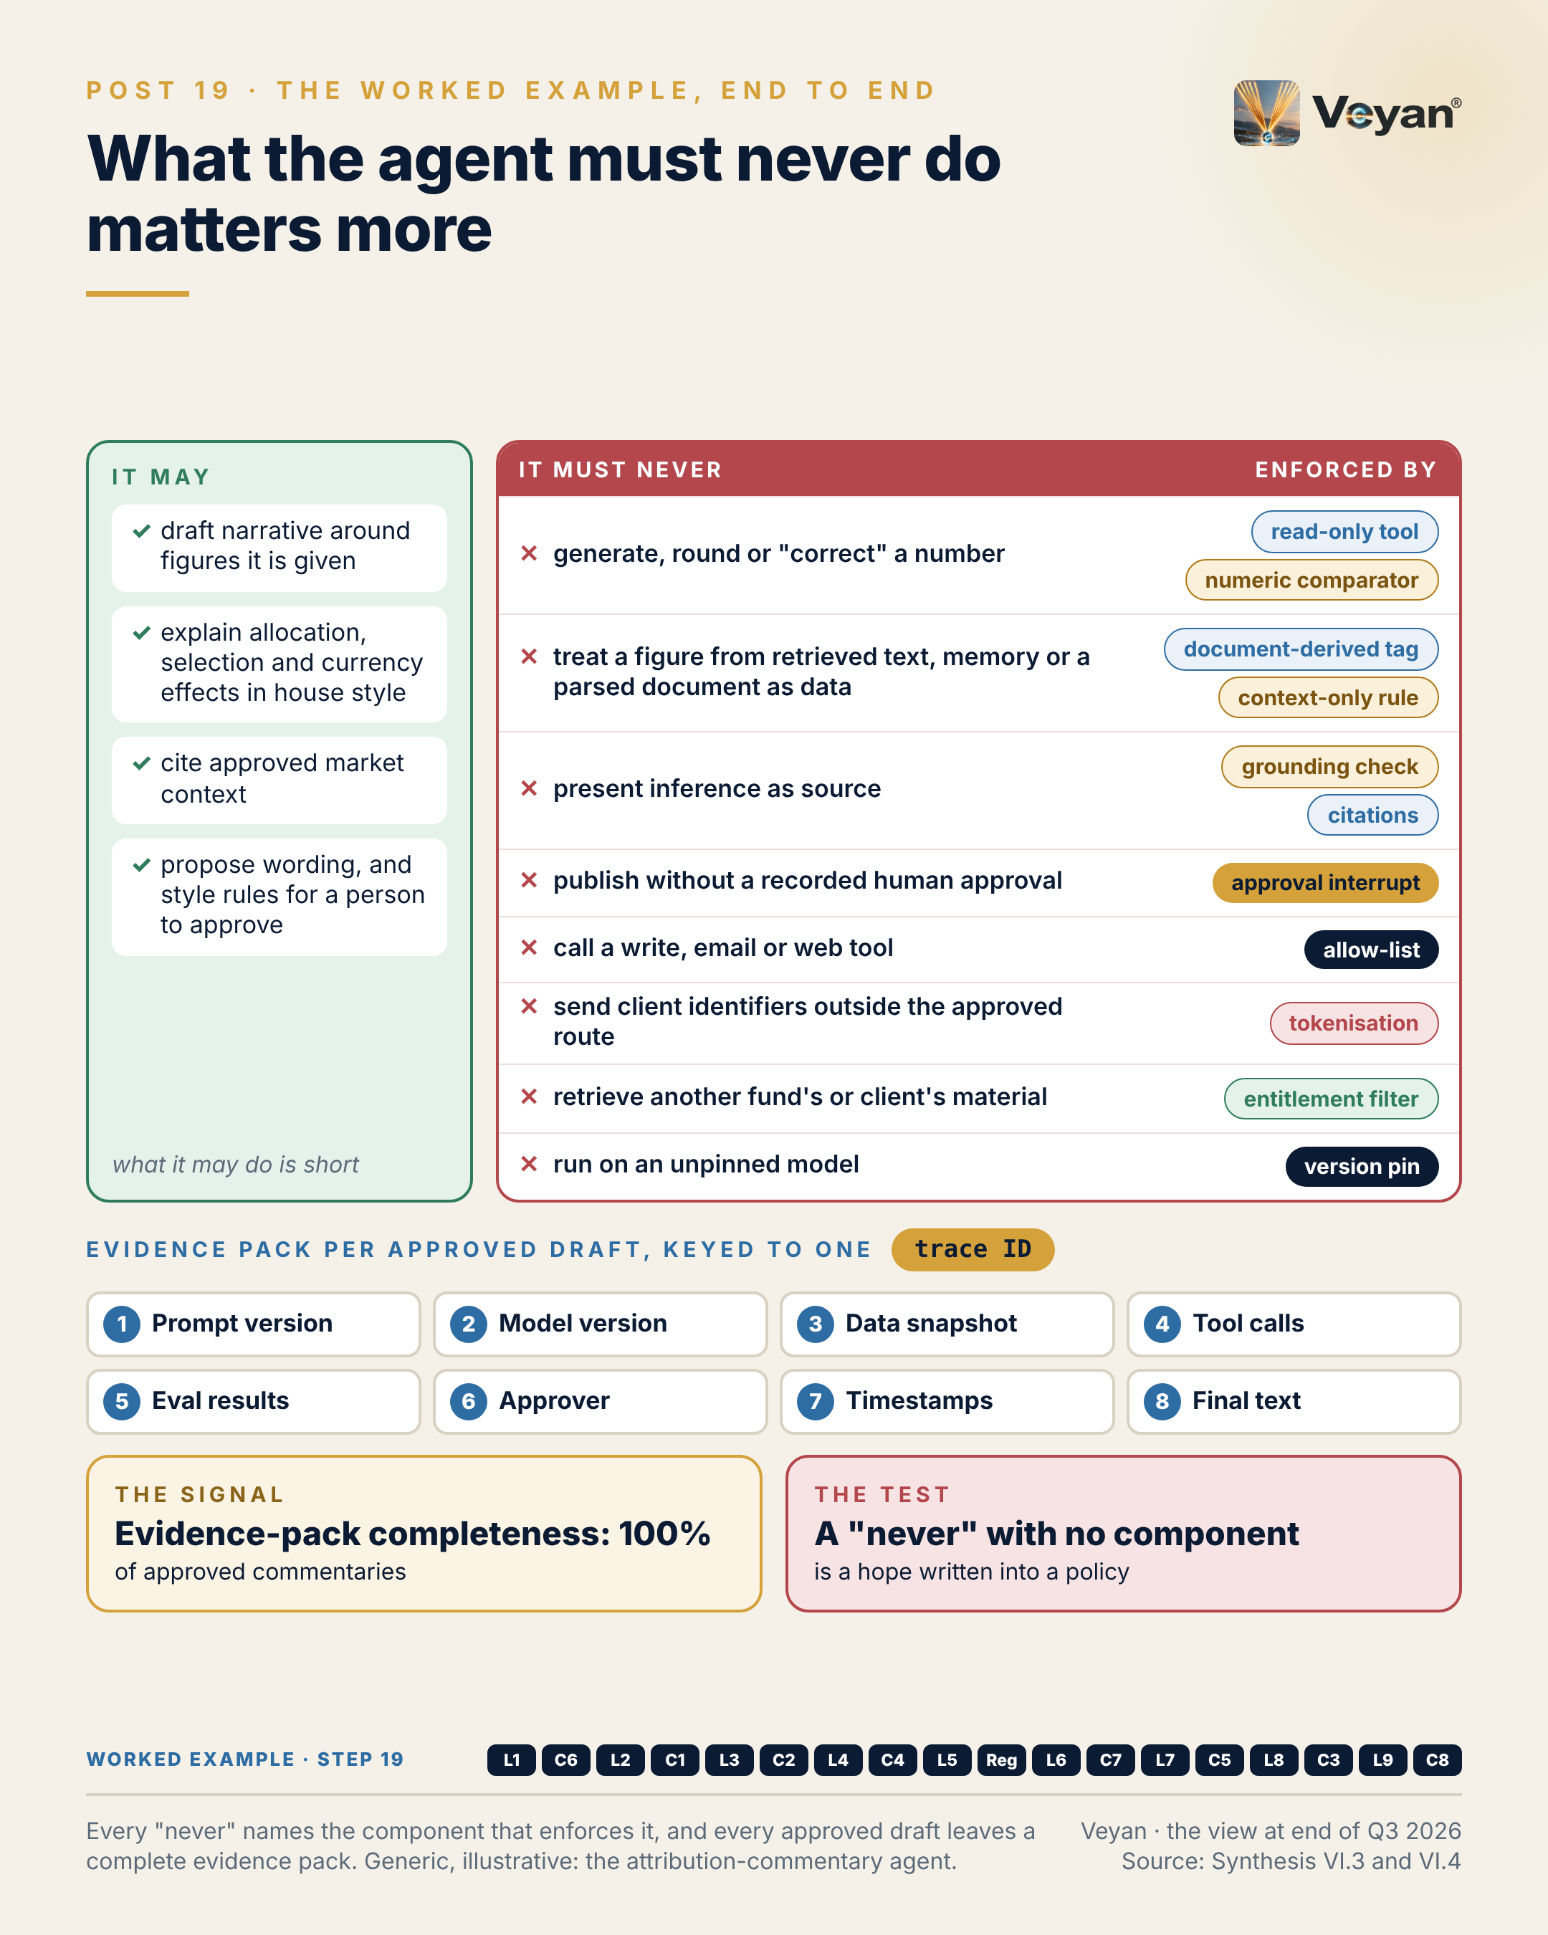
Visual: 08_Graphic/linkedin/P19.png (1080 × 1350, LinkedIn portrait); editable source P19.md, also as .html and .pdf.

First comment
Personal views. The worked example is generic and illustrative, not a description of any firm’s platform. Sources: the Enterprise GenAI Stack review, synthesis Part VI (VI.1 request trace, VI.3 boundaries with enforcing components, VI.4 evidence pack), and C8 §C8.12. - The design is cloud-neutral, with AWS, Azure and Google Cloud equivalents shown side by side (CP4-6). Examples by layer: Docling and pgvector for retrieval; LangGraph with a Postgres checkpointer, or Strands on AgentCore, Microsoft Agent Framework or Google ADK, for the workflow; LiteLLM, Kong, APIM or Apigee for the gateway; a two-vendor model portfolio on the primary cloud’s model service (Claude, GPT-6.1, Gemini or Mistral, with an independent alternative named wherever Claude appears; conflict of interest noted). - The use case is not an EU AI Act Annex III use; Article 50 is assessed and human editorial review applies (synthesis VI.4). - Worked example, step 19 (assembled). Adds: All eighteen pieces assembled into one request trace, with a ‘may / must never’ list in which every ‘never’ names the component that enforces it. Now: The design is complete end to end on paper. Never: Every ‘must never’ has an enforcing component, not a policy sentence.

Hashtags
#AgenticAI #AIGovernance

Re-verify before posting
- No product or regulatory facts in the body. Check that the first comment’s per-cloud examples match the final document.

Compliance check
- Personal views; worked example explicitly generic and illustrative: yes
- No internal systems or metrics: yes
- Vendors only in the first comment, with the conflict of interest noted: yes

Post 20 · Week 10 · Start small
Pair: Post 19 (Worked example, Week 10). Bridge: The stack post’s agent needs a platform; the control post argues that the minimum platform, plus a published “not yet” list, is the right first release.
Theme and source: Stack D, minimal start-small, and its “do NOT build yet” list. work/stageC/synthesis.md Part VII, Stack D (with the Stack A build-now and not-yet lists).
Tension: The most valuable part of a reference architecture is the “do not build yet” list.

Full post
The most valuable page in a reference architecture is often the “do not build yet” list.
Reference architectures tend to be read as shopping lists. Every box looks like a work package, and a programme that funds them all spends its first year building platform that nobody is using yet.
The minimum I would start with is not a weaker stack. It is the full regulated design with everything the first use case does not need removed. One gateway, deployed twice, with one route and a budget that fails closed. An agent identity acting on the analyst’s behalf with read-only scope. A configuration manifest in source control with a second approver. Deterministic output checks and identifier protection. The evaluation suite. One retrieval store you already run. One workflow with one approval step. Two model vendors qualified from day one, because exit must be real.
Then the list of what waits: long-term memory, autonomous agents, agent-to-agent delegation, web search, code sandboxes, a dedicated vector database, a second cloud, fine-tuning, a governance platform, a FinOps product, semantic caching, and anything still experimental.
The signal is gateway coverage: the share of production model calls that pass through the gateway. The target is 100%; any provider key found in application code is a defect. Without it there is no exit and no log of record.
The leadership move is to publish the “not yet” list with the same authority as the plan, and to revisit it only when evidence shows a real gap.
[Anecdote slot: one or two sentences on a time a deliberately small first release made the second one faster, and who held the line.]
Saying “not yet” clearly is how a platform earns the right to say yes later.

Short variant
The most valuable page in a reference architecture is often the “do not build yet” list.
Read as a shopping list, an architecture becomes a year of platform building with no user.
Start with the full regulated design, minus everything the first use case does not need: one gateway deployed twice, an agent identity with read-only scope, a configuration manifest with a second approver, deterministic output checks, the evaluation suite, one existing store, one workflow with one approval step, and two qualified model vendors.
Then publish what waits: memory, autonomous agents, web search, a dedicated vector database, a second cloud, fine-tuning, extra platforms.
The signal is gateway coverage: 100% of production model calls through the gateway.
Saying “not yet” clearly is how a platform earns the right to say yes later.

Anecdote slot
- Where: the bracketed line before the closing paragraph.
- Prompt: a programme where scope was deliberately cut to a minimum first release, and the reuse that followed proved the call. Or the opposite: an over-scoped platform that took too long to reach its first user, and what you would cut now. Credit whoever held the line on scope.
- Fits: platform modernisation; making invisible prevention work visible (the controls are the deliverable).
- Avoid: programme names, budgets or timelines.

Fallback version
The most valuable page in a reference architecture is often the “do not build yet” list.
Reference architectures tend to be read as shopping lists. Every box looks like a work package, and a programme that funds them all spends its first year building platform that nobody is using yet.
The right minimum is not a weaker stack. It is the full regulated design with everything the first use case does not need removed. One gateway, deployed twice, with one route and a budget that fails closed. An agent identity acting on the analyst’s behalf with read-only scope. A configuration manifest in source control with a second approver. Deterministic output checks and identifier protection. The evaluation suite. One retrieval store already in use. One workflow with one approval step. Two model vendors qualified from day one, because exit must be real.
Then the list of what waits: long-term memory, autonomous agents, agent-to-agent delegation, web search, code sandboxes, a dedicated vector database, a second cloud, fine-tuning, a governance platform, a FinOps product, semantic caching, and anything still experimental.
The signal is gateway coverage: the share of production model calls that pass through the gateway. The target is 100%; any provider key found in application code is a defect. Without it there is no exit and no log of record.
The leadership move is to publish the “not yet” list with the same authority as the plan, and to revisit it only when evidence shows a real gap.
The honest caveat: a small first release can look unambitious. Present the controls as the deliverable, because every later use case reuses them.
Saying “not yet” clearly is how a platform earns the right to say yes later.

Suggested visual
Two panels. Left, “Build now”: the Stack D minimum as a compact stack (gateway ×2, identity, manifest, checks, eval suite, one store, one workflow, two models). Right, “Do NOT build yet”: the not-yet items as greyed-out tiles, each with a one-word trigger for revisiting it (“evidence”, “load test”, “use case”). Source: synthesis Part VII, Stack D.
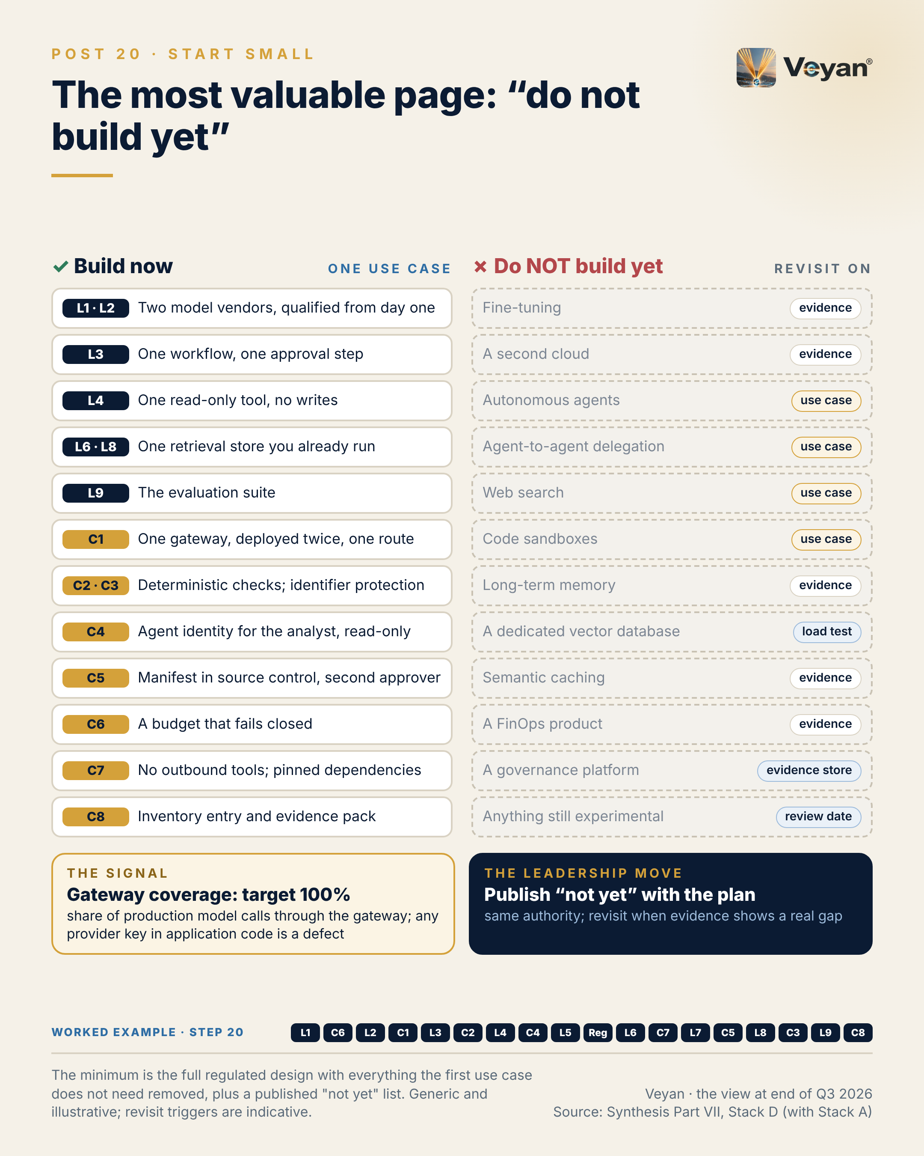
Visual: 08_Graphic/linkedin/P20.png (1080 × 1350, LinkedIn portrait); editable source P20.md, also as .html and .pdf.

First comment
Personal views. Sources: the Enterprise GenAI Stack review, synthesis Part VII, Stack D “Minimal start-small” (build-now table and “Do NOT build yet” list), with Stack A for comparison. - Stack D’s per-cloud equivalents: gateway as LiteLLM self-hosted, AgentCore Gateway (tools), APIM GA AI policies or Apigee; identity as AgentCore Identity, Entra Agent ID, or Okta/Entra; workflow on LangGraph, Strands on AgentCore, Microsoft Agent Framework or ADK; retrieval on pgvector (RDS, Azure Database for PostgreSQL or Cloud SQL); evaluation on Langfuse or MLflow with DeepEval, Promptfoo and one independent red-team tool; models on Bedrock, Foundry or Google Cloud with two vendors qualified. - Stack D’s not-yet list also names MCP beyond the first read-only tool, Agent Skills and a runtime AI-security platform. Agent Skills and MCP originated at Anthropic (conflict of interest noted). - The synthesis names the attribution commentary as a good first candidate “because its boundaries are clear and its numbers are checkable”. - Worked example, step 20 (minimum go-live). Adds: The build order for real: governance and evaluation first, then the gateway, retrieval, the workflow and one read-only tool; memory and everything on the ‘not yet’ list waits for evidence. Now: The agent can go live on the minimum platform. Never: Nothing is built before the evidence says it is needed.

Hashtags
#EnterpriseArchitecture #AgenticAI

Re-verify before posting
- The not-yet list against the final Part VII and the Part XI tiers (anything promoted from Experimental)

Compliance check
- Personal views; no reference to any firm’s programme: yes
- Vendors only in the first comment: yes

Week 11

Post 21 · Week 11 · Build vs buy
Pair: Post 22 (Where not to abstract, Week 11). Bridge: The stack post says to own a thin interface in front of what you buy; the control post warns against owning too many interfaces.
Theme and source: Build, buy or hybrid per component. work/stageC/synthesis.md Part VIII.
Tension: Build where you differentiate, buy where you would only be maintaining.

Full post
Build where you differentiate. Buy where you would only be maintaining.
For an asset manager adopting GenAI, very little of the stack differentiates. Training a foundation model is out of scope. Gateways, parsers, vector search, identity providers and secrets brokers are commodity infrastructure with a heavy security and maintenance burden. Buy them, or adopt open source.
What the firm should build is smaller and more important: whatever is its control statement, its evidence or its domain logic. Route definitions and fallback lists. The guardrail policy and its test sets. The numeric check against the attribution engine, which no vendor sells. The evaluation datasets. The release manifest. The evidence store. Read-only tools onto its own systems. The workflows.
Most of the rest lands in a third column: hybrid, meaning a bought or open-source engine behind a firm-owned interface and policy. That column has grown, because so many “neutral” products have changed owner. When a product may be replaced within the planning horizon, the interface and the data around it must already be yours.
The signal is configuration coverage: the share of production calls whose prompt, model, tool and retrieval settings resolve to an approved version the firm holds. The target is 100% for regulated outputs.
The leadership move is one build, buy or hybrid decision per component, plus one explicit “do not build yet”: fine-tuning, which adds a model to validate and can, in some cases, turn a deployer into a provider under the EU AI Act.
[Anecdote slot: one or two sentences on a build-or-buy call you would make differently today, or one that aged well, and who argued for it.]
Owning the right small things is what makes everything else replaceable.

Short variant
Build where you differentiate. Buy where you would only be maintaining.
For an asset manager, little of the GenAI stack differentiates. Gateways, parsers, vector search, identity and secrets are commodity: buy them, or adopt open source.
Build what is your control statement, evidence or domain logic: route definitions, guardrail policy and test sets, the numeric check no vendor sells, evaluation datasets, the release manifest, the evidence store, read-only tools, the workflows.
Much of the rest is hybrid: a bought engine behind a firm-owned interface. That column grows as “neutral” products change owner.
The signal is configuration coverage: every production call resolving to an approved version the firm holds.
And one explicit “not yet”: fine-tuning.
Owning the right small things makes everything else replaceable.

Anecdote slot
- Where: the bracketed line before the closing paragraph.
- Prompt: a build-or-buy decision from your career: a platform built in-house that became a maintenance burden, or a bought product whose exit was harder than expected because the firm’s own data or configuration lived inside it. Own the call if it was yours; credit the person who argued the other side.
- Fits: platform modernisation and data-infrastructure migration.
- Avoid: naming the vendor or the internal platform.

Fallback version
Build where you differentiate. Buy where you would only be maintaining.
For an asset manager adopting GenAI, very little of the stack differentiates. Training a foundation model is out of scope. Gateways, parsers, vector search, identity providers and secrets brokers are commodity infrastructure with a heavy security and maintenance burden. Buy them, or adopt open source.
What the firm should build is smaller and more important: whatever is its control statement, its evidence or its domain logic. Route definitions and fallback lists. The guardrail policy and its test sets. The numeric check against the attribution engine, which no vendor sells. The evaluation datasets. The release manifest. The evidence store. Read-only tools onto its own systems. The workflows.
Most of the rest lands in a third column: hybrid, meaning a bought or open-source engine behind a firm-owned interface and policy. That column has grown, because so many “neutral” products have changed owner. When a product may be replaced within the planning horizon, the interface and the data around it must already be yours.
The signal is configuration coverage: the share of production calls whose prompt, model, tool and retrieval settings resolve to an approved version the firm holds. The target is 100% for regulated outputs.
The leadership move is one build, buy or hybrid decision per component, plus one explicit “do not build yet”: fine-tuning, which adds a model to validate and can, in some cases, turn a deployer into a provider under the EU AI Act.
The honest caveat: hybrid is the most demanding column. It only pays if the interface stays thin and nobody starts rebuilding the product behind it.
Owning the right small things is what makes everything else replaceable.

Suggested visual
Three-column board, “Build · Hybrid · Buy”, with the 17 layers and controls placed as cards (for example, Build: tool servers, configuration of record, evidence store; Hybrid: gateway, guardrails, privacy, evaluation, retrieval optimisation; Buy: security tooling, foundation models, serving access). A separate red card reads “Do not build yet: fine-tuning”. Source: synthesis Part VIII table.
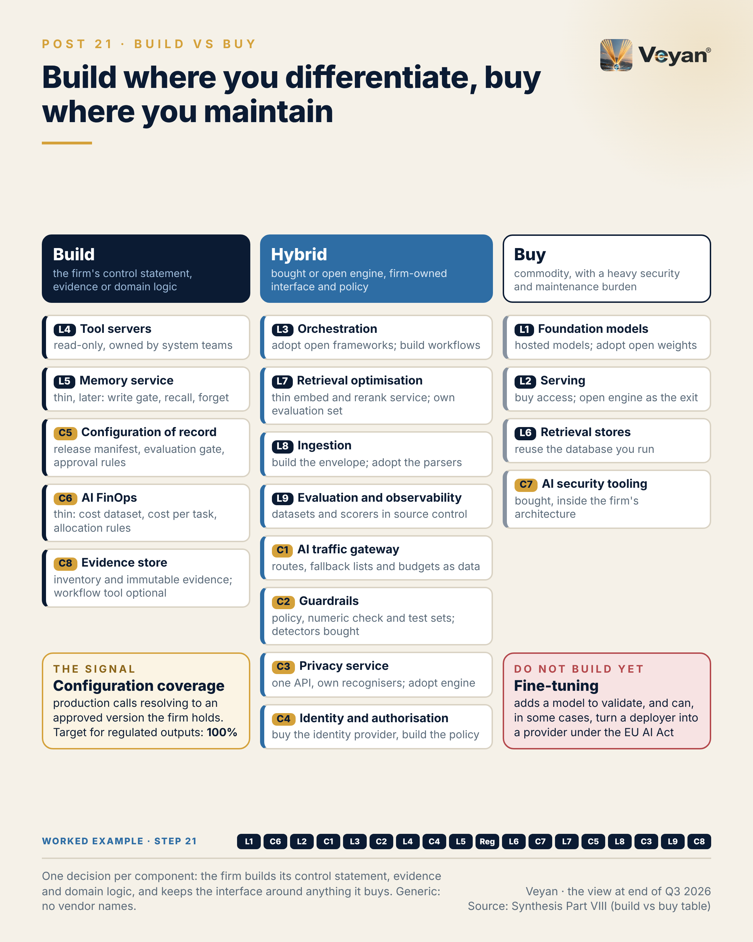
Visual: 08_Graphic/linkedin/P21.png (1080 × 1350, LinkedIn portrait); editable source P21.md, also as .html and .pdf.

First comment
Personal views. Source: the Enterprise GenAI Stack review, synthesis Part VIII (Build vs buy), the rule and the 18-row component table. - Products named in the “buy” and “hybrid” columns include LiteLLM Enterprise, Kong, APIM, Apigee and AgentCore Gateway (gateway); Presidio and Sensitive Data Protection (privacy); Entra Agent ID and Okta for AI Agents (identity); Langfuse, MLflow and LangSmith (evaluation); Docling and Unstructured (ingestion); LangGraph, Microsoft Agent Framework, ADK and Pydantic AI (orchestration); vLLM (serving); and hosted models from several vendors, including Anthropic, plus Gemma 4 or Mistral open weights. - The ownership changes behind “neutral products changed owner” are listed in synthesis Part I, finding 2. - Fine-tuning and EU AI Act Article 25 (deployer becoming provider): [R-EUAIA: A8-S011]; the synthesis lists fine-tuning as “do not build yet”. - Worked example, step 21 (build or buy). Adds: A build, hybrid or buy decision for each of the seventeen components: build the evidence store, configuration and tools; buy models, serving and security tooling; hybrid elsewhere. Now: Spend goes where the firm differentiates. Never: Fine-tuning stays off the list.

Hashtags
#EnterpriseArchitecture #BuildVsBuy

Re-verify before posting
- No dated facts in the body. Check the Article 25 wording if challenged (“can, in some cases”).

Compliance check
- Personal views: yes
- No statement about any firm’s sourcing decisions: yes
- Vendors only in the first comment: yes

Post 22 · Week 11 · Where not to abstract
Pair: Post 21 (Build vs buy, Week 11). Bridge: The stack post’s thin firm-owned interfaces are the right default; the control post names where adding one is the mistake.
Theme and source: What to abstract and what not to over-abstract. work/stageC/synthesis.md Part IX (IX.1, IX.2, IX.3).
Tension: Frameworks on top of frameworks.

Full post
Abstraction is how an architecture stays reversible. Too much of it is how an architecture stops moving.
The previous post argued for a firm-owned interface in front of anything you may replace. The trap is applying that everywhere. The classic case is a firm-wide wrapper around agent frameworks: frameworks on top of frameworks. It falls behind every upstream release, hides the features teams chose the framework for, and becomes a second product to maintain.
Abstract where switching is likely and the interface is small. Model routing through one API contract at the gateway. Observability through an open telemetry collector. Evaluation datasets in source control. Credentials through workload identity. Policy as code. Retrieval behind a thin interface. Embeddings with a version on every vector.
Do not abstract the framework. Keep the workflow specification, prompts, tools and evaluations outside it, and rewriting a well-specified workflow becomes bounded work. That is the real portability. Do not build a plug-in architecture for one workflow with one model step. Do not put a layer between every query and the database. And do not build an abstraction to hide a model you never pinned.
The signal is framework currency: days behind the pinned framework’s latest security fix, held inside the patch window, for example 30 days. Wrappers make that number drift.
The leadership move is to ask, of every proposed abstraction, what switching would cost without it. If the answer is a bounded rewrite, skip the abstraction.
[Anecdote slot: one or two sentences on an internal abstraction layer that cost more than it saved, or one that paid off, and what made the difference.]
Portability lives in the artefacts you own, not in the layers you add.

Short variant
Abstraction keeps an architecture reversible. Too much of it stops the architecture moving.
The classic mistake is a firm-wide wrapper around agent frameworks: frameworks on top of frameworks. It lags every release and becomes a second product to maintain.
Abstract where switching is likely and the interface is small: model routing at the gateway, an open telemetry collector, datasets in source control, workload identity, policy as code, a thin retrieval interface.
Do not abstract the framework. Keep workflow specifications, prompts, tools and evaluations outside it, and a rewrite becomes bounded work.
The signal is framework currency: days behind the latest security fix, held inside the patch window. Wrappers make it drift.
Ask what switching would cost without the abstraction. Portability lives in the artefacts you own, not the layers you add.

Anecdote slot
- Where: the bracketed line before the closing paragraph.
- Prompt: an internal “common layer” or wrapper (over a database, messaging system, cloud SDK or framework) that became a maintenance drag, or a thin interface that made a later migration easy. Credit the engineers who maintained or retired it; own the original sponsorship if it was yours.
- Fits: platform modernisation; developing leaders through delivery.
- Avoid: naming internal libraries or teams.

Fallback version
Abstraction is how an architecture stays reversible. Too much of it is how an architecture stops moving.
A firm-owned interface in front of anything replaceable is the right default. The trap is applying it everywhere. The classic case is a firm-wide wrapper around agent frameworks: frameworks on top of frameworks. It falls behind every upstream release, hides the features teams chose the framework for, and becomes a second product to maintain.
Abstract where switching is likely and the interface is small. Model routing through one API contract at the gateway. Observability through an open telemetry collector. Evaluation datasets in source control. Credentials through workload identity. Policy as code. Retrieval behind a thin interface. Embeddings with a version on every vector.
Do not abstract the framework. Keep the workflow specification, prompts, tools and evaluations outside it, and rewriting a well-specified workflow becomes bounded work. That is the real portability. Do not build a plug-in architecture for one workflow with one model step. Do not put a layer between every query and the database. And do not build an abstraction to hide a model you never pinned.
The signal is framework currency: days behind the pinned framework’s latest security fix, held inside the patch window, for example 30 days. Wrappers make that number drift.
The leadership move is to ask, of every proposed abstraction, what switching would cost without it. If the answer is a bounded rewrite, skip the abstraction.
The honest caveat: this is a judgement, and reasonable architects draw the line differently. A timed switch of one component settles most arguments.
Portability lives in the artefacts you own, not in the layers you add.

Suggested visual
Two lists side by side. “Abstract (thin, firm-owned)”: routing contract, telemetry collector, datasets, credentials, policy, retrieval interface, embed/rerank, privacy API, memory API, config fetch. “Do not over-abstract”: agent frameworks, single-workflow plug-ins, plain database access, store-bundled features, vendor model extras. A small strip beneath shows “multi-vendor necessary” versus “multi-vendor only adds complexity”. Source: synthesis IX.1–IX.3.
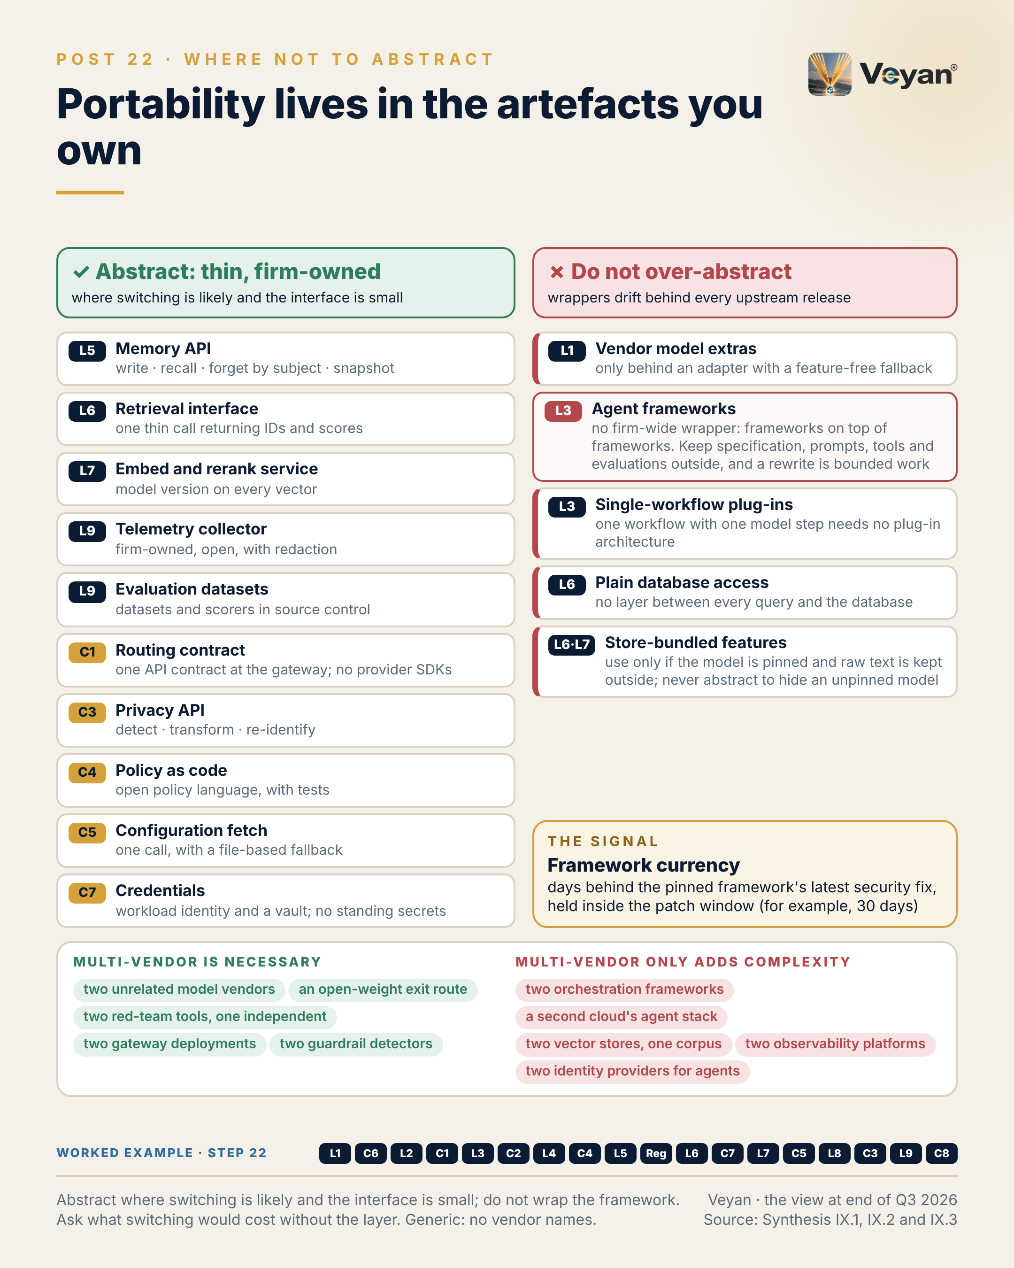
Visual: 08_Graphic/linkedin/P22.png (1080 × 1350, LinkedIn portrait); editable source P22.md, also as .html and .pdf.

First comment
Personal views. Source: the Enterprise GenAI Stack review, synthesis Part IX (IX.1 what to abstract, IX.2 what not to over-abstract, IX.3 where multi-vendor is necessary) and L3 §3.3 (framework currency KPI). - Frameworks named in the synthesis’s “do not wrap” guidance: LangGraph, Microsoft Agent Framework and Google ADK. - Open interfaces cited: an OpenAI-compatible routing contract accepted by every gateway assessed; OpenTelemetry or OpenInference for traces; OPA (Rego) or Cedar for policy. - IX.3 also lists where multi-vendor only adds complexity: two orchestration frameworks in one language estate, two vector stores for one corpus, two observability platforms of record, two IdPs for agents, a second cloud’s agent stack. - The 30-day patch window is an example target from the review, not a benchmark. - Worked example, step 22 (thin interfaces). Adds: Thin firm-owned interfaces where switching is likely (routing contract, telemetry, datasets, privacy, retrieval) and none around the agent framework. Now: Changing a vendor is a contained change. Never: No firm-wide wrapper around frameworks.

Hashtags
#SoftwareArchitecture #AgenticAI

Re-verify before posting
- No dated facts in the body.

Compliance check
- Personal views: yes
- No internal libraries or teams referenced: yes
- Vendors only in the first comment: yes

Week 12

Post 23 · Week 12 · Which lock-in is acceptable
Pair: Post 24 (Close, Week 12). Bridge: The stack post classifies which dependencies are worth accepting; the control post applies that to the final stack: what I would select, and what I would deliberately leave out.
Theme and source: Lock-in by layer and control: acceptable, manageable, unacceptable. work/stageC/synthesis.md Part IX.4 (lock-in table), with L6 §6.3 (rebuild-time KPI).
Tension: Some lock-in is a good trade, and the skill is knowing which.

Full post
Some lock-in is a good trade. The skill is knowing which.
Total avoidance is not a strategy. It produces the lowest common denominator everywhere, and the firm pays for portability it will never use. The better question, layer by layer, is what it would cost to leave, and whether that cost is acceptable, manageable with an abstraction, or unacceptable for a regulated workload.
Acceptable: open-weight models the firm holds, open serving engines, open orchestration frameworks, a stateless reranker, a vector index that can be rebuilt from source. Leaving costs little.
Manageable: a proprietary model behind the gateway with a qualified second vendor, a gateway product, the workforce identity provider, a managed agent runtime. Each is fine with the right interface and a rehearsed exit.
Unacceptable: a single proprietary model vendor behind an important business service; evaluation datasets that exist only in a vendor console; prompts and change history held only in a vendor registry; credentials held in a third party’s multi-tenant cloud; an evidence store held only by a vendor. Each turns an exit into a reconstruction.
The pattern is consistent. Lock-in to a product is usually tolerable. Lock-in of the firm’s own records, meaning its evidence, configuration, datasets and credentials, is not.
The retrieval layer shows the signal: rebuild time from approved sources with a pinned embedding model, inside the exit-plan tolerance and tested twice a year.
The leadership move is to classify each layer once, record it in the exit plan, and review it whenever ownership changes.
[Anecdote slot: one or two sentences on a dependency you accepted deliberately and never regretted, or one that crept in unnoticed.]
Choose dependencies deliberately. The accidental ones are expensive.

Short variant
Some lock-in is a good trade. The skill is knowing which.
Avoiding all of it buys the lowest common denominator everywhere. Ask instead, layer by layer: is the cost of leaving acceptable, manageable with an abstraction, or unacceptable?
Acceptable: open weights you hold, open engines and frameworks, an index you can rebuild.
Manageable: a proprietary model with a qualified second vendor, a gateway product, the identity provider.
Unacceptable: one model vendor behind an important service, or datasets, prompts, credentials and evidence held only by a vendor.
Lock-in to a product is usually tolerable. Lock-in of your own records is not.
One signal: index rebuild time from approved sources, tested twice a year.
Classify each layer once, and review it when ownership changes. The accidental dependencies are the expensive ones.

Anecdote slot
- Where: the bracketed line before the closing paragraph.
- Prompt: a technology dependency you accepted with open eyes and that served the firm well, or one that crept in through a convenience feature and became hard to leave. The lesson is the decision process, not the vendor. Credit the person who documented the exit, or own the dependency you did not see coming.
- Fits: platform modernisation; “audit outcomes as a symptom of operating-model design”.
- Avoid: naming the vendor or the platform.

Fallback version
Some lock-in is a good trade. The skill is knowing which.
Total avoidance is not a strategy. It produces the lowest common denominator everywhere, and the firm pays for portability it will never use. The better question, layer by layer, is what it would cost to leave, and whether that cost is acceptable, manageable with an abstraction, or unacceptable for a regulated workload.
Acceptable: open-weight models the firm holds, open serving engines, open orchestration frameworks, a stateless reranker, a vector index that can be rebuilt from source. Leaving costs little.
Manageable: a proprietary model behind the gateway with a qualified second vendor, a gateway product, the workforce identity provider, a managed agent runtime. Each is fine with the right interface and a rehearsed exit.
Unacceptable: a single proprietary model vendor behind an important business service; evaluation datasets that exist only in a vendor console; prompts and change history held only in a vendor registry; credentials held in a third party’s multi-tenant cloud; an evidence store held only by a vendor. Each turns an exit into a reconstruction.
The pattern is consistent. Lock-in to a product is usually tolerable. Lock-in of the firm’s own records, meaning its evidence, configuration, datasets and credentials, is not.
The retrieval layer shows the signal: rebuild time from approved sources with a pinned embedding model, inside the exit-plan tolerance and tested twice a year.
The leadership move is to classify each layer once, record it in the exit plan, and review it whenever ownership changes.
The honest caveat: the classification moves. A tolerable dependency becomes a concern when its owner changes.
Choose dependencies deliberately. The accidental ones are expensive.

Suggested visual
Heat-map table: the 17 layers and controls as rows; columns “acceptable”, “manageable”, “unacceptable”; each cell a short phrase from the synthesis table (vendor names removed). A highlighted band across the “unacceptable” column reads “the firm’s own records: evidence, configuration, datasets, credentials”. Source: synthesis IX.4.
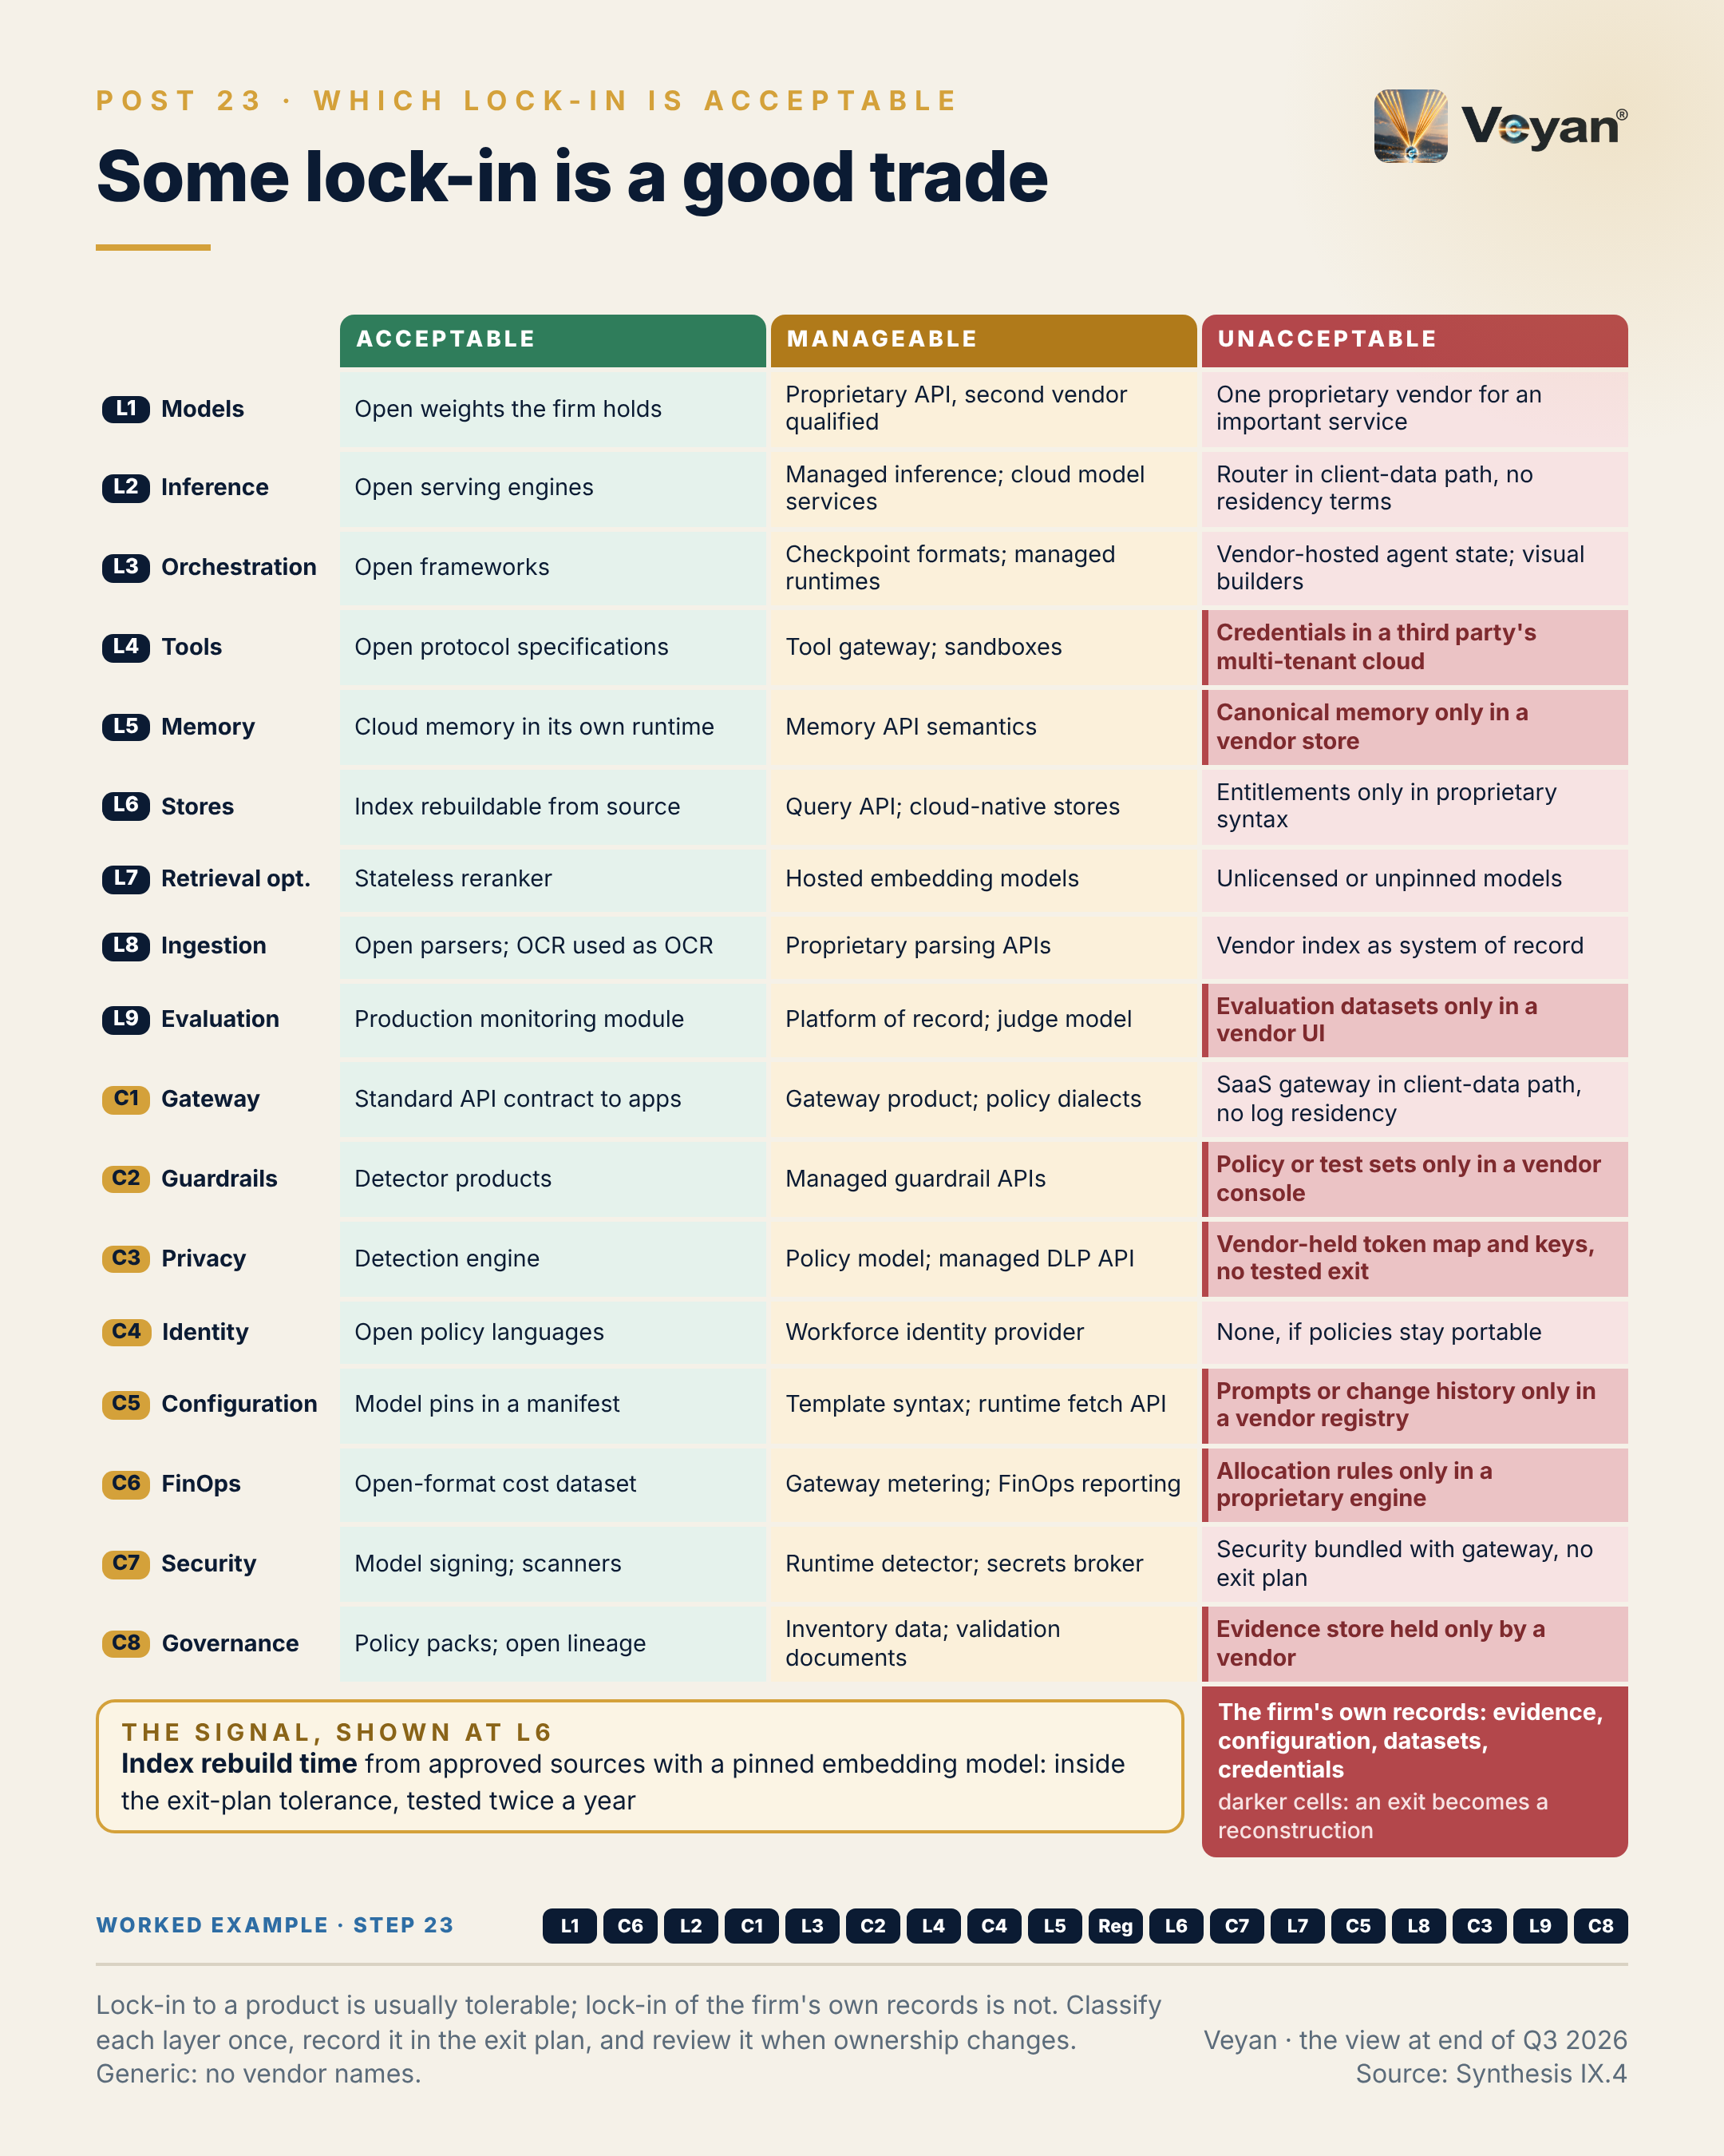
Visual: 08_Graphic/linkedin/P23.png (1080 × 1350, LinkedIn portrait); editable source P23.md, also as .html and .pdf.

First comment
Personal views. Source: the Enterprise GenAI Stack review, synthesis Part IX.4 (lock-in by layer and control) and L6 §6.3 (rebuild-time KPI). - Examples behind the categories: vLLM and SGLang (Apache-2.0, OpenAI-compatible) as acceptable [A4-S009, A4-S010]; MCP and A2A as open specifications under AAIF [A3-S018, A3-S116] (MCP originated at Anthropic; conflict of interest noted); credential custody in a third party’s multi-tenant cloud as unacceptable, following Composio’s May 2026 incident [B-L4-S007]; OpenAI’s Agent Builder shutting on 30 November 2026 as an example of vendor-hosted state [A4-S054]. - Each cell of the table has its rationale and abstraction in the synthesis; this post compresses it. - Worked example, step 23 (exit tested). Adds: Lock-in accepted knowingly per component, with the firm’s own records (evidence, configuration, datasets, credentials) kept out of any vendor’s hands, and an index rebuild drilled. Now: The agent survives the loss of any single vendor. Never: No vendor-held store is ever the only copy of the firm’s evidence.

Hashtags
#VendorRisk #EnterpriseArchitecture

Re-verify before posting
- Lock-in categories against the final Part IX.4 table
- Any new ownership change in a “manageable” category

Compliance check
- Personal views; no statement about any firm’s dependencies: yes
- Vendors only in the first comment: yes

Post 24 · Week 12 · Close: what I’d select, and what I’d deliberately not select
Pair: Post 23 (Which lock-in is acceptable, Week 12). Bridge: The stack post’s lock-in classification is the filter; the control post shows what passes through it, what does not, and what leading the change actually requires.
Theme and source: The final recommended stack on one page, and a lesson about leading the transformation. work/stageC/synthesis.md Part XI (XI.4 Experimental, XI.5 Products to avoid, XI.7 The answer in one paragraph), with Part I.1 (39 of 80 tiles) and I.2 (twelve decisions).
Tension: The full stack on one page, plus a lesson about leading the transformation.

Full post
Twelve weeks ago this series started from a popular diagram of the AI stack. On this review, 39 of its 80 product tiles were out of date. The diagram was a catalogue. The enterprise problem is a control system.
So here is what I would select, on one page.
First, a firm-owned control and evidence plane: one gateway of record for every model, tool and agent call; evaluation and observability from day one; an evidence store the firm owns; one privacy service; agent identities in the workforce directory; source control as the configuration of record. Beneath it, replaceable components: open document parsing inside a built envelope, vectors in a database the firm already runs, read-only tools behind a governed gateway, deterministic workflows on a durable engine, the primary cloud’s in-region model service with an open-weight exit route, and a two-vendor model portfolio.
And what I would deliberately not select: archived or deprecated products, unverifiable vendors, a third-party broker holding client tokens, licence-blocked weights, autonomous agents with write tools, memory before it is needed, and any vendor-held store as the only copy of the firm’s evidence.
The lesson about leading this is quieter than the architecture. The products will change again within months. What lasts is the operating model: who owns the evidence, who may approve, and what waits. The leadership move is to fund that plane before any product.
The signal I would keep in front of executives is the human-intervention rate: how often, and how much, reviewers edit what the system drafts. Supervisors already ask for it.
[Anecdote slot: one or two sentences crediting the people whose questions or work shaped your thinking on a transformation like this.]
Select the plane first. Everything beneath it is allowed to change.

Short variant
Twelve weeks ago this series started from a popular AI-stack diagram. On this review, 39 of its 80 tiles were out of date. It was a catalogue; the enterprise problem is a control system.
What I would select: a firm-owned control and evidence plane first, meaning one gateway of record, evaluation from day one, a firm-owned evidence store, one privacy service, agent identities and configuration in source control. Beneath it, replaceable components and a two-vendor model portfolio.
What I would deliberately not select: deprecated or unverifiable products, brokers holding client tokens, licence-blocked weights, autonomous agents with write tools, premature memory, and any vendor-held only copy of the evidence.
The signal for executives is the human-intervention rate.
Select the plane first. Everything beneath it is allowed to change.

Anecdote slot
- Where: the bracketed line before the closing paragraph.
- Prompt: as a close to the series, credit the people (by role, or by name with their permission) whose questions, pushback or delivery work shaped how you think about this transformation: a validator, an engineer, a risk partner, a portfolio manager. Alternatively, name the one belief you held at the start that the work changed.
- Fits: “share the lesson, credit the team”; developing leaders through delivery.
- Avoid: implying that any firm has adopted this stack, or naming colleagues without consent.

Fallback version
Twelve weeks ago this series started from a popular diagram of the AI stack. On this review, 39 of its 80 product tiles were out of date. The diagram was a catalogue. The enterprise problem is a control system.
So here is the selection, on one page.
First, a firm-owned control and evidence plane: one gateway of record for every model, tool and agent call; evaluation and observability from day one; an evidence store the firm owns; one privacy service; agent identities in the workforce directory; source control as the configuration of record. Beneath it, replaceable components: open document parsing inside a built envelope, vectors in a database the firm already runs, read-only tools behind a governed gateway, deterministic workflows on a durable engine, the primary cloud’s in-region model service with an open-weight exit route, and a two-vendor model portfolio.
And what to deliberately not select: archived or deprecated products, unverifiable vendors, a third-party broker holding client tokens, licence-blocked weights, autonomous agents with write tools, memory before it is needed, and any vendor-held store as the only copy of the firm’s evidence.
The lesson about leading this is quieter than the architecture. The products will change again within months. What lasts is the operating model: who owns the evidence, who may approve, and what waits. The leadership move is to fund that plane before any product.
The signal to keep in front of executives is the human-intervention rate: how often, and how much, reviewers edit what the system drafts. Supervisors already ask for it.
The honest caveat: this is a view as of autumn 2026, drawn from public evidence, and much of it will need re-checking within months.
Select the plane first. Everything beneath it is allowed to change.

Suggested visual
The one-page architecture from synthesis I.2, with vendor names removed: control plane (C1–C8 with the L9 evidence plane) across the top; agent, knowledge and model planes beneath. To the right, a short “Deliberately not selected” column with the categories from XI.5 and XI.7. Optional carousel: slide 1 the popular stack diagram with 39 tiles flagged; slide 2 the one-page architecture; slide 3 the twelve decisions; slide 4 “not selected”.
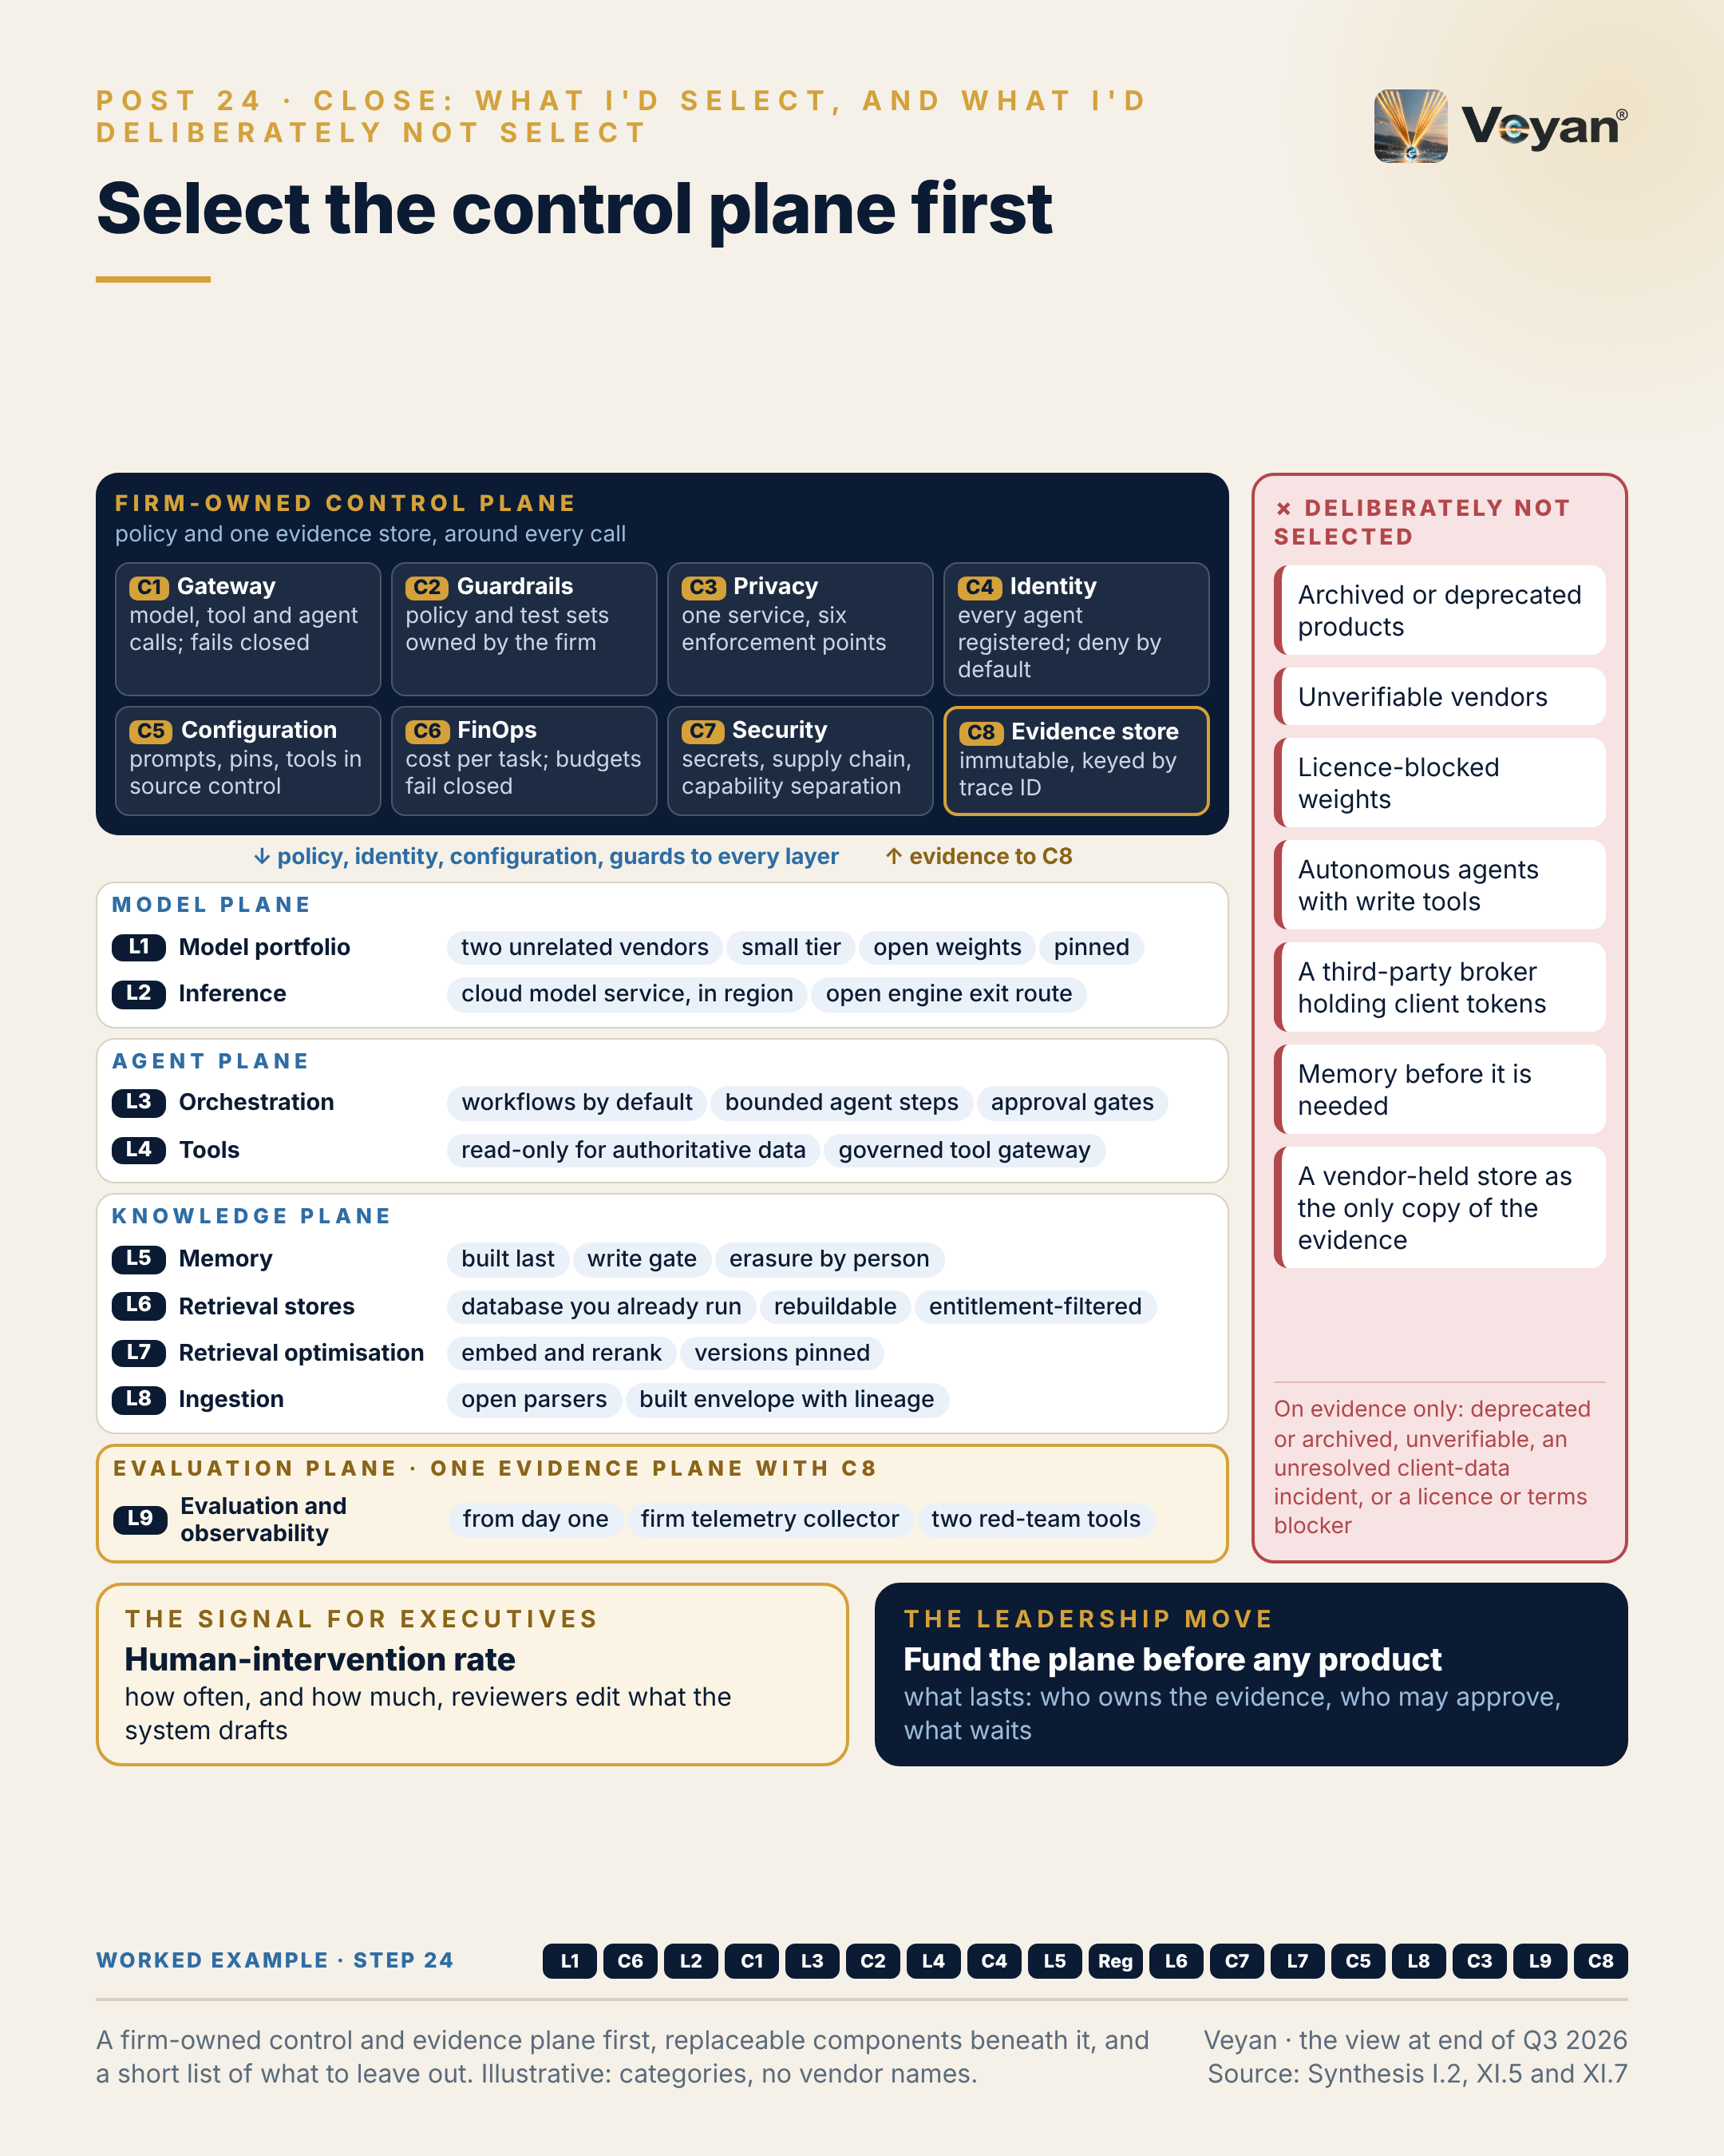
Visual: 08_Graphic/linkedin/P24.png (1080 × 1350, LinkedIn portrait); editable source P24.md, also as .html and .pdf.

First comment
Personal views; not a description of any firm’s platform or vendor choices. Sources: the Enterprise GenAI Stack review, synthesis Part I.1 (39 of 80 tiles out of date: 9 acquired, 9 mispositioned, 8 renamed, 8 with a wrong version label, 6 not publicly verifiable, 4 duplicated, 3 superseded, 2 deprecated, with some tiles carrying several flags), I.2 (twelve decisions), XI.5 (products to avoid, evidence-based only) and XI.7 (the answer in one paragraph). - The cloud-neutral core in the review: a hardened LiteLLM or Kong gateway; Langfuse or MLflow with a firm-owned OpenTelemetry Collector; Presidio; workforce IdP with OPA; Git; Docling and Unstructured; Sentence Transformers and pgvector; read-only MCP tools (OpenAPI tools as the independent alternative); LangGraph on Temporal; the primary cloud’s model service with vLLM as the exit route; a two-vendor portfolio drawn from OpenAI, Anthropic (with GPT-6.1 Sol, Gemini 3.8 Flash or Mistral Medium 3.5 as the named alternative), Mistral and, on Google Cloud, Gemini; Gemma 4 or Mistral self-hosted. - Conflict of interest: these drafts were prepared with an Anthropic model; Anthropic’s tier in the review was set by me, on neutral-rubric scores, not by the drafting tool, and an independent alternative is named wherever a Claude model, MCP or Agent Skills appears. - IOSCO’s supervisory toolkit names the level and frequency of human intervention as an indicator for asset managers [R-INTL-AI-ASSETMGMT: A8-S058]. - [Link to the published review, if released.] - Worked example, step 24 (signed off). Adds: The final selection: a firm-owned control and evidence plane, with replaceable components beneath it, and a published list of what was deliberately not selected. Now: The worked example is complete, governed and ready to run. Never: What was not selected stays off until the evidence changes.

Hashtags
#EnterpriseArchitecture #AIGovernance

Re-verify before posting
- The final Part XI lists (avoid and monitor), especially any item that has changed tier since October 2026
- Ownership and status changes across the products in the first comment

Compliance check
- Personal views; “what I would select” is a personal architectural view, not a firm decision: yes
- Anecdote prompt asks for consent before naming colleagues: yes
- Vendors only in the first comment, with the conflict of interest stated: yes

Week 13: buffer
No post is scheduled. Use the week for one of the following: - A slipped post. If any week 1–12 post was delayed (clearance, travel, a news week), move it here and keep the pair together where possible. - A reactive post. Use one of the templates below if a model launch, an acquisition or a regulatory milestone lands during the series. A reactive post can also replace a control-post slot if timing matters; move the displaced post to week 13. - A rest week. If the series ran to plan, skipping week 13 is fine. A short “thank you and where to find the full review” note is optional, and needs no template.
Before using week 13, re-run the “Re-verify” lists for any post moved into it.

Reactive templates
Each template is a full post with bracketed fields for the event details. Fill each field with one factual sentence from a primary source (the vendor’s or regulator’s own announcement), log that source, and keep vendor names out of the body and in the first comment. The bracketed fields are sized so that the filled post stays within 220–300 words. Each template links back to a layer post so the reactive piece reads as part of the series.

Template R1 · Model launch
Links back to: Post 1 (L1 Foundation models) and Post 17 (L9 Evaluation). Schedule: week 13 buffer, or in place of a control post within a week of the launch.
Tension: A new model is a portfolio decision, not a migration.

Full template
[One sentence: a major vendor released a new model or tier this week, described by category, for example “a new frontier tier” or “a smaller, cheaper mid-tier model”.] [One sentence on what is new, from the vendor’s own announcement: capability, tier, price or availability.]
The question for a regulated firm is not whether it is better. It is what it would take to use it safely, and how quickly.
In the architecture this series has described, a new model is a portfolio decision, not a migration. It arrives through the gateway as a candidate route. It is pinned to an exact version. It runs against the same evaluation suite as the models already in production, including the deterministic checks on numbers. If it passes, it can replace a mid-tier model or become the qualified fallback. If it wins only on the vendor’s own benchmark, it waits.
Three things to check first: where prompts are processed on the route you would actually use, not where data is stored; the retention and training terms for that route; and the retirement runway of the version you would pin.
The signal is how long your own evaluation suite takes to qualify or reject a new candidate. If the answer is months, the bottleneck is the harness, not the model.
The leadership move is to keep the frontier tier switched off by default, and switch it on only when evaluation shows the current tier fails a named use case.
New models will keep arriving. A firm that can evaluate one quickly, and switch by configuration, does not need to chase any of them.

Short variant
[One sentence: a major vendor released a new model or tier this week, described by category.]
For a regulated firm, the question is not whether it is better. It is what it would take to use it safely.
A new model is a portfolio decision, not a migration: a candidate route through the gateway, pinned to an exact version, run against the same evaluation suite as production. If it passes, it can become the primary or the qualified fallback. If it wins only on the vendor’s benchmark, it waits.
Check processing location on your actual route, retention and training terms, and the retirement runway.
The signal is how long your evaluation suite takes to qualify a candidate.
A firm that can evaluate quickly, and switch by configuration, does not need to chase any model.

Notes for use
- First comment: name the vendor and model and link the announcement; add sources from L1 §1.3 (qualified-alternative coverage, retirement runway) and §1.9 (portfolio steps). Name at least one comparable model from a different vendor, so the comment does not read as promotion. If the vendor is Anthropic, say that the series was drafted with an Anthropic model.
- Hashtags: #FoundationModels #LLMOps
- Re-verify: route-specific processing region and data terms on the hyperscaler service you would use; the GA versus preview status.
- Compliance: no statement about whether your firm will use the model; no benchmark figures in the body.
- Optional anecdote: one sentence on how your team evaluates new tools before adopting them. Replace the “leadership move” paragraph to stay within the word count.

Template R2 · Acquisition or change of ownership
Links back to: Post 17 (L9, ownership of evaluation tools), Post 4 (C1 gateway) and Post 23 (lock-in). Schedule: week 13 buffer, or in place of a control post within a week of the announcement.
Tension: Independence can no longer be assumed from a product’s origins; it has to be designed in.

Full template
[One sentence: a larger company agreed to acquire, or completed its acquisition of, a widely used tool in a named layer of the GenAI stack, described by category, for example “an evaluation platform” or “an AI gateway”.] [One sentence on status and stated plans, from the announcement.]
It is the latest in a long line. Over the past year much of the “neutral” tooling in the GenAI stack has moved under platform, security, database or model vendors. Independence can no longer be assumed from a product’s origins; it has to be designed in.
What changes for a firm that uses the product? Possibly nothing in the short term. But three questions are worth asking now rather than at renewal. Does the new owner sell something else in our stack, and does that weaken an independence we relied on, such as a test tool now owned by the vendor whose model it tests? Do our contracts, data terms and residency commitments survive the change of control? And for UK-regulated firms, from 18 March 2027 a significant change to a material third-party arrangement must be notified.
The architecture answer is the same as always: keep the product behind a firm-owned interface, keep the data it holds (traces, datasets, prompts, policies) exported, and know how long a switch would take.
The signal is time to switch the affected component to its alternative, by configuration or a bounded migration.
Ownership changes are a normal part of a maturing market. Being surprised by one is optional.

Short variant
[One sentence: a larger company agreed to acquire, or completed its acquisition of, a widely used tool in a named layer of the stack, described by category.]
Much of the “neutral” GenAI tooling has now moved under platform, security, database or model vendors. Independence has to be designed in.
Three questions to ask now, not at renewal. Does the new owner sell something else in our stack, weakening an independence we relied on? Do our contracts, data terms and residency survive the change of control? Is this a significant change to a material arrangement that must be notified?
Keep the product behind a firm-owned interface, keep its data exported, and know how long a switch would take.
The signal is time to switch the affected component.
Being surprised by an ownership change is optional.

Notes for use
- First comment: name both companies, link the announcement and state whether the deal has closed; point to synthesis Part I, finding 2 (ownership changes) and Part XI.6 (monitor list). Avoid any view on the deal’s merits.
- Hashtags: #VendorRisk #ThirdPartyRisk
- Re-verify: closing status; whether the acquirer has announced product or licence changes; the PS7/26 / PS26/2 date.
- Compliance: no statement about your firm’s contracts with either company; facts only from the announcement.
- Optional anecdote: one sentence on a supplier change of control you have managed. Replace the paragraph beginning “The architecture answer” to stay within the word count.

Template R3 · Regulatory milestone
Links back to: Post 18 (C8 model risk) and Post 10 (Regulated reality). Schedule: the week of the milestone, in place of a control post, or in the week 13 buffer.
Tension: A regulatory date is most useful as a refresh mandate for the architecture.

Full template
[One sentence: the date, and the instrument that took effect or was published, for example a supervisory statement, an application date or a designation list.] [One sentence on what it requires and of whom, from the official text: providers or deployers, which firms, which uses.]
It is easy to treat a regulatory date as a compliance project with an end. The better use is as a refresh mandate for the architecture.
For GenAI systems, most regulatory milestones ask for some combination of the same evidence: an inventory of what is running; validation that matches the versions in production; logs showing what the system saw and did; human oversight that is recorded; and exit plans that have been tested. A firm that has built a gateway of record, an evaluation suite, a configuration manifest and an evidence store keyed by trace ID already holds most of it.
So the question this week is not “what do we need to build?” It is “what can we already show, and where are the gaps?”
The signal is evidence-pack completeness for the use cases in scope: the share of outputs with a complete record. The gaps are the work plan.
The leadership move is to use the date to fund the evidence once, properly, rather than a separate response for each regime.
Each new date is easier for the firm that built the evidence once.

Short variant
[One sentence: the date, and the instrument that took effect or was published.]
A regulatory date is easy to treat as a compliance project with an end. It is more useful as a refresh mandate.
Most GenAI milestones ask for the same evidence: an inventory of what runs, validation matching production versions, logs of what the system saw and did, recorded human oversight, and tested exit plans. A gateway of record, an evaluation suite, a configuration manifest and an evidence store keyed by trace ID already hold most of it.
So ask what you can already show, and where the gaps are.
The signal is evidence-pack completeness for the use cases in scope.
Each new date is easier for the firm that built the evidence once.

Notes for use
- First comment: “Personal views; not legal advice.” Cite the official text, then the matching entry in regulatory_facts.json and synthesis Part V. Likely triggers during the series: the US agencies’ AI request for information, an updated DORA CTPP list or new UK CTP designations, the EU AI Act Article 50(2) date for systems already on the market (2 December 2026), PS7/26 / PS26/2 (18 March 2027), EU AI Act Annex III (2 December 2027).
- Hashtags: #EUAIAct #DORA by default. For a model-risk milestone, swap them for the pair used on Post 18 (model risk and AI governance).
- Re-verify: the date and scope against the official source on the day.
- Compliance: no statement about your firm’s readiness or engagement with any regulator.
- Optional anecdote: one sentence on an earlier deadline you turned into a broader refresh. Replace the “leadership move” paragraph to stay within the word count.

Appendix: automated checks
The checks are run with python3 -I over this file. For each of the 25 posts (Post 0 and Posts 1–24) they confirm that: - the full post and the fallback version are each 220–300 words, with the anecdote slot counted as drafted - the short variant is 120–150 words - the full post contains exactly one anecdote slot, and the short variant and fallback contain none - there are at most 2 hashtags - there are no emoji characters
The three reactive templates get the same length, hashtag and emoji checks. Word counts were taken two ways, a word-token count and a plain whitespace split; both had to fall in range.
Result on 9 October 2026: all 24 posts and 3 templates passed. Full posts are 261–290 words, short variants 123–142, fallback versions 269–297, and templates 231–268 (short variants 126–134). Post 0 was added later the same day and passed the same checks (full post 263 words, short variant 128, fallback 267).

Appendix: the worked example, step by step
An agent drafts the monthly Brinson-style performance-attribution commentary for a generic multi-asset fund; a portfolio manager approves every draft.
Step | Stage | Adds | Now works | Never
0 | The brief | The use case and its boundary: the agent writes words around numbers it is given; it never produces a number, and a named portfolio manager approves every draft. | Nothing is built yet; the design file starts empty. | No figure may come from a model.
1 | Models | Four model roles, each pinned to an exact version: a primary drafting model, a fallback from a different vendor, a small classifier for reviewer edits, and a self-hosted open-weight model for anything touching unmasked client data. | The agent has a primary and a qualified fallback in the approved region. | No alias or preview model, and no model ever generates, rounds or corrects a figure.
2 | Cost | A run ID on every call, tagged with use case and fund, joined to the trace; a monthly budget set from two month-end cycles; a per-run ceiling on model calls and tokens. | Cost is reported per approved commentary and per fund, not per token. | A runaway loop fails the run instead of the budget.
3 | Model access | Drafting through the primary cloud’s in-region model service, with capacity sized for the month-end peak and an open-weight route kept ready as the stressed exit. | Every fund’s draft can be produced in the narrow month-end window. | No router or provider that cannot guarantee region and retention.
4 | Gateway | One gateway route, attribution-commentary-draft: the workflow calls the route with its own identity and never holds a provider key; residency, fallback, budgets and inline guards live on the route. | Switching to the qualified fallback is a configuration change, drilled in hours. | If both models are unavailable, the route fails closed and the analyst is told the draft is delayed.
5 | Workflow | A pinned workflow graph: authorise, fetch the attribution snapshot, retrieve style and prior commentary, one drafting step, an evaluation gate, a human approval interrupt, then release by a separate service. | Every run follows the same path; a failed run resumes from its checkpoint with the same numbers. | Autonomy budget of one: the model drafts, but never chooses tools or order.
6 | Guardrails | A deterministic numeric comparator on every draft, injection screening of retrieved text, a PII check on output and denied topics (forecasts, advice). | A draft with any figure, sign or direction word that disagrees with the engine is blocked before a human sees it. | Guardrails back up the design; they never license more autonomy.
7 | Tools | Four tools behind the tool gateway: read-only attribution results with a snapshot hash, read-only fund reference data, a sandboxed calculator for derived figures, and retrieval of approved commentary. | Every figure in the draft traces to a snapshot ID and hash. | No write, publish or e-mail tool exists, so none can be misused.
8 | Identity | A registered agent identity with a named sponsor; it acts on behalf of the analyst with a read-only, minutes-long token; a different portfolio manager approves with step-up authentication. | Every action answers ‘who did this, on whose behalf, under which policy’. | The agent holds no standing credentials and can never approve.
9 | Memory | Deliberately little: a versioned glossary and style rules per fund, changed only by an approved pull request, recalled by version hash. | Any commentary can be regenerated with exactly the memory it used. | The agent may propose memory, never write it; no client identifiers in memory.
10 | Regulation | The regulatory mapping: not an Annex III use; transparency and literacy duties; model vendors as material outsourcing with exit plans; the agent recorded in the model inventory. | The design is defensible to a regulator, not only to an architect. | Never assume a vendor’s oversight covers the firm’s duties.
11 | Retrieval store | One store already run by the firm, with three collections (prior commentaries, style guide, approved market notes) and fund-level entitlement filters applied inside the search. | Context arrives only from documents the analyst is entitled to see. | No unfiltered fallback: no permitted result means an empty result.
12 | AI security | Defence in depth against a poisoned market note: nothing to hijack, numbers that cannot be rewritten, retrieved text marked as data, chunk screening, canary documents and human approval. | No single control has to catch an injected instruction. | Untrusted input, sensitive data and an outbound channel never meet in one agent.
13 | Retrieval quality | Two-stage retrieval of comparable past commentary (embed and rerank), with both model versions pinned and tagged on every vector. | The draft follows the fund’s own style and comparable months. | A mixed-version index is refused; migration runs as a shadow index behind a regression gate.
14 | Configuration | A release manifest per monthly cycle (prompt set, model pins, retrieval settings, tool list, guard policy, eval thresholds), approved by pull request with a second approver and gated by the eval suite. | Every setting that can change what a client reads is versioned and reversible. | No production prompt is ever edited in a console.
15 | Ingestion | Three corpora ingested under a control envelope: dual-parsed factsheet tables reconciled to the engine, prior commentaries with their permissions, and market notes from the approved register only. | Every chunk carries its source, version, permissions, classification and lineage. | No envelope, no index; parsed numbers are context only, never figures.
16 | Privacy | One privacy service called at six points: client names and mandates tokenised before any model call, detected again in output, re-identified only for the reviewing manager. | The model writes about ‘the mandate’ without ever seeing whose it is. | A clear-text identifier not in the approved inputs blocks the draft.
17 | Evaluation | The evaluation plane: numeric faithfulness (blocking), groundedness, style, trajectory, and a regression suite of 24 to 36 months of approved commentaries, all on one firm-owned telemetry spine. | Every change of model, prompt, index or judge is tested before it reaches a client. | Any numeric miss blocks; no human is asked to catch what code can check.
18 | Governance | The inventory entry for the use case and an evidence pack per approved commentary, keyed by one trace ID, written to an immutable archive. | Any approved commentary can be explained and re-performed on request. | The governed unit is the use case; the model is a vendor component inside it.
19 | Assembled | All eighteen pieces assembled into one request trace, with a ‘may / must never’ list in which every ‘never’ names the component that enforces it. | The design is complete end to end on paper. | Every ‘must never’ has an enforcing component, not a policy sentence.
20 | Minimum go-live | The build order for real: governance and evaluation first, then the gateway, retrieval, the workflow and one read-only tool; memory and everything on the ‘not yet’ list waits for evidence. | The agent can go live on the minimum platform. | Nothing is built before the evidence says it is needed.
21 | Build or buy | A build, hybrid or buy decision for each of the seventeen components: build the evidence store, configuration and tools; buy models, serving and security tooling; hybrid elsewhere. | Spend goes where the firm differentiates. | Fine-tuning stays off the list.
22 | Thin interfaces | Thin firm-owned interfaces where switching is likely (routing contract, telemetry, datasets, privacy, retrieval) and none around the agent framework. | Changing a vendor is a contained change. | No firm-wide wrapper around frameworks.
23 | Exit tested | Lock-in accepted knowingly per component, with the firm’s own records (evidence, configuration, datasets, credentials) kept out of any vendor’s hands, and an index rebuild drilled. | The agent survives the loss of any single vendor. | No vendor-held store is ever the only copy of the firm’s evidence.
24 | Signed off | The final selection: a firm-owned control and evidence plane, with replaceable components beneath it, and a published list of what was deliberately not selected. | The worked example is complete, governed and ready to run. | What was not selected stays off until the evidence changes.

