ARTG 5330 - Visualization Technologies

Final Project Proposal

Giulia Carvalho Afiune – NUID 001614983

The attached .csv file is a data set compiled by the United Nations High Commissioner for Refugees (UNHCR). It shows the number of refugees from each nationality that are present in each country across the globe in 2015. It’s possible to access, for example, the number of registered Syrian refugees in the United States and in Germany, or the number of refugees from the Democratic Republic of Congo in France, Italy, etc.

Using this data set for my final project, I intend to create an interactive map that shows the distribution of refugees by nationality around the world. I would design it in such a way that by selecting a country as host country, the user could see the top 5 nationalities with refugees currently living on that country. At the meantime, by selecting a country as origin country, the user would be able to see in what countries refugees from that nationality are currently living.

The goal is to create an interactive data visualization that is clear, accurate and in which information can be easily accessed by the user.

I wish to avoid complex maps that are difficult to read, such as distorted maps, maps with overlaying bar charts and maps with overlaying multiple arrows, such as the ones below. These types of visualization are commonly used to represent the refugee crisis, but they don’t provide easily understandable information.

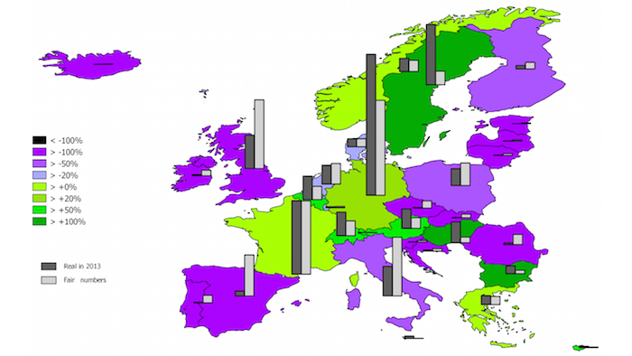

Fig 1: Ideal distribution of refugees in Europe. Source: voxeurop.eu

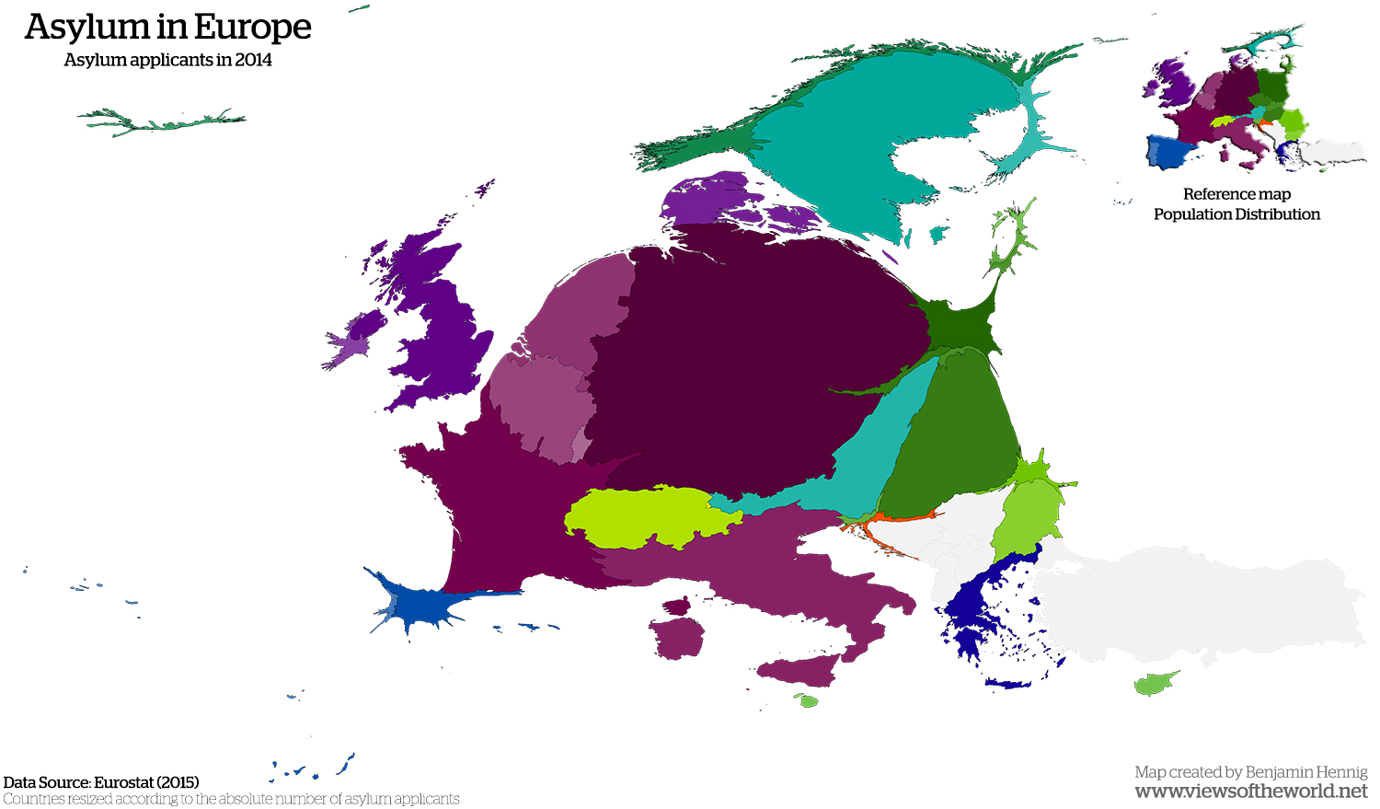

Fig 2: Asylum Seekers in Europe. Source: ViewsoftheWorld.net

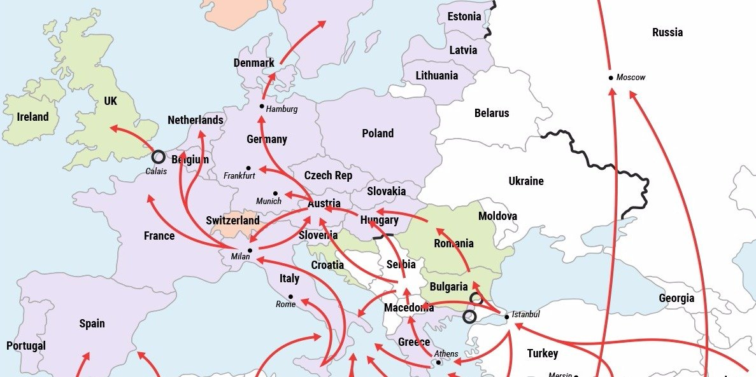

Fig 3: Routes of refugees to Europe. Source: Business Insider.

My intention is to create a visualization that can be easily interpreted, such as this graphic by the BBC, but also including an interactive and user-oriented feature:

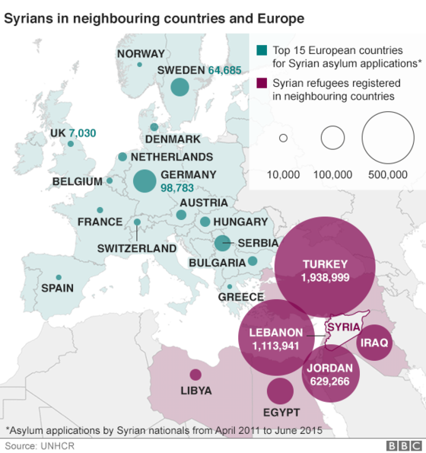

Fig 4: Syrians in neighboring countries and Europe. Source: BBC