Meta-analysis based on Sisks et al. (2018) - V.2

Giulia Bertoldo

4/10/2022

Table of Contents

# Packages and Data

# Load packages  
library(tidyverse)

## ── Attaching packages ─────────────────────────────────────── tidyverse 1.3.0 ──

## ✓ ggplot2 3.3.5 ✓ purrr 0.3.4  
## ✓ tibble 3.0.4 ✓ dplyr 1.0.2  
## ✓ tidyr 1.1.2 ✓ stringr 1.4.0  
## ✓ readr 1.4.0 ✓ forcats 0.5.0

## ── Conflicts ────────────────────────────────────────── tidyverse_conflicts() ──  
## x dplyr::filter() masks stats::filter()  
## x dplyr::lag() masks stats::lag()

library(meta)

## Warning: package 'meta' was built under R version 4.0.5

## Loading 'meta' package (version 5.2-0).  
## Type 'help(meta)' for a brief overview.  
## Readers of 'Meta-Analysis with R (Use R!)' should install  
## older version of 'meta' package: https://tinyurl.com/dt4y5drs

library(metafor)

## Loading required package: Matrix

##   
## Attaching package: 'Matrix'

## The following objects are masked from 'package:tidyr':  
##   
## expand, pack, unpack

##   
## Loading the 'metafor' package (version 3.0-2). For an  
## introduction to the package please type: help(metafor)

library(readxl)  
library(gridExtra) # for arranging qqplots

##   
## Attaching package: 'gridExtra'

## The following object is masked from 'package:dplyr':  
##   
## combine

library(multcomp) # for multiple comparisons

## Loading required package: mvtnorm

## Loading required package: survival

## Loading required package: TH.data

## Loading required package: MASS

##   
## Attaching package: 'MASS'

## The following object is masked from 'package:dplyr':  
##   
## select

##   
## Attaching package: 'TH.data'

## The following object is masked from 'package:MASS':  
##   
## geyser

# Import data  
df1 <- read_excel('data/mindset.xlsx', sheet = 'Meta-analysis 1')

# FUNCTION TO CALCULATE I^2 FOR EACH LEVEL IN A 3-LEVEL MODEL  
  
# Formulae 4.29 Chen 2015 + Paper  
# Higgins and Thompson (2002) preferred to define the typical within-study  
# sampling variance ... using the Q statistic:  
  
  
# Inputs:  
# v: variance (e.g. df$vi)  
# k: number of studies (e.g. length(df$vi))  
# rma_obj: meta-analysis object (e.g. multilevel1)  
  
multilevel_i2 <- function(v, k, rma_obj)  
{  
 k <- length(v)  
 list.inverse.variances <- 1 /(v)  
 sum.inverse.variances <- sum(list.inverse.variances)  
 numerator <- (k - 1) * sum.inverse.variances  
  
 squared.sum.inverse.variances <- (sum.inverse.variances)^2  
  
 list.inverse.variances.square <- 1 / (v^2)  
 sum.inverse.variances.square <- sum(list.inverse.variances.square)  
 denominator <- squared.sum.inverse.variances - sum.inverse.variances.square  
  
 estimated.sampling.variance <- numerator / denominator  
  
 I2_1 <- (estimated.sampling.variance) / (rma_obj$sigma2[1] + rma_obj$sigma2[2] + estimated.sampling.variance)  
  
 I2_2 <- (rma_obj$sigma2[1]) / (rma_obj$sigma2[1] + rma_obj$sigma2[2] + estimated.sampling.variance)  
  
 I2_3 <- (rma_obj$sigma2[2]) / (rma_obj$sigma2[1] + rma_obj$sigma2[2] + estimated.sampling.variance)  
  
 I2_1 <- round((amountvariancelevel1 <- I2_1 * 100),2)  
 I2_2 <- round((amountvariancelevel2 <- I2_2 * 100),2)  
 I2_3 <- round((amountvariancelevel3 <- I2_3 * 100),2)  
  
 col1 <- rbind(I2_1, I2_2, I2_3)  
 col2 <- rbind('Level 1', 'Level 2', 'Level 3')  
 I2_partition <- data.frame(col1, col2)  
 names(I2_partition) <- c('I2', 'Level')  
 print(I2_partition)  
  
 # Barplot  
 ggplot(I2_partition, aes(x="", y=I2, fill=Level))+  
 geom_bar(width = 1, stat = "identity") +  
 theme_light()  
  
}

# Data cleaning

# Glimpse data  
glimpse(df1)

## Rows: 273  
## Columns: 35  
## $ `Document #` <dbl> 1, 2, 2, 2, 3, 3, 3, 3, 4, 5, 6, …  
## $ `Study #` <dbl> 1, 2, 2, 2, 3, 3, 3, 3, 4, 5, 6, …  
## $ `Sample #` <dbl> 1, 2, 3, 4, 5, 81, 81, 81, 6, 7, …  
## $ `Sample Country` <chr> "Indonesia", "USA", "USA", "USA",…  
## $ `ES #` <dbl> 1, 2, 3, 4, 5, 6, 7, 8, 9, 10, 11…  
## $ Reference <chr> "Adatitomo (2015)", "Bagley (2016…  
## $ N <dbl> 123, 400, 1019, 710, 250, 272, 27…  
## $ `Adjusted N` <dbl> 123.000000, 400.000000, 1019.0000…  
## $ `Student Description` <chr> "second semester university stude…  
## $ `School Level` <chr> "post-secondary", "post-secondary…  
## $ `Development Stage` <chr> "Adults", "Adults", "Adults", "Ad…  
## $ `Risk status` <chr> "low", "moderate", "moderate", "m…  
## $ SES <chr> "not reported", "not reported", "…  
## $ `MS Measure` <chr> "Mindset about intelligence", "Dw…  
## $ `MS Measure Description` <chr> "6 items, 3 growth and 3 fixed fr…  
## $ `Mindset Type` <chr> "Intelligence", "Personal attribu…  
## $ `Achievement Measure Description` <chr> "Statistics final exam grade", "D…  
## $ `Academic Achievement Measure Type` <chr> "Course exam", "Course grade", "C…  
## $ `Lab-based` <chr> "no", "no", "no", "no", "no", "no…  
## $ Published <chr> "yes", "no", "no", "no", "no", "n…  
## $ `ES type` <chr> "continuous", "continuous", "cont…  
## $ Calculation <chr> "Pearson's r", "sqrt of bivariate…  
## $ Variance <dbl> 0.0079425749, 0.0024188215, 0.000…  
## $ `Adjusted Variance` <dbl> 0.0079425749, 0.0024188215, 0.000…  
## $ `Significant?` <chr> "N", "Y", "Y", "Y", "Y", "Y", "Y"…  
## $ r <dbl> -0.12500000, 0.13266499, 0.197230…  
## $ `Growth M` <dbl> NA, NA, NA, NA, NA, NA, NA, NA, N…  
## $ `Growth SD` <dbl> NA, NA, NA, NA, NA, NA, NA, NA, N…  
## $ `Other M` <dbl> NA, NA, NA, NA, NA, NA, NA, NA, N…  
## $ `Other SD` <dbl> NA, NA, NA, NA, NA, NA, NA, NA, N…  
## $ `Cohen's d` <dbl> NA, NA, NA, NA, NA, NA, NA, NA, N…  
## $ rpb <dbl> NA, NA, NA, NA, NA, NA, NA, NA, N…  
## $ rb <dbl> NA, NA, NA, NA, NA, NA, NA, NA, N…  
## $ `Calculated r` <dbl> NA, NA, NA, NA, NA, NA, NA, NA, N…  
## $ Notes <chr> "the authors of the study also me…

# Rename columns  
df2 <- rename(df1,   
 document_id = 'Document #',   
 study_id = 'Study #',  
 sample_id = 'Sample #',  
 sample_country = 'Sample Country',  
 es_id = 'ES #',  
 reference = 'Reference',   
 n = N,   
 adjusted_n = 'Adjusted N',   
 student_description = 'Student Description',   
 school_level = 'School Level',   
 development_stage = 'Development Stage',   
 risk_status = 'Risk status',   
 ses = SES,   
 ms_measure = 'MS Measure',   
 ms_measure_description = 'MS Measure Description',   
 mindset_type = 'Mindset Type',   
 achievement_measure_description = 'Achievement Measure Description',   
 academic_achievement_measure_type = 'Academic Achievement Measure Type',  
 lab_based = 'Lab-based',   
 published = 'Published',  
 es_type = 'ES type',   
 calculation = 'Calculation',   
 variance = 'Variance',   
 adjusted_variance = 'Adjusted Variance',   
 is_significant = 'Significant?',   
 growth_m = 'Growth M',  
 growth_sd = 'Growth SD',  
 other_m = 'Other M',   
 other_sd = 'Other SD',   
 cohen_d = "Cohen's d",  
 calculated_r = 'Calculated r',   
 notes = Notes)  
   
  
# Check that variable types is correct  
glimpse(df2)

## Rows: 273  
## Columns: 35  
## $ document_id <dbl> 1, 2, 2, 2, 3, 3, 3, 3, 4, 5, 6, 6,…  
## $ study_id <dbl> 1, 2, 2, 2, 3, 3, 3, 3, 4, 5, 6, 6,…  
## $ sample_id <dbl> 1, 2, 3, 4, 5, 81, 81, 81, 6, 7, 8,…  
## $ sample_country <chr> "Indonesia", "USA", "USA", "USA", "…  
## $ es_id <dbl> 1, 2, 3, 4, 5, 6, 7, 8, 9, 10, 11, …  
## $ reference <chr> "Adatitomo (2015)", "Bagley (2016) …  
## $ n <dbl> 123, 400, 1019, 710, 250, 272, 279,…  
## $ adjusted_n <dbl> 123.000000, 400.000000, 1019.000000…  
## $ student_description <chr> "second semester university student…  
## $ school_level <chr> "post-secondary", "post-secondary",…  
## $ development_stage <chr> "Adults", "Adults", "Adults", "Adul…  
## $ risk_status <chr> "low", "moderate", "moderate", "mod…  
## $ ses <chr> "not reported", "not reported", "no…  
## $ ms_measure <chr> "Mindset about intelligence", "Dwec…  
## $ ms_measure_description <chr> "6 items, 3 growth and 3 fixed from…  
## $ mindset_type <chr> "Intelligence", "Personal attribute…  
## $ achievement_measure_description <chr> "Statistics final exam grade", "Dev…  
## $ academic_achievement_measure_type <chr> "Course exam", "Course grade", "Cou…  
## $ lab_based <chr> "no", "no", "no", "no", "no", "no",…  
## $ published <chr> "yes", "no", "no", "no", "no", "no"…  
## $ es_type <chr> "continuous", "continuous", "contin…  
## $ calculation <chr> "Pearson's r", "sqrt of bivariate R…  
## $ variance <dbl> 0.0079425749, 0.0024188215, 0.00090…  
## $ adjusted_variance <dbl> 0.0079425749, 0.0024188215, 0.00090…  
## $ is_significant <chr> "N", "Y", "Y", "Y", "Y", "Y", "Y", …  
## $ r <dbl> -0.12500000, 0.13266499, 0.19723083…  
## $ growth_m <dbl> NA, NA, NA, NA, NA, NA, NA, NA, NA,…  
## $ growth_sd <dbl> NA, NA, NA, NA, NA, NA, NA, NA, NA,…  
## $ other_m <dbl> NA, NA, NA, NA, NA, NA, NA, NA, NA,…  
## $ other_sd <dbl> NA, NA, NA, NA, NA, NA, NA, NA, NA,…  
## $ cohen_d <dbl> NA, NA, NA, NA, NA, NA, NA, NA, NA,…  
## $ rpb <dbl> NA, NA, NA, NA, NA, NA, NA, NA, NA,…  
## $ rb <dbl> NA, NA, NA, NA, NA, NA, NA, NA, NA,…  
## $ calculated_r <dbl> NA, NA, NA, NA, NA, NA, NA, NA, NA,…  
## $ notes <chr> "the authors of the study also meas…

# Change school_level from character to factor   
df2$school_level <- as.factor(df2$school_level)  
levels(df2$school_level)

## [1] "elementary, middle and high"   
## [2] "graduate"   
## [3] "middle"   
## [4] "middle and secondary"   
## [5] "middle and secondary (mostly secondary)"  
## [6] "post-secondary"   
## [7] "primary"   
## [8] "primary and middle"   
## [9] "secondary"   
## [10] "vocational courses"

# Change development_stage from character to factor  
df2$development_stage <- as.factor(df2$development_stage)  
levels(df2$development_stage)

## [1] "Adolescents" "Adults" "Children" "Wide range" "Wide Range"

# Convert all "Wide range" level to "Wide Range"  
df2$development_stage <- recode_factor(df2$development_stage,   
 'Wide range' = 'Wide Range')  
levels(df2$development_stage)

## [1] "Wide Range" "Adolescents" "Adults" "Children"

# Change risk_status from character to factor  
df2$risk_status <- as.factor(df2$risk_status)  
levels(df2$risk_status)

## [1] "." "high" "low" "moderate"

## Note: The category '.' applies to 4 rows   
## These are studies from which it was not possible to determine the risk status  
## df2 %>%   
## filter(risk_status == '.')  
  
# Change ses from character to factor  
df2$ses <- as.factor(df2$ses)  
levels(df2$ses)

## [1] "low SES" "not low" "not reported"

# Change mindset_type from character to factor  
df2$mindset_type <- as.factor(df2$mindset_type)  
levels(df2$mindset_type)

## [1] "Ability"   
## [2] "Ability and Intelligence"   
## [3] "Ability and Performance"   
## [4] "Ability to learn"   
## [5] "Art Ability"   
## [6] "Biology Ability"   
## [7] "English Ability"   
## [8] "Intelligence"   
## [9] "Intelligence and Reading Ability"   
## [10] "Intelligence and Talent"   
## [11] "Intelligence, Math Ability, and Effort"  
## [12] "Math ability"   
## [13] "Math Ability"   
## [14] "Math intelligence"   
## [15] "Math Intelligence"   
## [16] "Performance and Intelligence"   
## [17] "Personal attributes"   
## [18] "Personality"   
## [19] "Physics Intelligence"   
## [20] "Reading Ability"   
## [21] "School Ability"   
## [22] "Science ability"   
## [23] "Science Ability"   
## [24] "Talent for School"   
## [25] "Verbal Intelligence"

# Change academic_achievement_measure_type from character to factor  
df2$academic_achievement_measure_type <- as.factor(df2$academic_achievement_measure_type)  
levels(df2$academic_achievement_measure_type)

## [1] "Course exam" "Course grade" "GPA"   
## [4] "Standardized test"

# Change lab_based from character to factor  
df2$lab_based <- as.factor(df2$lab_based)  
levels(df2$lab_based)

## [1] "no" "yes"

# Change published from character to factor  
df2$published <- as.factor(df2$published)  
levels(df2$published)

## [1] "no" "yes"

# Change es_type from character to factor  
df2$es_type <- as.factor(df2$es_type)  
levels(df2$es_type)

## [1] "categorical" "continuous"

# Change is_significant from character to factor  
df2$is_significant <- as.factor(df2$is_significant)  
levels(df2$is_significant)

## [1] "N" "Y"

# Create dataframe for metafor:   
# Calculate r-to-z transformed correlations and corresponding sampling variances  
df3 <- escalc(measure="ZCOR", ri=r, ni=n, data=df2)

# Exploratory Data Analysis

# How many effect sizes?   
length(df3$study_id)

## [1] 273

# How many studies?   
length(unique(df3$study_id))

## [1] 129

# How many samples?  
length(unique(df3$sample_id))

## [1] 162

# How many effect sizes per study?  
df_groub_by_study <- df3 %>%  
 group_by(study_id) %>%  
 summarize(n_es = n())

## `summarise()` ungrouping output (override with `.groups` argument)

summarize(df_groub_by_study,   
 min_n_es = min(n_es),  
 max_n_es = max(n_es),   
 median_n_es = median(n_es))

## # A tibble: 1 x 3  
## min_n_es max_n_es median_n_es  
## <int> <int> <int>  
## 1 1 24 1

ggplot(df_groub_by_study, aes(x=n_es)) +  
 geom_bar() +  
 labs(title = 'Number of effect sizes per study',   
 x = 'Number of effect sizes',  
 y = 'Count of studies') +  
 scale_x_continuous(breaks = seq(0:27)) +  
 scale_y_continuous(breaks = seq(from = 0, to =80, by=5)) +  
 theme_light()

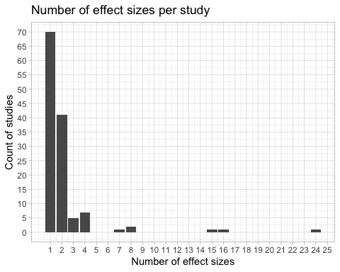

## Percentage of studies reporting 1 effect size   
df_percentage_es <- df_groub_by_study %>%  
 group_by(n_es) %>%  
 summarize(total = n()) %>%  
 mutate(percentage = round(total/sum(total), 3))

## `summarise()` ungrouping output (override with `.groups` argument)

# Check that sums to 100  
sum(df_percentage_es$percentage)

## [1] 1.002

## Percentage of studies with more than 2 effect sizes   
df_percentage_es %>%  
 filter(n_es > 2 ) %>%  
 mutate(sum = sum(percentage))

## # A tibble: 7 x 4  
## n_es total percentage sum  
## <int> <int> <dbl> <dbl>  
## 1 3 5 0.039 0.141  
## 2 4 7 0.054 0.141  
## 3 7 1 0.008 0.141  
## 4 8 2 0.016 0.141  
## 5 15 1 0.008 0.141  
## 6 16 1 0.008 0.141  
## 7 24 1 0.008 0.141

# Sample sizes   
## Minimum sample size  
min(df3$n)

## [1] 6

## Maximum sample size  
max(df3$n)

## [1] 167605

## Mean sample size  
mean(df3$n)

## [1] 1537.927

## Median sample size  
median(df3$n)

## [1] 165

# Which study has the highest sample size?  
df3 %>%  
 filter(n == max(df3$n))

## document_id study_id sample_id sample_country es_id reference   
## 1 17 18 29 Chile 55 Claro et al. (2016)   
## n adjusted_n student_description school_level   
## 1 167605 167605 10th grade public school students in Chile secondary   
## development_stage risk_status ses ms_measure   
## 1 Adolescents low low SES Theory of Intelligence Scale   
## ms_measure_description mindset_type   
## 1 2 items on a 6-point scale Intelligence   
## achievement_measure_description   
## 1 Average standardized language and math tests   
## academic_achievement_measure_type lab_based published es_type calculation   
## 1 Standardized test no yes continuous Pearson's r   
## variance adjusted_variance is_significant r growth_m growth_sd   
## 1 4.645135e-06 4.645135e-06 Y 0.343 NA NA   
## other_m other_sd cohen_d rpb rb calculated_r notes yi vi   
## 1 NA NA NA NA NA NA <NA> 0.3575 0.0000

# Claro et al. (2016)

# Open a png file   
jpeg("distribution_z.jpeg", width = 800, height = 400, quality = 100)  
# Explore graphically Fisher's Z  
density_z <- ggplot(df3, aes(x=yi)) +   
 geom_histogram(aes(y=..density..), colour = 'black', fill = "white") +  
 geom_density(alpha=.2, fill="#FF6666") +   
 labs(x = "Fisher's Z score",   
 y = "Density") +  
 theme_classic()  
  
# Fisher's Z  
qqplot_z <- ggplot(df3, aes(sample=yi)) +  
 stat_qq(distribution = stats::qnorm) +  
 stat_qq_line(distribution = stats::qnorm,) +  
 labs(x = "Theoretical Quantiles",   
 y = "Sample Quantiles") +  
 theme_classic()  
  
# Original r   
# qqplot_r <- ggplot(df3, aes(sample=r))+  
# stat_qq() +  
# stat_qq_line() +  
# theme_classic()  
  
grid.arrange(density_z, qqplot_z, ncol=2)

## `stat_bin()` using `bins = 30`. Pick better value with `binwidth`.

# Close the png file  
dev.off()

## quartz_off_screen   
## 2

# Meta-analysis 1: Random-effects model (REM)

Other notes: REML to estimate tau, no hakn correction.

# REM of the transformed correlations   
meta1 <- rma (yi = yi,   
 vi = vi,  
 measure = 'ZCOR',  
 data = df3,   
 slab = es_id,   
 method = 'REML')  
summary(meta1, digits = 3)

##   
## Random-Effects Model (k = 273; tau^2 estimator: REML)  
##   
## logLik deviance AIC BIC AICc   
## 60.314 -120.628 -116.628 -109.416 -116.583   
##   
## tau^2 (estimated amount of total heterogeneity): 0.019 (SE = 0.002)  
## tau (square root of estimated tau^2 value): 0.137  
## I^2 (total heterogeneity / total variability): 95.68%  
## H^2 (total variability / sampling variability): 23.13  
##   
## Test for Heterogeneity:  
## Q(df = 272) = 8958.240, p-val < .001  
##   
## Model Results:  
##   
## estimate se zval pval ci.lb ci.ub   
## 0.107 0.010 10.411 <.001 0.087 0.127 ***   
##   
## ---  
## Signif. codes: 0 '***' 0.001 '**' 0.01 '*' 0.05 '.' 0.1 ' ' 1

## Pooled effect size

# Transform from z to r and see if the values you obtain make sense:   
predict(meta1, digits=2, transf=transf.ztor)

##   
## pred ci.lb ci.ub pi.lb pi.ub   
## 0.11 0.09 0.13 -0.16 0.36

* Number of studies = 273
* estimate = 0.11, with 95% CI [0.09, 0.13]. (This is Pearson Correlation)
* The prediction interval ranges is $r=[−0.16,0.36]$. This means that it is possible that some future studies will find a negative correlation between mindset and academic achievement based on the present evidence. But the interval spans also over to a substantial positive effect.
* I will continue the analyses using meta1

# Meta-analysis 2: Random-effects model (REM) - For comparison with Sisks et al.

Other notes: DL to estimate tau, no hakn correction.

# REM of the transformed correlations   
meta2 <- rma (yi = yi,   
 vi = vi,  
 measure = 'ZCOR',  
 data = df3,   
 slab = es_id,   
 method = 'DL')  
summary(meta1, digits = 3)

##   
## Random-Effects Model (k = 273; tau^2 estimator: REML)  
##   
## logLik deviance AIC BIC AICc   
## 60.314 -120.628 -116.628 -109.416 -116.583   
##   
## tau^2 (estimated amount of total heterogeneity): 0.019 (SE = 0.002)  
## tau (square root of estimated tau^2 value): 0.137  
## I^2 (total heterogeneity / total variability): 95.68%  
## H^2 (total variability / sampling variability): 23.13  
##   
## Test for Heterogeneity:  
## Q(df = 272) = 8958.240, p-val < .001  
##   
## Model Results:  
##   
## estimate se zval pval ci.lb ci.ub   
## 0.107 0.010 10.411 <.001 0.087 0.127 ***   
##   
## ---  
## Signif. codes: 0 '***' 0.001 '**' 0.01 '*' 0.05 '.' 0.1 ' ' 1

### Analysis of between-studies heterogeneity

* Cochrane’s Q: If there was no heterogeneity this statistics should be distributed as a $χ^{2}$ distribution with 272 degrees of freedom. In our meta-analysis $Q=8958.24$ with p < .0001. We reject the null hypothesis of homogeneity. There is evidence for heterogeneity.

# Obtain confidence interval for tau^2, I^2, H  
# Interval for tau^2 is obtained iteratively either via the Q-profile method or via the generalized Q-statistic method  
# The square root of the inter- val bounds is also returned for easier interpretation.  
# Confidence intervals for I2 and H2 are also provided (Higgins & Thompson, 2002). Since I2 and H2 are just monotonic transfor- mations of tau2 the confidence intervals for I2 and H2 are also exact  
confint.rma.uni(meta1, digits = 3)

##   
## estimate ci.lb ci.ub   
## tau^2 0.019 0.016 0.028   
## tau 0.137 0.128 0.169   
## I^2(%) 95.677 95.077 97.103   
## H^2 23.132 20.312 34.523

* $I^{2}=95.68$ (95%CI:95.08 - 97.10%), meaning that about 96% of the variability in effect sizes is due between-study heterogeneity. This can be considered substantial heterogeneity (according to Thomppson’s rule of thumb).
* H^2 is 23.13. Values greater than 1 indicate heterogeneity.
* $τ^{2}$, the between-study variance, is 0.0187 with 95% confidence interval [0.016, 0.0284], which does not include zero. Indicates heterogeneity. The confidence interval for $τ^{2}$ was calculated based on the Q-profile method or the generalized Q-statistic method.
* $τ$, is the ’standard deviation of the true effect size and […] it tells us something about the range of the true effect sizes. The true effect sizes have an estimated standard deviation of $SD=0.1369$ expressed on the scale of (**Question: Pearson correlation or Fisher’s Z?)**

## Forest plot

pdf(file='forestplot_metafor.pdf', width = 8, height = 30)  
forest(meta1,  
 header = TRUE,   
 transf = transf.ztor,  
 showweights = TRUE,   
 order = 'obs',  
 efac = 0.2)  
  
### add text with Q-value, dfs, p-value, and I^2 statistic  
# https://www.metafor-project.org/doku.php/plots:forest_plot  
text(-4.6, -3, pos=4, cex=0.75, bquote(paste("RE Model (Q = ",  
 .(formatC(meta1$QE, digits=2, format="f")), ", df = ", .(meta1$k - meta1$p),  
 ", p = ", .(formatC(meta1$QEp, digits=2, format="f")), "; ", I^2, " = ",  
 .(formatC(meta1$I2, digits=1, format="f")), "%)")))  
dev.off()

## quartz_off_screen   
## 2

Notes:

* Many of the more precise studies (smaller confidence interval), have an average correlation between -0.03 and 0.24

## Caterpillar plot

# Open jpeg file  
jpeg("caterpillar.jpeg", quality = 100)  
  
# Source code:  
# http://www.metafor-project.org/doku.php/plots:caterpillar_plot   
### create plot  
forest(df3$yi, df3$vi,  
 xlim=c(-2.5,3.5), ### adjust horizontal plot region limits  
 order="obs", ### order by size of yi  
 slab=NA, annotate=FALSE, ### remove study labels and annotations  
 efac=0, ### remove vertical bars at end of CIs  
 pch=19, ### changing point symbol to filled circle  
 col="gray40", ### change color of points/CIs  
 psize=2, ### increase point size  
 cex.lab=1, cex.axis=1, ### increase size of x-axis title/labels  
 lty=c("solid","blank"), ### remove horizontal line at top of plot  
 transf = transf.ztor)   
   
### draw points one more time to make them easier to see  
points(sort(df3$yi), length(df3$vi):1, pch=19, cex=0.5)  
   
### add summary polygon at bottom and text  
addpoly(meta1, mlab="", cex=1, col = 'red')  
text(-2, -2, "RE Model", pos=4, offset=0, cex=1)  
  
# Close jpeg file  
dev.off()

## quartz_off_screen   
## 2

# Find minimum and maximum value of point estimates   
min(df2$r)

## [1] -0.6228928

max(df2$r)

## [1] 0.7531611

## Outliers and Influential cases

inf <- influence(meta1)  
pdf(file='infleunce.pdf')  
plot(inf)  
dev.off()

## quartz_off_screen   
## 2

### create Baujat plot  
baujat(meta1, symbol="slab")

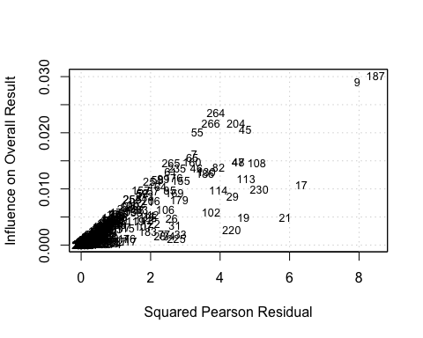

# Look at es_id = 9 and 187  
df3 %>% filter(es_id == 9)

## document_id study_id sample_id sample_country es_id reference n   
## 1 4 4 6 USA 9 Bergen (1991) 110   
## adjusted_n student_description school_level development_stage risk_status   
## 1 110 undergraduates post-secondary Adults low   
## ses ms_measure ms_measure_description mindset_type   
## 1 not reported Theory of Intelligence 8 items on a 7-point scale Intelligence   
## achievement_measure_description academic_achievement_measure_type lab_based   
## 1 ACT scores Standardized test no   
## published es_type calculation variance adjusted_variance is_significant   
## 1 no continuous Pearson's r 0.007064278 0.007064278 Y   
## r growth_m growth_sd other_m other_sd cohen_d rpb rb calculated_r   
## 1 -0.35 NA NA NA NA NA NA NA NA   
## notes   
## 1 the authors of the study used a measure where greater incremental theory was associated with lower scores, so we reversed the sign of the effect size   
## yi vi   
## 1 -0.3654 0.0093

## Subgroup analysis

Sisks et al. (2018) found as **significant** moderators:

* Student factors:
  + Developmental stage of the student: children, adolescents, adults
* Developmental stage as a moderator of mind-set on GPA

Sisks et al. (2018) found as **non- significant** moderators:

* Student factors:
  + Academic risk status: low-risk, moderately at risk, highly at-risk students
  + Socioeconomic status
* Academic achievement measure: Course exam, Course grade, GPA, Standardized test

### Developmental stage

# Prepare dataset  
levels(df3$development_stage)

## [1] "Wide Range" "Adolescents" "Adults" "Children"

# Subset to exclude "Wide Range"   
df3_develop <- filter(df3,   
 (development_stage == "Adolescents") |   
 (development_stage == "Adults") |  
 (development_stage == "Children"))  
# Adjust labels  
df3_develop$development_stage <- droplevels(df3_develop$development_stage)  
levels(df3_develop$development_stage)

## [1] "Adolescents" "Adults" "Children"

# Inspect visually the relationship between Fisher's z and the categories   
# x = developmental_stage y = Fisher's z   
ggplot(data=df3_develop, mapping = aes(x=development_stage, y = yi)) +  
 geom_dotplot(binaxis='y',   
 stackdir='center',   
 stackratio=1.5,   
 dotsize=0.5,  
 fill="#3399ff") +  
 stat_summary(fun.y=mean, geom="point", shape=18,  
 size=3, color="#ff5050")+  
 theme_classic()

## Warning: `fun.y` is deprecated. Use `fun` instead.

## Bin width defaults to 1/30 of the range of the data. Pick better value with `binwidth`.

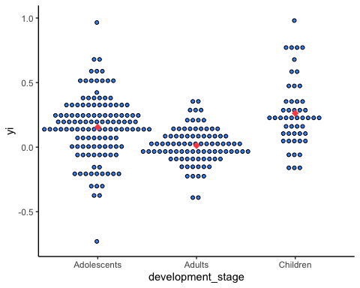

We see overlap in the outcome between the three categories, though it may be that children and adolescents show a higher effect than adults.

The range of values is larger for adolescents and children compared to adults. Probably this would call for estimating different tau^2 for each group

Next, I a weighted ANOVA. There are two options:

* common $τ^{2}$:
* different $τ^{2}$

# Fit meta-analysis:   
# COMMON TAU^2:   
## Same between-study variance within each subgroup (Adolescents, Adults, Children)  
meta1_develop1 <- rma (yi = yi,  
 vi = vi,  
 measure = 'ZCOR',  
 data = df3_develop,  
 mods = ~ development_stage-1)  
summary(meta1_develop1, digits = 3)

##   
## Mixed-Effects Model (k = 265; tau^2 estimator: REML)  
##   
## logLik deviance AIC BIC AICc   
## 78.298 -156.597 -148.597 -134.323 -148.441   
##   
## tau^2 (estimated amount of residual heterogeneity): 0.014 (SE = 0.002)  
## tau (square root of estimated tau^2 value): 0.119  
## I^2 (residual heterogeneity / unaccounted variability): 94.13%  
## H^2 (unaccounted variability / sampling variability): 17.03  
##   
## Test for Residual Heterogeneity:  
## QE(df = 262) = 5395.403, p-val < .001  
##   
## Test of Moderators (coefficients 1:3):  
## QM(df = 3) = 184.782, p-val < .001  
##   
## Model Results:  
##   
## estimate se zval pval ci.lb ci.ub   
## development_stageAdolescents 0.151 0.014 10.649 <.001 0.123 0.179   
## development_stageAdults 0.021 0.015 1.370 0.171 -0.009 0.050   
## development_stageChildren 0.201 0.024 8.337 <.001 0.154 0.248   
##   
## development_stageAdolescents ***   
## development_stageAdults   
## development_stageChildren ***   
##   
## ---  
## Signif. codes: 0 '***' 0.001 '**' 0.01 '*' 0.05 '.' 0.1 ' ' 1

# Transform the estimates of the differences from z to r   
transf.ztor(meta1_develop1$b)

## [,1]  
## development_stageAdolescents 0.14963377  
## development_stageAdults 0.02051523  
## development_stageChildren 0.19851106

# Multiple comparisons  
# https://wviechtb.github.io/metafor/reference/rma.uni.html  
multcomp_develop1 <- glht(meta1_develop1,  
 linfct=contrMat(c("Adolescents"=1,"Adults"=1,"Children"=1),  
 type="Tukey"),test=adjusted("bonferroni"))  
  
summary(multcomp_develop1)

##   
## Simultaneous Tests for General Linear Hypotheses  
##   
## Multiple Comparisons of Means: Tukey Contrasts  
##   
##   
## Fit: rma(yi = yi, vi = vi, mods = ~development_stage - 1, measure = "ZCOR",   
## data = df3_develop)  
##   
## Linear Hypotheses:  
## Estimate Std. Error z value Pr(>|z|)   
## Adults - Adolescents == 0 -0.13025 0.02061 -6.321 <0.001 ***  
## Children - Adolescents == 0 0.05042 0.02798 1.802 0.166   
## Children - Adults == 0 0.18066 0.02840 6.362 <0.001 ***  
## ---  
## Signif. codes: 0 '***' 0.001 '**' 0.01 '*' 0.05 '.' 0.1 ' ' 1  
## (Adjusted p values reported -- single-step method)

# Note that the estimate of the differences in the output are Fisher z

# Fit meta-analysis:   
# DIFFERENT TAU^2 PER SUBGROUP:   
## Different between-study variance within each subgroup (Adolescents, Adults, Children)  
# https://wviechtb.github.io/metafor/reference/rma.uni.html  
  
# We have to fit 3 models: ado, adu, chi  
meta1_develop2_ado <- rma (yi = yi,  
 vi = vi,  
 measure = 'ZCOR',  
 data = df3_develop,  
 mods = ~ development_stage-1,  
 subset = (development_stage=="Adolescents"))

## Warning: Redundant predictors dropped from the model.

summary(meta1_develop2_ado, digits = 3)

##   
## Random-Effects Model (k = 126; tau^2 estimator: REML)  
##   
## logLik deviance AIC BIC AICc   
## 20.075 -40.150 -36.150 -30.493 -36.051   
##   
## tau^2 (estimated amount of total heterogeneity): 0.019 (SE = 0.004)  
## tau (square root of estimated tau^2 value): 0.139  
## I^2 (total heterogeneity / total variability): 97.43%  
## H^2 (total variability / sampling variability): 38.85  
##   
## Test for Heterogeneity:  
## Q(df = 125) = 4868.986, p-val < .001  
##   
## Model Results:  
##   
## estimate se zval pval ci.lb ci.ub   
## 0.150 0.016 9.467 <.001 0.119 0.181 ***   
##   
## ---  
## Signif. codes: 0 '***' 0.001 '**' 0.01 '*' 0.05 '.' 0.1 ' ' 1

meta1_develop2_adu <- rma (yi = yi,  
 vi = vi,  
 measure = 'ZCOR',  
 data = df3_develop,  
 mods = ~ development_stage-1,  
 subset = (development_stage=="Adults"))

## Warning: Redundant predictors dropped from the model.

summary(meta1_develop2_adu, digits = 3)

##   
## Random-Effects Model (k = 89; tau^2 estimator: REML)  
##   
## logLik deviance AIC BIC AICc   
## 52.299 -104.599 -100.599 -95.644 -100.457   
##   
## tau^2 (estimated amount of total heterogeneity): 0.011 (SE = 0.002)  
## tau (square root of estimated tau^2 value): 0.104  
## I^2 (total heterogeneity / total variability): 81.25%  
## H^2 (total variability / sampling variability): 5.33  
##   
## Test for Heterogeneity:  
## Q(df = 88) = 394.676, p-val < .001  
##   
## Model Results:  
##   
## estimate se zval pval ci.lb ci.ub   
## 0.021 0.014 1.564 0.118 -0.005 0.048   
##   
## ---  
## Signif. codes: 0 '***' 0.001 '**' 0.01 '*' 0.05 '.' 0.1 ' ' 1

meta1_develop2_chi <- rma (yi = yi,  
 vi = vi,  
 measure = 'ZCOR',  
 data = df3_develop,  
 mods = ~ development_stage-1,  
 subset = (development_stage=="Children"))

## Warning: Redundant predictors dropped from the model.

summary(meta1_develop2_chi, digits =3)

##   
## Random-Effects Model (k = 50; tau^2 estimator: REML)  
##   
## logLik deviance AIC BIC AICc   
## 8.434 -16.869 -12.869 -9.085 -12.608   
##   
## tau^2 (estimated amount of total heterogeneity): 0.008 (SE = 0.003)  
## tau (square root of estimated tau^2 value): 0.090  
## I^2 (total heterogeneity / total variability): 68.25%  
## H^2 (total variability / sampling variability): 3.15  
##   
## Test for Heterogeneity:  
## Q(df = 49) = 131.742, p-val < .001  
##   
## Model Results:  
##   
## estimate se zval pval ci.lb ci.ub   
## 0.198 0.020 9.862 <.001 0.159 0.237 ***   
##   
## ---  
## Signif. codes: 0 '***' 0.001 '**' 0.01 '*' 0.05 '.' 0.1 ' ' 1

# Compare tau^2   
tau2_comp <- data.frame(rbind(meta1_develop1$tau2,   
 meta1_develop2_ado$tau2,  
 meta1_develop2_adu$tau2,  
 meta1_develop2_chi$tau2))  
names(tau2_comp) <- 'tau^2'  
rownames(tau2_comp) <- c('Common', 'Adolescents', 'Adults', 'Children')  
round(tau2_comp, 3)

## tau^2  
## Common 0.014  
## Adolescents 0.019  
## Adults 0.011  
## Children 0.008

# Compare I^2  
i2_comp <- data.frame(rbind(meta1_develop1$I2,   
 meta1_develop2_ado$I2,  
 meta1_develop2_adu$I2,  
 meta1_develop2_chi$I2))  
names(i2_comp) <- 'I^2'  
rownames(i2_comp) <- c('Common', 'Adolescents', 'Adults', 'Children')  
round(i2_comp,2)

## I^2  
## Common 94.13  
## Adolescents 97.43  
## Adults 81.25  
## Children 68.25

## Publication bias

### Funnel plot

# Reference: https://wviechtb.github.io/metafor/reference/funnel.html   
funnel(meta1,   
 level=c(90, 95, 99),   
 shade=c("white", "gray55", "gray75"),   
 legend=TRUE)

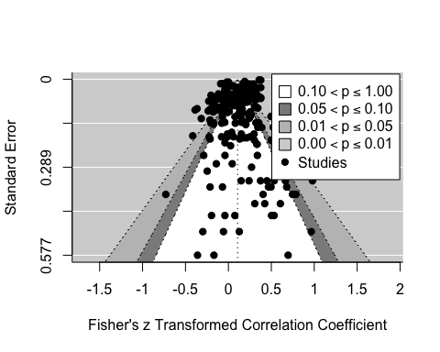

### Egger’s regression test

# Reference: https://wviechtb.github.io/metafor/reference/regtest.html  
meta1_regtst <- regtest(meta1, model = 'lm')  
meta1_regtst

##   
## Regression Test for Funnel Plot Asymmetry  
##   
## Model: weighted regression with multiplicative dispersion  
## Predictor: standard error  
##   
## Test for Funnel Plot Asymmetry: t = -9.1604, df = 271, p < .0001  
## Limit Estimate (as sei -> 0): b = 0.3149 (CI: 0.2975, 0.3323)

meta1_regtst$model

## [1] "lm"

meta1_regtst$predictor

## [1] "sei"

meta1_regtst$fit

##   
## Call:  
## lm(formula = yi ~ X - 1, weights = 1/vi)  
##   
## Coefficients:  
## Xintrcpt Xsei   
## 0.3149 -3.1671

We cannot reject the null hypothesis that the intercept is equal to zero. Therefore we do not have evidence for funnel plot asymmetry. ("When there is no publication bias, the expected z score should be scattered around zero. No publication bias means means that the precision is not related to the effect size reported (beta1=0)).

# Check with meta  
library(meta)  
meta_del <- metacor(cor = r,   
 n = n,   
 studlab = reference,   
 data= df2,   
 fixed = FALSE,   
 random = TRUE,   
 method.tau = 'REML',   
 hakn = FALSE,   
 title = "Mindset and Academic Achievement",   
 prediction = TRUE)  
metabias(meta_del, method.bias = 'linreg')

## Review: Mindset and Academic Achievement  
##   
## Linear regression test of funnel plot asymmetry  
##   
## Test result: t = -9.16, df = 271, p-value < 0.0001  
##   
## Sample estimates:  
## bias se.bias intercept se.intercept  
## -3.1671 0.3457 0.3149 0.0088  
##   
## Details:  
## - multiplicative residual heterogeneity variance (tau^2 = 25.2407)  
## - predictor: standard error  
## - weight: inverse variance  
## - reference: Egger et al. (1997), BMJ

### Trim and Fill method

# Trim and Fill R0  
meta1_tf_R0 <- trimfill(meta1,  
 estimator = 'R0')  
summary(meta1_tf_R0)

##   
## Estimated number of missing studies on the left side: 1 (SE = 2.0000)  
## Test of H0: no missing studies on the left side: p-val = 0.2500  
##   
## Random-Effects Model (k = 274; tau^2 estimator: REML)  
##   
## logLik deviance AIC BIC AICc   
## 57.4754 -114.9507 -110.9507 -103.7318 -110.9063   
##   
## tau^2 (estimated amount of total heterogeneity): 0.0189 (SE = 0.0023)  
## tau (square root of estimated tau^2 value): 0.1373  
## I^2 (total heterogeneity / total variability): 95.69%  
## H^2 (total variability / sampling variability): 23.18  
##   
## Test for Heterogeneity:  
## Q(df = 273) = 8968.0478, p-val < .0001  
##   
## Model Results:  
##   
## estimate se zval pval ci.lb ci.ub   
## 0.1064 0.0103 10.3236 <.0001 0.0862 0.1266 ***   
##   
## ---  
## Signif. codes: 0 '***' 0.001 '**' 0.01 '*' 0.05 '.' 0.1 ' ' 1

funnel(meta1_tf_R0, legend=TRUE, cex=1.2)

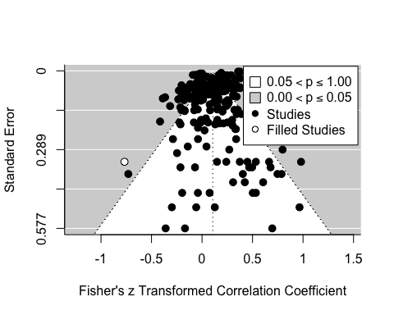

# Trim and Fill L0  
meta1_tf_L0 <- trimfill(meta1,  
 estimator = 'L0')  
summary(meta1_tf_L0)

##   
## Estimated number of missing studies on the left side: 10 (SE = 10.0506)  
##   
## Random-Effects Model (k = 283; tau^2 estimator: REML)  
##   
## logLik deviance AIC BIC AICc   
## 43.4255 -86.8511 -82.8511 -75.5673 -82.8081   
##   
## tau^2 (estimated amount of total heterogeneity): 0.0195 (SE = 0.0023)  
## tau (square root of estimated tau^2 value): 0.1397  
## I^2 (total heterogeneity / total variability): 95.69%  
## H^2 (total variability / sampling variability): 23.23  
##   
## Test for Heterogeneity:  
## Q(df = 282) = 9026.8722, p-val < .0001  
##   
## Model Results:  
##   
## estimate se zval pval ci.lb ci.ub   
## 0.1014 0.0104 9.7543 <.0001 0.0811 0.1218 ***   
##   
## ---  
## Signif. codes: 0 '***' 0.001 '**' 0.01 '*' 0.05 '.' 0.1 ' ' 1

funnel(meta1_tf_L0, legend=TRUE, cex=1.2)

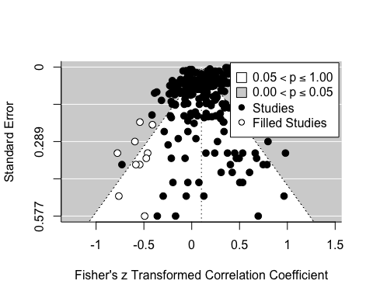

# Trim and Fill Q0  
meta1_tf_Q0 <- trimfill(meta1,  
 estimator = 'Q0')  
summary(meta1_tf_Q0)

##   
## Estimated number of missing studies on the left side: 11 (SE = 10.5006)  
##   
## Random-Effects Model (k = 284; tau^2 estimator: REML)  
##   
## logLik deviance AIC BIC AICc   
## 42.6380 -85.2760 -81.2760 -73.9851 -81.2331   
##   
## tau^2 (estimated amount of total heterogeneity): 0.0195 (SE = 0.0023)  
## tau (square root of estimated tau^2 value): 0.1397  
## I^2 (total heterogeneity / total variability): 95.68%  
## H^2 (total variability / sampling variability): 23.16  
##   
## Test for Heterogeneity:  
## Q(df = 283) = 9029.7282, p-val < .0001  
##   
## Model Results:  
##   
## estimate se zval pval ci.lb ci.ub   
## 0.1011 0.0104 9.7265 <.0001 0.0808 0.1215 ***   
##   
## ---  
## Signif. codes: 0 '***' 0.001 '**' 0.01 '*' 0.05 '.' 0.1 ' ' 1

funnel(meta1_tf_Q0, legend=TRUE, cex=1.2)

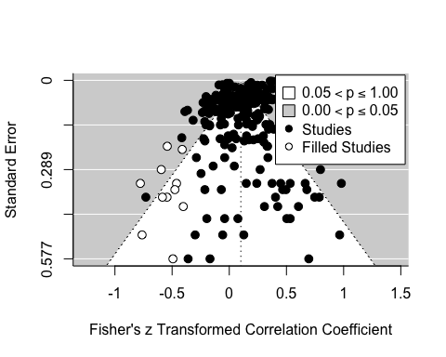

### Selection models

#### Three-parameter selection model

meta1_3psm1 <- selmodel(meta1,  
 type = 'stepfun',   
 steps = 0.025)  
summary(meta1_3psm1)

##   
## Random-Effects Model (k = 273; tau^2 estimator: ML)  
##   
## logLik deviance AIC BIC AICc   
## 61.4796 -122.9593 -116.9593 -106.1309 -116.8701   
##   
## tau^2 (estimated amount of total heterogeneity): 0.0184 (SE = 0.0024)  
## tau (square root of estimated tau^2 value): 0.1358  
##   
## Test for Heterogeneity:  
## LRT(df = 1) = 7767.9817, p-val < .0001  
##   
## Model Results:  
##   
## estimate se zval pval ci.lb ci.ub   
## 0.0977 0.0157 6.2393 <.0001 0.0670 0.1283 ***   
##   
## Test for Selection Model Parameters:  
## LRT(df = 1) = 0.6219, p-val = 0.4304  
##   
## Selection Model Results:  
##   
## k estimate se zval pval ci.lb ci.ub   
## 0 < p <= 0.025 102 1.0000 --- --- --- --- ---   
## 0.025 < p <= 1 171 0.8452 0.1800 -0.8599 0.3898 0.4923 1.1980   
##   
## ---  
## Signif. codes: 0 '***' 0.001 '**' 0.01 '*' 0.05 '.' 0.1 ' ' 1

meta1_3psm2 <- selmodel(meta1,  
 type = 'stepfun',   
 steps = 0.05)  
summary(meta1_3psm2)

##   
## Random-Effects Model (k = 273; tau^2 estimator: ML)  
##   
## logLik deviance AIC BIC AICc   
## 61.2635 -122.5271 -116.5271 -105.6987 -116.4379   
##   
## tau^2 (estimated amount of total heterogeneity): 0.0186 (SE = 0.0024)  
## tau (square root of estimated tau^2 value): 0.1364  
##   
## Test for Heterogeneity:  
## LRT(df = 1) = 7772.5697, p-val < .0001  
##   
## Model Results:  
##   
## estimate se zval pval ci.lb ci.ub   
## 0.1018 0.0158 6.4316 <.0001 0.0708 0.1328 ***   
##   
## Test for Selection Model Parameters:  
## LRT(df = 1) = 0.1897, p-val = 0.6632  
##   
## Selection Model Results:  
##   
## k estimate se zval pval ci.lb ci.ub   
## 0 < p <= 0.05 114 1.0000 --- --- --- --- ---   
## 0.05 < p <= 1 159 0.9141 0.1883 -0.4560 0.6484 0.5451 1.2831   
##   
## ---  
## Signif. codes: 0 '***' 0.001 '**' 0.01 '*' 0.05 '.' 0.1 ' ' 1

## Multilevel meta-analysis

meta1_multi1 <- rma.mv(yi = yi,   
 V = vi,   
 random = list(~1 | study_id/es_id),   
 data = df3,  
 slab = es_id)  
  
# QUESTION: I don't have to specify measure = 'ZCOR'?  
  
summary(meta1_multi1, digits =3)

##   
## Multivariate Meta-Analysis Model (k = 273; method: REML)  
##   
## logLik Deviance AIC BIC AICc   
## 83.431 -166.861 -160.861 -150.044 -160.772   
##   
## Variance Components:  
##   
## estim sqrt nlvls fixed factor   
## sigma^2.1 0.015 0.124 129 no study_id   
## sigma^2.2 0.004 0.064 273 no study_id/es_id   
##   
## Test for Heterogeneity:  
## Q(df = 272) = 8958.240, p-val < .001  
##   
## Model Results:  
##   
## estimate se zval pval ci.lb ci.ub   
## 0.091 0.013 6.842 <.001 0.065 0.117 ***   
##   
## ---  
## Signif. codes: 0 '***' 0.001 '**' 0.01 '*' 0.05 '.' 0.1 ' ' 1

* Variance components:
  + The between-study variance is sigma^2.1 = 0.0153 (equivalent to tau^2 in REM)- At this level we have 129 studies.
  + The within-study variance is sigma^2.2 = 0.0041. At this level we have 273 effect sizes.
* Estimate: 0.0906. However, this is a Fisher’s z, so we have to transform the effect back to a normal correlation:

round(transf.ztor(meta1_multi1$b), 3)

## [,1]  
## intrcpt 0.09

round(transf.ztor(meta1_multi1$ci.lb), 3)

## [1] 0.065

round(transf.ztor(meta1_multi1$ci.ub), 3)

## [1] 0.116

* The correlation is approximately 0.09 with 95%CI [0.065,0.116]
* The test for heterogeneity rejects the null hypothesis of homogeneity, “however this is not informative. Instead, we should look at the amount of heterogeneity caputred by each level in our model.” “We are interested in within-study variance (level 2) as well as between-study variance (level 3) and not the variance between all effect sizes in the dataset”.

### Testing the within-study variance

# Two-level model without within-study variance   
  
meta1_multi2 <- rma.mv(yi = yi,   
 V = vi,   
 random = list(~1 | study_id/es_id),   
 data = df3,  
 slab = es_id,  
 sigma2 = c(0, NA))  
  
# Perform a likelihood-ratio test to determine the significance of   
# the within-study variance  
anova(meta1_multi1, meta1_multi2)

##   
## df AIC BIC AICc logLik LRT pval QE   
## Full 3 -160.8614 -150.0440 -160.7718 83.4307 8958.2395   
## Reduced 2 -116.6280 -109.4164 -116.5834 60.3140 46.2334 <.0001 8958.2395

* From the LRT we “found significant variability between effect-sizes within studies”

### Testing the between-study variance

# Two-level model without between-study variance   
  
meta1_multi3 <- rma.mv(yi = yi,   
 V = vi,   
 random = list(~1 | study_id/es_id),   
 data = df3,  
 slab = es_id,  
 sigma2 = c(NA, 0))  
  
# Perform a likelihood-ratio test to determine the significance of   
# the within-study variance  
anova(meta1_multi1, meta1_multi3)

##   
## df AIC BIC AICc logLik LRT pval QE   
## Full 3 -160.8614 -150.0440 -160.7718 83.4307 8958.2395   
## Reduced 2 -77.8763 -70.6647 -77.8317 40.9382 84.9850 <.0001 8958.2395

* “Between-study variance is significant, since the fit of the full model is significantly better than the fit of the reduced model”. “We found significant variability between studies”
* However, we would like to know how the total variance is splitted in the different levels. See next section

### Distribution of variance over the three levels of the meta-analytic model

# I^2 at different levels  
# See function description under 'Packages and data' at the top  
multilevel_i2(v = df3$vi,   
 k = length(df3$vi),  
 rma_obj = meta1_multi1)

## I2 Level  
## I2_1 4.17 Level 1  
## I2_2 75.43 Level 2  
## I2_3 20.40 Level 3

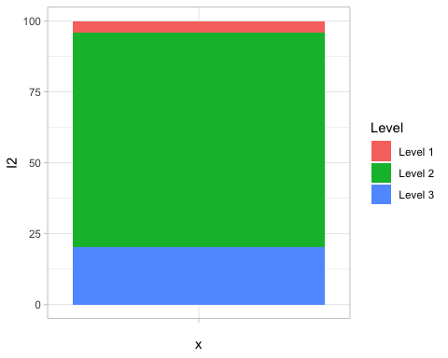 * Chen, 2015 pg. 92: “I2 can be interpreted as the proportion of the total variation of the effect size that is due to the between-study heterogeneity”

* 4.17 % of the total variance can be attributed to within-study sampling variance (level-1)
* 75.43 % of the total variance can be attributed to within study variance (differences between effect sizes within studies)
* 20.4 % of the total variance can be attributed to differences between studies at level 3.

Conclusion: A lot of the variance is within-studies

### Subgroup analysis

#### Developmental stage

# Fit 3-level model with developmental_stage as moderator  
  
meta1_multi1_develop1 <- rma.mv(yi = yi,   
 V = vi,  
 random = list(~1 | study_id/es_id),  
 data = df3_develop,  
 slab = es_id,  
 mods = ~ development_stage -1)  
  
# QUESTION: I don't have to specify measure = 'ZCOR'?  
summary(meta1_multi1_develop1, digits =3)

##   
## Multivariate Meta-Analysis Model (k = 265; method: REML)  
##   
## logLik Deviance AIC BIC AICc   
## 93.340 -186.680 -176.680 -158.839 -176.446   
##   
## Variance Components:  
##   
## estim sqrt nlvls fixed factor   
## sigma^2.1 0.011 0.103 123 no study_id   
## sigma^2.2 0.004 0.063 265 no study_id/es_id   
##   
## Test for Residual Heterogeneity:  
## QE(df = 262) = 5395.403, p-val < .001  
##   
## Test of Moderators (coefficients 1:3):  
## QM(df = 3) = 100.545, p-val < .001  
##   
## Model Results:  
##   
## estimate se zval pval ci.lb ci.ub   
## development_stageAdolescents 0.146 0.017 8.444 <.001 0.112 0.180 ***   
## development_stageAdults 0.006 0.018 0.316 0.752 -0.030 0.042   
## development_stageChildren 0.195 0.035 5.627 <.001 0.127 0.262 ***   
##   
## ---  
## Signif. codes: 0 '***' 0.001 '**' 0.01 '*' 0.05 '.' 0.1 ' ' 1

# Multiple comparisons  
multcomp_multi1_develop1 <- glht(meta1_multi1_develop1,  
 linfct=contrMat(c("Adolescents"=1,"Adults"=1,"Children"=1),  
 type="Tukey"),test=adjusted("bonferroni"))  
  
summary(multcomp_multi1_develop1)

##   
## Simultaneous Tests for General Linear Hypotheses  
##   
## Multiple Comparisons of Means: Tukey Contrasts  
##   
##   
## Fit: rma.mv(yi = yi, V = vi, mods = ~development_stage - 1, random = list(~1 |   
## study_id/es_id), data = df3_develop, slab = es_id)  
##   
## Linear Hypotheses:  
## Estimate Std. Error z value Pr(>|z|)   
## Adults - Adolescents == 0 -0.14067 0.02523 -5.575 <1e-04 ***  
## Children - Adolescents == 0 0.04808 0.03825 1.257 0.413   
## Children - Adults == 0 0.18875 0.03913 4.824 <1e-04 ***  
## ---  
## Signif. codes: 0 '***' 0.001 '**' 0.01 '*' 0.05 '.' 0.1 ' ' 1  
## (Adjusted p values reported -- single-step method)

# Note that the estimate of the differences in the output are Fisher z

* Test for residual heterogeneity is significant: there is significant unexplained variance left between all effect sizes in the data set after publication status has been added to the meta-analytic model
* Test of moderators: Omnibus test. We reject the null hypothesis of no moderation ? Developmental stage is a moderator
* Effects: Adolescents and children significantly different from zero, adults no.

##### Examine the residual within-study and between-study variance

multilevel_i2(df3_develop$vi,   
 k = length(df3_develop$vi),  
 rma_obj = meta1_multi1_develop1)

## I2 Level  
## I2_1 5.47 Level 1  
## I2_2 68.39 Level 2  
## I2_3 26.14 Level 3

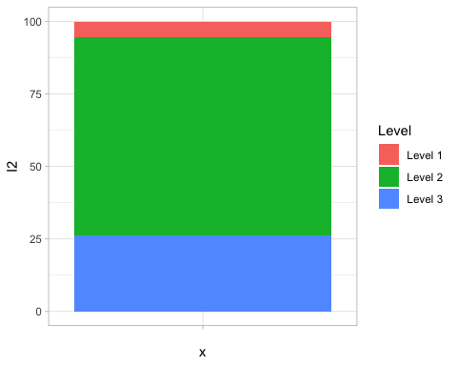

## Publication bias

### Multilevel version of Egger’s regression test

# Reference: Rodgers. RealData-Lehtonen-FinalTables.R Line 318  
rma.mv(yi ~ 1 + sqrt(vi),   
 V = vi,   
 random = ~ 1 | study_id/es_id,   
 data = df3)

##   
## Multivariate Meta-Analysis Model (k = 273; method: REML)  
##   
## Variance Components:  
##   
## estim sqrt nlvls fixed factor   
## sigma^2.1 0.0155 0.1243 129 no study_id   
## sigma^2.2 0.0041 0.0644 273 no study_id/es_id   
##   
## Test for Residual Heterogeneity:  
## QE(df = 271) = 6840.2376, p-val < .0001  
##   
## Test of Moderators (coefficient 2):  
## QM(df = 1) = 0.0000, p-val = 0.9992  
##   
## Model Results:  
##   
## estimate se zval pval ci.lb ci.ub   
## intrcpt 0.0906 0.0205 4.4106 <.0001 0.0503 0.1308 ***   
## sqrt(vi) 0.0002 0.2155 0.0010 0.9992 -0.4221 0.4226   
##   
## ---  
## Signif. codes: 0 '***' 0.001 '**' 0.01 '*' 0.05 '.' 0.1 ' ' 1

### Trim and Fill method

To perform the Trim and Fill, instead of ignoring dependence, like it was previously done, I can either sample one effect size per group or aggregate.

Here I create a new dataset where I aggregate the effect sizes

# Create dataset with aggregated effect sizes  
# My code  
# df4_aggregated<-  
# df3 %>%  
# group_by(study_id) %>%  
# summarise(new_n = sum(n),  
# sum_yi = sum(yi),   
# sum_vi = sum(vi),  
# new_yi = (1/new_n)*sum_yi,   
# new_vi = (1/new_n)*sum_vi)  
  
# Reference: Rodgers RealData-Lehtonen-FinalTables.R, line 75  
# df4_comparison <-  
# df3 %>%  
# group_by(study_id) %>%  
# summarise_at(vars(yi, vi), mean)  
  
# Fit a new model   
# meta3_aggreagated <- rma (yi = new_yi,  
# vi = new_vi,  
# measure = 'ZCOR',  
# data = df4_aggregated,  
#  method = 'REML')  
# summary(meta3_aggreagated, digits = 3)  
  
# Do trim and fill

Here I create a new dataset where I sample the effect sizes

# Reference: Rodgers RealData-Lehtonen-FinalTables.R, line 86  
  
set.seed(1)  
  
df4_sampled <-  
 df3 %>%  
 group_by(study_id) %>%  
 sample_n(size = 1)  
  
# Fit RMA  
meta3_sampled<- rma (yi = yi,  
 vi = vi,  
 measure = 'ZCOR',  
 data = df4_sampled,  
 method = 'REML')  
summary(meta3_sampled, digits = 3)

##   
## Random-Effects Model (k = 129; tau^2 estimator: REML)  
##   
## logLik deviance AIC BIC AICc   
## 50.032 -100.065 -96.065 -90.361 -95.969   
##   
## tau^2 (estimated amount of total heterogeneity): 0.018 (SE = 0.003)  
## tau (square root of estimated tau^2 value): 0.133  
## I^2 (total heterogeneity / total variability): 97.11%  
## H^2 (total variability / sampling variability): 34.56  
##   
## Test for Heterogeneity:  
## Q(df = 128) = 5315.481, p-val < .001  
##   
## Model Results:  
##   
## estimate se zval pval ci.lb ci.ub   
## 0.087 0.014 6.411 <.001 0.061 0.114 ***   
##   
## ---  
## Signif. codes: 0 '***' 0.001 '**' 0.01 '*' 0.05 '.' 0.1 ' ' 1

# Trim and Fill R0  
meta3_sampled_tf_R0 <- trimfill(meta3_sampled,  
 estimator = 'R0')  
summary(meta3_sampled_tf_R0 )

##   
## Estimated number of missing studies on the right side: 0 (SE = 1.4142)  
## Test of H0: no missing studies on the right side: p-val = 0.5000  
##   
## Random-Effects Model (k = 129; tau^2 estimator: REML)  
##   
## logLik deviance AIC BIC AICc   
## 50.0324 -100.0648 -96.0648 -90.3608 -95.9688   
##   
## tau^2 (estimated amount of total heterogeneity): 0.0176 (SE = 0.0029)  
## tau (square root of estimated tau^2 value): 0.1328  
## I^2 (total heterogeneity / total variability): 97.11%  
## H^2 (total variability / sampling variability): 34.56  
##   
## Test for Heterogeneity:  
## Q(df = 128) = 5315.4814, p-val < .0001  
##   
## Model Results:  
##   
## estimate se zval pval ci.lb ci.ub   
## 0.0873 0.0136 6.4110 <.0001 0.0606 0.1140 ***   
##   
## ---  
## Signif. codes: 0 '***' 0.001 '**' 0.01 '*' 0.05 '.' 0.1 ' ' 1

funnel(meta3_sampled_tf_R0 , legend=TRUE, cex=1.2)

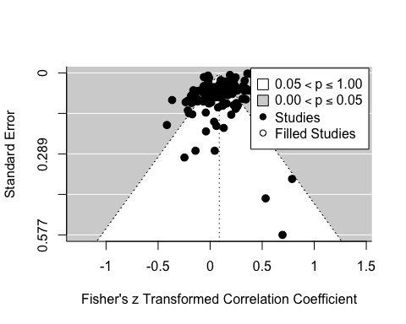

# Trim and Fill L0  
meta3_sampled_tf_L0 <- trimfill(meta3_sampled,  
 estimator = 'L0')  
summary(meta3_sampled_tf_L0)

##   
## Estimated number of missing studies on the right side: 11 (SE = 7.2144)  
##   
## Random-Effects Model (k = 140; tau^2 estimator: REML)  
##   
## logLik deviance AIC BIC AICc   
## 37.9023 -75.8046 -71.8046 -65.9356 -71.7163   
##   
## tau^2 (estimated amount of total heterogeneity): 0.0222 (SE = 0.0034)  
## tau (square root of estimated tau^2 value): 0.1490  
## I^2 (total heterogeneity / total variability): 97.50%  
## H^2 (total variability / sampling variability): 40.07  
##   
## Test for Heterogeneity:  
## Q(df = 139) = 5335.5685, p-val < .0001  
##   
## Model Results:  
##   
## estimate se zval pval ci.lb ci.ub   
## 0.1080 0.0145 7.4510 <.0001 0.0796 0.1364 ***   
##   
## ---  
## Signif. codes: 0 '***' 0.001 '**' 0.01 '*' 0.05 '.' 0.1 ' ' 1

funnel(meta3_sampled_tf_L0, legend=TRUE, cex=1.2)

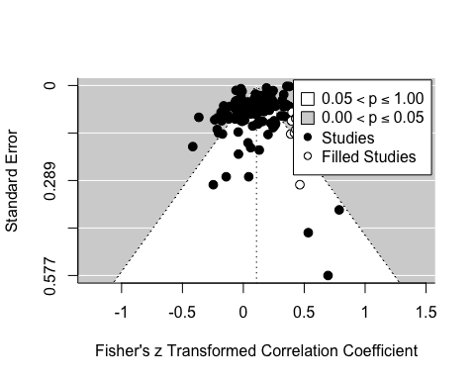

# Trim and Fill Q0  
meta3_sampled_tf_Q0 <- trimfill(meta3_sampled,  
 estimator = 'Q0')  
summary(meta3_sampled_tf_Q0)

##   
## Estimated number of missing studies on the right side: 14 (SE = 8.2478)  
##   
## Random-Effects Model (k = 143; tau^2 estimator: REML)  
##   
## logLik deviance AIC BIC AICc   
## 35.0823 -70.1646 -66.1646 -60.2529 -66.0783   
##   
## tau^2 (estimated amount of total heterogeneity): 0.0239 (SE = 0.0036)  
## tau (square root of estimated tau^2 value): 0.1546  
## I^2 (total heterogeneity / total variability): 97.64%  
## H^2 (total variability / sampling variability): 42.30  
##   
## Test for Heterogeneity:  
## Q(df = 142) = 5342.5898, p-val < .0001  
##   
## Model Results:  
##   
## estimate se zval pval ci.lb ci.ub   
## 0.1149 0.0148 7.7777 <.0001 0.0860 0.1439 ***   
##   
## ---  
## Signif. codes: 0 '***' 0.001 '**' 0.01 '*' 0.05 '.' 0.1 ' ' 1

funnel(meta3_sampled_tf_Q0, legend=TRUE, cex=1.2)

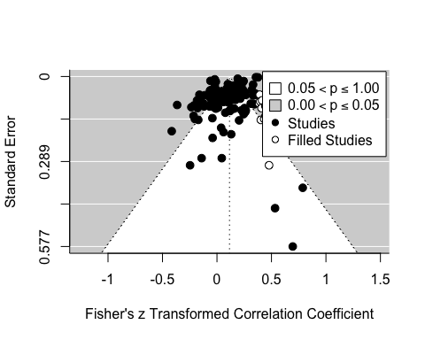

### Selection models

#### Three-parameter selection model

meta3_sampled_3psm1 <- selmodel(meta3_sampled,  
 type = 'stepfun',  
 steps = 0.025)  
summary(meta3_sampled_3psm1)

##   
## Random-Effects Model (k = 129; tau^2 estimator: ML)  
##   
## logLik deviance AIC BIC AICc   
## 51.1238 -102.2476 -96.2476 -87.6682 -96.0556   
##   
## tau^2 (estimated amount of total heterogeneity): 0.0173 (SE = 0.0029)  
## tau (square root of estimated tau^2 value): 0.1316  
##   
## Test for Heterogeneity:  
## LRT(df = 1) = 4556.9756, p-val < .0001  
##   
## Model Results:  
##   
## estimate se zval pval ci.lb ci.ub   
## 0.0788 0.0210 3.7487 0.0002 0.0376 0.1200 ***   
##   
## Test for Selection Model Parameters:  
## LRT(df = 1) = 0.2836, p-val = 0.5943  
##   
## Selection Model Results:  
##   
## k estimate se zval pval ci.lb ci.ub   
## 0 < p <= 0.025 50 1.0000 --- --- --- --- ---   
## 0.025 < p <= 1 79 0.8521 0.2559 -0.5780 0.5632 0.3504 1.3537   
##   
## ---  
## Signif. codes: 0 '***' 0.001 '**' 0.01 '*' 0.05 '.' 0.1 ' ' 1

meta3_sampled_3psm2 <- selmodel(meta3_sampled,  
 type = 'stepfun',  
 steps = 0.05)  
summary(meta3_sampled_3psm2)

##   
## Random-Effects Model (k = 129; tau^2 estimator: ML)  
##   
## logLik deviance AIC BIC AICc   
## 51.2401 -102.4803 -96.4803 -87.9008 -96.2883   
##   
## tau^2 (estimated amount of total heterogeneity): 0.0175 (SE = 0.0029)  
## tau (square root of estimated tau^2 value): 0.1322  
##   
## Test for Heterogeneity:  
## LRT(df = 1) = 4571.6890, p-val < .0001  
##   
## Model Results:  
##   
## estimate se zval pval ci.lb ci.ub   
## 0.0754 0.0216 3.4924 0.0005 0.0331 0.1177 ***   
##   
## Test for Selection Model Parameters:  
## LRT(df = 1) = 0.5163, p-val = 0.4724  
##   
## Selection Model Results:  
##   
## k estimate se zval pval ci.lb ci.ub   
## 0 < p <= 0.05 57 1.0000 --- --- --- --- ---   
## 0.05 < p <= 1 72 0.8088 0.2387 -0.8010 0.4231 0.3409 1.2767   
##   
## ---  
## Signif. codes: 0 '***' 0.001 '**' 0.01 '*' 0.05 '.' 0.1 ' ' 1