Bioinformatics 2019-2020
Date: 15 January 2020
Project report

Bioinformatics@Data Science A.Y. 2019-2020

Malignant Mesothelioma: a study on the interactome
Giulia Cassarà¹, Ivan Colantoni¹
¹Group no. 13

Starting from existing knowledge about a pathological condition we explore the related information sources (DisGeNet datasets), collect the list of human genes of interest and get protein-protein interaction data. After getting the data of interest we will build: seed genes interactome - interactions that involve seed genes only; union interactome -all proteins interacting with at least one seed gene; intersection interactome - all proteins interacting with at least one seed gene confirmed by both Dbs used in the protein-protein interaction data acquisition phase. Using the service Enrichr, we find and report in tables charts of the overrepresented GO categories limiting to the first 10 for each main category, BP, MF, CL) and the the overrepresented pathways (KEGG 2019 Human) for the seed genes and the union interactome genes.

The disease
Malignant mesothelioma is a cancer of the thin tissue (mesothelium) that lines the lung, chest wall, and abdomen. The major risk factor for mesothelioma is asbestos exposure.
In the section below we will see the genes involved in the disease (the so called seed genes) and the interactions between seed genes and non seed genes in the human organism. We collected the interaction data from two different PPI (Protein-Protein Interaction) sources and integrated together to build the seed genes interactome, the union interactome and the intersection interactome. Furthemore, we analyzed the network graph obtained by different interactomes using a Python library, NetworkX. We applied clustering methods for disease modules discovery. Finally, we found putative disease genes using DIAMOnD tool.
Seed genes
To get the list of the seed genes involved in the disease, we explored the DisGeNet website which has a search engine that helps users to find gene-disease associations
(GDAs). The gene-disease associations in DisGeNET is organized according to the types of source databases: for example, we get our GDAs from the CURATED dataset, which contains GDAs from UniProt, PsyGeNET, Orphanet, the CGI, CTD (human data), ClinGen, and the Genomics England PanelApp. From the browser we specified our disease of interest (Malignant Mesothelioma) and downloaded the dataset as tab separated text file.
Then, all of our data analysis is perfomed using a Python Library, Pandas, all configured under the Jupyter Lab framework. In Table 1 we show an example of the tab separated text file obtained from the procedure explained above. Of course, for the demonstration purpose we omitted some informations.
Table 1. List of seed genes for the Malignant Mesothelioma disease obtained from the CURATED dataset of the DisGeNet database.
Gene | Gene_id | UniProt | Gene_Full_Name | Protein_Class
NAT2 | 10 | P11245 | N-acetyltransferase 2 | transferase
PARP1 | 142 | P09874 | poly(ADP-ribose) polymerase 1 | NaN
ANXA2 | 302 | P07355 | Annexin A2 | NaN
APOA1 | 335 | P02647 | Apolipoprotein A1 | NaN

For all genes in the seed gene list, we have checked if the symbols were updated and approved on the HGNC website. All of the gene symbols were approved.
Then, we have collected the following information from Uniprot:
- Official gene symbol.
- Uniprot AC (a.k.a. ‘Uniprot entry’).
- Protein name.
- Entrez Gene ID (a.k.a ‘GeneID),
- and a very brief description of its function
Every information was collected from Uniprot’s section Reviewed (Swiss-Prot). Anyway, for the last point, we had to clean the string of function’s description and truncate the string to keep it shorter and more readable.

In Table 2 we show an example of the tab separated csv file obtained from the procedure written above. Of course, for the demonstration purpose we omitted some informations.
We noticed that every gene has a function description in Uniprot Swiss Reviewed, except for the protein transducin beta like 1 X-linked receptor 1.

Symbol | Name | GeneID | UniprotAC | Function
NAT2 | N-acetyltransferase 2 | 10 | P11245 | Participates in the detoxification of a plethora of hydrazine and arylamine drug
PARP1 | poly(ADP-ribose) polymerase 1 | 142 | Q6N069 | Auxillary subunit of the N-terminal acetyltransferase A (NatA) complex which displays alpha (N-terminal) acetyltransferase activit
ANXA2 | annexin A2 | 302 | Q9H2H9 | Functions as a sodium-dependent amino acid transporte
APOA1 | apolipoprotein A1 | 335 | P09874 | Poly-ADP-ribosyltransferase that mediates poly-ADP-ribosylation of proteins and plays a key role in DNA repair
Summary on interaction data
For each seed gene, we collected all binary protein interactions from two different PPI sources:
- Biogrid Human, latest release available
- IID Integrated Interactions Database (experimental data only)

Table 3 Summarize the main results reporting:
no. of seed genes found in each different Dbs; total no. of interacting proteins, including seed genes, for each DB; total no. of interactions found in each DB.

Source Database | No. of seed genes | No. of interacting proteins | No. of interactions
Biogrid | 104 of 109 | 17899 | 485380
IID | 104 of 109 | 17278 | 270230

We have retrieved some informations from Uniprot about missing genes. These are the genes missing in Biogrid: CCL27, which has full name C-C motif chemokine 27 and is a Chemotactic factor that attracts skin-associated memory T-lymphocytes; MIR125A, MIR126, MIR484, PWAR6 haven’t any Uniprot corrispondence.
These are the genes missing from IID: GPR27 which is an Orphan receptor and possible candidate for amine-like G-protein coupled receptor. MIR125A, MIR126, MIR484, PWAR6 haven’t any Uniprot corrispondence.

Interactome data
We have Build and stored three tables from all Dbs:
- seed genes interactome: interactions that involve seed genes only
- union interactome: all proteins interacting with at least one seed gene.
- intersection interactome: all proteins interacting with at least one seed gene confirmed by both DBs
In the format:
interactor A gene symbol, interactor B gene symbol, interactor A Uniprot AC, interactor B
Uniprot AC, database source

Seed genes interactome
We iteratively build a Pandas dataframe that contains the seed genes that interact in both Biogrid and IID, indicating the source db from which the interaction originates. We then saved the interactome as a tab-separated csv file. After eliminating the redundancies, we obtained a total number of 480 seed genes that interact on both databases.

Union Interactome
The construction of the union interactome was more cumbersome. We had to consider all the interactions in which one of the interactor is a seed gene. A nonseed gene interacts at least once with a seed gene; then, in the union interactome we also considered interactions between nonseeds.
In the Python implementation, we first built the dataframe containing seed-nonseed interactions for both databases.
Then for the nonseed-nonseed interactions we first built a list containing the gene symbols of the nonseeds.
Iterating on both dataframes we memorized the positions where both interactors are nonseeds, and at the end of the cycle we took the rows positioned in those indexes and we built a new dataframe, one for each database.
Finally, we merged all the tables obtained in the previous steps (the table with the seed-nonseed interactions and the two tables with the nonseed-nonseed interactions) and saved in the usual tabular csv format.

Intersection Interactome
The construction of the intersection interactome was pretty straightforward.
We splitted the table with all proteins interacting with at least one seed gene confirmed
by both DBs by the 'source_db' column. We dropped the 'source_db' column and merged again the two tables. In pandas, the default type of merge will use all columns and is inner, so it returns a new dataframe with values present in both dataframes.

Enrichment analysis

To perform the analysis on Enrichr, one must pass a list of genes, one for each row, both for the union and for the seed interactome.
But first, we had to clean up the symbols: many symbols were separated by a ";". It was necessary to create an ad-hoc function that would separate those symbols, one for each line. Other symbols were the full name of the protein and therefore had to be deleted. After this preliminary cleaning phase we passed the list of symbols to HGNC which returned the list of approved symbols which were also good for Enrichr. Finally, we have collected the tables of interest from Enrichr -KEGG HUMAN 2019 and the Ontologies tables of the GO categories overrepresented-. The tables are shown below. For simplicity purpose, not all columns are listed in this report: the complete version of the tables can be consulted among the documents attached to the report.

Kegg Human

Table 4 – Kegg Human for Union Interactome
Term | Overlap | P-Value | Adjusted P-value | Odds Ratio | Combined Score
Pathways in cancer | 332/530 | 2.3160184215191657e-68 | 7.133336738279031e-66 | 2.3304132973944296 | 362.9290980239513
Proteoglycans in cancer | 148/201 | 1.1968845263714163e-43 | 1.8432021706119808e-41 | 2.7392797915185976 | 270.7269582669007
MAPK signaling pathway | 190/295 | 6.589420977602359e-42 | 6.765138870338424e-40 | 2.396085552865214 | 227.20428017464832
Neurotrophin signaling pathway | 100/119 | 6.681108708752214e-39 | 5.144453705739206e-37 | 3.12625050020008 | 274.8022167574134
Human T-cell leukemia virus 1 infection | 151/219 | 7.713025893092007e-39 | 4.751223950144676e-37 | 2.5650956729723857 | 225.10743021521782
Cellular senescence | 122/160 | 7.740662923139611e-39 | 3.973540300545002e-37 | 2.8366815476190474 | 248.9310923049112
Chronic myeloid leukemia | 72/76 | 2.212717327939685e-36 | 9.735956242934615e-35 | 3.524436090225564 | 289.35212180706884
MicroRNAs in cancer | 183/299 | 5.378868699539398e-36 | 2.0708644493226677e-34 | 2.2769350215002397 | 184.91122572831318
Cell cycle | 100/124 | 7.722340351336125e-36 | 2.6427564757905847e-34 | 3.000192012288786 | 242.56236161726193
FoxO signaling pathway | 104/132 | 1.5456864924884733e-35 | 4.7607143968644975e-34 | 2.9310966810966814 | 234.9420841108548
Table 5 – Kegg Human for Seed genes
Term | Overlap | P-value | Adjusted P-value | Odds Ratio | Combined Score
Pathways in cancer | 28/530 | 3.897228444575711e-20 | 1.200346360929319e-17 | 9.693612601696383 | 433.22146927792573
Cytokine-cytokine receptor interaction | 22/294 | 4.2162985923687685e-19 | 6.493099832247902e-17 | 13.730262747300756 | 580.9296017973247
PI3K-Akt signaling pathway | 21/354 | 3.3004782409568536e-16 | 3.388490994049037e-14 | 10.884776862074327 | 388.01284210700084
Gastric cancer | 14/149 | 7.624401769285048e-14 | 5.870789362349487e-12 | 17.240317714426453 | 520.7409939607603
Melanoma | 10/72 | 6.135713154692977e-12 | 3.7795993032908735e-10 | 25.484199796126408 | 657.9229052213992
Hepatocellular carcinoma | 13/168 | 7.547315642500119e-12 | 3.8742886964833937e-10 | 14.198339886413278 | 363.61705884563713
MicroRNAs in cancer | 15/299 | 8.435036230126662e-11 | 3.711415941255731e-09 | 9.204995244085788 | 213.5194563996091
Proteoglycans in cancer | 12/201 | 1.02050112873949e-09 | 3.928929345647037e-08 | 10.954402300424485 | 226.7886844049197
JAK-STAT signaling pathway | 11/162 | 1.3552588265201067e-09 | 4.6379968729799205e-08 | 12.458942122550685 | 254.40254528793014
Rheumatoid arthritis | 9/91 | 1.6385277794983662e-09 | 5.046665560854968e-08 | 18.146990624054844 | 367.10396056733885
Table 6 – GO Biological Process 2018 for Seed Genes
Term | Overlap | P-value | Adjusted P-value | Odds Ratio | Combined Score
cytokine-mediated signaling pathway | 33/633 | 1.3250962069344388e-23 | 6.761965943986441e-20 | 9.565633288403843 | 503.89816322760987
regulation of cell proliferation | 33/740 | 1.728056361838507e-21 | 4.4091358072309494e-18 | 8.182494421026531 | 391.18288097824717
negative regulation of cell proliferation | 22/363 | 3.806861592803352e-17 | 6.475471569358503e-14 | 11.120378092855155 | 420.42970764675295
negative regulation of cellular process | 25/534 | 9.212689193067938e-17 | 1.1753088238056418e-13 | 8.590179706559463 | 317.17833889146505
cellular response to cytokine stimulus | 23/456 | 3.725153514596662e-16 | 3.801891676997353e-13 | 9.254788347014324 | 328.78795621030633
positive regulation of intracellular signal transduction | 21/479 | 1.3000676570450667e-13 | 1.1057075423168293e-10 | 8.044281856313804 | 238.6834145833249
positive regulation of MAPK cascade | 17/289 | 3.2266561954769925e-13 | 2.352232366502728e-10 | 10.793308148947652 | 310.43885419871435
positive regulation of protein phosphorylation | 18/412 | 9.256557917538748e-12 | 5.904526881650029e-09 | 8.01638906208248 | 203.66188622417422
positive regulation of cell migration | 14/221 | 1.700397687971899e-11 | 9.641254890800668e-09 | 11.623562621943623 | 288.2361526936057
positive regulation of leukocyte chemotaxis | 9/61 | 4.1505804953766564e-11 | 2.1180412267907072e-08 | 27.07174011129493 | 647.1550319766269
Table 7 – GO Biological Process 2018 for union interactome
Term | Overlap | P-value | Adjusted P-value | Odds Ratio | Combined Score
focal adhesion | 246/356 | 2.0307521217463597E-63 | 9.057154462988762e-61 | 2.582736819118132 | 372.82956497885874
nuclear body | 312/618 | 2.8626122970109088E-37 | 6.383625422334327e-35 | 1.8869533505215432 | 158.7756401506712
nuclear chromosome part | 223/392 | 6.3003903982783755E-37 | 9.366580392107184e-35 | 2.1262476210816974 | 177.23344878903697
chromatin | 182/296 | 1.7710370351351232E-36 | 1.9747062941756622e-34 | 2.298130685348028 | 189.18556079506217
nucleolus | 329/676 | 3.2856822475828046E-35 | 2.930828564843861e-33 | 1.819048366782076 | 144.43408463071447
cytosolic part | 114/159 | 2.5530499276119735E-32 | 1.8977671128582333e-30 | 2.67980239983357 | 194.9433893639449
cytosolic ribosome | 89/124 | 1.3972500602057802E-25 | 8.902478955025399e-24 | 2.682645993212001 | 153.52815549613666
cytoskeleton | 244/520 | 1.6517829255469964E-23 | 9.208689809924503e-22 | 1.753805902563144 | 92.00045179987413
chromosome | telomeric region (GO:0000781) | 86/124 | 4.106995466029021e-23 | 0.0 | 2.592219723777889
nuclear speck | 159/296 | 4.484949237649398E-23 | 2.000287359991632e-21 | 2.0077075767600903 | 103.31408203448869
Table 8 – GO Cellular Component 2018 for Seed Genes
Term | Overlap | P-value | Adjusted P-value | Odds Ratio | Combined Score
endoplasmic reticulum lumen | 10/270 | 2.243366742502301E-6 | 0.0010005415671560263 | 6.795786612300374 | 88.39641733225105
secretory granule lumen | 10/317 | 9.260444955473252E-6 | 0.002065079225070535 | 5.788209417416722 | 67.08394905862652
Golgi lumen | 5/98 | 1.9905230370730948E-4 | 0.029592442484486673 | 9.361542782250515 | 79.77853337459462
membrane raft | 5/119 | 4.890641338098951E-4 | 0.0545306509198033 | 7.709505820676895 | 58.76969334749621
micro-ribonucleoprotein complex | 2/7 | 6.07108833817942E-4 | 0.05415410797656043 | 52.42463958060288 | 388.2989507254963
cytoplasmic vesicle lumen | 5/129 | 7.060183179056919E-4 | 0.052480694964323095 | 7.111869710546903 | 51.60279763008014
RISC-loading complex | 2/9 | 0.001033366784759019 | 0.06584022657178892 | 40.77471967380224 | 280.32346928993604
RISC complex | 2/9 | 0.001033366784759019 | 0.05761019825031531 | 40.77471967380224 | 280.32346928993604
RNAi effector complex | 2/9 | 0.001033366784759019 | 0.05120906511139139 | 40.77471967380224 | 280.32346928993604
endoribonuclease complex | 2/13 | 0.0022073067613513895 | 0.09844588155627197 | 28.228652081863093 | 172.64593272108507
integral component of plasma membrane | 17/1463 | 0.002352100148907491 | 0.09536696967388555 | 2.1321025666752367 | 12.904437078779413

Table 9 – GO Cellular Component 2018 for union interactome
Term | Overlap | P-value | Adjusted P-value | Odds Ratio | Combined Score
focal adhesion | 251/356 | 4.5346082209039613E-67 | 2.022435266523167E-64 | 2.6229768592830394 | 400.68978123491956
nuclear body | 318/618 | 1.1458242188789406E-39 | 2.5551880081000377E-37 | 1.914297272306981 | 171.64487992538255
nuclear chromosome part | 225/392 | 9.696848035164027E-38 | 1.441598074561052E-35 | 2.1353407434402336 | 181.98747404685267
chromatin | 184/296 | 1.6808370213764038E-37 | 1.8741332788346904E-35 | 2.3125804375804377 | 195.82088567023192
nucleolus | 335/676 | 2.0728760143590152E-37 | 1.8490054048082416E-35 | 1.8436091152437306 | 155.72359910650673
cytosolic part | 118/159 | 1.3052605504227113E-35 | 9.702436758142153E-34 | 2.7609314165917938 | 221.7692637732338
cytosolic ribosome | 92/124 | 4.867179530715983E-28 | 3.101088672427612E-26 | 2.7601766513056836 | 173.5871452195253
cytoskeleton | 247/520 | 2.07532927998706E-24 | 1.156996073592786E-22 | 1.7671130952380953 | 96.36407418439946
nuclear speck | 161/296 | 6.989001469895008E-24 | 3.4634385061924156E-22 | 2.023507882882883 | 107.88879542793433

Table 10 – GO Molecular Function 2018 for Seed Genes
Term | Overlap | P-value | Adjusted P-value | Odds Ratio | Combined Score
cytokine activity | 16/155 | 2.4729931254453526E-16 | 2.846415087387601E-13 | 18.940514945250072 | 680.6450624059376
chemokine activity | 8/46 | 1.3174298501626127E-10 | 7.581808787685836E-8 | 31.910650179497406 | 725.9726581438525
chemokine receptor binding | 8/49 | 2.2464562489679202E-10 | 8.618903808540254E-8 | 29.956936903201644 | 665.5381975150697
cytokine receptor binding | 11/137 | 2.2491254011031932E-10 | 6.471858341674439E-8 | 14.732471706957744 | 327.2864186687703
growth factor activity | 8/69 | 3.806975911266136E-9 | 8.763658547734645E-7 | 21.273766786331606 | 412.42240525569827
CCR chemokine receptor binding | 6/38 | 5.46275429125203E-8 | 1.0479383648718477E-5 | 28.971511347175277 | 484.48269335895384
growth factor receptor binding | 7/92 | 7.036776737660981E-7 | 1.1570471464353985E-4 | 13.960909453530117 | 197.78344245668825
CXCR chemokine receptor binding | 4/17 | 1.8808008431372562E-6 | 2.706002213063727E-4 | 43.17323259579061 | 569.1878204612692
phosphatidylinositol-4,5-bisphosphate 3-kinase activity | 6/68 | 1.8972531588132644E-6 | 2.4263759842156304E-4 | 16.189962223421478 | 213.304426719709
phosphatidylinositol bisphosphate kinase activity | 6/71 | 2.449916455653453E-6 | 2.8198538404571245E-4 | 15.505879312572684 | 200.32753534651505
phosphatidylinositol 3-kinase activity | 6/76 | 3.6581738178341934E-6 | 3.8277800584792334E-4 | 14.485755673587638 | 181.3406058707963

Table 11 – GO Molecular Function 2018 for Union interactome
Term | Overlap | P-value | Adjusted P-value | Odds Ratio | Combined Score
RNA binding | 784/1387 | 2.1033101487881945e-129 | 2.420909981255212e-126 | 2.102859889449652 | 623.056282269345
ubiquitin-like protein ligase binding | 218/297 | 1.9553527383479043e-63 | 1.125305500919219e-60 | 2.7306798140131474 | 394.2891122920125
cadherin binding | 223/313 | 5.7003348126335006e-61 | 2.1870284564470527e-58 | 2.650521071048228 | 367.67277076419657
ubiquitin protein ligase binding | 208/284 | 2.7866643968572264e-60 | 8.01862680195667e-58 | 2.724681421864521 | 373.63627249426
protein kinase binding | 289/495 | 2.377291220000058e-50 | 5.4725243884401337e-48 | 2.172017797017797 | 248.18190583988815
kinase binding | 247/418 | 2.137297724191196e-44 | 4.1000494675734443e-42 | 2.198322510822511 | 221.0505653886766
protein kinase activity | 286/513 | 2.2513515012897213e-44 | 3.701865111406383e-42 | 2.074050867910517 | 208.44670290557488
transcription regulatory region DNA binding | 223/37 | 4.872974981030829e-41 | 7.010992753958106e-39 | 2.2182168321874207 | 205.89995317705942
transcription coactivator activity | 183/291 | 2.683954168284042e-38 | 3.43247916410548e-36 | 2.33953117329406 | 202.39504655411312
DNA binding | 408/893 | 4.7041898858607056e-35 | 5.4145225586256724e-33 | 1.6997280435130382 | 134.3499459614465
NETWORK MEASURES
Interactomes data
 | UNION | INTERSECTION | SEED
No. of Nodes | 5612 | 2521 | 74
No. of Edges | 204691 | 3261 | 175
Average Path Length | 2.4101 | 3.9022 | 2.7512
Average clustering coeff. | 0.1553 | 0.0083 | 0.2319
Average degree | 72.9416 | 2.6070 | 4.7297
No. of isolated nodes | 0 | 0 | 15
Network diameter | 5 | 10 | 6
Network radius | 2.5 | 5 | 3
Centralization | 0.291 | 0.215 | 0.279
# Connected Components | 1 | 17 | 17
Global: I, U, SIG

In this paragraph we focus on the analysis of the data retrieved in the previous points. In order to do that for that kind of biological data we build up graphs. We have used two main tools to overcome that problem: the Python library networkx and Cytoscape, which attempts the most hard-computationally tasks. The graphical results can be seen in Figure 1, Figure2, Figure3. Respectively of Union-interactome, Intersection-Interactome and Seed Genes-Interactome.
The results of the global measures are stored in the table above. Isolating the Largest Connected Components for I and U we have noticed that, since there is only one connected components with no. of nodes >20, some measures coincides between global networks and those one with the LCC.
For those networks I-LCC and U-LCC we have computed local measures.

Largest Connected Component

 | U-LCC | I-LCC
No. of Nodes | 5612 | 2481
No. of Edges | 204691 | 3234
Average Path Length | 2.4101 | 3.9022
Average cluste coeff. | 0.1553 | 0.0083
Average degree | 72.9416 | 0.2070
Diameter | 5 | 10
Radius | 2.5 | 5
Centralization | 0.291 | 0.215

ID | Degree | Betweennes | Closeness | Eigenvector
APLP1 | 299 | 0.01245 | 0.532 | 0.064
CITED2 | 387 | 0.01131 | 0.498 | 0.073
EP300 | 421 | 0.00851 | 0.377 | 0.031
APOB | 200 | 0.00844 | 0.446 | 0.042
CSF1R | 182 | 0.00812 | 0.361 | 0.039
PRRC2A | 223 | 0.00786 | 0.374 | 0.078
LSM1 | 168 | 0.00723 | 0.446 | 0.066
SLC4A1 | 182 | 0.00443 | 0.461 | 0.063
BCL3 | 255 | 0.00415 | 0.403 | 0.054
ADRB1 | 123 | 0.00411 | 0.38 | 0.046
Local I-LCC

CLUSTERING
We used MCL cluster algorithm implemented in Cytoscape in order to perform community detection both on I-LCC and U-LCC. We set inflation value = 2.0 and ran over 18 iterations. From the clusters obtained we selected those one which have more than 10 nodes, which appeared to be 4 for I-LCC and 19 for U-LCC. Finally we performed hypergeometric test on such communities via the module scipy.stats in order to select the significant ones which excludes the under-representation of seed genes. In the table below are reported the total number of genes and the seed-genes for each clusters.

Putative Disease Modules
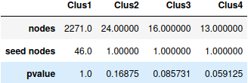
I_LCC

U_LCC
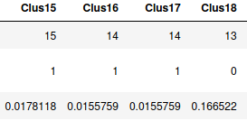
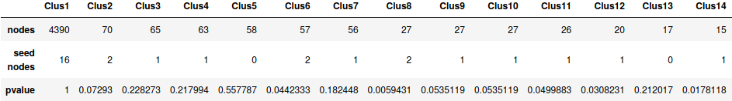

From that we found out that statistically relevant clusters where just 8, all from the U-LCC network:
IDs: ‘Clus6’,’Clus8’,’Clus11’,’Clus12’,’Clus14’,’Clus15’,’Clus16’,’Clus17’. We classify them as Putative Disease Modules.

DIAMOnD 30 genes

DIAMOnD tool implemented by Barbasi group allows to detect the full disease module given a number of known proteins. We ran that algorithm over the whole BIOgrid_interactome and our seed_file. Here is reported the output of the first 30 genes found by the algorithm.

- GLIS2
- MAP2K5
- ERBB2
- CDKN2B
- EPHA2
- FGFR4
- CBLC
- LATS2
- MDM4
- STK11
- PDGFRA
- MAP2K3
- CDK4
- CD44
- CCND2
- BECN1
- GRM1
- KDELR2
- TERT
- AKT1
- CDKN2C
- ARNT
- FZR1
- RASSF1
- CCNE1
- TEAD2
- MAP3K5
- MAP2K6
- HIF1A
- MYC

Finally we have uploaded the whole set of 200 genes to enrichr to find the over-represented GO categories. Results of the enrichr analysis are showed below, limited to the first 10 categories.

Biological process | Cellular Component | Molecular Function
thyroid hormone mediated signaling pathway | HSP90-CDC37 chaperone complex | RNA-directed 5'-3' RNA polymerase activity
cellular hyperosmotic salinity response | TEAD-2-YAP complex | RNA polymerase II transcription coactivator binding
N-terminal peptidyl-lysine acetylation | Rb-E2F complex
positive regulation of transforming growth factor beta3 production | Ku70:Ku80 complex | Krueppel-associated box domain binding
rRNA export from nucleus | heteromeric SMAD protein complex | DNA-dependent protein kinase activity
N-terminal peptidyl-lysine acetylation | Ku70:Ku80 complex | HLH domain binding
regulation of response to gamma radiation | cyclin E1-CDK2 complex | IkappaB kinase activity
response to metformin | activin responsive factor complex | TFIIB-class transcription factor binding
regulation of secretion of lysosomal enzymes | brahma complex | primary miRNA binding
Gene Ontology DIAMOnD

Kegg Pathways
P53 pathway feedback loops 1
nsulin/IGF pathway-protein kinase B signaling cascade
p53 pathway feedback loops 2
JAK/STAT signaling pathway
p53 pathway by glucose deprivation
Hypoxia response via HIF activation
P53 pathway
Ras Pathway
Interferon-gamma signaling pathway
Interleukin signaling pathway
Kegg Pathway DIAMOnD
GRAPHS IMAGES

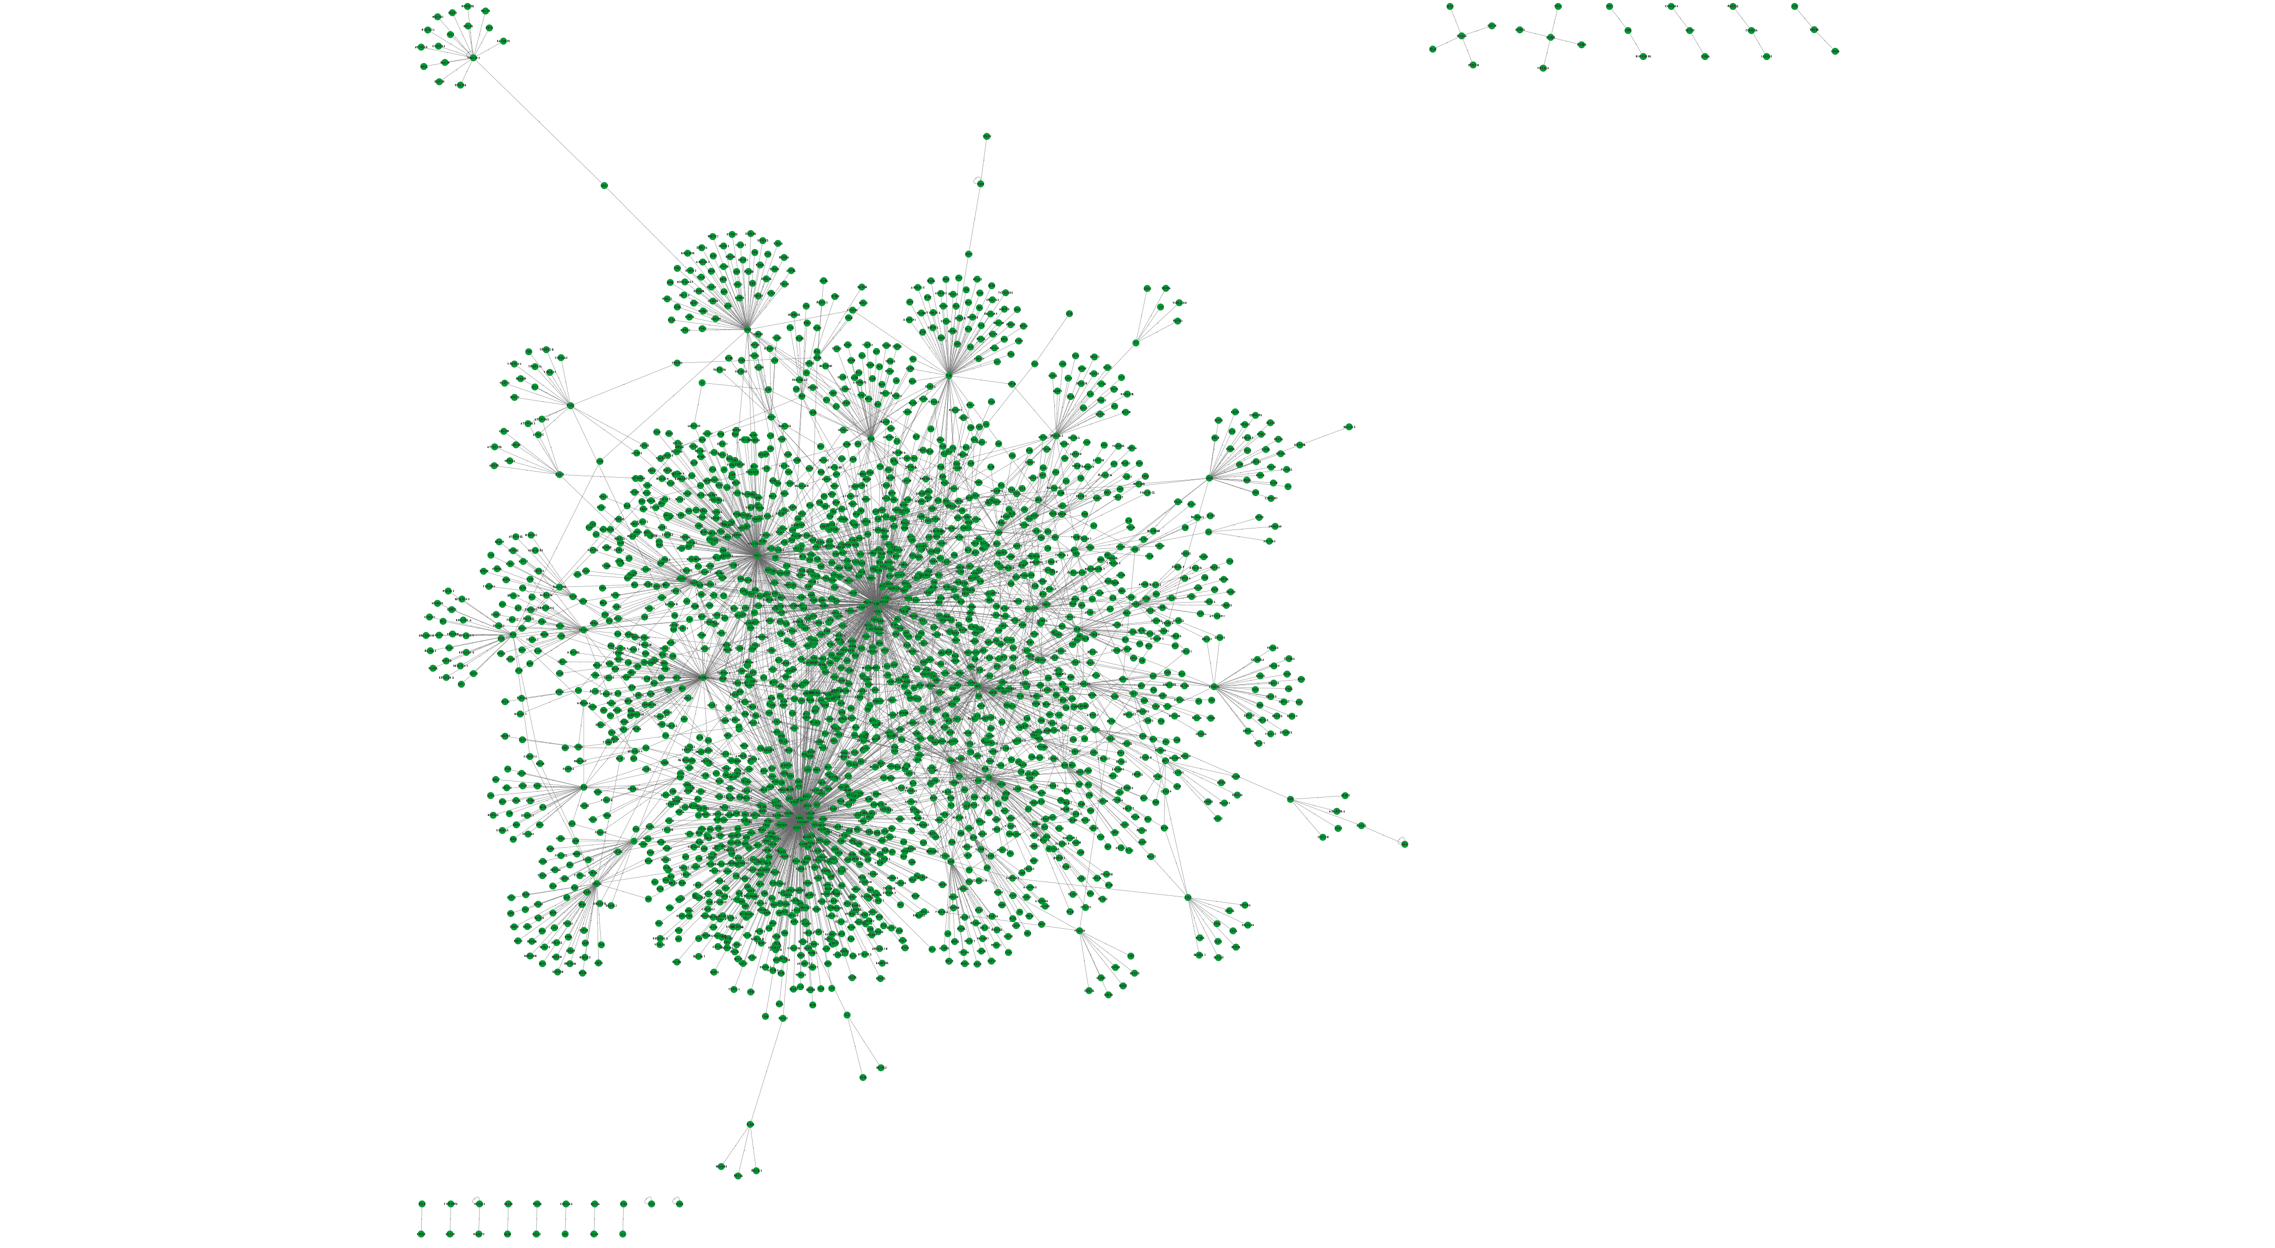

Intersection Interactome

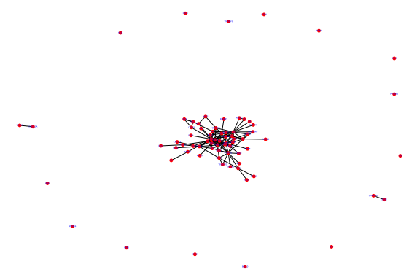

SGI

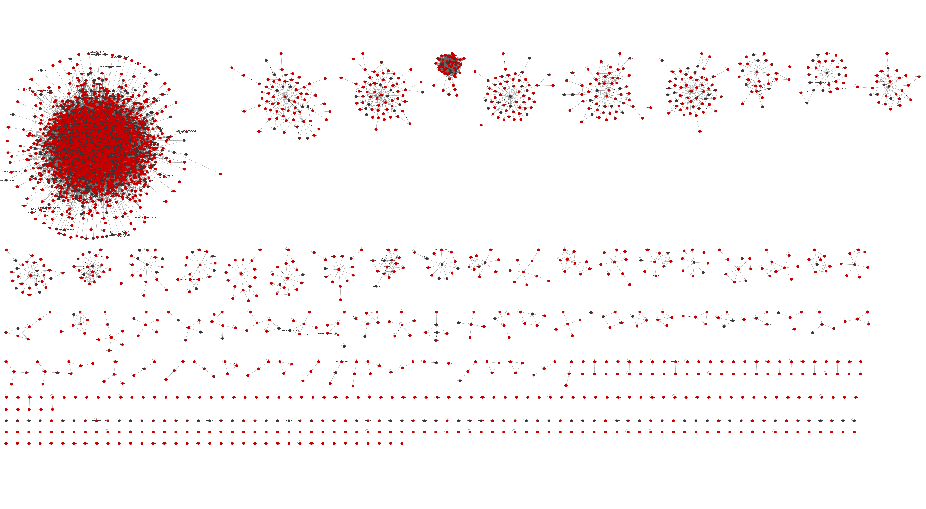

Union Interactome Clustered

