GENERAL DATASET ANALYSIS
This R script performs an exploratory analysis on a dataset of financial market indicators. The code begins by importing the dataframe: one part contains the time series data for various financial indices divided in weeks, and another part provides metadata with descriptions for each variable. A key feature in the dataset is the anomaly label Y, which marks unusual market conditions. The script calculates summary statistics for each variable, including mean, standard deviation, minimum, maximum, and the percentage of missing values. These statistics are merged with the metadata to create an informative summary table. The results show a clean dataset with a wide range of world market indices, such as equity indices (e.g., MSCI USA, Europe, Japan), fixed income instruments, commodities, and economic indicators. This table helps to quickly understand the behavior and scale of each indicator across the observation period, highlighting differences in volatility and range.
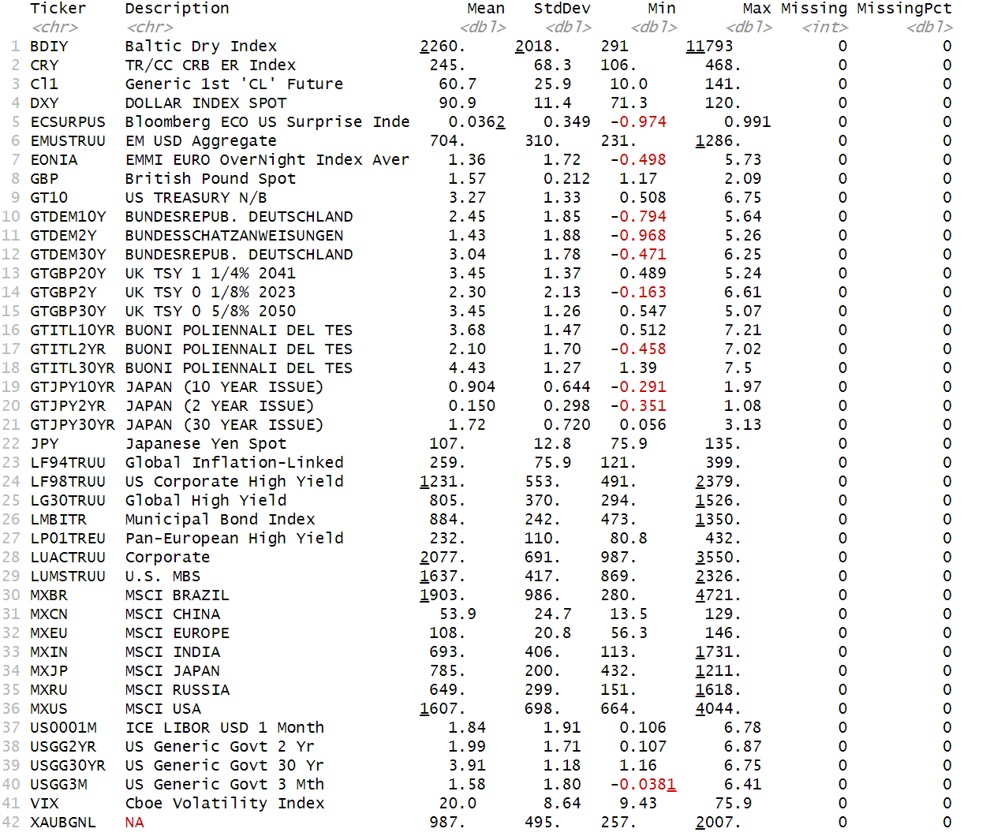
The graphs included in the analysis serve two purposes. The first is a time series plot of the MSCI USA index (MXUS), where normal market movements are shown in blue, and anomalies are highlighted in red. This visualization clearly identifies periods of unusual market behavior and is useful for spotting financial stress events or outliers. The second graph is a scatterplot matrix. It compares selected global equity indices (MXUS, MXEU, MXJP, MXCN, MXIN, MXBR), among the most important worldwide, to explore relationships between them and to visually assess how anomalies are distributed. The diagonal elements show the density distribution for each variable. The plots suggest strong positive correlations among most indices, especially between developed markets such as the US, Europe, and Japan. In contrast, emerging markets like China, India, and Brazil show more scattered patterns. The anomalies tend to appear at the extremes of distributions or in more isolated regions of the plots, suggesting that they correspond to unusual or extreme market conditions. Overall, the graphs provide valuable visual confirmation of patterns and anomalies in the dataset, supporting further investigation or model development for financial early warning systems.
