Course Rationale

Giulia Forsythe

January 19, 2016

# Why am I taking this course?

I haven’t completed an open online course since my numerous times through [#ds106](http://ds106.us/), and even then the “requirements” for completion were so loose, it’s debatable I really have the dedication and commitment to see an open course through to the end. 

It is with that introduction that I preface that I am very interested in taking #hist3907o because I like the idea of handling historical data, [making cool things](https://knightlab.northwestern.edu/), learning github and markdown, and hopefully some other tools: gephi or some sort of [open map application](http://www.openhistoricalmap.org/)?

I might add at this point, I’m not sure that participation in this course is completely open. Do I need to register and pay? 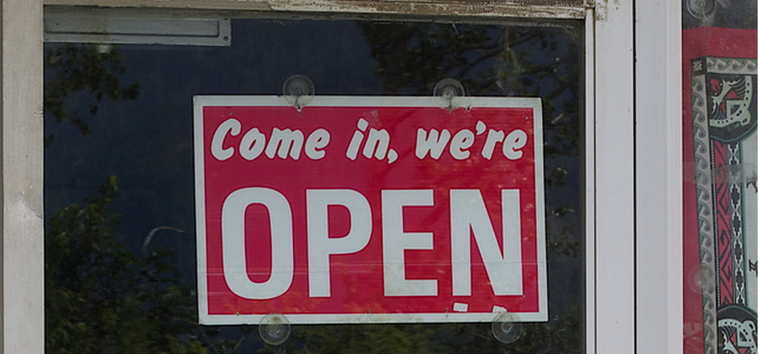

I’m not against paying for a course but I think I’ll see if I can make my way through module 1 before I put myself on the radar. I neither want to waste Professor Graham’s time nor embarrass myself. I’ll not officially sign up until I’m sure I have what it takes to complete this. I’m editing in Dillinger right now and have installed Atom and Git-it; I’m off to a good start. I think? There are so many rabbit holes to explore, it’s taking exceptionally long to complete any particular task. That’s what Saturday nights are for, right?

Additionally I should mention, I’ve been working with two very interesting historians at Brock as part of my work in educational development and online course design and have started working a bit with a third to work out some ways we can bring more digital humanities within our history department.

Finally, some of the most interesting people I follow on twitter consider themselves digital historians and I’d like to understand their world a bit better.

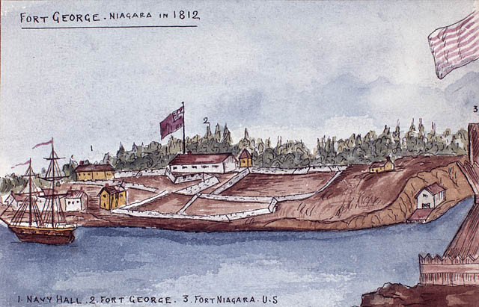

fort george

You can find my existing blog at http://gforsythe.ca/

## testing

What happens if I insert a reference here? (Weingart 67)

# Bibliography

Weingart, Scott. “The Joys of Abundance: The Era of Big Data.” *The Historian&#039;s Macroscope: Big Digital History* May 2013. Web. 19TZ Jan. 2016.