test

Giulia

today

# This is a test header

## this is my subheader

And this is my text with a reference here Johnson-Laird & Oatley (1989) or here (Mellmann, 2017) another.



this is my caption

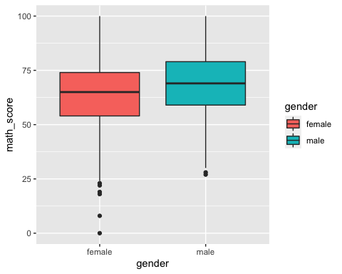

## # A tibble: 2 × 3  
## gender math_mean read_mean  
## <chr> <dbl> <dbl>  
## 1 female 63.6 72.6  
## 2 male 68.7 65.5

# References

Johnson-Laird, P. N., & Oatley, K. (1989). The language of emotions: An analysis of a semantic field. *Cognition and Emotion*, *3*(2), 81–123.

Mellmann, K. (2017). *Emotionalisieren BT - Erzählen: Ein interdisziplinäres Handbuch* (M. Martínez, Ed.; pp. 243–249). J.B. Metzler. <https://doi.org/10.1007/978-3-476-05364-0_36>