Bookdown Word Document

Your Name

26 May 2025

## 1 Bookdown Word Document

This is a simple example of a Bookdown document that can be rendered to a Word document format. You can include text, code chunks, and other elements as needed.

## 2 Basic formatting

You can use Markdown syntax to format your text. For example, you can create **bold text**, *italic text*, and inline code.

You can also create lists: - Item 1 - Item 2 - Subitem 2.1 - Subitem 2.2

### 2.1 Cross-referencing

You can reference sections, figures, and tables. For example, see Figure 1 for an example figure.

plot(cars)

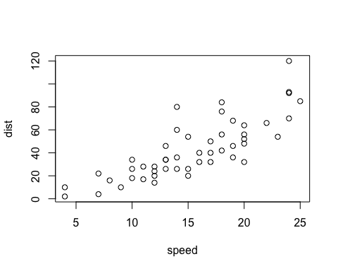

Figure 1: An example figure

If you want to reference a table, you can do so like this: Table 1.

Table 1: An example table

|  | mpg | cyl | disp | hp | drat | wt | qsec | vs | am | gear | carb |
| --- | --- | --- | --- | --- | --- | --- | --- | --- | --- | --- | --- |
| Mazda RX4 | 21.0 | 6 | 160 | 110 | 3.90 | 2.620 | 16.46 | 0 | 1 | 4 | 4 |
| Mazda RX4 Wag | 21.0 | 6 | 160 | 110 | 3.90 | 2.875 | 17.02 | 0 | 1 | 4 | 4 |
| Datsun 710 | 22.8 | 4 | 108 | 93 | 3.85 | 2.320 | 18.61 | 1 | 1 | 4 | 1 |
| Hornet 4 Drive | 21.4 | 6 | 258 | 110 | 3.08 | 3.215 | 19.44 | 1 | 0 | 3 | 1 |
| Hornet Sportabout | 18.7 | 8 | 360 | 175 | 3.15 | 3.440 | 17.02 | 0 | 0 | 3 | 2 |
| Valiant | 18.1 | 6 | 225 | 105 | 2.76 | 3.460 | 20.22 | 1 | 0 | 3 | 1 |

You can also rerference a Figure that is not embedded inside a chunk, like this: Figure 2.

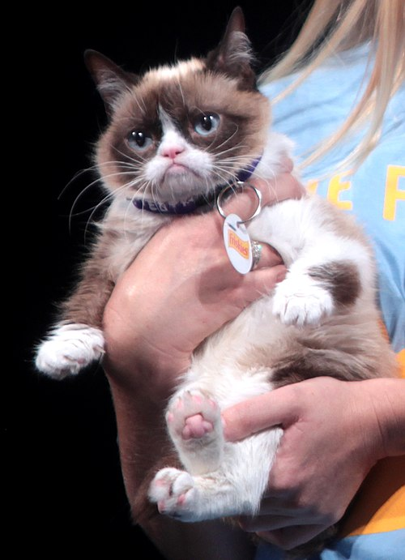

Figure 2: Grumpy cat

Or you can refer to a rmd table like this: Table 2.

Table 2: Six spatial entities categories grouped under the umbrella terms RURAL and URBAN, and respective sub-categories.

| **Category** | **Description** | **Subcategory (if any)** |
| --- | --- | --- |
| RURAL | **‘rural entities’**: spatial terms relating to – or characteristic of – the countryside, in particular related to human settlements or infrastructures, as opposed to those of the city (for example *Wanderweg*: footpath, *Feld*: field, *Hütte*: hut, shack); |  |
|  | **‘natural entities’**: terms describing spatial elements as found in nature, not involving anything made or done by people (for example *Baum*: tree, *Bach*: brook, *Felsen*: rock); |  |
|  | **‘rural geolocations (geoloc_rur)’**: proper names of villages and small towns – with less than 5000 inhabitants – in Switzerland, Austria, Germany, France and Italy (for example *Zumdorf*, *Enggwil*, *Huttwil*) | village |
|  | **‘natural geolocations (geoloc_nat)’**: proper names of natural locations such as mountains, rivers, valley, lakes (for example *Matterhorn*, *Mont Blanc*, *Donau*), | forest, mountain, stream/lake , valley |

## 3 References

And finally, you can include references in your document. For example, Woolf (1927) for a sample citation, or (Woolf 1927, 1925) for multiple citations. You can also use the @ syntax to refer to specific pages, like Woolf (1927, 123). At the end of the document, you can include a bibliography section that will automatically format your references.

## Bibliography

Woolf, Virginia. 1925. *Mrs Dalloway*. 1996th ed. Ware: Wordsworth Classics.

———. 1927. *To the Lighthouse*. 1994th ed. Ware: Wordsworth Classics.