**Report**

**Challenges**

Actually there was a lot of issues that i face during the development of that application but here are some of that i remember very clearly and i spent a lot of time to resolve that

**MongoDB Connection**

We face issue in connecting database. The problem was that MongoDB server not running. After checking, we start the service and it work fine.

**Error in Schema Validation**

Sometimes, if we forget to provide required fields in POST request, server return error. To fix it, we add validation in schema.

**Duplicate Entry Issue**

When same _id is sent multiple times, it give error. We solve this by adding unique: true in schema.

**Learning RESTful API**

At first, it was hard to understand how APIs work, but after practice, we do it properly

**design decisions**

During developing the application as a beginner i wasn’t know about the folder and design structure of the code but i just did the code and run the application after that i realise that my code is not looking good and also another body will not understand that so to make it good for that i did some research on it and found some very useful recourses

I found a complete blog on the design structure which was in the medium.com site and also found an official node js GitHub repository on that

After that i created the official design structure

Here is the image of my design structure

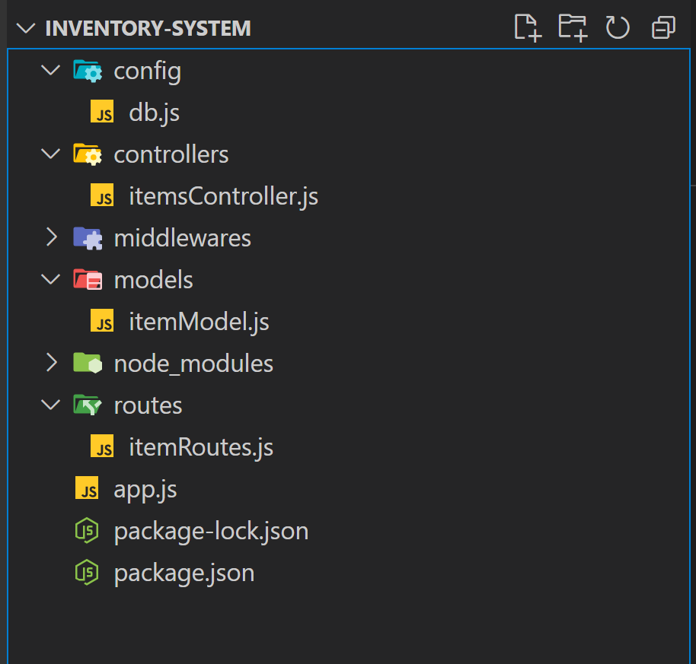

**future improvements**

There is a lot of things that we can improve in that application but there are few thing that i have to mention over here which will be very good and also necessary for the future improvements

**Middleware for Security**

In future, we can add middleware for security, such as:

Authentication: To secure API routes.

Authorization: To restrict access based on user roles.

**Pagination for Large Data**

Add pagination to the GET /items endpoint so it can handle large amount of data more efficiently.

**Search Functionality**

Add a search feature to find items by name or description.