UNIVERSIDADE FEDERAL DO RIO GRANDE DO SUL

FACULDADE DE FARMÁCIA

GIULIANO NETTO FLORES CRUZ

GENOMIC ANALYSIS OF MACROPHAGE GENE SIGNATURES DURING IDIOPATHIC PULMONARY FIBROSIS DEVELOPMENT

PORTO ALEGRE, RS

2018

Giuliano Netto Flores Cruz

Genomic analysis of macrophage gene signatures during idiopathic pulmonary fibrosis development

Undergraduate thesis presented as partial requirement for the achievement of the Bachelor degree in Pharmacy.

Academic Adviser: Prof. Paulo J. Saraiva, Msc.

Form Teacher: Prof. Alexandre M. Fuentefria, PhD.

Form Teacher: Prof. Otavio J. Saraiva, Msc.

Porto Alegre, RS

2018

ABSTRACT

INTRODUCTION

Idiopathic Pulmonary Fibrosis (IPF) is a deadly disease for which there is currently no available cure. Below goes an image:

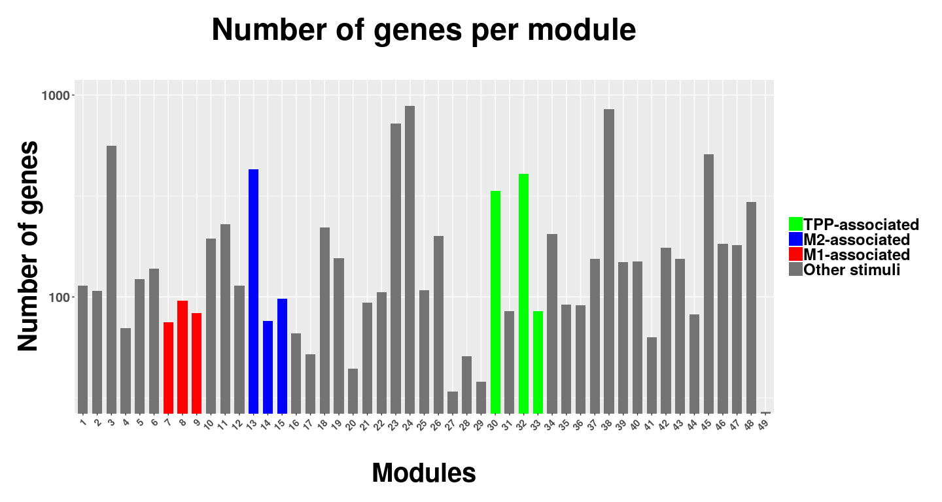

BIBLIOGRAPHICAL REVIEW

# DEFINING MACROPHAGE GENE SIGNATURES

## Macrophage Modules

## 1.2 hello

# Hi

METHODS

RESULTS AND DISCUSSION

CONCLUSION

REFERENCES

BAUER, Y. et al. A novel genomic signature with translational significance for human idiopathic pulmonary fibrosis. **American Journal of Respiratory Cell and Molecular Biology**, [s. l.], v. 52, n. 2, p. 217–231, 2015.

BECKER, M. et al. Integrated Transcriptomics Establish Macrophage Polarization Signatures and have Potential Applications for Clinical Health and Disease. **Scientific Reports**, [s. l.], v. 5, n. July, p. 1–12, 2015. Disponível em: <<http://dx.doi.org/10.1038/srep13351>>X

APPENDIX