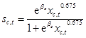
Cattle (AnimalGroup 1):

Sheep and Goats (AnimalGroup 2):

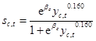

Pigs (AnimalGroup 3):
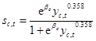

Poultry (AnimalGroup 4):
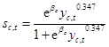

Buffalo (AnimalGroup 5):
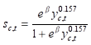

Camel (AnimalGroup 6):
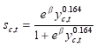

Equidae (Animal Group 7):
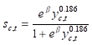

Rabbits (AnimalGroup 8):
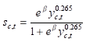

x = livestock density
y = labor productivity in agriculture
We do not know beta (country fixed effect) and s. But we have data for 2005 and can solve for beta:
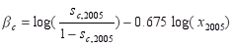

To get the country fixed effect. After that, we can implement them for each country and year

