Third Assignment

15 November 2014

# Research question and methodology

As stated in previous assignment, our research project aims to look at the impact of decentralization on health provision in Benin. Access to basic health-related services has been one of the core Millenium Development Goals; it is also regarded as basic human rights. For the past decade, governments and policymakers in developing countries have invested in improving basic sanitation and health-related facilities in urban and rural areas. Decentralization and devolution of public administration are two important channels through which these governments, and development agencies, achieve these goals.

In Benin, legal provisions on decentralization has transfered part of health provision competencies to subnational entities (districts and municipalities. Since the year 2002, municipal governments are increasingly responsible for providing basic services and infrastructures such as water access. To offset the vertical imbalance of subnational governments, the central government have conceded some tax raising powers and has also use intergovernmental transfers through the National Commission on Local Finances.

Proponents of decentralization share the view that public services delivery is more efficient at the local level. Yet, as stated from previous paper, there are many controversies with regards to the efficiency of decentralization mechanisms on public goods delivery. In this project, we want to draw from theories and empirical approaches in public finances to investigate the following question: **What impact does decentralization have on the provision of health-related services and infrastructures in Benin?**.

Studying the relationship between decentralization and health provision is a very challenging exercise as it requires consistent and reliable microeconomic data which are, very often, not openly avaible or not consistent. For this reason, we have decided to broaden our approache by first looking at aggregate health-related data of Benin, such as health public expenditures over the past few years. In addition to the macroeconomic overview, we explore microeconomic and subnational data on health provision.

This paper is divided into three sections. The first one bring a general overview on health-related expenditures and provision in Benin over the years 2005 to 2010. The datasets are obtained from the World Bank (WB) and World Health Organization (WHO). The second part looks at the microeconomic effect of decentralization on basic health-related facilities. For this purpose, we compute an indicator for decentralization, and we use health-related indicators provided in Benin's Integrated Modular Households Survey (EMICoV). Because we have missing values in the households survey, we have decided to restrict our model to only two years: 2010 and 2011, for which we have a balanced panel. The final section present our basic regression models and some potential issues that we might need to solve in the final paper.

# Macroeconomic Overview

In this section, we use data analytics tools to scrape openly available datasets on Benin's health-related expenditures and services. The first dataset is obtained from the World Bank (WB) and include the following indicators:

## World Bank Indicators

1. health expenditure per capita (SH.XPD.PCAP): sum of public and private health expenditures as a ratio of total population. This indicator covers the provision of health services (preventive and curative), family planning activities, nutrition activities, and emergency aid designated for health but does not include provision of water and sanitation. Data are in current U.S. dollars.
2. public health expenditure (SH.XPD.PUBL): recurrent and capital spending from government (central and local) budgets, external borrowings and grants (including donations from international agencies and nongovernmental organizations), and social (or compulsory) health insurance funds.
3. improved sanitation facilities(SH.STA.ACSN): access to improved sanitation facilities as the percentage of the population using improved sanitation facilities. This indicator includes flush/pour flush (to piped sewer system, septic tank, pit latrine), ventilated improved pit (VIP) latrine, pit latrine with slab, and composting toilet.

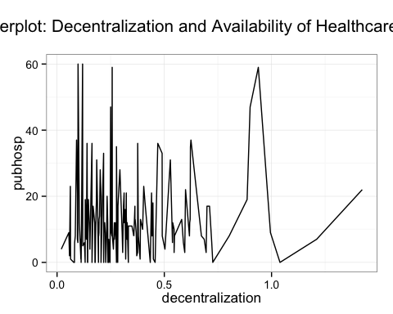 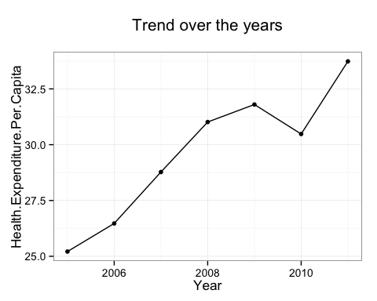 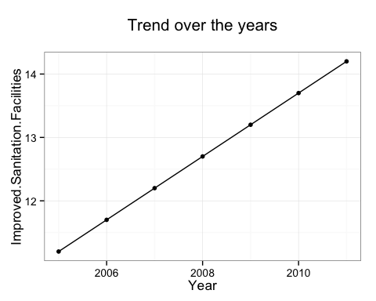

The above graphs suggest that all three elements: public health expenditure, health expenditure per capita, and improved sanitation, have considerably increased over the timespan 2005 to 2011. As mentionned above and in our research proposal, the central government in Benin (alike other developing countries in West-Africa) have used decentralization as a mechanisms to reacht he targets of the Millenium Development Goal. Therefore, since health expenditure is highly decentralized, we could potentially argue that the macroeconomic overview is related to the outcome on a micro level. The microeconomic approach in section 2 will therefore help us testing this assumption.

## World Health Organization Indicators

The second dataset is taken from the WHO databases, particularly from the Global Health Obervatory Data which provides information on health infrastructures per 100,000 population in Benin including:

1. Health posts, that are either community centres or health environments with a very limited number of beds with limited curative and preventive care resources normally assisted by health workers or nurses,
2. Health centers,which includes the number of health centres from the public and private sectors, per 100,000 population
3. Number of district/rural hospitals from the public and private sectors, per 100,000 population,
4. Number of provincial hospitals from the public and private sectors, per 100,000 population,
5. Number of specialized hospitals delivering mainly tertiary care from the public and private sectors, per 100,000 population. These specialized hospitals could be regional, specialized, research hospitals or Federal/National Institutes.
6. Number of specialized hospitals delivering mainly tertiary care from the public and private sectors, per 100,000 population. These specialized hospitals could be: regional, specialized, research hospitals or Federal/National Institutes.

Unlinke the dataset from the World Bank, this datasets only provide Benin-related indicators for the years 2010 and 2013, which we extracted for this project.

## Merging WB and WHO datasets

Once we have our datasets, it is useful to merge them together so as to work easily and quickly with one dataset that would include all the needed variables.

# Microeconomic Analysis

In this section, we explore provision of health-related services and infrastructures on a local level. Particularly, we look at the impact of decentralization on the access to basic health-related sercices and infrastructure.The datasets on local finances are obtained from the National Commission on Local Finances of Benin. Health-related expenditures and provision are from Benin's Integrated Modular Surveys on Household Living Conditions (EMICoV) and the Demographic and Health Survey.

## Description of Variables

### Independent variable: Decentralization

Decentralization typically defined in public planning, management and decision making, as the transfer of authority and power from higher to lower levels of governing, or from national to sub-national levels[@rondinelli1983collins]. It has different characteristics for different writers which often describe it as either delegation, devaluation,de-concentration,and privatization of responsibility and authority of tasks to lower level of administration. Yet, decentralization is a very complex mechanism. In general, its measurement involves two elements: the level and the degree where the degree can be regarded as the distribution of power over the decision made inside the system, whereas the level takes into account sociological and political aspects.

The definition and measurement of decentralizaiton has led to long academic debate, with several authors proposing new indicators as the most reliable proxy, giving birth to a multiplicity of indicators using different approaches. Due to this high degree of complexity, which encompasses a number of political, fiscal and administrative dimensions, it is difficult to assess and measure the outcome of decentralization mechanisms in an empirical study.

A large part of the debate on decentralization measurement regards the choice between revenue versus expenditure decentralization. Because decentralized health provision implies both decentralized revenues and expenditure, fwe propose here to use the Revenue authonomy(RA) indicator used by [@akai2002sakata] and [@habibi2003etal] to proxy for decentralization. This indicator is defined as the ratio of own-source revenues over the total expenditures of a subnational entity.

% Table created by stargazer v.5.1 by Marek Hlavac, Harvard University. E-mail: hlavac at fas.harvard.edu % Date and time: Gio, Nov 13, 2014 - 16:17:29

### Dependent variables

Like decentralization, it is very challenging to find a composite proxy for health provision. We have therefore decided to focus on some key variables which data is only available on a macro level. These variables are drawn from Benin's EmiCoV (2010,2011) and are defined as follwos: (i) access to water: defined as the percentage of households in the municipality that have access to water (ii)access to toilet facilities: percentage of households in the municipality that have access to toilet facilities (iii)water provision infrastructure: percentage of households in that municipality that are connected to SONEB (water pipeline) (iv) hospital: the number of existing hospital or public healthcare center in the municpality.

### Explanatory variables

In addition to decentralization, we use a set of variables to account for heterogeneity accross the municipalities, such as population, population density, per capita consumption, public expenditure per capita, households health consumption, indicators on monetary poverty, average literacy rate of the head of households, as well as monetary poverty indice, all of them obtained from Benin's EmiCov (2010, 2011). We assume that these variables might have some impact either on health health-related expenditures on municipal or households level, and also some impact on decentralization process per se. The basic econometric model will be further specified in the final paper.

% Table created by stargazer v.5.1 by Marek Hlavac, Harvard University. E-mail: hlavac at fas.harvard.edu % Date and time: Gio, Nov 13, 2014 - 16:17:29

# Basic Regression models

In our basic mode, we regress decentralization our independent variables as above-mentionned.

### Model estimations

*Effect of Decentralization on Water Access*

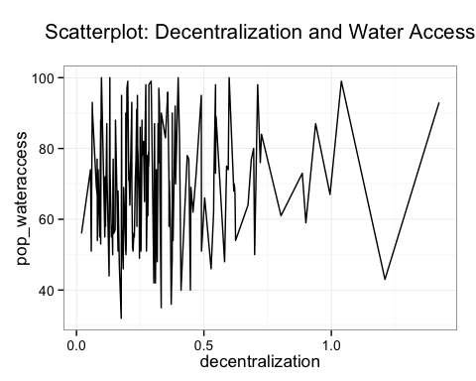

In this model, decentralization reveals to be insignificant, while household consumption ratio on health and average literacy rate of household's head result to be slightly significant. This may be due to mispecification of the model.

*Effect of decentralization on access to toilet facilities*

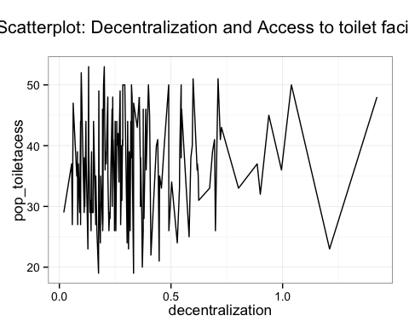

Alike the model on water access, decentralization seems to not have a particular effect on the access to toilet facilities, while average literacy rate of head of households results to be significant.

*Effect of decentralization on water pipeline connection*

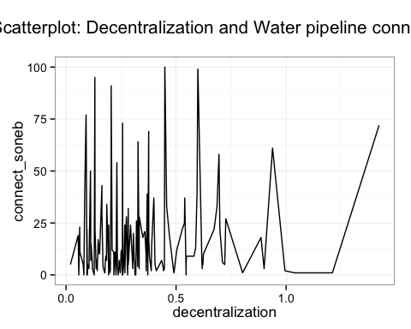

In this model, our key explanatory variable 'decentralization' seems to have no impact of connection to water delivery infrastrucure. In reverse, population density, public expenditures per capita, households health consumption and average literacy rate of heads of households reveal to be significant, with education highly significant.

*Effect of decentralization on availability of public health infrastructure*



Like the previous models, decentralization does not seem to be a significant elements in the availability of healthcare centers at the subnational level. With regards to the explanatory variables: population, population density, and average literacy rate of the head of households seem to be strongly determinants of the existence of healthcare centers. Public expenditures per capita and poverty level result to be significant as well.

# Potential Issues

The macroeconomic overview suggests that Benin's has experienced an improvement on health-services delivery over the past few years. Given that health-related services is highly decentralized, we have tested the impact of decentralization on some key health-related variables, issued from Benin's Households Survy. The microeconomic analysis, however, did not find any significant imapct of decentralization (proxied by the ratio of own-revenue to total expenditures) on the provision of health-related services and infrastructures. Given that exisiting literatures provide various decentralization indicators, the significance found in the microeconomic analysis might be the result of a misleading indicator. Moreover, because public services in Benin is highly financed by intergovernmental (rather than own-source revenues), it might be more reliable to consider an indicator or a model that takes into account this factor. Therefore, we propose to revise our proxy for decentralization and to further work on our model specification.