Technical University of Cluj-Napoca
Programming Techniques

DOCUMENTATION

ASSIGNMENT 2

QUEUES MANAGEMENT APPLICATION USING
THREADS AND SYNCHRONIZATION MECHANISMS

STUDENT NAME: Giurgiu Anca-Maria
GROUP: 30424

CONTENTS

1. Assignment Objective 3
2. Problem Analysis, Modeling, Scenarios, Use Cases 3
3. Design 3
4. Implementation 3
5. Results 3
6. Conclusions 3
7. Bibliography 3

Assignment Objective
Design and implement a queues management application which assigns clients to queues such that the waiting time is minimized.
Queues are commonly used to model real world domains. The main objective of a queue is to provide a place for a "client" to wait before receiving a "service". The management of queue-based systems is interested in minimizing the time amount their "clients" are waiting in queues before they are served. One way to minimize the waiting time is to add more servers, i.e., more queues in the system (each queue is considered as having an associated processor) but this approach increases the costs of the service supplier.
The queues management application should simulate (by defining a simulation time 𝑡𝑠𝑖𝑚𝑢𝑙𝑎𝑡𝑖𝑜𝑛) a series of N clients arriving for service, entering Q queues, waiting, being served and finally leaving the queues. All clients are generated when the simulation is started, and are characterized by three parameters: ID (a number between 1 and N), 𝑡𝑎𝑟𝑟𝑖𝑣𝑎𝑙 (simulation time when they are ready to enter the queue) and 𝑡𝑠𝑒𝑟𝑣𝑖𝑐𝑒 (time interval or duration needed to serve the client; i.e. waiting time when the client is in front of the queue). The application tracks the total time spent by every client in the queues and computes the average waiting time. Each client is added to the queue with the minimum waiting time when its 𝑡𝑎𝑟𝑟𝑖𝑣𝑎𝑙 time is greater than or equal to the simulation time (𝑡𝑎𝑟𝑟𝑖𝑣𝑎𝑙 ≥ 𝑡𝑠𝑖𝑚𝑢𝑙𝑎𝑡𝑖𝑜𝑛).

Problem Analysis, Modeling, Scenarios, Use Cases
The goals of this application are to simulate a real-world scenario of a queue management system. Instead of using clients and servers, the simulation will be using threads. Each thread is a separate queue that can work on one client at a time. A very similar approach is used by actual internet servers that use software like Apache or NGINX. Each client that sends a request to the server gets their responses from a separate thread created just for their own request.
The clients are randomly generated. Each one has its own service time and arrival time. A maximum client number is required, but if that number is not reached during the simulation time entered, fewer will be generated.
The entry parameters are:
▪ The number of queues available. There is a maximum of 10 queues, because of screen space limitations.
▪ Minimum and maximum arrival interval: the time space between 2 different clients. The value will be chosen at random from the interval.
▪ Minimum and maximum service time: the time required to process a client. The value will be chosen at random from the interval.
▪ Simulation interval: the starting and finishing time of the simulation.
▪ Maximum number of clients: The maximum number of clients allowed to be processed during a simulation.
The output parameters are:
▪ The total “dead time” for each queue (in seconds)
▪ The average waiting time for every queue (in seconds)
▪ The “peak hour”, when the most clients were served
▪ The total number of clients served in the simulation
▪ The average service time length (in seconds)
▪ The number of clients and the average waiting time for a user-given interval.

Design
a) Package diagram
In object-oriented programming (OOP) development, model-view-controller (MVC) is the name of a methodology for successfully and efficiently relating the user interface to the underlying data models. This proposes three main areas to be used in the development of the application:
- Model: represents the logical structure of the data used by the software application;
- View: represents a collection of elements used in the user interface (everything that the user can see and interact with; for example buttons, text boxes, labels, scrollers etc.);
- Controller: represents the connection between the model and the view.
This project is designed based on this MVC methodology, having the following packages:
- GUI (Graphical User Interface) : contains 4 classes, SimulationFrame, FileWriting, View and Controller
- Model : contains 3 classes, Client, QueueClass and RandomGenerator
- BusinessLogic: contains 6 classes, ConcreteStrategyQueue, ConcreteStrategyTime, Scheduler, SelectionPolicy, SimulationManager and Strategy

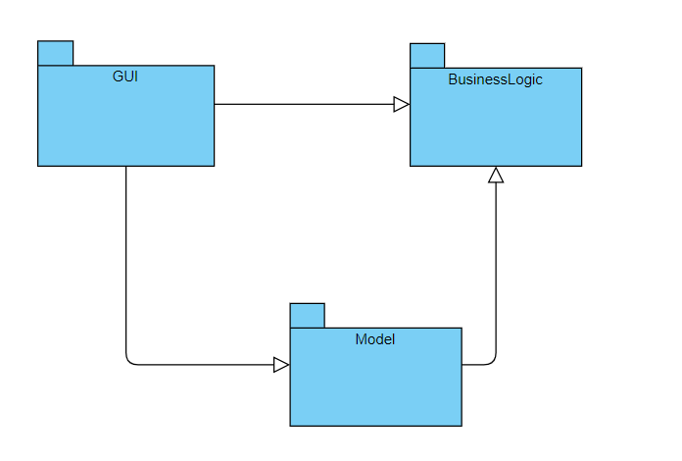
c) Class diagram
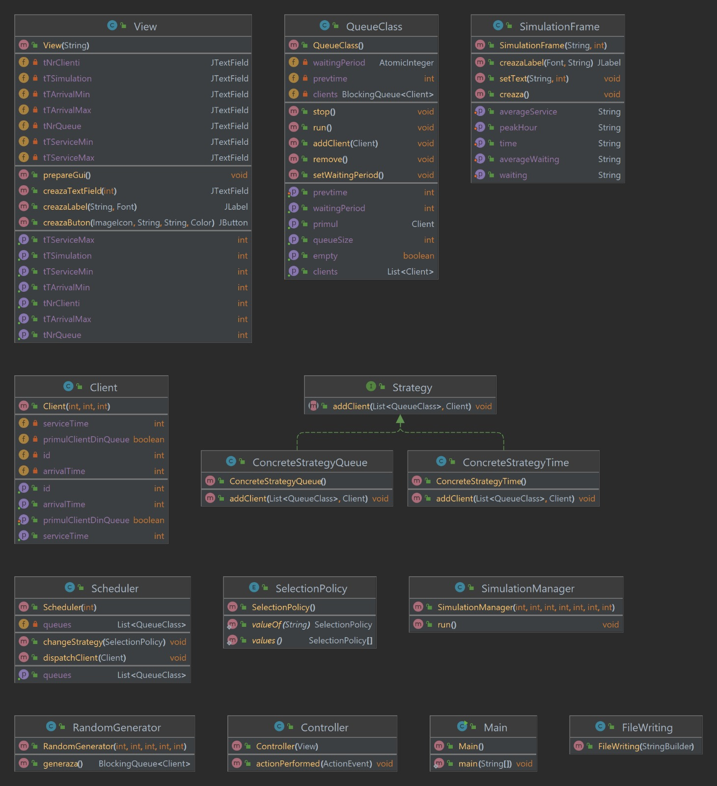

d)Design
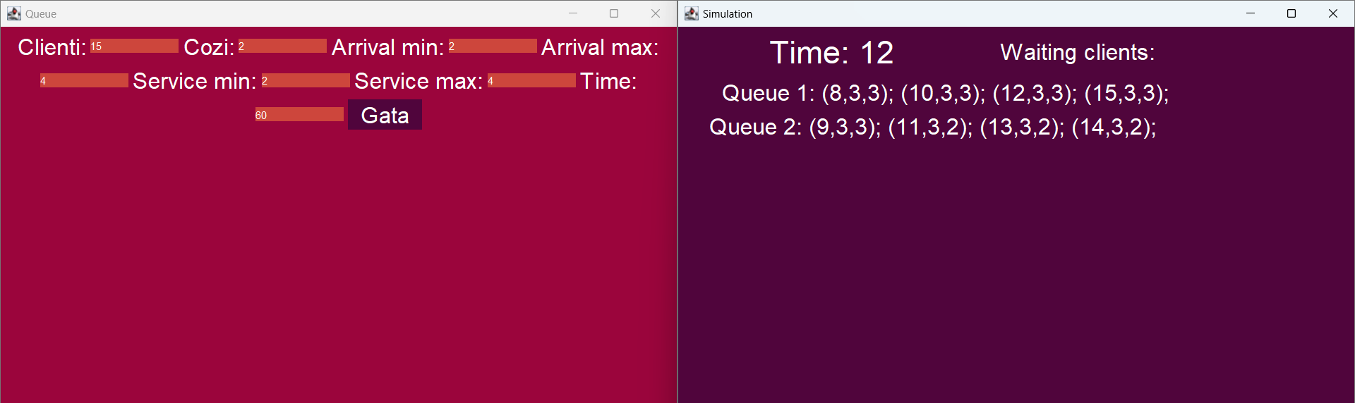

Implementation
View
View is responsible for arranging the window/s that will be seen by the user, essentially designing the layout of the application. In order to create a user friendly interface, I used FlowLayout.
For each object I created a function to define the respective object.
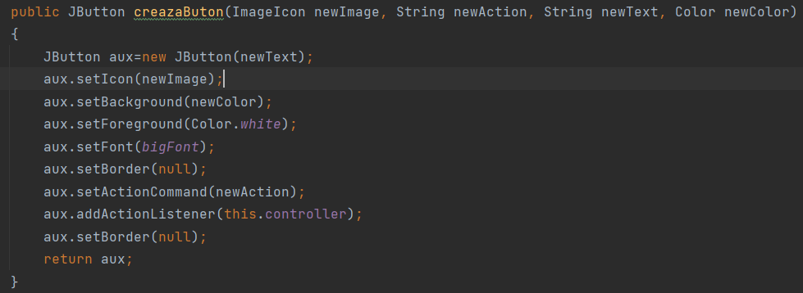
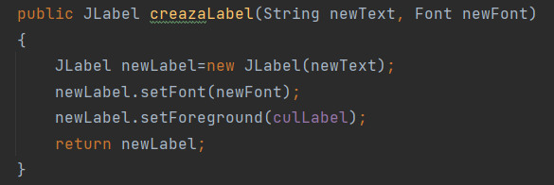
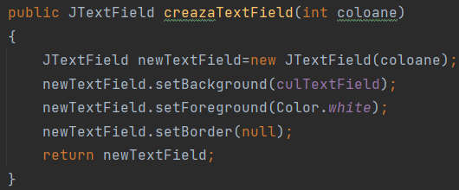
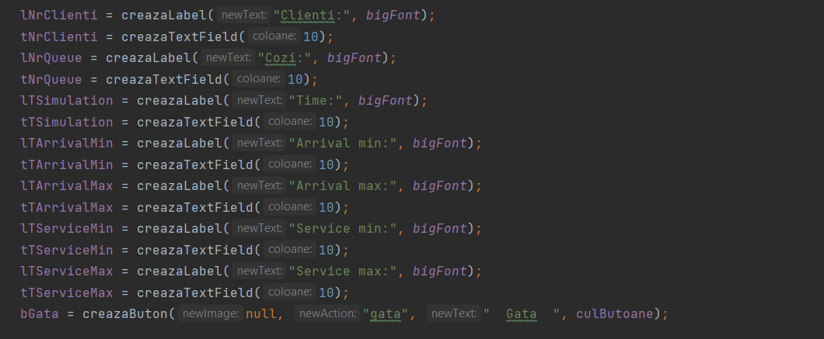
prepareGui() method is the one in charge with the display (positioning the buttons, labels, text boxes)
View(String) method is a constructor that initializes the frame of the GUI and also calls method prepareGui().
Controller
As it is implied from its name, the Controller controls the software application. Controllers act as an interface between Model and View components to process all the business logic and incoming requests, manipulate data using the DataModel component and interact with the Views to render the final output. For example, the user will handle all the interactions and inputs from the View and perform operations on one or two polynomials.
Controller gets called by the view when one of the buttons is clicked.
public void actionPerformed(ActionEvent e)

view attribute holds the refference to the caller view
op attribute is an object from the class Operations

FileWriting
This class represents a simple implementation to write the contents of a StringBuilder object into a file named output.txt.

SimulationFrame
This class represents a Swing graphical user interface (GUI) for a simulation. This GUI has a JFrame with a FlowLayout layout manager. It displays a JLabel object for the time, a JLabel object for the total waiting time, noQueue number of JLabel objects, and three JLabel objects for the average waiting time, average service time, and peak hour of the simulation.
Overall, this class provides a basic implementation of a GUI for a simulation, but it is not complete as it does not provide any user interaction or further functionality beyond displaying various labels.

Client
It has the following properties:
- id (integer): the unique identifier of the client.
- arrivalTime (integer): the time when the client arrives in the system.
- serviceTime (integer): the time required to serve the client.
It also has a boolean property primulClientDinQueue which is set to false by default.
It has a constructor that takes id, arrivalTime, and serviceTime as parameters and initializes the corresponding properties with these values. It also sets primulClientDinQueue to false.
It has getter methods for all properties. It also has a setter method for primulClientDinQueue.
QueueClass
This is a Java class that implements a queue of clients with a waiting period. The queue is implemented using a LinkedBlockingQueue object from the java.util.concurrent package. The clients queue holds objects of type Client, which is not defined in the code provided.
The class has a constructor that initializes the queue and waiting period. There is also an addClient method that adds a new client to the queue and updates the waiting period. The stop method sets the isRunning flag to false, which is used to stop the thread running the queue.
The run method is the main method of the class, and is executed by a separate thread. It repeatedly checks if the queue is empty, and if so, waits for 100ms before checking again. If the queue is not empty, it retrieves the first element of the queue, represented by the element method, and waits for the amount of time specified by the client's serviceTime attribute, which is not defined in the code provided. The setWaitingPeriod method decrements the waiting period by 1, and the getWaitingPeriod method returns the current waiting period.
The class also has several other methods to manipulate the queue. The getEmpty method returns true if the queue is empty, and false otherwise. The getPrimul method returns the first client in the queue without removing it. The remove method removes the first client from the queue. The setPrevtime method sets the previous time to a specified value, and the getPrevtime method returns the previous time. Finally, the getQueueSize method returns the size of the queue, and the getClients method returns a list of all the clients in the queue.
RandomGenerator
This class generates a blocking queue of Client objects with random properties such as arrival time and service time.
The generaza method generates the blocking queue of clients using a Random object. It iterates numberOfClients times and generates random values for the arrival time and service time using the nextInt method of the Random object. It then creates a Client object with these values and adds it to the queue. The method returns the generated queue.
Overall, this class provides a convenient way to generate a queue of Client objects with random properties, which can be used for simulation or testing purposes in a larger program.
Strategy
The Strategy interface defines a method for adding a client to a list of queue objects. It is likely part of a larger program that implements different queue strategies, each implementing the Strategy interface with a unique implementation of the addClient method. This allows for flexibility and customization of the queue system without modifying the entire program.
ConcreteStrategyQueue
public class ConcreteStrategyQueue implements Strategy {
@Override
public void addClient(List<QueueClass> queues, Client client) {
QueueClass shortestQueue = queues.get(0);
for (QueueClass queue : queues) {
if (queue.getQueueSize() < shortestQueue.getQueueSize()) {
shortestQueue = queue;
}
}
shortestQueue.addClient(client);
}
}

This is a Java code implementation of the Strategy design pattern. The Strategy interface defines a method called addClient, which is implemented by different concrete strategy classes. The ConcreteStrategyQueue class implements the addClient method by selecting the shortest queue from a list of queues and adding the client to that queue. This allows the client to be added to the queue that has the shortest waiting time, improving overall efficiency and reducing waiting times.

ConcreteStrategyTime

public class ConcreteStrategyTime implements Strategy {
@Override
public void addClient(List<QueueClass> queues, Client c) {
QueueClass selectedQueue = null;
int minWaitingPeriod = Integer.MAX_VALUE;
for (QueueClass queue : queues) {
int serverWaitingPeriod = queue.getWaitingPeriod() + c.getServiceTime();
if (serverWaitingPeriod < minWaitingPeriod) {
selectedQueue = queue;
minWaitingPeriod = serverWaitingPeriod;
}
}
if (selectedQueue != null) {
selectedQueue.addClient(c);
}
}
}

The ConcreteStrategyTime class is an implementation of the Strategy interface in the context of a queuing system. This implementation adds a client to the queue with the shortest expected waiting period, taking into account the waiting time of clients already in the queue and the service time of the new client.
To do so, the addClient method receives a list of QueueClass objects (representing the available queues) and a Client object to be added. It then iterates through each queue, calculating the expected waiting period for the new client in each queue by adding the new client's service time to the waiting period of the last client in that queue. It selects the queue with the shortest expected waiting period and adds the new client to that queue. If there are multiple queues with the same shortest expected waiting period, it adds the client to the first such queue encountered in the iteration.
This strategy can be useful in a system where minimizing the expected waiting time of clients is a priority, as it assigns clients to the queue where they are expected to wait the least amount of time. However, it may not always be the optimal strategy depending on the specific requirements and characteristics of the queuing system.

SelectionPolicy

public enum SelectionPolicy {
SHORTEST_QUEUE,SHORTEST_TIME
}

This is an enum that defines two values, SHORTEST_QUEUE and SHORTEST_TIME, which represent the two selection policies for adding clients to queues. The SHORTEST_QUEUE policy selects the queue with the smallest number of clients, while the SHORTEST_TIME policy selects the queue that will have the shortest waiting time for the new client, taking into account the current waiting times of the clients in each queue.
Scheduler
This is a Java class that implements a scheduling system for clients. It has a list of QueueClass objects that represent the queues and a maximum number of queues. It also has a strategy that determines how clients are added to the queues. The constructor initializes the queues and starts a thread for each queue. The changeStrategy method changes the strategy based on a SelectionPolicy. If the policy is SHORTEST_QUEUE, it sets the strategy to ConcreteStrategyQueue, and if it's SHORTEST_TIME, it sets the strategy to ConcreteStrategyTime. The dispatchClient method adds a client to one of the queues using the selected strategy. The getQueues method returns the list of queues.

SimulationManager
This class represents a simulation of a queuing system, in which clients arrive randomly and are served by a number of available servers. The code defines a class SimulationManager that implements the Runnable interface, and contains a number of properties and methods that define the behavior of the system.
The SimulationManager class has a number of properties that are used to define the parameters of the simulation, including the time limit of the simulation (timeLimit), the maximum and minimum arrival times and service times of clients, the number of queues and clients, and a SelectionPolicy enum that is used to specify the policy used to select which queue a client should join. There are also a number of other properties that are used to track various statistics during the simulation.
The SimulationManager class has a constructor that takes in a number of parameters, including the parameters described above, and uses them to initialize various internal properties, such as a RandomGenerator that is used to generate random clients, a Scheduler that is used to manage the queues, and a BlockingQueue that is used to store clients that are waiting to be served.
public SimulationManager(int timeLimit, int maxServiceTime, int minServiceTime, int maxArrivalTime, int minArrivalTime, int numberOfQueues, int numberOfClients) {
this.timeLimit = timeLimit;
this.maxArrivalTime = maxArrivalTime;
this.minArrivalTime = minArrivalTime;
this.maxServiceTime = maxServiceTime;
this.minServiceTime = minServiceTime;
this.numberOfQueues = numberOfQueues;
this.numberOfClients = numberOfClients;
randomClientGenerator = new RandomGenerator(numberOfClients, maxServiceTime, minServiceTime, maxArrivalTime, minArrivalTime);
scheduler = new Scheduler(numberOfQueues);
scheduler.changeStrategy(selectionPolicy);
for (int i = 0; i < numberOfQueues; i++) {
Thread queueThread = new Thread(scheduler.getQueues().get(i));
queueThread.start();
}
waitingClients = randomClientGenerator.generaza();
}

The SimulationManager class also defines a run method that implements the main loop of the simulation. Inside the loop, the code checks if any clients have arrived at the current time, and if so, dispatches them to the appropriate queue. It also checks if any clients in the queues have finished being served, and removes them from the queue. It then updates various statistics, such as the average waiting time and the number of clients in each queue, and updates the GUI to display the current state of the system.

public void run() {
frame = new SimulationFrame("Simulation", numberOfQueues);
averageWTPerQueue = new int[numberOfQueues];
personsWTPerQueue = new int[numberOfQueues];
peakHour = new int[timeLimit + 1];
int currentTime = 0;
while (currentTime < timeLimit) {
s = "Time: " + (currentTime + 1);
frame.setTime(s);
for (Iterator<Client> iterator = waitingClients.iterator(); iterator.hasNext(); ) {
Client client = iterator.next();
if (client.getArrivalTime() == currentTime + 1) {
totalService = totalService + client.getServiceTime();
scheduler.dispatchClient(client);
iterator.remove();
waitingClients.remove(client);
}
}
int k = 0;
for (QueueClass gueue : scheduler.getQueues()) {
if (!gueue.getEmpty()) {
Client client = gueue.getPrimul();
if (gueue.getPrevtime() + client.getServiceTime() == currentTime + 1) {
averageWTPerQueue[k] = averageWTPerQueue[k] + (currentTime + 1 - client.getArrivalTime());
personsWTPerQueue[k]++;
if (gueue.getQueueSize() > 1)
gueue.setPrevtime(currentTime + 1);
else if (!waitingClients.isEmpty())
gueue.setPrevtime(waitingClients.element().getArrivalTime());
gueue.remove();
}
}
k++;
}
for (QueueClass gueue2 : scheduler.getQueues()) {
if (!gueue2.getEmpty())
gueue2.setWaitingPeriod();
}
int time = currentTime + 1;
output.append("Time ").append(time).append("\nWaiting clients: ");
aux = "";
for (Client client : waitingClients) {
aux = aux + "(" + (client.getId() + 1) + "," + client.getArrivalTime() + "," + client.getServiceTime() + "); ";
output.append("(").append(client.getId() + 1).append(",").append(client.getArrivalTime()).append(",").append(client.getServiceTime()).append("); ");
}
s = " Waiting clients:" + aux + " ";
frame.setWaiting(s);
output.append("\n");
int i = 0;
for (QueueClass gueue1 : scheduler.getQueues()) {
i++;
output.append("Queue ").append(i).append(": ");
if (gueue1.getEmpty()) {
output.append("closed\n");
aux = "closed";
} else {
aux = "";
for (Client client : gueue1.getClients()) {
peakHour[currentTime + 1]++;
output.append("(").append(client.getId() + 1).append(",").append(client.getArrivalTime()).append(",").append(client.getServiceTime()).append("); ");
aux = aux + "(" + (client.getId() + 1) + "," + client.getArrivalTime() + "," + client.getServiceTime() + "); ";
}
output.append("\n");
}
s = "Queue " + i + ": " + aux + " ";
frame.setText(s, i);
}
currentTime++;
try {
Thread.sleep(1000);
} catch (InterruptedException e) {
e.printStackTrace();
}
}
for (int i = 0; i < numberOfQueues; i++) {
if (personsWTPerQueue[i] == 0)
personsWTPerQueue[i] = 1;
totalWT = totalWT + averageWTPerQueue[i] / personsWTPerQueue[i];
}
totalWT = totalWT / numberOfQueues;
output.append("Average waiting time: ").append(totalWT);
s = " Average waiting time: " + totalWT;
frame.setAverageWaiting(s);
output.append("\n");
totalService = totalService / numberOfClients;
output.append("Average service time: ").append(totalService);
s = " Average service time: " + totalService;
frame.setAverageService(s);
output.append("\n");
int maxPeakHour = 0;
for (int i = 0; i < timeLimit; i++) {
if (peakHour[i] > peakHour[maxPeakHour])
maxPeakHour = i;
}
output.append("Peak Hour: ").append(maxPeakHour);
s = " Peak Hour: " + maxPeakHour;
frame.setPeakHour(s);
output.append("\n");
FileWriting fw = new FileWriting(output);
}

At the end of the simulation, the code calculates and outputs the average waiting time for the system. Overall, this code is a basic implementation of a queuing system simulation, and could be used as a starting point for more complex simulations.

Conclusions
This project was a good way to learn and understand the way threads and more importantly thread synchronization work. While the threads in this simulation don’t really do much, in the real world, on web servers, and in enterprise applications threads do lots of different things and their management and synchronization are essential.
In conclusion, as with all the other projects that I have completed during this course, I have learned important lessons about the way software is written, and my insight into the world of threads and processes has been further developed.

Bibliography
Object-Oriented Programming - Lecture Slides of prof. Marius Joldos
Programming Techniques – Lectures of prof. Cristina Bianca Pop
https://www.w3schools.com/java/java_threads.asp
https://www.geeksforgeeks.org/blockingqueue-interface-in-java/
https://www.geeksforgeeks.org/atomic-variables-in-java-with-examples/s

