Holubtsi Zupa
Cabbage Roll Soup (GF)
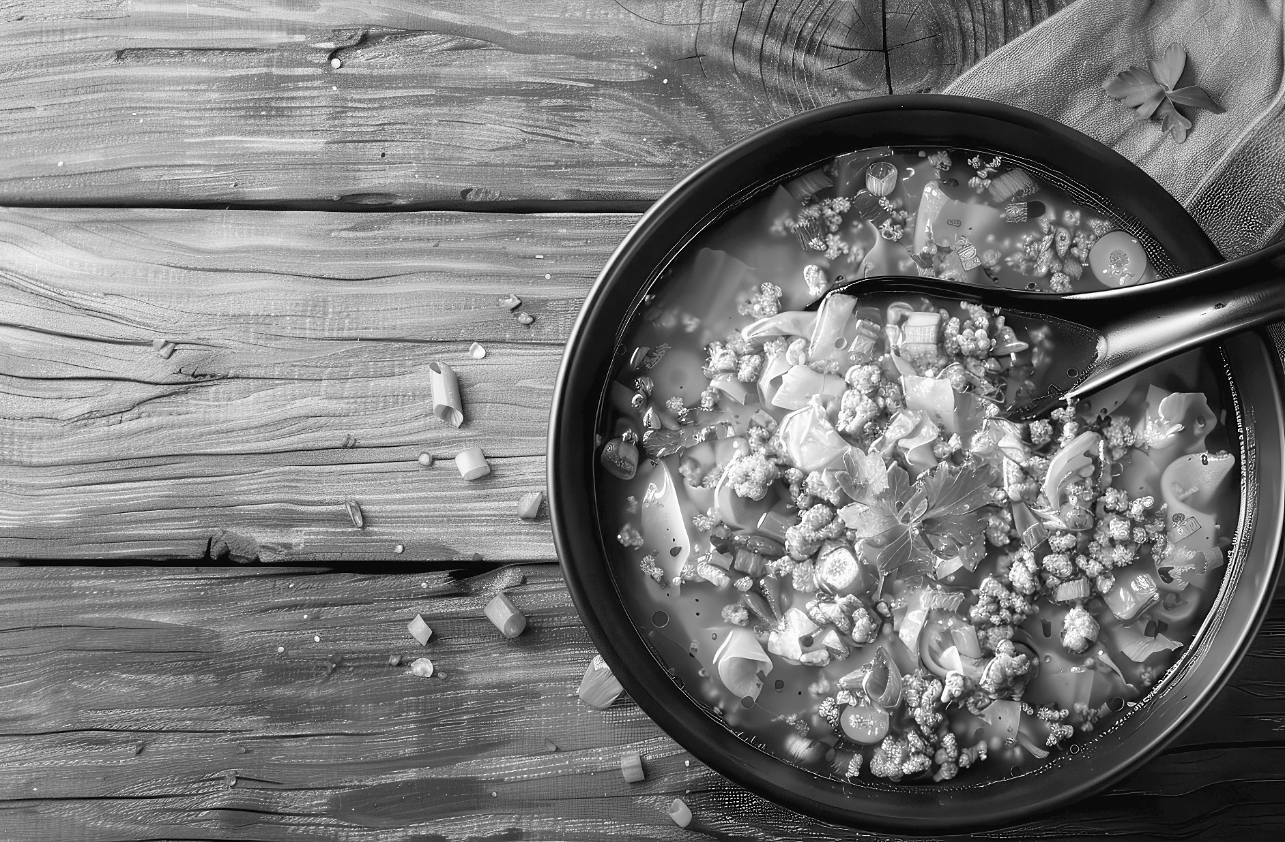
In my first book, I present to you entire chapter of Holubtsi recipes. Even linyvi, lazy ones. But it don’t get lazier than my Holubtsi Zupa! No rolling, naturally, and now, not even layering. Wooeee, you going to give your friends and family traditional taste of holubtsi, without burning your fingers or getting sweaty. Also, this recipe is gluten free if you stick to rice and not barley. Just don’t let it stick to you. Ha!
Holubtsi Soup is recipe that is also common with Mennonite people. Here is why, at least once in your life, you should have Mennonite boyfriend: When I am 14, I start seeing this guy, Bernie Friesen, who work in cheese factory. He is very, very cute, so I ignore he sometimes forget to remove his hair net before picking me up from cheese making factory. So one day, Bernie and I are kissing like crazy. I pull back and look him in his big blue eyes, long string of spit connecting us. Mine? His? Does it matter? I say, “Ber-nie, when you first know you looooove me?”
Bernie roll his eyes up like he is having seizure. “Well, I think it was when I saw you ride that palomino horse up the driveway. I noticed your big, strong thighs, and my imagination went wild.”
And that is why every girl should at least once, date Mennonite boy.
Ingredients:
◦ Lean ground beef, 1 lb.
◦ Extra virgin olive or soniashnyk, sunflower oil, 1 tbsp.
◦ Peeled, chopped garlic cloves, 5 or more depending on how Ukrainian you want to taste, and who you going to kiss. Do not use crushed crap from jar! Must be fresh
◦ Medium onion, one. Peel and chop fine
◦ Medium carrots, 2. Peel and shred
◦ Beef broth, 4 cups. See my beef broth recipe in first book and DO NOT use canned crap with monosadisticglucosaphetamine
◦ Tomatoes, large can. This usually 32 oz. I like taste of stewed ones in this soup
◦ Bay leaf, 1
◦ Uncooked white rice, 1 cup
◦ Cabbage, whole pile. About 4 cups, shredded or thinly sliced
◦ Salt and pepper to taste. Start with 1 tsp. salt, ½ tsp. pepper and add as you go. Use fresh cracked black pepper, and always keep tasting your recipe!
◦ One big soup pot. No need to use separate pans and make more dirty
Your Option:
◦ Substitute ground venison or lamb for beef
◦ Use smetana, sour cream, as garnish
◦ Substitute barley for rice. If you use barley, extend cook time to 30 minutes from 20
◦ Try various types of rice for that Ukrainian-Indian Fusionski taste. I love Basmati (sweet) and Jasmine (very sweet). Jasmine will shorten cooking time to 15 minutes from 20
◦ Add dill to taste. I recommend starting with ½ cup, chopped very finely
◦ Crisp bacon in your air fryer and add near end of cook. Kolbasa is also nice addition, chopped in mini cubes. So cute.
◦ Are several ideas for Holubtsi in my first book. Feel free to experiment with various types in this zupa
◦ If you prefer fresh tomatoes, I recommend very ripe Roma. Or for super cute effect, tiny tomatoes in various colors
◦ Try little bit basil and/or oregano for that Ukrainianski-Italiano Fusionski taste
Baba Alert: if you are new to being Ukrainian, some kolbasa is kind where you can eat skin. Other type have skin you have to remove. Use your best judgment. Also, in emergency where you forget to buy kolbasa at Ukrainian store, drive like crazy person to 7-11 and get beef jerky. One way to eat Holubtsi Soup is like shot with chaser: bite beef jerky, take slurp soup. Repeat.
Recipe:
Brown meat in soup pot. Preheat pot for few minutes, with oil, on medium heat. Keep stirring meat to say, “Break it up!” Noone want clumpy soup. If you used fatty meat, drain off liquid fat.
Make meat shove over so there is space in middle. Pour in onion and garlic, continuing to stir. Watch them careful so they get nice and tender and little bit see through, but not burnt.
Add shredded or cubed carrot, and stir for two minutes. Put water on to boil in case you need later.
Pour in broth and stir around till everything else is floating nicely. Add bay leaf, tomatoes, rice, salt and pepper.
Bring to boil, then reduce heat immediately to simmer. After watching too much Gordon Ramsay (because he is hot and he cooks), Baba realize not everyone know what this mean. Reduce heat to medium-low. There will be tiny bubbles on top, like baby farting in bathtub. Simmer 10 minutes, stirring now and then.
Add shredded cabbage and cook till tender. Use pot cover. About 10–15 more minutes. If you used barley instead of rice, use full time for total of 30 minutes. Check on soup while simmering. If too thick, add boiling water and stir. Never use tap water straight. It will taste horrible.
Taste your soup when you think is almost done. Add more seasoning if needed.
Ukrainian Proverbs
A hungry wolf is stronger than a satisfied dog. Keep husband on edge.
Too many cooks spoil the broth. So stay out of my kitchen unless you are invited.
Fear of death takes away from the simple joy of living. Take risk!
Bez Hluteny Paska
Gluten Free Paska
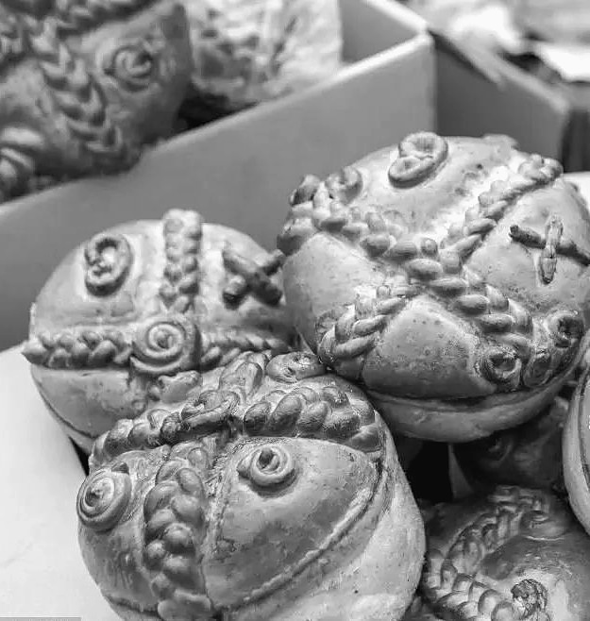
Hoo boy Poopchik, has Baba gotten lots requests for this! Wheat is not at all what we knew as children. Is all Monsanto-sized, hybridized, GMO’d, pesticided and herbicided. Not to mention grown in toxic synthetic fertilizer, instead of healthy manure. Of course, regular Paska is in Breads chapter of my first book, and rituals associated with. Making Paska is extremely spiritual ritual, to call good health and abundance into your household. In nutshell, make your house is quiet, and you are in calm spirit to bake sacred bread. Below is best flour for gluten free one that I know. This recipe makes one, 8 inch round Paska is always round, shape of Nature and cosmos.
Ingredients:
◦ Kinnikinnick All Purpose Flour Blend (gluten free), 2 packages=2 lbs. Use whole package in recipe, use flour from second for use while kneading
◦ Xanthan gum, 1 tbsp.
◦ Salt, 2 tsp.
◦ Baking powder, 1 tsp.
◦ Instant yeast, quick rising, 2 ½ tsp.
◦ White sugar, ½ tbsp.
◦ 2% milk, 1 ½ cups, warm. 1 ¼ cups goes in dough, ¼ cup is for egg wash
◦ Water, ¼ cup, warm
◦ Soniashnyk (safflower oil), 3 tbsp.
◦ Butter, ¾ cup, softened. ¼ cup goes into dough. ¼ is to grease baking pan, ¼ is for brushing on top of paska
◦ Honey, ¼ cup
◦ Large eggs, 6. Organic are best. 4 in dough, 2 for egg wash on Paska
◦ Lemon juice, 1 tbsp. Optional. It give nice zing zing, but you can leave it out if preferred. It has no effect on chemistry of this recipe.
◦ Springform pan or bundt pan, 8”–9”. Never use square or rectangular
◦ Pastry or clean paint brush. You can use one from dollar shtora, I don’t care
◦ Kitchen scale
◦ Cooling rack
◦ 9” × 13” pan
◦ Tin foil
Your Option:
In Baba’s Kitchen: Ukrainian Soul Food are suggestions for adding to your Paska, like raisins and saffron. Paska is traditional in white, yellow and black: for ancestors, sun and Mata Zemlya, Mother Earth.
Paska Recipe:
Grease your pan and forget about it.
Mix together yeast, water and sugar. Let it sit, ruminate and bubble for 5 minutes.
Stir together dry ingredients: flour, baking powder, xanthan gum and salt. Xanthan gum is powder, not for chewing. You don’t have to spit out your tobacco for this one. If you are going to use mixer (of course not!), put on that paddle thing.
In second bowl, mix eggs, oil, softened butter, honey and lemon juice.
Add warm milk and yeast to bowl with liquids. Mix for a minute. Patiently and gently add dry mixture to liquid, mixing in. Keep speed low, then increase speed for 3 minutes. Either your arm or your button finger will get tired. Sprinkle flour on clean counter, and spill dough on top. Sprinkle more flour on top of dough. You’ll use about 1/3 to 1/2 cup flour. Knead with gentle fingers till it feel like flour is all throughout dough. It will feel less sticky, but not firm. Is lighter feel than bread dough.
Cover with plastic, and let rest 20 minutes. Dough will give sigh of relief from being pummeled, like you do after good massage. After time is up, divide dough. Use kitchen scale to measure out one 260 gram (.57 lb.) piece. If kitchen scale is lacking, put aside 1/5 of dough for making ropey design on top of Paska. Remainder of dough, large piece, will be Paska.
Push this dough around in calm prayerful attitude like I instruct you in first book.
Make round shape, and press into your pan. Press down lightly, until dough is ¼” from all sides of pan. Create design on Paska with dough you reserved. Again, instructions in my first book. Start water boiling for proofer. Cover with plastic and proof for 50 minutes. You can make proofer by placing cooling rack over 9” × 13” pan, filled with boiling water.
Preheat oven to 375 F and melt butter. Brush Paska dough with melted butter OR with egg wash, as in regular Paska recipe. Egg wash is 2 beaten eggs with splash milk. This make browner crust.
Bake for one hour. Halfway through, remove Paska from oven and make it little tinfoil hat. You can maybe borrow one from “that” neighbour.
Once you take from oven, remove foil and let cool for at least 10 minutes. Then remove springform sides and base. Allow to cool completely before serving. Remember Paska is always served with rushnyk, sacred embroidered cloth. Gluten free Paska has best texture when eaten within 48 hours.
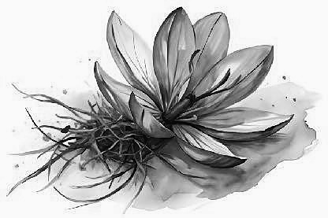 | Saffron is harvested from certain crocus, and make intense yellow Paska. Saffron instructions are in my first book. It takes 150 flowers to make 1 gram of saffron!
Bez Hluteny Varenyky
Gluten Free Varenyky
(Perohy-Perogies)
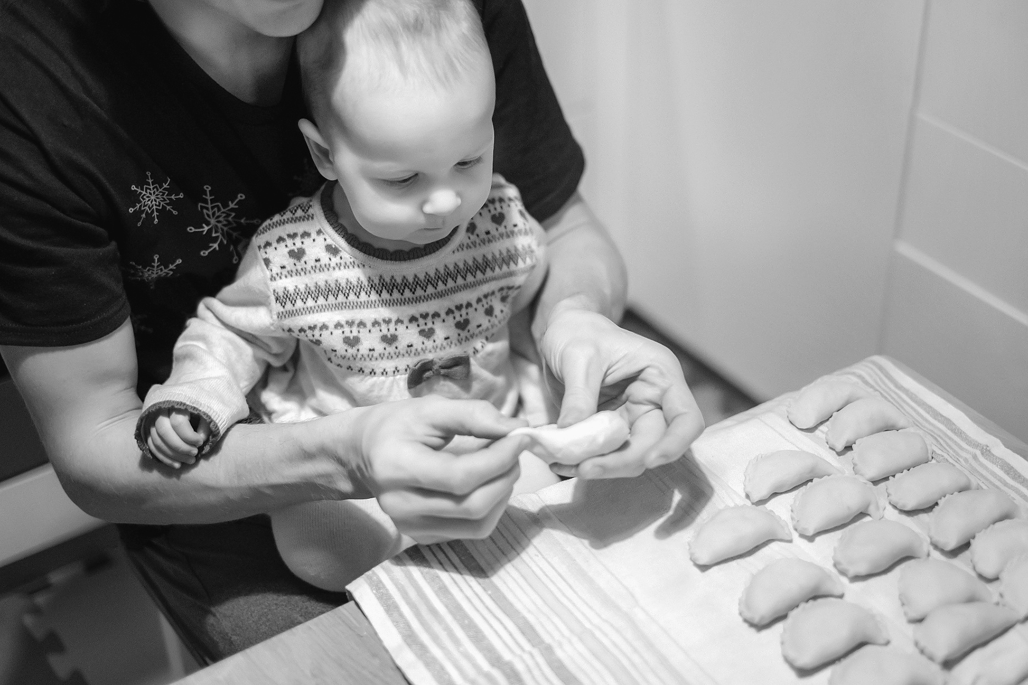
Now, what you ask me for, over and over again. More people are discovering they are sensitive or even allergic to wheat. Jury is outraged whether is wheat in general, or if terrible things they are doing in laboratory to make it nothing like what our parents raised and baked with. Loaf bread used to weigh at least one pound. Now is like cotton ball. Poopchik, this can’t be healthy. Speaking of not healthy: Baba thought she saw guy she went on date with, at pool. That was years ago. She hoped he didn’t notice her, as he spend whole date laying out his expectations of wife staying home to cook from scratch, and clean apartment. As if! She is pretty sure it was him—if he got his ears waxed since. She will never cook for him. So now you know, Baba spend lots time in pool. One day, she is in one her favorite water features at pool: River. Suddenly, small boy get crammed up her dupa, headfirst. We make it around entire island, me batting at him, but unsuccessful. Finally, he go POP! and I am free. He is shaken, but okay. I immediate ask for his parents, so I can control narrative. Poopchik, be careful on those water features.
My first book contains whole chapter of varenyky recipes. Below, I teach you Potato and Cheddar. If Bob’s Red Mill Gluten Free products are not in your grocery shtora, they can be purchased online.
Ingredients:
Dough
◦ Bob’s Red Mill Gluten Free Pizza Crust Mix, 2 cups. Do not use packet of yeast that comes with mix. Reserve small amount of flour for dusting counter
◦ Salt, ½ teaspoon
◦ Egg, one slightly beaten but not defeated
◦ Whole milk, 1 cup
◦ Large mixing bowl
◦ 2 large pots
◦ Rolling pin
◦ Tea towel, slightly damp
◦ Wooden and slotted spoons
◦ Drinking glass for cutting circles, plus one for drinking while you cook, Short and squat, like many Babas.
◦ Colander with tea towel underneath
Potato Cheddar Filling
◦ Red or white potatoes, 10 medium. Russet is too grainy for smooth operator like you
◦ Medium or old cheddar cheese, 1 cup
◦ Butter, ½ cup
◦ Smetana, 1 tablespoon for recipe, unlimited for slathering
◦ Salt, 1 teaspoon
◦ Coarse black pepper, ½ teaspoon
◦ Organic cooking onion, ½, or shallots, 2
◦ Potato masher
Filling Recipe. Make this first:
Peel and cook potatoes with salt. In meantime, fry onion with butter. If you are really coordinated, you can use same fry pan as you will fry varenyky. Drain and mash with cheese and pepper.
Recipe:
Prepare dough in big mixing bowl. Pour in pizza mix (but not packet of yeast), and make well in middle. Then pour in other ingredients. Start kneading. Maybe you like rubber gloves, maybe you like feel of dough on fingers. It’s your thing, do what you want to do. I enjoy finishing kneading on floured counter. Once you finish kneading, and dough feel it is finished kneading you, roll out dough. It does not need to rest like if it have gluten or yeast. You may need a baba to show you right thickness. Is feel thing. But your varenyky will still turn out with that nice slippery feel.
Start water boiling in big pot, with 1 teaspoon salt.
Cut circles with drinking glass. Children often enjoy this part. Is how I started my intrepid journey into lifelong cooking. Place circles on slightly damp tea towel, not touching each other. Put 1 teaspoon your favorite filling on each circle. Then dip your fingers in flour mix, and pinch pinch pinch edges. Pinch from outside edge of moon to inside, or you end up with long weirdo varenyky.
When water is boiling real good, gently drop varenyky into it. No more than 10 at time, Poopchik! Stir gently with wooden spoon. Varenyky will start floating to top, like fat little white men. Once they are all there, boil for 4 more minutes. Remove from water with slotted spoon, into colander.
Rinse under cold water, and let drain.
Cut up onion and fry in butter till soft, but not yet brown. Add varenyky and fry till they are soft or crispy, however you like.
Try any filling I show you in my first book, with cornucopia of fillings: cheese, mushroom, kapusta, potato, fruit, cottage cheese, meat, fish, even with non dairy dough, and also Vushky, “little ears.” Plus Lazy Varenyky.

