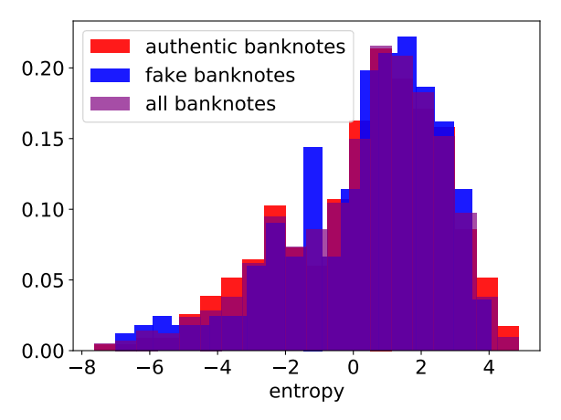
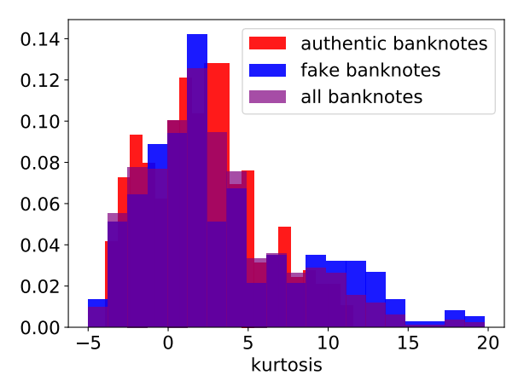
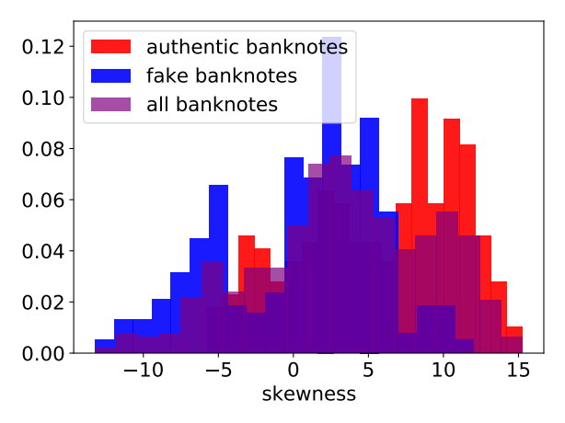
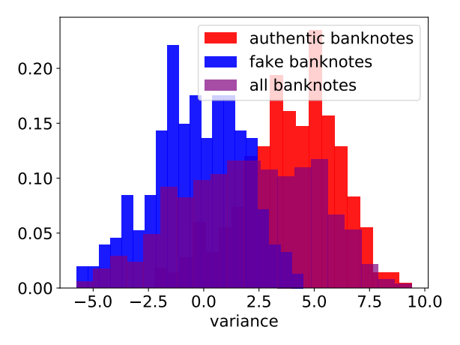
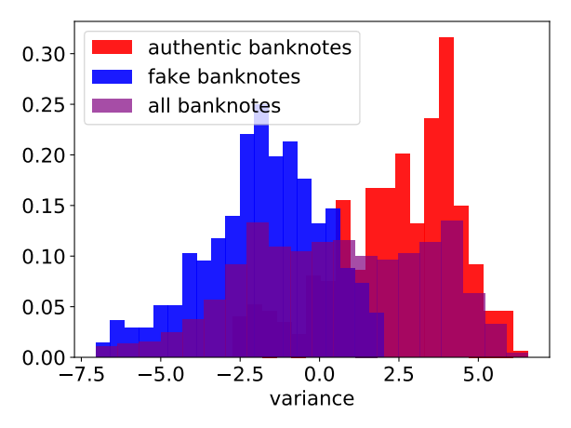
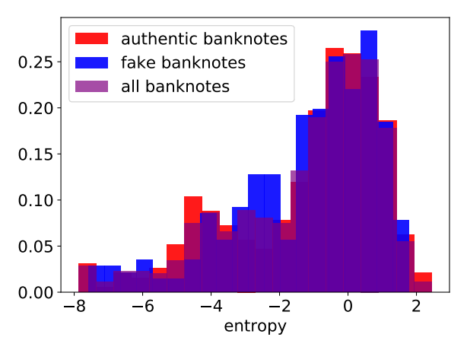
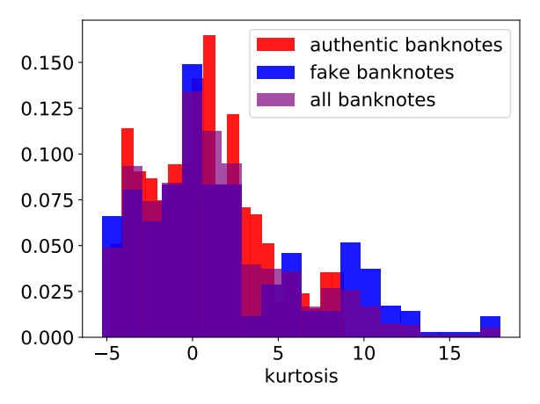
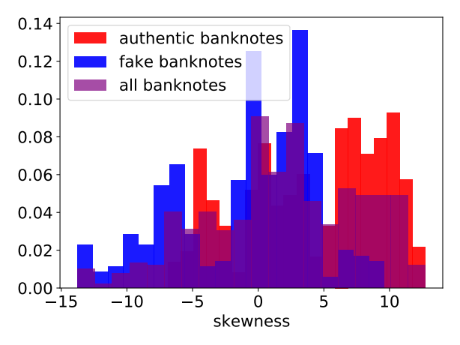
REPORT: BANKNOTE AUTHENTICATION
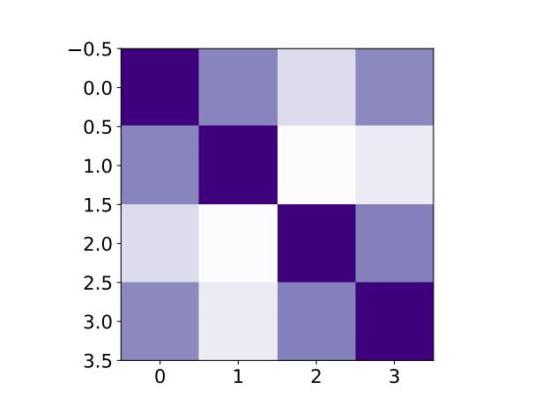Figure 2: Correlation matrix heatmap Training dataset degraded with noise
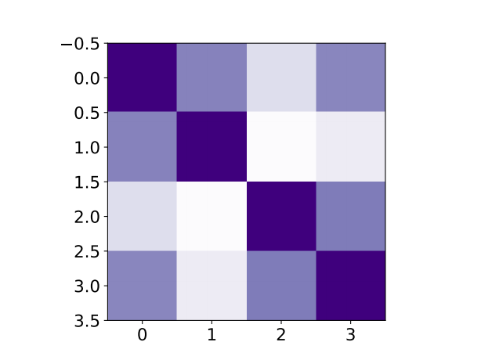Figure 1: Correlation matrix heatmap Training dataset
Giuseppe Salvi, s287583
15/09/2021
1. DESCRIPTION OF THE PROBLEM AND DATASET ANALYSIS
The project requires verifying whether a banknote is authentic or not, the dataset is taken from the UCI machine learning repository¹ and contains 675 samples for the training dataset (Train.txt), and 697 for the testing dataset (Test.txt) . There is also a second version of the data that corresponds to the original data degraded by noise (TrainH.txt, TestH.txt). There are 5 attributes out of which 4 are the features and one is the target attribute, that contains two values: 0 for authentic banknote, 1 for fake. The features are continuous and correspond to variance, skewness, kurtosis and entropy.
The training set contains 675 samples, 374 correspond to authentic banknotes, while 301 correspond to fake banknotes. The evaluation set contains 697 samples, 388 correspond to authentic banknotes, while 309 correspond to fake banknotes. The same happens for the degraded version of the dataset. So the dataset contains a balanced ratio of both classes (55,4% – 44,6% for train dataset, 55,7% - 44,3% for test dataset). Given the small amount of data, a k-fold cross-validation technique could be a good idea to estimate more reliable parameters for our models.
Histograms of features of Train dataset

Histograms of features of Train dataset degraded with noise

We can see that some features have a Gaussian-like distribution more than others, and in some cases the two classes are clearly separable, for example if we look at the variance feature in both the original train set and the corrupted one.
Correlation analysis
By lookiing at the heat map showing the Pearson correlation coefficient, we can see that there is no particular correlation between the features, the highest value is between kurtosis and entropy (feature 2 and 3) and has a value of 0.33 for the original case and 0. 313 for the dataset degraded with noise. This, and also the fact that we have few features, suggests that we can avoid using dimensionality reduction techniques such as PCA.

