**Question One.**

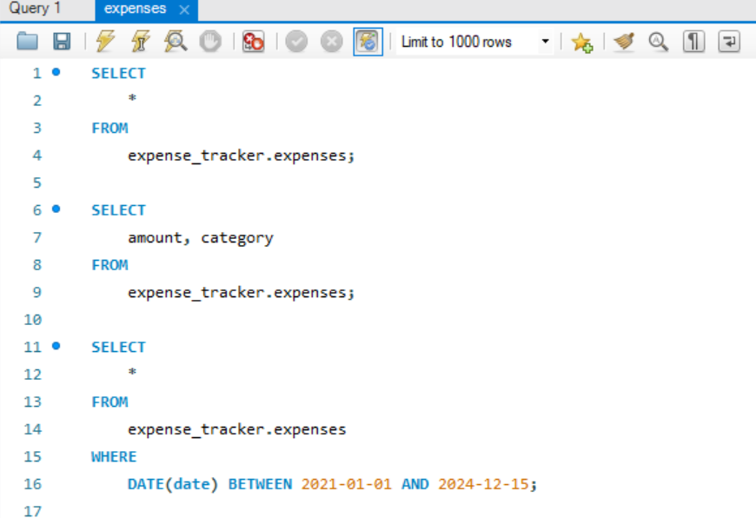

**Question Two.**

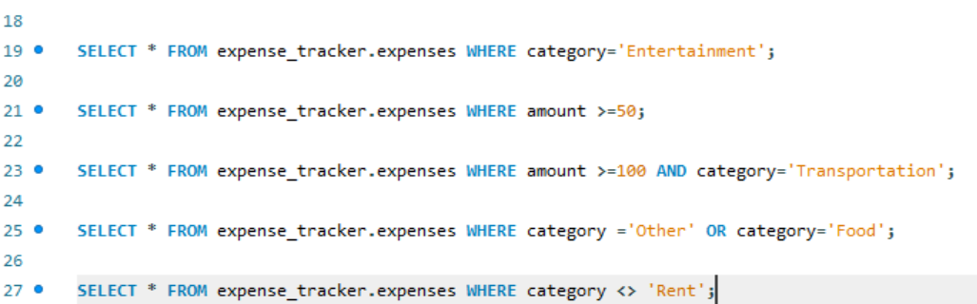

**Question Three.**

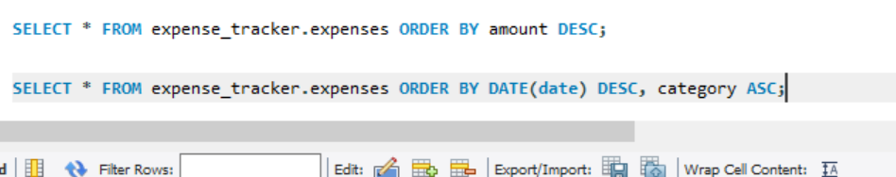

**Question Four.**

