DOCUMENTATION

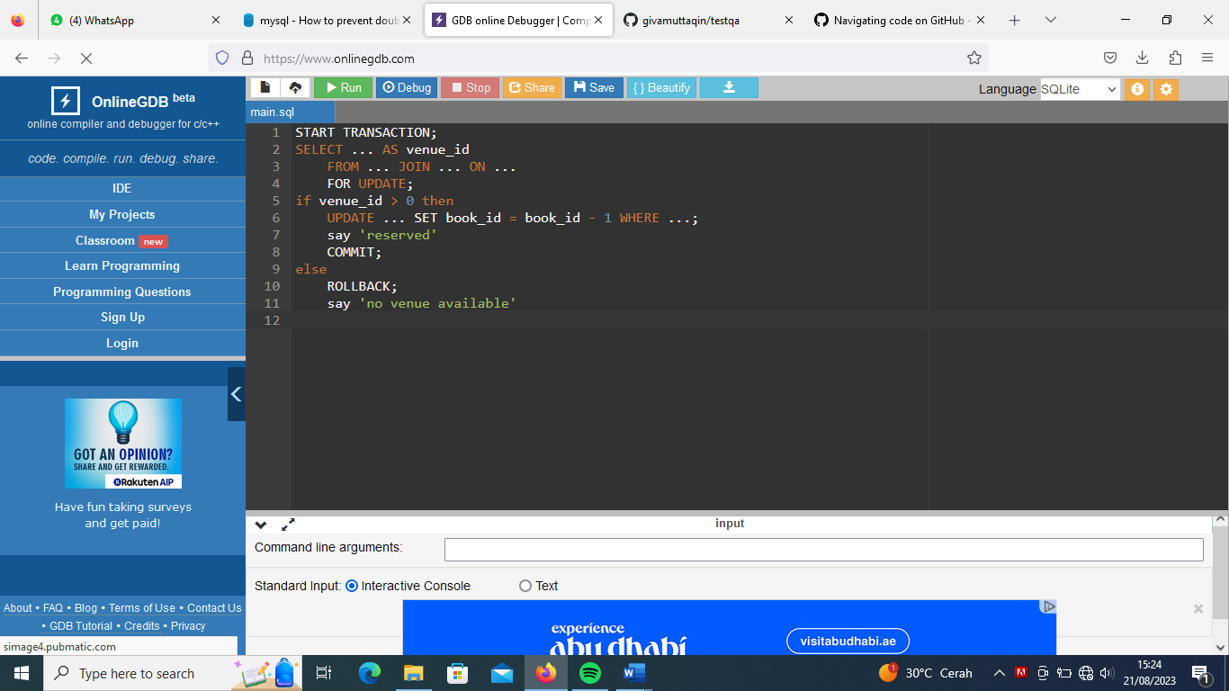

* The following pseudo-code demonstrates the "general principle" for "Check for availability, then either consume the item or abort".
* Use "transactions", and be sure to include FOR UPDATE:
* Using ENGINE=InnoDB on the table, plus FOR UPDATE and BEGIN...COMMIT/ROLLBACK are the SQL pieces to us in MySQL.