How to get the text?

1. Open Facebook and change your view to the “classic Facebook”

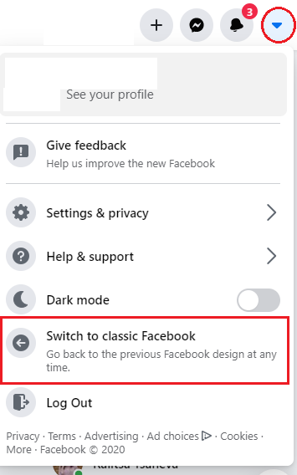

1. Open: <https://www.facebook.com/events/birthdays/>

Scroll down to the end – the same month, but the next year.

1. Press F12 on your keyboard. If it’s not , choice Elements. Then press CTRL + F

to open the search bar. Find birthdays_content.

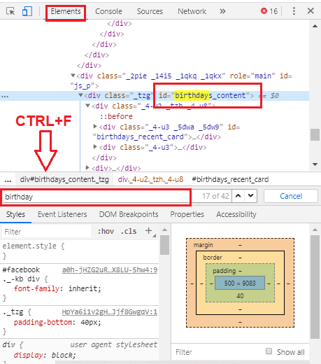

1. Click the right button of your mouse and choice copy – copy outerHTML

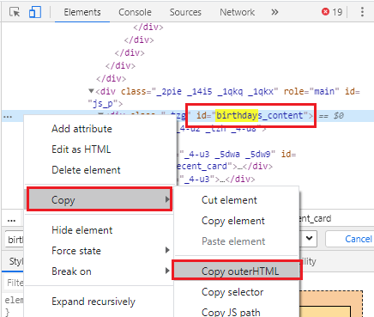

Then paste the text on: <https://givanov95.github.io/birthdays-fromFB/> and choice “Download Calendar CVS”.