**GET ACCOUT INFO**

SELECT t1.accountId, t1.userId, t3.Name, t1.totalBalance, t2.accountType FROM givedo.accounts t1

INNER JOIN givedo.account_type t2 ON t1.accountTypeId=t2.accountTypeId

INNER JOIN givedo.users t3 ON t3.userId=t1.userId

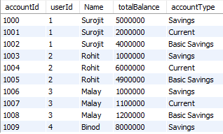

**NOTE: Amount has to be in in paisa**

**1. Transfer between accounts belonging to the same user is not allowed.**

Headers: Content-Type:application/json

Payload: {

"fromAccountId": 1001,

"toAccountId": 1002,

"amount": 1000

}

**2.Source account should have the required amount for the transaction to succeed**

Headers: Content-Type:application/json

Payload: {

"fromAccountId": 1001,

"toAccountId": 1003,

"amount": 5000001

}

**3.The balance in the ‘BasicSavings’ account type should never exceed Rs. 50,000**

Headers: Content-Type:application/json

Payload: {

"fromAccountId": 1004,

"toAccountId": 1002,

"amount": 1000001

}

**4.SUCCESS CASE**

Headers: Content-Type:application/json

Payload: {

"fromAccountId": 1004,

"toAccountId": 1001,

"amount": 1000000

}